Boinc Tasks History Reader “BThistory”

Fred has graciously allowed my program BThistory to be promoted as an add-on to Boinctasks.

BTHistory reads one or more Boinctasks’s history files and allows data analysis for elapsed time, throughput and idle time. If more than one file is opened, then comparisons can be made between different systems. New or unknown applications are reported, highlighted and can be compared. The program is written in C# and compiled under Visual Studio 2017. One can download the executables or build the sources at GitHub/JStateson. Additional utility programs are included in the VS2017 solution and are explained in another document.

1. BTHistory main form and throughput analysis

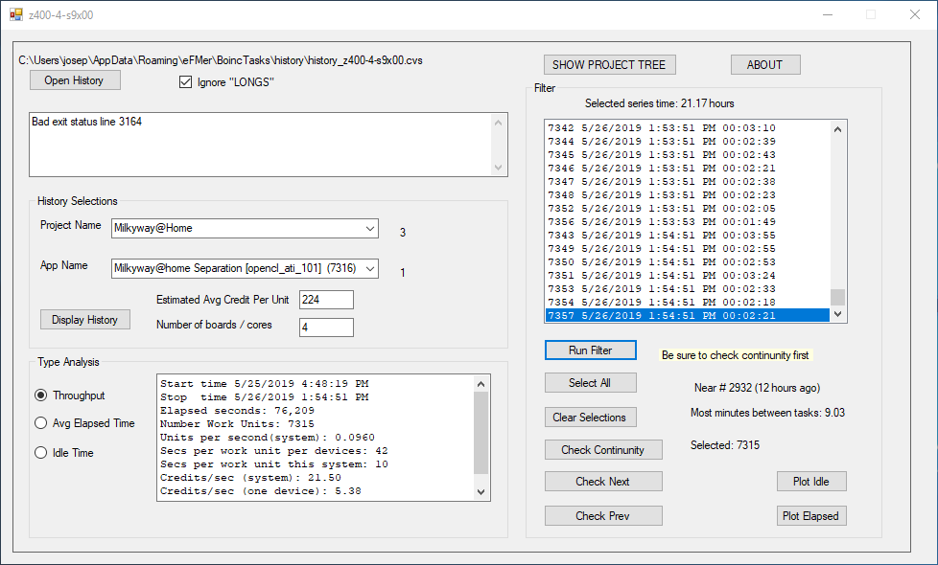

The history file “z400-4-s9x00” has been opened and there are 3 projects. That can be selected (milkyway) and that project has only one app running on this system. The throughput filter is selected, all results were selected (except 3164 which had a problem) and the continuity check was done. Knowing that this system had 4 boards and average credit was 225 points, the results show about 5 credits per second.

The “1” adjacent to the App Name box indicates there is only 1 app associated with Milkyway, at least on this particular system.

1. BThistory and Elapsed Time

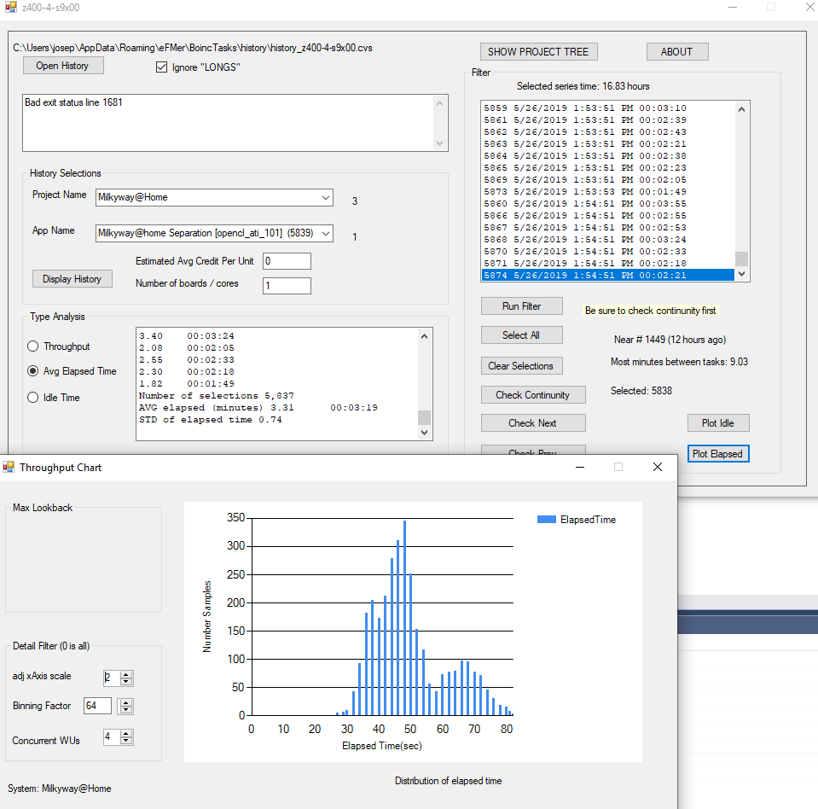

Elapsed time is in minutes, but the plot parameters were changed to show the effective ET since four tasks were being run concurrently each GPU. If there were 5 GPUs that mean of 50 seconds (as shown above) indicates the system with 5 GPUs will produce about (50 / 5 = 10 seconds per work unit)

1. BThistory Idle time

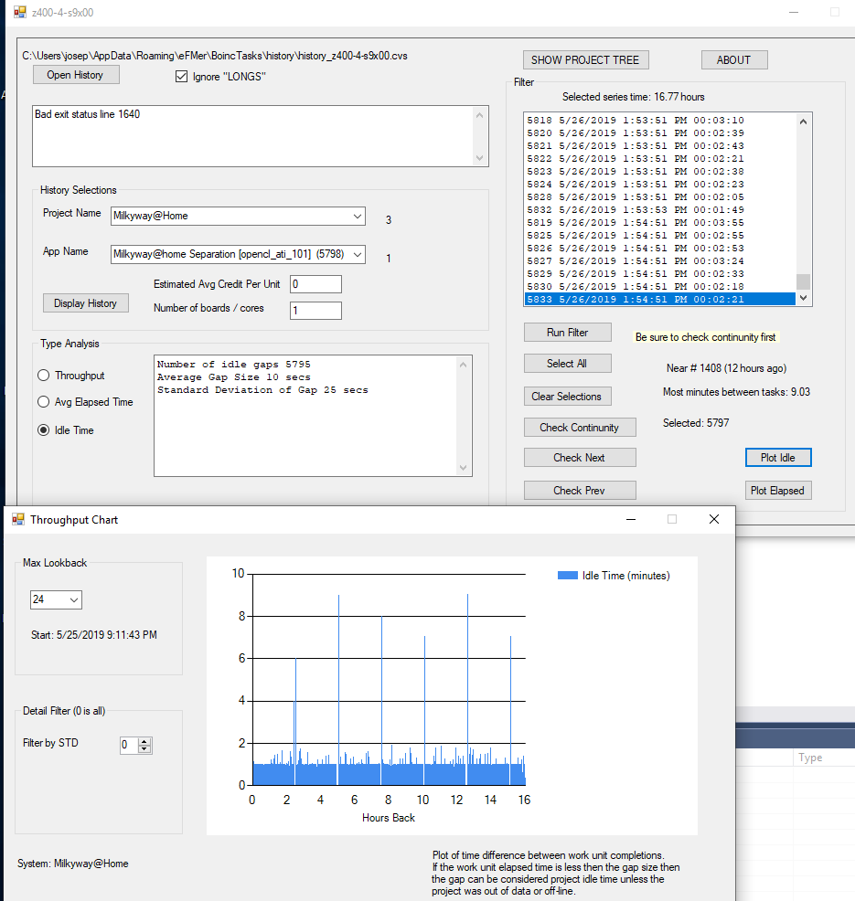

The Idle Time analysis is useful to show when projects run out of data or, as in the case above, the project fails to provide data until all the data has been processed. In that case, where the system is waiting for data to arrive, the gap is considered idle time. The above data shows that about every two hours there is a 6 to 9 minute gap before the server provides data.

1. BThistory Project Structure

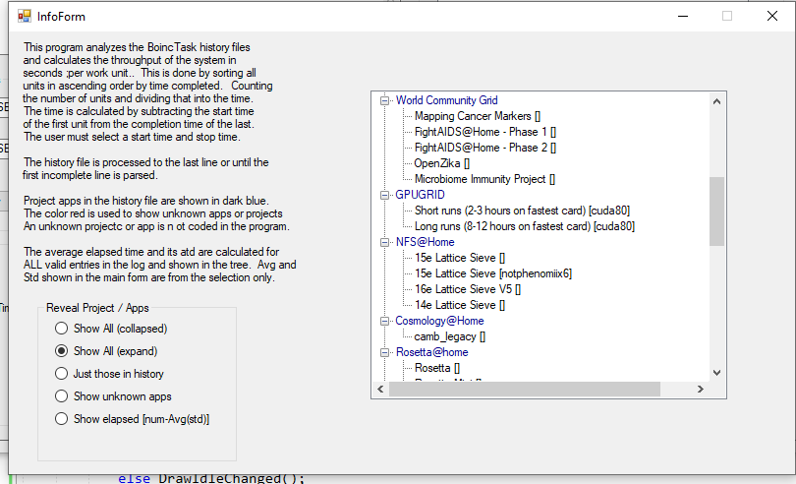

This shows which projects are in the BThistory database or are in the history file

1. BThistory Select multiple systems

If more than one history file is opened, then the BThistory produces a a comparison of the different systems. Typically the files of interest end in CVS and do not have phrase “_long_” in the filename. In the event that the “long” files do contain data then you should uncheck that exclusion.

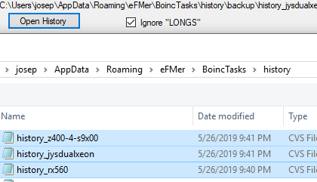

5.1 BThistory Comparison

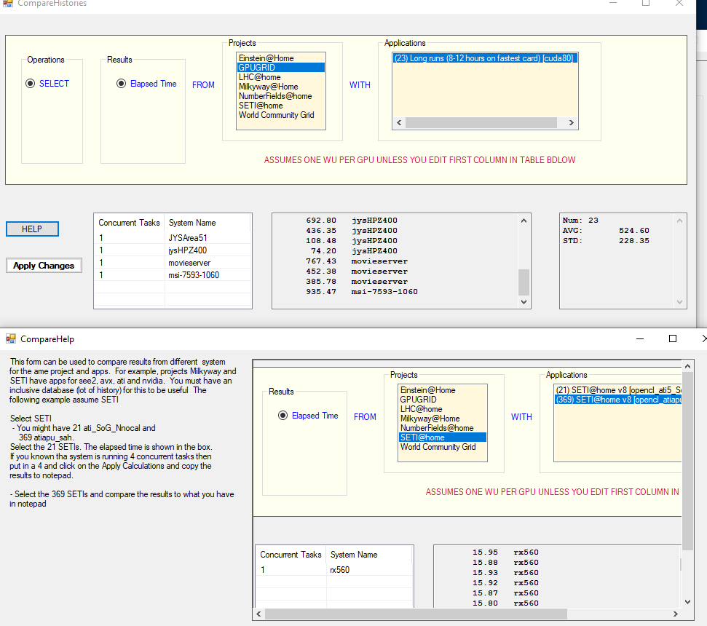

This feature allows comparison of systems across the same project and app.