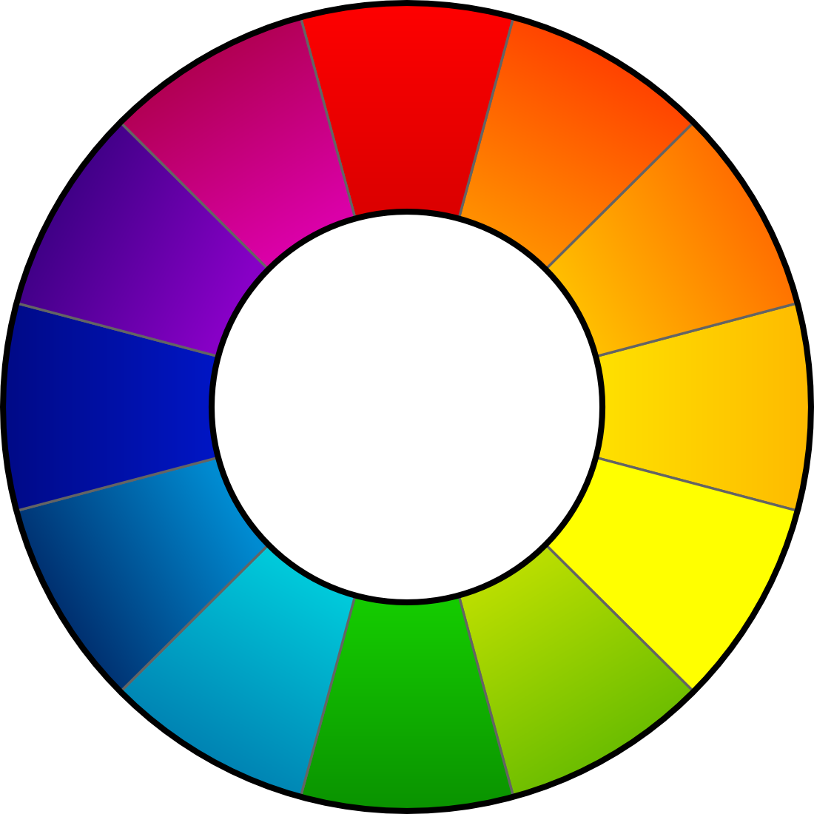
RawTherapee
Users Manual

This document was last edited on 2009-09-04 by Karl Loncarek.
This document may be freely distributed.

Contents
Introduction 4
What is RawTherapee? 4
What cameras are supported? 4
What are the requirements? 5
Starting RawTherapee 5
The User Interface 5
(1) Histogram 6
(2) Tools Panel 6
(3) Postprocessing Profiles Switcher 7
(4) History & Snapshots 8
(5) Preview Image 8
(6) Image Details 9
(7) Image Processing 9
(8) Directory & File Browser 9
(9) Save & Preferences & Send to editor 11
General 11
Image Processing 11
File Browser 12
Output Options 12
Color Management 13
Image Processing Parameters 13
Exposure 13
Exposure 14
Highlight Recovery 14
Shadows / Highlights 15
Luminance Curve 16
Detail 16
Sharpening 17
Luminance Noise Reduction 18
Color Noise Reduction 18
Color 18
White Balance 19
Channel Mixer 19
Color Boost 20
Color Shift 20
ICM 21
Transform 21
Crop 22
Rotate 22
Distortion 23
C/A Correction 23
Vignetting Correction 23
Resize 23
Metadata 23
EXIF 23
IPTC 24
Frequently Asked Questions 24
Q: RT is not starting or doing strange things (i.e runtime error), what should I do? 24
Q: Is it possible to use RT on a portable device, e.g. a USB thumb drive? 25
Q: What is the recommended sequence of image processing operations? 25
Q: How does the internal workflow of RT look like, i.e. In which order are the changed parameters applied? 25
Q: How to create black&white images? 27
Q: How can I restore the current image (reset all settings done)? 27
Q: What happens when changing the curve in the Image Processing curve editors of Exposure (called Tone Curve) and Luminance Curve? 28
Q: What are the best USM (unsharp mask) settings? 29
Q: What is color management? 29
Q: I would like to create an own theme. How can I do that? 33
Q: Which keyboard shortcuts are available? 33
Glossary 34

Introduction

What is RawTherapee?
RawTherapee is a free RAW converter and digital photo processing software. It is available for Windows and for Linux and is actively developed.
RawTherapee is used to adjust some of the most often changed parameters when optimizing digital images. A normal user often just wants to adjust the white balance or brightness of a photo he took. Instead of using a big and expensive image editor you could use a small and fast (specialized) tool like RawTherapee.
More and more cameras also support RAW formats. RAW files usually offer higher color depth than JPGs (JPG is limited to 8 Bit per color). So the adjustments are done with the high color depth and then afterwards converted to or saved as JPGs. Thus you loose no picture detail in the JPG as you would when changing the JPG itself.
RawTherapee supports JPG (8 bit), PNG (8 or 16 bit) and TIFF (8 or 16 bit). All image processing is done in 16 bit/channel mode.
Different to other RAW converters it can use EAHD as demosaicing algorithm. More information about the results compared to others could be found on http://www.rawtherapee.com.

What cameras are supported?
The raw loading engine of RawTherapee is based on dcraw (RawTherapee 2.4.1 uses DCRaw 8.97). This means that all cameras supported by dcraw are also supported, that use a classical RGB Bayer pattern sensor.
If your camera is not listed, but works with the software; or if it is listed but RawTherapee can not read it, please send me an email to: gabor at rawtherapee dot com.
Supported Cameras, i.e. formats:
- Adobe Digital Negative (DNG)
- Canon PowerShot G3, G5, G6, G7, G9, G10, G11, SD300, S30, S40, S45, S50, S60, S70, Pro1, S2 IS, S3 IS, S5 IS, A460, A470, A530, A570, A590, A610, A620, A630, A640, A650, A710 IS, A720 IS, SX1 IS, SX10
- Canon EOS D30, D60, 10D, 20D, 30D, 40D, 50D, 5D, 5D Mark II, 300D (Digital Rebel), 350D (Digital Rebel XT), 400D (Digital Rebel XTi), 450D (Digital Rebel XSi), 500D (Digital Rebel T1i), 1000D (Digital Rebel XS), 1D, 1Ds, 1D Mark II, 1D Mark III, 1D Mark II N, 1Ds Mark II, 1Ds Mark III
- Casio QV-2000UX, QV-3000EX, QV-3500EX, QV-4000, QV-5700, QV-R51, QV-R61, EX-S100, EX-Z4, EX-Z50, EX-Z55, Exilim Pro 505/600/700
- Kodak DC20, DC25, DC40, DC50, DC120, DCS315C, DCS330C, DCS420, DCS460, DCS460A, DCS520C, DCS560C, DCS620C, DCS620X, DCS660C, DCS660M, DCS720X, DCS760C, DCS760M, EOSDCS1, EOSDCS3B, NC2000F, PB645C, PB645H, PB645M, DCS Pro 14n, DCS Pro 14nx, DCS Pro SLR/c, DCS Pro SLR/n, P850, P880
- Minolta RD175, DiMAGE 5, 7, 7i, 7Hi, A1, A2, A200, G400, G500, G530, G600, Z2, Dynax/Maxxum 5D, Dynax/Maxxum 7D
- Nikon D1, D1H, D1X, D2H, D2Hs, D2X, D2Xs, D3, D3X, D40, D40X, D50, D60, D70, D70s, D80, D90, D100, D200, D300, D700, D3000, D5000, E2100, E3700, E5400, E8400, E8700, E8800, Coolpix P6000
- Olympus C3030Z, C5050Z, C5060WZ, C7070WZ, C70Z, C7000Z, C740UZ, C770UZ, C8080WZ, E-1, E-3, E-10, E-20, E-300, E-330, E-400, E-410, E-420, E-500, E-510, E-520, E-620, E-P1, SP310, SP320, SP350, SP500UZ, SP510UZ, SP550UZ, SP560UZ, SP570UZ
- Panasonic DMC FZ8, FZ18, FZ28, FZ30, FZ50, FX150, L1, LC1, LX1, LX2, LX3, L10, L1, G1, GH1, GF1
- Pentax *ist D, DL, DL2, DS, DS2, K100D, K100D Super, K200D, K10D, K20D, K2000/K-m, K7
- Sony DSC-R1, DSC-V3, DSLR-A100, A200, A300, A350, A700, A900
- Samsung GX-1S, GX-10
- Fuji FinePix E550, E900, F700, F710, F800, F810, S2Pro, S3Pro, S5Pro, S20Pro, S5000, S5100/S5500, S5200/S5600, S6000fd, S6500fd, S7000, S9000/S9500, S9100/S9600, IS-1
- Some Sinar, Phase One, Leaf, AVT, Leica, Hasselblad, Imacon, Mamiya cameras

What are the requirements?
- A fast processor with SSE support is recommended but not required.
- At least 512MB of RAM
- Minimum recommended screen resolution 1024x768
- Windows version: Windows 2000, XP or Vista (32bit)
- Linux version: GTK+ 2.14, GTKmm 2.14 series

Starting RawTherapee
Simply double click on the RawTherapee icon. That's all.
When you provide an image filename (with or without path) to “rt.exe” RawTherapee loads this file and shows a Preview Image.
Just another thing to mention (which might be quite important to some users): RawTherapee is already quite portable, which means that nothing is written into registry. Simply a directory RawTherapee is created in the HOME directory of the current user (see also here on more information about portable usage).

The User Interface
When starting RawTherapee it is usually started in a maximized window. You will see the following window:
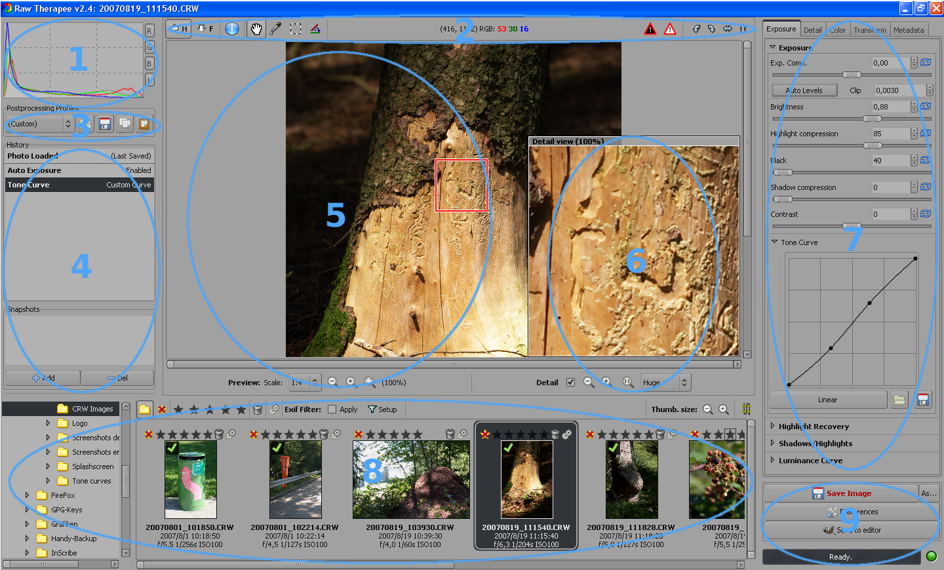
In the above image there are several areas in the window which are marked above with numbers. Below a more detailed description of these areas:

(1) Histogram
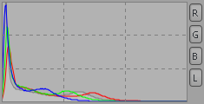 | Here you see the histogram of the currently edited image. If you selected a Crop, you'll see a histogram of the cropped area. Each of the displayed channels can be switched on and off separately. When you switch off one channel, the others may be magnified to fully use the available space. Displayed channels are:  - Red (red line)  - Green (green line)  - Blue (blue line)  - Luminance (gray line/area)  If you have a very peaky histogram double click on it and then the scale is changed (histogram is magnified thus smaller values can be seen better).

(2) Tools Panel
The Tools Panel contains several symbols which allow fast usage of RawTherapee.
Hides/Displays the Histogram, Postprocessing Profile Switcher and the History & Snapshots. You can also use the key to hide/display them.
H
When pressing the first time it hides/displays the Directory & File Browser. Pressing it again enlarges the Directory & File Browser and hides the Preview Image (3-State Button). You can also use the key to switch between the different views.
F
Shows the most important EXIF informations of the currently edited image in the preview area. Those informations are:
- Camera type
- F-stop and shutter speed
- ISO setting
- Focal length
- Used Lens
You can drag the image with the mouse and move it when the preview is bigger than the available viewing area (because of the magnification). This works also in the details window. This tool is activated by default. You can also use the key to activate it.
N
N
The mouse cursor changes to a picker. Click with this picker on an gray or white area to correct the white balance, i.e. color temperature. It might be necessary to do this several times as the areas might contain small color variations which are not visible thus leading to totally different results. You can also use the key to activate it. You can cancel this function by doing a right click with the mouse. The hand tool is then automatically activated again.
W
Select the area of the image which should be used for the developed image. For setting the crop parameters take a look at the Crop Parameters. When you selected a part of the image the surrounding area will be darkened or brightened. You can switch between dark and bright border simply by pressing and double clicking in the border area. To move the crop area around press and drag the area with the mouse.
Ctrl
Shift
You can also use the key to activate it.
C
The image will be rotated for the angle that is displayed. Use this tool to draw a line ideally over a line on your image that should be horizontal or vertical (maybe some edge). When using this function you will draw a line that is considered to be horizontal or vertical afterwards. To achieve that the image will be rotated accordingly. You can also use to activate it.
S
The center area shows the actual position of the mouse pointer within the image (in pixels). Also the RGB values of that point is given. When you click on RGB: the display changes to HSV values which is also shown with the text HSV:. This setting is not saved. Each time you run RawTherapee this setting is reset to RGB.
Shows the area of your image that is too dark and gets clipped. With that you can judge whether you maybe darkened the image too much and thus would loose important picture information. Depending on your Preferences this area could also blink.
Shows the area of your image that is too bright and gets clipped. With that you can judge whether you maybe brightened the image too much and thus would loose important picture information. Depending on your Preferences this area could also blink.
Rotate the image left by 90 degrees.
Rotate the image right by 90 degrees.
Flip the image horizontally.
Flip the image vertically.

(3) Postprocessing Profiles Switcher
Let's assume you have found some great settings on sharpening or optimum settings for noise reduction for use with your camera. You can save the sum of settings you did to the image in a profile. You could then easily apply all your great settings on the image you are currently working on simply by loading a new profile. Your own profiles are saved in the users home directory.
If you want to share the newly created profile with other users of your computer you have to copy it into the profiles folder within the applications folder.
You could even define in the Preferences which profile should be used as default when loading a RAW or JPG image.
There are already some default profiles:
- neutral – Some default values are used. No image processing is done. Same as a fresh edit of the image.
- default – The brightness is automatically adjusted and slight sharpening is applied.
- crisp – Same as default but additionally increased contrast and increased sharpening is applied.
When you already worked on a image other choices are available:
- (Last Photo) – All of the settings used for the last edited image will be used for the current image also.
- (Last Saved) – All the settings are applied that have been done during the last edit of this image.
- (Custom) – Those are your actual settings/changes that are visible in the history.
The following buttons are available
Load and apply a profile
Save current changes to your image as new profile
Copy current changes to your image as profile to the clipboard
Apply profile from the clipboard to the actual image

(4) History & Snapshots
In the history you can see all the adjustments you have done since loading the image. It is like a detailed Undo/Redo memory. Jumping back to a previous step is done by clicking on the last correct step in the history list. You'll see also the values that have been used to achieve that step. If you do not change anything you can easily jump back and forth to get an idea how the image looked before and after. Undo can also be achieved by pressing +, redo is done by ++.
Ctrl
Z
Shift
Ctrl
Z
Additionally you could use snapshots. With snapshots you save one or more important steps or positions within your history for a fast later recall. Simply click on Add to save it. Use Del to remove it again. If you want to give a snapshot a special name simply double click on it's name in the list. Then you can change the name to your liking.
Snapshots are only available during editing the image. As soon you select another image for editing all snapshots are lost.

(5) Preview Image
Here the currently edited image is displayed. If the background color in the preview area disturbs you when working on your image simply double click on it with the left mouse button. Then the background color changes to black, white, and gray (default) again.
You can select the scale the image is loaded with. Basically you can influence the processing time with it. The lower the size is the lower the processing time, e.g. a scale of 1:1 needs more time for loading than 1:2 (4 times longer to be precise).
You have the choice between the following scales: 1:1, 1:2, 1:3, 1:4, 1:5, 1:6, 1:7, 1:8.
With using the scale, the original image is made smaller and the result is then displayed. Also all the adjustments you do are applied to the preview so you can see the effect immediately. Normally a scale of 1:1 is not needed, as you also can check the Image Details.
When using a scale that results in an image being bigger than the preview area you can move around the visible part and also can zoom it. Next on the right of the zoom icons (see below) the actual zooming factor is displayed, e.g. 20%. The available zoom range is 20% - 100%. Instead of using the buttons below you can also use the mousewheel to zoom in/out. Double clicking on the image zooms it back to 100%.
Zooms out one step
Zooms in one step
Sets the zoom so the image fits into the available Preview area.

(6) Image Details
To activate the Image Details simply click into the checkbox named Detail. You can select the area that is occupied by the Image Details: Small, Normal, Large or Huge. By default each pixel on the monitor represents one pixel of the image.
You can move around the area which is visible in the Details simply by dragging the red square with the mouse or by dragging the visible content within the Image Details box with the hand tool.
Also you can use the zoom icons below or the mouse wheel to zoom in/out the Image Details. Double clicking into the details windows switches automatically to 100%. The available zoom range is 100% - 800%.
Zooms out the image details one step
Zooms in the image details one step
Sets the original size which means each pixel on the monitor represents one pixel of the image.

(7) Image Processing
The Image Processing Parameters are organized into several tabs which group the available functions for easier access. They are explained in detail later in this document (see below).

(8) Directory & File Browser
On the left side you can see a directory tree. Use it to select the desired directory on your harddisk. Clicking on the triangle next to the name opens or closes that directory to show or hide the subdirectories. After double clicking on the desired directory thumbnails for the file browser are created right of the directory tree. On first opening the desired directory thumbnails are created from the images. Those thumbnails are cached to reduce later loading times. The thumbnails are displayed as soon they have been generated. The thumbnail generation and caching continues as background process.
All changes done to the content of the directory you have currently opened in RawTherapee is monitored. This means additional images are also shown as thumbnails and thumbnails for deleted images are removed.
At the top of the File Browser you see some symbols:
Show all images of the selected directory
Show only unranked images
Show only images ranked with the selected amount of stars
Show only images marked for deletion. Additionally you have the possibility to finally delete those images by pressing Empty Trash.
Show processing queue. When the button Start Processing is pressed the images are processed immediately and e.g. a JPGs are created. When Stop Processing is pressed the images are just ready for processing. No action happens. This is the default setting.
Additionally you can access and change the Output Options through Settings.
Decreases the thumbnail size
Increases the thumbnail size
Switch between vertical/horizontal alignment of the thumbnails
Additionally you can define an filter based on EXIF values. Check Apply and Setup the desired values.
Below each image you will see also some basic EXIF information and the date/time (can be switched off in the Preferences).
Above each image you can see some markers. The visible markers may vary. This depends whether e.g. the processing queue is showed. You can directly click on those markers to set them.
Shows the ranking of the image. You can rank an image with up to 5 stars.
Move image to the internal trash
Restore image from internal trash
Send image to the processing queue
Delete image from processing queue
Move image to head of processing queue
Move image to end of processing queue
On the top left corner of the image you can see a green checkmark when you changed the Image Processing Parameters of that image. Additionally when you have saved (developed) that image an overlayed floppy disk icon is visible. Thus you can see which images you processed already in the current session. Restarting RawTherapee removes the floppy disk icon again.
To process an image simply double click on it. Then a Preview Image will be created and displayed in the main working area. This might take some time depending on the size of the image. You can also load the next image by pressing the key , to load the previous image press .
PageUp
PageDown
When you right click on an image a context menu opens. This menu allows all modifications that can be achieved by the buttons at the top of the File Browser. Some of those items can also be called directly via hotkeys. moves the image to trash, + restores it again. By pressing + you select all images.
Delete
Shift
Delete
Ctrl
A
Additionally you can apply profiles completely or in part to the selected images. Those profiles may be saved or have been before copied to the clipboard. You can also delete applied profiles. It then looks like the image has not been worked on yet. You can also copy and paste by using the keyboard. + copies the profile, + pastes it, ++ does a partial paste. Partial paste means you can select which parameters should be applied.
Ctrl
C
Ctrl
V
Shift
Ctrl
V

(9) Save & Preferences & Send to editor
Pressing Save Image saves (or develops) the currently edited image with the same filename (except the extension) and the format in the directory you defined in the Preferences (see Output Options). By default the file is saved as JPG in a subdirectory converted of the actual picture directory. If you save it again a “-1” is added to the filename. Saving again adds “-2” etc.
Alternatively you can save the file with a different filename. Simply click on As... to do so.
When pressing the Preferences button the Preferences dialog opens and you can set some default setting of RawTherapee.
This area contains also an additional button Send to editor. When you press this button the image is processed and afterwards opened with the image editor of your choice that can be defined at the General tab of the preferences.
When the preferences window opens you can access several tabs which are described below. Additionally you can Save and Load existing preferences. The About button shows the splashscreen.

General
You can set the default language of the GUI here. To apply your change you have to restart Raw Therapee. If there are still some untranslated words in your selected language, the english words will be displayed.
If you prefer a different look for the RawTherapee GUI you can select a different Default theme. For the same look as with version 2.3 select default here. You will see the result of the theme change immediately without the need to restart RT.
Additionally you can set the clipping indicators which could be activated in the Tools Panel. Set the values which should be considered as clipped (maximum or minimum). The maximum value is 255 which represents the highest possible brightness. To some of us it might be also helpful to activate blinking of the clipped areas for better visibility.
You can also define the date format that is used when displaying the small preview images in the file browser. Available formatting strings are: %y : year, %m : month, %d : day
For example, the hungarian date format is: %y/%m/%d
The last setting on this tab defines which program should be used to open the image when pressing the button Send to editor. By default Photoshop and Gimp are supported. But by defining an own command line you can call every other image processing program also. The filename of the developed image is then passed to that program as command line option.

Image Processing
Here you can define which default Postprocessing Profiles should be used when loading RAW files or the other supported image formats.
You can also define how the processing profiles of the images should be handled. It can be saved together with the input file and/or in the cache. Additionally you can define which of those should be preferred when loading a Preview Image.
Also the demosaicing algorithm could be defined. You can select between EAHD, HPHD and VNG-4. HPHD is at least twice as fast as EAHD, and is parallelizable (so on dual core processors it is even faster), and has better noise pattern. HPHD is now the default demosaicing method in RawTherapee. It also has some drawbacks compared to EAHD: with cameras having a weak antialias filter it entails moire and zipper effect a bit more often. If you are not pleased with its result, you can switch back to EAHD for best quality.
Especially for Olympus users there is another algorithm: VNG-4. It eliminates mazing artifacts that are created by the other algorithms.
You can also define the amount of steps used to suppress false colors when applying the demosaicing algorithm. False colors (speckles) could be introduced during the demosaicing phase where very fine detail is resolved. False color suppression is similar to color smoothing. The luminance channel is not affected by this suppression. This is usually done by every software that does demosiacing.

File Browser
At the top you can define the Image directory at startup. It could be the RawTherapee Installation directory, the Last visited directory, the Home directory, or you define an Other directory.
Next you can set some File Browser Options. This option defines whether you can see date and time or EXIF information below the images in the file browser.
You can also define a list of parsed extensions i.e. which files are recognized as images. Some extensions are defined by default. Those can be deactivated by removing the checkmark in front of it. If an desired extension is missing you can easily add it by using the plus button.
At the bottom of that page there are several Cache Options that influence the speed of loading/generating the thumbnails. These options are quite self-explaining. When the option Live Thumbnails is activated almost all changes done to the image will be done also to the thumbnail (like rotation, crop, exposure settings etc.). This could lead to higher processing times though. It is recommended to not change the cache options.

Output Options
Here you can define what file format the developed image file will have. You can choose between JPG (8 Bit), TIFF (8 bit), TIFF (16 bit), PNG (8 bit), and PNG (16 bit). For JPG you can also change the quality. For PNG you can change the compression ratio. Additionally you can define whether the processing parameters are saved together with the ouput image.
You can also define the Output Directory here. The output path is specified by a single formatted string that can contain the following special control codes:
%f, %d1, %d2, ..., %p1, %p2, ...
These formatting strings refer to the directories and sub-paths of the path of the raw file.
For example, if /home/tom/image/02-09-2006/dsc0012.nef has been opened, the meaning of the formatting strings are the following: %f=dsc0012, %d1=02-09-2006, %d2=image, ..., %p1=/home/tom/image/02-09-2006, %p2=/home/tom/image, p3=/home/tom, ...
If you want to save the output image where the original is, write: %p1/%f
If you want to save the output image in a directory 'converted' located the directory of the original, write: %p1/converted/%f
If you want to save the output image in directory '/home/tom/converted' with keeping the same subdirectory of dates, write: %p2/converted/%d1/%f
Alternatively you can define a totally different directory for saving developed files.

Color Management
Here you can define the directory where ICC profiles could be found. You should also define the ICC profile of your monitor when you've done a calibration. If you don't do it, the displayed image will be displayed with wrong colors.
You can also set the colorimetric intent which defines how the ICC profiles are used for translation between gamuts or color spaces (a very good and detailed information about intents could be found on Steves Digicams or Cambridge In Colour. Below a summary):
- Perceptual – If the color gamut of your image is higher than that one your device (monitor or printer) is able of then it is compressed a bit to fit the gamut of your device as far as possible. This might result in an image with reduced saturation, the hue is still kept. It might look a bit dull. But this is not really that much visible as the color relations stay the same. This method is activated by default (recommended)
- Relative Colorimetric – The colors existing in the color gamuts of both your image and your device are kept and displayed 100% perfect. If the color does not exist within the color gamut of your device the nearest possible value is taken. This might lead to some banding effects especially visible in blue sky. The white point will be corrected.
- Saturation – Very similar to Perceptual, but here it is tried to keep the saturation and change the hue instead. This is very useful for e.g. screen shots or similar. It could also be used when you do not care of some possible color shift as long the image does not look dull.
- Absolute Colorimetric – Similar to Relative Colorimetric. It tries to reproduce the exact colors recorded in the original scene. The white point will not be corrected. It is normally used, when the gamuts of your image and your device are nearly the same. For example for: reproduction of specific colors like reproductions of fabric or logo colors.

Image Processing Parameters
The Image Processing Parameters are organized into several tabs which group the available functions for easier access. There are following tabs available: Exposure, Detail, Color, Transform, and Metadata. If there is not enough space for all the tabs you'll additionally see two arrows next to the tab titles to ease switching the active tab. Exposure functions are used to correct the brightness of the image. Detail functions improve the image (Sharpening, Noise Reduction etc.). The Color tab contains all functions used to change the color of the image (White Balance, Color Shift, Channel Mixer etc.). Transform functions change the image (Rotating, Cropping etc.). Metadata contains the functions for changing/adding EXIF and IPTC informations.
All image processing parameters described below (including EXIF and IPTC) will be saved, when you create a new postprocessing profile.
General hints for the description of the Image Processing Parameters below:
Wherever you see a slider with an additional value display you can set the value by moving the slider, by entering a value, or by clicking on the up/down button. Additionally:
Clicking on this icon resets the parameter value back to its default value

Exposure
This tab contains function to adjust the brightness of the image.

Exposure
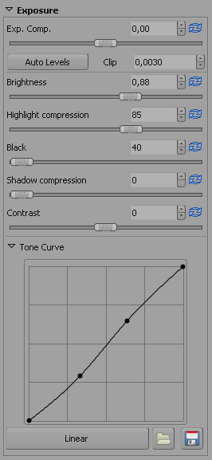 | The Exp. Comp. (Exposure Compensation) slider is only available for RAW images. The compensation is applied before any other adjustments (gamma correction) are done.  The Auto Levels button increases the brightness automatically while the percentage of the blown out area on the image does not reach the specified maximal clipping ratio set by Clip. It is recommended to switch this button on and afterwards adjust the brightness if the resulting image is too bright or looks dull.  The Brightness slider is similar to Exp. Comp.. But here the brightness is adjusted after the gamma correction. Exp. Comp. is only available for RAW images.  With Highlight compression some details could be recovered that got lost during the increase of brightness. The upper part of the dynamic range is then compressed using values below 100. Keep in mind that no detail could be recovered that does not exist (was not recorded). The value given is the percentage of the used dynamic range after compression.  Pixel values darker than Black will be set to zero. Increasing the black level improves images with fog or a gray halo.  Shadow compression does the same as compress highlights, but it then just recovers details that where lost during increase of the black level or while darkening the image.  The Contrast slider increases the brightness of pixels brighter than the average and darkens the pixels darker than the average. Unlike many other image processing software, increasing the contrast in RawTherapee does not blow highlights or loose details in shadows because a special sigmoid transfer function (centered at the average luminance) is used.  With the Tone Curve you can create a custom tone curve. You can use as many defining points as you like. With the button Linear you can reset it. You can also load and save you custom curve for later usage. This curve is applied on the RGB channels. For some examples of curves take a look at the Frequently Asked Questions.

Highlight Recovery
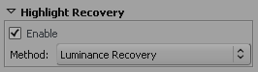 | This function is only available when working on RAW images.  On overexposed images too bright color values are clipped and therefore lost. However it happens quite often that not all the three (red, green and blue) color channels are lost on an overexposed area on the image. In this case it is possible to recover color and detail information based on the available remaining (not burnt) color components.  You can select whether RawTherapee could try Luminance Recovery (recovered details will be gray) or Color Propagation which will additionally try to recover colors. It might happen that strange (falsely guessed) color could be introduced. Therefore it is recommended to use this feature only on moderately overexposed images.  You can also choose the CIELab Blending method. This method simply reduces the luminance channel to have an unclipped pixel and then tries to recover the color information as far as possible form the A and B channels.

Shadows / Highlights
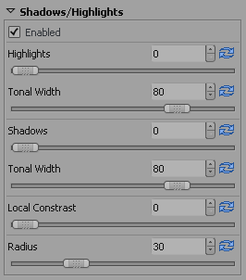 | With this feature it is possible to brighten the shadows while leaving the bright areas in the image as they are. Thus no clipping of the highlights will occur. This is done with the slider Shadows. This feature is also known as fill light in other software. The name and function is the same as in Photoshop.  The opposite thing, darkening the bright areas while leaving the shadows is done by the Highlights slider.  At first the algorithm detects the dark and bright areas. The Radius is used to decide whether a pixel belongs to the bright or dark area. The default setting of 30 gives quite good results. The highlight Tonal Width sets the threshold above which the pixels are considered to be highlight pixels. For example, setting it to 100 means that all pixels brighter than the average image brightness are considered to be highlights. Setting it to 0 means that no pixels belong to highlights.  The shadows Tonal Width setting works the same way but just for the shadows instead.  Local Contrast is adaptive contrast adjustment depending on contrast within a specified area. It increases contrast in small areas while keeping the global contrast (which could be set with the contrast slider in Exposure). The resulting image will look more three-dimensional. This feature is very useful when you have a foggy image or took your picture through a window. The effect can be very subtle. In fact it is the same as an unsharp mask with high radius and small value. For optimal results the slider should be between 5 and 20.

Luminance Curve
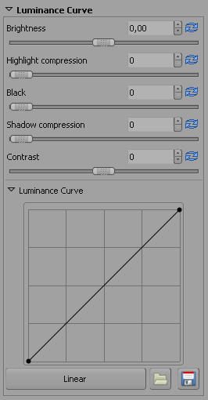 | This is identical to the settings in Exposure except that these settings are applied on the CIELAB luminance channel and not on the RGB channels.  Because it works on the CIELAB luminance channels the result will look different when e.g. changing the Contrast in the CIELAB color space.  It's your decision what you prefer. There are people who can make wonders with the proper adjustment of the CIELAB luminance curve.  With the Luminance Curve you can create a custom tone curve. You can place as many defining points as you like. With the button Linear you can reset it to the shown value. You can also load and save you custom curve for later usage. This curve is applied on the L (Luminance) channel of the CIELAB color space. For some examples of curves take a look at the Frequently Asked Questions.

Detail
This tab contains functions to improve details of the image.

Sharpening
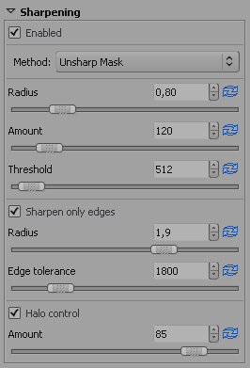  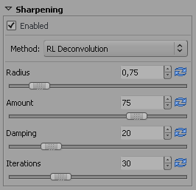 | The sharpening in RawTherapee can be done with two Methods: Classical unsharp mask (USM) or with the RL Deconvolution algorithm.  Lets first look at the Unsharp Mask settings: The Radius determines the width of the sharpening halo. The Amount parameter controls the strength of the sharpening. The Threshold parameter is used to prevent the sharpening of noise: If a pixel luminance differs only a bit from its neighbors (the difference is less than the threshold), then it is not sharpened. Note that sharpening operates in 16 bit per channel mode, thus your threshold setting you are used to from other image editing software has to be multiplied by 256. You can set the threshold also to 0 but then everything will be sharpened (even the noise).  In general the quality of sharpening is best if the sharpening radius is as small as possible. For “normal” images (normal: not too blurry) it should be set between 0.8 and 2. My experience is that for 6 megapixel cameras 0.8 is a pleasing setting with amount of 150. For DSLRs having an antialiasing filter weaker than average the amount should be smaller (e.g. 100 for Nikon D70). The present 10 (and more) megapixel cameras produce a significantly softer image, thus the radius should be set between 1 and 1.5.  If you activate Sharpen Only Edges the noise sharpening can be avoided completely. The Radius is used for the noise detection. If the noise is low a lower radius could be used and vice versa. A higher radius slows down the image processing. Edge Tolerance determines how much a pixel has to differ from its neighbor to be considered as an edge and not as noise. It's very similar to the USM threshold parameter and has a high impact on the visual quality. For low ISO (low noise) images use 1000 or less, for high ISO images use 2500-3000 or even more.  Halo Control is used to avoid halo effects when sharpening too aggressive.  The second Method RL Deconvolution works on a different approach. Here it is assumed that there is gaussian blur (like applying a gaussian filter) that might be produced by e.g. the lens or motion. In reality the blur might come close to gaussian blur, but not exactly. Therefore some artifacts like haloes might occur when you try to remove the gaussian blur.  You can define the Radius of the gaussian blur you want to remove. When you set the Amount to 100% the gaussian blur will be removed completely, but as this gives a harsh result a lower setting is recommended. The Damping is used to avoid sharpening of noise on smooth areas.  As deconvolution cannot be done perfectly at the first time several Iterations are necessary. How much is changed between each iteration is defined by the Richardson-Lucy (RL) algorithm. The more iterations are used the more perfectly the gaussian blur is removed. But with each iteration the speed decreases and the danger of halo artifacts rises. Normally you don't want to remove the gaussian blur perfectly due to personal visual taste and speed. The default settings should be fine most of the time.  It is recommended to check the results of the sharpening in the Image Details as the preview does not reflect the sharpening settings correctly.

Luminance Noise Reduction
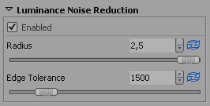 | RawTherapee has an edge preserving algorithm to remove luminance noise from high ISO images. The Radius is used for the noise detection. On low noise the radius could be low also. For noisy images a high radius gives better results but slows down the image processing speed.  Edge Tolerance determines how much a pixel has to differ from its neighbor to be considered as an edge and not as noise. It's very similar to the USM threshold parameter and has a high impact on the visual quality. (see also Sharpening).  On some cameras it makes sense to use the luminance noise removal even at low ISO images. For example the Nikon D70 camera has some noise even at its base ISO. Applying a tiny bit luminance noise reduction (Radius 1 and Tolerance 1000) makes the images look smooth as Canon images. For high ISO images use 2500-3000 or even more for Edge Tolerance.  It is recommended to check the results of the noise reduction in the Image Details as the preview does not reflect the denoising settings correctly.

Color Noise Reduction
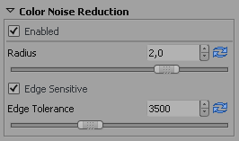 | To remove the color noise with RawTherapee there are two options: one can apply edge sensitive denoising method, or the traditional Gaussian filter on the CIELAB “a” and “b” channels. It is strongly suggested to use the traditional Gaussian filter since it is much more effective in reducing the color noise. Since it does not affect the luminance channel the image will remain as sharp as before. You can set the Radius of the Gaussian filter. Increasing it does not slow down the image processing speed.  The Edge Tolerance works the same way as in Luminance Noise Reduction.  It is recommended to check the results of the noise reduction in the Image Details as the preview does not reflect the denoising settings correctly.

Color
Here you can adjust the colors of the image.

White Balance
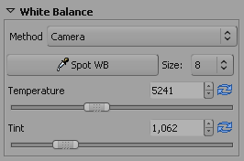 | The methods used could be:  - Camera – Takes the white balance used by the camera  - Auto – Automatically corrects the white balance  - Custom – Uses the values set below  You can also use the Spot WB tool (see also Tools Panel) to obtain the correct white balance of your image. You can cancel the Spot WB tool by doing a right click with your mouse. You can also activate this function by pressing the key . You can also set the Size of the area watched by the spot tool.  W  To cancel this function simply do a right click with your mouse.  Alternatively you can set the color temperature and the Tint manually. Moving Temperature to the left makes the image cooler (blueish), moving to the right warmer (yellowish). Moving the tint to the left makes the image purpleish, moving to the right greenish.

Channel Mixer
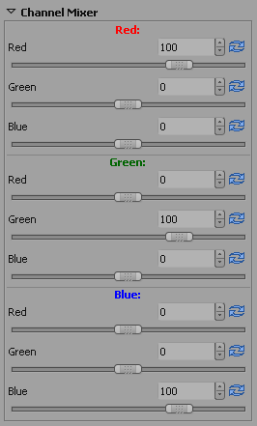 | This function is used for special effects.  As you can see the Channel Mixer is divided into three sections: Red:, Green:, Blue:. Those sections represent the three available color output channels in an RGB image (see section titles). All values shown here are percentages.  The mixture of real current RGB values and the slider settings modify the respective color value mentioned in the section title. If the other two colors have no RGB values for this pixel, there will be no effect when you change their sliders.  This stuff is difficult to explain and understand thus an example shows best how a channel mixer works: Lets assume a pixel with the RGB values 200, 100, 50.  Now lets change the the Green: output channel (see title). When you set the Green slider to 70% the RGB values of that point will be 200, 70, 50 (the G part has been reduced to 70% of it original value).  Now lets decrease the Red slider to -20%. Now the RGB values of that point will be 200, 30, 50 (the G part has been reduced for 20% of the Red RGB value: 20% of 200 is 40)  Now lets increase the Blue slider to 200%. The RGB values of that point will change to 200, 130, 50 (the G part has been increased for 200% of the Blue RGB value: 200% of 50 is 100).  This effect works the same for each color output channel.  But beware it might easily happen that portions of your image might become blown or black.  Most of time the Channel Mixer will be used on black and white images to improve the look. Set Color Boost to -100 to work on a black and white image.

Color Boost
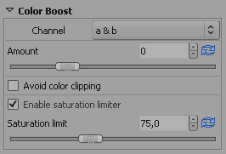  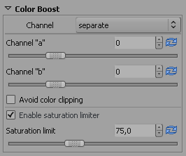 | Contrary to most software RawTherapee boosts the color by amplifying the a&b channels in CIELAB color space by Amount. You can also boost the channels separate. Just select the desired mode in Channel. Moving the slider to -100 sets the chrominance channels to 0 resulting in a black and white image defined in the luminance channel. Increasing the value gives a more colorful image.  Sometimes too much color boost can burn out some color components. For example boosting a strong red color usually burns out the red channel in the final image. You can avoid this by switching on Avoid Color Clipping. But beware: Activating it will slow down the image processing significantly.  Applying too much color boost may result in a very artificial looking image because the already well saturated colors become too saturated. Enable Saturation Limiter to avoid this because then pixels with more chrominance than set by the slider will be much less boosted than the other pixels.

Color Shift
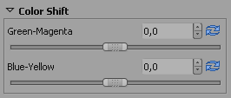 | The two sliders in this tool basically shift the CIELAB “a” and “b” channels. The Green-Magenta slider shifts the “a” channel, the Blue-Yellow shifts the “b” channel. With this tool you can remove/add color cast from/to your image.

ICM
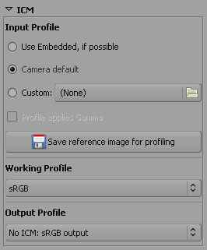 | At the top you can define which Input Profile should be used. Use embedded, if possible tries to use the profile that comes with the image itself. Camera default uses the profile of your camera, i.e. does not apply any color translations to the image. With Custom you can select some other profile stored on your computer. When you activate this option there is another option available: Profile applies Gamma. There are some custom camera profiles available on the internet that have gamma correction already implemented. To avoid that gamma correction is applied twice (by the camera profile itself and RawTherapee), leading to strange colors, you should activate this option.  You can also press the button Save reference image for profiling. This saves the linear image before the input profile is applied. This file can be used for profiling i.e. creating a new camera profile. Information on creating a camera profile could be found here for example.  Then you can define which Working Profile should be used. Which working profile you choose depends very much on the later use of your image. For highest compatibility use sRGB. Use it also if you don't know what color management might be useful for. If you only plan to show your images on your monitor or in the internet this is also a good choice. Because then no profile has to be embedded into a JPG as sRGB is always assumed as default. If you plan to print your image Adobe RGB might be a better choice as it was developed to work best with CMYK devices such as printers. But you could also change to ProPhoto, WideGamut, BruceRGB, Beta RGB, and BestRGB. But beware using a color profile with a big gamut may lead to problems or unwanted colors depending on the colorimetric intent (see Preferences – Color Management). See Frequently Asked Questions for more informations about color management and differences between the available color profiles.  At the bottom you can define the Output Profile. Depending on your settings you will have a list of possible color profiles (that could be found on your computer). At least you will have one choice: No ICM: sRGB output – this is standard nowadays for all kind of images, when no profile is embedded.

Transform
This tab contains functions to change the image.

Crop
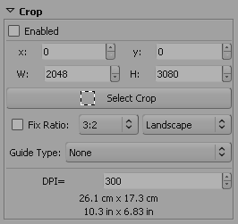 | You can simply use the Select Crop tool (see also Tools Panel) or the corresponding button here to select an image area that will be used for the final developed image. You can also press the key to activate this function.  C  It is possible to set the position (x, y), width W, and height H of the cropped area. Alternatively you can use a Fix Ratio for the crop shape. Available ratios are: 3:2, 4:3, 16:9, 16:10, 5:4, 2:1, 1:1, DIN. You can also set the orientation to Landscape or Portrait.  The Guide Type shows some lines to help you find the right crop for fulfilling some known positioning rules. Possible values are: None, Rule of thirds, Rule of diagonals, Harmonic means 1, Harmonic means 2, Harmonic means 3, Harmonic means 4.  To get a pleasing result your object or leading line should be placed on one of those lines. Ideally your object should be located on or at a crossing point of two lines.  If you set the DPI value of your printer you can see the physical dimensions of the crop rectangle in cm and inch units.  When you selected a part of the image the surrounding area (border) will be darkened or brightened. You can switch between dark and bright border simply by pressing and double clicking in the border area.  Ctrl  To move the crop area around press and drag the area with the mouse.  Shift

Rotate
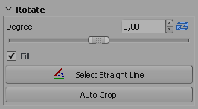 | You can simply use the Select Straight Line tool (see also Tools Panel) or the corresponding button here to rotate the image. You can also activate this function by pressing the key . When using this function you will draw a line that is considered to be horizontal or vertical afterwards. To achieve that the image will be rotated accordingly.  S  You can also set the Degree how much the image should be rotated by entering a value. A negative value will rotate clockwise, a positive counterclockwise (maximum is 45 degrees in each direction).  When the Fill option is not checked, the image will be rotated but black areas (mainly in the corners) will occur. With this option checked the image will be magnified enough to fill those otherwise black areas will occur. The original image size will be kept.  When the Fill option is unchecked you could use Auto Crop to get an image without black edges. The crop will then automatically be sized to contain most of the image without any black edges. This means the resulting image gets smaller.

Distortion
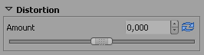 | A negative Amount will correct barrel distortion, a positive will correct pincushion distortion of the image. Entering a 0 value switches off lens distortion correction. Activating this parameter will slow down image processing speed.

C/A Correction
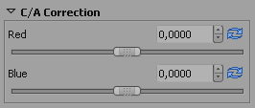 | The chromatic aberration can corrected by using the two sliders Red and Blue. Normally you won't see any C/A in the preview therefore it is highly recommended to use the Image Details (I even suggest to magnify to 200%) when you apply this kind of correction. As in other software tools, this algorithm eliminates moderate chromatic aberration quite well. Do not expect miracles with images having extremely high chromatic aberration.

Vignetting Correction
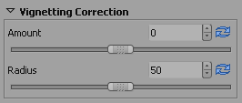 | With that tool you can correct vignetting effects on your taken pictures. Setting the Amount slider to a positive value brightens the four edges of the images to correct the classical vignetting. Setting it to a negative value darkens them.  The Radius influences how much of the images beginning from the edges will be brightened or darkened.

Resize
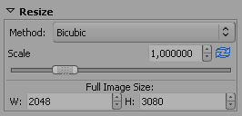 | Here you can define how your developed image will be resized. First you can change the Method that is used for resizing. Nearest is a very fast method as it does not change any colors but simply uses the existing color information. The result will lack details. Bilinear gives a better result. Bicubic is the best available interpolation method as is keeps fine details better. Bicubic come in two additional flavours Bicubic (Sharper) and Bicubic (Softer). Those do additional sharpening or softening after resizing the image. Bicubic is the default setting here.  There are two ways to set the size: Either you set the Scale or you set the Full Image Size in pixels.  The scale can be chosen between 0.2 (1:5) and 4 (4:1).

Metadata
This tab contains again two tabs. EXIF and IPTC.

EXIF
Here you can control which EXIF metadata will be contained in the saved (developed) image file. The EXIF metadat is usually created by the camera itself and implemented into the RAW image file.
Basic EXIF informations are directly visible. Extended EXIF information and so called “makernotes” are organized into a tree. Click on the arrow at the very left of the desired subtree and you'll see it's content. “makernotes” are informations varying between camera manufacturers and even between camera models.
You can Remove, Keep, or Add/Edit EXIF metadata. Manipulating metadata does not change the source file in any way! If you want to restore a value you maybe changed or removed by accident simply press Reset. Reset All works similar but is used for trees and works recursive, means all values changed/removed in this subtree are restored.
You can Add/Edit the following EXIF information: Artist, Copyright, ImageDescription and Exif.UserComment.
Only the english names of the EXIF fields are displayed for easy reference. They are not translated when you choose a different GUI language.
The EXIF information is marked with different signs:
This information is available within the source file and will be copied to the final (developed) image.
This information will be removed and not saved into the final image
This information was added/changed by you and the new value will be saved into the final image.

IPTC
IPTC values belong also to the group of metadata, as they are integrated into the image files but do not add any picture details (additional or different pixels) to the image. Basically the metadata summarized as IPTC contains additional information about your image. As this information is saved within the image file it cannot get lost. This eases the the workflow a lot as you don't have to care about another file when e.g. backing up or sorting your images.
IPTC is usually used to describe the image in detail. There are a lot image database softwares that use the (IPTC) information saved in images to e.g. fill their descriptive fields. For example you can also use IPTC fields when you try to sell your images. Most online companies willing to sell your images support IPTC tags when you upload your images to their databases, thus you have less work. Adding e.g. keywords on your computer at home is much more comfortable than doing it through the web browser. Multiple Keywords and Suppl. Categories can be added/removed using the plus and minus signs next to it.
Not all available IPTC fields are supported by RawTherapee, only the most used. If you want to change/add some other IPTC fields use some other software that supports it, e.g. XnView.
If your source file is a JPEG it might happen that it contains already some IPTC information. This information will be loaded and displayed automatically.
The button Reset resets the IPTC values to those saved in your current profile. Embedded resets all IPTC values to those stored in the source file. There are two more buttons:
This button copies your current IPTC setting to the clipboard. This is especially useful, when you have multiple image you want to apply the same IPTC values.
This button pastes the formerly copied IPTC settings from the clipboard to your current image.

Frequently Asked Questions
Following RT stands for "RawTherapee".

Q: RT is not starting or doing strange things (i.e runtime error), what should I do?
A: Close RT and delete the whole RawTherapee folder within your HOME directory. Then restart RT again. Then it should start without any problems.
Such a problem might occur, when you updated from an e.g. beta version and the configuration file structure has changed. Alternatively the configuration file(s) might be damaged.

Q: Is it possible to use RT on a portable device, e.g. a USB thumb drive?
A: Yes it is. As RT does not write anything into the registry (windows) this is a simple task. Simply edit the file options within the RT applications directory and change the value MultiUser=true to MultiUser=false. With that no RAWTherapee folder is created within the users HOME directory. With MultiUser=true for each user a RawTherapee folder will be created within his HOME directory the first time RT is run.

Q: What is the recommended sequence of image processing operations?
A: The recommended sequence is the same for all image manipulation software. First of all do White Balance, then do all the Transform operations if necessary, e.g. Resize, Rotate, Distortion, C/A Correction, Vignetting Correction etc., because these settings influence the image most. Only cropping could be done later. Then do the basic stuff. First correct Exposure and use a curve (or Luminance curve) for more pleasing exposure correction. Now change the Color to your taste (Color Shift, Color Boost, Channel Mixer etc.). Then check the Shadows/Highlights, do Highlight Recovery where needed. After that do Luminance Noise Reduction (and Color Noise Reduction where needed). And as very last thing do Sharpening.
Or simply do all operations first that change the image most. And just do Sharpening last!
On the other hand it's always best to get the image right when you're taking the photo. The less you have to change within RawTherapee the more details will be kept.

Q: How does the internal workflow of RT look like, i.e. In which order are the changed parameters applied?
A: Following you can see in which order all parameters are applied. The results of some groups of parameters are cached to speed up processing. Some of those parameters are not done for the preview image. Those are marked accordingly.
Result is cached
White Balance
Color
RAW Decoding, 16 bit
Internal
Processing
Demosaicing
Preferences
Highlight Recovery
Exposure
ICM: Conversion to Working Color Space (Input Profile ► Working Profile)
Color
RAW
JPG/TIFF
Result is cached
Resize
Transform
PREVIEW
Result is cached
Rotation

Lens Distortion

C/A Correction

Vignetting Correction
Transform
PREVIEW
Result is cached
Channel Mixer
Color
Shadows / Highlights
Exposure
Exposure & Tone Curve (RGB separate)
Exposure
Write EXIF / IPTC Metadata into header
Metadata
Crop
Transform
Conversion to CIELAB Color Space, 16 bit (Working Profile ► CIELAB)
Internal
Processing
Luminance Curve
Exposure
Color Boost
Color
Color Shift
Color
Luminance Noise Reduction
Detail
PREVIEW
Sharpening
Detail
PREVIEW
Color Noise Reduction
Detail
PREVIEW
ICM: Conversion to Output Color Space (CIELAB ► Output Profile)
Color
JPG/TIFF
Result is cached
Resize
Transform
PREVIEW
Not done for
preview image
Applied parameter
Parameter location (tab)
Applied in one step
Group of steps
Explanation:

Q: How to create black&white images?
A: This is easy: Go to tab Color, open tool Color Boost then set Amount to -100 and you'll get a black and white image. You can then use the Channel Mixer to change the image (emphasize specific areas) to your liking.

Q: How can I restore the current image (reset all settings done)?
A: There are two ways to achieve this: 1. Right click on the thumbnail of the image then select Clear profile 2. Select a postprocessing profile. This will reset all settings you've done to those saved in the profile. Ideally choose the one you defined in the settings as default for your image file type. You can do this also directly when right clicking on the desired thumbnail and selecting Apply profile or Paste profile (when you copied it before).

Q: What happens when changing the curve in the Image Processing curve editors of Exposure (called Tone Curve) and Luminance Curve?
A: The curve is a representation for the brightness throughout the whole tonal range. The horizontal axis represents the brightness of the image itself (left: black, right: white). The vertical axis represents the brightness of the result (bottom: black, top: white). Depending on the channel the manipulation is done with the result might look a bit different. In exposure the change influences all colors, in luminance curve it only influences the luminance channel. The differences could be best seen when trying the negative curve example at the end.
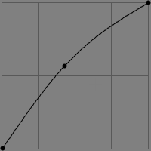 | A curve like this will brighten the midtones of currently edited image. No clipping will occur.  If you just want to darken the whole image equally use a linear line and just move the top right point down (stay at the right border). No additional clipping will occur then. Moving the point left will give additional clipping of the highlights. This simply changes the white point.
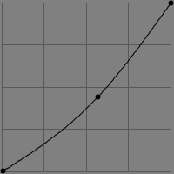 | A curve like this will darken the midtones of the currently edited image. No clipping will occur.  If you just want to brighten the whole image equally use a linear line and just move the bottom left point up (stay at the left border). No additional clipping will occur then. Moving the point right will give additional clipping of the shadows. This simply changes the black point.
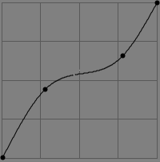 | The classical S-curve will be used most of time. It brightens the darker areas and darkens the brighter areas. The black and white point are kept. Thus no clipping occurs.  Such a curve could also be used to simply brighten the darker areas while keeping the highlights.
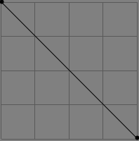 | The negative curve simply inverts the image.  When using this curve in Exposure the result will look like a film negative. The colors will be inverted also.  When using this curve in Luminance Curve only the luminance will be inverted, e.g. a bright shade of red will become a dark shade of red, but it still will stay a shade of red, the color will not change!  This effect is hard to describe, simply try it yourself to get a feeling and see the differences in the result.
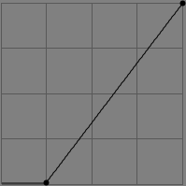 | This curve simply changes the black point of the image. The color value below your setting is then changed to absolute black.
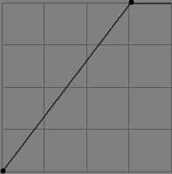 | This curve simply changes the white point of the image. The color value above your setting is then changed to absolute white.

Q: What are the best USM (unsharp mask) settings?
A: Well there is no universal answer. It depends very much on your personal liking. See Sharpening for some examples.

Q: What is color management?
A: Color management is a set of software and procedures to obtain predictable colors on any output device, e.g. monitors and printers. Each device (camera, scanner, printer, monitor etc.) responds to or produces color differently. A color profile is used to tell how the recorded colors of an input device, e.g. a camera have to be recalculated to fit into the working color space (Working Profile). You can think of a profile like of a color palette. In fact it is a table that relate numerical data, e.g. RGB (211,25,17), to colors expressed in device-independent CIE color spaces (often CIELAB).
The heart of color management is the translation between devices with different gamuts and files with different color spaces. The translation between gamuts could happen with different methods: Perceptual, Relative Colorimetric, Absolute Colorimetric, and Saturation. Those methods are also known as colorimetic intent and are described above.
All manipulations to the image are done in the working color space. RawTherapee uses for some operations the LAB color space that contains all the colors that a human eye can see and therefore needs no profile for it. For the other operations it works in a RGB-like color space. Here a working color profile is needed which defines the gamut in which your changes are done. Following a small image showing where profiles are used:
Device
Color
Profile
Input Device
e.g. Camera
Output
Device
e.g. Monitor
Output
Device
e.g. Printer
Working
Color
Space
Working
Color
Profile
Device
Color
Profile
Device
Color
Profile
Working
Color
Profile
Working
Color
Profile
Translation

Translation

Translation
The above mentioned translation always happens in LAB color space.
Which working color profile should be used depends very much on the intended usage of your image.
Example: When you plan to show the image only on your monitor or in the internet than the sRGB color profile is sufficient as it contains the gamut a typical monitor is capable of. On the other hand when you plan to print your image AdobeRGB might be the better choice. AdobeRGB is optimized for typical printers that use CMYK for printing and offers a larger color space.
But when you use a profile with a much higher gamut than the output device is capable of some kind of conversion will happen. The conversion is mainly influenced by the Colorimetric Intent (see above).
One word on monitor calibration (as there are a lot of confusions): Use a hardware device (a colorimeter, e.g. Spyder2) to calibrate your monitor! Everything else is not accurate enough! After calibration a profile is created which contains the LUT information and the color translation table. Under windows with each windows boot the LUT (Look Up Table) is loaded into the graphics card. This LUT includes informations about black point, white point and gamma. Those values are set systemwide during boot thus images will look quite OK already even with application not supporting color management. If you have multiple monitors the LUT is only used for the first (calibrated) monitor. To have all monitors calibrated you'd need a separate graphics card for each monitor with an own LUT.
The second part of the color profile is the color translation itself. Do not think because you activated it in the color management preferences of your monitor (within display settings) that all applications use this color profile automatically! Windows only tells asking applications which color profile they should use as monitor profile nothing else! Some applications use this information and load the correct monitor profile on their own. RawTherapee has to be told which profile to use as it is crossplatform and in Linux there is no color management integrated by default. (BTW: With Linux you can use xcalib to load the LUT out of the color profile created under windows).
A very good explanation about color management (for more in depth information) was written by Norman Koran and could be found on his Website. Following some gamut projections with additional comments. Those projections are taken from Bruce Lindbloom. On his website you can also easily compare two color gamuts. Each gamut is rendered as its L* value only, so darker shades represent darker colors.
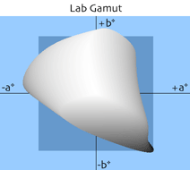 | This gamut could be seen by the human eye (all available colors).
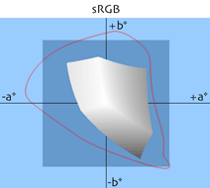 | This gamut was especially developed for monitors. Therefore most monitors could display it. There are some special (expensive) monitors that could display more colors. This one is used for highest compatibility.
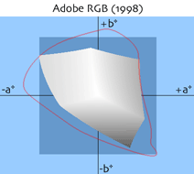 | This gamut was developed with the goal to contain most of the colors a CMYK color printer could print. Compared to sRGB especially the green tones are improved.  It also contains almost all reflective colors that could be found nowadays. This is a safe, conservative choice for a working color profile.
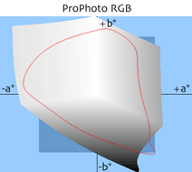 | This gamut was developed by Kodak with photographic output in mind. As you can see there are a lot imaginary colors which do not exist and are not visible. When working with that color profile it is recommended to save your image in 16bit to avoid posterization. On the other hand almost the complete LAB color space is available. Therefore this profile is often recommended as working profile when working with RAW files.
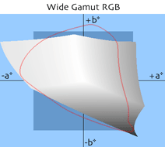 | This is an expanded version of the AdobeRGB.
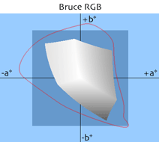 | This gamut was created by Bruce Fraser. It is a compromise between AdobeRGB and ColorMatch RGB (shipped with Photoshop 5). It was designed with output in mind thus contains optimal colors for displays and printing.
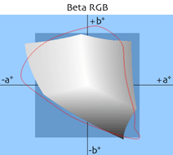 | This gamut was created by Bruce Lindbloom. It was created to contain as much important colors such as different film types, color charts and printing gamuts.
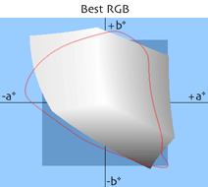 | This gamut is features D-50 white point and gamma 2.2. It is optimized to cover the gamut of Fujichrome Velvia .

Q: I would like to create an own theme. How can I do that?
A: You can find the themes in the theme directory within the RT installation directory. Looking into this directory you can find some files. Basically all those files are gtkrc files which control the colors and font of the RT GUI. Best starting point is an existing theme which you can copy and change to your liking. The colors within the theme file are defined with RGB hexadecimal values. Here some starting information:
bg values define the background colors of most widgets.
fg values define the foreground colors of most widgets.
base values set the background color of lists, editable text boxes, and other widgets.
text values set the foreground color of widgets that use base for the background.
For more detailed information about this topic could be found here (see chapter “Styles”):
http://library.gnome.org/devel/gtk/stable/gtk-Resource-Files.html

Q: Which keyboard shortcuts are available?
A: Here a list of available keyboard shortcuts:
Key | Where? | Function
PageUp | File Browser | Load next image file
PageDown | File Browser | Load previous image file
Delete | File Browser | Move image to the internal trash
+  Shift  Delete | File Browser | Restore image from the internal trash
+  Ctrl  A | File Browser | Mark all images
+  Ctrl  C | File Browser | Copy current Profile
+  Ctrl  V | File Browser | Paste Profile
++  Shift  Ctrl  V | File Browser | Partially Paste Profile
F | GUI | 3-State-Button: Hides/Displays/Maximizes the File Browser.
H | GUI | Hides/Displays the Histogram, Postprocessing Profile Switcher and the History & Snapshots.
+  Ctrl  Z | History | Undo last change
++  Shift  Ctrl  Z | History | Redo last change
N | Toolbar | Activate Hand Tool
C | Toolbar | Activate Crop Tool
W | Toolbar | Activate WB Spot Tool
S | Toolbar | Activate Rotate/Straighten Tool

Glossary
Sources for this glossary are http://www.wikipedia.org and others.
CIELAB This is a color space designed to approximate human vision. Its “L” (Luminance) component closely matches human feeling of lightness. RGB models the output of physical devices. The CIELAB color model is used to describe all colors visible to a human eye. The “a” and “b” components are opposite colors. This color space is usually much bigger than the gamut of an output device. The “a” channel can be changed between green and magenta (red). The “b” channel can be changed between yellow and blue.
CMYK Cyan, Magenta, Yellow, Key – Another way to create a color. Key is black color. This way of representation is normally used by color printers.
Color Gamut is a complete subset of colors. Normally it refers to the subset of colors that could be represented or displayed by e.g. a monitor or any other output device. You can also see it as the sum of the colors found in an image. Changing colors also changes the gamut of that image. For example: a printer is capable of printing colors that could not be displayed on the monitor or printed on some other printer. This comes form different techniques used to show the color.
DNG Digital NeGative – Opened RAW format created by Adobe to avoid the proliferation of proprietary formats. DNG is based on the TIFF format, it can include a thumbnail and/or real size JPG preview (not necessarily up-to-date). Some brands, like PENTAX, offer the possibility to capture the picture in their PEF format or in DNG without quality loss. A section in the DNG format is still allocated to proprietary data. Another one permits to keep the original RAW data as backup. The presence and the management of these sections depends on the camera and the image manipulation software used.
DSLR Digital Single Lens Reflex – A type of digital camera that is known to take low-noise pictures at high quality. Normally more expensive than some point-and-shoot cameras you can buy in every electronics store. Also a lens change system is integrated.
EXIF EXchangeable Image File Format – Metadata set designed for digital cameras incorporated in TIFF files (optional), JPEG files (optional), DNG and some proprietary RAW formats. Those data contains information about the parameters used at capture time (brand name, model number, focal length, aperture, exposure, image orientation, etc.)
HSV Hue, Saturation, Value – a different way to define the color of a pixel (see RGB)
ICC ICC (International Color Consortium) Profiles are normally used to display an image on your monitor the same way as it will be displayed when being printed on your printer (if it also uses a profile. Most printers available nowadays do)
IPTC International Press Telecommunications Council – For images they created a standard which describes how and which additional metadata information may be included into the image header. The additional metadata is meant for usage in press to ease e.g. sorting and searching for images that contain specific attributes (keywords, categories etc.). This information is integrated into the image file and are always available and cannot get lost by accident. Another way to save those information as extra file was invented by Apple and is called XMP.
RGB Red, Green, Blue – Theses are the pixel colors used to be combined to a visible pixel by e.g. monitors. It is used mainly in computer graphics as the humans visual system works in a way that is similar - though not quite identical - to an RGB color space. The most commonly used color spaces are sRGB and Adobe RGB.
RAW file An image file format that contains the image as exactly taken by the camera sensor. Often those images do have a higher resolution per channel, e.g. 12 bit or newer cameras 14 bits. Possible extensions are: CRW, NEF, CR2 etc.

http://www.cybercom.net/%7Edcoffin/dcraw/
http://steves-digicams.com/techcorner/July_2005.html
http://www.cambridgeincolour.com/tutorials/color-space-conversion.htm
http://www.steves-digicams.com/techcorner/January_2007.html
http://en.wikipedia.org/wiki/SRGB_color_space
http://en.wikipedia.org/wiki/Adobe_RGB_color_space
http://en.wikipedia.org/wiki/ProPhoto_RGB_color_space
http://en.wikipedia.org/wiki/Adobe_Wide_Gamut_RGB_color_space
http://www.creativepro.com/story/feature/6541.html
http://www.brucelindbloom.com/index.html?BetaRGB.html
http://www.xnview.com
http://www.normankoren.com/color_management.html
http://brucelindbloom.com/index.html?WorkingSpaceInfo.html

