Design Document: Functional Simulator for Subset of ARM instruction set

Introduction

This document outlines the design and implementation details of myRISCVSim, a functional simulator developed to execute a subset of the ARM instruction set. The simulator is designed to provide a structured and efficient way to process machine instructions while mimicking the fundamental stages of a processor pipeline.

Input/Output

Input Format
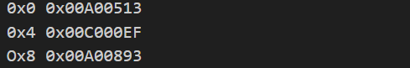
The simulator takes a MEM file as input, which contains encoded RISCV instructions along with their respective memory addresses. The instructions are stored sequentially, with each entry specifying an address-instruction pair.
Example:

Functional Behavior and output

The simulator processes instructions through the following five-stage pipeline:

Fetch: Reads the instruction from memory.

Decode: Interprets the instruction and extracts necessary operands.

Execute: Performs arithmetic, logic, or branch operations.

Memory Access: Handles load/store instructions.

Writeback: Updates register values.

Execution continues until the SWI 0x11 instruction (0xEF000011) is encountered. At this point, the simulator halts and writes the updated memory contents to an output file.

For better traceability, the simulator prints execution logs for each stage. For instance, for instruction 0x00008067, the log might look like this:
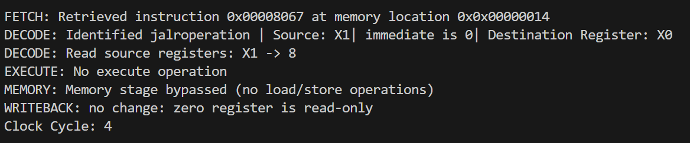

Design of Simulator

Data structure

The key data structures used in the simulator include:

Registers: A global array representing 32 general-purpose registers.

Memory: An unordered map that stores instruction and data memory dynamically.

Program Counter (PC): Keeps track of the address of the current instruction.

Intermediate Data Registers: Used to temporarily hold values during different pipeline stages.

Instruction Lookup Table: A structured mapping of opcodes, function codes, and instruction types for efficient decoding.

Simulator flow:

The simulator operates in two primary steps:

Memory Initialization: The MEM file is read into memory, storing the encoded instructions.

Instruction Processing: The simulator runs an instruction cycle loop until a termination condition is met.

Implementation of Pipeline Stages

Fetch Stage
The fetch stage retrieves the next instruction from memory at the address specified by the Program Counter (PC). The instruction is fetched as a 32-bit value stored in four consecutive memory locations (little-endian format). The simulator constructs the instruction word using these memory bytes.

After fetching, the PC is incremented by 4 to point to the next instruction unless a branch or jump alters the flow of execution.

Decode Stage
The instruction word is broken down into different fields using bitwise operations and a structured lookup table. The simulator extracts:
- Opcode: Determines the instruction type.
- Source and Destination Registers: Extracted based on instruction format (R-type, I-type, etc.).
- Immediate Values or Offsets: Processed and sign-extended if needed.
Example output:

The instruction is now prepared for execution.

Execute Stage
The execution stage performs the actual computation based on the decoded instruction. Depending on the operation type, the simulator selects an arithmetic, logical, or control operation:
- ALU Operations (ADD, SUB, AND, OR, XOR, etc.)
- Shift Operations (SLL, SRL, SRA)
- Branch Comparisons (BEQ, BNE, BGE, BLT)
- Jump Instructions (JAL, JALR)
Optimized helper functions process these operations efficiently:

For branch instructions, if the condition is met, the PC is updated to the target address.

Memory Stage
For load/store instructions, memory is accessed in this stage. The simulator:
- Computes the effective memory address using base + offset.
- Loads data from memory into a register (for load instructions like LW, LH, LB, etc.).
- Stores data from a register into memory (for store instructions like SW, SH, SB, etc.).
If no memory access is required, the stage is skipped:



Writeback Stage
In this final stage, the result computed in the Execute or Memory stage is written back to the register file. The destination register is updated with the computed value.

If the instruction is a store operation, no register is updated in this stage.

Termination
The simulator halts execution when it encounters the instruction:
0xEF000011 (SWI 0x11)
At this point, the final state of memory and registers is written to output files:
- Final memory contents to a file.
- Register states to another file.

Test plan
To ensure correctness and robustness, the simulator is tested with the following programs, each implemented in both iterative and recursive approaches:
- Bubble Sort – Sorting an array using nested loops and comparisons.
- Fibonacci Sequence – Generating Fibonacci numbers up to a given index.
- Factorial Calculation – Computing the factorial of a number.
These test cases validate the simulator’s handling of:
- Arithmetic operations
- Branching and control flow
- Memory access and data handling
- Function calls and recursion
By structuring and optimizing execution through lookup tables, modular function calls, and efficient memory management, myRISCVSim provides a reliable and scalable framework for RISCV instruction simulation.
Graphical User Interface (GUI) Integration
To enhance usability, a Graphical User Interface (GUI) has been integrated using Python and Tkinter. The GUI simplifies the process of loading, running, and analyzing RISC-V programs through an interactive interface.
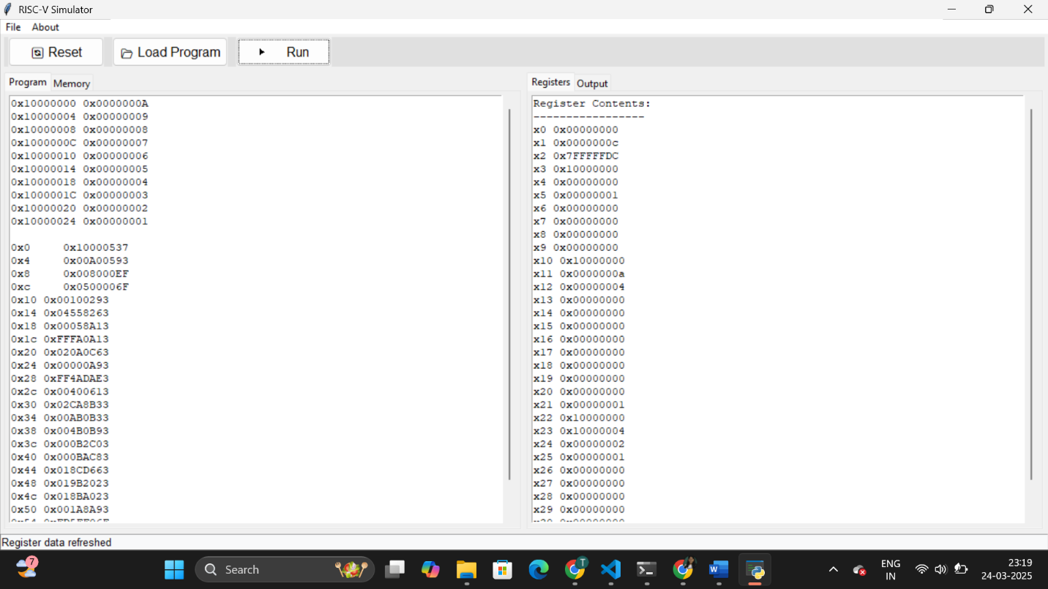
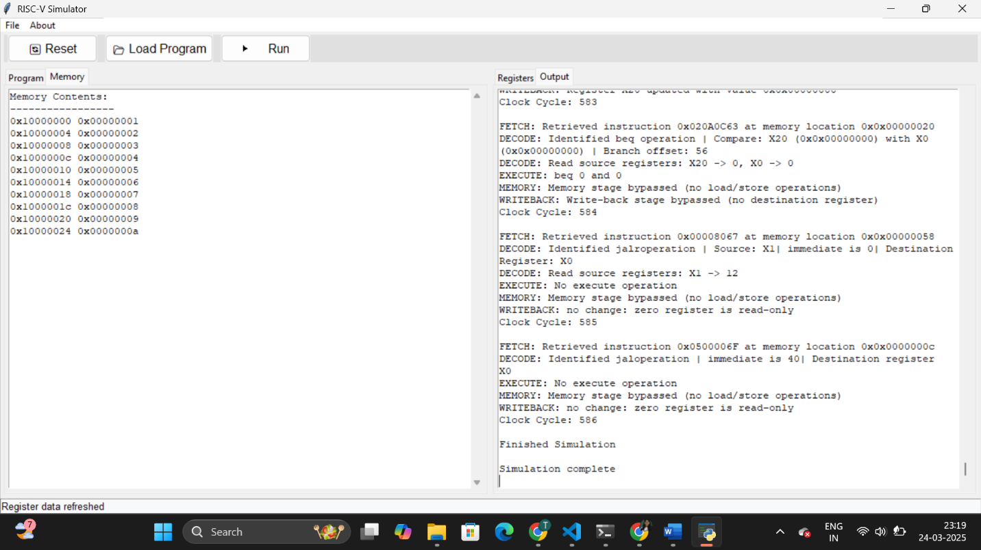
Features of the GUI:
- Program Loading: Users can load .mc files directly through the interface.
- Execution Control: The GUI allows users to start, stop, and reset the simulation.
- Real-Time Logging: Displays instruction execution logs dynamically.
- Register and Memory Viewers: Provides an organized view of register contents and memory states.
- Search Functionality: Users can search for specific memory addresses or register values.
- Output Saving: Allows exporting execution logs and results for further analysis.

