This simple tutorial explains how to connect from R to mySQL database

Using the mySQL workbench we have created a schema and then add a table using the scripts (I assume you have already set up mySQL workbench and familiar with it),

LOAD DATA LOCAL INFILE 'path to your csv' INTO TABLE schemaName.tableName FIELDS TERMINATED BY ',' ENCLOSED BY '"' LINES TERMINATED BY '\n';

Check if data is in your table:

select * from schemaName.tableName

Until now, we have created a table and import data, now we need to create a MYSQL ODBC DSN (data source name)

Please follow the instruction taken from <http://www.geeksengine.com/article/mysql-odbc.html>, there may be slight changes depending on your OS.

**Steps to set up MySQL ODBC DSN**

Following the following steps to set up MySQL ODBC DSN (Data Source Name).

1. Open ODBC Data Source Administrator.

To open ODBC Administrator, click Start, point to Settings, and then click Control Panel. Double-click Administrative Tools, and then double-click Data Sources (ODBC).

1. Click System DSN tab and click Add button (a System DSN is available to all users of the computer, including Services. If you want to create a DSN that is only available to you, create User DSN).

An ODBC System data source stores information about how to connect to the indicated data provider. A System data source is visible to all users on this machine

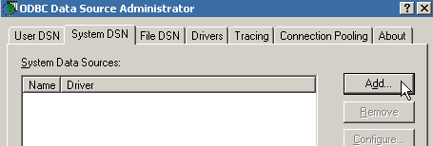

1. In the Create New Data Source window, scroll down until you find MySQL ODBC 3.51 Driver. Select it and click Finish. If you can't see ***MySQL ODBC 3051 Driver*** in the list, you need to download and install [MySQL Connector/ODBC 3.51](http://dev.mysql.com/downloads/connector/odbc/3.51.html) first.

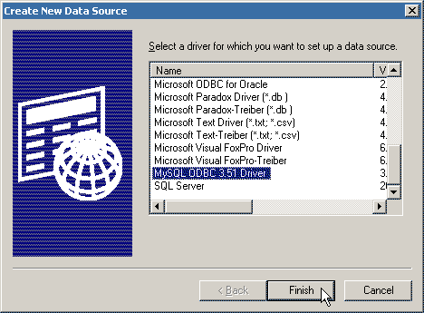

1. Now fill in connection information about how to connect to a database in MySQL.
   * **Data Source Name:** A unique name here to identify this data source. It has nothing to do with any system names. Just make up a name that you think is appropriate. Here we type in myodbc.
   * **Description:** A brief description about this data source.
   * **Server:** Host name or IP address of the MySQL server. The default is localhost.
   * **User:** The MySQL username used to connect to MySQL server. Normally you can username ***root***. Make sure you have installed MySQL server. Refer to [MySQL installation guide](http://www.geeksengine.com/article/install-mysql.html) here.
   * **Password:** The password for the User. Type in the password of root user.
   * **Database:** The default database name used when connecting to MySQL server. Click the drop-down box and select the database you need to connect to. Here we choose northwind. If you don't have northwind database in your MySQL server, you can run this command to create an empty northwind database:**CREATE DATABASE northwind**

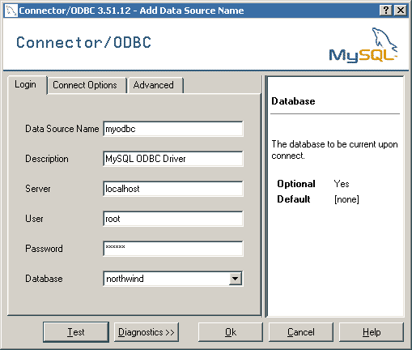

Note: **If you don't use default MySQL port 3306**, you need to specify its Port number, and/or other info on Connect Options tab. See screenshot below. If you don't specify anything, the connection to localhost will be using default port 3306.

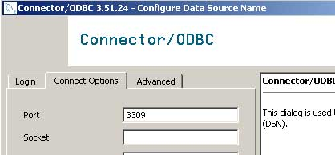

1. Click Test button to make sure the connection information you just entered is correct.

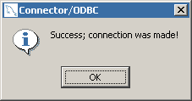

1. Click OK to create the DSN. Screenshot below shows that myodbc has been created. Click OK to close ODBC Administrator.

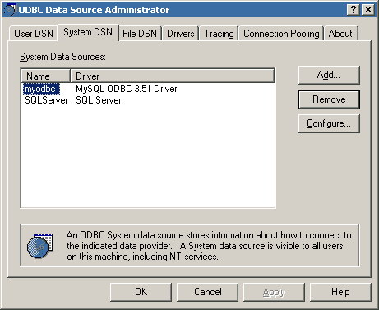

# [Connect R to MySQL with RODBC using](http://stackoverflow.com/questions/9539544/connect-r-to-mysql-with-rodbc-using-dsn) DSN

Using R, we can connect and get our data, in this case my table name is tomato and dsn name is rtest :

#from database we can get data

require(RODBC)

db <-odbcConnect("rtest")

db

tomatoTable <- sqlQuery (db, "SELECT * FROM tomato", stringsAsFactors=FALSE)

head(tomatoTable)

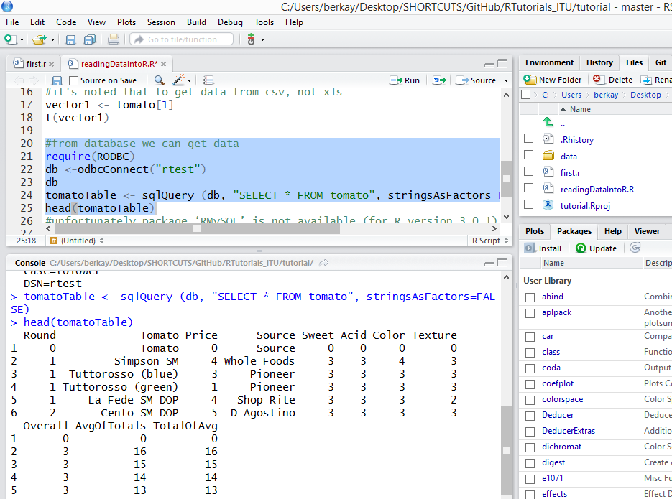

It works, in my MySQL table I have configured the values as INT for that reason I cannot get the precisions which is given as warning while importing data to my table using the LOAD command.