# FEATURE LIST

# Welcome Message

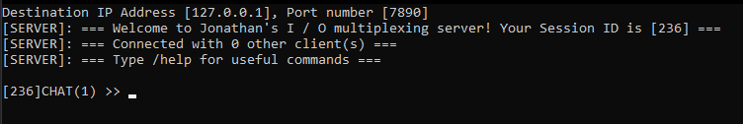

* Shows the user their session ID, how many clients are inside with them along with a pointer to the help menu.
* Their chat prompt will also display their ID along with their chat mode which is indicated as a number within the brackets.

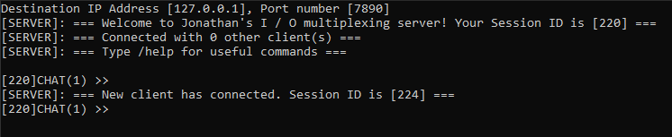



It will also show when new clients join and leave

# Broadcast Message

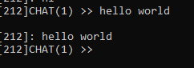

* When sending messages, it will show up on all clients
* It also shows which client it came from



This is done using a for loop to send to every socket that is connected

# Help Menu

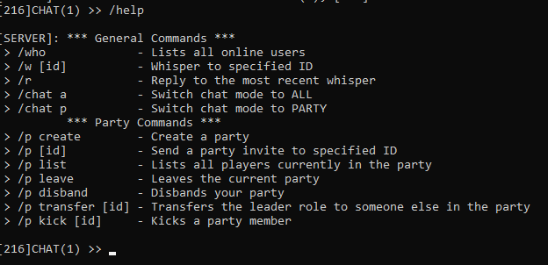

* Use /help to show all available commands
* Is sent under 1 data name

# Check online clients

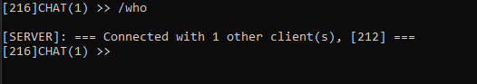

* Use /who to see all online clients and their ID’s

# Whispering

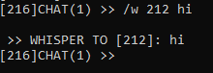

* Use /w [id] (message) to privately dm a client
* To save the recipient from having to type the id multiple times they can reply to the most recent whisper with /r (message)

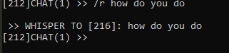

To achieve this I saved the most recent whisper’s id by passing it as a packet and sending it back to the server

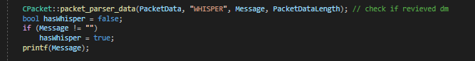



# Chat modes



* Use /chat a or /chat p to switch between chat modes
* Being in party chat will only send messages to party chat and not to other clients that are not in the same party
* Not being in a party will not allow you to switch to party chat

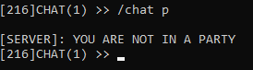

# Creating a party

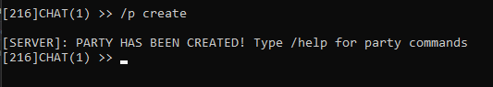

* Use /p create to create a party
* Puts the user that created it as the default leader with the partyID being the same as Session ID

# Inviting another client

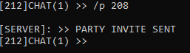

* Use /p [id] to invite a player to a party
* Confirmation messages will be sent to both players
* Upon accepting both will receive server update

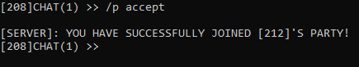

# Show party members

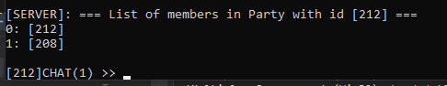

* Use /p list to show all users in a party
* 0 is assigned to the leader of the party while 1 is for the members

# Leaving party

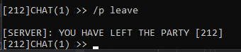

* Use /p leave to leave a party you are currently in
* If the party upon leaving has only 1 user left it will be disbanded

# Disbanding party

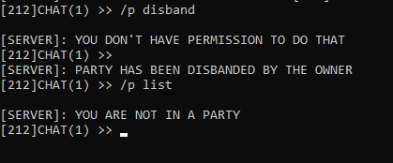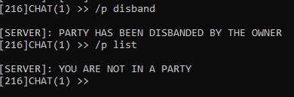

* Use /p disband to disband a party
* Only works if you are the leader of the party
* Acts as a way to kick all users

# Transferring ownership

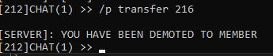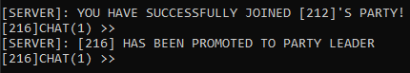

* Use /p transfer [id] to transfer leadership of the party
* Only works if you are the leader of the party

# Party Kick





* Use /p kick [id] to kick a user from the party
* Only works if you are the leader of the party

# USER GUIDE

* Use whisper to privately dm anyone
* Your own session ID is easily identifiable with the text prompt
* /r reply only works if someone has whispered to you beforehand
* Make sure to create a party first before using any party commands
* You can switch between party chat and all chat
* Users that are not in your party cannot see messages from your party

Packet_manager.h deals with all the packets

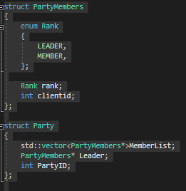

these structs keep track of player parties

39 void no_rank(SOCKET ClientSocket)

The error message given if player is not high enough ranking int their party

53 void send_party_invite(fd_set ReadFds, char Message[], int MessageLength, SOCKET ClientSocket)

Sends a party invite to another user

128 void add_party_member(SOCKET ClientAccepted, Party* party, int ClientSent)

Adds the user after he accepts the party invite

170 void create_party(int ClientSent)

Creates a party

198 void accept_party_invite(SOCKET ClientAccepted, int ClientSent, int partyid)

Accepts a party invite which adds him to the party

225 void decline_party_invite(fd_set ReadFds, SOCKET ClientDecline, int ClientSent, int partyID)

Declines party invite

268 void list_members(SOCKET ClientSocket, int partyid)

Lists al members in a party

295 void leave_party(SOCKET ClientSocket, int partyid)

Leave a party on your on

358 void disband_party(SOCKET ClientSocket, int partyid)

Disband the party as a leader

405 void party_kick(SOCKET ClientSocket, char Message[], int MessageLength, int partyid)

Kick a specific user in your party as a leader

510 void party_transfer(SOCKET ClientSocket, char Message[], int MessageLength, int partyid)

Transfer leadership role onto another user in your party

597 void party_chat(SOCKET ClientSocket)

Chat to you party members only

612 void all_chat(SOCKET ClientSocket)

Chat with everyone in the chat room

627void no_party(SOCKET ClientSocket)

No party exception message for party commands

641 void send_welcome_message(SOCKET ClientSocket)

Sends the welcome message

663 void session_info_message(fd_set ReadFds, SOCKET ClientSocket)

Sends the info message about users already connected

695 void send_notice_message(fd_set ReadFds, SOCKET ClientSocket)

Sends the notice message when a player joins/leaves

724 void show_online(fd_set ReadFds, SOCKET ClientSocket)

Shows all online users

758 void whisper_to_one(fd_set ReadFds, char Message[], int MessageLength, SOCKET ClientSocket)

Privately dms a user

835 void reply_to_one(fd_set ReadFds, char Message[], int MessageLength, SOCKET ClientSocket, char TargetSocket[])

Replies to the most recent whisper

902 void send_to_all(fd_set ReadFds, char Message[], int MessageLength, SOCKET ClientSocket)

Sends to all users

912 void send_to_party(fd_set ReadFds, char Message[], int MessageLength, SOCKET ClientSocket, int partyid)

Sends to only users in party

926 void ShowHelp(SOCKET ClientSocket

List of all available commands in the chatroom