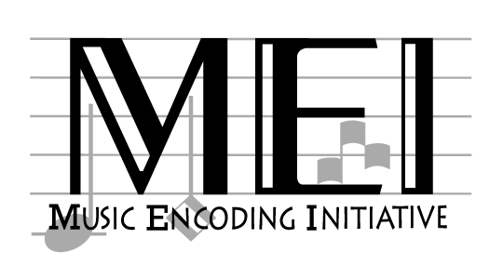

# Music Encoding Initiative

# Tag Library

# 2010-05 Release

# Prepared and maintained by the

# Music Encoding Initiative Working Group

|  |  |  |
| --- | --- | --- |
|  |  |  |
| This project is supported jointly by the National Endowment for the Humanities and the Deutsche Forschungsgemeinschaft. Any views, findings, conclusions or recommendations expressed in this publication do not necessarily reflect those of the National Endowment for the Humanities or the Deutsche Forschungsgemeinschaft. | | |

Charlottesville and Detmold, 2010

# Acknowledgments

# Many institutions and individuals assisted in the preparation of this tag library and in the overall development of the Music Encoding Initiative (MEI) schema.

# Grateful acknowledgment is given to the following institutions for their generous contributions: the National Endowment for the Humanities (NEH) and the Deutsche Forschungsgemeinschaft (DFG) for their joint support of the MEI project;

the Institute for Advanced Technology in the Humanities at the University of Virginia and the Hochschule für Musik in Detmold for graciously hosting the grant-funded meetings;

the Musikwissenschaftliches Seminar Detmold/ Universität Paderborn;

the Center for Computer-Assisted Research in the Humanities at Stanford University for permission to make use of their large collection of encoded music;

the Akademie der Wissenschaften und der Literatur in Mainz;

and the University of Virginia Library for providing an environment in which ... ;

The following individuals have provided much-appreciated commitments of time and energy to the development of MEI: Johannes Kepper (Edirom, Detmold); Erin Mayhood (Music Library, University of Virginia); Stefan Morent (Department of Musicology, University of Tubingen); Laurent Pugin (McGill University, Montreal); Daniel Rowenstrunk (Edirom, Detmold); Craig Sapp (Center for Computer-Assisted Research in the Humanities, Stanford University); Eleanor Selfridge-Field (Center for Computer-Assisted Research in the Humanities, Stanford University); Christine Siegert (OPERA Project, Universitat Bayreuth); Joachim Veit, (Carl-Maria-von-Weber-Gesamtausgabe, Academy of Music, Detmold, and University of Paderborn); and Raffaele Viglianti (Kings College, London);

Thanks to Bernhard R. Appel (Beethoven-Archiv und Verlag, Beethoven-Haus, Bonn); Donald Byrd (Indiana University); J. Stephen Downie (Graduate School of Library and Information Science, University of Illinois at Urbana-Champaign); Richard Freedman (Haverford College, PA); Oliver Huck (Universitat Hamburg); Fotis Jannidis (Institut fur Deutsche Philologie, Universitat Wurzburg); Axel Teich Geertinger (Royal Danish Library); and Frans Wiering (Information and Computing Sciences Department, University of Utrecht) for providing expertise ...

Also thanks to Sebastian Rahtz and Terry Catapano for their problem-solving assistance during the development of the RNG schema.

A large debt of gratitude is owed to those early adopters who recognized the potential of MEI: Julian Dabbert, Axel Teich Geertinger, Johannes Kepper, Stefan Morent, Laurent Pugin, Craig Sapp, Christine Siegert, Raffaele Viglianti.

Daniel Pitti (Institute for Advanced Technology in the Humanities, University of Virginia) deserves special recognition for ...

Gabriele Buschmeier (Akademie der Wissenschaften und der Literatur, Mainz) ...

Finally, thanks to you, dear reader, for your interest in MEI.

# Introduction

The Music Encoding Initiative (MEI) schema is a set of rules for recording the intellectual and physical characteristics of music notation documents so that the information contained in them may be searched, retrieved, displayed, and exchanged in a predictable and platform-independent manner. The MEI rules are expressed in the form of a RelaxNG (RNG) schema. Because schemas are intended to be read chiefly by computers, they are often accompanied by documentation designed for human comprehension. This tag library, which is a comprehensive list of MEI elements, is one such piece of documentation. It is intended to serve as a reference tool for music encoders. Through the use of natural-language definitions and examples, it assists users of MEI in achieving effective and consistent markup. Despite translating XML and RNG terminology and concepts into more accessible language, the tag library is still a technical document that presupposes readers will possess a minimal understanding of XML and music notation. Novice encoders will need to supplement their use of the tag library by consulting MEI application guidelines, attending introductory MEI workshops and training classes, and referring to other information sources.

As a natural-language translation of the MEI schema, the tag library conveys information about the three principal tasks accomplished by the schema. First, the schema breaks down the content of music notation documents into data fields or categories of information called "elements". All of these elements are named, define, and described in the MEI Tag Library. Second, the tag library identifies and defines attributes associated with those elements. Attributes are characteristics or properties that further refine the element. Last, and perhaps most importantly, the tag library expresses the schema structure by explaining the relationship between elements, specifying where the elements may be used and describing how they may be modified by attributes. While two of the basic purposes of MEI are to facilitate the searching and display of encoded music notation documents in an electronic environment, nothing in the tag library addresses their specific implementation. Searching and display are entirely dependent on software applications outside the scope of MEI.

Throughout the tag library, coded examples augment the narrative explanations and help illustrate the role, relationship, and usage of elements and attributes. The MEI schema contains only a few required elements, the rest are optional. Therefore, the amount of markup desired will vary from one situation to another depending on intellectual, technical, and financial considerations. Creating encoded music notation documents for inclusion union databases may also result in tagging requirements that are separate from those dictated by the schema.

The tag library is divided into five sections. It begins with an outline of MEI Design Principles. This is followed by an overview of the structure of a typical MEI instance and an explanation of terms and conventions used in the tag library. Element definitions comprise the fourth and largest section of the tag library, while an index by element name concludes the documentation.

Suggestions for new elements or revised descriptions may be submitted to the MEI Working Group via the MEI discussion list at mei-l@lists.uni-paderborn.de.

# MEI Design Principles

This section of the tag library defines principles and criteria for designing, developing, and maintaining an XML-based encoding scheme for music notation documents.

## Definitions and Parameters

1. A music notation document is one that contains music notation; that is, any one of a number of "visual analogues of musical sound, either as a record of sound heard or imagined, or as a set of visual instructions for performers."[1]
2. The encoding scheme permits both the creation of new music notation documents and the conversion of existing ones from print and other electronic formats. However, conversion of existing documents may require revisions in content or rearrangement of information.

## General Principles

1. No *prima facia* distinction is made between a primary source of music notation, such as an autograph or published score, and a secondary source, such as a scholarly edition based on one or more primary sources. The tag set encompasses both, the encoder must choose the elements and attributes most appropriate in each case.
2. As an encoded representation of one or more music notation documents, an MEI file may be employed as a surrogate for the original materials.
3. Although the encoding scheme does not define or prescribe intellectual content for music notation documents, it does define content designation and is intended to be used with available data content standards. MEI identifies the essential data elements within music notation documents and establishes codes and conventions necessary for capturing and distinguishing information within those elements for future action or manipulation. While there are a few elements that ought to appear in any MEI document, various intellectual, technical, and economic factors influence the level of detail of analysis and encoding actually undertaken. Taking this into consideration, the encoding scheme is designed with a minimum of required elements and allows for progressively more detailed levels of description as desired.
4. The encoding scheme preserves and enhances the current functionality of existing music notation documents. It permits identification of document structures and content that support description, navigation, analysis, and online and print presentation.
5. The encoding scheme is intended to facilitate interchange between notational tools. It aims to assist in the creation of more effective and consistent encoding, encourage the creation of union databases of music notation documents, and permit the reuse of encoded data for multiple output purposes. It will also ensure that machine-readable music notation documents will outlive changing hardware and software environments because they are based on a platform-independent standard.

## Structural Features

1. The encoding scheme is based on eXtensible Markup Language (XML), a text-based format for representing structured information. It is expressed as a RelaxNG (RNG) schema, referred to as the "Music Encoding Initiative" or "MEI" schema.
2. Related or complementary standards, such as the Text Encoding Initiative (TEI) Guidelines for Electronic Text Encoding and Interchange, the Encoded Archival Description (EAD) DTD, MARC formats, existing notation encoding schemes, etc. have been consulted and employed as appropriate. The data model includes a header that is similar to the TEI header, and TEI and EAD naming conventions and tag structures have been used whenever feasible. With respect to metadata, MEI recognizes the inter-relationship between the metadata content found in the MEI header and that of catalog records, authority records, and finding aids, and it provides for the use of an encoding equivalency attribute for MEI elements corresponding fields in other metadata standards.
3. The encoding standard consists of three parts: an RNG-compliant schema, a tag library containing definitions of the schema's elements and attributes as well as examples of tag use, and application guidelines.
4. To ensure broad international and multi-repertoire application of MEI, exising musical terminology was used in building the data model where practical. In addition, a method for localization of the data model's names has been provided. Finally, extensive use of attributes in the schema permits the refinement of element meanings with specific geographic or temporal contexts.

## Control and Maintenance

1. Control and maintenance of the schema and its documentation will be provided by a maintenance agency working in concert with the national and international music communities, assisted in an advisory capacity by other interested groups of users.

# Overview of MEI Structure

In most cases, an MEI file, like many other representations, has a "header + message" structure. This is a commonly-occurring structure because it effectively separates metadata and data. In MEI these two parts of the file are called meihead and music and are contained within an mei element.

The meihead element contains metadata about the encoded data found in the music element. The header is modeled on the TEI teiHeader element and therefore has the same components as in TEI – filedesc, encodingdesc, profiledesc, and revisiondesc – plus an optional meiid element. The filedesc and meiid elements are required. Filedesc contains further sub-elements describing the electronic file itself and the sources from which it was drawn. The encodingdesc element documents the relationship between an electronic file and the source or sources from which it was derived. That is, it describes the purpose of the encoding and the methods used to create the file. A description of the non-bibliographic aspects of the creation of a work, that is, the languages and sub-languages used, the situation in which it was produced, e.g. the participants, setting, reception history, etc., is provided for by the profiledesc element and its children. The revisiondesc element provides a place to encode the revision history for the electronic file.

The music element of the MEI file contains the actual encoded content. MEI is agnostic regarding the definition of the term *music* – it is simply the thing being encoded. It can be a monophonic song or a complex symphony – the character of the work is encoded by the music element's components. The underlying assumption, however, is that the work being encoded is or can be expressed in a *notated* form. A musical work in MEI terms may be a collection of works, such as a printed collected edition or an electronic database of related works.

The music element allows front, body, and back components. Critical editions and collections of works often contain extensive text, such as a table of contents, an introduction, commentary, a biography, an index, etc. Accommodating this text within MEI gives control of the text as well as the notation markup to the encoder of the MEI instance and to the music markup community rather than the creators and maintainers of the text standard. In addition to front and back matter, MEI can also encode the introductory or explanatory text sometimes found between sections of a musical work.

The body element encodes the musical content of the work. It contains one or more discrete, linear segments, called mdiv (“musical division”). An mdiv is the highest-level indication of the structure of the composition. For example, a single mdiv indicates a single-movement work; however, when a musical work can be broken into several top-level segments, the body element may contain multiple mdiv elements. The mdiv element is a generic one which may be typed – a symphony, for example, usually consists of movements while operas are made up of acts. A part or score may be divided into linear segments or sections. Section elements often function as a scoping mechanism for clef signs, key and meter signatures, plus metronome, tempo, and expression markings. Their use also minimizes the need for backward scanning to establish context when the starting point for access is not at the beginning of the score. Section elements may also be used for other user-defined, i.e., analytical or editorial, purposes, and arbitrarily nested to any desired level. There is also an ending element, a specialized instance of section element that may not be recursively nested.

When the facsimile module is activated, the facsimile element is also allowed within music. Facsimile contains a representation of a written source in the form of a set of images rather than as transcribed text. Multiple facsimile elements may be used when multiple sets of images are needed, for example, when there are multiple sources. Within facsimile image files may be referenced using graphic elements and bounding boxes of areas of interest within the image may be indicated through the use of zone elements. Elements that mark semantic content may be linked to particular images or zones using the facs attribute, which is available when the facsimile module is activated.

An mdiv element may contain one or both of two possible views. The score element contains a traditional, full open score while the parts element contains each performer’s view of the work. Score and parts views are intended to accommodate different methods of organizing the markup – no particular presentation is implied, and software may render a collection of parts as a score or a score as a collection of parts. The explicit encoding of two views is necessary because it is not always possible to automatically derive one view from the other. In addition, separating scores and parts can eliminate a great deal of markup complexity.

A part element contains an individual performer’s view of the score, effectively a mini-score requiring all the encoding features of a full score. The encoding of individual parts is practical when they do not share visual characteristics, such as typeface or page layout, with the full score. Part elements in MEI have little to do with voice leading, which can be encoded using the next attribute available on all event-type elements.

In both score and part views, the scoredef element and its sub-elements are used to describe logical characteristics of the encoded music, such as key signature, the "actual" key (as opposed to the notated key signature), meter, etc. and visual features, such as page size, staff groupings and labels, etc.

Depending upon the time period of the notation and the encoder's needs, multiple methods of organization are possible in section elements. When the CMN module is "switched on", measure-by-measure encoding is allowed, with staff sub-elements within measure. However, when the mensural or neumes module is enabled, staff-by-staff organization is expected, a historically appropriate approach for these notation styles which do not have measures. In any case, layer sub-elements are expected within staff. *Note that it is possible to use both of these organization methods simultaneously by enabling more than one of the CMN, mensural, or neumes modules; however, this is considered an advanced topic and is not covered in this introduction.*

It is important to note that within the layer element, semantic events, not visual symbols, are modeled. Events are the typical, time-based, discrete atoms of musical data, such as notes, chords, rests, etc. While events may have visual properties, modeling symbols places too much emphasis on presentational qualities and makes the markup less generally useful as a generic “music” markup standard.

So-called "control events", such as dynamics, ties, phrase marks, pedal marks, etc., depend upon other events, such as notes or rests, for their existence. They often do not fit the principal hierarchy of sections, measures and staves. Neither can they always be treated as properties of other events. Therefore, a second class of events exists in MEI for these musical elements.

Additional document elements, sometimes erroneously called "root" elements, may be employed in addition to the mei element. The meicorpus element can be employed to create a single file that contains multiple MEI instances or the meihead element can be used to create a "stand-alone" header; that is, an MEI instance that transmits only metadata without any accompanying music notation markup. Conversely, the music element may serve as the document element for a file that is expected to be inserted into another XML document, a TEI (Text Encoding Initiative) file for example, that already provides a context for the included material.

# Tag Library Conventions

The "MEI Elements" section of the tag library contains descriptions of 238 elements, arranged alphabetically by their tag names. The "Index by Element Name" section makes it possible to locate those elements with tag names that might be hard to find alphabetically. For example, the index entry "bowed tremolo" points to the tag name "<btrem>". The index also serves as a concise, easily browsable list of all MEI elements.

The "MEI Elements" section presents information for each element as shown in Figure 1.

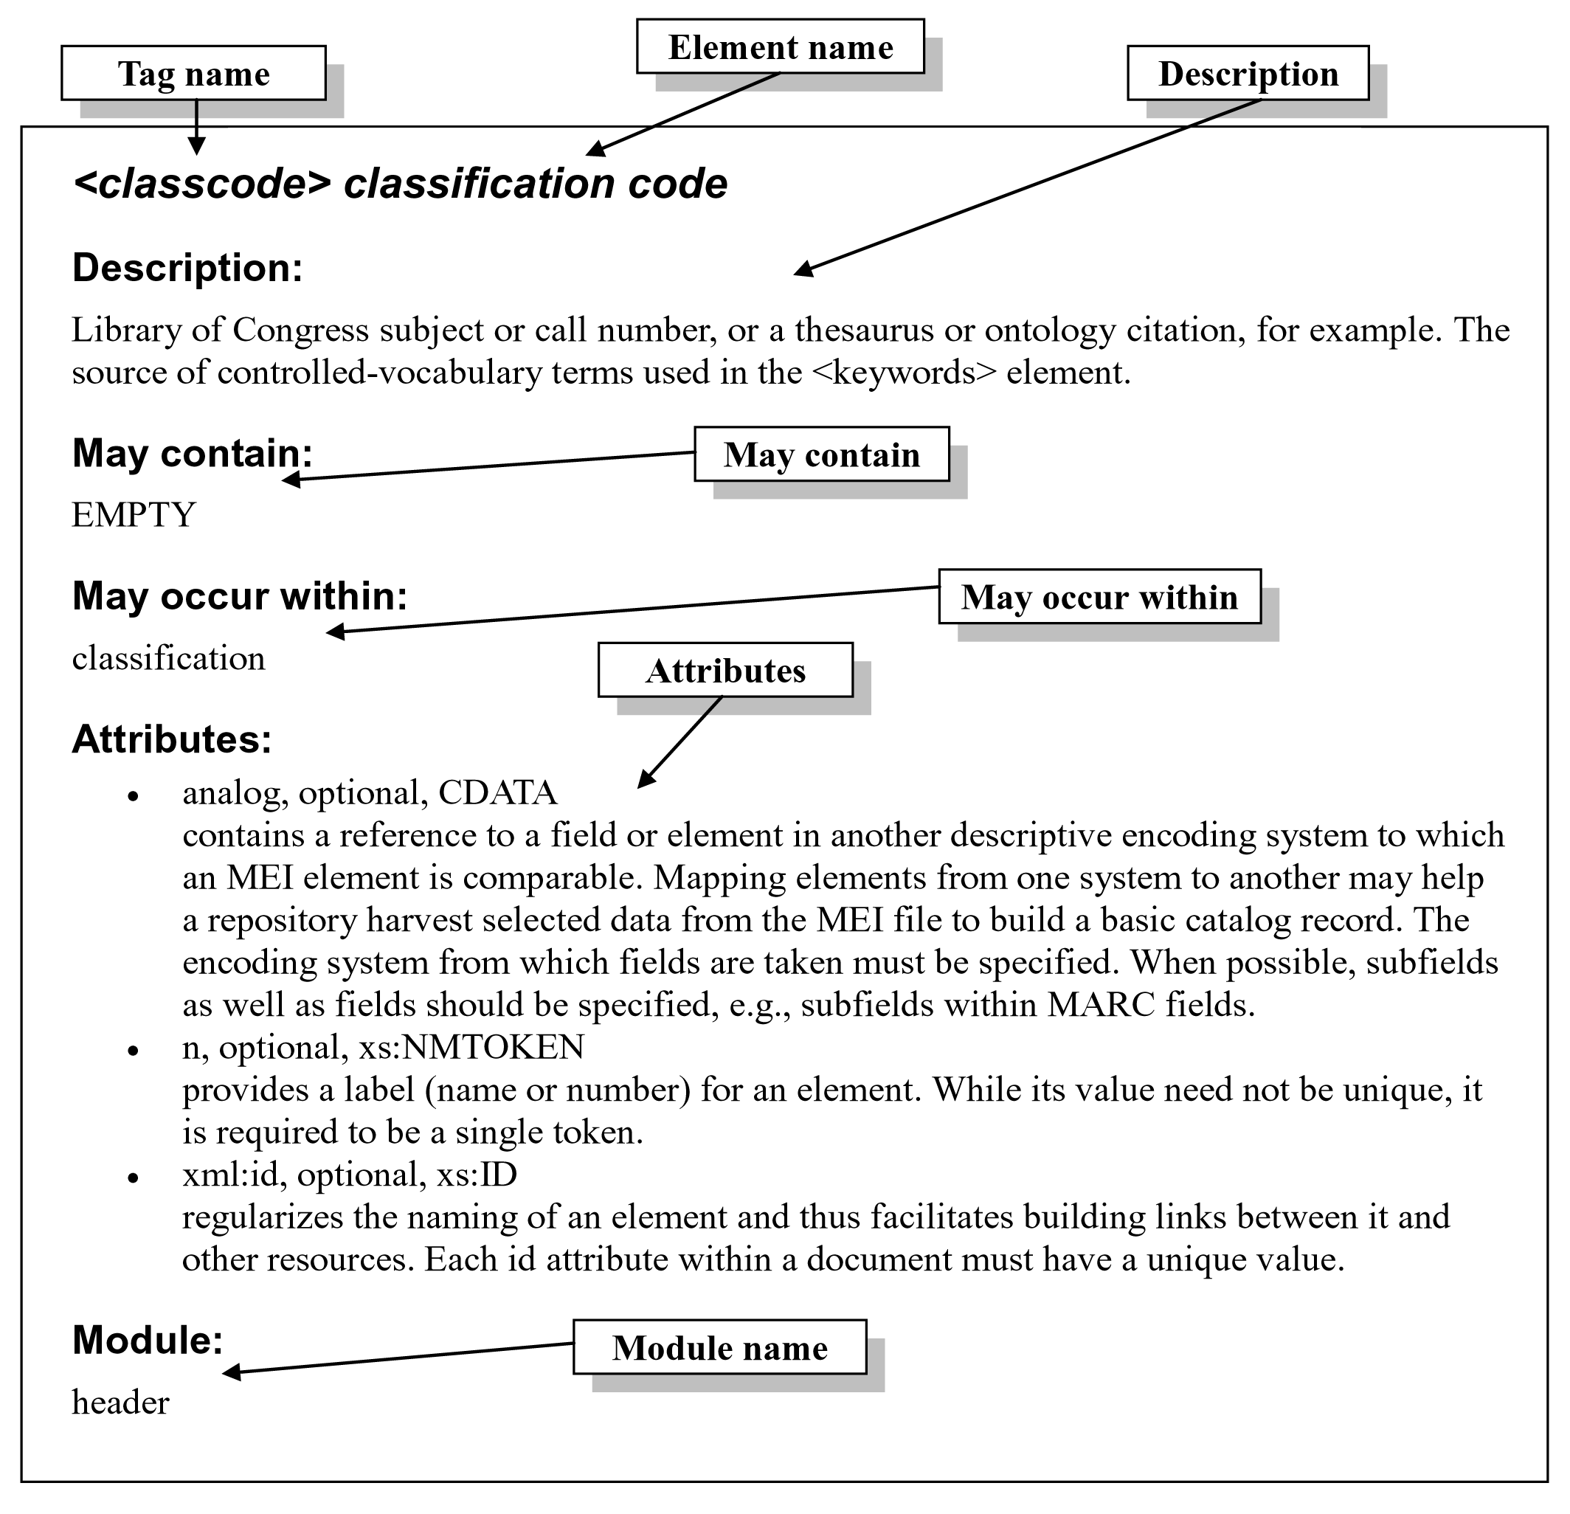

Figure

**Tag Name:** Short, nmemonic form of the element name that is used in the machine-readable XML document. The tag name is the first word at the top of the entry. Tag names appear between angle brackets, e.g., <mei>, except in the listings under "May contain" and "May occur within". They are always in lower case.

**Element Name:** Expanded version of the tag name that more fully describes the element's meaning. The full name of the element is usually a word or phrase that identifies the element's purpose. In the tag library, the element name follows the tag name.

**Description:** Definition of the element typically drawn from standard reference works, glossaries, basic dictionaries, and data dictionaries, such as Gardner Read's *Music Notation: A Manual of Modern Practice*, *Grove Music Online*, Carl Parrish's *Notation of Medieval Music*, the *Text Encoding Initiative Guidelines*, the *Encoded Archival Description Tag Library*, etc. Additional text describes how the element is used, differentiates it from similar elements, points out useful attributes, provides an illustrative example, or directs the reader to related elements.

**May contain:** Identifies other elements that may occur within the element being defined. Elements may be empty (e.g., permit no element content); or they may contain text (called PCDATA), other elements, or a mixture of text and elements. The abbreviation PCDATA (parsed character data) indicates that text content is allowed directly inside the element, but the text cannot include characters, such as left angle brackets, that might be interpreted by an XML parser as action codes. The list of permitted elements usually includes more elements than are generally needed because similar elements share the same content model. This practice eases the task of authoring a schema and aids machine processing of encoded documents.

**May occur within:** Identifies all the elements within which the described element may appear. This information conveys the sense of where and how often an element is available throughout the schema. Definitions of parent elements may provide additional information about an element's usage.

**Attributes:** Identifies all attributes associated with the element. Each entry in the list of attributes contains the attribute name, an indication of whether the attribute is optional or required, and the datatype to which a value is expected to conform.

**Module name:** Identifies the schema module in which the element is defined. In order to use the element, this module must be activated.

1. Ian D. Bent, et al. "Notation." *Grove Music Online*. *Oxford Music Online*. 15 Apr. 2010 <http://www.oxfordmusiconline.com/ subscriber/article/grove/music/20114>