PROJECT 1 – Build Your Mini SOC (Sysmon + Splunk)
Student Name: Cesar Garrido
Course / Section: ITSY-2472
Date: 3/4/2026

Instructions to the Student
This is a fillable lab document. Wherever you see a screenshot placeholder, pause, take a screenshot of your screen, and paste it directly below the placeholder. All placeholders must have screenshots to receive full credit.

Screenshot 1: Sysmon Download Page
Paste a screenshot showing the Sysmon download page from the Microsoft website.
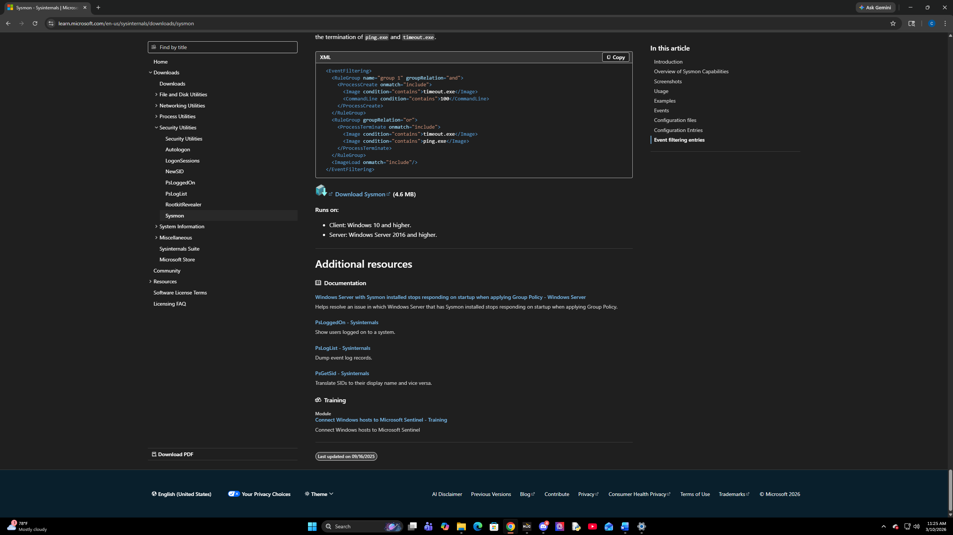

Screenshot 2: Sysmon Files Extracted
Paste a screenshot showing Sysmon64.exe and sysmon.xml (the config file) on your Desktop.

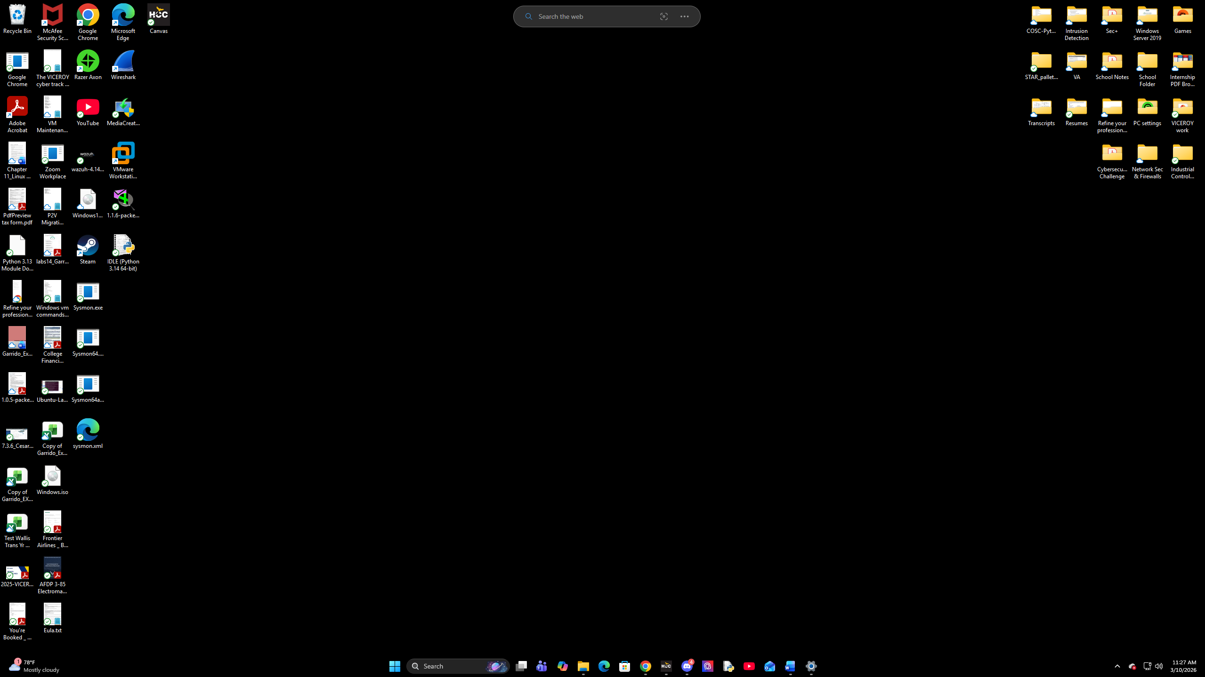

Screenshot 3: Sysmon Installation Success
Paste a screenshot of the Admin Command Prompt showing the message "Sysmon installed".
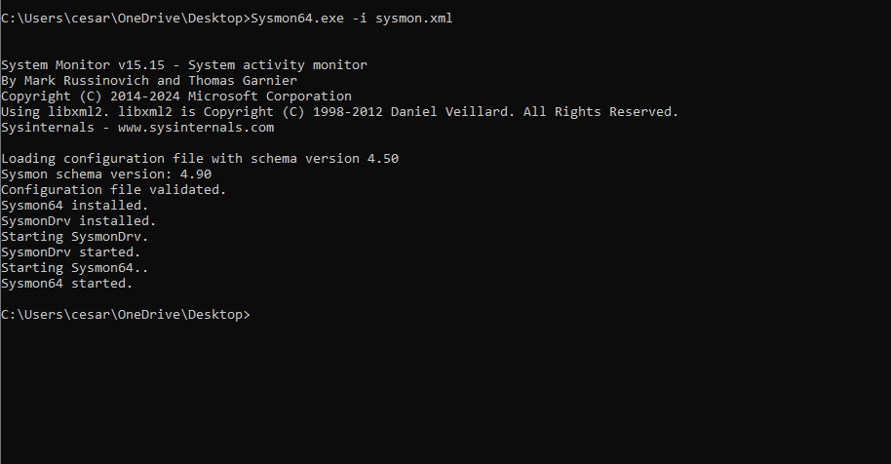

Screenshot 4: Sysmon Logs in Event Viewer
Paste a screenshot showing the path: Applications and Services Logs > Microsoft > Windows > Sysmon > Operational.
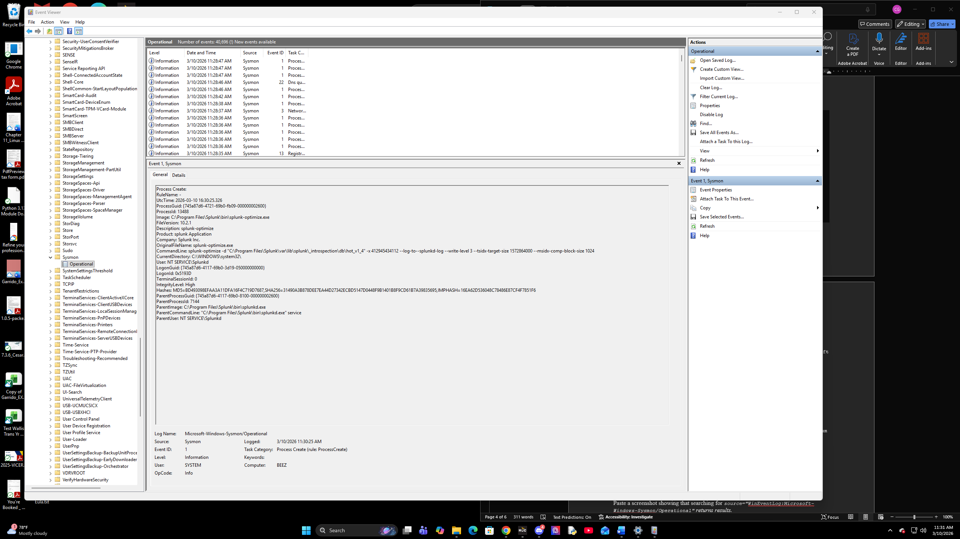

Screenshot 5: Manual Splunk Configuration (New Fail-Safe Step)
Paste a screenshot of your inputs.conf file open in Notepad. The file path C:\Program Files\Splunk\etc\system\local\inputs.conf must be visible at the top, and the code block must be visible inside.
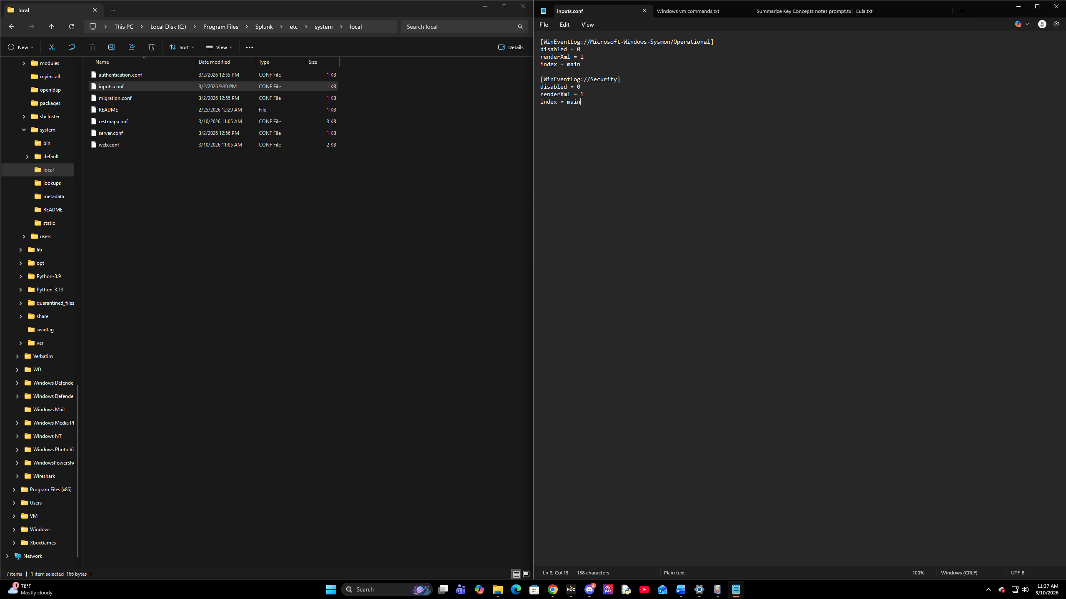

Screenshot 6: Verifying the Connection
Paste a screenshot showing that searching for source="WinEventLog:Microsoft-Windows-Sysmon/Operational" returns results.
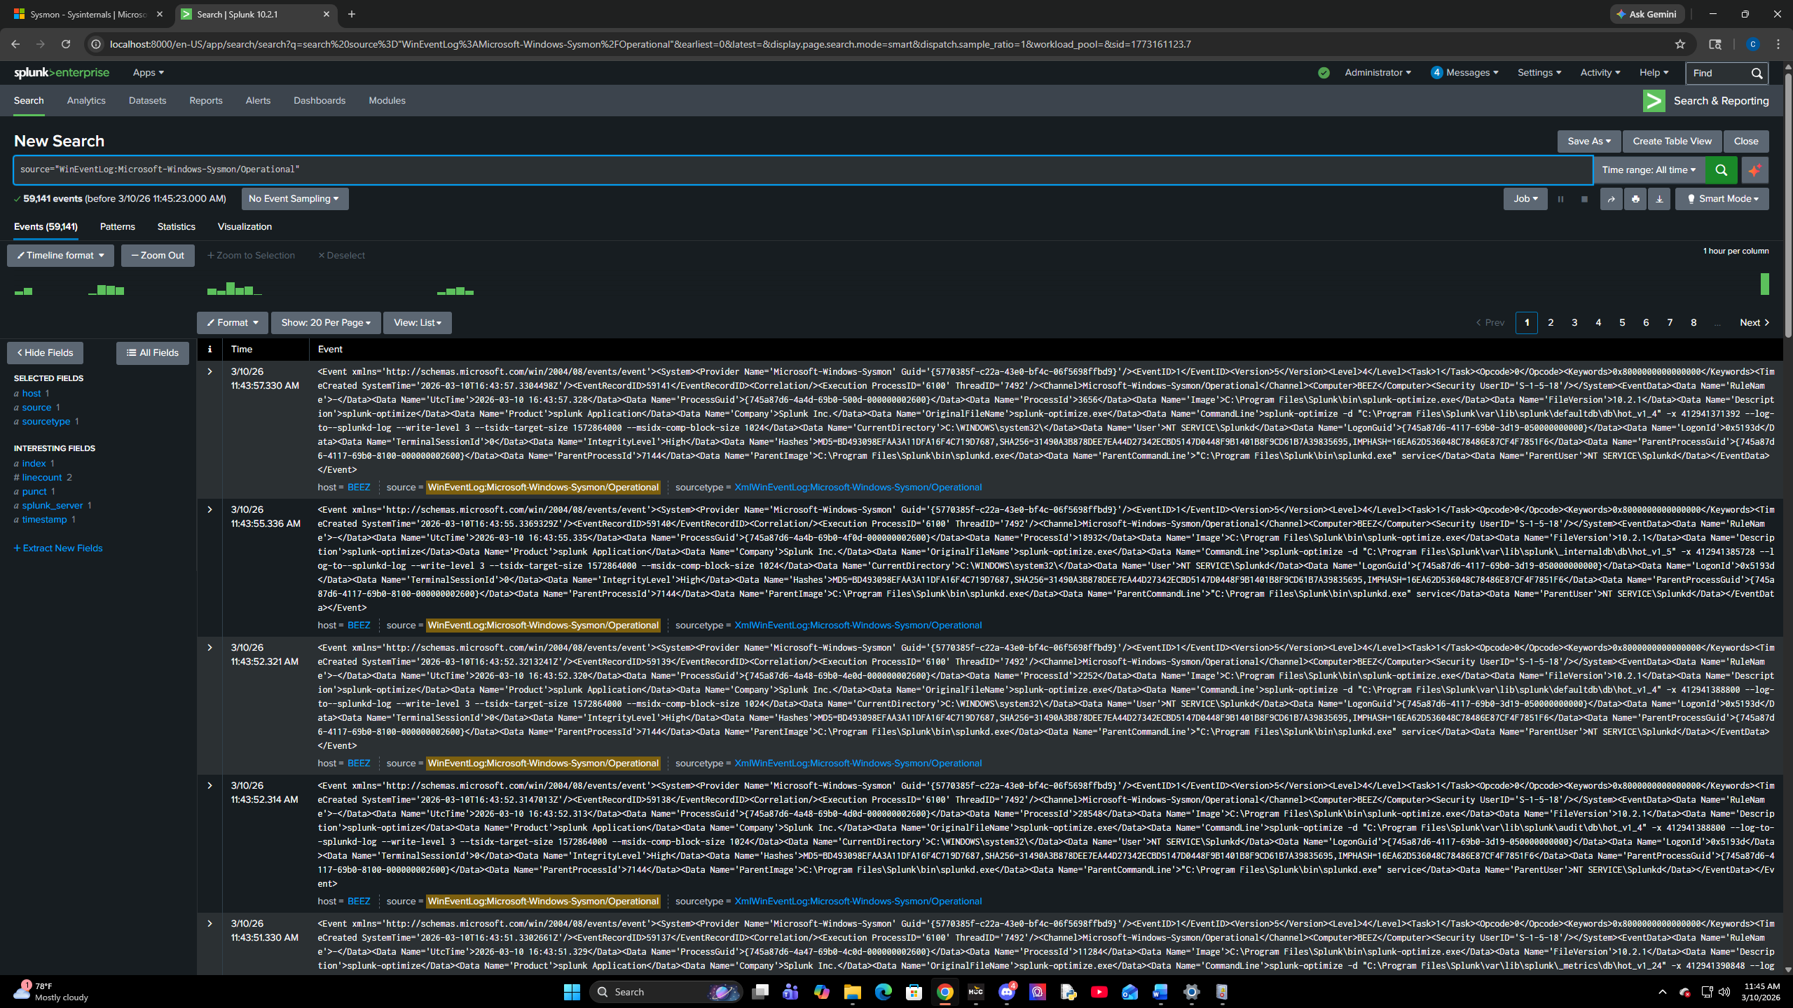
Screenshot 7: The Final Detection
Paste a screenshot showing the results for index=main whoami. You must expand the event to show the command you typed in PowerShell.
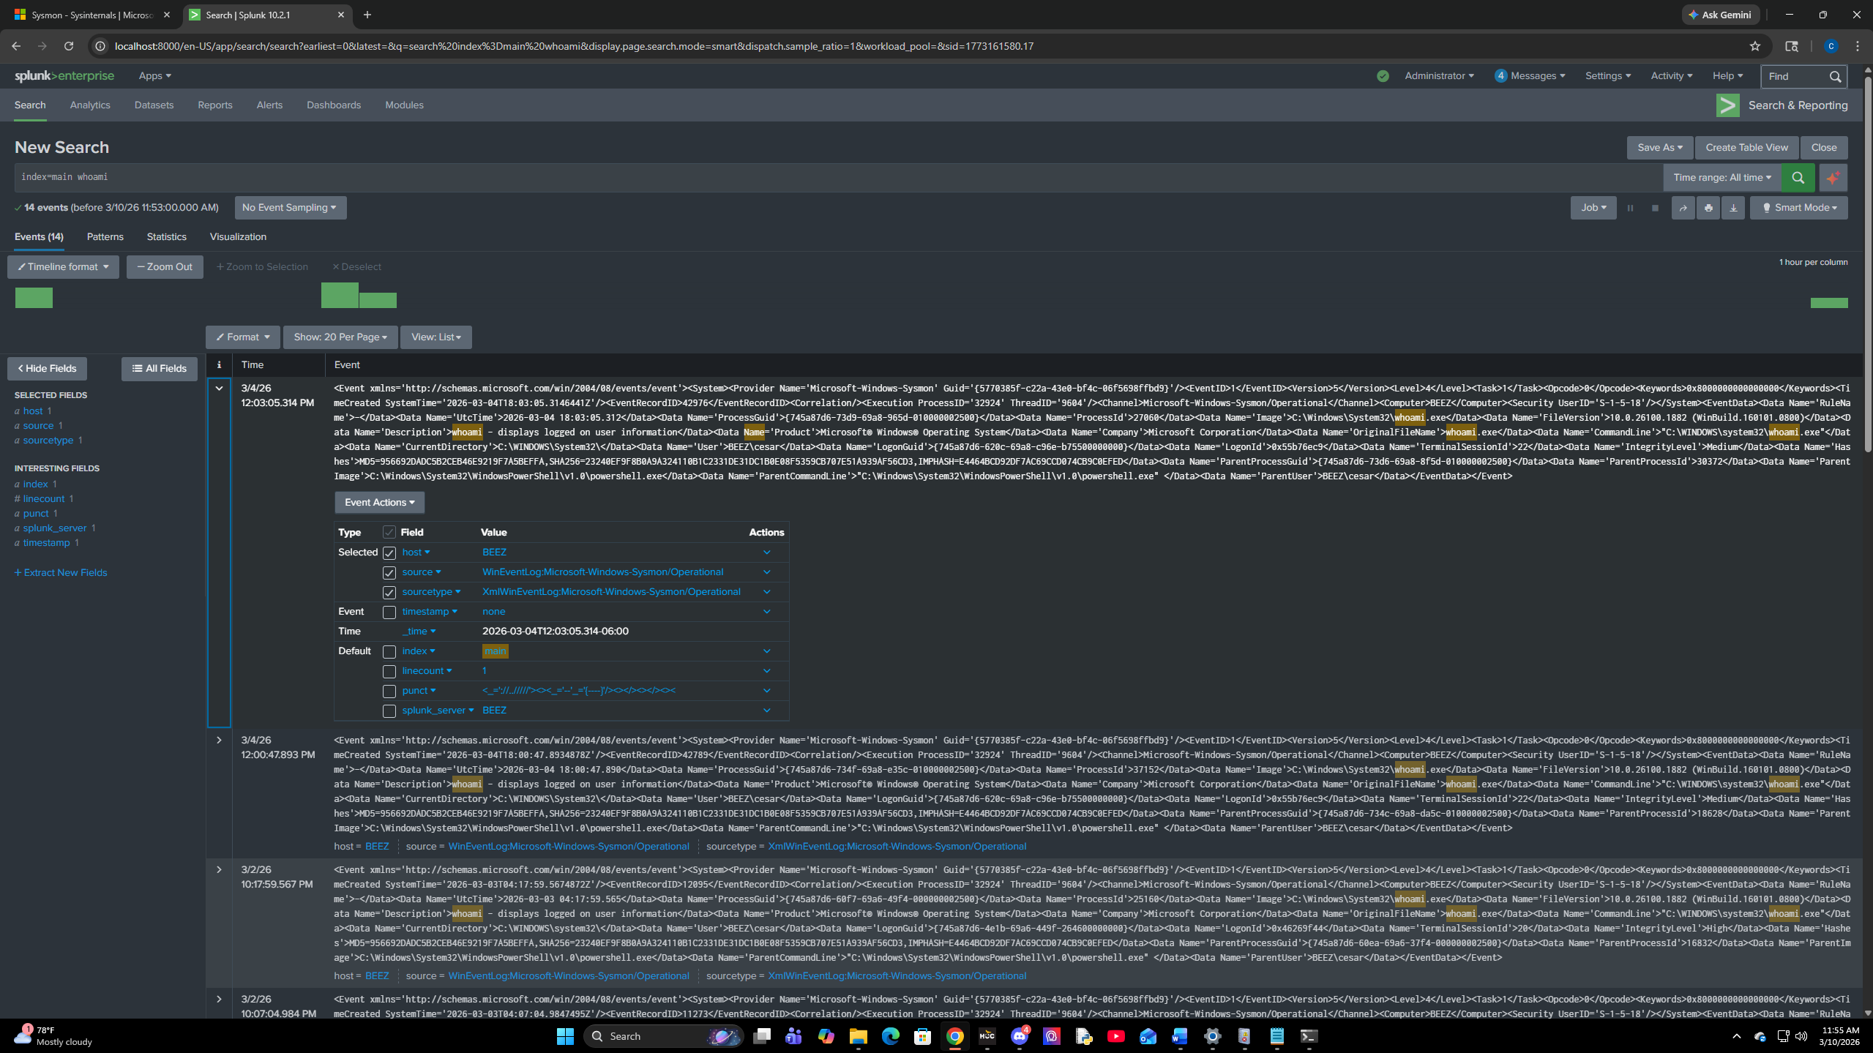

Reflection Questions
1. What did you learn about Sysmon and why it is important in cybersecurity?
- Your response: In this lab I learned that Sysmon is a Windows system service that logs detailed information about system activity and sends it to the Windows event log. Unlike the default Windows logging, Sysmon records deeper security data such as process creation, network connections, file creation timestamps, and PowerShell activity. This information is valuable for cybersecurity professionals because it helps detect suspicious or malicious behavior on a system.
2. What challenges did you face during this lab (e.g., the missing menu or hidden file extensions), and how did you overcome them?
- Your response: One challenge I faced during this lab was locating and navigating unfamiliar menus in Windows. As well as understanding how Sysmon logs appear in Event Viewer and Splunk, since the interface can be overwhelming. I solved this problem by reviewing the Event ID’s and filtering logs to focus on relevant activity.
3. Why do SOC analysts rely on tools like Splunk instead of just using Event Viewer?
- Your response: SOC analysts rely on tools like Splunk because they provide centralized logging, advanced search capabilities, and real-time analysis across multiple systems. Event Viewer is limited to a single machine and can be difficult to use when analyzing large amounts of data.
4. How did it feel to generate activity in PowerShell and then see it appear as a security event in Splunk?
- Your response: It was interesting and rewarding to generate activity in PowerShell and then see it appear in Splunk as a security event. It made the connection between user actions and the system monitoring very clear. Seeing the logs in real time helped me understand how SOC analysts track activity and investigate potential threats. It also showed how even simple commands can be recorded and analyzed for security purposes.

