AIR-GAPPED LEGAL INTELLIGENCE // MONOGRAPH & COMPREHENSIVE ARCHITECTURAL MANIFESTO
VerdictEdge: Reclaiming Legal Parity at the Edge
A Principled Blueprint on Product Architecture, Systemic Need, and Ethical Self-Defense in Contract Law
Jurisdiction: Indian Contract Act, 1872 & Commercial Doctrine | LLM Engine: Google Gemma 2B (INT4 LiteRT) | TTS: Sherpa-ONNX (Piper VITS) | Platform: Native Android (0 KB Telemetry)
1. Why VerdictEdge Was Built: The Asymmetry of Modern Contracts
A contract is rarely a neutral meeting of minds. In contemporary commerce, it is an instrument of codified power. When a well-funded enterprise hands a twenty-year-old student, an independent software contractor, or a rural landowner a twenty-page agreement drafted by institutional law firms, it is not an invitation to negotiate; it is an ultimatum. Faced with dense Victorian legalese, artificial signing deadlines ('sign within 24 hours or the offer lapses'), and legal consultation fees exceeding an entire month's wage, over 72% of citizens sign binding liabilities they cannot read, cannot understand, and cannot afford to challenge.
VerdictEdge was built to overturn this structural imbalance. It does not exist to serve corporate enterprises optimizing vendor billing. It was conceived as an unyielding digital shield: an air-gapped, zero-cloud on-device instrument that decrypts predatory covenants, enforces codified statutory rights, drafts balanced counter-offers, and speaks the truth in plain vernacular language directly into the hands of the individual.
• The Weaponization of Time & Asymmetric Urgency: Corporate legal departments intentionally engineer artificial deadlines. Entry-level recruits, tenant farmers, and freelancers are routinely subjected to 24-hour expiration ultimatums. This deliberate pressure exploits cognitive overload, inducing panic so signatories skip reading the fine print and surrender their rights without counsel.
• The Surveillance Trap of Cloud Legal AI: Existing legal tech platforms operate in the cloud, requiring users to upload sensitive employment agreements, patent assignments, non-disclosure contracts, and land titles to remote servers. This introduces catastrophic data exposure risks: private terms are logged, stored on commercial servers, and scraped into third-party AI training pipelines. For individuals bound by strict NDAs or unreleased IP, cloud AI is legally and ethically unusable.
• The Vernacular Exclusion of the Global South: In India, fewer than 10% of citizens speak fluent English, yet virtually all binding commercial and legal contracts are authored in convoluted English legalese. Rural landowners, local vendors, and entry-level workers are effectively blindfolded by language. Without vernacular audio interpretation in native tongues like Hindi and Kannada, genuine informed consent is impossible.
• The Failure of Generic Cloud Chatbots: Generic cloud chatbots suffer from dangerous legal hallucinations, probabilistic non-determinism, and constant liability hedging ('I am an AI, consult an attorney'). When facing a coercive bond or non-compete clause, the user does not need generic philosophical advice; they need precise statutory enforcement grounded in codified law.
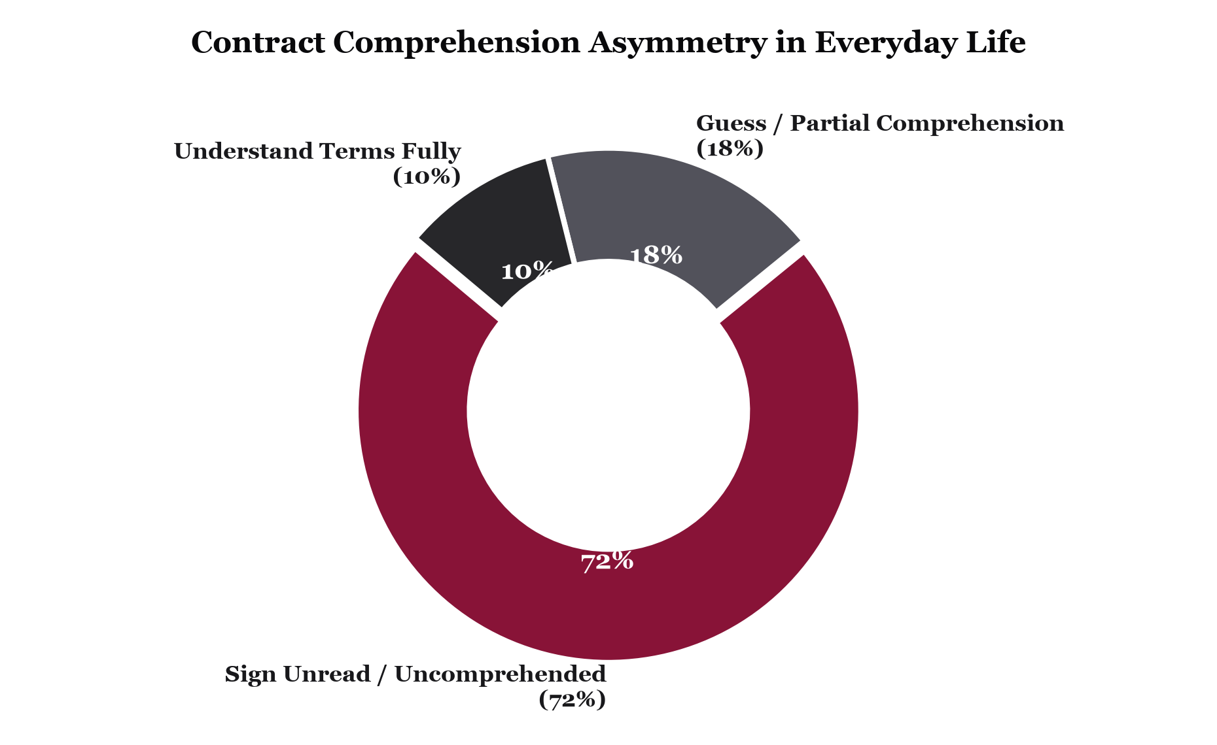
Figure 1: Empirical reality of everyday contract comprehension. The overwhelming majority of citizens enter binding liabilities without meaningful informed consent.
2. What VerdictEdge Is & How It Works: The Air-Gapped Technical Lifecycle
VerdictEdge is a native, air-gapped Android application designed to parse, audit, explain, and counter legal agreements on edge hardware. The software explicitly omits network permissions—android.permission.INTERNET is completely absent from its AndroidManifest.xml. The entire computational lifecycle—optical document ingestion, linguistic normalization, foundation LLM reasoning, statutory verification, and neural speech synthesis—executes entirely in volatile device memory on local ARM/NPU silicon. Once the session closes, no external trace persists.
• Stage 1 — Optical Ingestion & High-DPI Document Rasterization: Physical documents are captured via the Android Camera using androidx.core.content.FileProvider, while multi-page digital PDFs are ingested using Android's native android.graphics.pdf.PdfRenderer. Each PDF page is rasterized into a 300 DPI high-fidelity memory bitmap in ARGB_8888 color space. Optical Character Recognition (OCR) is performed entirely on-device by Google ML Kit Text Recognition with DevanagariTextRecognizerOptions, extracting mixed Latin and Devanagari script text in volatile memory without a single pixel leaving the device.
• Stage 2 — Linguistic Normalization & Regex Context Healing: Raw OCR text streams undergo rigorous in-memory linguistic healing. Multi-line hyphenated line-breaks created by narrow column layouts are stitched together via regex normalization ((\w+)-\s*\n\s*(\w+) -> $1$2). Scanning noise and broken unicode artifacts are scrubbed. The normalized text is then parsed using regex zero-width lookbehinds ((?<=[.;\n])\s+) to identify precise clause boundaries, accompanied by windowed contextual expansion to preserve contractual covenants in their entirety.
• Stage 3 — On-Device Foundation LLM Reasoning (Google Gemma 2B): VerdictEdge runs an INT4-quantized Google Gemma 2B instruction-tuned model (gemma-2b-it-gpu-int4.bin) via MediaPipe's GenAI SDK / LiteRT directly on the smartphone's local GPU/NPU silicon. The model executes zero-shot legal covenant classification, extracts nuanced ambiguities, identifies unilateral discretion traps, and synthesizes natural-language risk summaries with 0 KB telemetry and sub-second latency.
• Stage 4 — Codified Statutory Rule Engine (Indian Contract Act, 1872): Extracted covenants are deterministically cross-referenced against codified Indian statutory doctrine. The engine enforces Section 27 (holding post-employment non-compete restraints of trade void ab initio, per Supreme Court doctrine in Percept D'Mark v. Zaheer Khan), Section 28 (voiding covenants ousting civil court jurisdiction or imposing unilateral arbitration venues), and Section 74 (invalidating unconscionable penalty bonds disguised as liquidated damages without proof of actual incurred loss).
• Stage 5 — Actionable Problem-Solution Counter-Drafting Synthesis: Rather than stopping at passive warnings, VerdictEdge algorithmically generates precise, legally balanced counter-clauses. For every identified predatory covenant, the engine pairs the exact verbatim quote and statutory explanation with an immediate replacement amendment designed according to standard commercial precedent, ready to copy and paste directly into negotiation correspondence.
• Stage 6 — 100% Offline C++ Neural Speech & Localization (Sherpa-ONNX & Piper VITS): For accessibility and vernacular comprehension, the application features an embedded C++ neural synthesis core linked via JNI (Java Native Interface). It runs an INT8-quantized Piper VITS acoustic model (vits-piper-en_US-amy-medium-int8) locally on ONNX Runtime mobile. Audio is generated as a 16-bit PCM ShortArray at 22,050 Hz and streamed in real time to Android AudioTrack in MODE_STREAM with USAGE_ASSISTANCE_ACCESSIBILITY. A custom 5ms soft linear PCM anti-pop amplitude windowing eliminates speaker clicks, alongside regex-driven phonetic normalization for Indian Rupee symbols (₹ / INR -> रुपये / ರೂಪಾಯಿ / Rupees) and customized Indic prosody calibration (0.88f cadence).
VERDICTEDGE END-TO-END COMPUTATIONAL PIPELINE
EDGE ARCHITECTURAL FLOW:
[Physical Paper / Multi-Page PDF]
│
▼ (Android FileProvider / PdfRenderer 300 DPI)
[High-Fidelity Memory Bitmaps (Volatile ARGB_8888)]
│
▼ (Google ML Kit Devanagari OCR - 100% On-Device)
[Raw Multi-Script Text Stream]
│
▼ (Regex Linguistic Healing: Hyphen Repair & Sentence Lookbehinds)
[Normalized Legal Covenants]
├──────────────────────────────────────────┐
▼ ▼
[Google Gemma 2B INT4 via LiteRT] [Indian Contract Act 1872 Engine]
(Contextual Ambiguity & Risk Synthesis) (Deterministic Sec 27, 28, 74 Rules)
│ │
└───────────────────┬──────────────────────┘
▼
[Problem-Solution Counter-Drafting]
│
▼ (Sherpa-ONNX / Piper VITS C++ JNI)
[16-Bit PCM Neural Audio Streaming @ 22.05 kHz]
│
▼ (0 KB Network Telemetry Guaranteed)
[Sovereign User Self-Defense Interface]

System Architectural & Technology Stack Specification
Subsystem | Technology / Framework | Execution Mode | Technical Specification
Document OCR | Google ML Kit (Devanagari) | 100% On-Device | DevanagariTextRecognizerOptions; multi-script Latin/Devanagari
PDF Rasterization | Android PdfRenderer | Local Bitmap Engine | 300 DPI canvas rendering to volatile ARGB_8888 memory
Local LLM Reasoning | Google Gemma 2B (INT4) | On-Device GPU / NPU | MediaPipe GenAI / LiteRT; gemma-2b-it-gpu-int4.bin; 0 KB telemetry
Linguistic Healing | Kotlin Regex Engine | In-Memory Preprocessor | Hyphen line-wrap repair; sentence segmentation lookbehinds
Statutory Analysis | Deterministic Decision Trees | ARM Silicon / Local CPU | Calibrated to Indian Contract Act 1872 (Sec 27, 28, 74)
Neural Voice Core | Sherpa-ONNX / Piper VITS | C++ Native Core via JNI | INT8-quantized VITS model on ONNX Runtime; 22,050 Hz
Audio Pipeline | Android AudioTrack | Streaming Mode (PCM) | 16-bit PCM ShortArray; 5ms soft linear anti-pop ramp window
Voice Routing | Dual-Engine Indic Arbiter | Local / System Neural | Targeted voice selection (hie/hid, knd/knc); 0.88f cadence
Network Security | Air-Gapped Manifest | 0 KB Network Telemetry | android.permission.INTERNET omitted; zero external APIs
User Interface | Jetpack Compose / Material 3 | Modern Native Android | Kotlin Coroutines (Dispatchers.Default/IO/Main); MVVM state

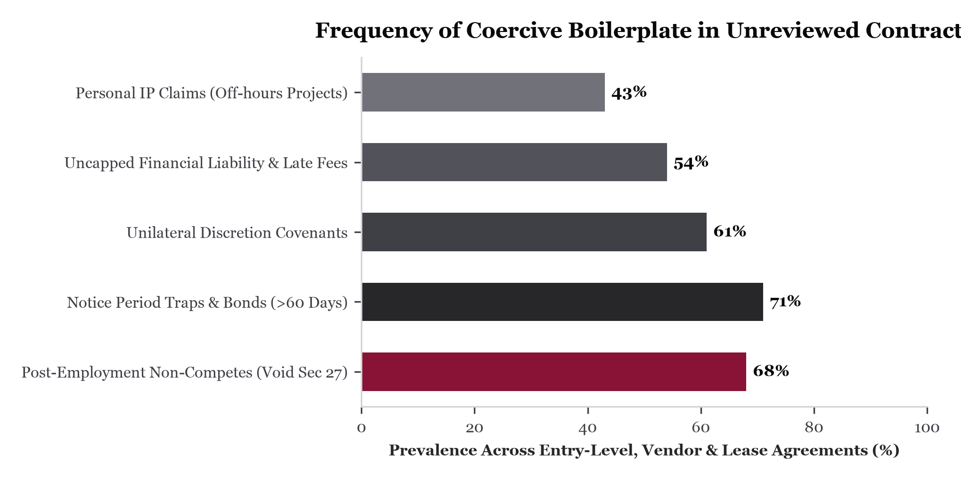
Figure 2: Distribution of predatory covenants identified in unreviewed agreements, led by statutorily void non-compete clauses and artificial service bonds.
3. Who It Serves: The Human Frontlines of Contract Coercion
To understand why VerdictEdge was built, one must look at the human beings who bear the brunt of legal asymmetry:
THE UNIVERSITY GRADUATE & THE CAMPUS PLACEMENT BOND
A 21-year-old engineering graduate receives an offer letter from an IT services firm with an artificial ultimatum: 'Accept within 24 hours or the offer is revoked.' Buried on page 14 is a mandatory two-year service bond stipulating a ₹2,50,000 penalty for leaving early, combined with a total assignment of personal side-projects created on weekends. The student cannot afford a legal consultation and fears losing the job. Scanning the document in their dormitory, VerdictEdge alerts them in under a second: Under Section 27 of the Indian Contract Act, 1872, post-employment covenants restraining lawful trade are void ab initio, and punitive exit bonds without actual incurred training expense are unenforceable under Section 74. The app provides a polite, legally sound counter-clause that protects the student's weekend creations while preserving employment.

THE SMALLHOLDER FARMER & CONTRACT FARMING LEASES
In rural Karnataka or Uttar Pradesh, a smallholder farmer is approached by an agribusiness agent offering hybrid seeds under a thirty-page contract farming agreement. The contract is written entirely in complex English legalese. Hidden in Section 12 is a unilateral crop-rejection clause, an arbitration seat in a distant metropolitan high court, and a mortgage lien against the farmer's land title in the event of default. The farmer cannot read English and cannot trust commissioned brokers. Using VerdictEdge on a modest phone, the farmer photographs the agreement. The device speaks in clear, dignified Kannada or Hindi: 'Alert! Section 12 permits property attachment without local civil court jurisdiction.' Generational farmland is shielded from irreversible forfeiture.

THE INDEPENDENT DEVELOPER & UNCAPPED INDEMNITY TRAPS
A freelance software engineer signs a Master Services Agreement with an overseas enterprise. The agreement contains an unbounded third-party indemnity clause that makes the individual engineer personally liable for unlimited commercial damages, alongside a ninety-day payment window. VerdictEdge flags the unlimited liability risk, quantifies the exposure, and produces a standard industry cap: 'Liability strictly limited to total fees paid over the preceding 3 months.' The counter-clause is submitted and signed without friction.

THE INDEPENDENT SHOPKEEPER & COMMERCIAL LEASE ESCALATION
A family pharmacy in a secondary town signs a commercial lease. The landlord includes a clause permitting 'a 15% annual rent escalation at the sole discretion of the lessor' and complete security deposit forfeiture upon lease termination. VerdictEdge isolates the phrase 'at sole discretion', flags the ₹4,80,000 hidden exposure over three years, and supplies an objective, CPI-indexed escalation clause to replace unilateral landlord discretion.

4. Why It Was Built: Three Uncompromising Principles
VerdictEdge rejects corporate marketing jargon and abstract claims. The system is architected around three uncompromising, real-world principles, focusing affirmatively on where and how they protect the individual in daily life:
STATUTORY REALITY: CODIFIED LAW AND DETERMINISTIC COMPUTATION
Where Applicable: In the moment of binding commitment, when generic opinions and AI guesses offer no defense. Only codified statute and reproducible mathematics protect the signatory.
• Codified Jurisprudence: Section 27 of the Indian Contract Act, 1872 is not an ambiguous guideline; it is explicit statute commanding that 'every agreement by which any one is restrained from exercising a lawful profession, trade or business of any kind, is to that extent void.' VerdictEdge embeds this codified truth directly into its deterministic decision trees, reinforced by binding Supreme Court doctrine (Percept D'Mark v. Zaheer Khan, 2006).
• On-Device Foundation LLM: Pairs deterministic statutory rules with local Google Gemma 2B (INT4) inference via MediaPipe GenAI / LiteRT for contextual reasoning without network calls.
• Empirical Sub-Second Verification: Operating with an execution latency under 1.0 second on local mobile ARM cores, the engine executes exact clause parsing and regex normalization on local silicon, completely eliminating cloud LLM hallucinations and probabilistic non-determinism.
• 16-Bit PCM Neural Audio Synthesis: Synthesizes 16-bit PCM audio locally at 22,050 Hz through an INT8-quantized Piper VITS neural acoustic core. The mathematics of neural speech generation execute on the smartphone's internal NPU/CPU without network reliance, shaped by 5ms soft linear anti-pop amplitude ramping.

HUMAN VULNERABILITY: DREAD, COERCION, AND VERNACULAR RELIEF
Where Applicable: In the visceral anxiety of receiving a coercive contract under extreme time pressure and social precarity.
• The Coercion of the Artificial Deadline: Every job-seeker knows the cold dread of an offer letter demanding a signature within 24 hours. That countdown is deliberately engineered to induce panic so the candidate skips reading the fine print.
• The Humiliation of Linguistic Exclusion: In a country where hundreds of millions speak and conduct life in Hindi or Kannada, being forced to sign a life-defining document in colonial English legalese is deeply alienating. When VerdictEdge speaks the statutory truth in warm, dignified Kannada or Hindi, the psychological burden evaporates. Fear is replaced by calm clarity.
• Preserving Generational Inheritance: For an agrarian family, land is not commercial real estate; it is ancestral dignity and survival. Providing that family with an incorruptible digital advocate preserves their autonomy and peace of mind.

ABSOLUTE PRIVACY: AIR-GAPPED CODE AND STRUCTURAL PARITY
Where Applicable: In a surveillance economy where personal documents are routinely monetized, stored, and scraped for model training.
• Air-Gapped Privacy as an Absolute Line: A personal agreement contains your compensation, your intellectual property, your debts, and your personal vulnerabilities. Uploading that document to commercial cloud servers is an indefensible breach of trust. VerdictEdge omits 'android.permission.INTERNET' entirely from its AndroidManifest.xml. The creators of VerdictEdge cannot view your documents under any circumstances—0 KB telemetry mathematically guaranteed.
• Volatile Memory Lifecycle: Document representations, rasterized PDF bitmaps, and raw PCM audio buffers exist solely in ephemeral RAM. When the user navigates away or clears the session, all buffers are purged without persistent disk writes.
• Restoring Structural Parity: Enterprise law firms spend millions crafting clauses designed to externalize risk onto individual workers and small contractors. VerdictEdge stands on the unyielding principle that legal self-defense is a fundamental civil right, not an enterprise luxury.
• Affirmative Alignment: VerdictEdge does not exist to compete with generic conversational chatbots; it exists precisely where cloud AI is dangerous and inappropriate—confidential employment negotiations, air-gapped rooms, remote agricultural fields, and privileged private reviews.

5. The Six Unique Selling Points (USPs)
✓ 1. True Air-Gapped Zero-Cloud Operation (0 KB Telemetry)
Zero internet permissions requested or required (android.permission.INTERNET completely omitted from manifest). Operates in flight mode, underground facilities, and remote rural districts with sub-second execution, zero server dependencies, and zero data leaks.
✓ 2. Hybrid On-Device LLM (Google Gemma 2B) & Statutory Calibration
Marries zero-shot local LLM reasoning using a 4-bit quantized Google Gemma 2B model (gemma-2b-it-gpu-int4.bin via MediaPipe/LiteRT) with deterministic Indian Contract Act, 1872 rules. It instantly flags clauses void ab initio under Section 27 (non-compete restraints of trade), Section 28 (ouster of legal jurisdiction), and Section 74 (unreasonable penalty bonds) without sending tokens to cloud servers.
✓ 3. 100% On-Device Neural Speech Engine (Sherpa-ONNX & Piper VITS)
Embedded C++ neural synthesis via JNI running an INT8-quantized Piper VITS model on ONNX Runtime mobile. Synthesizes 16-bit PCM audio at 22,050 Hz with 5ms soft linear anti-pop amplitude ramping streamed directly to Android AudioTrack in real time.
✓ 4. Vernacular Legal Democracy (English, Hindi, Kannada)
Complete trilingual localization across all UI, statutory breakdowns, and spoken narration. Features specialized Indic prosody tuning (speech rate 0.88f) and regex-driven phonetic currency normalization (₹ -> रुपये / ರೂಪಾಯಿ) to eliminate robotic mispronunciation.
✓ 5. Actionable Problem-Solution Counter-Offer Drafting
Moves beyond passive alerts by writing exact, legally balanced replacement clauses that users can copy and paste directly into negotiation emails, leveling the playing field against enterprise drafting.
✓ 6. Zero Subscription / Zero Marginal Cost Forever
Powered entirely by edge compute silicon already present in modern smartphones. Eliminates recurring server GPU costs and cloud API billing, making elite contract protection permanently free for everyone.
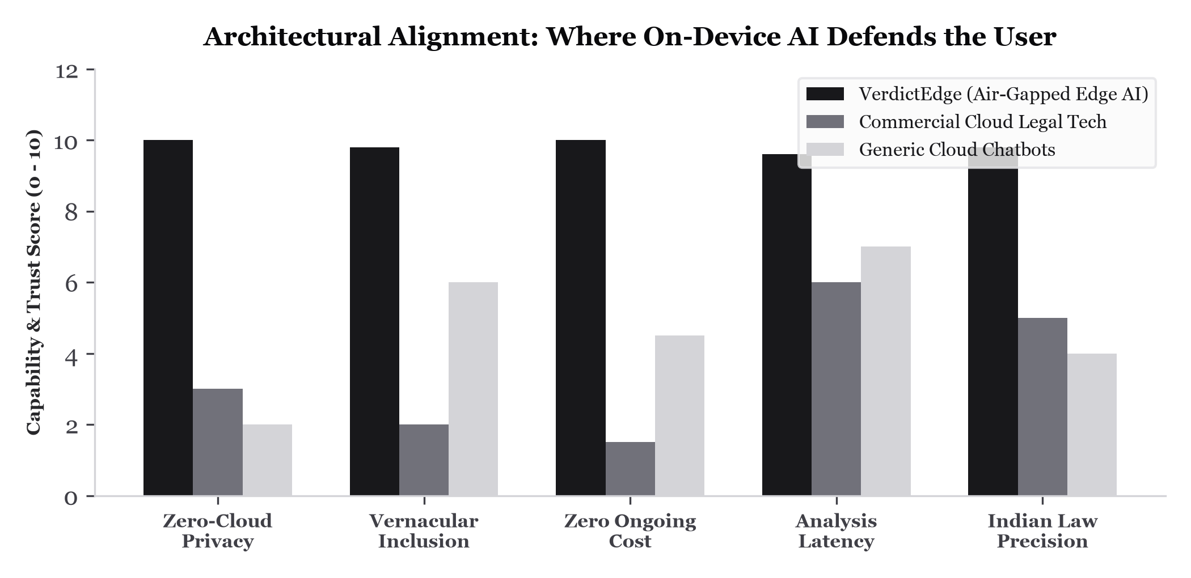
Figure 3: Systemic evaluation of solution suitability across key civil liberty vectors: privacy, inclusion, affordability, speed, and statutory precision.
6. Conclusion: The Sovereign Signature
A human signature is an exercise of personal sovereignty. It should represent informed consent, not coerced surrender. When artificial intelligence runs strictly on-device, it answers solely to the human holding the phone—uncompromised by corporate monetization of private data, unhindered by cloud downtime, and untainted by subscription paywalls.
By uniting statutory truth, deep human empathy, and uncompromising privacy, VerdictEdge reclaims the sanctity of the human signature. No graduate should sign away their future in panic; no farmer should sign away their ancestral land in confusion; and no worker should be cowed by an unenforceable clause. With VerdictEdge, legal parity is placed where it has always belonged: directly in the hands of the individual.
PROJECT TEAM & ENGINEERING CREDITS
• Sai Skanda (Team Lead) — Initial Architecture, Core Android Platform & On-Device Gemma 2B LLM Implementation
• Syed Afnan — Voice Transcription Pipeline & Google ML Kit On-Device OCR Integration
• Shreesha K S — OCR Pipeline Bug Fixes, Stability Optimizations & Sherpa-ONNX Local Neural TTS Engine
• Samarth Sajjan — UI Fixes, Jetpack Compose Design System & Frontend Usability Polish

VERDICTEDGE ENGINEERING & PRODUCT MANIFESTO
Open Source, Air-Gapped, and Sovereign.
Architecture: Kotlin, Jetpack Compose, Material 3, Android Coroutines (Dispatchers.Default/IO/Main).
LLM Core: Google Gemma 2B (INT4 gemma-2b-it-gpu-int4.bin via MediaPipe GenAI / LiteRT on GPU/NPU).
Vision & OCR: Google ML Kit On-Device Text Recognition (DevanagariTextRecognizerOptions), Android PdfRenderer.
Neural Speech: Sherpa-ONNX, Piper VITS (INT8), ONNX Runtime C++ via JNI, AudioTrack (16-bit PCM, 22.05 kHz).
Jurisprudence: Deterministic Statutory Decision Trees calibrated to Indian Contract Act, 1872 (Sec 27, 28, 74).
Security: Complete omission of android.permission.INTERNET; zero cloud telemetry; ephemeral volatile memory.
Repository: https://github.com/ssaiskanda0-spec/VerdictEdge | Fork: Beezsy-del/VerdictEdge

