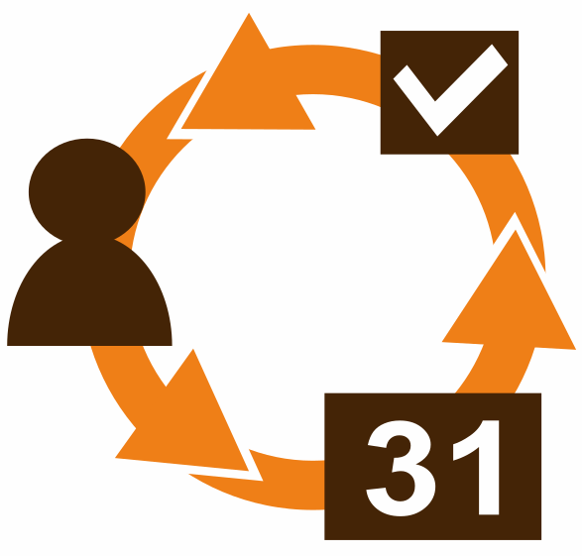 | CDav module for Dolibarr

Introduction
This module for Dolibarr 7.0/8.0/9.0 add CardDAV / CalDAV and ICS synchronization. It uses included [Sabre/DAV](http://sabre.io/dav/) library.

Features
- Read and Edit calendars through CalDAV
- Read and Edit address Books through CardDAV
- Read calendars through ICS Full version or only Free/Busy (hide details)
- Access Dolibarr documents through WebDAV (if admin)
- New option in version 2.x : automatic tasks generation in projects with services from linked Propositions and/or Orders, and sync tasks as tasks and/or events (multiple participants feature)

Each user can access his/her contacts address book (public and own private contacts), his/her own calendar and other users calendars according to his/her rights.
Dolibarr contact informations fill personal informations in client software cards (including contact photo).
Third party informations (to which contact is attached) fill professional informations in client software cards.
Cards updated in client software fill only Dolibarr contacts (not Society).
It is possible to select which contacts to sync with CDAV_CONTACT_TAG configuration value in Home / Setup / Other setup. Enter a contact tag value and then only contacts with this tag will be synced (empty value for all).
Calendar records with "Status / Percentage" set to "Not applicable" are converted to events in CalDAV (VEVENT), others are converted to tasks (VTODO).
Note : recurring events are not handled (Dolibarr does not handle them nor).
Tasks durations are retrieved from service's card if defined (minutes, hours, days or weeks only), otherwise, from documents extra field filled in.

Module setup
To configure this module, go to “Home”, then from the option menu :
“Configuration” → “Modules” → “Cdav” (in Interfaces Modules list) : click the gear wheel symbol at the end of the line to enter setup.
Configuration detail
* generate tasks from linked document(s) OR not
* synchronize project tasks as calendar events AND/OR todo tasks
* set up of 3 initial tasks that will appear before services coming from document(s)
* set up of 3 final tasks that will appear after services coming from document(s)
* define user role in project to select user to which attribute on generated tasks from document(s)
* define user role on new project task creation
* define start and end time of a working day (to indicate the beginning of the day, and for tasks whose duration is specified in days)
* restrict services to be converted as task by specifying a tag
* force generation of tasks for each service lines from attached documents with cdav duration if tag filter is missing or not specified

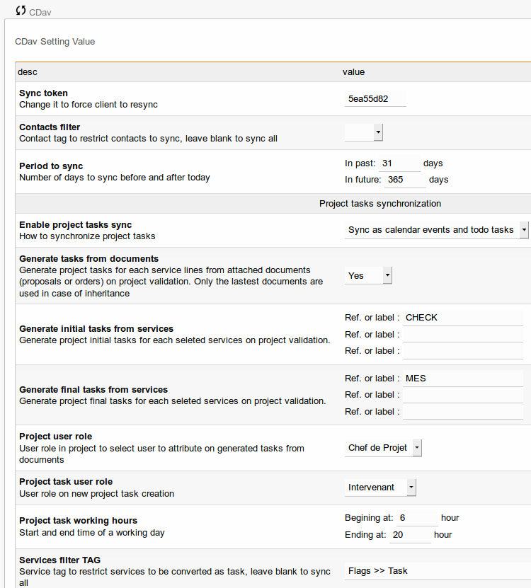

Usage
1/ Manually create a project, link it to a third party society, and set up the date ; leave it in draft status
2/ Contact tab : Affect contact(s) with correct role
3/ Overview tab : Attach (or create) document(s) : proposals or orders including concerned services ; if none, only initial and final tasks will be generated. Concerned services are those whose flag (according to setup) is checked, or those duration (extra field) has been filled in into linked documents (proposals or orders)
4/ Project tab :Validate project to generate tasks
5/ You can use your CalDAV client software to retrieve and drag-drop events if necessary

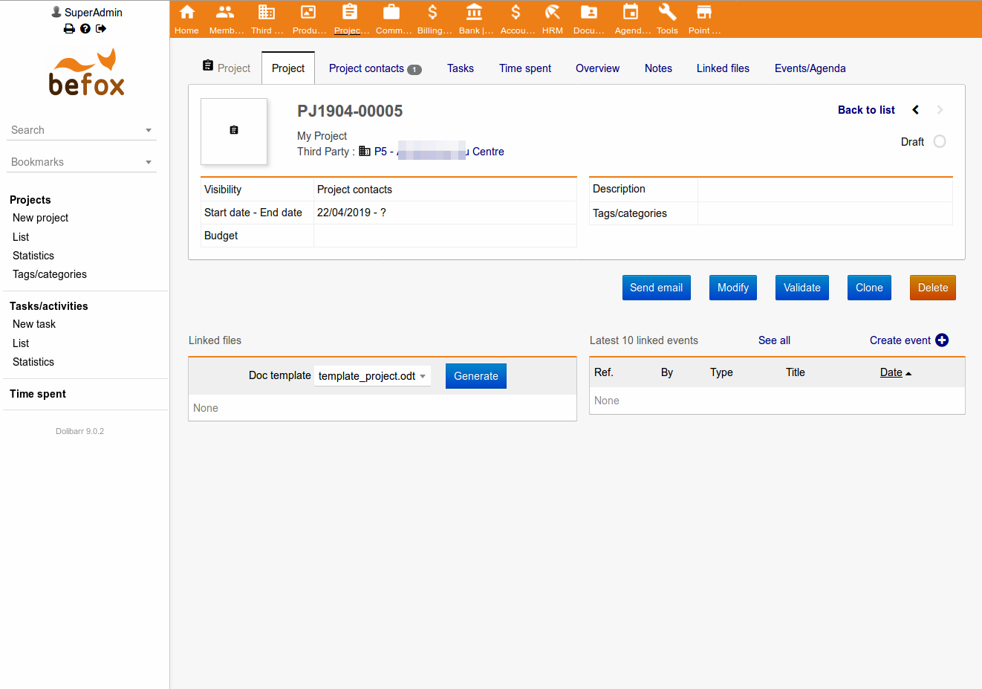
1/ Manually create a project, link it to a third party society, and set up the date ; leave it in draft status

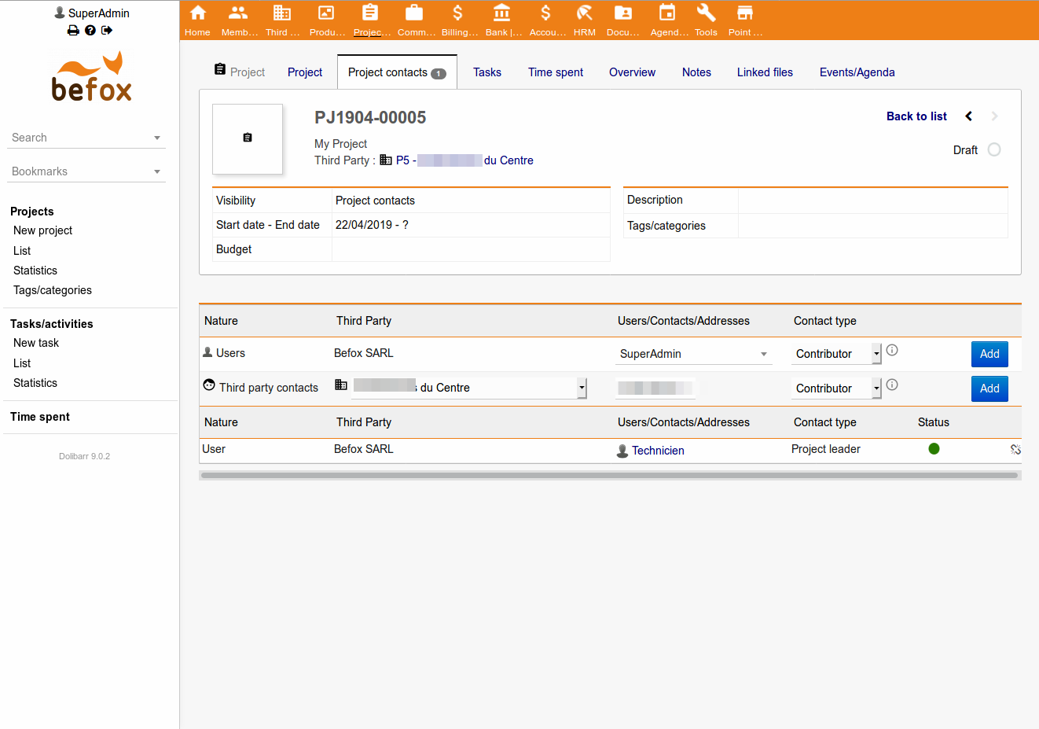
2/ Project contacts tab : Affect contact(s) with correct role
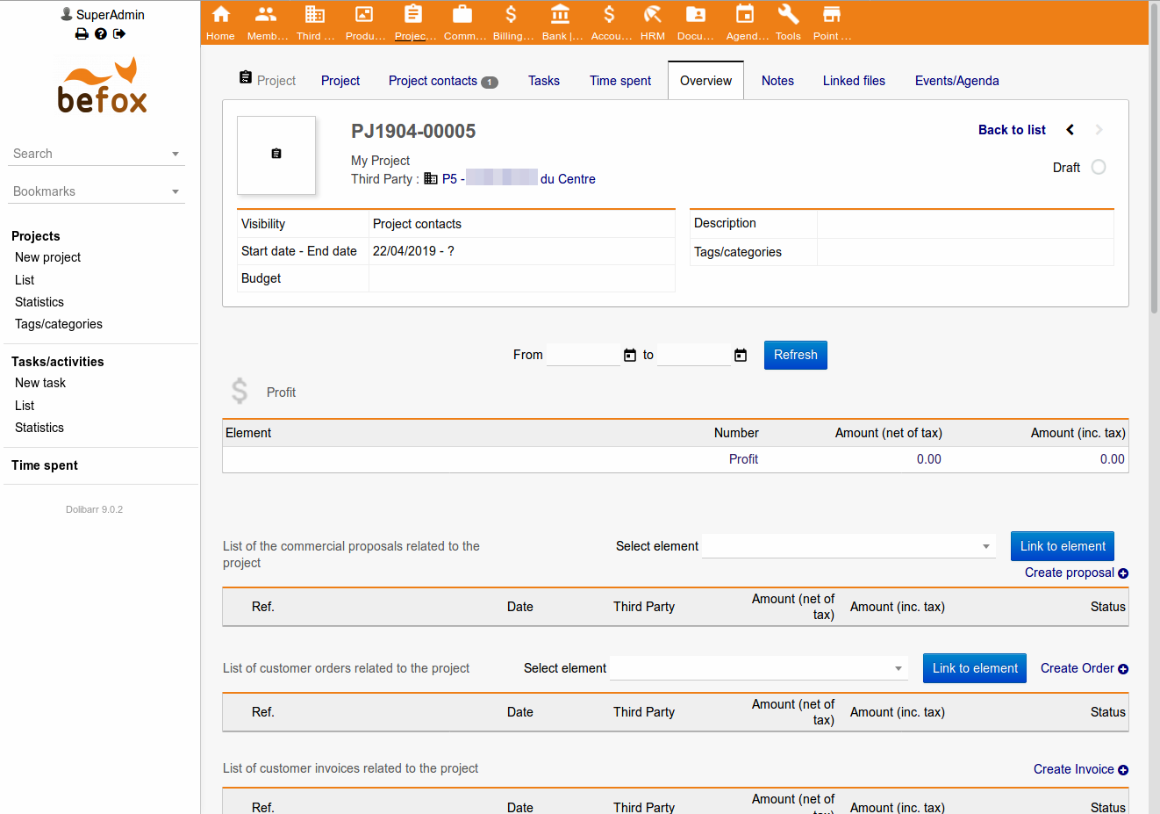
3/ Overview tab : Attach document(s) : proposals or orders including at least 1 concerned service
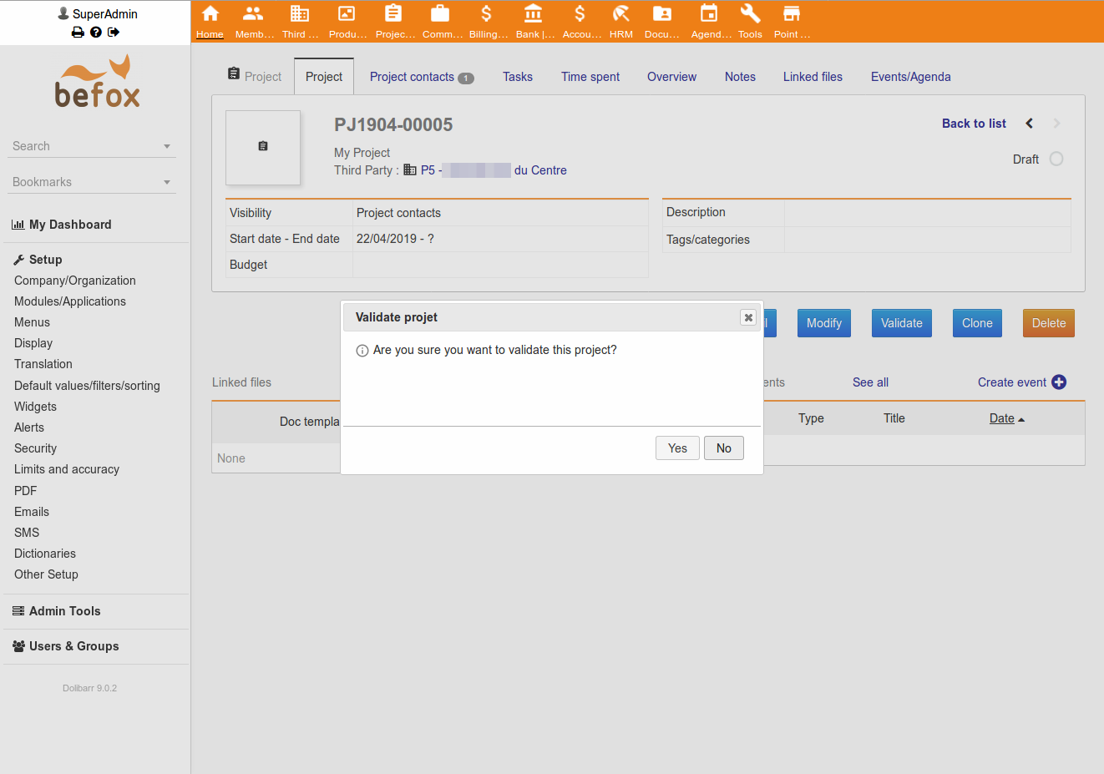
4/ Project tab :Validate project generate tasks → all tasks will begin at the starting date of the project, at the beginning hour of the working day
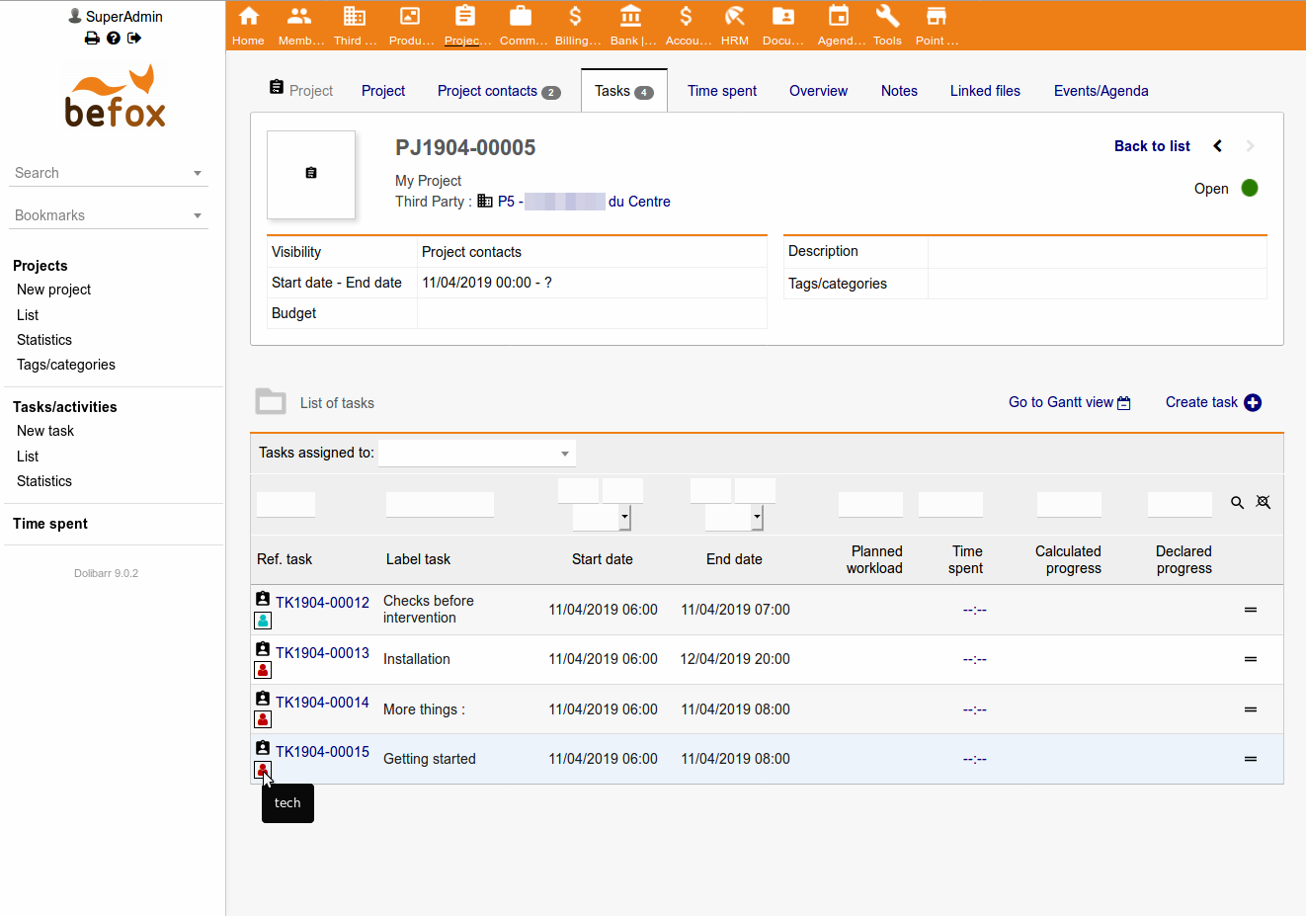

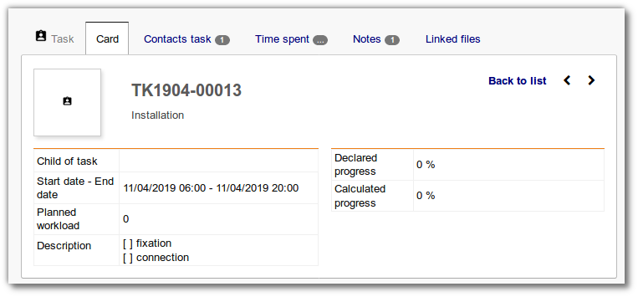

5/ You can use your CDAV client software to retrieve and drag-drop events if necessary (all affected users will receive modification)

Notes
* Multi-day durations tasks are maintained as a single task, eg from 31/07/2018 at 8am to 02/08/2018 at 7pm
* Duration of service are not used for populate "Planned workload" field of tasks, but only for specify its ending hour
* Description of services are useful to create subtasks if sequences of dash character followed by a space (- ) are detected at the beginning of a line ; if you use android apps like DAVx⁵ (CalDAV/CardDAV Synchronization and Client) and Tasks (Keep track of your list of goals) you will be able to use check-boxes for these tasks
* If you chose to synchronize project tasks as calendar events AND todo tasks, modifying a task will automatically modify the corresponding event and reciprocally. All affected users will receive modifications.
* Tasks can be modified from client application but not canceled : Dolibarr keep trace of last affectation
* After generating tasks, you can modify/complete each of them or create more tasks manually (here too you can fill description zone with '- ' at the beginning of lines to create subtasks)

Help improvements
If you find the module is useful and want to finance improvements, please consider to pay it on [Dolistore] (https://www.dolistore.com/modules/526-Synchronisation-CardDAV---CalDAV---ICS.html)

How to install
PHP between 5.5.x and 7.0.x is required.
Dolibarr native calendar module must be activated *before* installing CDav module.
* Clone repository _git clone https://github.com/Befox/cdav.git_ and install cdav directory in dolibarr/htdocs/
* Or unzip [last release](https://github.com/Befox/cdav/archive/master.zip), rename _cdav-master_ to _cdav_ and copy it into dolibarr/htdocs/
Enable CDav module in Interfaces Modules list.
It would add a link in Agenda left menu and in Contacts left menu to access DAV / ICS URLs.
Use these URLs in your CardDAV or CalDAV client software.

How to upgrade
* Disable CDav module in Interfaces Modules list.
* Unzip last version or _git pull_ in dolibarr/htdocs/cdav
* Enable CDav module in Modules list.

DAV URLs

For Thunderbird
[Thunderbird](https://www.mozilla.org/thunderbird/) (with [Lightning by Mozilla](https://addons.mozilla.org/thunderbird/addon/lightning/) and [TbSync by John Bieling https://addons.thunderbird.net/fr/thunderbird/addon/tbsync/]
https://server.example.com/dolibarr/htdocs/cdav/server.php/calendars/<connected-user-login>/<calendar-user-id>-cal-<calendar-user-login>
https://server.example.com/dolibarr/htdocs/cdav/server.php/addressbooks/<connected-user-login>/default/

For DAVDroid
[DAVDroid](https://davdroid.bitfire.at/) can detect automatically address book and all existing calendars (if an event exists) with generic DAV URL :
https://server.example.com/dolibarr/htdocs/cdav/
You can use a tasks application to manage Dolibarr tasks (VTODO) on Android. DAVDroid is compatible with [OpenTasks](https://github.com/dmfs/opentasks).
Be careful, if you use https, DAVDroid needs a valid SSL certificate, excluding auto-signed certificates.

For iOS
iOS uses _principals_ url to grab list of CalDAV or CardDAV resources :
https://server.example.com/dolibarr/htdocs/cdav/server.php/principals/<connected-user-login>

WebDAV
Admin users can also access Dolibarr documents through WebDAV with WebDAV URL :
https://server.example.com/dolibarr/htdocs/cdav/server.php/documents/

Troubleshooting
To test cdav module, you can use DAVDroid url https://server.example.com/dolibarr/htdocs/cdav/ in a web browser. Error messages are clearer.

Apache web server
Apache *rewrite* module is necessary if you use fcgi or php-fpm mode. In this case, .htacess file in cdav module has to be read by Apache or reported in your Apache configuration.
SetEnvIf Authorization "(.*)" HTTP_AUTHORIZATION=$1
or
<IfModule mod_fastcgi.c>
<IfModule mod_rewrite.c>
RewriteEngine on
RewriteRule .* - [E=HTTP_AUTHORIZATION:%{HTTP:Authorization}]
</IfModule>
</IfModule>
It is recommanded to *disable* these Apache modules : *dav* / *dav_fs* / *dav_lock*

nginx web server
To solve authentication loop, add these directives to your nginx "location" rubrique :
fastcgi_param PHP_AUTH_USER $remote_user;
fastcgi_param PHP_AUTH_PW $http_authorization;
or
fastcgi_pass_header Authorization;

nginx reverse proxy
To solve authentication loop, add this directive to your nginx "location" rubrique :
proxy_pass_header Authorization;

Suggestion
Combinating Caldav module with Thunderbird on PC and few mobile apps, and you will obtain a simple but efficient solution to drive your tech teams !
Thunderbird: 3 modules to install
  - Lightning (by Mozilla Calendar Project)
  - Provider for CalDAV & CardDAV (by John Bieling)
  - TbSync (by John Bieling) and configure it :
    - Add CalDav/CardDav account, and got to Manual Configuration
    - Account name = flastname
    - CalDav server adress = https://server.example.com/dolibarr/htdocs/custom/cdav/server.php
    - CardDav server adress = https://server.example.com/dolibarr/htdocs/custom/cdav/server.php
    - User name = flastname
    - Password = øøøøøøøø
→ Using tasks and events sync, managers will be able to adapt employees agenda by drag-and-drop on their events from day to another ; user's colors (in Dolibarr) will be affected for their respective events ; tasks will be sync with new date or modif

Android: install these 2 apps from store (e-g f-droid)
  - DAVx5
    - add an “account using URL and username”
    - URL : https://server.example.com/dolibarr/htdocs/custom/cdav/server.php
    - Username = flastname
    - Password = øøøøøøøø
  - OpenTasks (Keep...)
    - Configure "Showed Lists" to select interesting users
→ Technicians will be coached with detailed tasks from day to day
