This is my Trouble shooting journal.
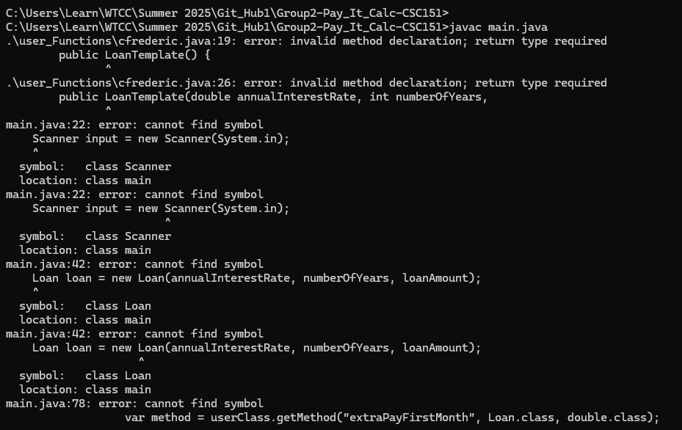
*The Issue was that in public LoanTemplate() – is a template object. The rule with java is that template must match the class name. In this version the class name is cfrederic. In the main function, cfrederic cannot be substituted for the LoanTemplate object. If I want to substitute different user’s functions into the program then the LoanTemplate object cannot be renamed, or the program would off a single person’s functions alone.
The default script for the functions could be used if I turned off the user import statements, So I had a backup option.
This version of the directory structure ran and only produced.
However, I don’t know how the LoanTemplate object would be run through the main function. In this version the class names were all different. So, I revert the structure back to this than the main function should run the same.
I then attempted to change the directory structure. Before all users were in the same folder, which I thought was useful. The package feature in java is great because it allowed me to access the functions in each individual’s file -- all in the same folder -- as if they were all simply in the same file, but just contained in different classes. So, an alternative to using the package feature would just be to copy all users into the same file, and skip the package feature. However main file still uses the TemplateLoan() object and again the TemplateLoan() object must be the same as the class name in the main.
To attempt to fix this issue. I reorganized the directory structure.
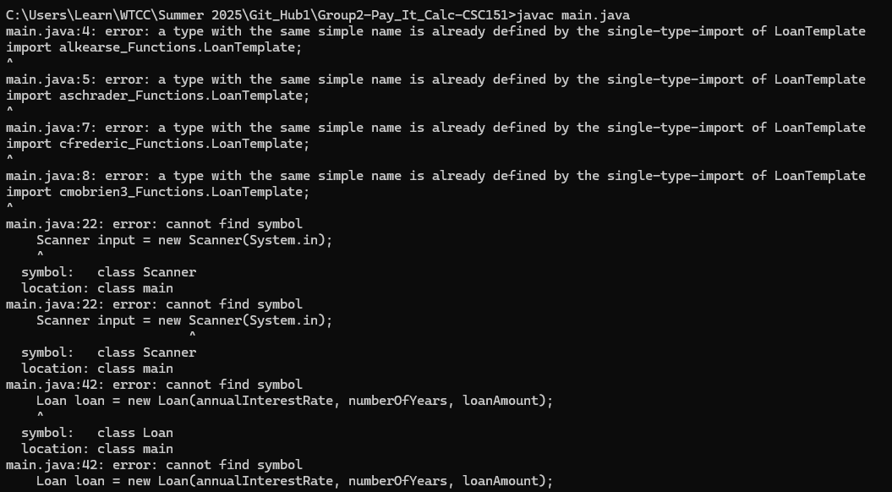
Here I attempted to fix the fact that the class name must match the TemplateLoan() object name for each individual user. I did this by creating a separate folder for each user and renaming the package -- which works when the package name matches the folder name. I then renamed all the classes to be the same (TemplateLoan). My import statements were then <filename(user’s name)/packagename>.<class name/TemplateLoan()>.
This attempt ran with just 10 errors.
I ran the code the an AI Reviewer: and received the correction
“That error means you now have two different definitions of LoanTemplate visible to main.java, and Java doesn’t know which one to use.”
“a type with the same simple name is already defined by the single-type-import of LoanTemplate
import aschrader_Functions.LoanTemplate;”

**From the AI review: It appears that only one class with the name LoanTemplate can be imported from any package.**
“This happens when both of these are true:
- You imported LoanTemplate explicitly
- AND you also have another class named LoanTemplate in the same package or folder as main.java.
Java does not allow two classes with the same simple name (LoanTemplate) to be visible at the same time.
** So, basically the package feature works exactly the same as putting all of the user classes into the same file. So, application itself can only run with one users code.
So, I tried to run the default code from another user.
Here is the import statement I turned off:
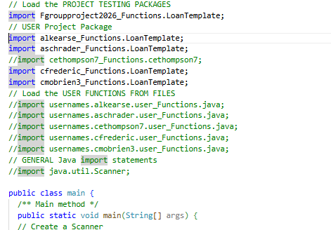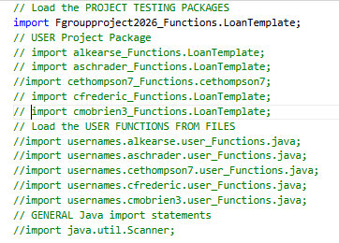
The code ran with jus six errors.
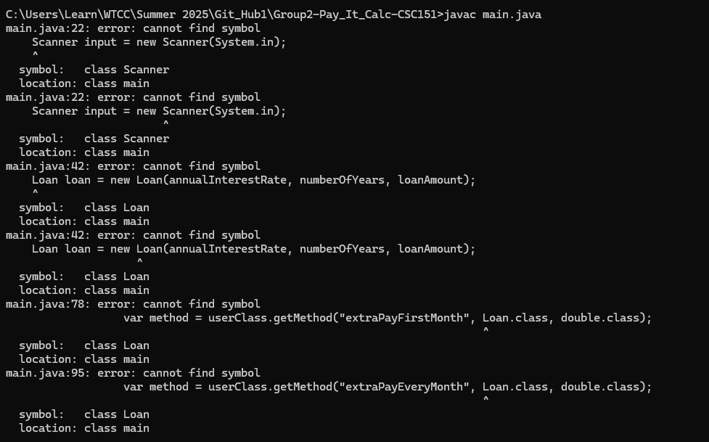
The import was off:
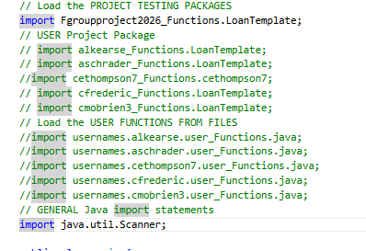

That code ran with just 4 errors.
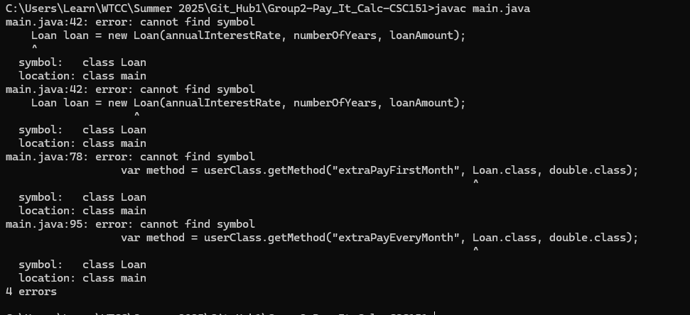
Down to 2 errors: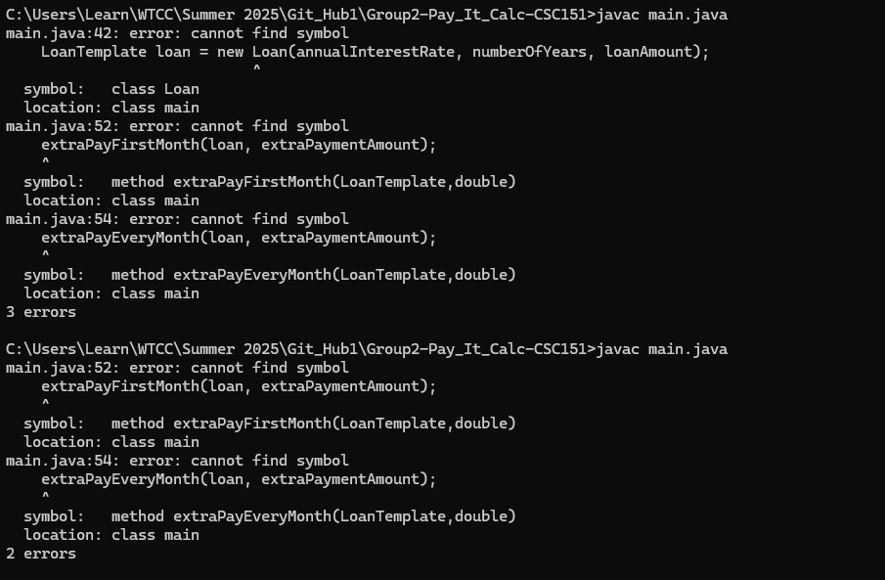

This is the final app running in terminal.
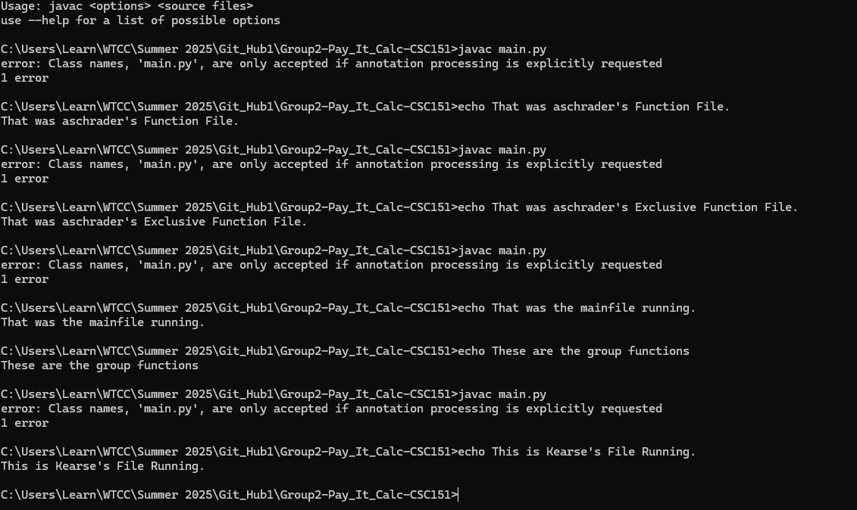

This is the final directory form

