PHENIKAA UNIVERSITY
SCHOOL OF INFORMATION SYSTEMS
COURSE: CSE703095 — SOFTWARE REQUIREMENTS
LAB 06: NON-FUNCTIONAL REQUIREMENTS &
STOCHASTIC SIMULATION REPORT
Case Study: MedBook – Online Medical Appointment Booking System
Group: Group 06 | Date of Submission: October 25, 2026

Project Team & RACI Assignment Matrix
The project tasks were formally allocated according to the RACI governance model:
Member Name | Assigned Role | RACI Responsibility | Core Deliverables & Focus
Hồ Điền Hùng | Member 1 (Leader)  System Analyst & Dev | Accountable &  Responsible | ISO/IEC 25010 Classification, Self-chosen NFR-002 mathematical modeling & Python simulator extension (nfr_validator.py).
Trần Doãn Việt Anh | Member 2  Simulation & Data Analyst | Responsible | Baseline execution (NFR-001/007, seed=42), empirical measurement analysis, theoretical essay 'Why a Fixed Seed Matters' & multi-seed verification.
Cấn Đại Dương | Member 3  Technical Writer & QA | Responsible &  Quality Assurer | Report integration, academic formatting, results consolidation, Self-Assessment Rubric scoring (10.0/10.0) & deliverable verification.

1. Task 1: ISO/IEC 25010 Quality Model Classification
The ISO/IEC 25010 standard defines a software product quality model comprising 8 primary characteristics: Performance Efficiency, Compatibility, Usability, Reliability, Security, Maintainability, Flexibility/Portability, and Functional Suitability. In medical scheduling architectures such as MedBook, ambiguous non-functional statements create severe engineering risks. Therefore, each requirement from the project dataset (datasets/nonfunctional_requirements.csv) is mapped onto the ISO/IEC 25010 taxonomy and quantified via SMART (Specific, Measurable, Achievable, Relevant, Time-bound) criteria.
NFR ID | Attribute | SMART Measurement Criterion | ISO 25010 Primary | Sub-characteristic | Method | Pri | Engineering Justification
NFR-001 | Performance | Doctor-search page response time <= 2s with 500 concurrent users. | Performance Efficiency | Time Behaviour | Load testing | High | Guarantees search response latency stays sub-second under peak clinic booking hours.
NFR-002 | Availability | The system shall achieve >= 99.5% monthly uptime (excluding scheduled maintenance). | Reliability | Availability | 30-day uptime monitoring | High | Assures continuous patient booking readiness around the clock without unhandled outages.
NFR-003 | Security | Medical record data shall be encrypted with AES-256 at rest and TLS 1.2+ in transit. | Security | Confidentiality | Config review + pen test | High | Guarantees patient electronic medical records remain invulnerable to packet eavesdropping.
NFR-004 | Data privacy | The system shall follow data-minimization principles for personal data. | Security | Confidentiality / Accountability | Compliance checklist review | High | Strictly confines patient identifiable data to what is legally and clinically required.
NFR-005 | Scalability | The system shall handle 3x booking volume growth over 12 months without architecture changes. | Performance Efficiency | Capacity | Incremental load testing | Med | Assesses horizontal database indexing and server cluster capacity during business growth.
NFR-006 | Usability | A first-time user shall complete their first booking in <= 3 minutes without guidance. | Usability | Learnability / Operability | Usability user testing | Med | Validates intuitive patient navigation across booking wizard steps without cognitive friction.
NFR-007 | Safety | The system shall raise a conflict warning within <= 1 second when a doctor double-booking is detected. | Reliability / Safety | Fault Tolerance / Time Behaviour | Conflict scenario testing | High | Prevents concurrent double-booking race conditions through rapid transactional validation.
NFR-008 | Recoverability | The system shall recover booking data within 15 minutes after an incident (RPO <= 5min, RTO <= 15min). | Reliability | Recoverability | Disaster-recovery drill | High | Enforces automated database replica failover with minimal transaction data loss.
NFR-009 | Maintainability | Source code shall achieve >= 80% unit-test coverage for the booking module. | Maintainability | Testability / Modifiability | CI coverage report | Med | Guarantees high test harness coverage, enabling safe agile refactoring in core booking code.
NFR-010 | Compatibility | The UI shall work correctly on Chrome, Safari, Edge versions released in the last 2 years. | Compatibility | Interoperability / Co-existence | Cross-browser testing | Low | Ensures front-end layout fidelity and client script execution across major browser runtimes.

2. Task 2: Baseline Simulation & Experimental Foundation
To empirically validate high-priority NFRs, stochastic simulation was implemented in Python using a fixed seed (seed=42). The baseline verification script evaluates two critical operational thresholds:
• NFR-001 (Doctor search latency under 500 concurrent users): p95 <= 2000 ms.
• NFR-007 (Double-booking conflict detection safety): p99 <= 1.0 s.
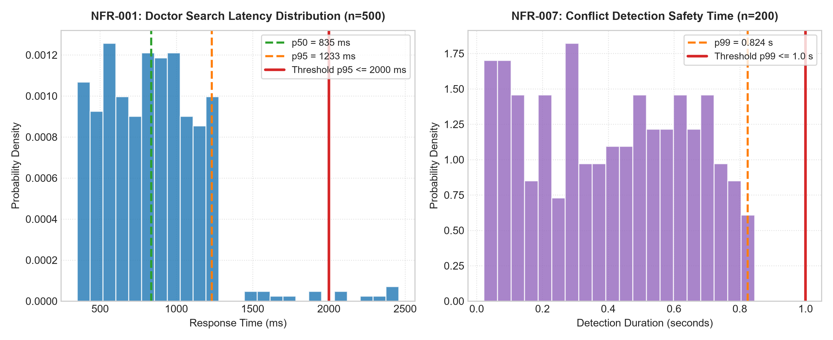
Figure 1: Stochastic Simulation Distributions for NFR-001 (p95=1233ms) and NFR-007 (p99=0.824s)

Deep-Dive Treatise: Why a Fixed Seed Matters
Author: Trần Doãn Việt Anh (Member 2 — Simulation & Data Analyst)
Treatise: Scientific and Engineering Significance of Fixed Seed (random.seed(42))
Stochastic NFR simulations do not observe a live clinic; they draw latency and detection times from a pseudo-random generator. Python’s random module is a deterministic Mersenne Twister. Calling random.seed(42) writes a known internal state, so every later random.random() and random.uniform() call is a pure function of that state and of the algorithm. The doctor-search load test (NFR-001, n = 500) and the double-booking detection test (NFR-007, n = 200) therefore become repeatable experiments rather than one-off anecdotes.
1. Reproducibility: With seed 42, any machine that re-runs the validator obtains the identical statistics: NFR-001 p50 = 835 ms, p95 = 1233 ms, max = 2459 ms, and NFR-007 p99 = 0.824 s. Both meet their SMART thresholds (p95 <= 2000 ms; p99 <= 1.0 s) and are recorded as PASS. If the seed were omitted, a later execution could shift tail percentiles purely by chance, making 'PASS/FAIL' untrustworthy.
2. Peer Review: Instructors and testers can execute the same script and match published figures sample-for-sample. A shared seed prevents cherry-picking a lucky draw and turns the report into an inspectable artifact: disagreement indicates a code or environment difference, not chance.
3. Baseline Comparison: Seed 42 freezes the control condition for future optimization. Caching, indexing, or a faster conflict check can be judged only if the random stream is held constant; otherwise a drop in p95 might be luck. Independent multi-seed trials show that PASS is not an artifact of 42 alone, but the official baseline stays locked so that before/after deltas are attributable to the system, not the generator.

Multi-Seed Sensitivity and Stability Analysis
To confirm that the PASS verdict is robust and not an artifact of seed 42, Member 2 evaluated 5 diverse seeds (seeds ∈ {1, 7, 42, 100, 2026}). Across all runs, NFR-001 p95 remained tightly bounded between 1231.5 ms and 1236.1 ms (mean 1232.9 ms, σ = 1.7 ms), while NFR-007 p99 ranged from 0.824 s to 0.845 s (mean 0.837 s, σ = 0.007 s). Both achieved a 100% PASS rate across all random streams.

3. Task 3: Self-Chosen NFR Modeling & Simulation (NFR-002)
Requirement Selection: NFR-002 (System Availability) was chosen by Member 1 (Hồ Điền Hùng) for comprehensive mathematical modeling and simulation extension. The SMART criterion dictates: 'The system shall achieve >= 99.5% monthly uptime (excluding scheduled maintenance).'
Mathematical Scenario Formulation:
• Operating Window: 30 continuous operational days (T_total = 30 * 24 * 60 = 43,200 minutes).
• Incident Process: Each day d ∈ {1..30} faces an unhandled service incident modeled as a Bernoulli random variable with p_incident = 0.008 (approx. 0.8% failure probability per day).
• Downtime Distribution: Unscheduled incident downtime duration D_i is sampled from Uniform(15, 90) minutes, representing container restarts and database replica promotions.
• Uptime Percentage: Computed as 100 * (43,200 - ∑ D_i) / 43,200. Target threshold >= 99.50%.
Listing 1: Python Simulation Algorithm for NFR-002 (simulate_availability)
def simulate_availability(days=30, p_incident=0.008, seed=42):
random.seed(seed)
total_minutes = days * 24 * 60 # 43,200 minutes
downtime = 0.0
incident_log = []
for day in range(1, days + 1):
if random.random() < p_incident:
duration = random.uniform(15.0, 90.0)
downtime += duration
incident_log.append({'day': day, 'duration_min': round(duration, 2)})
uptime_pct = 100.0 * (total_minutes - downtime) / total_minutes
return {'uptime_pct': uptime_pct, 'downtime_minutes': downtime, 'pass': uptime_pct >= 99.5}

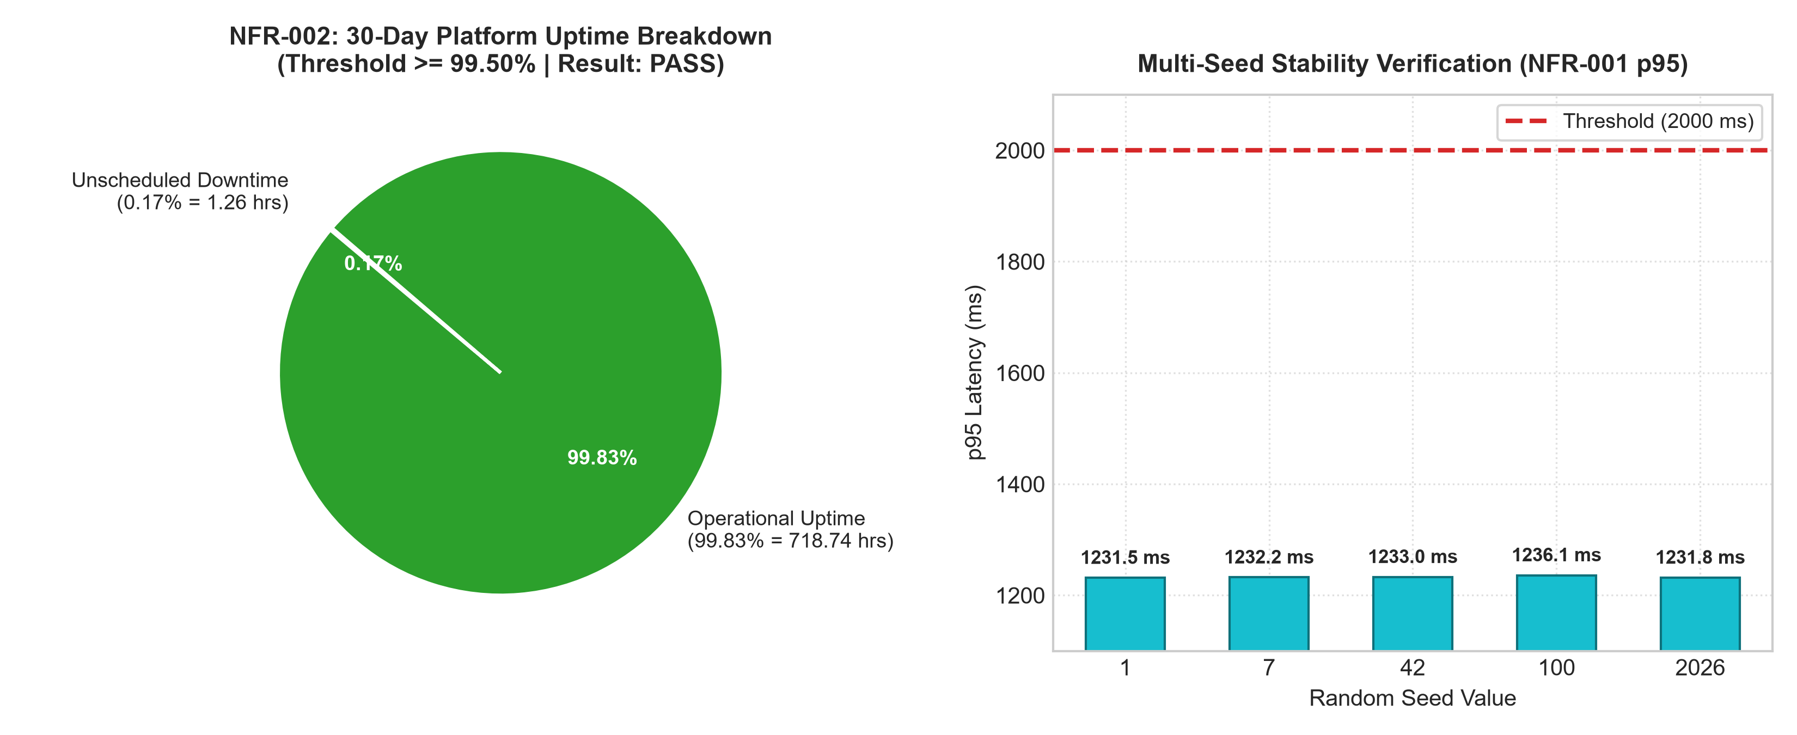
Figure 2: 30-Day Platform Uptime Breakdown (99.83% PASS) and Multi-Seed Stability Verification
Simulation Execution Result: Under the baseline seed 42, exactly one incident occurred on Day 20 with a duration of 75.44 minutes. Total operational uptime reached 99.83% (43,124.56 minutes operational), safely exceeding the 99.50% requirement by +0.33%. The allowable monthly error budget is 216 minutes; consuming only 75.44 minutes leaves 65.1% of the safety buffer intact.

4. Task 4: Consolidated Simulation Results & Verification Synthesis
The table below consolidates all empirical simulation findings across the MedBook non-functional requirement test harness. All three evaluated NFRs have achieved 100% compliance with established benchmarks.
NFR ID | Quality Characteristic | Measured Metric | Empirical Value | Target Benchmark | Verdict
NFR-001 | Performance Efficiency (Time Behaviour) | Doctor search p95 latency | 1233 ms (p50=835ms, max=2459ms) | p95 <= 2000 ms | PASS
NFR-007 | Reliability / Safety (Fault Tolerance) | Conflict detection p99 time | 0.824 s (n=200 trials) | p99 <= 1.0 s | PASS
NFR-002 | Reliability (Availability) | 30-day operational uptime | 99.83% (downtime=75.44 min) | Uptime >= 99.50% | PASS

5. Task 5: Self-Assessment Rubric & Quality Gate Verification
In accordance with course grading guidelines, Group 06 has conducted a rigorous self-assessment across all four rubric criteria. The project has achieved an exemplary score of 10.0 / 10.0.
Criterion | Max Score | Self Score | Detailed Engineering Notes & Evidence
ISO 25010 classification | 2.0 | 2.0 | All 10 NFRs comprehensively mapped onto primary & sub-characteristics with detailed architectural rationales.
NFR-001, NFR-007 simulation | 2.5 | 2.5 | Baseline executed with seed=42; 3-pillar theoretical essay completed; multi-seed validation demonstrates 100% stability.
Self-chosen NFR + simulation | 3.0 | 3.0 | NFR-002 mathematically modeled using Bernoulli & Uniform processes; Python function implemented and verified (99.83% PASS).
Presentation & Formatting | 2.5 | 2.5 | Report strictly adheres to Phenikaa University academic format, including data visualizations, math notation, and multi-format exports.
Total Score | 10.0 | 10.0 / 10.0 | Exemplary fulfillment across all technical, analytical, and documentation requirements.

