|  |  |
| --- | --- |
|  | **Department of Computer Science**  **University of Management and Technology** |

**Assignment Description File**

|  |  |
| --- | --- |
| Course Name: | **Software Engineering** |
| Section: | **V1** |
| Teacher: | **Fasiha Ashraf** |
| Student Name n ID | **M. Soban Mian(F2019266137), Ali Hussnain(F2019266161), Ahsan Ali(F2019266138)** |
| Assignment No.: | **3** |
| Project Title | Quizzer (The online exam platform) |

**NOTE: PLAGIARISED ASSIGNMENT EITHER FROM CLASSMATES OR INTERNET WILL BE MARKED STRAIGHT ZERO.NO ASSIGNMENT WILL BE ACCEPTED AFTER DEADLINE.ALWAYS MENTION SECTION ON ASSIGNMENT**

**FOLLOW THE TEMPLATE ATTACHED**

**Assignment Description:**

**Q1:** Feature comparison of Existing Systems

**Q2:** Draw DFDs

**Submission Guidelines:**

Make a word file.

Submit hard copy in class

**SEE THE TEMPLATE ATTACHED**

# Feature Comparison

Give feature comparison of existing systems in the form of Table

|  |  |  |  |
| --- | --- | --- | --- |
| Sr No. | Comparison Feature | Karigar | Easyfix |
| 1 | Within city | It is for Karachi and people in Karachi can only be facilitated | It is not for the city it will just provide online facility to contact workers |
| 2 | Interface | Not user friendly | User friendly interface |
| 3 | Account | Provide this opportunity | Don’t Provide this opportunity |
| 4 | Platform | Smart phones | Website |

# Data flow diagram (optional)

## Data Flow Diagram Level 0

Identifies sources and sinks only e.g

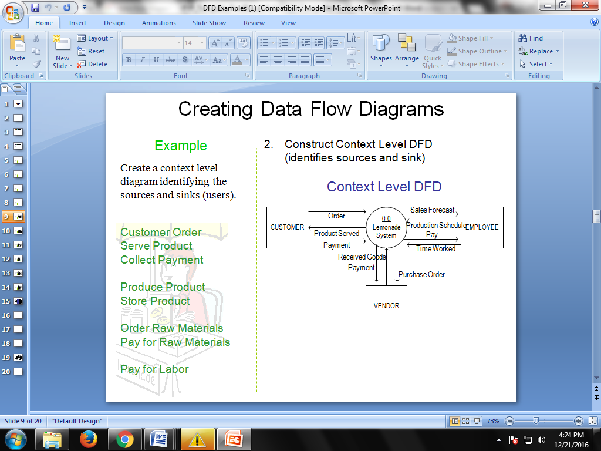

## Data Flow Diagram Level 1

Identifies actual data flows and data stores e.g

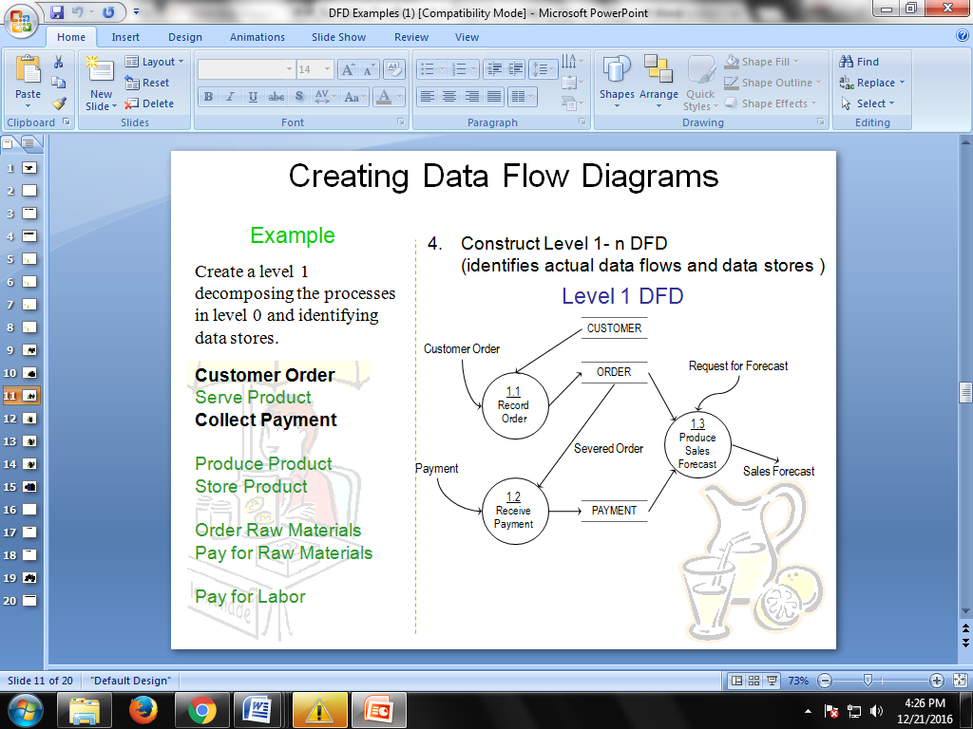

## Data Flow Diagram Level 2

If Applicable to your scenario