Project Management System

Prashant Jatoo | 2311146

A dissertation submitted in fulfillment of the requirements for the degree of
Bsc (Hons) Computer Science

University of Mauritius
Faculty of Information, Communication & Digital Technologies (FOICDT)

April 2026
Table of Contents
Acknowledgment 11
Abstract 13
Table of Abbreviations 14
Chapter 1 - Introduction 15
1.1. Problem Statement 15
1.2. Project Aims 17
Chapter 2 - Background Study 19
2.1. Literature review 19
2.2. Comparison of Existing Solutions 22
2.3. Appraisal 24
2.4. Proposed System Features 25
2.4.1. Role-Based Access Control 25
2.4.2. Administrator Dashboard 25
2.4.3. Project Management 25
2.4.4. Progress Log Generation 26
2.4.5. Deliverable Task Management 26
2.4.6. AI Feedback Compliance Analysis 26
2.4.7. Meeting Scheduling 27
2.4.8. Notification & Reminder System 27
2.5. System Architecture 28
2.5.1. 3-Tier Architecture 28
2.5.2. Inter-Layer Interaction 29
2.5.2.1. Website Rendering Model 29
2.5.2.2. Object Relational Mapper (ORM) 30
Chapter 3 - Analysis 31
3.1. System Requirements 31
3.1.1. Functional Requirements 31
3.1.2. Non-Functional Requirements 35
3.2. Evaluation of Tools/Approaches 35
3.2.1. Server Side Web Development Framework 37
3.2.1.1. Evaluation Criteria 37
3.2.1.2. Development Framework Comparison 37
3.2.1.3. Choice of Framework 39
3.2.2. Client Side Web Development Framework 40
3.2.2.1. Evaluation Criteria 40
3.2.2.2. Development Framework Comparison 41
3.2.2.3. Choice of Framework 42
3.2.3. Database 43
3.2.3.1. Evaluation Criteria 43
3.2.3.2. Database Comparison 43
3.2.3.3. Choice of Database 45
3.2.4. Artificial Intelligence Strategy for Feedback Compliance Checking 45
3.2.4.1. Comparison of Artificial Intelligence Strategies 46
3.2.4.2. Choice of Artificial Intelligence Strategy 47
3.2.4.3. Evaluation Criteria for Large Language Models 47
3.2.4.4. Comparison of Large Language Models 47
3.2.4.5. Choice of Large Language Model 48
3.2.5. Asynchronous Background Processing Strategy 49
3.2.5.1. Evaluation Criteria 49
3.2.5.2. Comparison of Processing Strategies 49
3.2.5.3. Selection of Processing Strategy 50
Chapter 4 - Design 51
4.1. Use Case Diagrams 51
4.1.1. User Management Subsystem 52
4.1.2. Meeting Scheduling Subsystem 52
4.1.3. Project Management Subsystem 53
4.1.4. Task Management Subsystem 54
4.1.5. Deliverable Submission Subsystem 55
4.1.6. Feedback Management Subsystem 56
4.2. Class Diagrams 57
4.2.1. Class Diagram (Data) 58
4.2.2. Class Diagram (Logic) 59
4.2.2.1. Service Classes 59
4.2.2.2. Background Workers 60
4.3. Sequence Diagrams 61
4.4. Entity Relationship Diagram 71
4.5. Interface Design 72
Chapter 5 - Implementation 77
5.1. Data Definition 77
5.2. Application Features 77
5.2.1. Session Management 78
5.2.1.1. Client Side Token Orchestration 78
5.2.1.2. Server Side Token Life-cycle 80
5.2.1.2.1. Token Generation 81
5.2.1.2.2. Token Transmission 82
5.2.1.2.3. Custom Authorization Policy 83
5.2.2. Meeting Display Workflow 84
5.2.2.1. Server Data Retrieval 84
5.2.2.2. Temporal Data Management 86
5.2.2.3. Scheduler Rendering 86
5.2.3. Task Edit Workflow 90
5.2.3.1. Task Modal Architecture 90
5.2.3.2. Data Mutation 94
5.2.3.3. Server-Side Transactions 95
5.2.4. AI Feedback Analysis 96
5.2.4.1. AI Compliance Job Creation 97
5.2.4.1.1. Payload Construction 99
5.2.4.1.2. Configuration Definition 99
5.2.4.2. Asynchronous Job Execution 100
5.2.5. Progress Log Report Generation 103
Chapter 6 - Testing 104
6.1. Integration Testing 104
6.1.1. FR1/FR2/FR3 104
6.1.2. FR2/FR4 108
6.1.3. FR5/FR6 111
6.1.4. FR7 113
6.1.5. FR9 114
6.1.6. FR8/FR11 115
6.1.7. FR10/FR13 116
6.1.8. FR12/FR14 118
6.1.9. FR15/FR16/FR17 119
6.1.10. FR18/FR19/FR20 120
6.2. User Acceptance Testing 121
Chapter 7 - Conclusion 127
7.1. Project Summary & Achievements 127
7.2. Critical Evaluation 127
7.2.1. System Strengths 127
7.2.2. Technical Difficulties Faced 128
7.3. Limitations 129
7.4. Future Work 130
References 131
Appendix 1: Glossary of Technical Terms 136
Appendix 2: Data Definition 140
Appendix 3: Figures for Integration Testing 145
Validation of Login Functionality 145
Validation of User List Ingestion 146
Validation of User Creation Feature 148
Validation of User Edit Feature 150
Project Supervision List Ingestion Feature 152
Project Creation Feature 155
Project Edit Feature 157
Project Archive/Restore Feature 158
Project CRUD Feature (Supervisor/Student) 158
Dashboard Navigation 160
Task Creation Feature 162
Task Edit Feature 164
Task Deletion Feature 165
Automatic Task Updates 166
Feedback CRUD Feature (Supervisor/Student) 167
Task Lock Feature 170
Staged Deliverable Logic 170
Deliverable Submission Logic 172
Feedback Criterion Override 173
AI Analysis 174
Meeting Participant RSVP Actions 176
Meeting Non-Participant RSVP Actions 179
Notifications & Reminders 179
Progress Log Report Generation 181
Appendix 4: Project Declaration Form 182
Appendix 5: Progress Log 183
Appendix 6: Project Submission Form 185
Appendix 7: Supervisor Statement 186
Appendix 8: Turnitin Receipt 187

Table of Figures
Figure 1: SSR vs CSR 28
Figure 2: Frontend Framework Demand Graph (radixweb, 2023) 40
Figure 3: Gemini-2.5 flash vs Claude 3.5 Sonnet LLM Benchmarks 48
Figure 4: Use Case Diagram - User Management 51
Figure 5: Use Case Diagram - Meeting Scheduling Subsystem 51
Figure 6: Use Case Diagram - Project Management Subsystem 52
Figure 7: Use Case Diagram - Project Task Management Subsystem 53
Figure 8: Use Case Diagram - Deliverable Management Subsystem 54
Figure 9: Use Case Diagram - Feedback Management Subsystem 55
Figure 10: Class Diagrams - Data 57
Figure 11: Class Diagram - Service Classes 58
Figure 12: Class Diagram (AI Background Worker) - Subsystem 59
Figure 13: Class Diagram (Mail Background Worker) - Subsystem 59
Figure 14: Sequence Diagram - User Authentication 60
Figure 15: Sequence Diagram - User Management 61
Figure 16: Sequence Diagram - Project Management (Admin) 62
Figure 17: Sequence Diagram - Project Management (User + Supervisor) 63
Figure 18: Sequence Diagram - Task Management 64
Figure 19: Sequence Diagram - Deliverable Management 65
Figure 20: Sequence Diagram - Meeting Scheduling 66
Figure 21: Sequence Diagram - Feedback Management 67
Figure 22: Sequence Diagram - AI Compliance 68
Figure 23: Sequence Diagram - Mail Management 69
Figure 24: Entity Relationship Diagram 70
Figure 25: PMS - Login 71
Figure 26: PMS - Projects Dashboard (Supervisor) 71
Figure 27: PMS - Meeting Scheduler 72
Figure 28: PMS - Tasks Dashboard (Supervisor) 72
Figure 29: PMS - Task Display (Supervisor) 73
Figure 30: PMS - Task Display - Provide Feedback Modal (Supervisor) 73
Figure 31: PMS - Task Display (Student) 74
Figure 32: Admin Dashboard (Users) 74
Figure 33: Admin Dashboard (Projects) 75
Figure 34: Auth API in auth.providers.tsx 77
Figure 35: performRefresh in auth.providers.tsx 78
Figure 36: Generate Token method in Token.Service.cs 80
Figure 37: Setting Refresh Token Cookie in User.Controller.cs 81
Figure 38: Ownership Policy 82
Figure 39: GetSupervisorMeetings method in Meetings.Service.cs 83
Figure 40: GetSupervisorMeetings method in Meetings.Controller.cs 84
Figure 41: SchedulerRoute + Meeting Query code snippet in scheduler.route.tsx 86
Figure 42: Scheduler in scheduler.component.tsx 87
Figure 43: adaptMeetingData in scheduler.component.tsx 88
Figure 44: PMS - Project Task Modal 89
Figure 45: Task Modal - State and Data 90
Figure 46: Task List Entry Menu – Edit Button Handler 90
Figure 47: Task Modal - Handlers 90
Figure 48: Task Modal in dashboard-tasks.route.tsx 91
Figure 49: Modal.Fields in modal.component.tsx 91
Figure 50: Modal.TextField in modal.components.tsx 92
Figure 51: Task Edit Mutation in dashboard-tasks.route.tsx 93
Figure 52: Task Modal - Handle Task Edit 93
Figure 53: EditProjectTask in ProjectTask.Service.cs 94
Figure 54: PMS - Task w/ Feedback Interface 95
Figure 55: Check Compliance Handler in task.route.tsx 96
Figure 56: AI Compliance Job Polling in task.route.tsx 96
Figure 57: CreateAndEnqueueAIComplianceJob in AICompliance.Service.cs 97
Figure 58: AI Response Schema in AICompliance.Service.cs 98
Figure 59: AIWorker in AIWorker.Lib.cs 99
Figure 60: AIJob Queue in AICompliance.Service.cs 100
Figure 61: Execute AI Compliance Job in AICompliance.Service.cs 101
Figure 62: Execute AI Job in AICompliance.Service.cs 101
Figure 63: GenerateProgressLogReport in PdfUtils.Lib.cs 102
Figure 64: Test Cases - Login Functionality 104
Figure 65: Test Cases - User Ingestion List 104
Figure 66: Test Cases – User Creation Feature 105
Figure 67: Test Cases - User Edit Feature 106
Figure 68: Test Cases - User Deletion Feature 106
Figure 69: Test Cases - Project Supervision List Ingestion Feature 107
Figure 70: Test Cases - Project Creation Feature 108
Figure 71: Test Cases - Project Edit Feature 109
Figure 72: Test Cases - Project Archive/Restore Feature 109
Figure 73: Test Cases - CRUD Projects (Supervisor + Student) 110
Figure 74: Test Cases - Navigation Logic 111
Figure 75: Task Creation Feature 112
Figure 76: Test Cases - Test Edit Feature 112
Figure 77: Test Cases - Task Deletion Feature 113
Figure 78: Test Cases - Automatic Task Updates 113
Figure 79: Test Cases - Feedback CRUD Operations 114
Figure 80: Test Cases - Task Locking Logic 115
Figure 81: Test Cases - Staged Deliverable 115
Figure 82: Test Cases - Deliverable Submission Logic 116
Figure 83: Test Cases - Override Criterion & AI Compliance Logic 117
Figure 84: Test Cases - Meeting RSVP Actions (Participants) 118
Figure 85: Meeting RSVP Actions (Non-Participants) 119
Figure 86: Test Cases - Reminder/Notifications & Progress Log Report 119
Figure 87: User Survey – Traditional Supervision Section - 1 120
Figure 88: User Survey – Traditional Supervision Section - 2 120
Figure 89: User Survey– Traditional Supervision Section - 3 121
Figure 90: User Survey – Traditional Supervision Section - 4 121
Figure 91: User Survey - System Usability - 1 122
Figure 92: User Survey - System Usability - 2 122
Figure 93: User Survey - System Usability - 3 123
Figure 94: User Survey - System Usability - 4 123
Figure 95: User Survey- System Usability - 5 124
Figure 96: User Survey - System Usability - 6 124
Figure 97: User Survey - Most Valuable Feature 125
Figure 98: User Survey - Suggested Improvement 125

Index of Tables
Table 1: Table of Abbreviations 10
Table 2: Features & Limitations of Existing Solutions 18
Table 3: Comparative Analysis of Existing Solutions 21
Table 4: Functional Requirements 30
Table 5: Non-Functional Requirements 34
Table 6: Development Framework Comparison 36
Table 7: Client-Side Development Framework Comparison 40
Table 8: Database Comparison 42
Table 9: Comparison of Artificial Intelligence Strategies 45
Table 10: Comparison of Large Language Model APIs 46
Table 11: Comparison of Asynchronous Processing Strategies 48

Acknowledgment
I would like to start by expressing my gratitude to my supervisor, Mr. Selvanaden Sathan. This dissertation would not have been possible without his guidance. He is a disciplined mentor with a strong sense of academic rigor; a fact which is evidenced by numerous meetings that have been conducted to guide us through our final year project.

As will be explored in the contents of this dissertation, effective supervision is the key to academic success. At the very outset, we have been inculcated with the discipline and mindset required to deliver a dissertation worthy of the standard of this institution. I am equally fortunate to have had the constant support and encouragement of my parents and other people who lent me help along the way. Their presence has been essential in keeping me focused during the more stressful stages of this project.

Abstract
This dissertation outlines the lack of a standardized process for final year project supervision, the various bottlenecks present in manual ad-hoc supervision methods and the overall adverse implication they have on the scalability of the process at the institutional level.

To resolve this, a web-based Project Management System is proposed. It combines various software-based solutions derived from the problem statement, with each designed to streamline a specific inefficiency in manual supervision. A comprehensive background study of the domain has equally been conducted and the existing systems have been used as reference for designing the web platform, and to identify additional features to enhance it further.

Adhering to key design principles such as maintainability and separation of concerns, the platform leverages the React and ASP.NET Core 10 frameworks and PostgreSQL database. The multi-role application integrates a centralized project management dashboard, a meeting scheduler, progress log generation, automatic reminders and an AI feedback analysis feature on deliverable submissions, into a single cohesive environment.

On the completion of its implementation, the system had undergone extensive integration testing to validate its functional requirements. Moreover, user acceptance testing was conducted to evaluate its usability, and the feedback from the survey indicated that the platform effectively addresses the bottlenecks identified. The system was then evaluated on its strengths, the difficulties encountered during development, limitations and future work based on the responses from the survey.

In conclusion, this dissertation presents a comprehensive platform that offers a streamlined alternative to ad-hoc manual supervision methods, turning academic supervision from a key bottleneck in many institutions to an efficient and scalable process.

Table of Abbreviations
Table 1: Table of Abbreviations
Abbreviations | Description
UoM | University of Mauritius
CRUD | Create, Read, Update, Delete
CSR | Client-Side Rendering
SSR | Server-Side Rendering
DOM | Document Object Model
REST | Representational State Transfer
SOAP | Simple Object Access Protocol
JSON | JavaScript Object Notation
JWT | JSON Web Token
RBAC | Role-Based Access Control
XSS | Cross-Site Scripting
CSRF | Cross-Site Request Forgery
RDBMS | Relational Database Management System
ORM | Object Relational Mapper
ACID | Atomicity, Consistency, Isolation, Durability
LLM | Large Language Model

Introduction
The final year project is the cornerstone of any undergraduate academic program, serving as the final evaluation for the award of a degree. Its importance is further highlighted by the fact that it represents the crystallization of knowledge of a graduate throughout their academic journey so far and hence serves as a testament of their skills to industry recruiters or for the pursuit of higher graduate studies.

At the University of Mauritius (UoM), final year projects are traditionally proposed either by the faculty staff or by the students themselves, and are then allocated accordingly in the form of a supervisor(s)-student pairing. The supervision process is structured as a feedback loop whereby students are expected to iterate over their Dissertation, which is a comprehensive document describing the project’s aims, literature review, methodology and its results, based on their supervisor’s feedback.

Therefore, it is important that every aspect of the supervision process, from the meetings conducted between the supervisor and the students to the feedback given remain as effective as possible, for they shape not only the student’s academic success but also the metrics that determine the credibility of the institution as well.

Problem Statement
According to a recent paper on project supervision (Stynes, P. and Pathak, P., 2022), the traditional supervisory process for final year projects is not scalable. While the research focuses mainly on the postgraduate level, the underlying issues identified - the supervisor’s limited time and attention - are directly applicable for undergraduate programs as well. This constraint leads to significant workload for academics and degrades the quality of the supervision feedback, specifically within institutions with high enrollment numbers. As a result of these inefficiencies, the quality of final year projects may suffer, affecting the institution’s overall academic output and its credibility. This can be an emerging problem within the University of Mauritius’ (UOM) Faculty of Information and Communications Technology (FOICDT), whereby the total enrollment has increased from 916 in 2020 to 1339 in 2022 (University of Mauritius, 2025), representing an increase in 46.2%. This rapid growth places a significant strain on the academic staff, who must adhere to manual and inefficient processes.

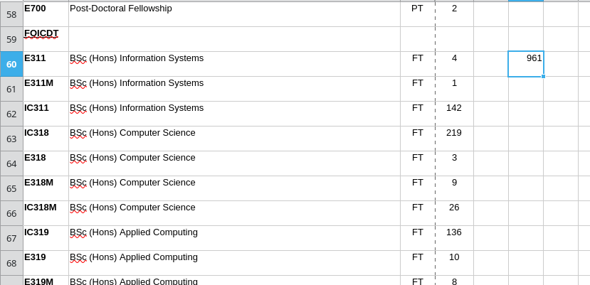Figure 1: Sum of Total Enrollment for UoM’s FOICDT 2019-2020

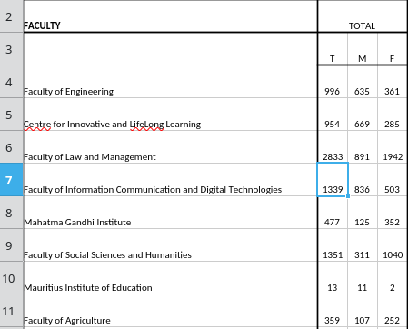Figure 2: Sum of Total Enrollment for UoM’s FOICDT 2021-2022

Supervisors who are already encumbered from managing multiple students, have seen their workload increase further. Much of it comprises of menial tasks such as managing communications via email, progress tracking, rescheduling meetings due to conflicting schedules and even progress log report generation. Most notably, however, the process of manually verifying a re-submitted student’s work against prior feedback remains a time-consuming and arduous task. This difficulty scales with the number of projects that the supervisor needs to oversee, primarily because they need to remember or cross-reference previous material in order to perform this task correctly.

Thus, a greater portion of the workload is dedicated to handling administrative overhead as opposed to their core responsibilities such as teaching, supervising and research, impacting the quantity and quality of feedback provided. Evidently, these affect the students as well since providing insufficient or vague feedback makes it more difficult to identify and resolve underlying issues, triggering a loss in motivation for both parties. Consequently, the probability that the project meets academic standards reduces significantly.

Project Aims
The aim of this project is to develop a Project Management System that automates repetitive tasks to streamline the existing supervision workflow as discussed above.
It will thus comprise of the following aims and objectives:
- Role-Based Access Control: RBAC enforces role-specific permissions on the functionalities of the system to maintain a clear role hierarchy. This ensures that the system is compliant with key security principles of confidentiality and integrity.
- Project & Task Management: An intuitive dashboard that centralizes project, task, and deliverable management and hence eliminates the need to piece together information from scattered emails and miscellaneous communications.
- Administrator Dashboard & Ingestion: An administrator dashboard for the management of users and their corresponding projects. It offers bulk insertion through excel file ingestion to automate the manual creation of entries.
- AI Feedback Analysis: An AI component that performs comparison on document re-submissions to verify if feedback criteria have been met or not, and track the relevant document changes.
- Meeting Scheduling: A calendar scheduler that shows the availability of all project members by maintaining a shared meeting schedule which offers a different perspective for each individual member. This is achieved by using visual markers to distinguish between different types of meeting appointments (organized, attended, accepted, pending and unrelated meetings). The aim of the shared calendar is to allow for optimal management strategies of meeting appointments in order to reduce scheduling conflicts.
- Reminders & Email Notifications: Reminders and email notifications are automatically generated to keep users alerted to important tasks and meeting events.
- Progress Log Report Generation: A feature that automatically aggregates meeting and task metadata into a report, eliminating the manual burden of compiling progress logs.

Background Study
This chapter provides a comprehensive review of the current domain pertaining to learning/project management systems used in the academic landscape, and how these research findings form a baseline for the system to be implemented.

It will be divided into five distinct sections:
- Literature Review – An overview of existing solutions derived from widely commercial software and academic research from various institutions.
- Comparison of Existing Solutions – A comparative analysis of the solutions identified in the literature review.
- Appraisal – An evaluation on the overall strengths and weaknesses of the current domain.
- Proposed System Features – The list of features to be included in the proposed system.
- System Architecture – A high-level description of the proposed platform’s structure and component interactions.

Literature review
The table below outlines the features and limitations gathered from the systems identified.
Table 2: Features & Limitations of Existing Solutions
Existing Solutions | Features | Limitations
A Web Based Final Year Project Supervision System  (Beekhy, 2013) | - Appointment scheduling system which uses the supervisor’s calendar as a basis for scheduling meetings (Google Aps’ API for Calendar display).  - Document management system where supervisors can set tasks for deliverable submissions/re-submissions.  - Progress tracker with Gantt chart visualization to provide a complete picture of project’s progress. | - No visual distinctions or logical organization of different types of meeting appointments (accepted, rejected and other appointments)  - The author conflates progress reports with task deliverable submissions (Beekhy, 2013, p. 85). Therefore, the system lacks an automated progress log report generation functionality.
Creatrix Campus (Creatrix Campus, 2025:-b, Creatrix Campus, 2025:-c) | - Centralized document repository for change tracking and version control.  - Customizable review and approval workflows to streamline dissertation management (Low-code configurations).  - Reporting analytics for evaluating dissertation and thesis milestones for both students and supervisors.  - Meeting management software includes meeting scheduling with conflict avoidance and attendance tracking. | - No out-of-the-box solution for automated feedback checking; training is required for developers to implement and maintain custom review and approval workflows.  - Enterprise-level pricing may present a significant financial barrier.
Moodle as a Final Year Project Management System (Khamaruddin et al., 2018) | - The system re-purposes Moodle’s forum activity module to provide reminders with email notifications for important tasks and deadlines.  - Assignment activity module in Moodle allows supervisors to set assignments where students can submit drafts and final documents.  - Progress updates are tracked via the system’s course administration module. | - Assignment activity module does not provide change tracking between submissions.  - The system lacks a meeting planning and automatic feedback checking system.
Final Year Project Management System for Information Technology Programmes (Leung et al., 2018) | - The system has a File Sharing and Repository module to centralize document and code submissions.  - Project Management module provides students with a shared workspace and a scheduler for them to create tasks and set deadlines.  - Basic progress tracking feature for each student. | - The system lacks a meeting scheduling and automatic feedback checking system.  - Group-based submission may obscure work accountability for individual students.
Google Workspace for Education (Google, 2025) | - Google Classroom acts as the core of the system where supervisors can make classes for project students and create assignments with deadlines.  - Google Classroom integrates seamlessly with Google Calendar, which can be used as a basis for meeting scheduling.  - Google Docs allows keeping track of different document versions for version control and overall change tracking using “Suggest” mode.  - Google Docs integrate with Google Assignment for feedback submission. | - Lack of customization flexibility to incorporate an AI solution for feedback compliance checking.  - Inadequate progress tracking capabilities to provide an overview of project’s progress.
Web-Based Final Year Project Supervision Management System (FYPSMS (Olayinka, 2024) | - Student home page for uploading project work documents and viewing progress.  - Supervisor dashboard to view progress for multiple students and project inspection page for viewing, downloading documents & providing feedback. | - The system lacks a dedicated meeting scheduling system and automatic feedback checking.  - There is no feature to track changes between document submissions.

Comparison of Existing Solutions
The table below outlines a comparative analysis of the systems with respect to the requirements derived from the problem statement.
Table 3: Comparative Analysis of Existing Solutions
Solutions | Meeting Scheduling & Reminder Notification System | Deliverable Submission/ Re-Submission | Automatic Feedback Compliance Checking | Progress Tracking (progress log or visual) | Specific Features
A Web Based FYP Supervision System | ✓ | ✓ | ✗ | ✗ | - Meeting scheduling based on the supervisor calendar.  - Gantt Chart visualization for progress tracking
Creatrix Campus | ✓ | ✓ | ? | ✓ | - Low code platform to create review and approval workflows for deliverables.  - Meeting Attendance tracking
Moodle as a FYP Management System | ✓ | ✗ | ✗ | ✓ | - Re-purposing existing open-source Moodle modules to provide specific features
FYP Management System for IT Programmes | ✗ | ✗ | ✗ | ✗ | - Architecture for streamlining group-based project supervision
Google Workspace for Education | ✓ | ✓ | ✗ | ✗ | - Document versioning for visible change tracking  - Prevent document editing/re-submission during feedback
Web-Based FYPSMS | ✗ | ✗ | ✗ | ✓ | - Dedicated dashboards for system administrators and external examiners

Appraisal
The ecosystem of digital solutions aimed at addressing the inefficiencies in academic management is already mature enough to justify their widespread adoption among universities around the globe. The extent to which these tools are integrated within the IT infrastructure varies significantly from one institution to another. For instance, some institutions use standard tools like Learning Management Systems for basic project management and communication. Others, however, adopt full-fledged centralized platforms to manage the entire supervision process from smart meeting scheduling to document management with progress tracking.

The University of Mauritius currently uses Google Workspace for Education as a general education platform for a variety of courses to provide learning material, centralize assignment submissions or simply to broadcast reminders to particular cohorts. However, as Beekhy (2013) pointed out, there is no unanimously agreed upon methodology, and subsequently no centralized system supervisors use for the supervision process.

An evaluation of the project management systems listed so far shows that they tend to address areas concerning project allocation, meeting scheduling and managing deliverable submission. Most of them are adapted for the one-on-one supervision process although Leung et al. (2018) described a system that provides features dedicated for group-based supervision. Nonetheless, one functional gap that all of these systems have in common is that they lack some form of automated feedback verification for deliverable file re-submissions. In fact, most of them typically employ a rudimentary feedback mechanism whereby feedback is provided in the form of a comment rather than structured criteria that can have different states (met, unmet).

Proposed System Features
This section will present the proposed system features based on the solutions identified in the previous context and the application’s intended purpose.

Role-Based Access Control
Firstly, the web platform will require a way to verify users of the system and determine which set of features of the system they will be allowed to access (scope of their actions). For this purpose, the system will have to provide authentication – verify users based on their credentials and categorize them as either one of the stakeholders of the system:
- Administrator(s)
- Supervisors
- Students

Administrator Dashboard
To ensure the integrity of user data and accurately reflect administrative records, user creation and project assignment will be centralized within an administrator’s dashboard. Bulk insertion of data can be streamlined through a list ingestion feature.
This will need to account for two types of lists separately - a user list for the creation of new users and a project supervision list for the creation of new projects – to simplify development concerns and provide a degree of flexibility to the list ingestion feature.

Project Management
Supervisors and students will primarily interact through the project management and meeting scheduling components. The system enforces a strict hierarchy whereby administrators having the highest privileges, followed by supervisors and lastly, the students.
Project creation and assignment capabilities will be be delegated uniquely to administrator users to enforce strict separation of administrative concerns from project supervision. However, to maintain a level of flexibility, supervisors will possess privileges to edit and archive their corresponding projects. Lastly, students will only possess read-only permissions.

Progress Log Generation
To eliminate the administrative burden of manually referencing meeting and task history, the system features a progress log report generation component. It automatically compiles reports by aggregating real-time data for a given project, making these reports available for both student and supervisor roles.

Deliverable Task Management
The core supervision process follows an iterative life-cycle: the supervisor sets a task that expects a deliverable, the student submits/re-submits, and the supervisor reviews and provides feedback. To facilitate this, the system allows supervisors to create, update, and delete tasks for specific projects. They can also lock a task to prevent re-submissions to provide structured feedback. Once provided, feedback is displayed in a structured tabular format visible to both users.

Students are able to upload and delete deliverable files in a staging area prior to final submission. This concept is featured in Google Classroom’s assignment submission process. To ensure the student has taken feedback into consideration, the system blocks re-submission until all feedback criteria are either marked as "met" or overridden.

AI Feedback Compliance Analysis
The inclusion of an AI Feedback Analysis component is justified by the high cost-benefit ratio present in manual feedback analysis. While providing new feedback remains a core supervisor responsibility, verifying if feedback has been considered in a re-submission remains an arduous task.
The AI model performs a comparison between deliverables to track changes and evaluate if feedback criteria have been met. Since AI models are usually stochastic, the system grants students the permission to override the status of unmet criteria for transparency, ensuring the AI acts as a support tool with a fallback mechanism.

Meeting Scheduling
Expanding on Bheeky’s (2013) meeting scheduling module, this component aims to greatly reduce the cognitive effort required to schedule and manage appointments. Supervisors share a calendar with all their students; this visibility of meetings from other students helps both the students and the supervisor in avoiding scheduling conflicts.
Meeting stakeholders are categorized as organizers or attendees. Organizers can cancel booked meetings, while attendees can accept or reject invitations. To enhance usability, the scheduler assigns different colors to distinguish between meeting events (accepted, rejected, organized, or unrelated), facilitating more efficient event processing. To maintain administrative control, students are restricted to booking appointments exclusively with their assigned supervisor.

Notification & Reminder System
To keep the students and supervisors aware of important events, relevant updates such as task deadlines and meeting events are tracked via a system of reminders and automated emails.
Important reminders retain a high visibility within the user interface to alert users to critical events and keep them updated upon logging into the platform. Additionally, when the users are away from the platform, email notifications serve as a means to keep them informed on various project updates.

System Architecture
The overall structure of the system is achieved through a top-down decomposition. This section will first consider the logical separation of the application before elaborating on the mechanisms by which the layers will interact.
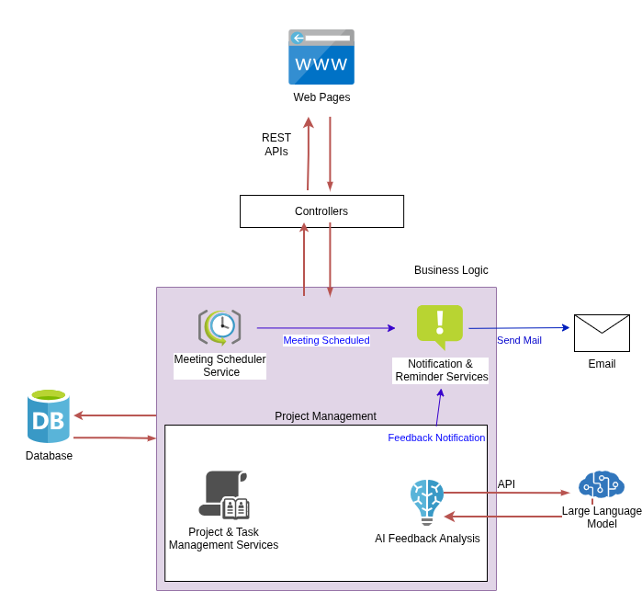Figure 3: High-Level System Architecture

3-Tier Architecture
The 3-tier architecture partitions a client-server application into distinct logical layers, ensuring the separation of responsibilities. The web application will therefore be organized as the following tiers:
- Presentation Tier – The user interface for displaying data and handling user interaction with the data.
- Application Tier – The part of the application that handles its core business logic.
- Data Tier – The persistent data storage layer for storing and retrieving the data of the business.

Inter-Layer Interaction
While the 3-Tier architecture states a pattern for the logical organization of the application, it does not enforce this separation on a physical level. This concern – specifically the separation between the presentation and application tiers - is determined by the model used for rendering web pages on the client.

Website Rendering Model
Traditionally, in web development, the rendering model was and still is governed by two main approaches – Server-Side Rendering and Client-Side Rendering. Their differences are tabulated in the figure below.
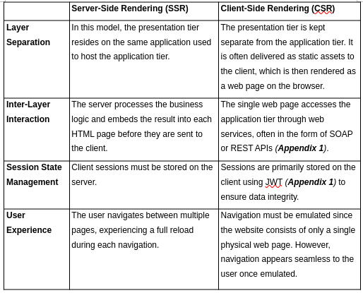Figure 1: SSR vs CSR

CSR is preferred over SSR for two key reasons. Firstly, the physical decoupling of the presentation tier from the application tier enables the use of more sophisticated web development frameworks for designing user interfaces on the client. These can enhance the user experience further aside from improving the web page navigation experience.

More importantly however is that CSR allows user sessions to be stored on the client’s browser. Consequently, the application server does not need to keep track of the user session internally because it is included in every request from the client. This approach ensures that the application tier can be scaled horizontally – multiple servers can handle the request from the client as opposed to only the server that would store the session state.

Object Relational Mapper (ORM)
In traditional web development, the application tier usually interacts with the DBMS in the data tier through SQL statements. However, this approach requires the reconciliation of the Object-Oriented structure of the application entities with the Relation structure used by the database, and developing this bridge between the two layers is a time consuming process.

An ORM (Appendix 1) is therefore used to automate this translation while offering the following guarantees:
- Security – ORMs use parameterized queries internally to retrieve and store data, and hence provide a robust layer of defense against SQL injection attacks.
- Abstraction – ORMs decouples business logic from SQL syntax specific to a particular DBMS, ensuring that such responsibility is handled solely in the application tier. It allows provides a degree of independence from a database provider, facilitating any future migration to a new database.

Analysis
This chapter presents a critical analysis of the overall design and strategic decisions required to implement the system from the proposed features in the preceding chapter. The primary purpose of system analysis is to formalize clear boundaries and expectations for the web application as well as provide rigorous justifications for the technologies and approaches used to meet the project’s objectives.

It will thus be organized into two distinct sections:
- System Requirements – In this section, the proposed system features are formalized into functional and non-functional requirements. This formalization ensures that the requirements of the system are distinct, actionable and testable.
- Evaluation of Tools/Approaches – For each technical choice in the implementation of the application, the most suitable tools or approaches employed in the realization of key system features are shortlisted and evaluated against their specific criteria.

System Requirements
The system requirements are divided into functional requirements that specify its behavior and core functionalities and non-functional requirements that specify the operational boundaries in terms of performance, security and maintainability.

Functional Requirements
The following table details the functional requirements, organized by their categories.
Table 4: Functional Requirements
Functional Requirement Number | Category | Description
FR1 | User Management | The system shall provide an Administrator Dashboard, accessible only to administrator users, for centralized user and project management.
FR2 | User Management | The system shall allow Administrators to manually create, edit, and delete user accounts, as well as create, edit, and archive projects (including the specification of supervisor-student pairings).
FR3 | User Management | The system shall automate user account creation and role assignment by parsing a supervisor-to-student pairing list, which aligns with official records.
FR4 | Project Management | The system shall automatically establish supervisor-student project relationships based on the list provided.
FR5 | Project Management | The system shall provide a Dashboard for supervisor and student users to manage and navigate through their assigned projects and their corresponding tasks.
FR6 | Project Management | Supervisors shall be authorized to view, update, and archive multiple projects within their assigned scope, while students shall have view-only access to their assigned project
FR7 | Task Management | Supervisors shall be able to create, update, and delete project tasks, including setting deadlines.
FR8 | Task Management | Supervisors shall be able to provide feedback on the latest task submission. To maintain integrity, the system shall provide a function to lock the task, preventing further submissions.
FR9 | Task Management | The system shall automatically update tasks statuses based on the deadline and the submission activity. The status of a task shall be “completed” upon submission, “pending” if the deadline has not passed and “missing” if the deadline passes without a submission.
FR10 | Deliverable Workflow | The system shall provide a staging area for students to upload, submit and delete deliverable files prior to final submission.
FR11 | Deliverable Workflow | The system shall display supervisor feedback criteria for the latest deliverable submission in a structured tabular format.
FR12 | AI Feedback Analysis | The system shall utilize a multi-modal LLM to evaluate deliverable re-submissions against prior feedback criteria, while tracking pertinent changes for each.
FR13 | AI Feedback Analysis | The system shall block deliverable re-submission until all feedback criteria are marked as "Met" by the AI or "Overridden" by the student or when a “locked” task is unlocked by the supervisor.
FR14 | AI Feedback Analysis | The system shall allow students to override unmet AI criteria, updating the status to "Overridden" for supervisor visibility.
FR15 | Meeting Scheduling | The system shall provide a shared calendar for students to view their supervisor's existing meeting schedule.
FR16 | Meeting Scheduling | The system shall enable users to book, cancel, or RSVP (Accept/Reject) to meetings, with a color-coded calendar reflecting the invitation state (e.g., Accepted, Pending).
FR17 | Meeting Scheduling | Students shall be restricted to booking meeting appointments exclusively with their assigned supervisor.
FR18 | Notifications & Reminders | The system shall generate Reminders for time-based events (e.g., meeting requests, task deadlines) and Email Notifications for both general and time-based events (e.g., deliverable submission, task update)
FR19 | Notifications & Reminders | The system shall provide a dedicated reminder section, visible after login, to ensure students and supervisors remain updated on the project’s status.
FR20 | Progress Log Report | The system shall automatically generate progress log reports by aggregating project task and meeting data.

Non-Functional Requirements
The following table dictates the non-functional requirements.
Table 5: Non-Functional Requirements
Non-Functional Requirement Number | Description
NFR1 | The system shall enforce Role-Based Access Control (Appendix 1) by only authorizing users to access resources and views/user interface elements based on the permission sets associated with their roles.
NFR2 | All server requests shall have a response time of less than 2000ms.
NFR3 | The system shall maintain high responsiveness by delegating AI compliance analysis and email dispatching to a background worker. This separation ensures that LLM invocations and mail-server delays do not degrade the user experience.

Evaluation of Tools/Approaches
The evaluation of each technical choice will be conducted systematically, consisting of three parts:
- Evaluation Criteria
- Comparison of Shortlisted Tools/Approaches
- Justification for the Tool/Approach selected

The most important technical considerations are highlighted below and are presented in detail in the upcoming sub-sections:
- Server Side Web Development Framework - This represents the language and framework used for both the implementation of the business logic and the orchestration of the web server, which exposes an interface for the logic with the client-facing part of the web application.
- Client Side Web Development Framework - This represents the languages and framework responsible for building the user interface that will be accessible on the client’s web browser, as well as handling user interactions with the web server.
- Database - The primary responsibility of the database is to persist and manage data for the web application. It ensures that they are easily accessible and structured according to the constraints imposed by the business logic.
- Artificial Intelligence Strategy for Feedback Compliance Checking - This represents the AI strategy and model designed to perform the comparison between the latest and previous deliverable documents, verify compliance of the latest deliverable with a given set of feedback criteria and summarize the changes observed.
- Asynchronous Background Processing Strategy - This represents the mechanism used to handle time-consuming tasks outside of the main request lifecycle. By offloading operations like AI analysis and email dispatch to background workers, the system avoids request timeouts and high latency responses.

Server Side Web Development Framework
The features of the server side framework of choice must reflect the requirements of the application tier, which leans more on the performance and robustness of the system. These desirable attributes are highlighted in the evaluation criteria below:

Evaluation Criteria
- Programming Language Features – Characteristics of the underlying language such as type safety, garbage collection for memory safety and automatic memory management, whether the language is compiled or interpreted.
- Ecosystem - Availability of third-party libraries for facilitating the development of custom application components, support for integration with external services such as databases and APIs and documentation quality.
- Built-in Abstractions – Provision of in-built features that handle tasks (such as sanitizing input to guard against XSS (Appendix 1)) without having to write the low level logic. This reduces development time and human error for critical code sections.
- Response Latency & Concurrency – If the framework offers a web server, response latency is the speed it can process requests. On the other hand, concurrency is the ability of the server to handle multiple simultaneous user requests.

Development Framework Comparison
The three most suitable web development frameworks have been identified and listed below for comparison:
Table 6: Development Framework Comparison
 | .NET Core (C#) | Laravel (PHP) | Next.js (Javascript/Typescript)
Programming Language Features | Its underlying language, C# is a strongly-typed, memory-safe and compiled high level language with support for a wide variety of operations and features. | PHP is an interpreted language with optional type safety, built specifically for web development. It has libraries and language features to support tasks such as session management & input validation. | Javascript, officially known as ECMAScript, is an interpreted language that is used for both client-side and server-side logic. Its flexible syntax allows for rapid prototyping. Type safety is provided by Typescript, which is a super set of Javascript.
Ecosystem | .NET offers an ecosystem of packages via Nuget package manager, including both community-developed and Microsoft-backed libraries. (ASP.NET Core, 2024) | Laravel provides an ecosystem of both official and community-developed packages through the Composer dependency manager for PHP. (Laravel, 2011) | Next.js makes use of the node package manager (npm) which manages the largest registry of packages and therefore, provides the largest ecosystem of readily available tools. (Nextjs, 2024)
Built-in Abstractions | .NET has built-in middlewares for Authentication, logging and testing with built-in features against CSRF & XSS (Appendix 1) attacks.  It also provides .NET Entity Framework ORM (Appendix 1) for database abstraction. | Laravel has out-of-the-box CSRF (Appendix 1) protection and middlewares for request JSON schema validation and logging.  It provides Eloquent ORM for database abstraction. | The built-in abstractions provided by Next.js are primarily concerned with optimizing performance for website rendering on the client.
Response Latency & Concurrency | C# is compiled into a highly optimized intermediate language and then executed, ensuring high performance. Furthermore, its multi-threaded nature allows it to efficiently handle multiple I/O requests simultaneously. As a result, it can tolerate high loads. | PHP has high overhead per request and thus a high response latency due to architectural considerations and blocking I/O operations.  Laravel Octane is required to achieve lower latencies and higher concurrency support via persistent memory and asynchronous processing. | The underlying runtime, Node.js uses a single-threaded event loop for non-blocking IO, which is efficient for concurrent network requests.  Next.js improves website performance for the client by providing features such as Server-Side rendering (Appendix 1)

Choice of Framework
.NET core will the be the most appropriate choice for the development framework based on the criteria given and the following additional justifications:
- The web platform must be designed handle thousands of concurrent users, especially when nearing the submission deadlines, during which deliverable submissions may soar considerably. This will be a common criteria in determining the most suitable technology to use. Buljić et al. (2025) showed that .NET Core consistently outperforms other web frameworks in response latency and handling concurrent HTTP requests.
- The ecosystem and built-in abstractions for .NET are more aligned with the requirements of the project – robust middlewares for authentication, testing and logging will reduce development time considerably while its ecosystem has official libraries for a range of tasks including LLM interactions.
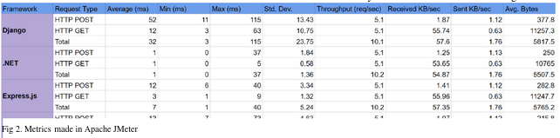Figure 5: Server Side Framework Performance Metrics (Buljić et al., 2025)

Client Side Web Development Framework
Since the presentation tier has a widely different set of requirements from the application tier, the client side framework used to construct the user interface on the client’s browser must also have a different set of attributes, outlined in the following set of evaluation criteria below.

It should additionally be highlighted that due to the prerequisite of Client-Side Rendering (CSR), full web frameworks such as Laravel and .NET Razor pages are disqualified from the list since they are mainly oriented towards SSR.

Evaluation Criteria
- Development Complexity – It encompasses the learning curve of the framework.
- Framework Features – The various client side frameworks, often derivatives of HTML, CSS and Javascript, need to possess qualities such as ease of development, performance, maintainability and re-usability.
- Debugging – This describes the ease and extent to which static and runtime issues in the presentation tier’s code can identified. The framework or underlying language may feature type safety to facilitate static code verification and support runtime tools to support testing and profiling user interaction.
- Ecosystem – Availability of third party libraries for integration with external services or to leverage existing and reliable components to implement system features.

Development Framework Comparison
The solutions have been evaluated from a shortlist comprising standard web languages, such as HTML, CSS, and Javascript, alongside the most prominent modern client-facing web frameworks.
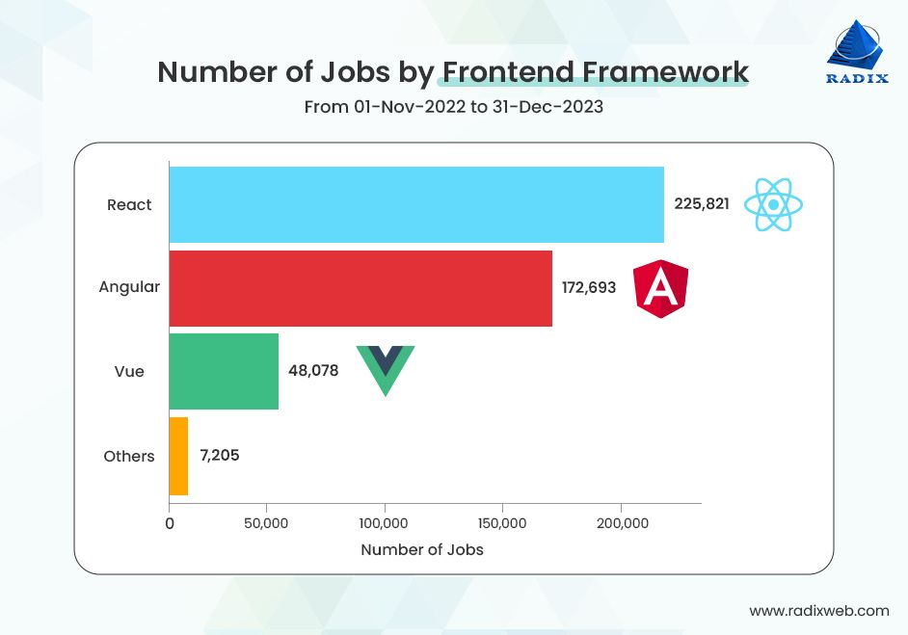Figure 2: Frontend Framework Demand Graph (radixweb, 2023)

Table 7: Client-Side Development Framework Comparison
 | HTML + CSS + Javascript | React + Typescript | Vue.js + Typescript
Development Complexity | It has the lowest complexity due to absence specialized abstractions and build steps required to produce a working web page. | Development requires knowledge of the React Virtual DOM (see appendix) alongside specialized syntax.  Additionally, initial setup for React with Typescript can be complex. (React, 2025) | It uses a template-based approach that is closer to standard HTML and hence does not boast a high complexity. (Vue.js, 2025)
Framework Features | It lacks important features required to make code maintainable and re-usable. | React uses a component-based architecture that enables excellent re-usability.  Moreover, the Virtual DOM ensures high performance for UI updates. | Vue features built-in transitions that simplify complex UI states.  Vue has marginally higher performance than React.
Debugging | There are no static type checking and no specialized developer tools for debugging. Furthermore, runtime errors are often vague. | Typescript provides static type safety. The React DevTools browser extension allows for inspection and profiling of individual UI elements. | Vue DevTools provides profiling and inspection utilities.
Ecosystem | Developers must manually integrate external code, leading to poor system maintainability. | React has the largest ecosystem with both corporate and community-backed libraries. | Vue has a smaller ecosystem of third party libraries as compared to React.

Choice of Framework
React + Typescript will be chosen as the client side web development framework primarily due to the superior ecosystem that it boasts as compared to Vue.js. This also includes documentation and extensive coverage on obscure bugs and best practices used for designing web applications.

Database
The database is a critical component in ensuring the persistence of data as per the requirements of the system. Its importance is comparable to the choice of the system architecture because a poor choice may become a bottleneck in the system’s performance and scalability.
The database to use will be selected based on the criteria as commonly stipulated by database vendors (Belagatti, 2025), curated to suit the use cases of the system:

Evaluation Criteria
- Performance
- Security & Reliability
- Scalability (Appendix 1)
- Cost & Licensing
- Development Framework Integration
- Large Object Storage & Retrieval

Database Comparison
The candidates for the database shortlist have been identified based on the performance benchmarks established by Belagatti (2025).
Table 8: Database Comparison
 | PostgreSQL | Microsoft SQL Server | MySQL
Performance | PostgreSQL offers higher performance than MySQL for frequent update and delete operations.  It offers less performance than MySQL for frequent read operations. (AWS - PostgreSQL vs MySQL, 2025)  Supports more advanced indexing techniques as compared to MySQL. | SQL Server offers the highest performance due to several optimization capabilities.  Supports advanced indexing techniques | MySQL is less performative on for heavy update workloads than PostgreSQL.  It outperforms PostgreSQL in frequent read operations (AWS - PostgreSQL vs MySQL, 2025)
Security & Reliability | ACID (Appendix 1) compliant with support for advanced indexes for reliability | Extensive feature set for ensuring security and reliability including ACID compliance | ACID compliance depends on the storage engine used
Scalability (Appendix 1) | Scales both vertically (increasing resources for a single server) and horizontally (increasing number of servers) | Scales both vertically and horizontally | Scales better horizontally than vertically
Cost & Licensing | Free & Open-source | Requires licensing for large scale enterprise environments | Free & Open-source
Development Framework Integration | .NET Core support provided by Npgsql, which is an open-source data provider package. | Microsoft provides an official data provider for SQL Server and native libraries are specifically optimized for interaction with SQL Server. | .NET Core support provided by MySqlConnector, which is open-source.
Large Object Storage & Retrieval | PostgreSQL uses TOAST (PostgreSQL: Docs – TOAST, 2025) optimization to compress large objects before writing to disk.  TOAST also makes retrieval slightly faster than MySQL by making records cache-friendly. | Less storage compression efficiency offered as compared to PostgreSQL. | No inherent compression techniques for large objects and has less storage efficiency than PostgreSQL.

Choice of Database
In spite of SQL Server being the most advanced of the databases listed, PostgreSQL will be selected due to SQL Server’s expensive licensing costs. The decision is also based on the additional reasoning:
- Since deliverables may often be text documents ranging from 5-150 pages long, PostgreSQL will be more suitable for handling large text objects due to its TOAST optimization features, optimizing storage utilization. Read operations will also be slightly more efficient.
- Despite the consensus that web applications have a higher read-write ratio, the number of write operations can significantly increase when taking into account the meeting scheduling and reminder system. Therefore, PostgreSQL will be most suited for handling this change in workload.

Artificial Intelligence Strategy for Feedback Compliance Checking
Before evaluating specific strategies, it is necessary to highlight the paradigm shift in Natural Language Processing (NLP) techniques according to Bommasani et al. (2021). They argue that the advent of foundational models (Appendix 1) have presented an emerging way of building AI systems over traditional Machine Learning (ML) techniques. Their differences are highlighted in the table below:

Comparison of Artificial Intelligence Strategies
Table 9: Comparison of Artificial Intelligence Strategies
 | Classical ML | Foundational Models
Logic | In traditional ML, the behavior of the AI system is explicitly defined through the choice of an ML algorithm (e.g. Supervised, Unsupervised and Reinforcement Learning) on a dataset. | The system’s behavior is induced by the phenomenon Bommasani et al. (2021) describes as emergence – a by-product of the foundational model’s vast training and parameters that allows it solve tasks it was not explicitly programmed for.
Training Data Requirements | The performance of the model correlates directly with the size and quality of the data used. | They model can be improved with additional data but they can operate without.
Operational Cost | Classical ML models are lightweight and have low inference requirements. | Foundational models require significant computing resources for inference.
System Latency | They have fast response times because the behavior of the system is explicitly defined. | They have slow response times since the models must apply reasoning through their broad internal knowledge to induce an answer.

Choice of Artificial Intelligence Strategy
Since the task to be performed - comparing two documents, summarizing the changes and verifying compliance against a given set of feedback criteria – requires the model to understand language semantics and a wide range of domain knowledge about a dissertation subject, an ML model will be unable to perform this task as effectively as a foundational model.

Hence, Large Language Models (LLMs) – a specific type of foundational models – are required. The choice of the Large Language Model is based on the set of the evaluation criteria identified according to the operational requirements of the feedback compliance task.

Evaluation Criteria for Large Language Models
- Multi-modality – The capacity to process figures and tables within the document.
- Internal Optimizations – The optimizations provided by the model to increase the efficiency of the task.
- Context Window – The maximum amount of tokens the model can hold in memory without suffering from significant loss in accuracy.
- Operational Cost – The financial sustainability of the system based on token pricing

Comparison of Large Language Models
The LLM shortlist is derived from current industry-standard performance benchmarks (2026).
Table 10: Comparison of Large Language Model APIs
 | Claude 3.5 Sonnet | GPT-4o | Gemini 2.5 Flash
Multi-modality | High-fidelity image and document processing | Native multi-modal capabilities | It has the highest multi-modality since text, images and video are processed in a single stream.
Internal Optimizations | Leverages Prompt Caching to reduce cost and latency for repetitive contexts. | Leverages Speculative Decoding to optimize efficiency in predicting output. | Uses Flash Attention & Distillation to minimize computational costs during inference.
Context Window | 200,000 tokens | 128,000 tokens | 1,000,000 tokens
Operational Cost | Highest cost per token | Moderate costs per token | Lowest costs per token

Choice of Large Language Model
Aside from being the most economical and optimal choice, Gemini-2.5 flash (Google DeepMind, 2025) will be selected on the basis of two key reasons pertaining to the feedback compliance task:
- Document comparison involves processing large chunks of text and images, requiring the model to ingest a large number of input tokens. The model must therefore possess a large context window and Gemini-2.5 flash meets this requirement.
- To account for the supervisor’s feedback encompassing figures within the document, the model must be able to analyze them as well. In that case, Gemini-2.5 is the most suitable for the task since it has native multi-modal capabilities.
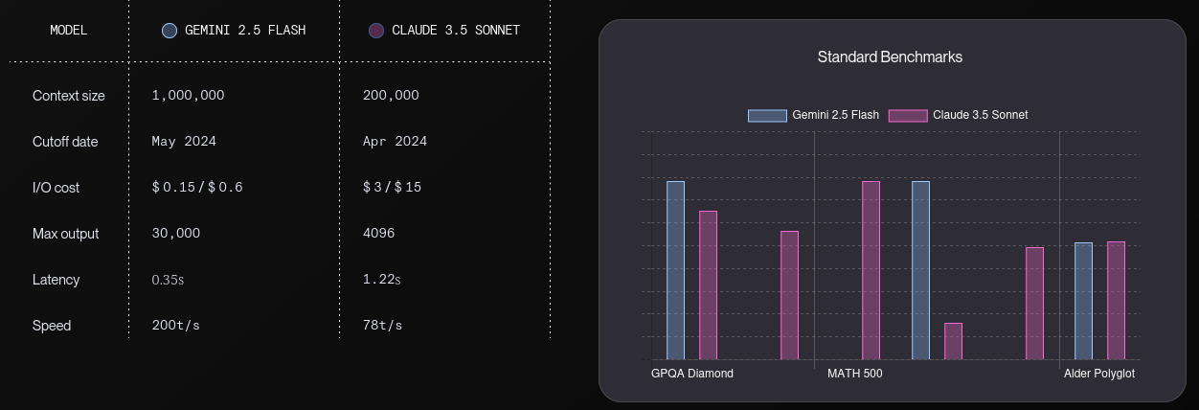Figure 3: Gemini-2.5 flash vs Claude 3.5 Sonnet LLM Benchmarks

Asynchronous Background Processing Strategy
The selection of the appropriate asynchronous processing strategy is based on the trade-off between the implementation overhead and the reliability of the system under concurrent workloads. The criteria listed below encompasses this balance:

Evaluation Criteria
- Implementation Complexity - The effort required to configure the queuing mechanism and the necessity for additional servers or third-party dependencies.
- Reliability - The ability to manage concurrent workloads without data corruption or loss due to race conditions.
- Scalability - The ability to handle a sudden influx of background tasks without degrading the performance of the system.

Comparison of Processing Strategies
The following table details a comparative analysis of the background processing strategies.
Table 11: Comparison of Asynchronous Processing Strategies
 | In-Memory Queues (Appendix 1) | External Message Broker
Implementation Complexity | .NET channels (IEvangelist,  2023) implement an in-memory queue, offering the lowest overhead as it utilizes built-in language features. | High overhead due to the requirement of hosting, and maintaining a dedicated message broker (Appendix 1) instance and external connection logic.
Reliability | Medium reliability as the tasks are volatile and stored in application memory. | Highest reliability as tasks are persisted to disk, allowing jobs to survive server failures.
Scalability | Scalability is vertically bound by the CPU and memory resources of the primary web server hosting the application | Highly scalable as worker nodes can be scaled horizontally and independently of the main web application to handle load.

Selection of Processing Strategy
In-Memory Queues (.NET Channels) will be selected as the asynchronous processing strategy. Despite external message brokers offering superior persistence, the overhead of maintaining a distributed architecture outweighs its benefits for the current scope of the system. Furthermore, the decision is also based on the fact that running background workers in the same application enables sharing of dependencies natively without requiring the defintion of an API.

Design
This section will provide the necessary specifications for the system’s design, including both structural and behavioral UML diagrams, arranged in the following order:
- Use Case Diagrams
- Class Diagrams
- Sequence Diagrams
- Entity Relationship Diagram

Use Case Diagrams
From the user’s perspective, the system can be divided into 6 sub-systems:
- User Management Subsystem
- Meeting Scheduling Subsystem
- Project Management Subsystem
- Task Management Subsystem
- Deliverable Management Subsystem
- Feedback Management Subsystem

User Management Subsystem
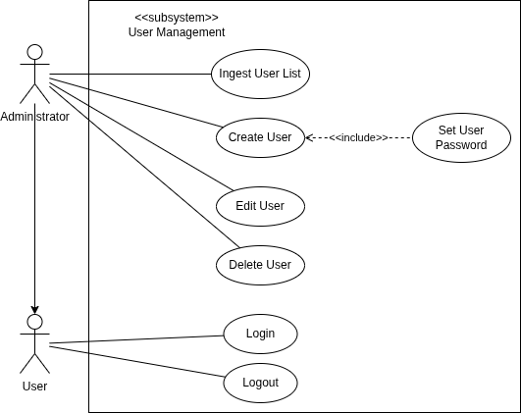Figure 4: Use Case Diagram - User Management

Meeting Scheduling Subsystem
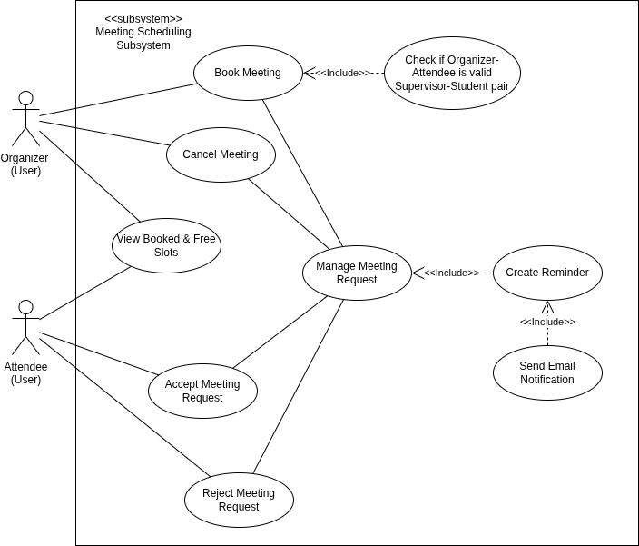Figure 5: Use Case Diagram - Meeting Scheduling Subsystem

Project Management Subsystem
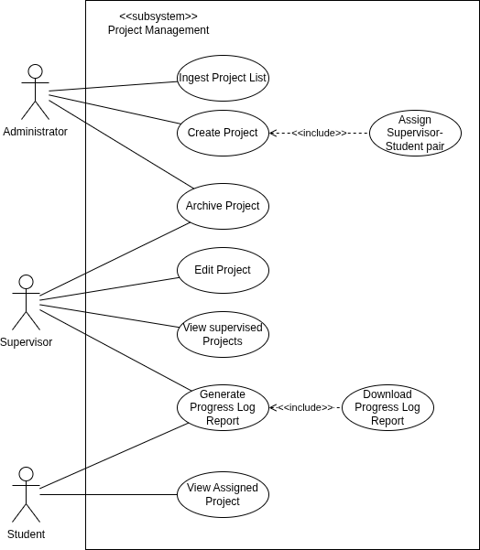Figure 6: Use Case Diagram - Project Management Subsystem

Task Management Subsystem
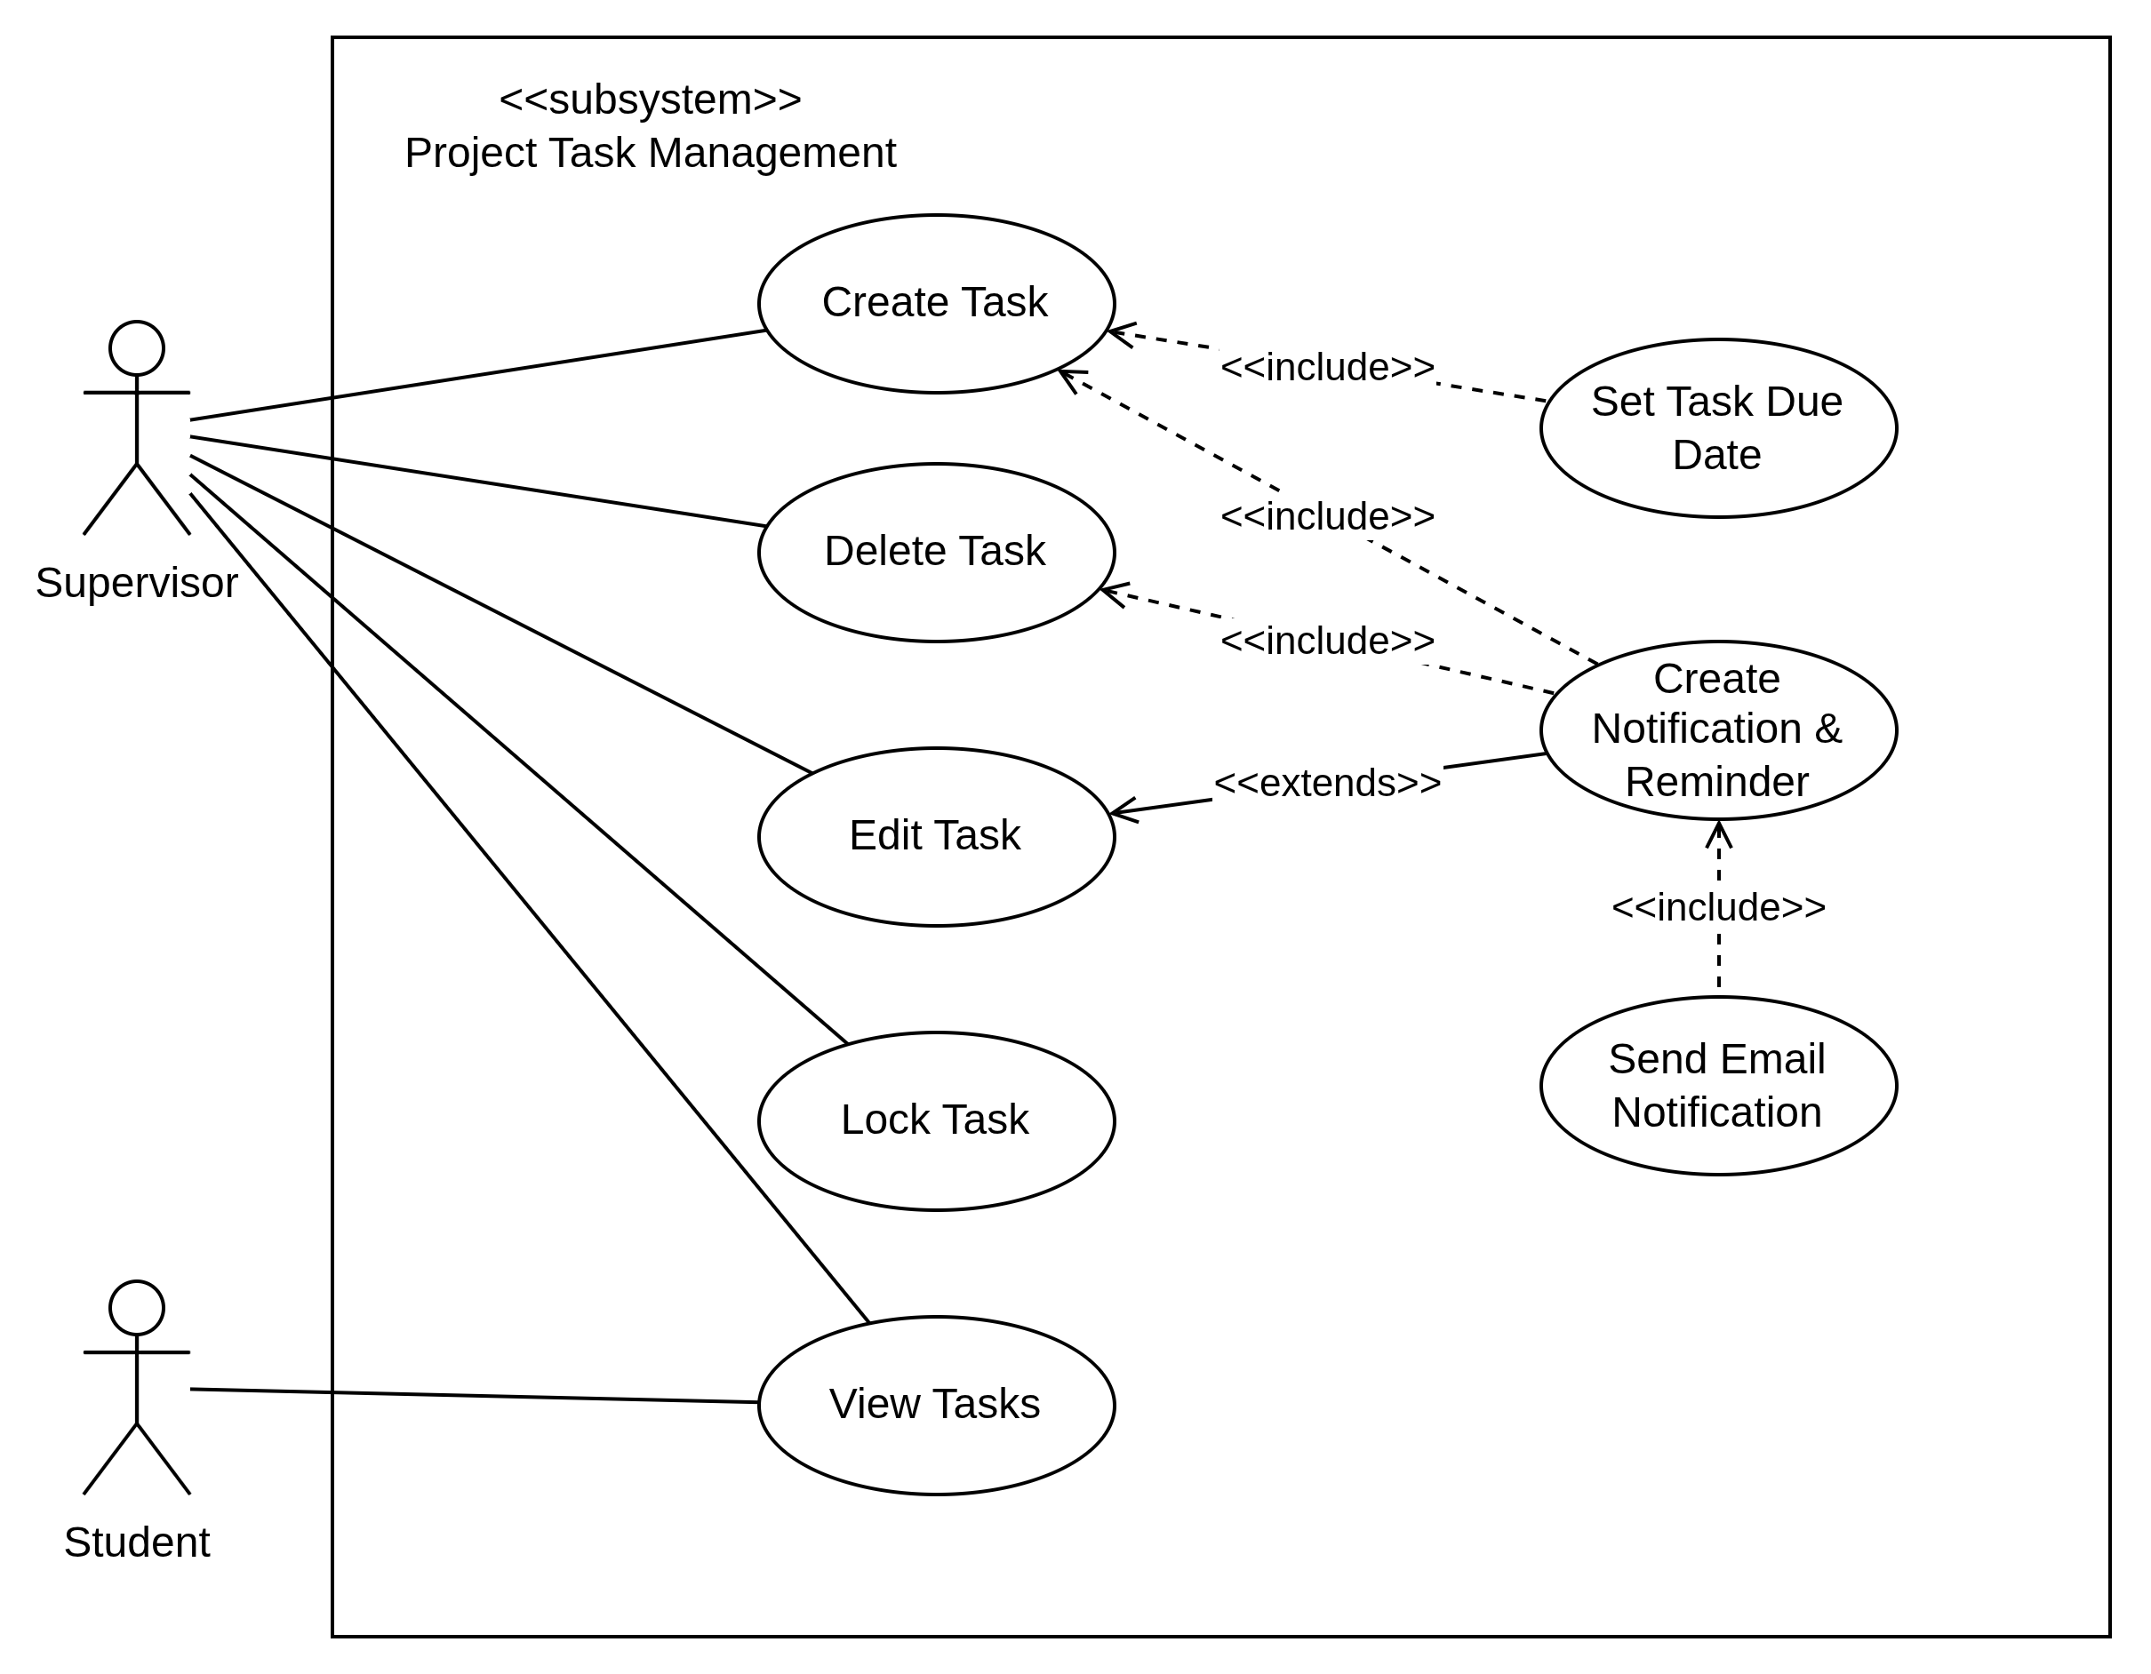Figure 7: Use Case Diagram - Project Task Management Subsystem

Deliverable Submission Subsystem
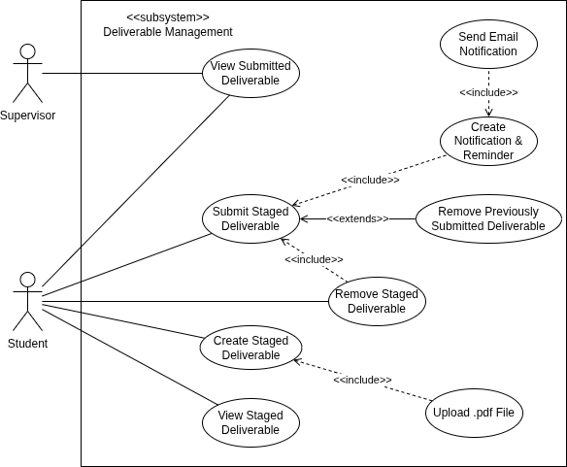Figure 8: Use Case Diagram - Deliverable Management Subsystem

Feedback Management Subsystem
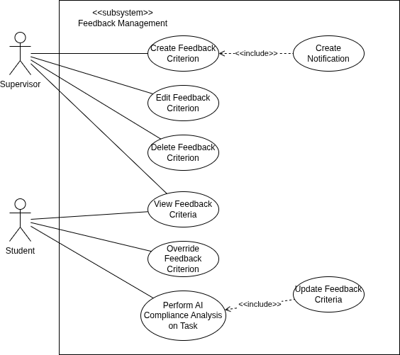Figure 9: Use Case Diagram - Feedback Management Subsystem

Class Diagrams
Class diagrams are static structural diagrams used in object-oriented modeling to visualize a system’s architecture. They are organized as follows:
- Class Diagram (Data) - It depicts the data model of the application.
- Class Diagrams (Logic) - They depict the relationship (dependencies & associations) between the classes.
To maintain clarity and decouple the business logic presented by the class and sequence diagrams from framework-specific features (EF Core) and other application constraints, the diagrams will not explicitly show the underlying architecture for every classes.

Class Diagram (Data)
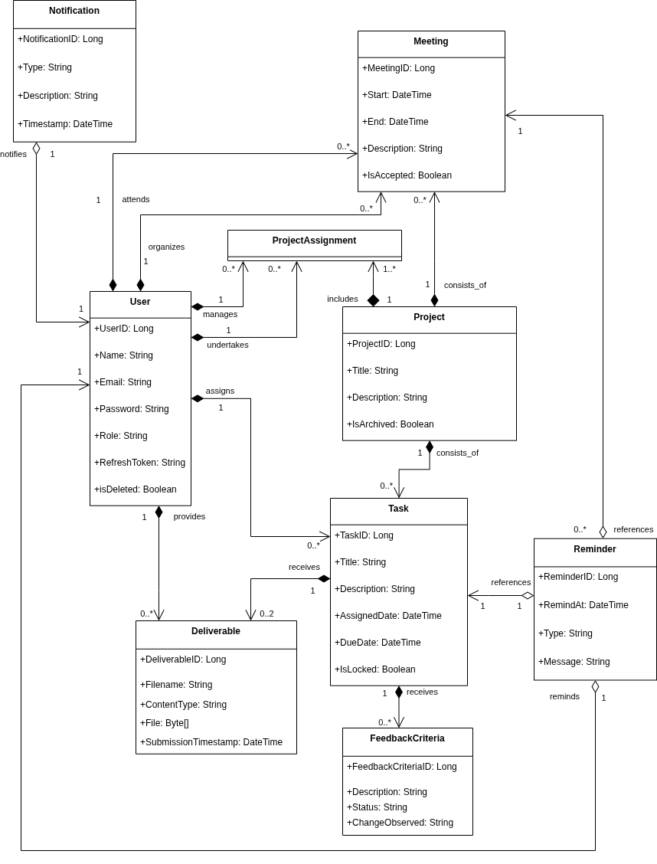Figure 10: Class Diagrams - Data

Class Diagram (Logic)
The class diagrams are organized further as:
- Service Classes
- Background Workers

Service Classes
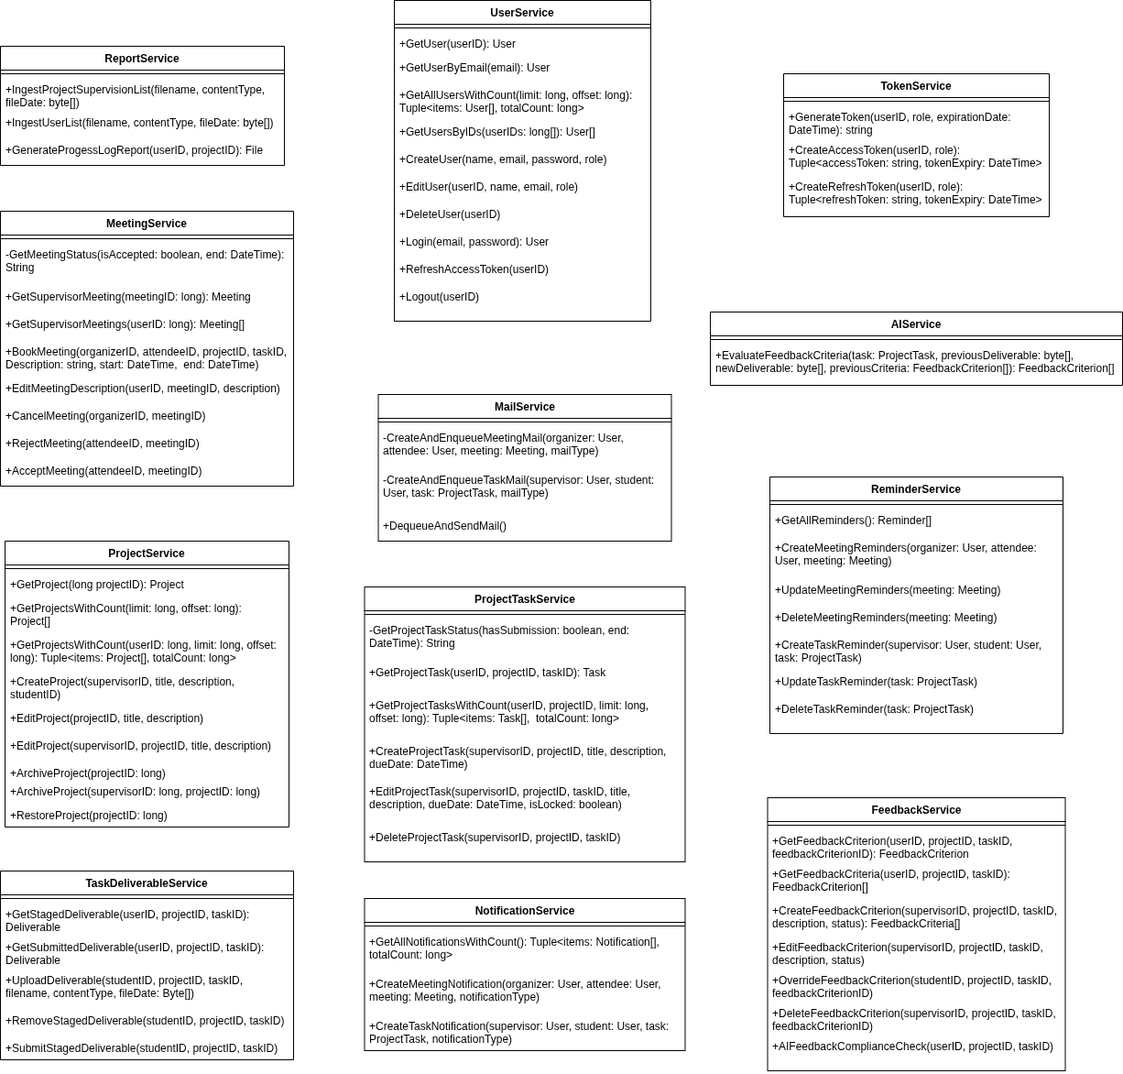Figure 11: Class Diagram - Service Classes
The service classes illustrated in the above diagram implement a pattern that decouples the business logic of from their specific underlying data classes. Their interactions are intentionally omitted to preserve the clarity of the diagram.

Background Workers
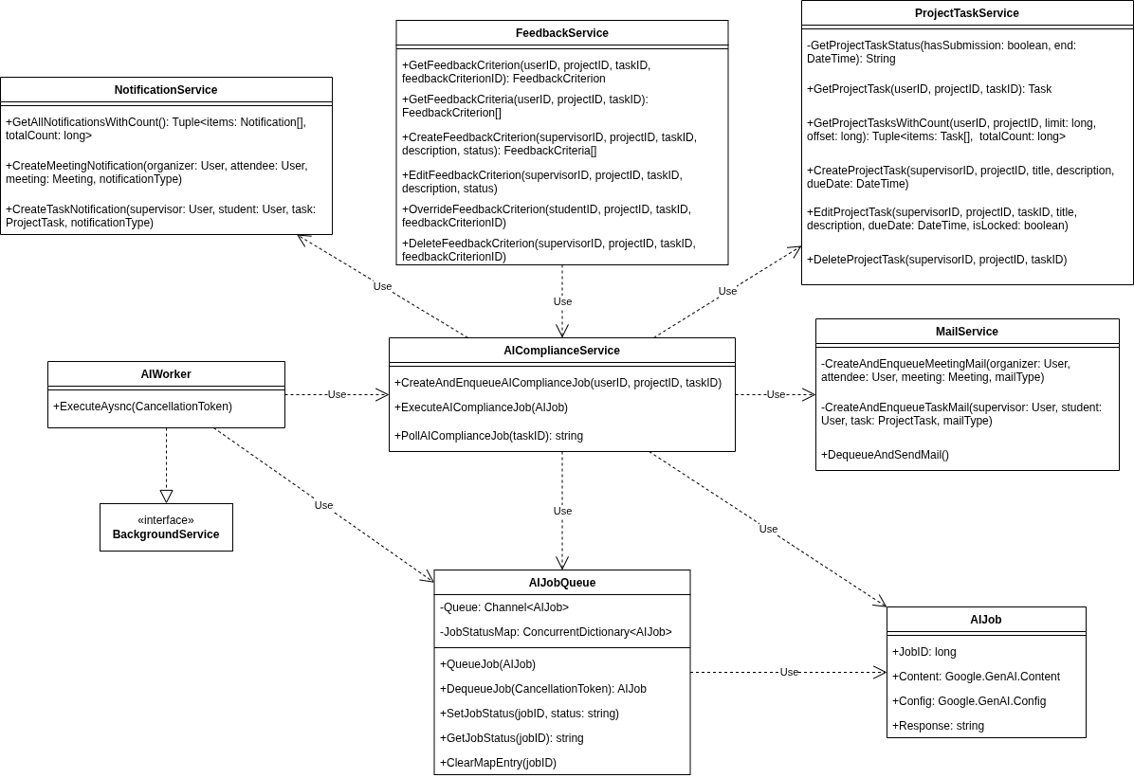Figure 12: Class Diagram (AI Background Worker) - Subsystem
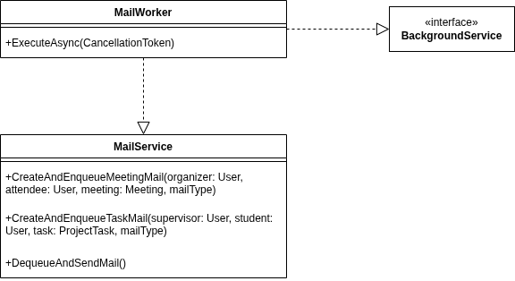Figure 13: Class Diagram (Mail Background Worker) - Subsystem

Sequence Diagrams
Sequence Diagrams aim to provide more detail to the how classes described in the previous section interact over time.
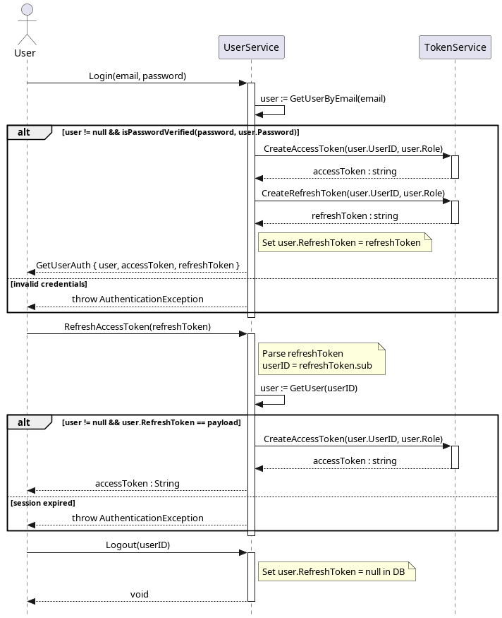Figure 14: Sequence Diagram - User Authentication
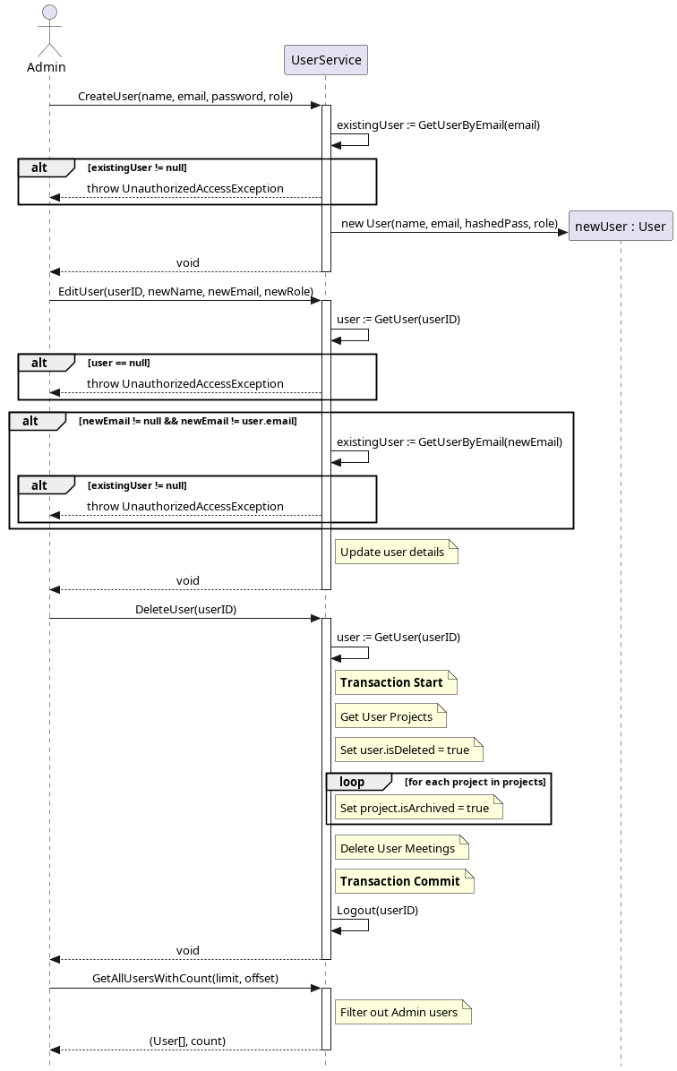Figure 15: Sequence Diagram - User Management
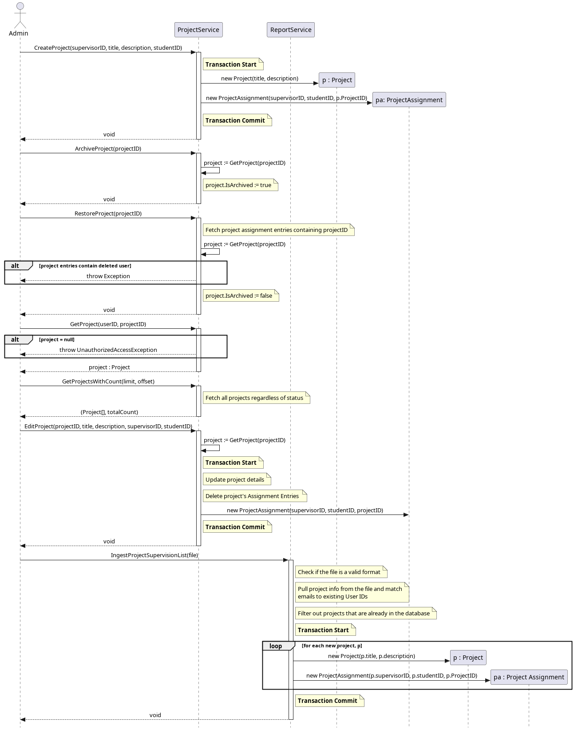Figure 16: Sequence Diagram - Project Management (Admin)
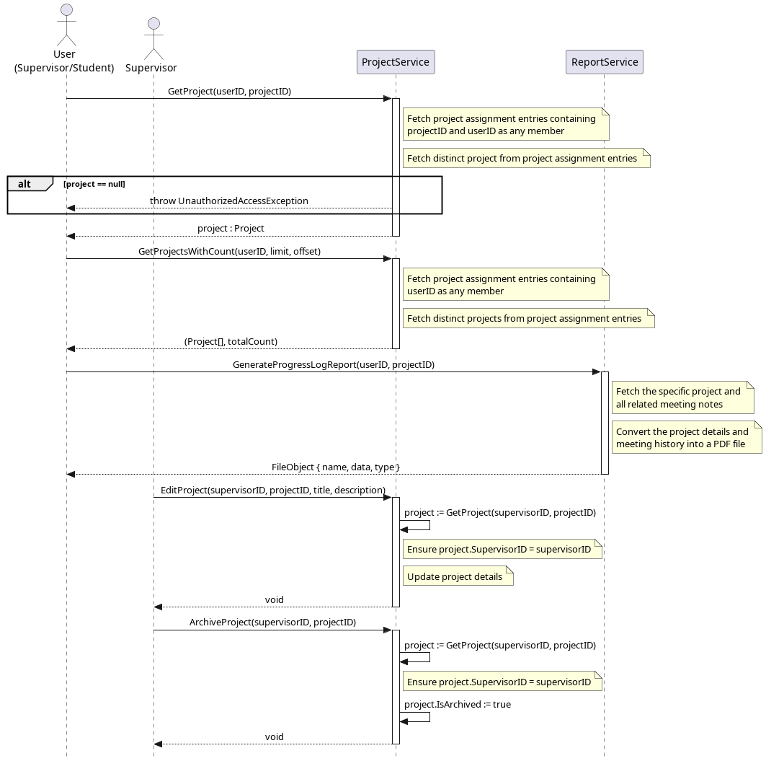Figure 17: Sequence Diagram - Project Management (User + Supervisor)

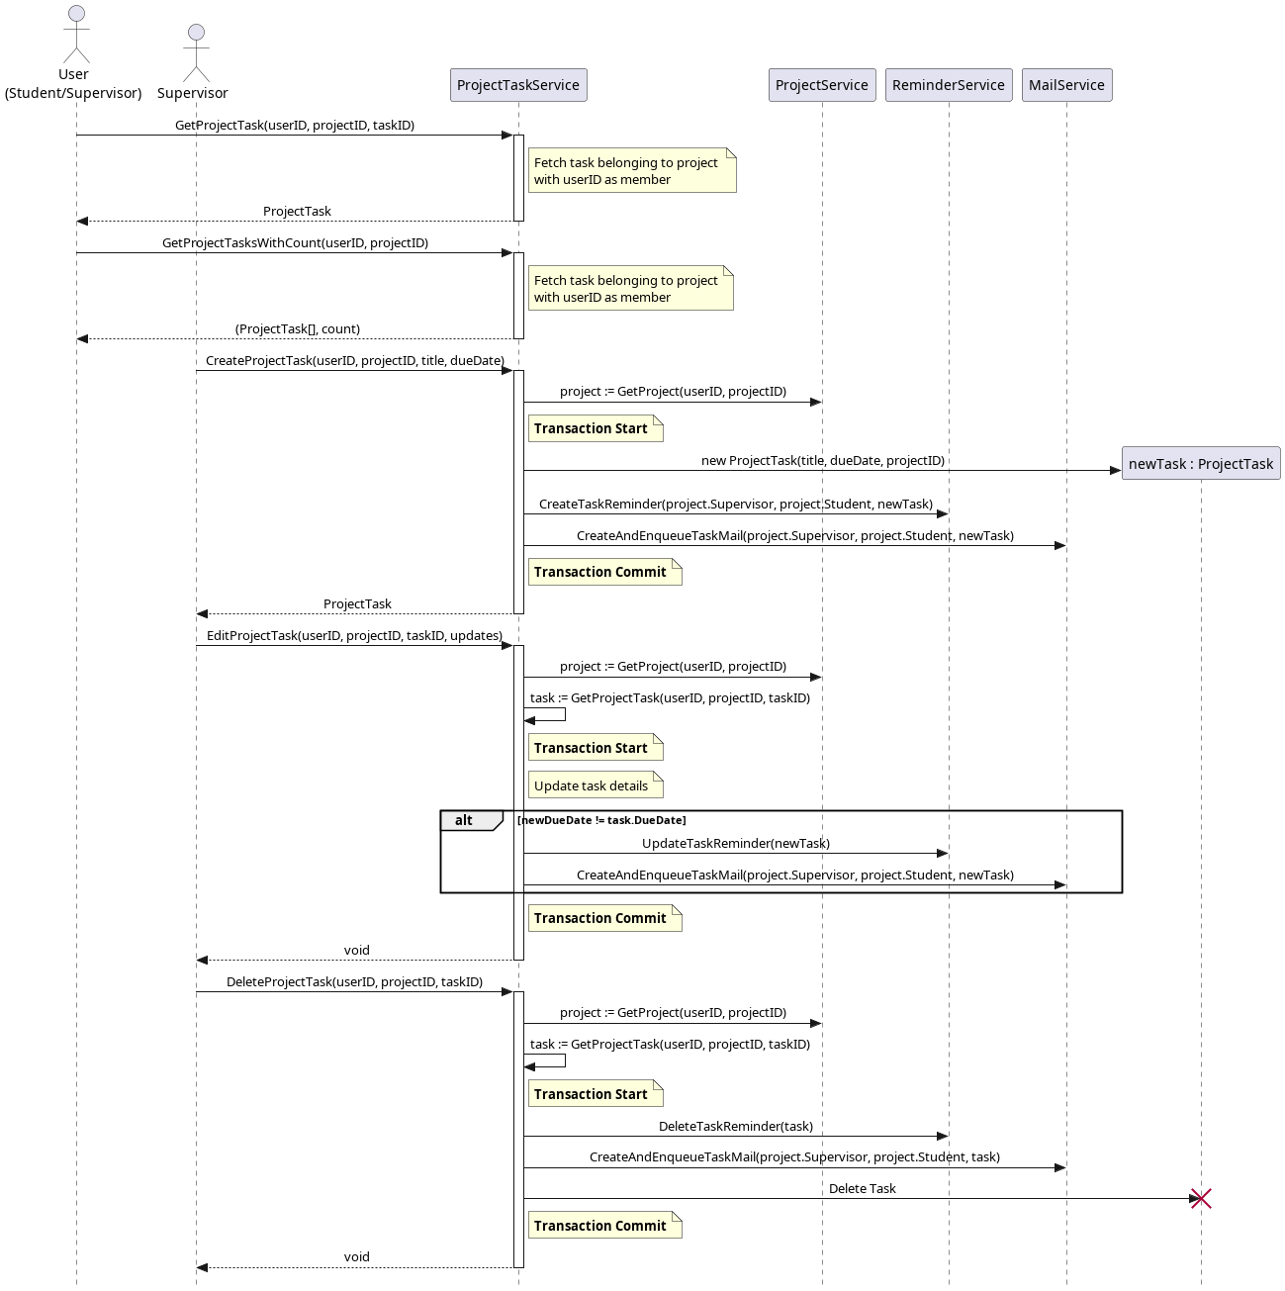Figure 18: Sequence Diagram - Task Management

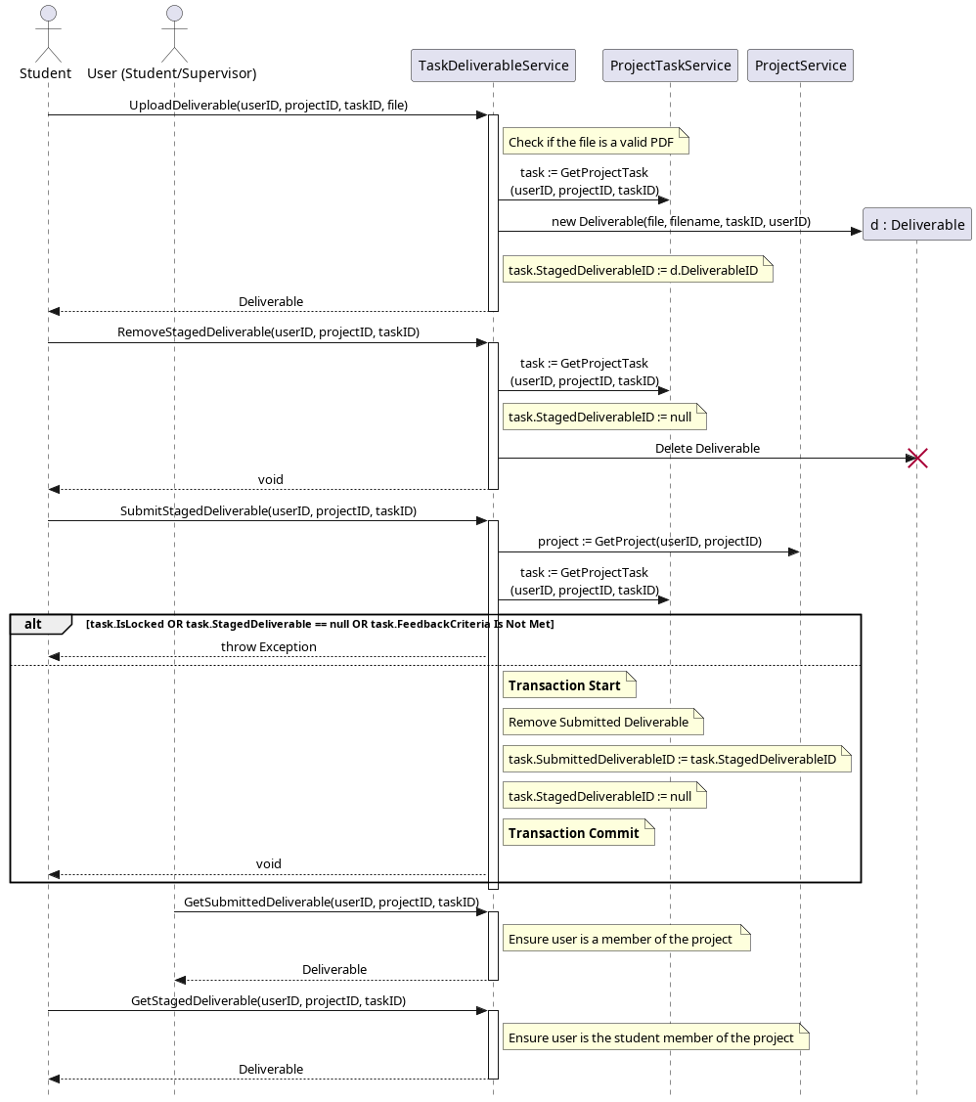Figure 19: Sequence Diagram - Deliverable Management

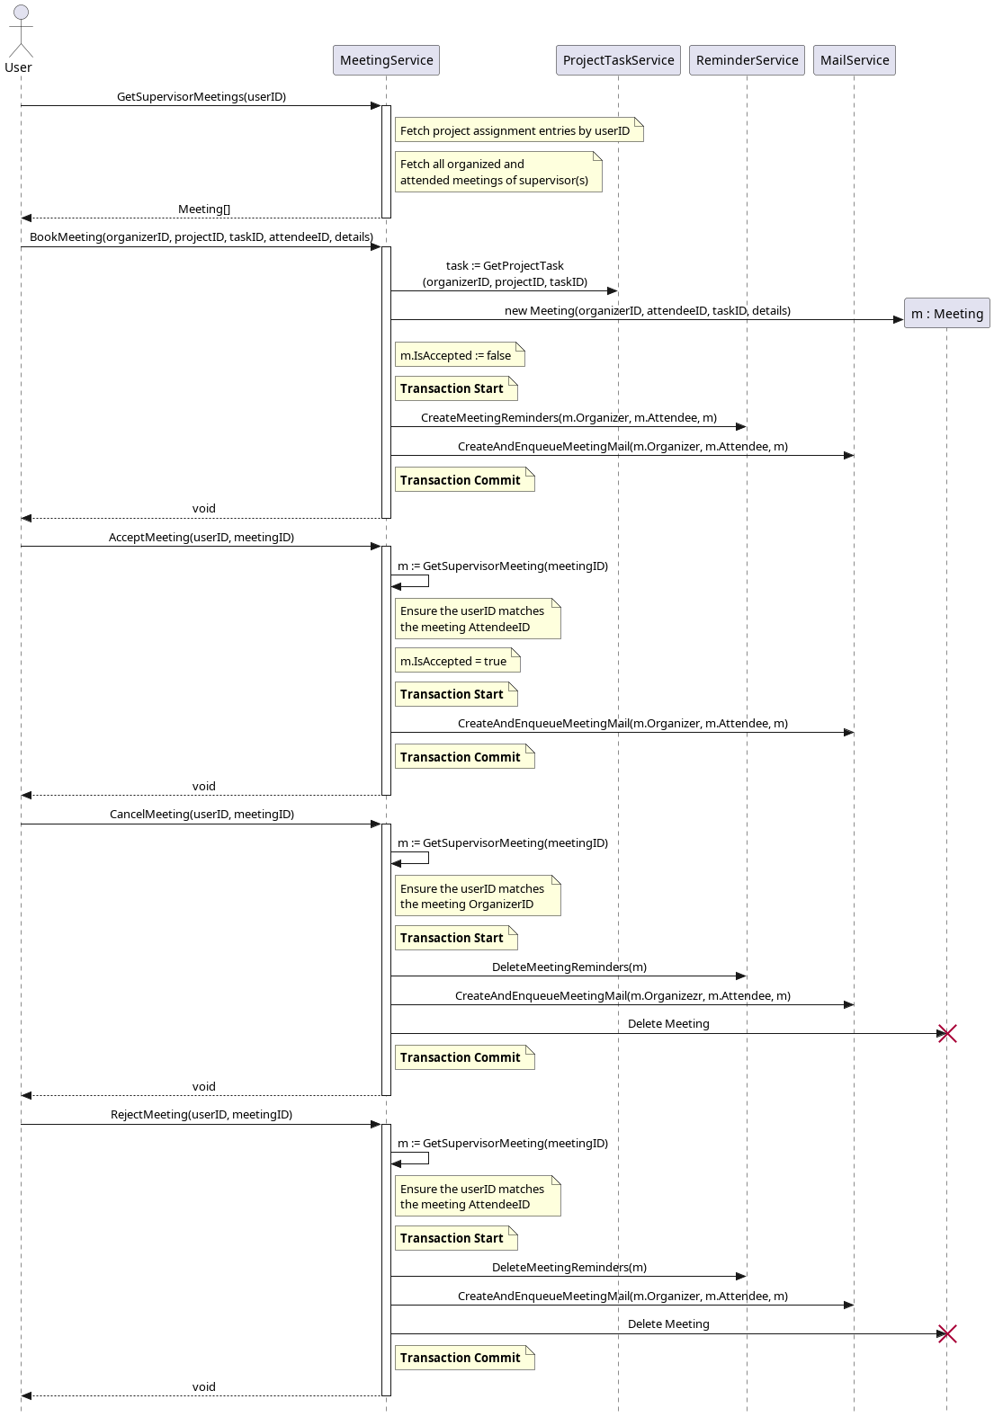Figure 20: Sequence Diagram - Meeting Scheduling
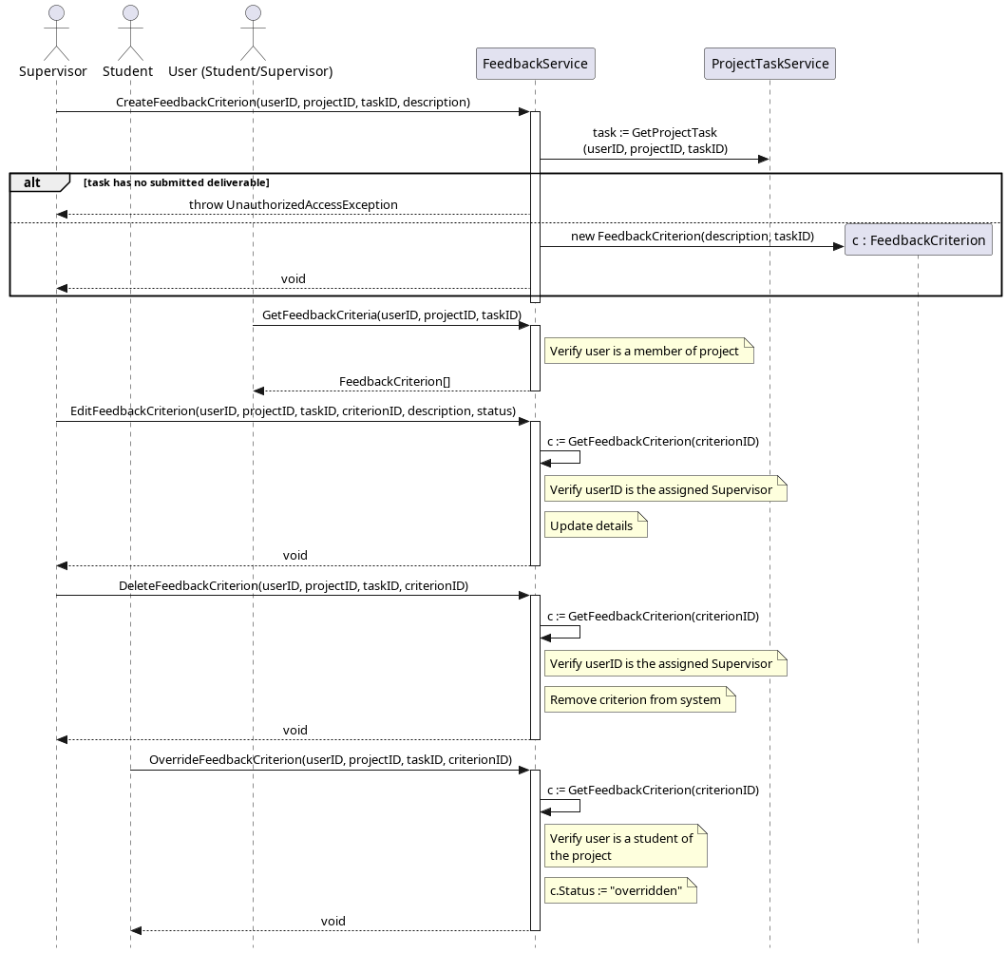Figure 21: Sequence Diagram - Feedback Management

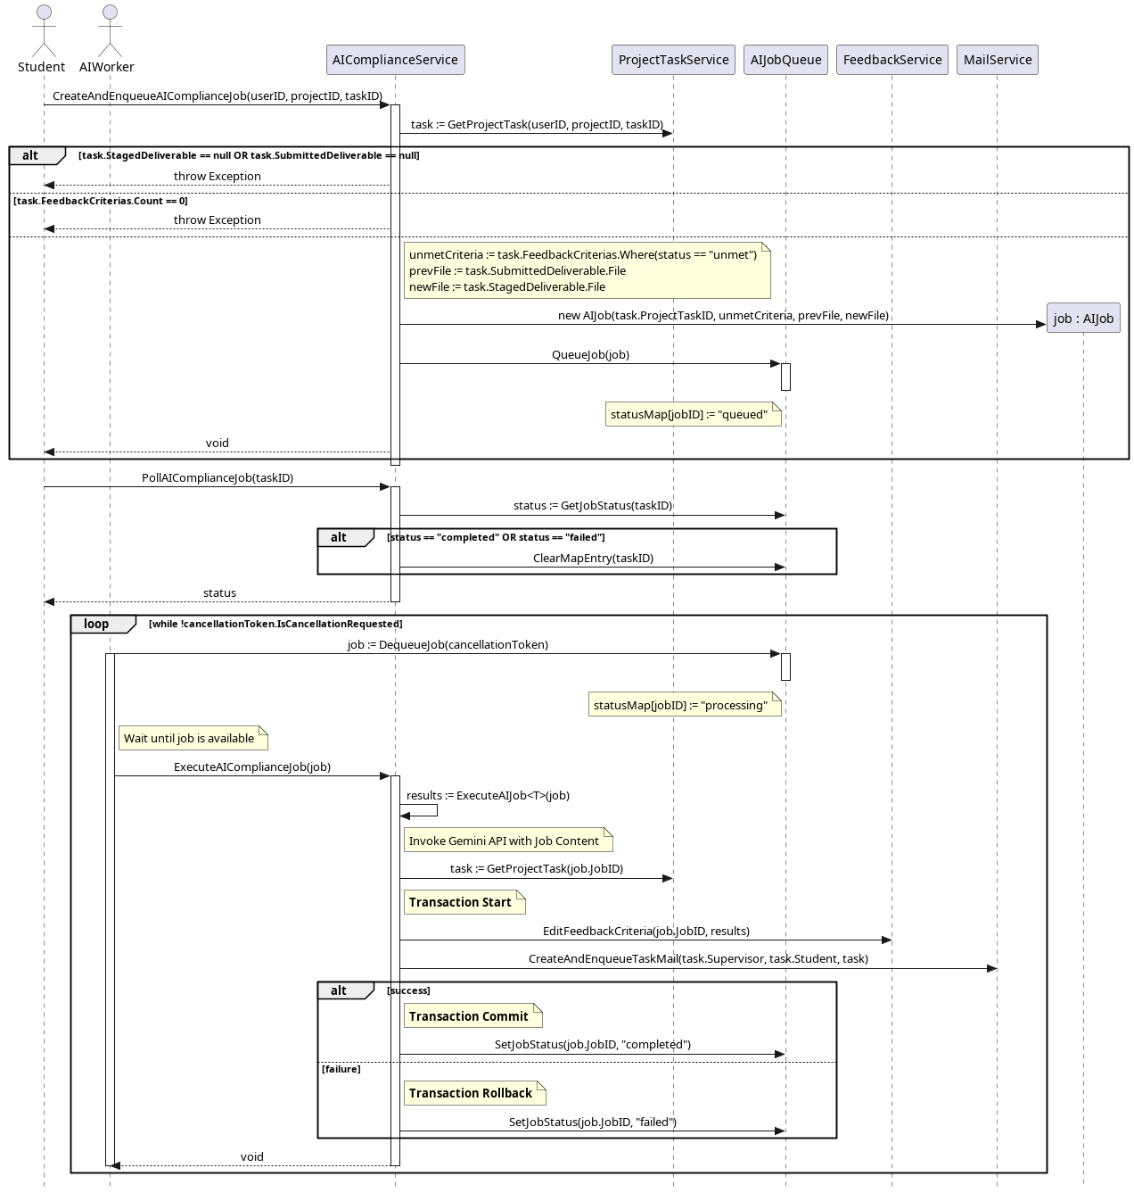Figure 22: Sequence Diagram - AI Compliance

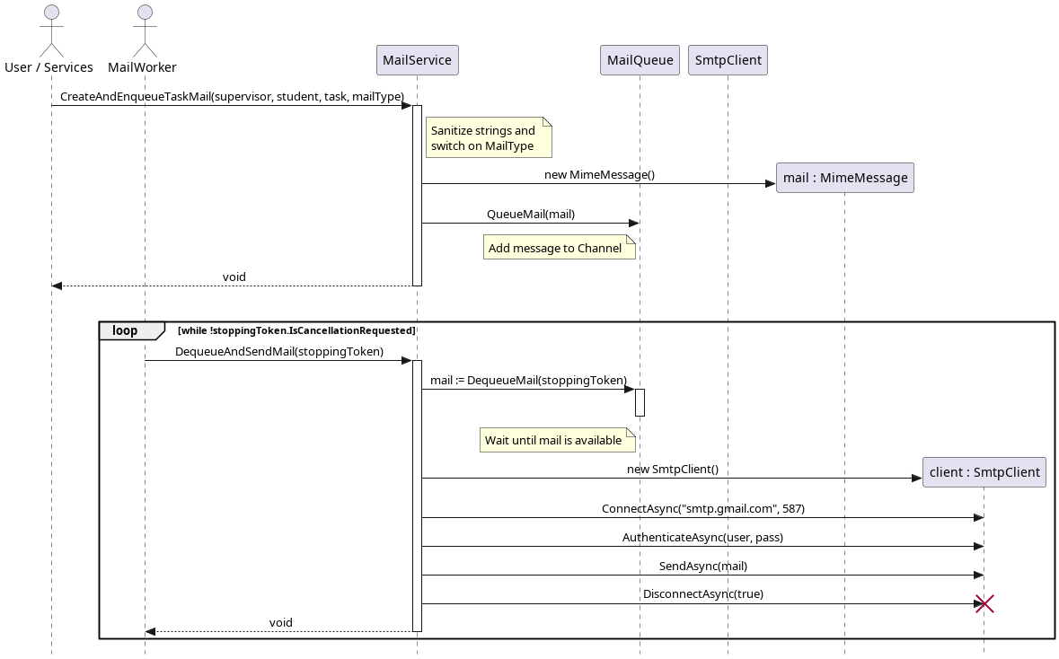Figure 23: Sequence Diagram - Mail Management

Entity Relationship Diagram
The ERD depicts the database tables, their columns and their relations with one another based on the domain class diagram.
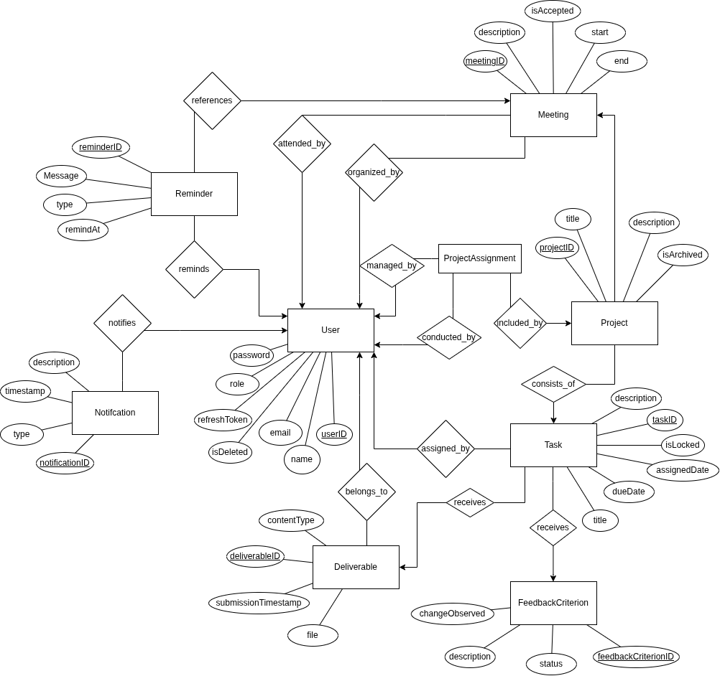Figure 24: Entity Relationship Diagram

Interface Design
This section will contain the design for the interface
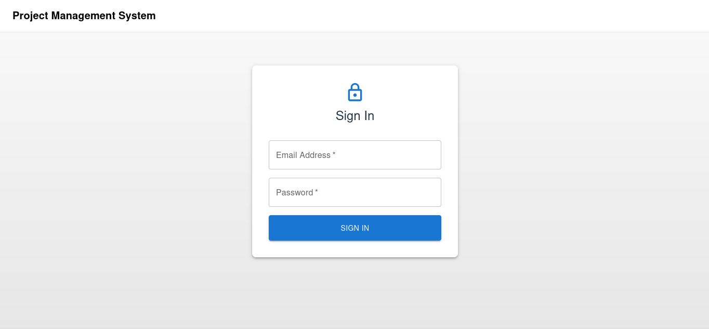Figure 25: PMS - Login
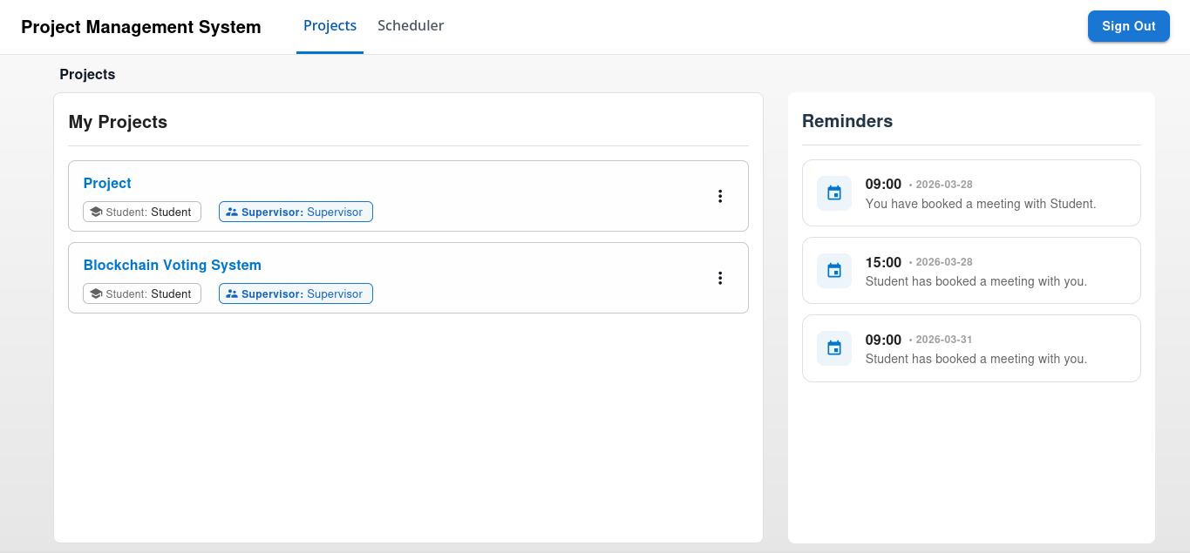Figure 26: PMS - Projects Dashboard (Supervisor)

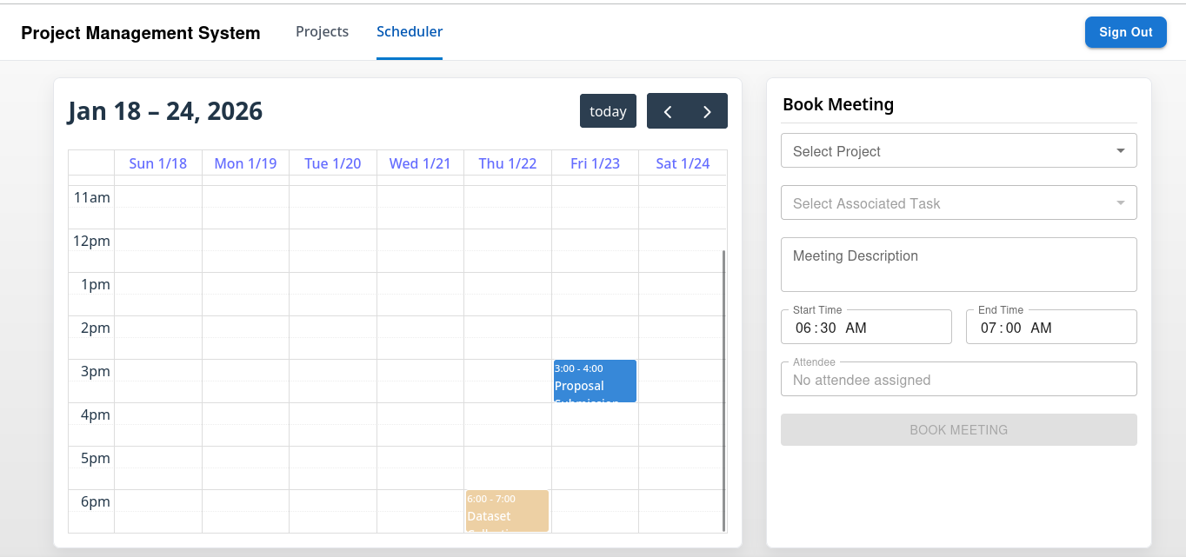Figure 27: PMS - Meeting Scheduler
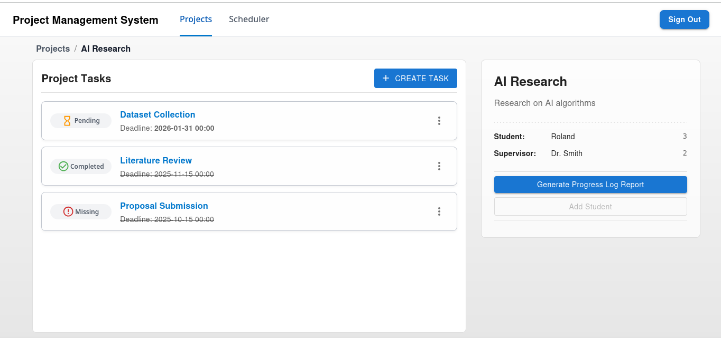Figure 28: PMS - Tasks Dashboard (Supervisor)

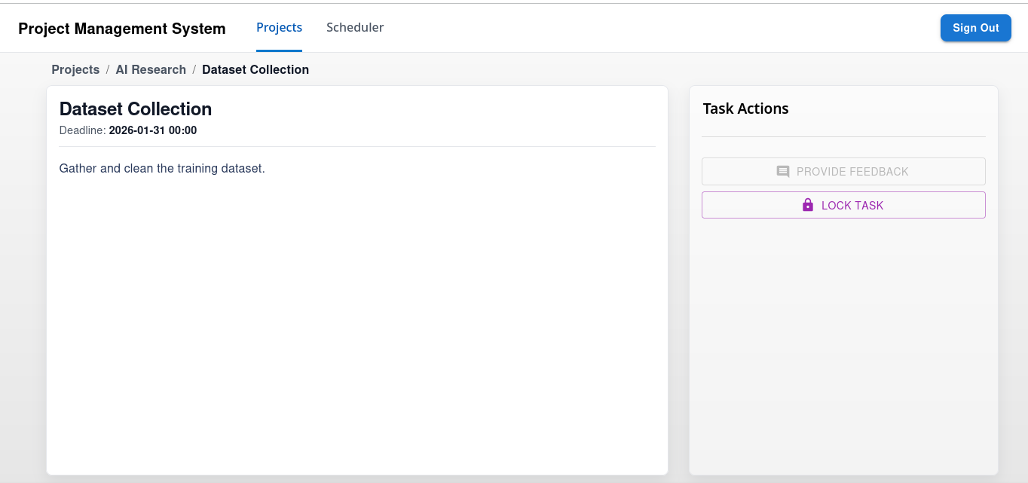Figure 29: PMS - Task Display (Supervisor)
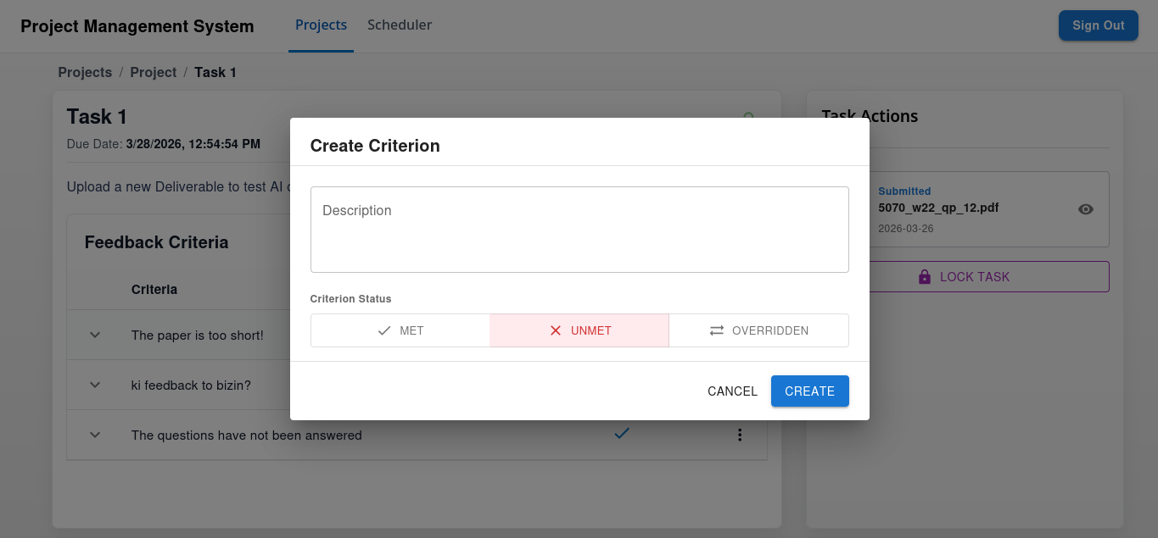Figure 30: PMS - Task Display - Provide Feedback Modal (Supervisor)

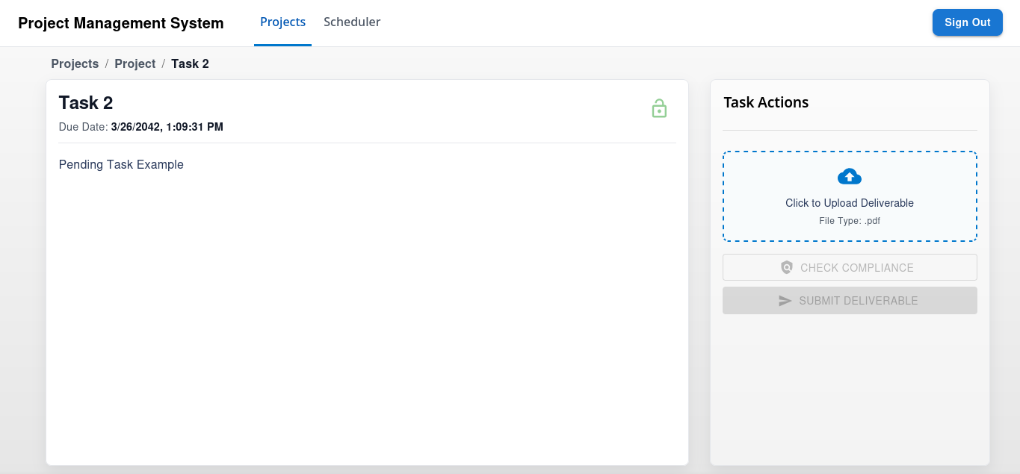Figure 31: PMS - Task Display (Student)

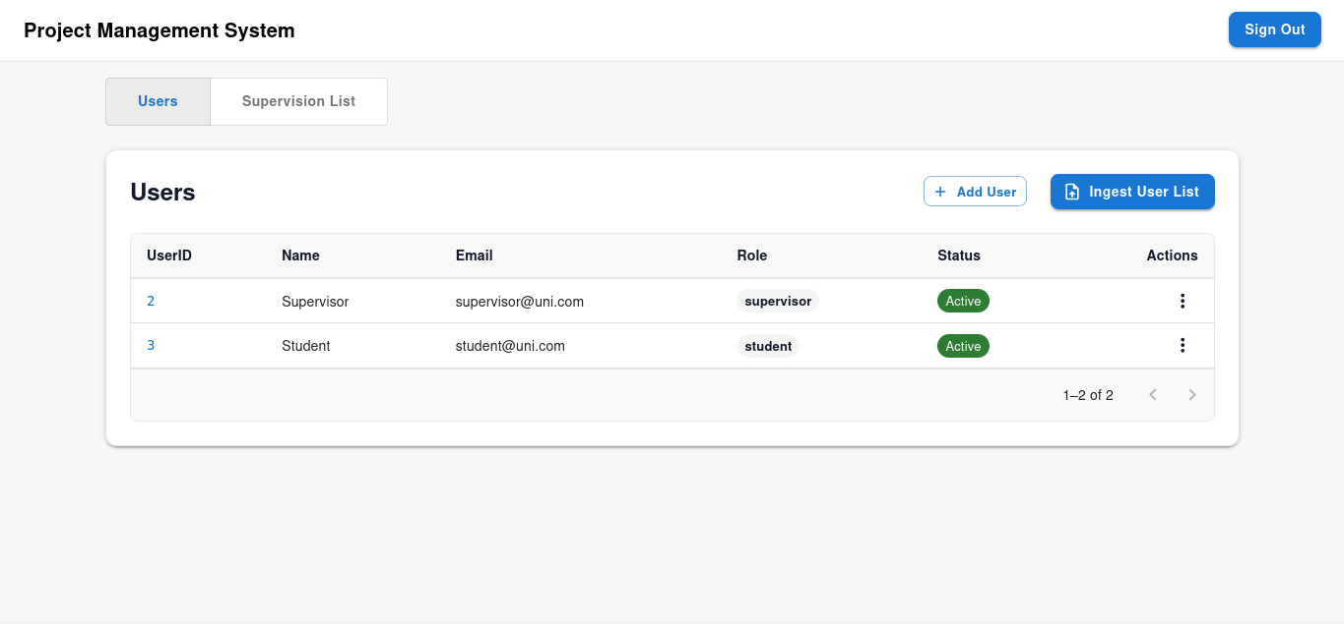Figure 32: Admin Dashboard (Users)

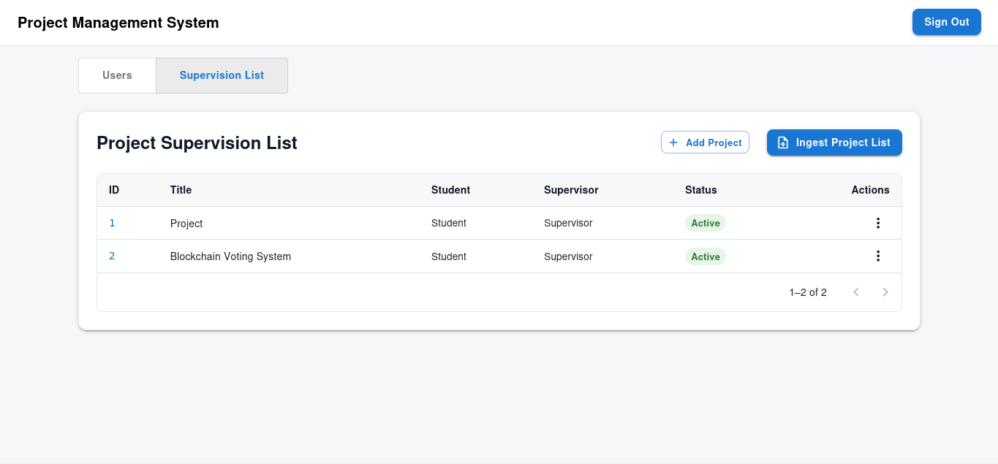Figure 33: Admin Dashboard (Projects)

Implementation
This chapter aims to provide details into the development of the code logic of the application from the design schema and architectural considerations.

Data Definition
The data model definitions and entity configurations have been relocated to Appendix 2. It details the Entity Framework Core (EF Core) classes and the configurations used to map them to the underlying PostgreSQL database.

Application Features
The code-base of the application adheres to key software engineering principles such as maintainability and consistency. This section will therefore only cover the pertinent code sections and the corresponding patterns that underpin the rest of the application code.

The following content will be covered:
- Session Management
- Meeting Display Workflow
- Task Edit Workflow
- AI Feedback Analysis
- Progress Log Report Generation

Session Management
In any secure system, identity verification and access to resources are both governed by two key security principles - authentication and authorization. Since the client and server are physically separate, the system employs a stateless strategy using JWTs – access tokens for resource access authorization and refresh tokens for session renewal. This approach ensures that the user’s identity is cryptographically verifiable and that their session remains secure across the different tiers of the web application.

The following sub-sections will cover Client-Side Token Orchestration and Server-Side Token Life-cycle.

Client Side Token Orchestration
To ensure maintainability, authentication and authorization logic is centralized to a custom React Provider (see appendix). All actions that may change the authentication state of the application are defined as callbacks or other objects and are included in the data that the provider makes available to downstream components.
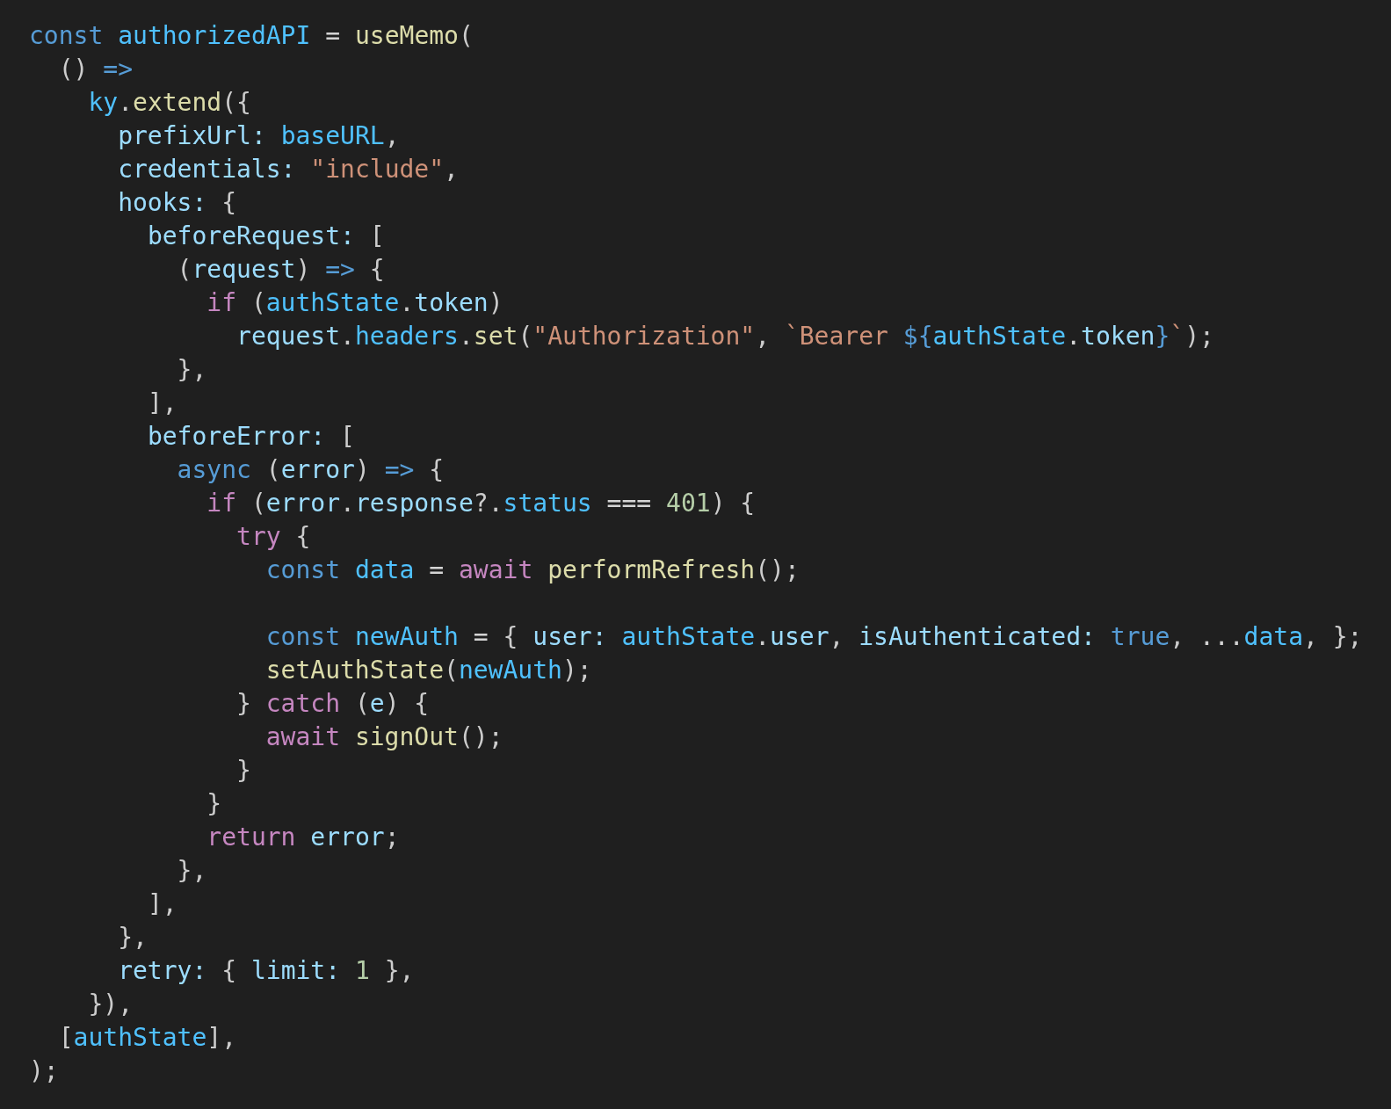Figure 34: Auth API in auth.providers.tsx
The orchestration is primarily handled by an authorized ky instance – a library wraps the native fetch API - to eliminate code duplication through the following mechanisms:
- Request Interception: Before every outgoing request, the ky instance automatically injects the access token into the Authorization header prefixing it with ‘Bearer’. This is a standard practice for creating authenticated REST APIs.
- Automatic Token Refresh For Session Recovery: In the event of access token expiry, subsequent API calls will produce a 401 error. This would be intercepted by the instance to automatically refresh the token. However, if the session could not be recovered, then the user will be forced to logout.
- Request De-duplication: Multiple concurrent API calls may trigger simultaneous refresh attempts, which the server could flag as a replay attack (Appendix 1). To resolve this problem, the client utilizes a refreshPromise variable to track the initial refresh request. Subsequent calls await this single promise, ensuring only one request is sent to the token refresh endpoint.

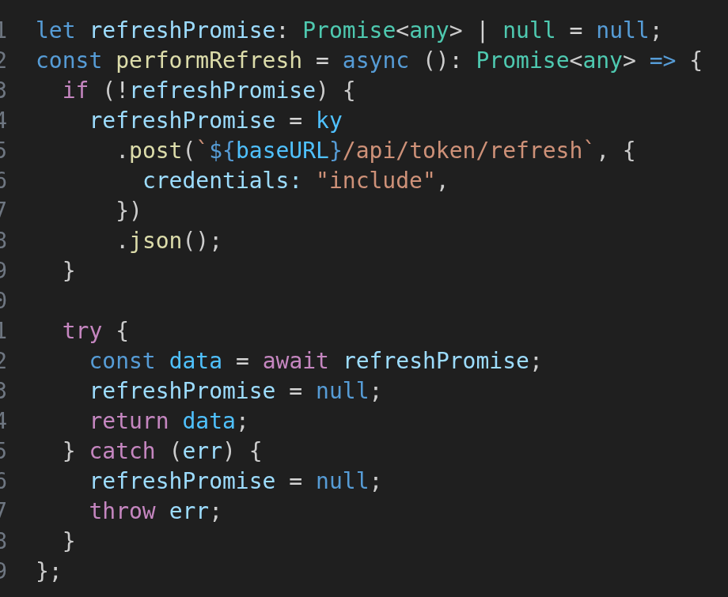Figure 35: performRefresh in auth.providers.tsx

As mentioned above, the React Provider pattern (Appendix 1) allows for the creation of modular components for centralized logic. However, whenever the state variables and callbacks made available through the provider are updated, all of the components that use the provider are forced to re-render, leading to performance bottlenecks. To solve this, React memoization hooks (Appendix 1) – useMemo and useCallback – are used to restrict the conditions under which the aforementioned variables and callbacks are re-created.

Server Side Token Life-cycle
While the client manages the session, the server is responsible for the secure generation, transmission and validation of the tokens.

The following items are covered in the upcoming sub-sections:
- Token Generation
- Token Transmission
- Custom Ownership Authorization

Token Generation
The tokens are generated with claims to enable user identification. The sub claim which the subject identifier as defined by OpenID Connect (Sakimura et al., 2024) is mapped to the userID, and the role claim represents the role of the user.

The generation process follows a two-stage workflow:
- Initialization of the Credential: During the instantiation of the token service, the server retrieves a secret key from its environment variables to construct the signing credentials using the HMACSHA256 algorithm. This ensures that only the application server can generate and validate tokens (Microsoft, 2024) because the resulting hash from HMACSHA256 becomes unique to both the input data and the secret key provided.
- Token Signing: When the token is generated, the HMACSHA256 algorithm, which utilizes the secret key as a symmetric key, generates a digital signature for the token. The token is then bundled with the digital signature and is then serialized into a string representation for transmission.

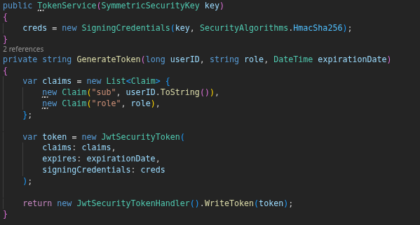Figure 36: Generate Token method in Token.Service.cs

Token Transmission
As mentioned earlier, the application distinguishes between access and refresh tokens. While access tokens are employed in the authorization for resource access, refresh tokens possess the ability to generate new access tokens, and therefore renew expired sessions. Therefore, it is paramount to ensure that they are transmitted securely.
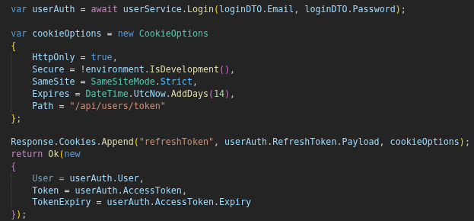Figure 37: Setting Refresh Token Cookie in User.Controller.cs
The following are the security measures employed:
- HTTP-Only Cookie: The refresh token is transmitted as an HTTP-only cookie, which prevents programmatic access via JavaScript and thus prevents XSS risks. Its scope is also restricted to the token refresh and logout endpoints to ensure it is only sent when necessary.
- CSRF Mitigation: By setting the SameSite attribute to Strict, the browser is instructed to only include the cookie only when the website domain for the client matches that for the application server. This effectively prevents Cross-Site Request Forgery (CSRF) attempts.

Custom Authorization Policy
In the .NET security framework, authorization is performed via security policies. While .NET provides a built-in RBAC policy, it lacks a dedicated Ownership policy that works with API route search parameters. To address this, a custom Ownership policy was implemented.

In the figure below, a custom requirement and its corresponding handler is created for the policy. The handler executes after the user’s identity has been verified. It extracts the sub claim from the validated JWT, and compares it against the userID route parameter of the incoming request. Its function is to essentially prevent users from performing actions on behalf of other users (e.g userID: 1 cannot perform GET /api/users/2/projects).

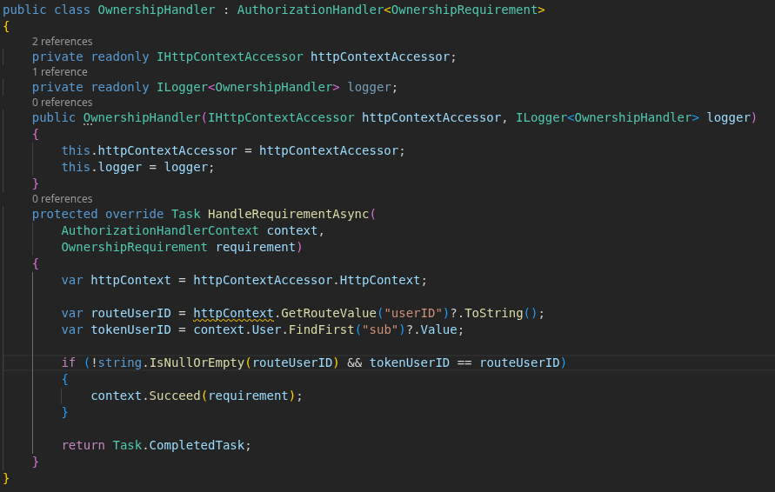Figure 38: Ownership Policy

Meeting Display Workflow
While the Meeting Display Workflow may not necessarily be one of the more complex features of the system, it introduces several design patterns and concepts that underlie other functionalities.

The section will be broken into the following distinct parts:
- Server Data Retrieval
- Temporal Data Management
- Scheduler Rendering

Server Data Retrieval
The workflow initially starts with the client making a request to fetch meeting data from the server. The server, or more specifically, the web host will listen for such HTTP requests and dispatch threads to service them. It will search for the controller which maps the request route/URL and instantiate it alongside its dependencies before calling the appropriate method.
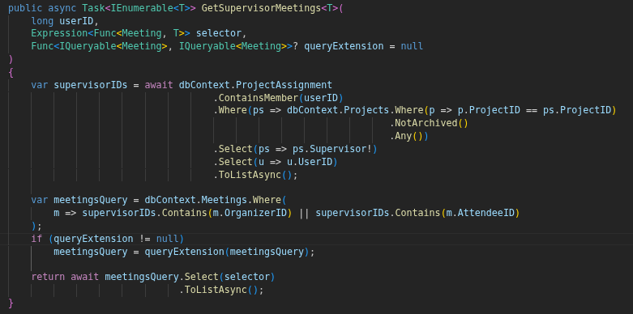Figure 39: GetSupervisorMeetings method in Meetings.Service.cs
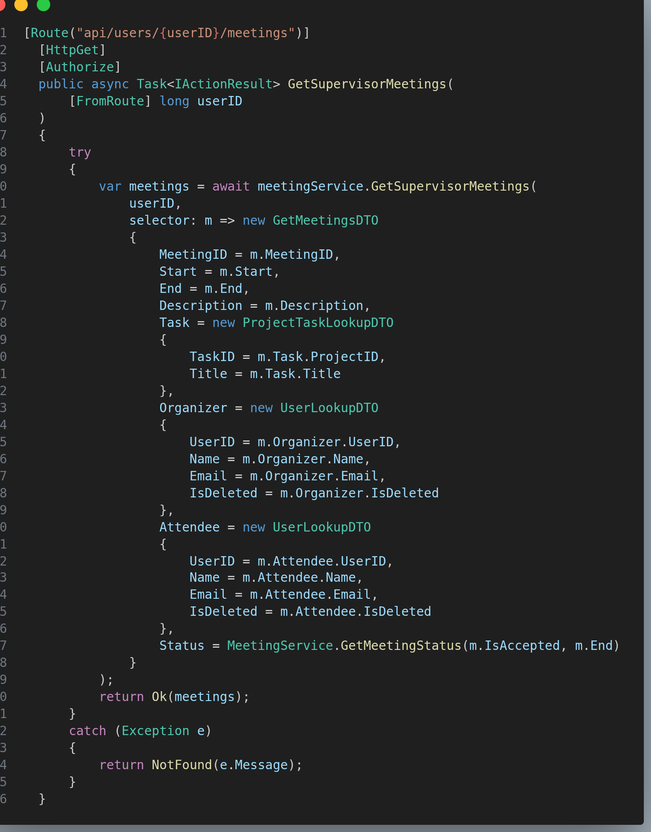Figure 40: GetSupervisorMeetings method in Meetings.Controller.cs
The role of the controller method is intercept a specific request, dictated by its associated Route annotation, parse the data from the request’s route parameters, body and optionally search parameters and then execute the application logic before returning a response to the client.
In the example shown in the figure above, the meetings controller method will invoke the meetingService.GetSupervisorMeetings method to retrieve meeting data from the database. This method, along with similar services, is governed by the following architectural patterns and mechanisms:
- Generics: The service employs Generics (Appendix 1) to define a standardized query interface that dynamically determines the output format of the retrieved data. This flexibility allows the system to return data either as raw entities when EF Core's change tracking feature (Appendix 1) is required, or as DTOs for securely transmitting data to the client.
- EF Core: Entity Framework Core manages complex database logic while abstracting its underlying schema. As explained in a preceding section, it allows developers to treat database entities as classes in the application tier.
- Query Extensions: They allow for optional customization of the base query. This mechanism ensure that the retrieval logic remains modular while retaining the performance of fetching related data in the same number of database round-trips as the base query.

Temporal Data Management
It is important to highlight that temporal data are stored and transmitted in UTC format to avoid ambiguities associated with different time zones. Nonetheless, upon reaching the client, it is parsed and automatically converted into the user’s local date and time, which is then displayed within the scheduler.

Scheduler Rendering
On the client, the scheduler.route.tsx file logically represents the web page for the meeting scheduler. The route files in the application adhere to a standardized pattern whereby server side data fetching are centralized within the route-level components. This approach facilitates code organization and ensures that other components are purely focused on presentation.
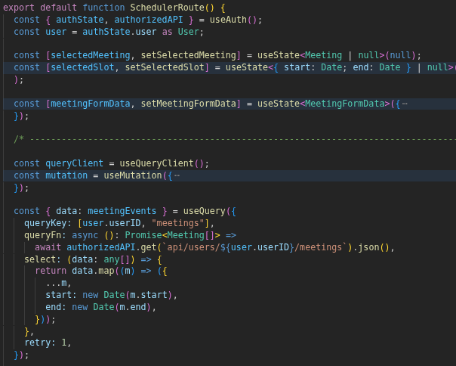Figure 41: SchedulerRoute + Meeting Query code snippet in scheduler.route.tsx
To manage the meeting data life-cycle, the Tanstack Query (tanstack.com, 2026) external library is used. It provides utilities to synchronize component state with the latest server data. The useQuery hook, which is one of such utilities, manages the state of the HTTP request such that when a request transitions from one state to another (successful response or error), it will cause React will automatically re-render the component to display the fetched data.

Tanstack Query considerably overhauls the React useEffect hook (Appendix 1), which often requires significant boilerplate to handle loading states and error catching. Its primary strength lies in the programmatic invalidation of queries; by assigning a unique queryKey, the system can trigger a background refetch whenever related data is updated. This ensures the scheduler always displays the most current data without manually having to manage it.

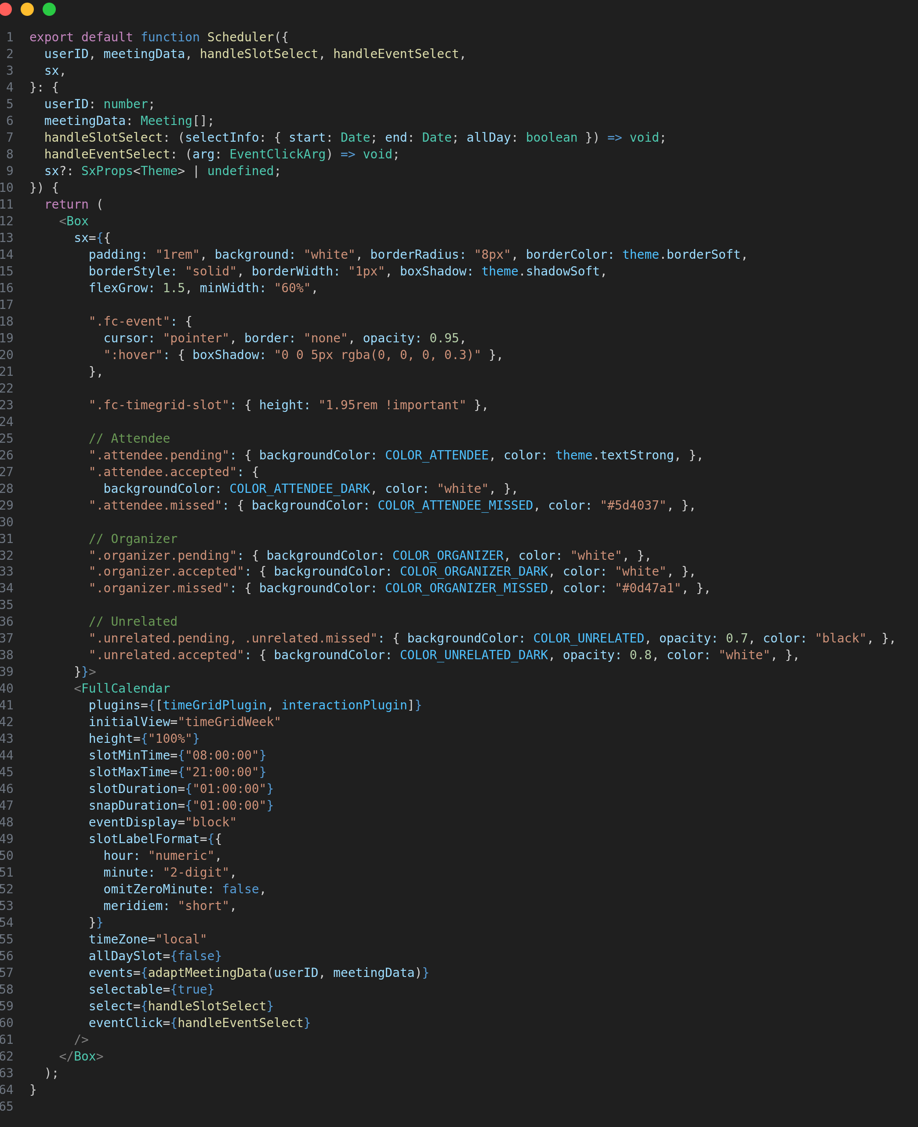Figure 42: Scheduler in scheduler.component.tsx
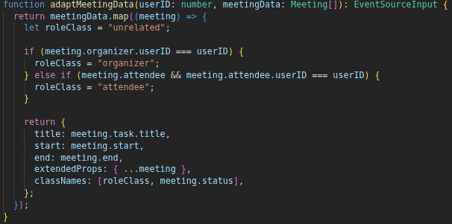Figure 43: adaptMeetingData in scheduler.component.tsx
The last stage of the workflow consists of displaying the meeting data within the Fullcalendar (fullcalendar.io, 2026) scheduler component. There are two important points to consider in this process:
- The Scheduler Component: The FullCalendar component from the react-fullcalendar external library, is configured with the timeGridWeek plugin to display a structured weekly view. Other configurations are provided to render the scheduler functional.
- Data Adaptation: The adaptMeetingData function serves as a bridge between the meeting collection from the server and the format required by FullCalendar. Visual flairs are injected into the formatted data as CSS classes, based on the user’s meeting role and its status.

Task Edit Workflow
This section mainly highlights the architecture of the task modal, the overall task edit workflow and the integration of a mailing service on the server. It will be divided into 3 parts:
- Task Modal Architecture
- Data Mutation
- Server-Side Transactions
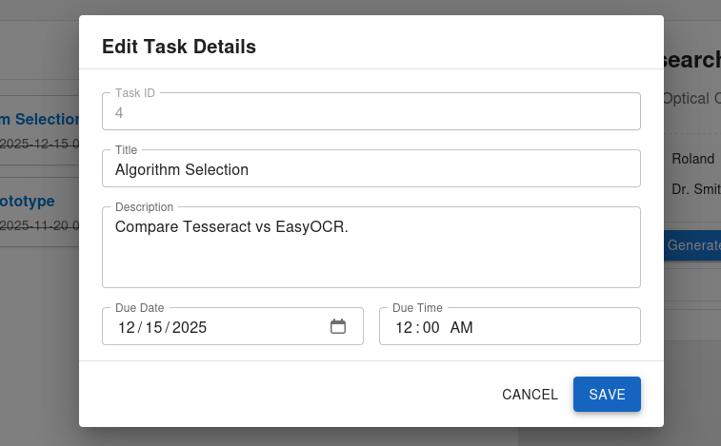Figure 44: PMS - Project Task Modal

Task Modal Architecture
The task modal has been intentionally designed to be modular and to have the capacity to seamlessly operate with other components. The following points provide more detail on the approach used:
- Component Composition: Instead of developing a single component, the modal is decomposed into modular sub-components, satisfying two objectives. Firstly, it provides a clear outline of the structure of the component, allowing developers to understand its layout at a glance and secondly, it enhances re-usability by allowing individual pieces of the modal to be swapped interchangeably.
- Centralized Event Handling: All event handlers are defined within the parent route component and passed down to the other components. This centralization enables the modal and other downstream components to interact indirectly with one another.

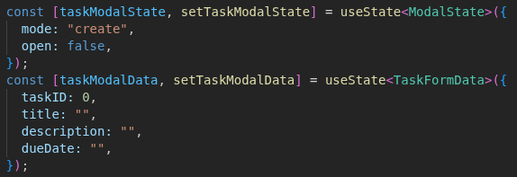Figure 45: Task Modal - State and Data
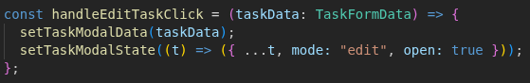Figure 46: Task List Entry Menu – Edit Button Handler
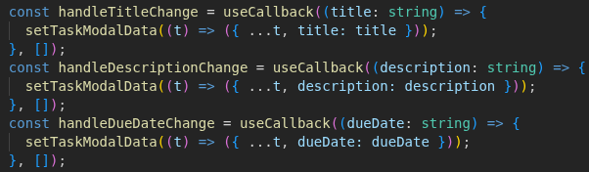Figure 47: Task Modal - Handlers
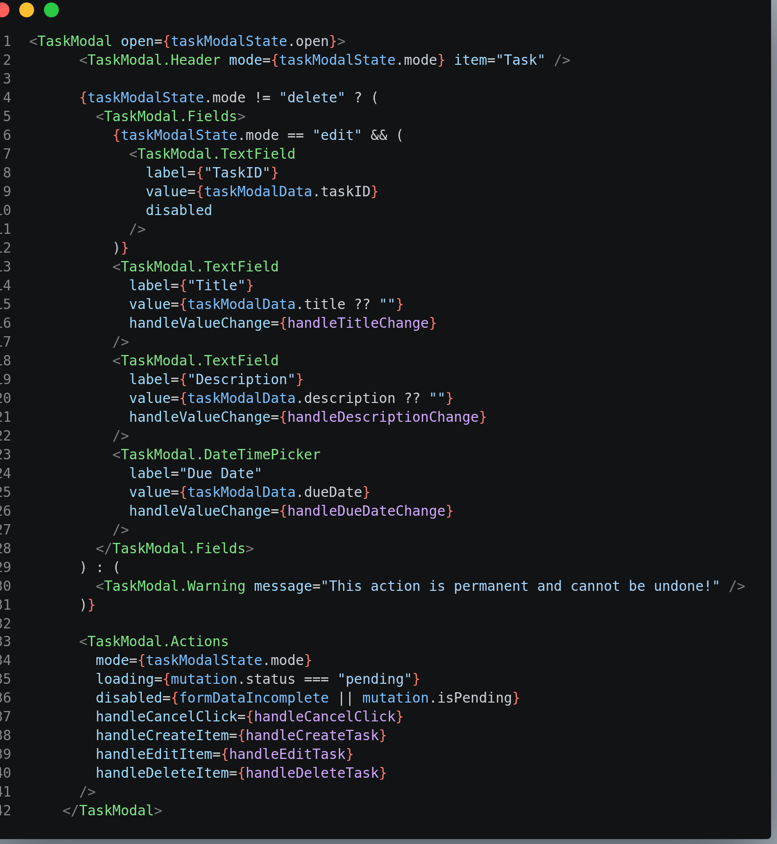Figure 48: Task Modal in dashboard-tasks.route.tsx
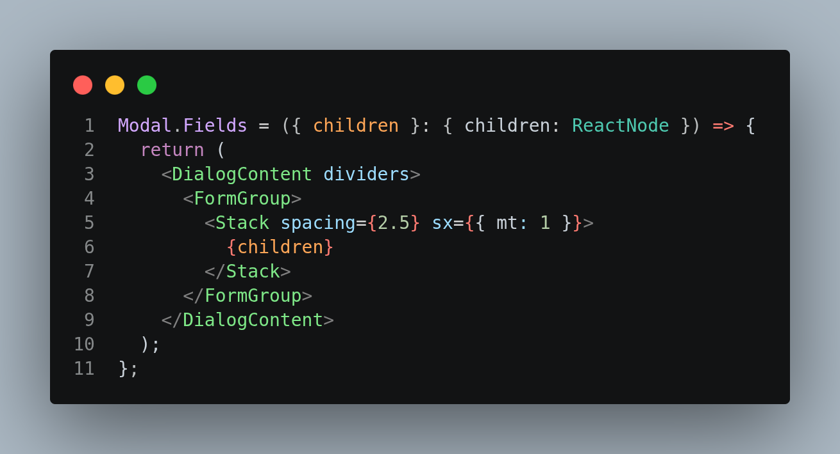Figure 49: Modal.Fields in modal.component.tsx

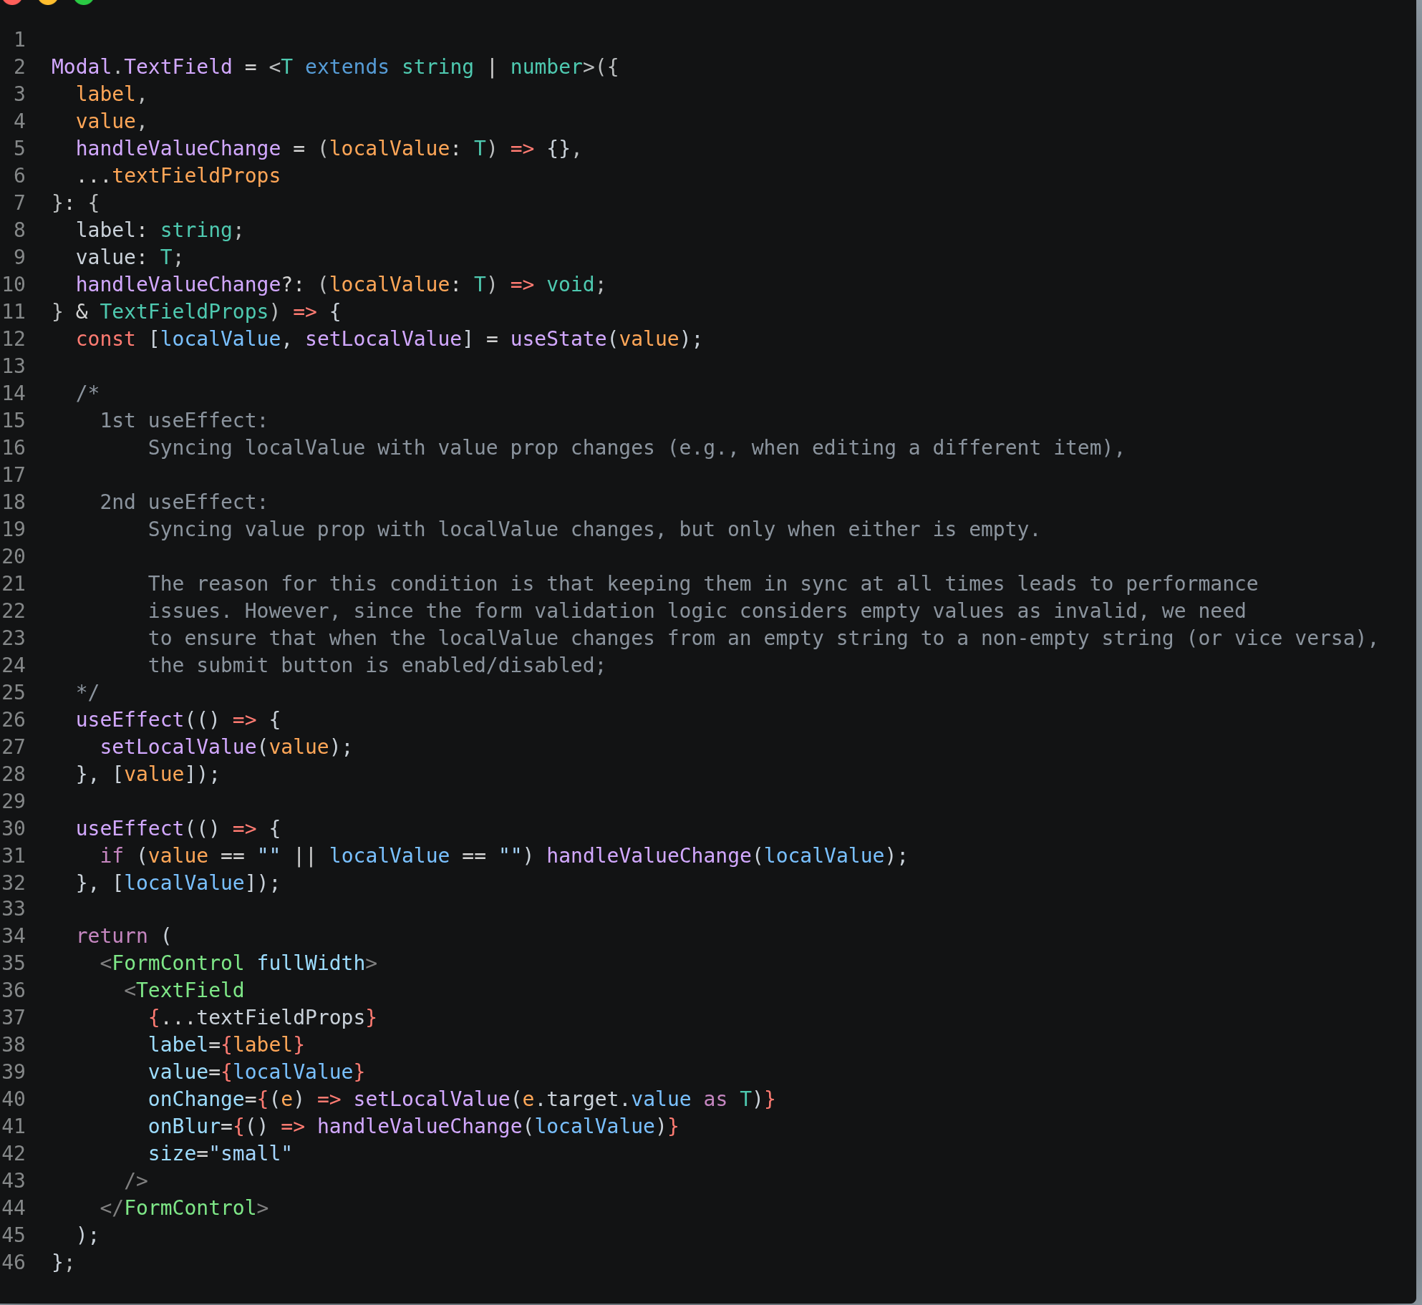Figure 50: Modal.TextField in modal.components.tsx

The implementation of the underlying sub-components (composite components) leverages Material UI (mui.com, 2026), an external UI library that offers a wide range of customizable and thoroughly-tested components. The use of external UI libraries also significantly reduces development complexity and enhances code readability and maintenance.

Data Mutation
Once the save button in the task modal is clicked, a request is sent to the server to update that specific task. Tanstack Query’s mutation feature ensures that the corresponding task data is re-fetched from the server upon completion of the update request.
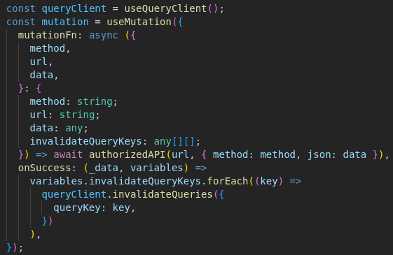Figure 51: Task Edit Mutation in dashboard-tasks.route.tsx
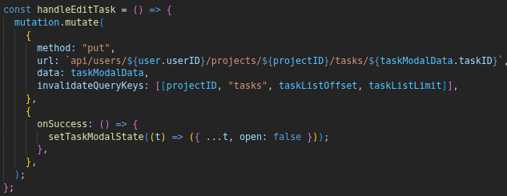Figure 52: Task Modal - Handle Task Edit
Upon receiving a successful response from the server, the mutation executes a callback that invalidates queries associated with a given query key (e.g., [projectID, “tasks”, taskListOffset, taskListLimit] is associated with the task fetching request). This instructs Tanstack Query that the local data is outdated and hence the new data should be re-fetched.

Server-Side Transactions
The task edit workflow encompasses several additional service utilization, from creating new reminders to drafting email notifications. To ensure atomicity of the operations, they are wrapped in a database transaction.
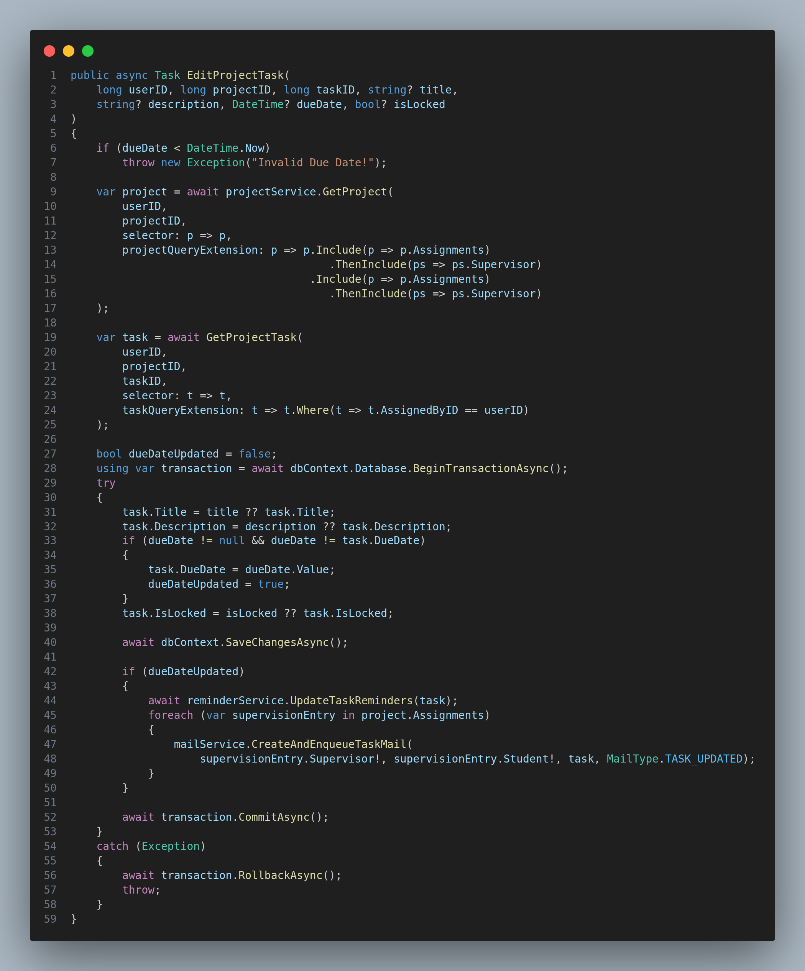Figure 53: EditProjectTask in ProjectTask.Service.cs

AI Feedback Analysis
The AI Feedback Analysis component compares the newly staged deliverable with the previous deliverable submission to update the feedback criteria, tracking the relevant changes for each of them.
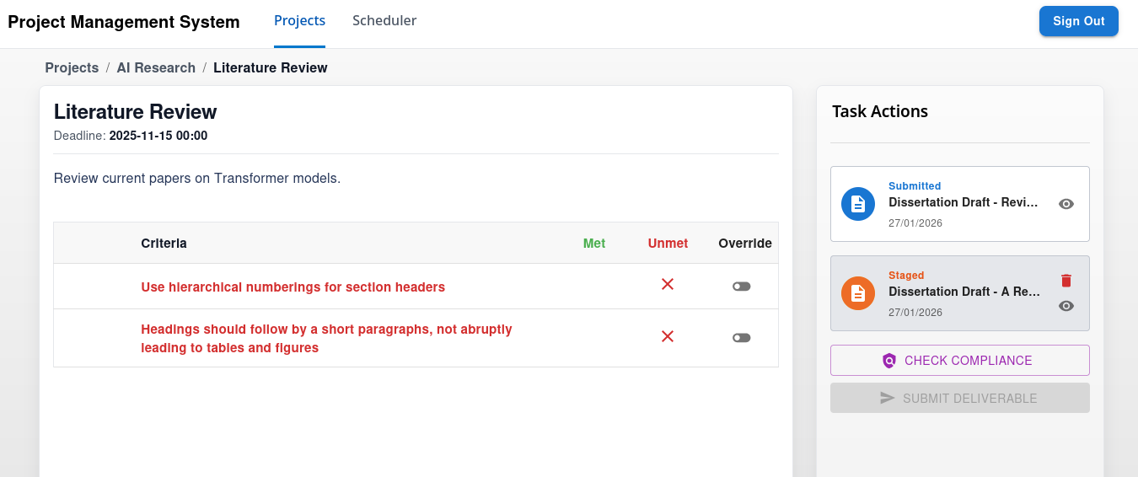Figure 54: PMS - Task w/ Feedback Interface
Due to the high latency associated with Large Language Model (LLM) processing, the AI compliance analysis is implemented as an asynchronous operation. This ensures that the web server remains responsive while the Gemini Multi-modal LLM performs the comparative analysis and updates the feedback criteria. However, the primary weakness of this approach is that the client would require a way to receive an update from the server once the LLM has produced a response. While bi-directional communication (such as Websockets) was considered, polling has been opted instead due to its lower implementation complexity. By continuously polling the server on the status of the AI compliance job, the client is then able to determine when the AI analysis has completed and thus refresh the feedback criteria.

This section will thus be divided into two parts:
- AI Compliance Job Creation
- Asynchronous Job Execution.

AI Compliance Job Creation
Upon clicking on the “Check Compliance” button, a request for creating the background job is sent to the server. Then, after the server accepts the request, the client will start polling its status. If the job status changes to completed, the refresh will be triggered, updating the UI with the changes.

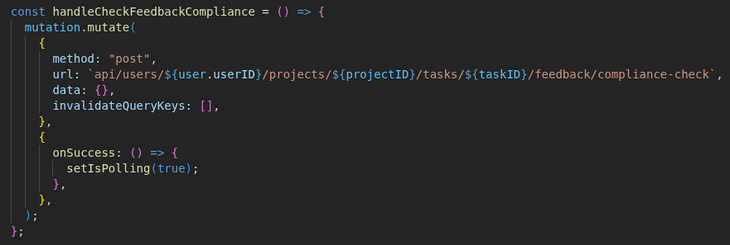Figure 55: Check Compliance Handler in task.route.tsx
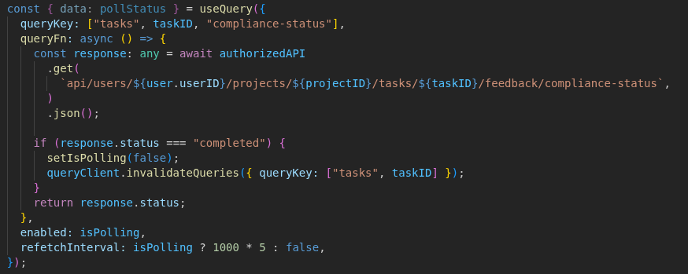Figure 56: AI Compliance Job Polling in task.route.tsx
On the server, the request to create a new job will first validate the user request and fetch the required data to construct the LLM prompt. An AIJob object will encapsulate both the actual payload and the configuration for that specific LLM invocation call. Lastly, it then gets passed to the background queue.
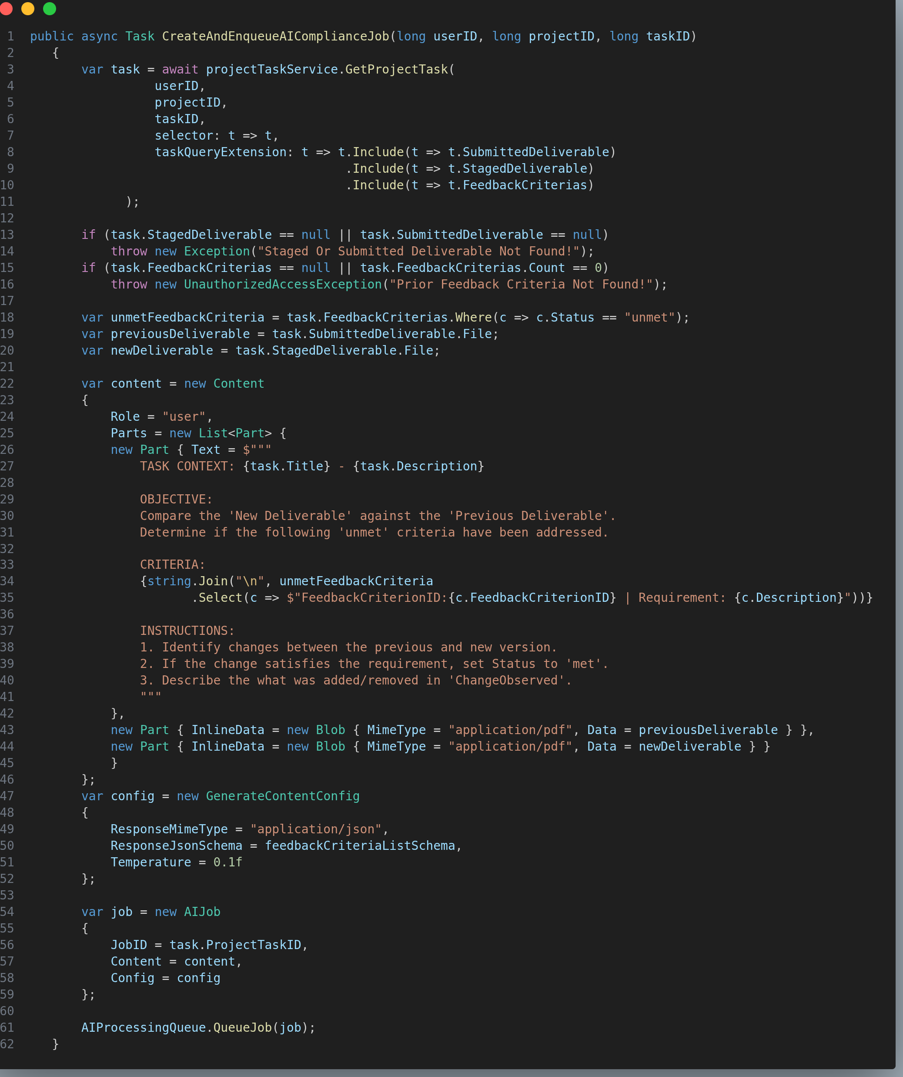Figure 57: CreateAndEnqueueAIComplianceJob in AICompliance.Service.cs
To understand the mechanism behind an LLM API invocation, it is important to consider these two points in greater detail:
- Payload Construction
- Configuration Definition

Payload Construction
The payload to be sent to Gemini (Google DeepMind, 2025) will include the prompt with the task objectives, the unmet feedback criteria and the two deliverable files. The PDF document files are attached as raw binary data as blob objects.
There are a few advantages of sending them as raw binary data as opposed to text format:
- This approach preserves the model’s ability to consider figures and document layout as opposed document text extraction, which is a lossy process.
- Gemini can leverage its internal document processing tools and multi-modal nature to reduce the input tokens that are computed by the model.

Configuration Definition
The purpose of providing a configuration is to control how the LLM will process the payload and constrain the output.
- The first configuration involves specifying a schema (shown in the Figure below) to constrain the output of the model. To guarantee a valid output, the model zeroes out probabilities for other tokens that do not align with the given schema during inference.
- The second configuration is the temperature of the AI model, which determines the variety of the model’s response. Restricting the temperature to a low value causes the model to only prioritize the most likely token probabilities during processing, and also reduces hallucinations.
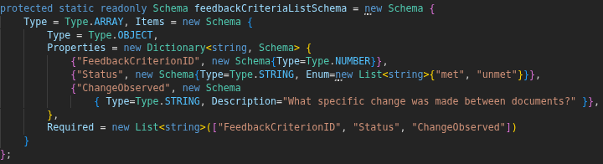Figure 58: AI Response Schema in AICompliance.Service.cs

Asynchronous Job Execution
The background worker will implement .NET’s Background Service interface. This would allow it to be managed by the framework, ensuring it operates parallel to the web server.
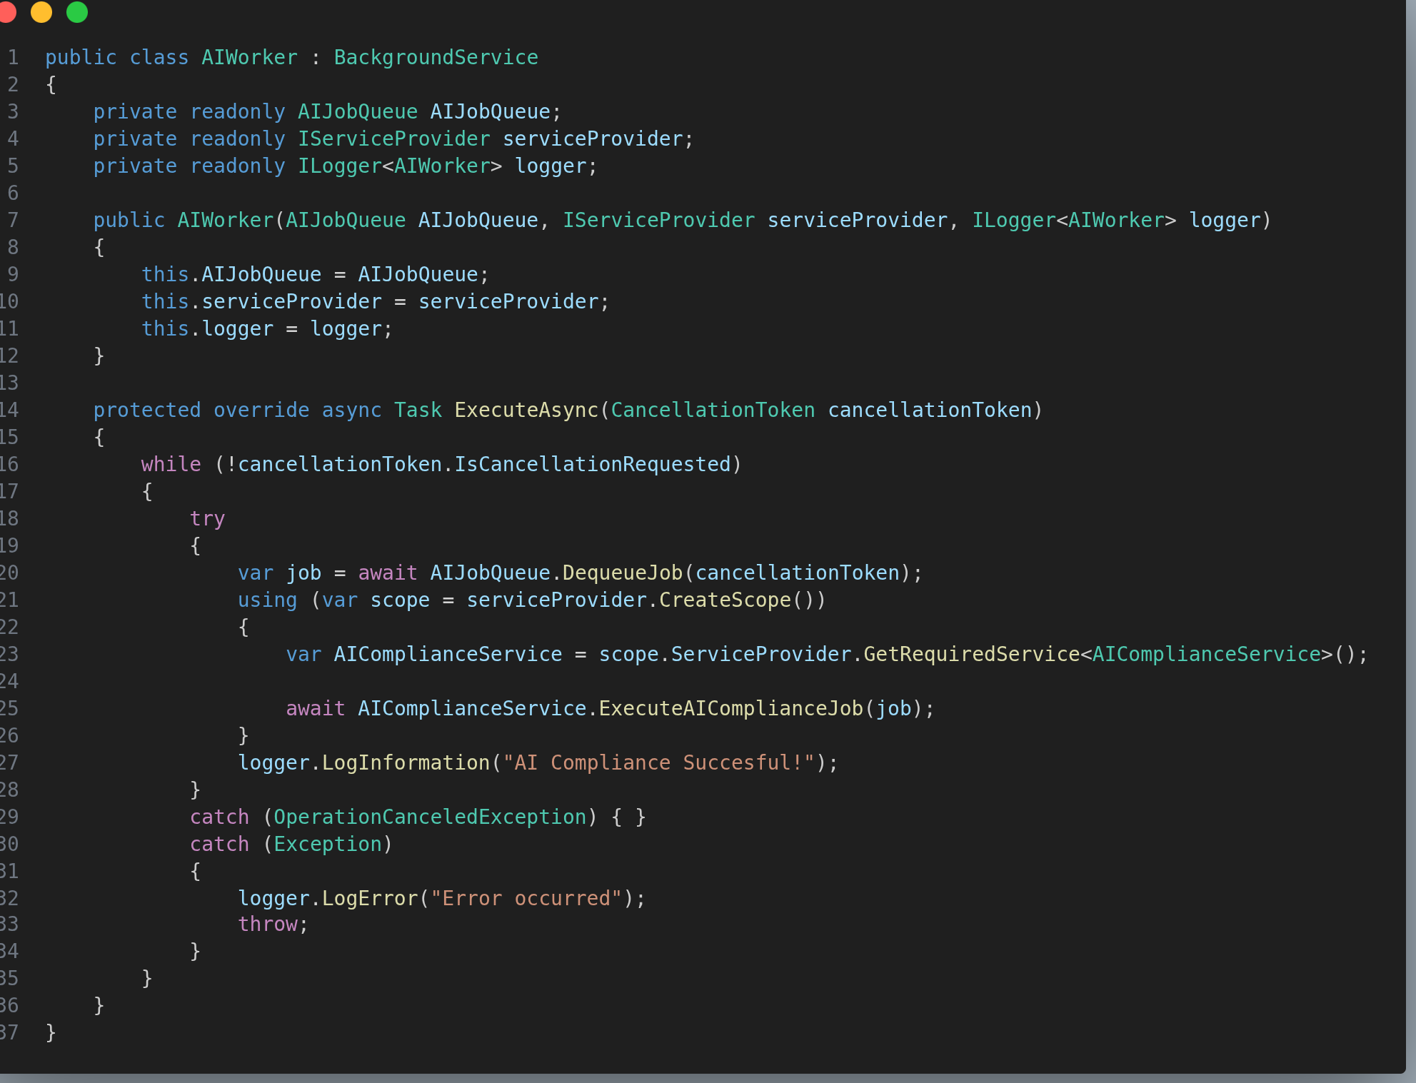Figure 59: AIWorker in AIWorker.Lib.cs

As shown in the figure above, the worker maintains a continuous loop that listens for incoming jobs from the queue. Upon consuming a job from the queue, a temporary scope is created to set the boundary for the lifetime of services meant to run per user request. While this is performed automatically when the web server dispatches a new thread to service an HTTP request, it must be invoked manually for background services.

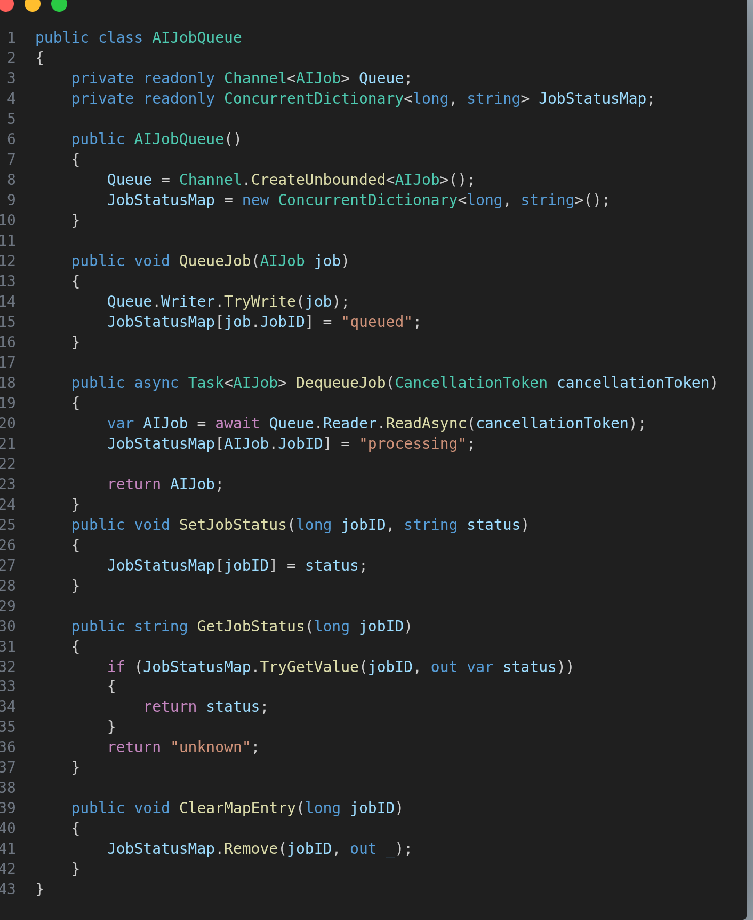Figure 60: AIJob Queue in AICompliance.Service.cs

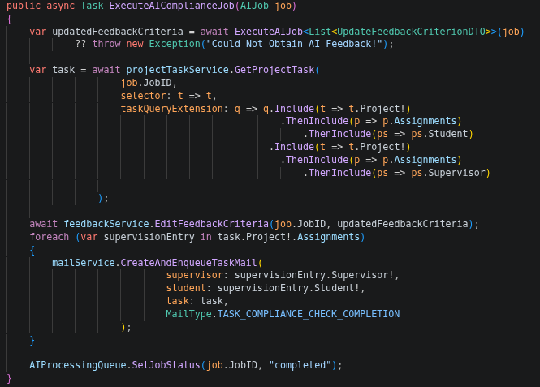Figure 61: Execute Compliance Job in AICompliance.Service.cs
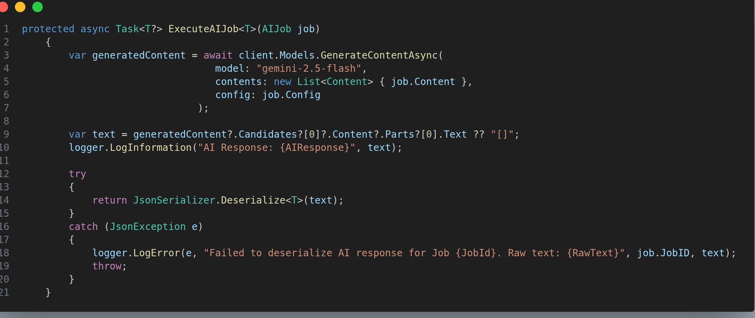Figure 62: Execute AI Job in AICompliance.Service.cs
Once the job execution begins, the system invokes Gemini LLM with the payload and the configuration stored in the Job object. The resulting response is parsed into a JSON object, which is then converted into a suitable format for persisting the changes to the feedback criteria in the database. Lastly, if the updates were successful, an email notification is created and sent to the supervisor and the status of the job in the queue is updated to notify any polling thread of its completion.

Progress Log Report Generation
The progress log report generation feature leverages QuestPDF (QuestPDF, 2020), which is a library that simplifies layout concerns such as word wrapping and element positioning.
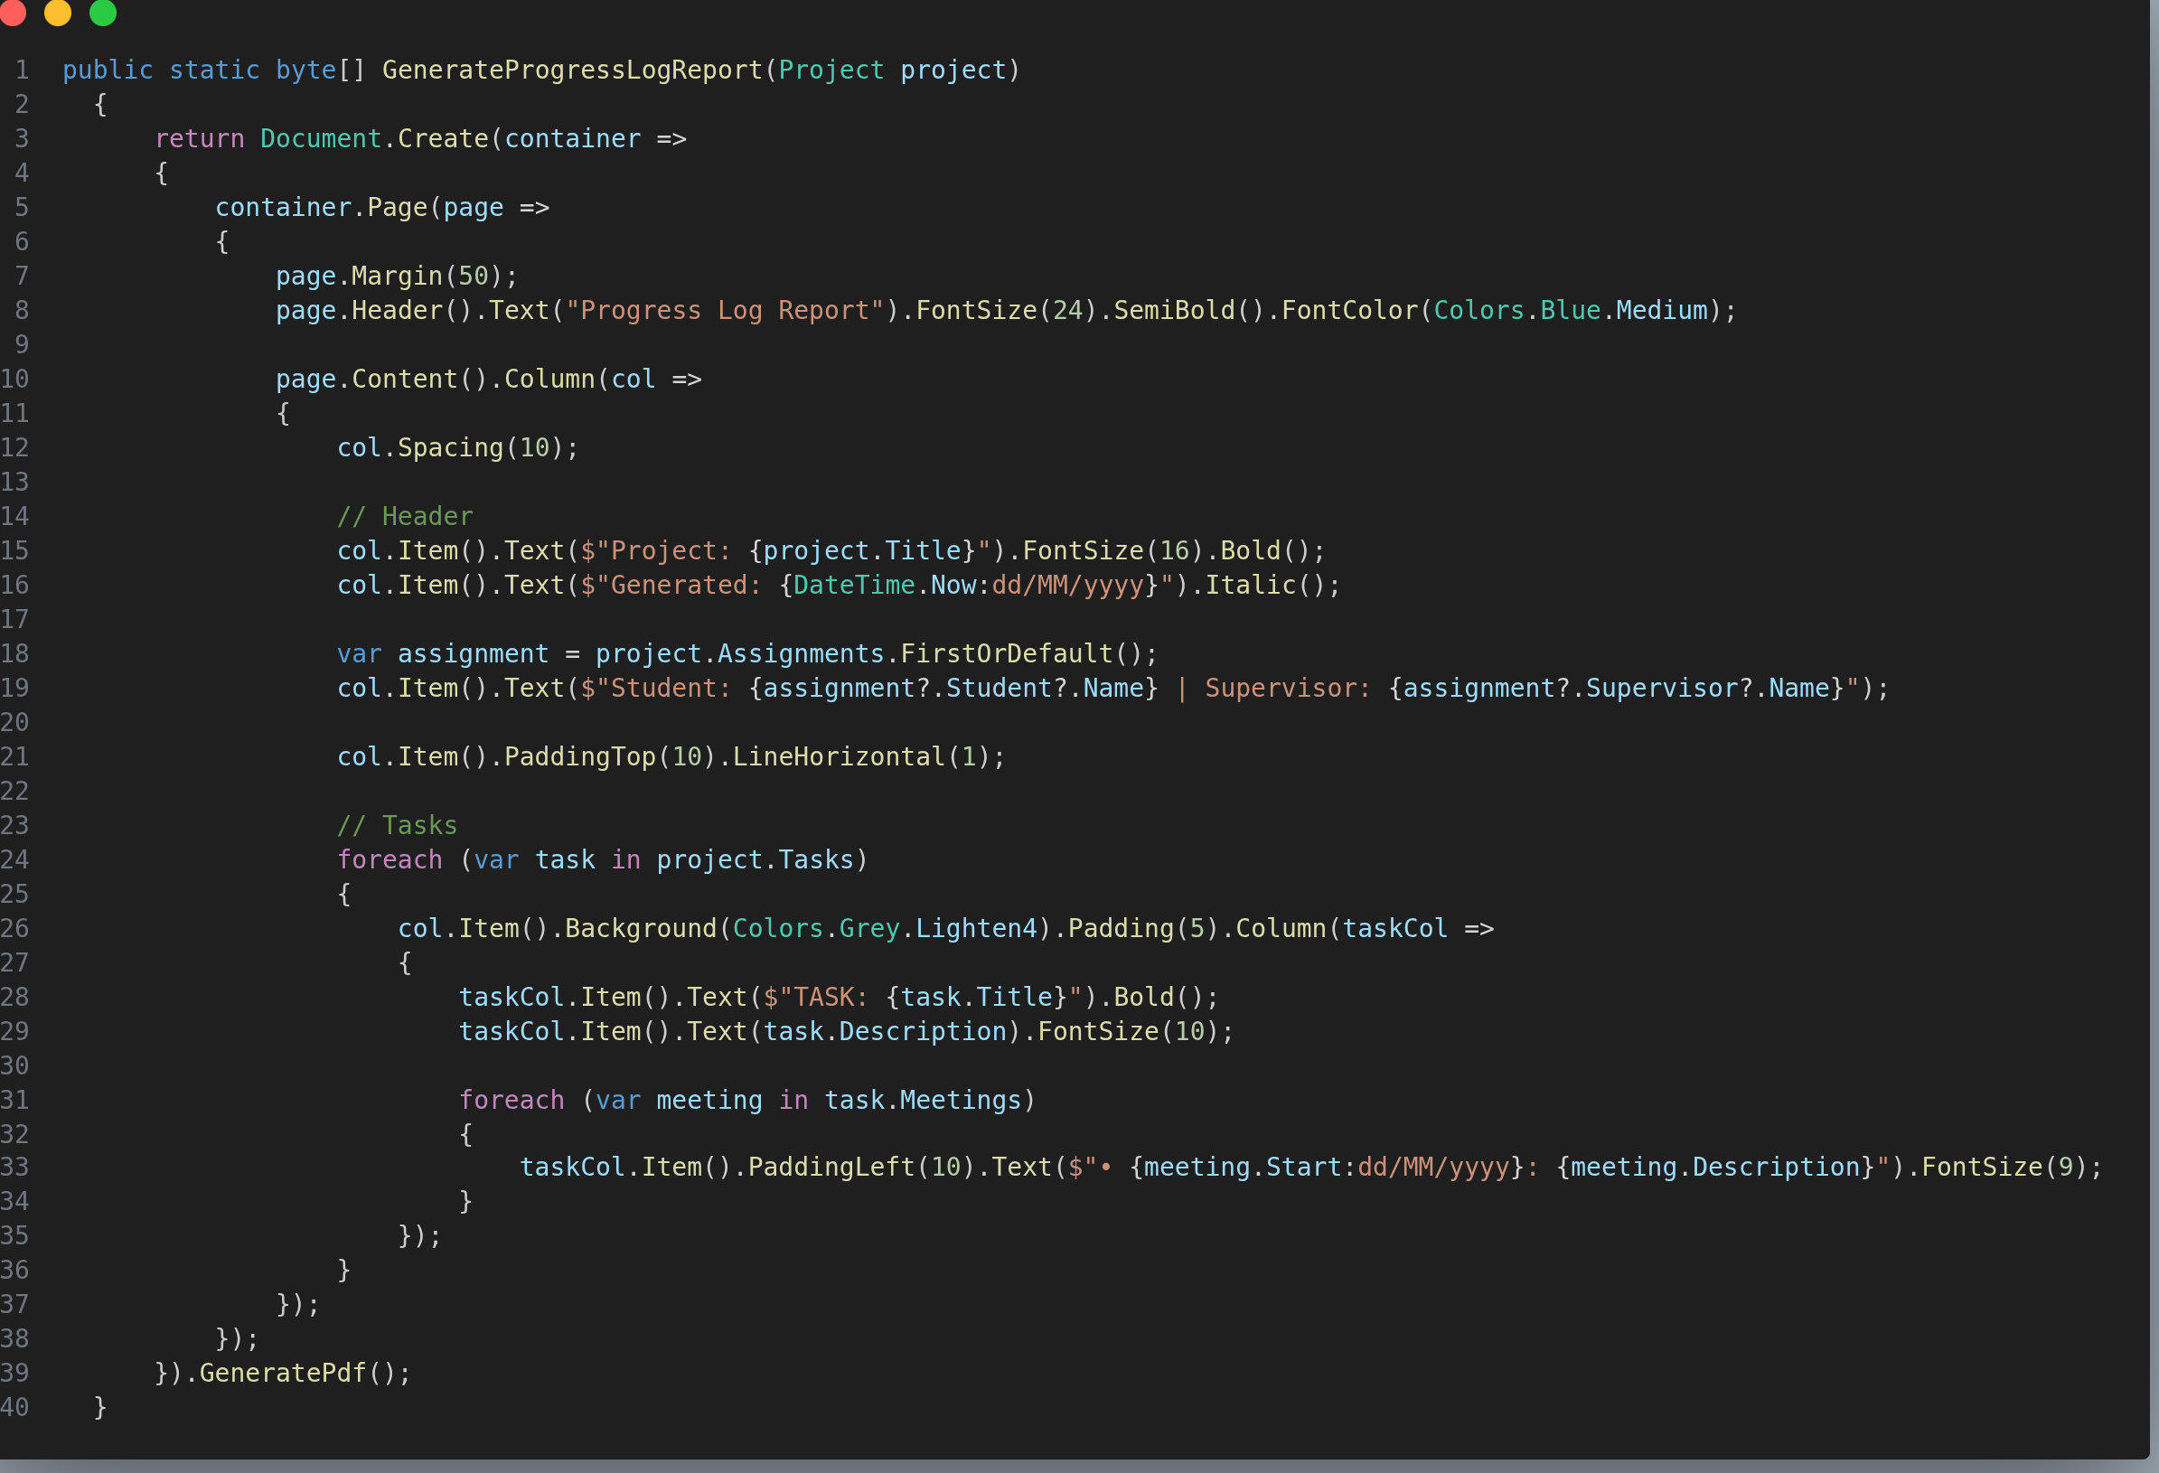Figure 63: GenerateProgressLogReport in PdfUtils.Lib.cs
The progress log report comprises of a project overview, section for project members, and a detailed list of every project task organized in chronological order. Meeting descriptions are also included to show the specific discussions for the corresponding tasks they were associated with.

Testing
The aims of software testing is to ensure that the system conforms to both the requirements specified in the Analysis section and the overall expectations of users from using a project management system.

This chapter is divided into 2 sections - Integration Testing and User Acceptance Testing.

Integration Testing
Integration Testing focuses on validating the interaction between groups of software components. It involves simulating real user scenarios, encompassing both normal and abnormal behavior to ensure that code coverage spans across all tiers (presentation, application, data).

These test cases are packaged into test suites according to the functional requirements in the Analysis chapter, and are covered in the subsequent sections. Each section has related entries in Appendix 3, which contains the diagrams illustrating the actual test observations.

FR1/FR2/FR3
The following tables demonstrate the test cases for user login, the user list ingestion feature and manual CRUD operations on user.
- Validation of Login Functionality
The figure below shows the test cases for the login functionality.
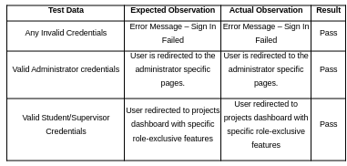Figure 64: Test Cases - Login Functionality

- Validation of User List Ingestion Feature
The figure below shows the table for the test cases for the user list ingestion feature.
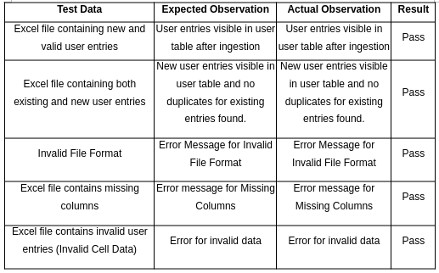Figure 65: Test Cases - User Ingestion List
- Validation of User Create Feature
The figure below shows the test cases for creating a user through the user modal.
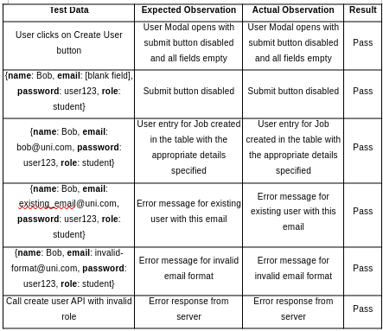Figure 66: Test Cases – User Creation Feature

- Validation of User Edit Feature
The figure below shows the test cases for editing a specific user by clicking on the more button (triple dots) in user table entry and then clicking the edit button.
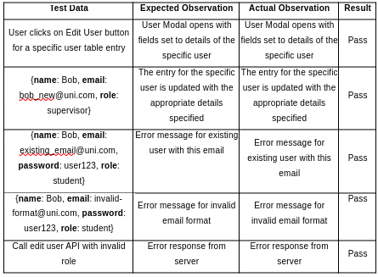Figure 67: Test Cases - User Edit Feature

- Validation of User Deletion Feature
The figure below shows the test cases for deleting a specific user by clicking on the more button (triple dots) in user table entry and then clicking the delete button.
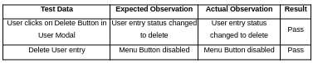Figure 68: Test Cases - User Deletion Feature

FR2/FR4
The following tables demonstrate the test cases project supervision list ingestion feature and manual CRUD operations on projects.

- Validation of Project Supervision List Ingestion Feature
The figure below shows the table for the test cases for the project supervision list ingestion feature.
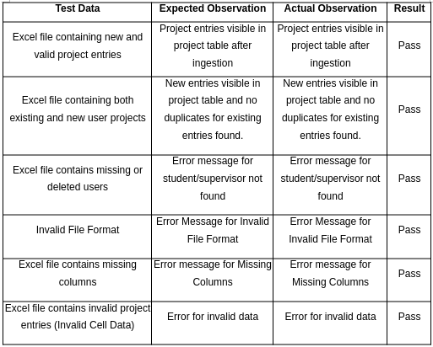Figure 69: Test Cases - Project Supervision List Ingestion Feature

- Validation of Project Creation Feature
The figure below shows the test cases for creating a project through the project modal.
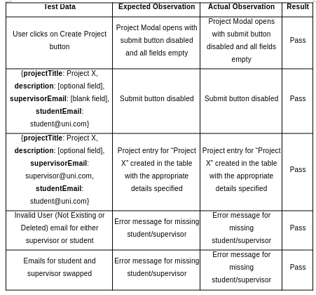Figure 70: Test Cases - Project Creation Feature

- Validation of Project Edit Feature
The figure below shows the test cases for editing a specific project by clicking on the more button (triple dots) in project table entry and then clicking the edit button.
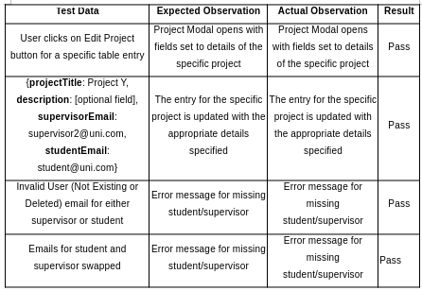Figure 71: Test Cases - Project Edit Feature

- Validation of Project Archive/Restore Feature
The figure below shows the test cases for archiving/restoring a specific project by clicking on the more button (triple dots) in project table entry and then clicking the archive/restore button.
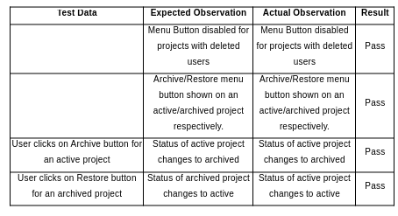Figure 72: Test Cases - Project Archive/Restore Feature

FR5/FR6
The following tables demonstrate the test cases for performing CRUD operations on a project, and testing the navigation logic of the projects dashboard.

- Validation of Project CRUD Operations (Supervisor)
The figure below shows the test cases for performing CRUD operations on project as either a Supervisor or a Student.
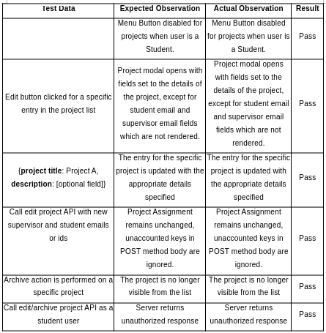Figure 73: Test Cases - CRUD Projects (Supervisor + Student)

- Validation of Project Dashboard Navigation Logic
The figure below shows the test cases for the navigation logic of the supervisor/student dashboard (Project Dashboard).
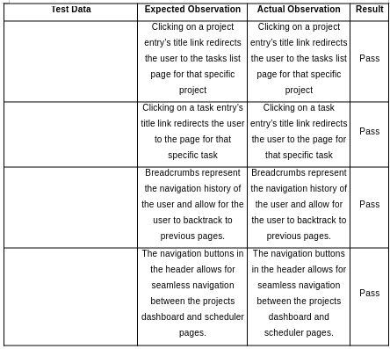Figure 74: Test Cases - Navigation Logic

FR7
The following tables demonstrate the test cases for performing CRUD operations on a task.
- Validation of Task Creation Feature
The figure below shows the test cases for creating a project task as a Supervisor.
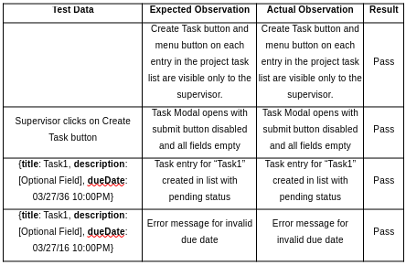Figure 75: Task Creation Feature

- Validation of Task Edit Feature
The figure below shows the test cases for editing a project task.
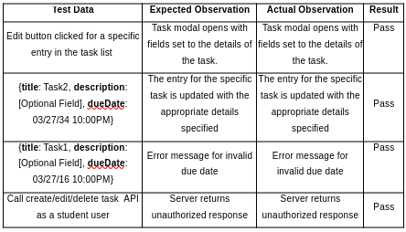Figure 76: Test Cases - Test Edit Feature

- Validation of Task Deletion Feature
The figure below shows the test cases for deleting a project task.
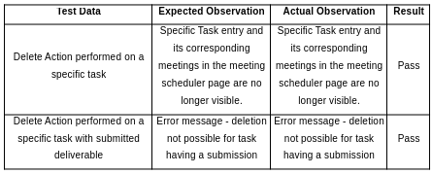Figure 77: Test Cases - Task Deletion Feature

FR9
The following table demonstrates the test cases for automatic task status updates.
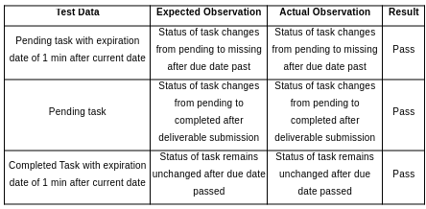Figure 78: Test Cases - Automatic Task Updates

FR8/FR11
The following tables demonstrate the test cases for performing CRUD operations on a feedback criterion and the logic for locking/unlocking a task.

- Validation of CRUD operations on Feedback
The figure below shows the test cases for performing CRUD operation on feedback criteria.
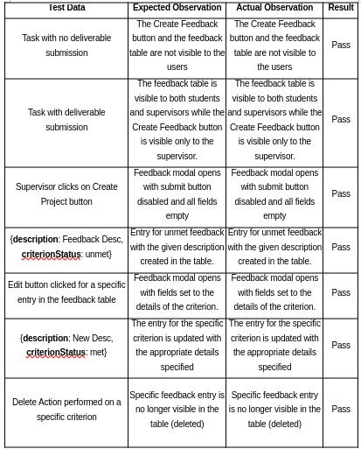Figure 79: Test Cases - Feedback CRUD Operations
- Validation of Task Locking Logic
The figure below shows the test cases for task locking logic.
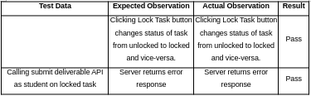Figure 80: Test Cases - Task Locking Logic

FR10/FR13
The following tables demonstrate the test cases for performing CRUD operations a deliverable in the staging area (staging/staged deliverable), file upload size and a submitted deliverable.

- Validation of Staged Deliverable Logic
The figure below shows the test cases for the deliverable staging logic.
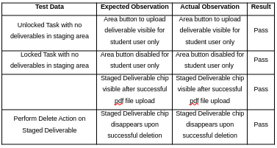Figure 81: Test Cases - Staged Deliverable

- Validation of Deliverable Submission Logic
The figure below shows the test cases for the deliverable submission logic.
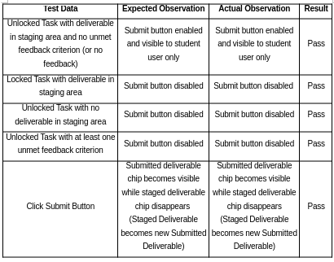Figure 82: Test Cases - Deliverable Submission Logic

FR12/FR14
The following table demonstrates the test cases for the criterion override logic and the AI compliance verification feature.
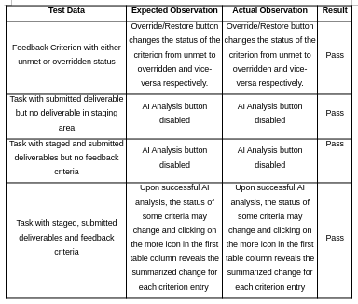Figure 83: Test Cases - Override Criterion & AI Compliance Logic

FR15/FR16/FR17
The following tables demonstrates the test cases for the RSVP actions on meetings for participants and non-participants.
- Validation of RSVP Actions for Meeting Participants
The figure below shows the test cases for the RSVP action logic for meeting participants.
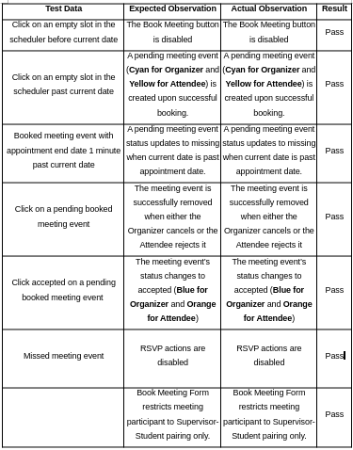Figure 84: Test Cases - Meeting RSVP Actions (Participants)

- Validation of RSVP Actions for Meeting Participants
The figure below shows the test cases for the RSVP action logic for users who are not meeting participants.
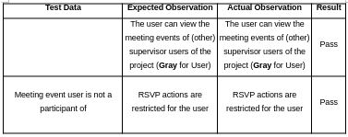Figure 85: Meeting RSVP Actions (Non-Participants)

FR18/FR19/FR20
The following table demonstrates the test cases for the reminder and notification logic and the progress log report generation feature.
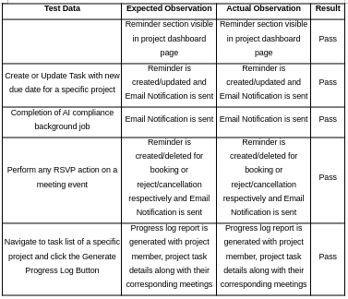Figure 86: Test Cases - Reminder/Notifications & Progress Log Report

User Acceptance Testing
User acceptance testing has been conducted with students from different faculties to obtain constructive feedback on different aspects of the system. They have been asked to complete a survey which was organized on Google Forms.

The following figures shows the responses obtained:
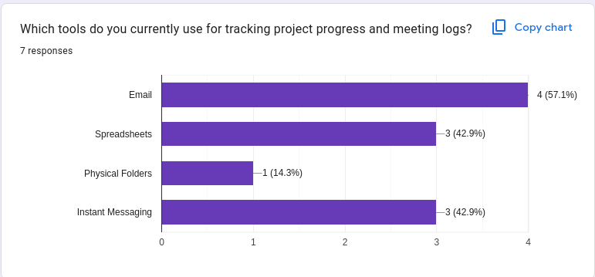Figure 87: User Survey – Traditional Supervision Section - 1

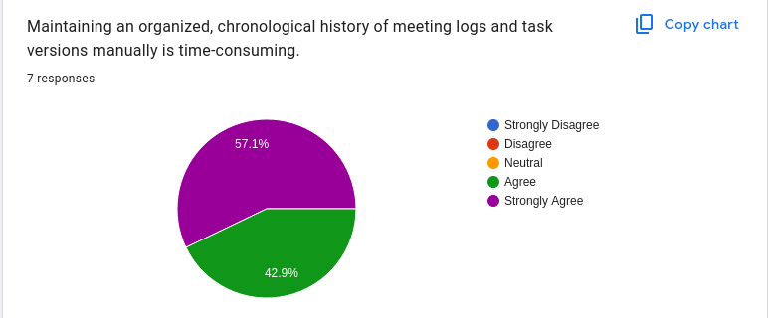Figure 88: User Survey – Traditional Supervision Section - 2

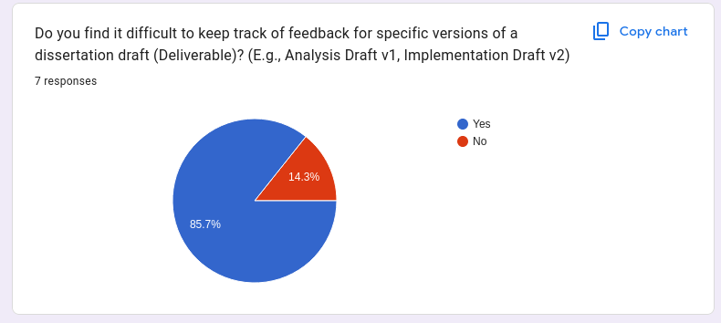Figure 89: User Survey– Traditional Supervision Section - 3

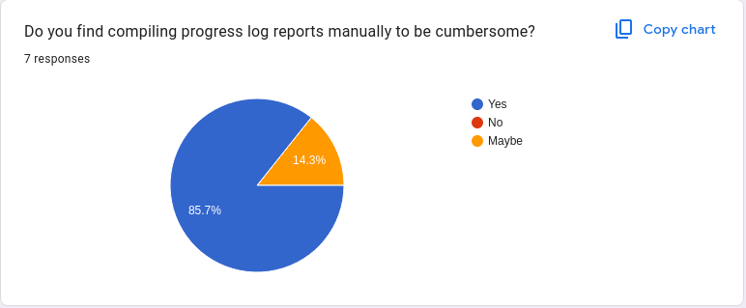Figure 90: User Survey – Traditional Supervision Section - 4

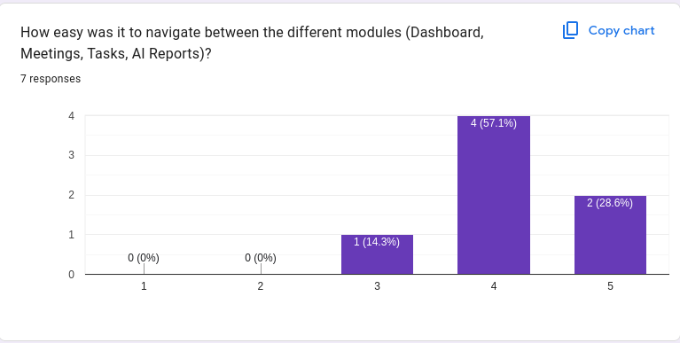Figure 91: User Survey - System Usability - 1

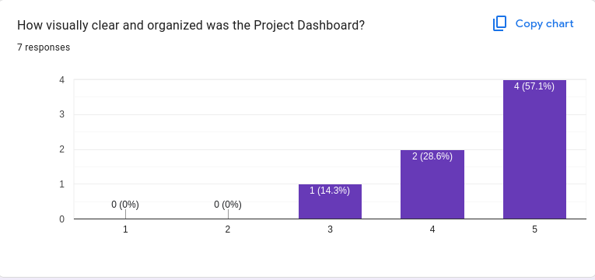Figure 92: User Survey - System Usability - 2

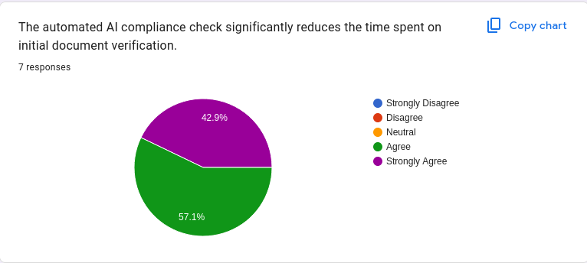Figure 93: User Survey - System Usability - 3

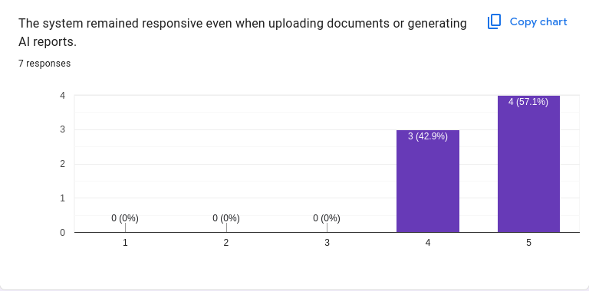Figure 94: User Survey - System Usability - 4

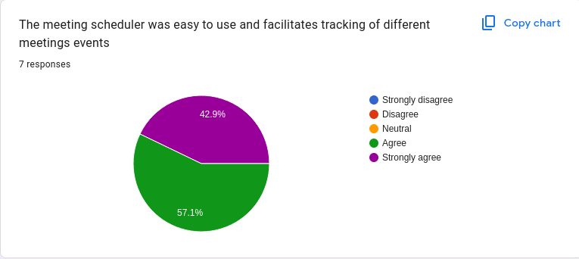Figure 95: User Survey- System Usability - 5

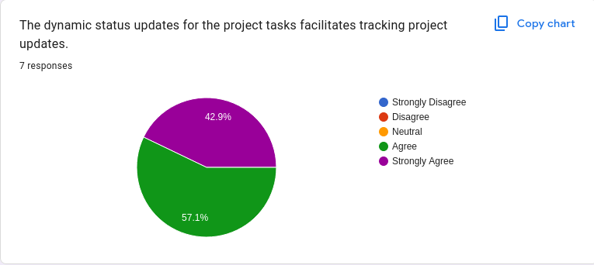Figure 96: User Survey - System Usability - 6

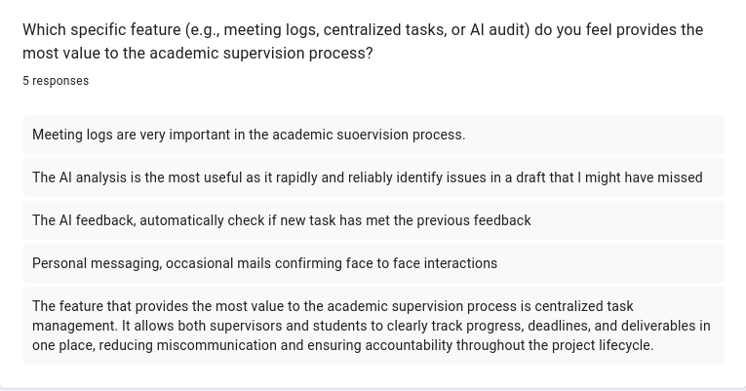Figure 97: User Survey - Most Valuable Feature

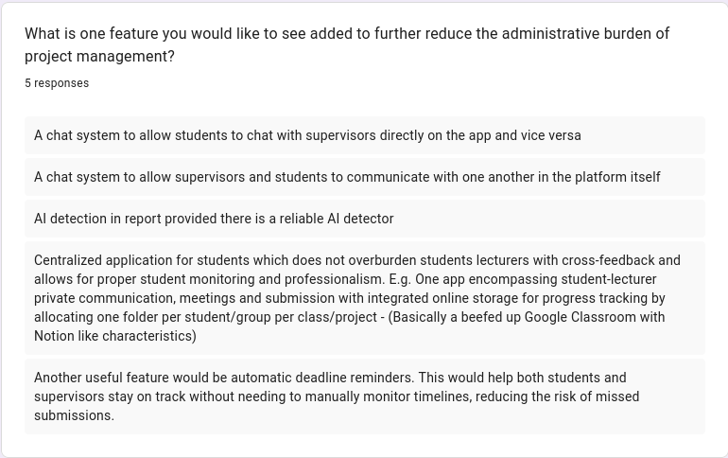Figure 98: User Survey - Suggested Improvement

Conclusion
The conclusion serves as a summary and brief analysis of the research and development effort undertaken throughout the entire project.

It will be divided into sections encompassing the project achievements, a critical evaluation of the system, difficulties faced during development and lastly its limitations and future work based on the survey from the preceding chapter.

Project Summary & Achievements
The primary aim of the project was to streamline traditional academic supervision, specifically to make it adaptable to the challenges caused by rising enrollment numbers in the FoICDT programmes at UoM. The objectives specified for this project, each of which aiming to tackle a specific inefficiency, have all been met successfully. The system automates repetitive menial tasks, such as progress log generation and meeting scheduling, while introducing an AI component to verify feedback criteria in student re-submissions. The final deliverable is a fully tested web application that provides a viable alternative to manual and often ad-hoc supervision processes.

Critical Evaluation
This section provides an evaluation of the project, outlining the strengths of the system as well as the difficulties faced during its design and implementation.

System Strengths
The core strength of the system is undoubtedly its underlying architecture, which has been designed to be modular and adaptable to evolving requirements while remaining readable and easily maintainable. Additionally, the use of industry-standard frameworks such as the .NET ecosystem facilitates adoption of the project by professional developers for further development.
In terms of its functionalities, the system stands out from its predecessors by offering the novel feature of automatic feedback compliance checking, which successfully provides a fast and efficient solution compared to manual and time-consuming document reviews.

The system’s functionalities and performance have also been thoroughly validated by the automated integration test suite (Playwright End-To-End Testing) with a 95% pass rate, accounting for the challenges posed by the stochastic nature of foundational models.

Technical Difficulties Faced
The following are the significant blockers encountered during development:
- Authentication & RBAC – Designing a robust token based authentication system that integrated seamlessly with the API and the client was a significant undertaking primarily because it had a complex logic flow spanning both the client and the server. It was ultimately resolved but had a greater complexity than anticipated.
- AI Analysis Background Worker & Job Status Persistence – Following the complications mentioned during the implementation of the feature, the greatest challenge faced was in decoupling the AI analysis functionality from the request-response cycle. Several concerns had to be accounted for when re-designing this feature, namely, how to persist the job status, how to queue and process the AI job, and how to inform the client once it was complete. Ultimately, compromises were made to reduce the complexity of the system while maintaining an acceptable performance.

Limitations
Despite the successful implementation of the major objectives, it is important to highlight some of the limitations of the system:
- Optimization for AI Document Processing – In an ideal system, only relevant document pages, from both the staged and submitted documents, are selected for processing. However, the current approach involves sending them in their entirety to the foundational model. The result is that the AI analysis feature has a high token expenditure. While further research was conducted into integrating Vision-based Retrieval-Augmented-Generation systems that operate with VLMs (ColPali, 2025) with the foundational model, such solutions were discarded to their high hardware requirements. Alternative approaches such as traditional text-only RAG would require complex document pre-processing pipelines and have their own set of drawbacks - such as the inability to process figures - that would significantly degrade the performance of the AI analysis feature.
- Memory Cache - Currently, AI job statuses are managed using in-memory .NET concurrent dictionaries, which restricts the system's scalability. Because this cache is local to the web server's memory, state information is not shared across multiple server instances. Hence, a separate caching tier would ideally be used instead to mitigate the issue of volatile storage and data accessibility across the different instances.

Future Work
While the current implementation of the Project Management System is functional for academic supervision, the following are some improvements that make it viable for academic use:
- Co-supervision & Programme Coordinators – The current system currently adheres to one-on-one project supervision although the data schema and processing logic have been made flexible to support co-supervision. In addition, another user role – Programme Coordinators - can be added to allow for more fined-grained control over user management for individual programmes.
- Mobile Accessibility – The decoupling of the presentation tier from the application tier offers the possibility of developing separate interfaces for different device types while utilizing the same underlying API. Mobile technologies can be considered to develop an interface accessible to smartphone users.
- In-App Communication – Communication currently relies on external apps, which can lead to project-related discussions being scattered across different platforms. Thus, a native chat system could be integrated to allow students and supervisors to message each other directly within the app. This would keep all project talk in one professional space and make it easier to find specific information when needed.

References
Stynes, P. and Pathak, P. (2022). A Research Supervision Framework for Quality and Scalability. In Proceedings of the 14th International Conference on Computer Supported Education - Volume 2: CSEDU; ISBN 978-989-758-562-3; ISSN 2184-5026, SciTePress, pages 395-403. DOI: 10.5220/0011093900003182.

sites.google.com. (n.d.). UoM Students Statistics - Students Enrolment (ASRO). [online] Available at: https://sites.google.com/uom.ac.mu/uomstudentsstatistics/students-enrolment-asro. [Accessed 24 Sept. 2025]

Beekhy, B.S. (2013). A web based final year project supervision system. Undergraduate dissertation, University of Mauritius. [online] Available at: https://library.uom.ac.mu/libero/WebOpac.cls?VERSION=2&ACTION=DISPLAY&RSN=10186243 [Accessed 14 Sept. 2025].

Creatrix Campus (2025.-a). Higher Education Solutions for Modern Campuses | Creatrix Campus [online] Available at: https://www.creatrixcampus.com/ [Accessed 14 Sept. 2025].

Creatrix Campus (2025.-b). Thesis Management System. [online] Available at:
https://www.creatrixcampus.com/thesis-management-system [Accessed 13 Sept. 2025].

Creatrix Campus (2025.-c). Meeting Management Software Higher Education. [online] Available at: https://www.creatrixcampus.com/Meeting-Management-Software-Higher-Education [Accessed 13 Sept. 2025].

Khamaruddin, P.N., Sauki, A.N., Othman, N.S. and Kadri, A.F. (2017) ‘Using Moodle as an integrated Final Year Project management system’, in 2017 IEEE 9th International Conference on Engineering Education (ICEED). Kanazawa, Japan: IEEE, pp. 238–243. doi: 10.1109/ICEED.2017.8251200.

Leung, Chun-Hang & Lai, Chung-Lun & Yuan, Tsun-Kit & Pang, Wai-Man & Tang, Jeff & Ho, Wai-shing & Wong, Tak-Lam. (2015). The Development of a Final Year Project Management System for Information Technology Programmes. Communications in Computer and Information Science. 494. 86-97. doi: 10.1007/978-3-662-46158-7_9.

Google (2025.-a). Compare G Suite editions. [online] Available at:
https://support.google.com/a/answer/7370133?hl=en [Accessed 15 Sept. 2025].

Google (2025.-b). Google Classroom. [online] Available at: https://edu.google.com/workspace-for-education/classroom/ [Accessed 15 Sept. 2025].

Google (2025.-c). Google Calendar. [online] Available at: https://www.google.com/calendar/about/ [Accessed 15 Sept. 2025].

Google (2025.-d). See what’s changed in a file - Google Docs Editors Help. [online] Available at: https://support.google.com/docs/answer/190843?hl=en&co=GENIE.Platform%3DDesktop
[Accessed 15 Sept. 2025].

Google (2025.-e). About Assignments - Google for Education. [online] Available at:
https://edu.google.com/assignments/ [Accessed 15 Sept. 2025].

Olayinka, S.O., Adeniyi, A.O. and [Other Authors] (2024) ‘Mitigating the challenges of final year projects supervision in Nigeria tertiary institutions for improved quality assurance’, World Journal of Advanced Engineering Technology and Sciences, 12(02), pp. 179–188. doi: 10.30574/wjaets.2024.12.2.0286.

Microsoft (2024). ASP.NET | Open-source web framework for .NET. [online] Microsoft. Available at: https://dotnet.microsoft.com/en-us/apps/aspnet. [Accessed 24 Mar. 2026]
‌Laravel (2011). Laravel - The PHP Framework For Web Artisans. [online] Laravel.com. Available at: https://laravel.com. [Accessed 24 Mar. 2026]
Vercel (2024). Getting Started | Next.js. [online] nextjs.org. Available at: https://nextjs.org/docs. [Accessed 24 Mar. 2026]
‌
Buljić, Imad & Kadusic, Esad & Cvijanovic, Tamara & Hadzajlic, Narcisa & Zivic, Natasa. (2025). Comparative Performance Analysis of Leading Backend Frameworks for Developers. 1-5. doi: 10.1109/INFOTEH64129.2025.10959250.

Panchal, B. (2024). Front End Statistics: Trends, Insights and Innovations. [online] Radixweb. Available at: https://radixweb.com/blog/frontend-statistics. [Accessed 24 Mar. 2026]

Meta Open Source (2025). React. [online] react.dev. Available at: https://react.dev/. [Accessed 24 Mar. 2026]

You, E. (2014). Vue.js. [online] Vuejs.org. Available at: https://vuejs.org/. [Accessed 24 Mar. 2026]

Belagatti, P. (2025) How to Choose the Right SQL Database. SingleStore. Available at: https://www.singlestore.com/blog/how-to-choose-the-right-sql-database/ [Accessed: 19 Nov. 2025].

Amazon Web Services (n.d.). MySQL vs. PostgreSQL - Comparing Relational Database Management Systems (RDBMS) - AWS. [online] Amazon Web Services, Inc. Available at: https://aws.amazon.com/compare/the-difference-between-mysql-vs-postgresql/. [Accessed 24 Mar. 2026]
‌
PostgreSQL Documentation. (2025). 65.2. TOAST. [online] Available at: https://www.postgresql.org/docs/current/storage-toast.html. [Accessed 24 Mar. 2026]
Bommasani, Rishi & Hudson, Drew & Adeli, Ehsan & Altman, Russ & Arora, Simran & Arx, Sydney & Bernstein, Michael & Bohg, Jeannette & Bosselut, Antoine & Brunskill, Emma & Brynjolfsson, Erik & Buch, Shyamal & Card, Dallas & Castellon, Rodrigo & Chatterji, Niladri & Chen, Annie & Creel, Kathleen & Davis, Jared & Demszky, Dora & Liang, Percy. (2021). On the Opportunities and Risks of Foundation Models. doi: 10.48550/arXiv.2108.07258.

Vellum. (2025). LLM Leaderboard - Vellum. [online] Available at: https://vellum.ai/llm-leaderboard [Accessed 24 Mar. 2026].
‌
IEvangelist (2023). Channels - .NET. [online] Microsoft.com. Available at: https://learn.microsoft.com/en-us/dotnet/core/extensions/channels. [Accessed 24 Mar. 2026]

Google DeepMind. (2025). Gemini. [online] Available at: https://deepmind.google/models/gemini/. [Accessed 25 Mar. 2026]

‌Sakimura, N., Bradley, J., Jones, M., de Medeiros, B. and Mortimore, C. (2014) OpenID Connect Core 1.0 incorporating errata set 1. Available at: https://openid.net/specs/openid-connect-core-1_0.html [Accessed: 24 Jan. 2026].

Microsoft (2024) HMACSHA256 Class (System.Security.Cryptography). Available at: https://learn.microsoft.com/en-us/dotnet/api/system.security.cryptography.hmacsha256 [Accessed: 24 Jan. 2026]

Microsoft (2024) Policy-based authorization in ASP.NET Core. Available at: https://learn.microsoft.com/en-us/aspnet/core/security/authorization/policies [Accessed: 25 Jan. 2026]

MDN Web Docs. (2025). Client-side rendering (CSR) - MDN Web Docs Glossary: Definitions of Web-related terms | MDN. [online] Available at: https://developer.mozilla.org/en-US/docs/Glossary/CSR. [Accessed 30 Mar. 2026]

tanstack.com. (2026). Overview | TanStack Query Docs. [online] Available at: https://tanstack.com/query/latest/docs/framework/react/overview. [Accessed 30 Mar. 2026]

fullcalendar.io. (2020). React Component - Docs | FullCalendar. [online] Available at: https://fullcalendar.io/docs/react. [Accessed 30 Mar. 2026]

mui.com. (2026). React Components - Material UI. [online] Available at: https://mui.com/material-ui/. [Accessed 30 Mar. 2026]
‌
Questpdf.com. (2020). QuestPDF | C# PDF Generation Library. [online] Available at: https://www.questpdf.com/. [Accessed 30 Mar. 2026]

Appendix 1: Glossary of Technical Terms
Term | Definition
CSR | Client-Side Rendering: It refers to the practice of generating HTML content using JavaScript in the browser. (MDN Web Docs, 2025)
SSR | Server-Side Rendering: It refers to the practice of generating HTML content on the server and sending it to the client. (MDN Web Docs, 2025)
DOM | Document Object Model: It is an API that represents and interacts with any HTML or XML-based markup language document. The DOM is a document model loaded in the browser and representing the document as a node tree, or DOM tree, where each node represents part of the document (e.g., an element, text string, or comment). (MDN Web Docs, 2025)
Virtual DOM | Virtual Document Object Model: A programming concept where an ideal representation of a UI is kept in memory and synced with the "real" DOM. This process, known as reconciliation, optimizes performance by minimizing direct manipulation of the browser's DOM (Meta, 2026).
Horizontal Scalability | Scaling Out: The capacity of a system to distribute increased workload by adding more nodes (servers) to the network, allowing the system to function as a single logical unit while handling higher traffic (Abbott & Fisher, 2026).
Vertical Scalability | Scaling Up: The process of adding more power (CPU, RAM) to an existing server. Unlike horizontal scaling, it is fundamentally limited by the maximum hardware specifications of an individual machine (Microsoft Azure, 2026).
REST | Representational State Transfer: An architectural style for distributed hypermedia systems. It relies on a stateless, client-server, cacheable communications protocol, typically HTTP, to enable interoperability between web systems (Fielding, 2000).
SOAP | Simple Object Access Protocol: An XML-based protocol for exchanging structured information in a decentralized, distributed environment. (NIST, 2026)
JWT | JSON Web Token: A data exchange format made of a header, payload, and signature where the header and the payload take the form of JSON objects. They are encoded and concatenated with the aggregate being signed to generate a signature. (NIST, 2026)
RBAC | Role-Based Access Control: Access control based on user roles (i.e., a collection of access authorizations a user receives based on an explicit or implicit assumption of a given role). Role permissions may be inherited through a role hierarchy and typically reflect the permissions needed to perform defined functions within an organization. A given role may apply to a single individual or to several individuals. (NIST, 2026)
XSS | Cross-Site Scripting: Cross-Site Scripting is a security flaw found in some Web applications that enables unauthorized parties to cause client-side scripts to be executed by other users of the Web application. (NIST, 2026)
CSRF | Cross-Site Request Forgery: A type of Web exploit where an unauthorized party causes commands to be transmitted by a trusted user of a Web site without that user’s knowledge. (NIST, 2026)
Replay Attack | An attack that involves the capture of transmitted authentication or access control information and its subsequent retransmission with the intent of producing an unauthorized effect or gaining unauthorized access. (NIST, 2026)
ACID | Atomicity, Consistency, Isolation, Durability: A set of database transaction properties intended to guarantee data validity despite errors or failures. In relational systems like PostgreSQL, these ensure reliable transaction processing (Haerder & Reuter, 1983).
ORM | Object-Relational Mapping: A technique for accessing a relational database from an object-oriented language. Frameworks like EF Core abstract SQL queries, allowing developers to interact with data as C# objects (Microsoft, 2026).
Foundational Model | A paradigm in artificial intelligence where a single large-scale model, trained on vast quantities of data, can be adapted to a wide range of downstream tasks. These models, such as Google Gemini, serve as the core generative engine for diverse applications including text synthesis and code generation (Bommasani et al., 2021).
VLM | Vision-Language Model: A multimodal AI architecture designed to process and reason across both image and text inputs. These models leverage joint embeddings to analyze document layouts and visual context (Google DeepMind, 2024).
In-Memory Queue | A high-performance data structure used for asynchronous communication between different components of the same application. In the .NET ecosystem, Channels provide a thread-safe, "producer-consumer" implementation that allows tasks to be queued and processed in the background without blocking the main execution thread (Microsoft, 2026).
Message Broker | An intermediary software module that facilitates the exchange of messages between formal services or applications. Unlike in-memory queues, a broker (e.g., RabbitMQ or Azure Service Bus) provides persistence and decoupling across distributed systems, ensuring that messages are delivered even if the sending or receiving service is temporarily unavailable (IBM, 2026).
Provider Pattern | A design pattern used to make data available to multiple child components without passing it through props manually at every level (Patterns.dev, 2026).
React useState | A React Hook that allows components to manage and persist their local state between re-renders. (React, 2026).
React useEffect | A React Hook that lets you synchronize a component with an external system. (React, 2026)
React useMemo | A React Hook that lets you cache the result of a calculation between re-renders. (React, 2026)
React useCallback | A React Hook that lets you cache a function definition between re-renders. (React, 2026)
Generics | Generics are classes, structures, interfaces, and methods that have placeholders (type parameters) for one or more of the types that they store or use. A generic collection class might use a type parameter as a placeholder for the type of objects that it stores. The type parameters appear as the types of its fields and the parameter types of its methods. A generic method might use its type parameter as the type of its return value or as the type of one of its formal parameters. (Microsoft, 2026)

Appendix 2: Data Definition
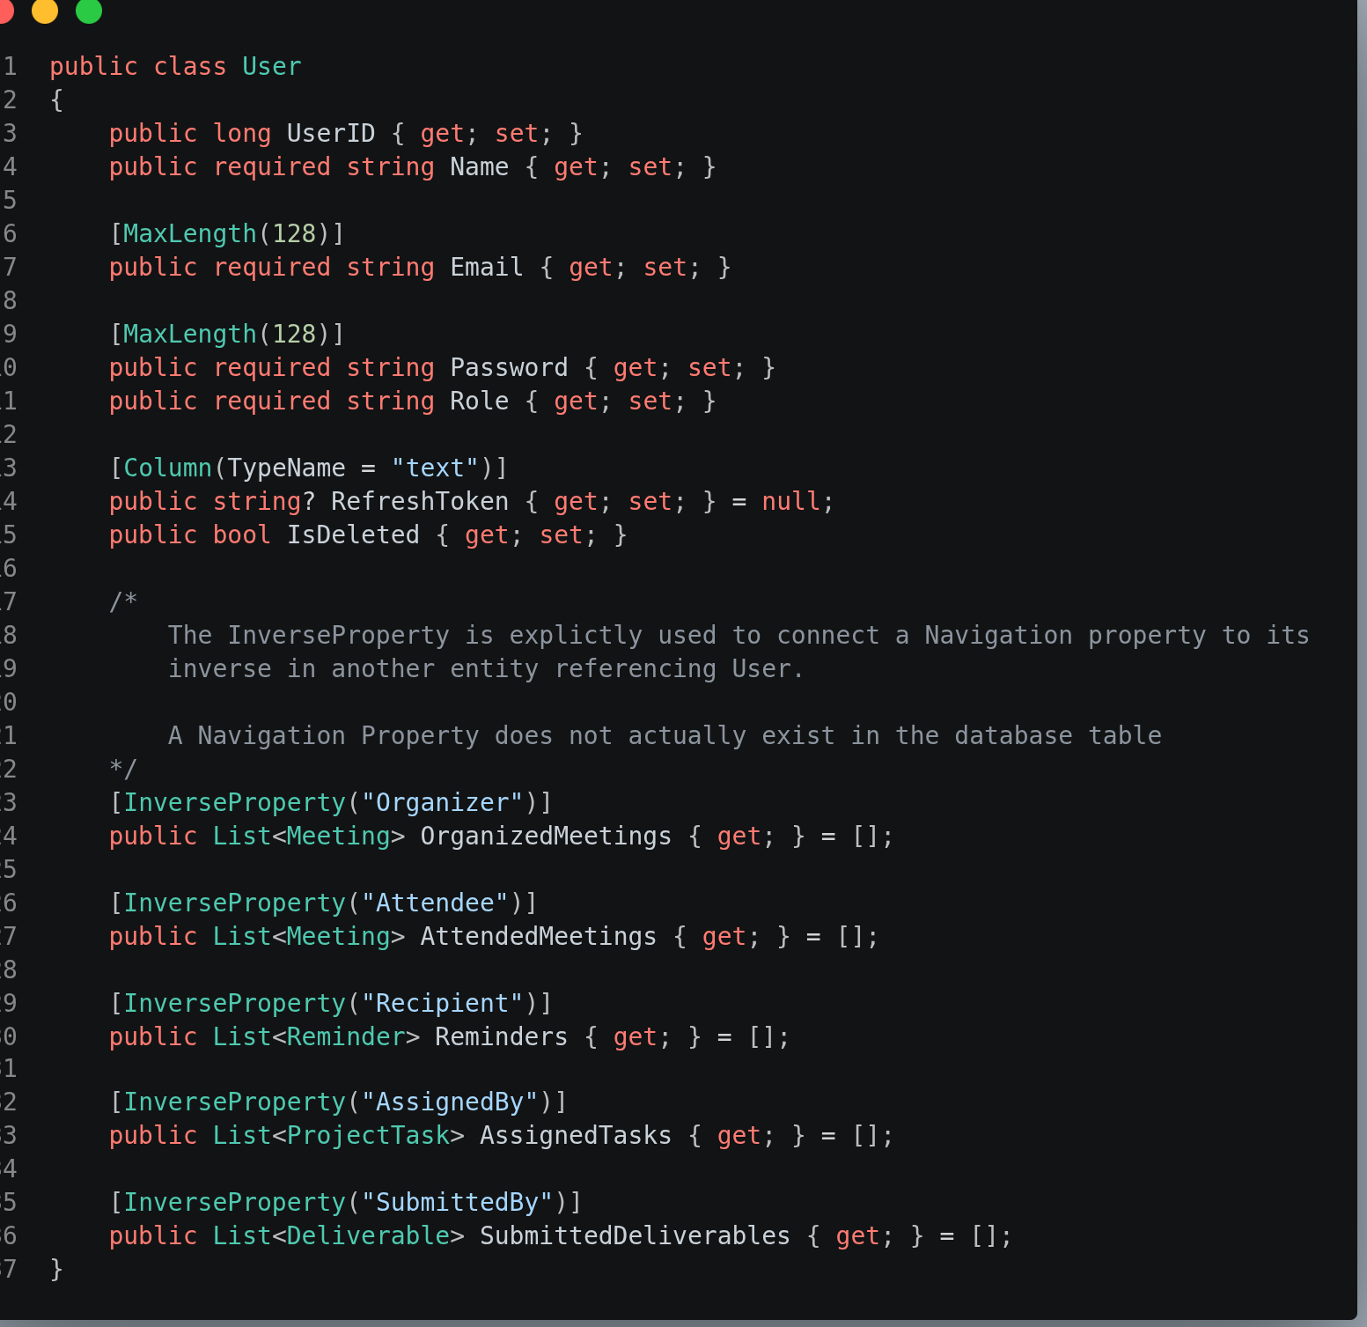Figure 99: Entity Classes - User
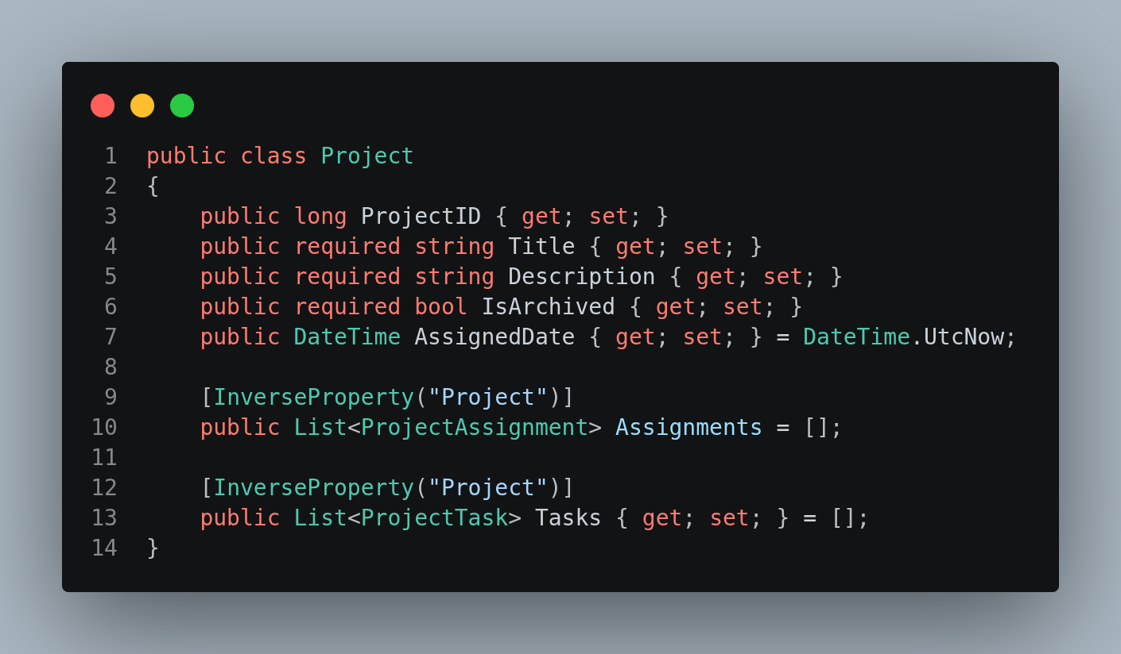Figure 100: Entity Class - Project

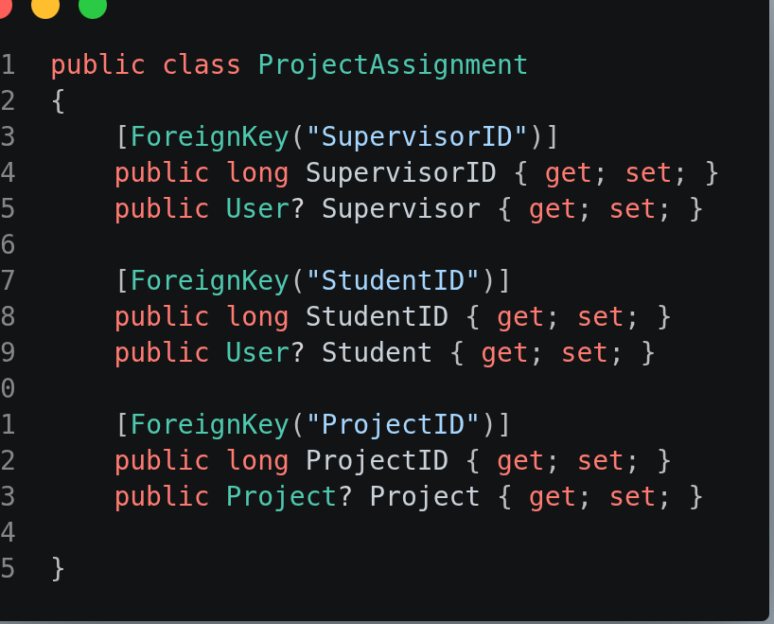Figure 101: Entity Class - Project Assignment

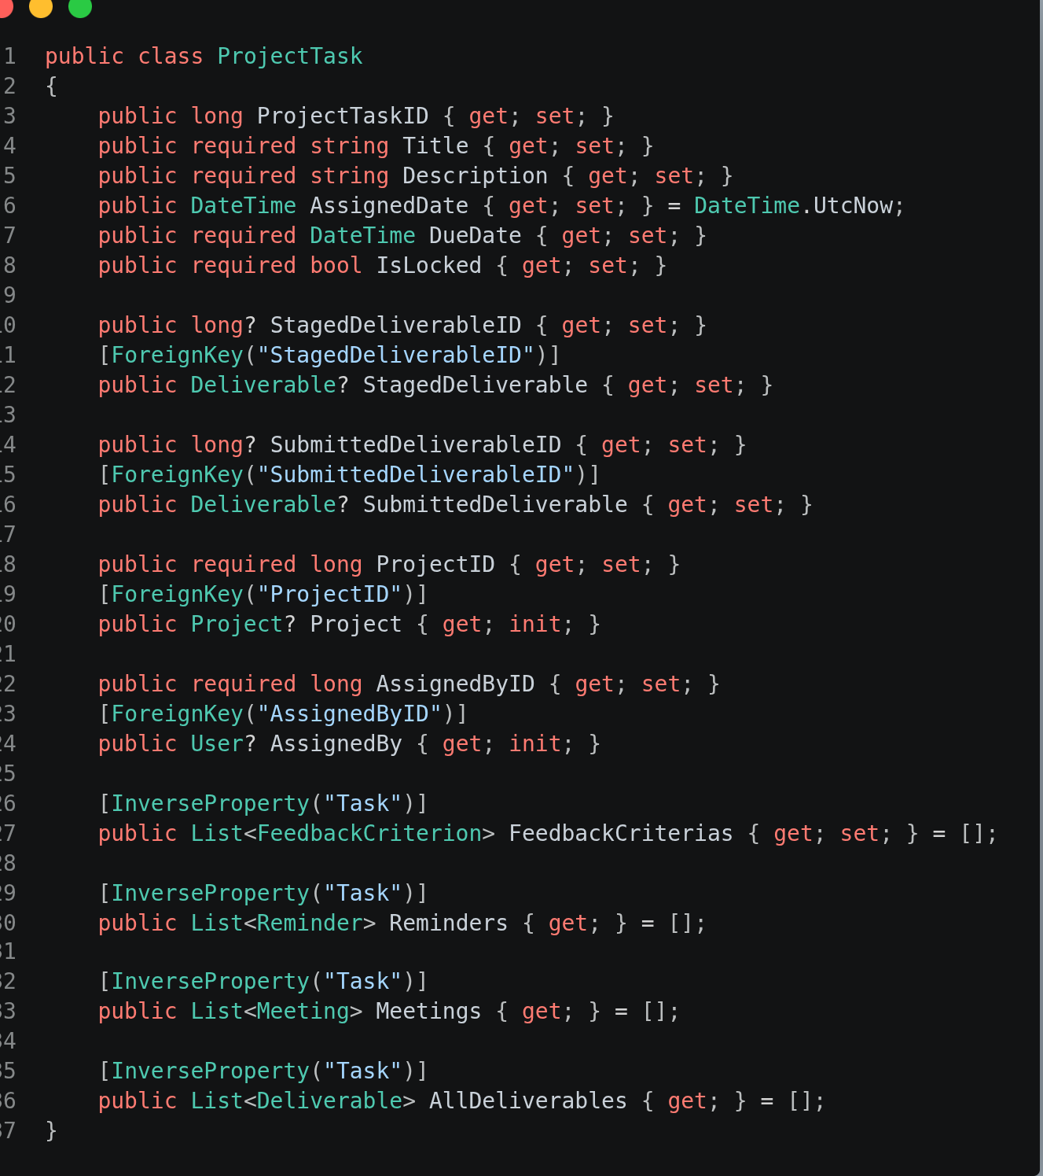Figure 102: Entity Class - Project Task
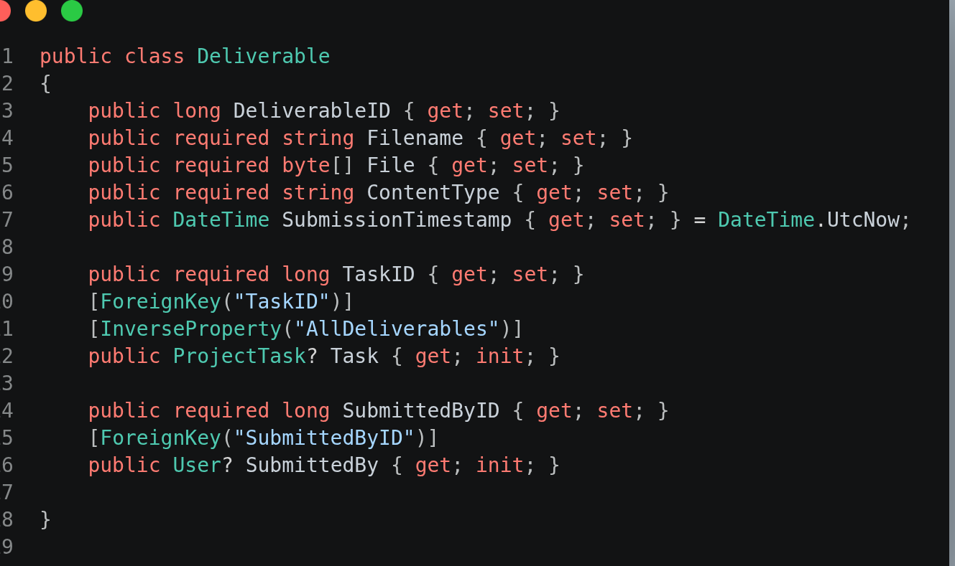Figure 103: Entity Class - Deliverable
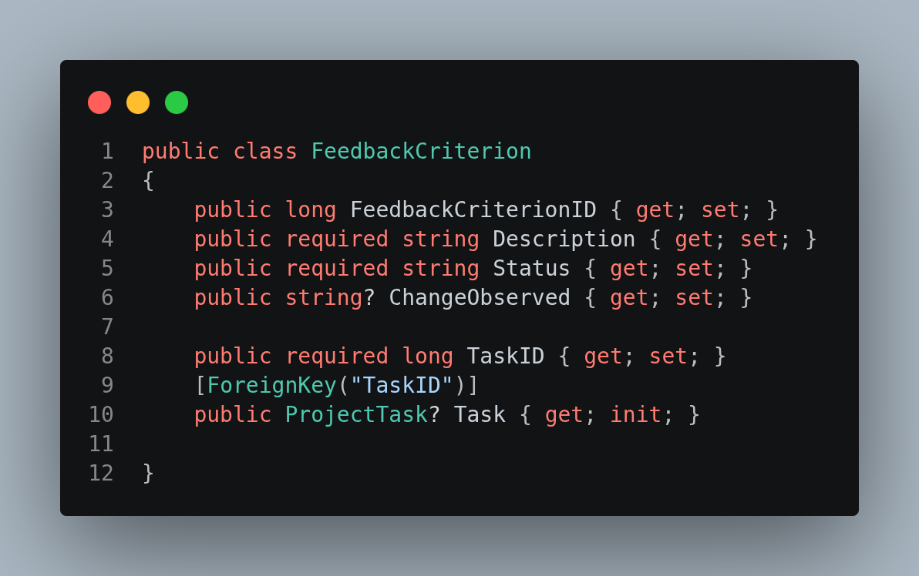Figure 104: Entity Class - Feedback Criterion
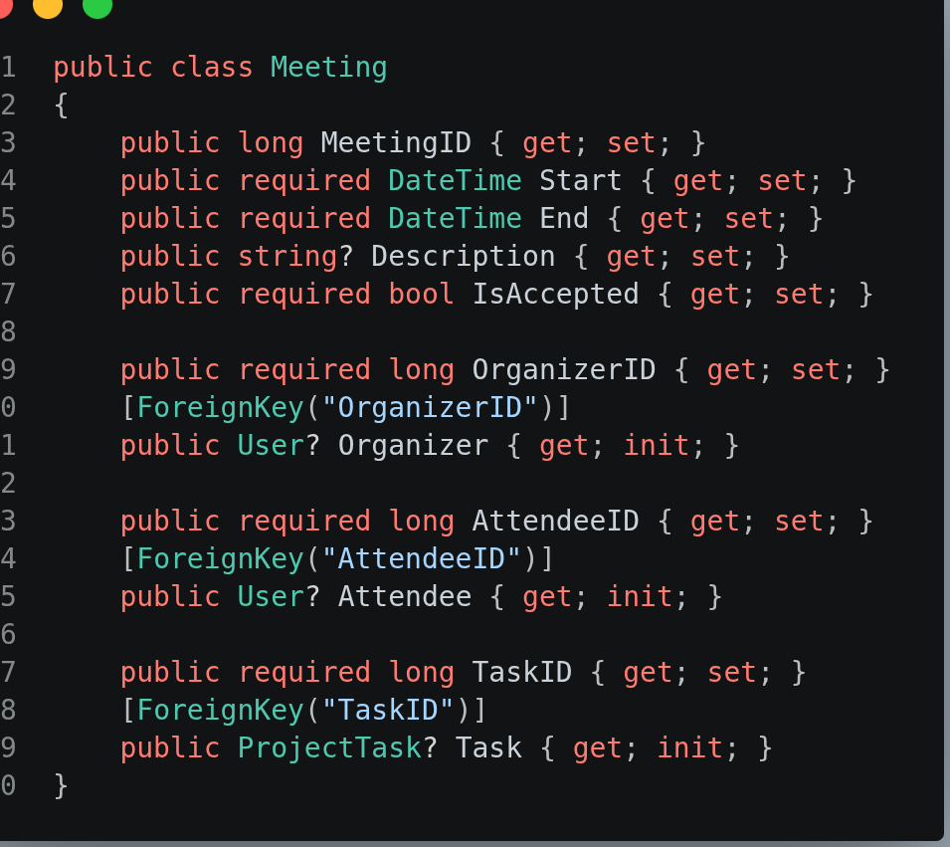Figure 105: Entity Class - Meeting
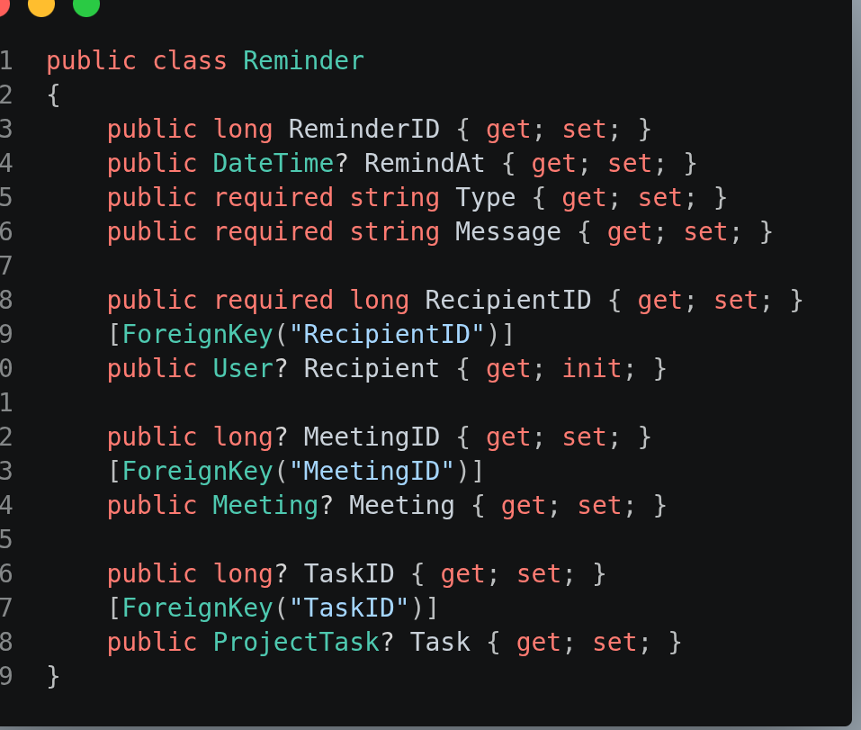Figure 106: Entity Class - Reminder
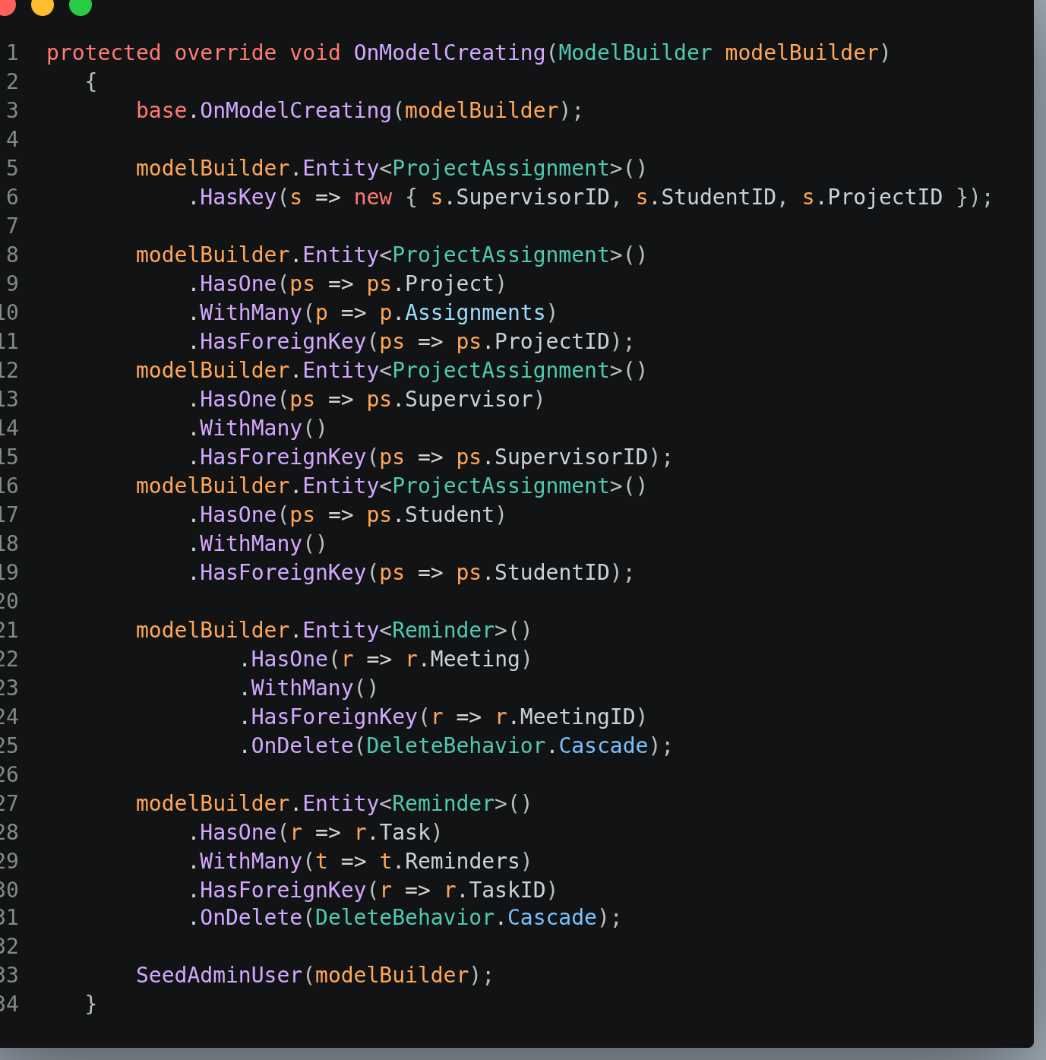Figure 107: Entity Classes – Additional Configurations
Note: Additional configurations need to be specified to define complex relationships and behavior (e.g., composite key definition and cascade on delete)

Appendix 3: Figures for Integration Testing

Validation of Login Functionality

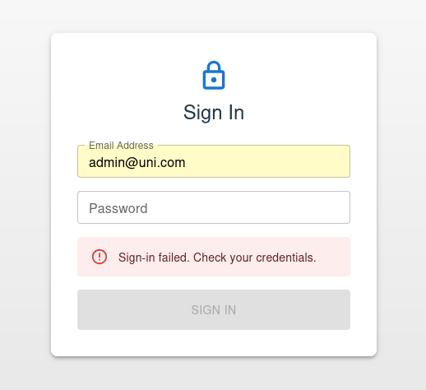Figure 108: Invalid Credentials

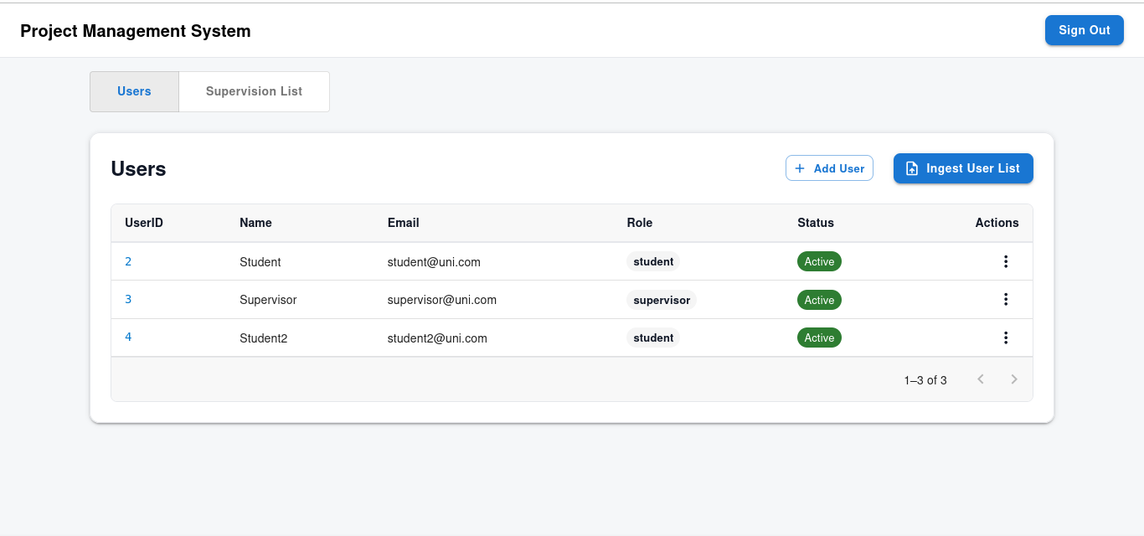Figure 109: Admin: Successful Login

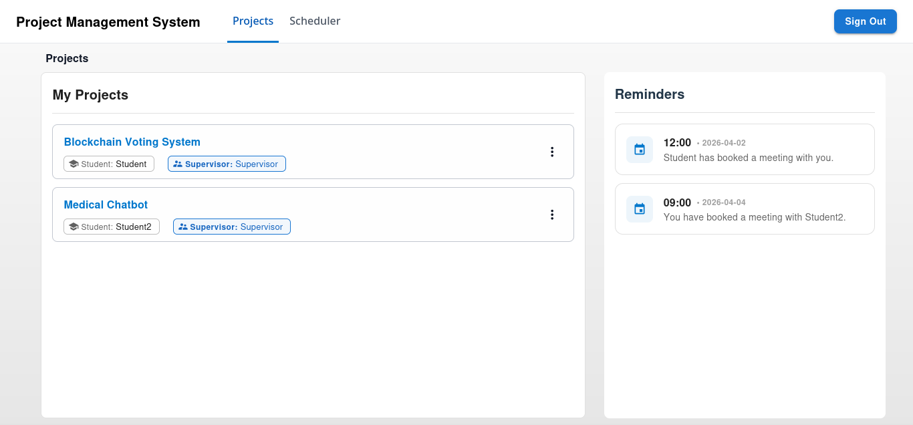Figure 110: Supervisor/Student: Successful Login

Validation of User List Ingestion

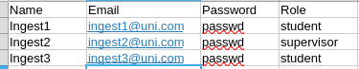Figure 111: User List Excel - No Existing

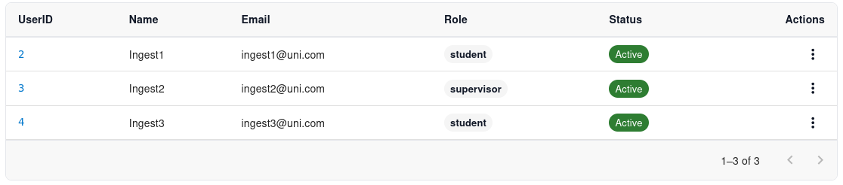Figure 112: User List Ingestion - No Existing
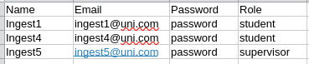Figure 113: User List Excel - Partial Existing

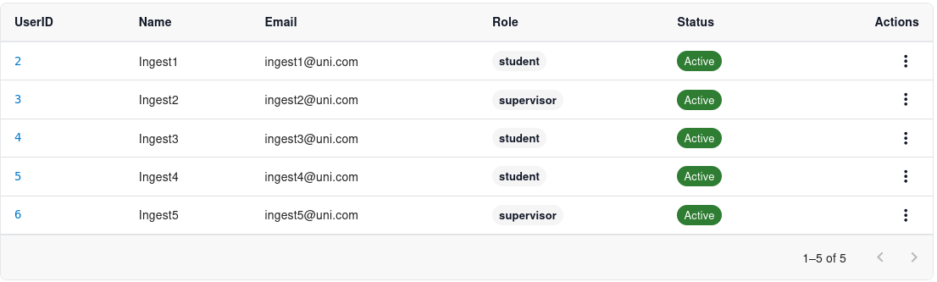Figure 114: User List Ingestion - Partial Existing

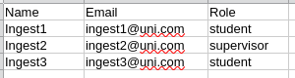Figure 115: User List Excel - Missing Columns

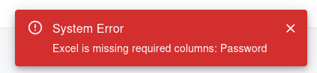Figure 116: User List Ingestion - Missing Columns

Figure 117: User List Ingestion - Invalid Format

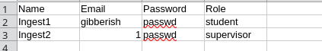Figure 118: User List Excel - Invalid Data

Figure 119: User List Ingestion - Invalid Data

Validation of User Creation Feature
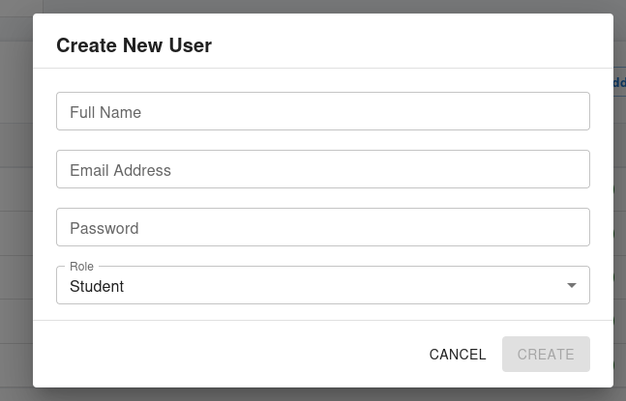Figure 120: Create User: Empty User Modal
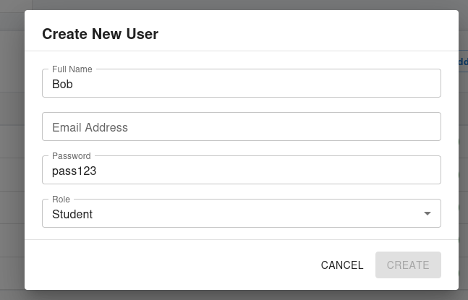Figure 121: Create User: Submit Disabled

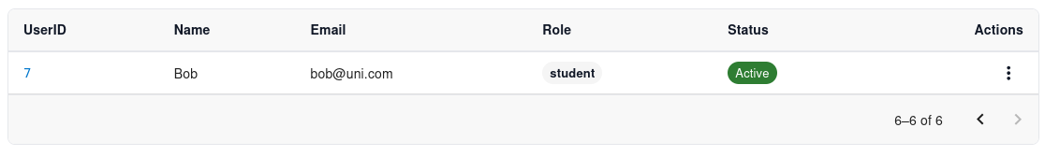Figure 122: Create User: Normal Behaviour

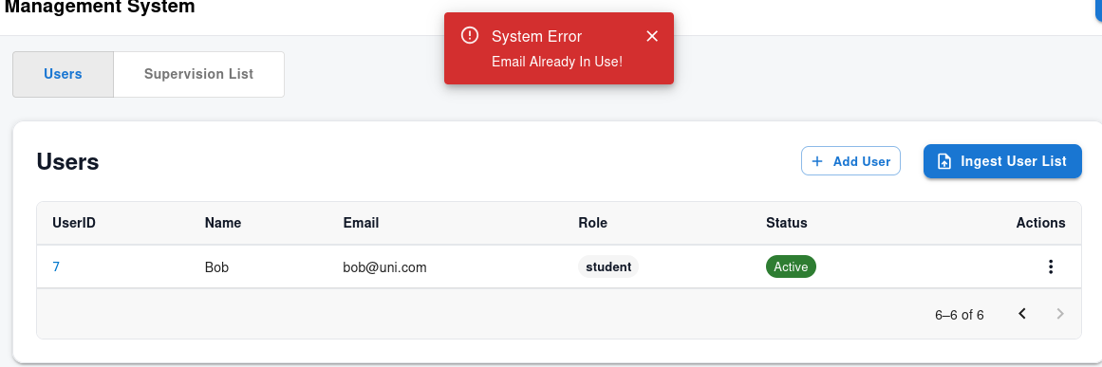Figure 123: Create User: Email (bob@uni.com) belongs to existing user

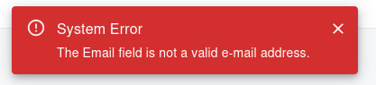Figure 124: Create User: Invalid Email Address Format

Validation of User Edit Feature
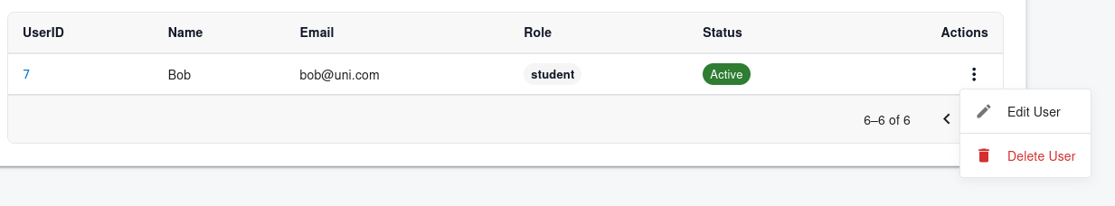Figure 125: User Edit - Menu Button Clicked

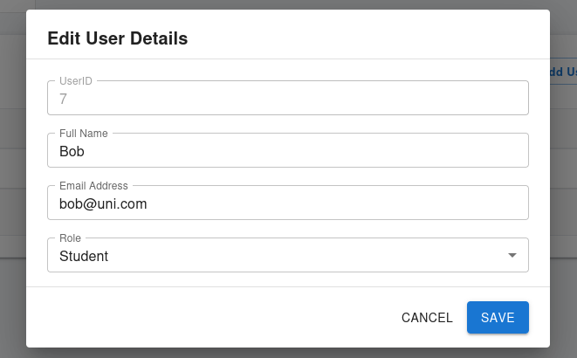Figure 126: User Edit - User Modal

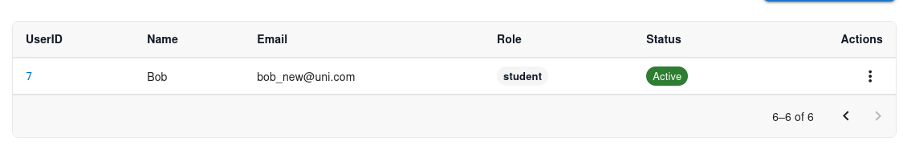Figure 127: User Edit - New Email

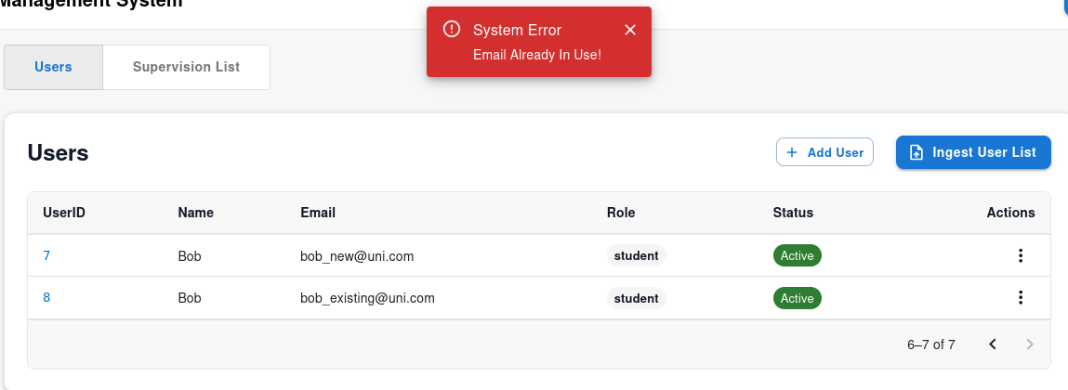Figure 128: User Edit - Change To Existing Email (bob_new -> bob_existing)

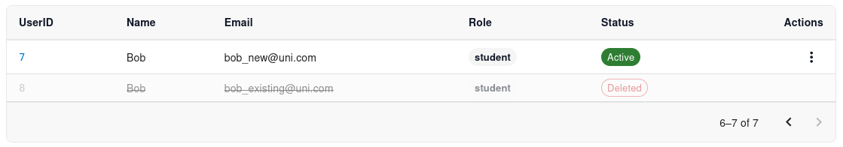Figure 129: User Delete - Delete (bob_existing)

Project Supervision List Ingestion Feature
Note that most of the users referenced in the project lists have already been created prior to testing.
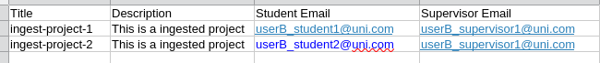Figure 130: Project List Excel - No Existing

Figure 131: Project List Ingestion - No Existing

Figure 132: Project List Excel - Partial Existing

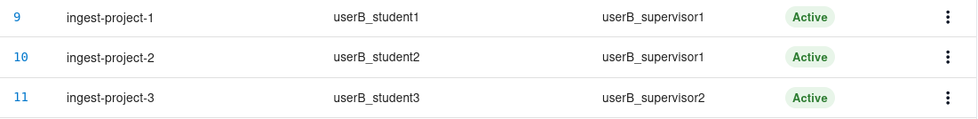Figure 133: Project List Ingestion - Partial Existing

Figure 134: Project List Ingestion - Invalid Format

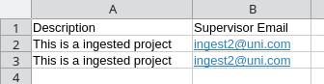Figure 135: Project List Excel - Missing Columns

Figure 136: Project List Ingestion - Missing Columns

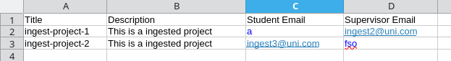Figure 137: Project List Excel - Invalid Data

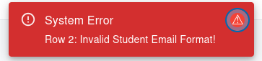Figure 138: Project List Ingestion - Invalid Data

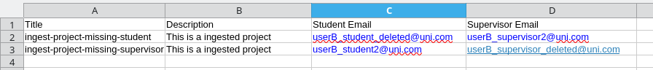Figure 139: Project List Excel - Missing/Deleted Users

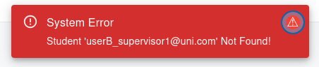Figure 140: Project List Ingestion - Missing/Deleted Users

Figure 141: Project List Excel - Invalid Roles

Figure 142: Project List Ingestion – Invalid Roles (Count as Missing/Deleted)

Project Creation Feature
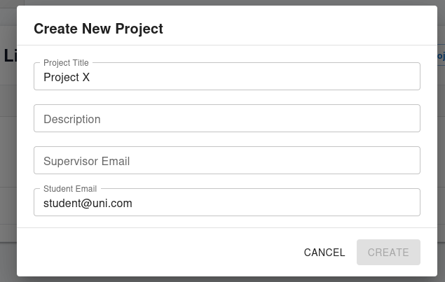Figure 143: Project Creation – Incomplete Form
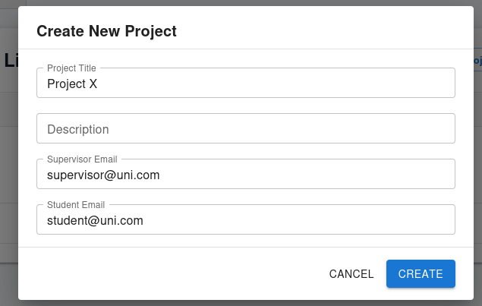Figure 144: Project Creation – Before Creation (Normal)
Figure 145: Project Creation – After Creation (Normal)
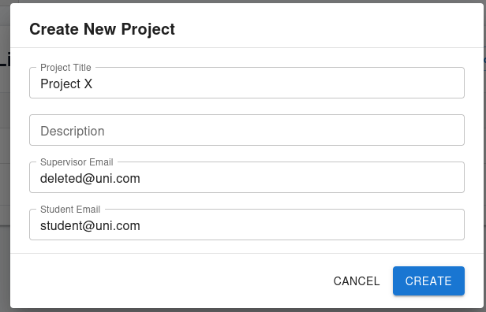Figure 146: Create Project - Deleted/Missing User (Before Creation)
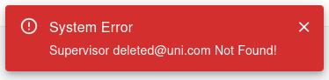Figure 147: Create Project - Deleted/Missing User (Attempted Creation)

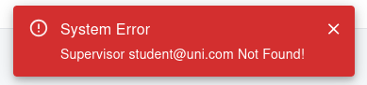Figure 148: Create Project - Invalid Roles (Swap Student and Supervisor)

Project Edit Feature
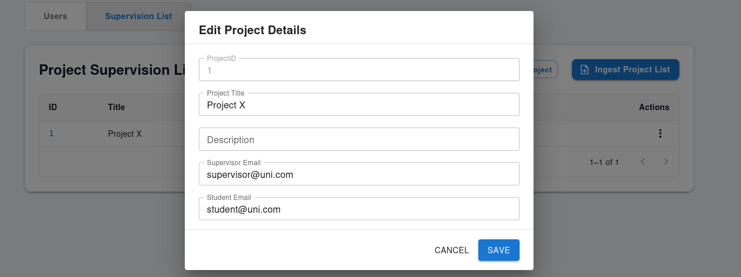Figure 149: Edit Project - Edit Modal

Figure 150: Edit Project - Normal Behavior (Project X -> Project Y)

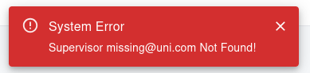Figure 151: Edit Project – Missing/Deleted User
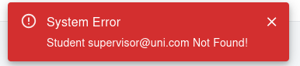Figure 152: Edit Project - Invalid User Role

Project Archive/Restore Feature
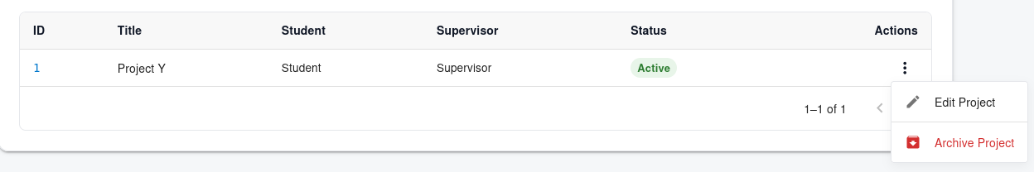Figure 153: Project Archive/Restore - Archive Button For Active Project

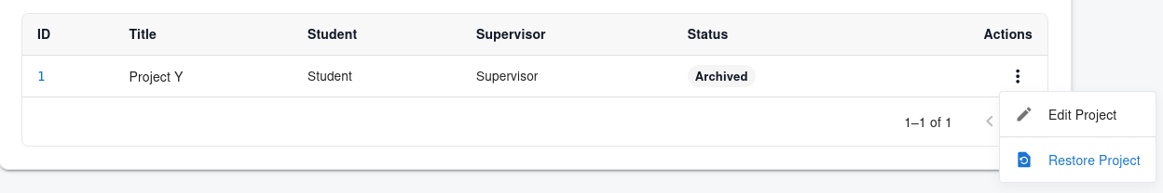Figure 154: Project Archive/Restore - Restore Button for Archived Project

Project CRUD Feature (Supervisor/Student)
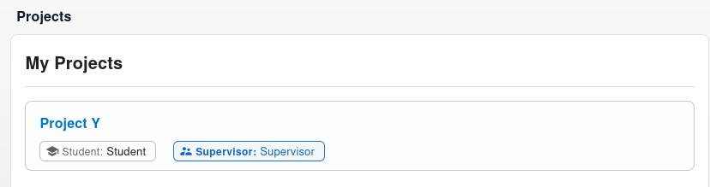Figure 155: Project Page – Student View (Menu Disabled)
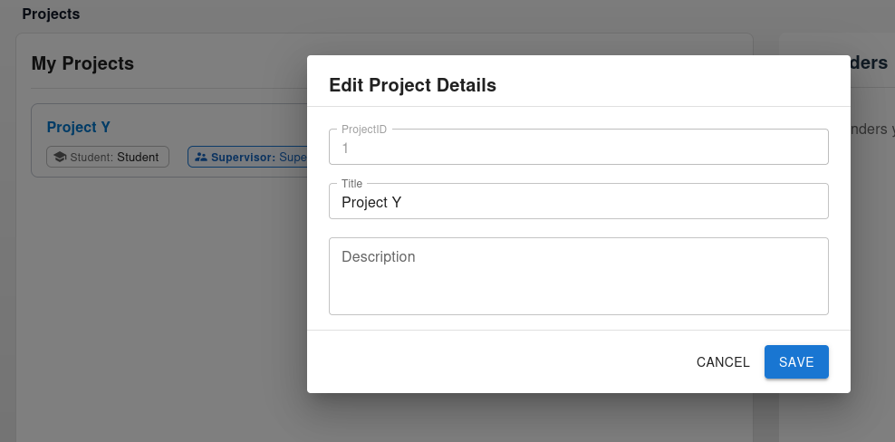Figure 156: Project CRUD - Project Modal (After Edit)

Figure 157: Project CRUD - Edit (Project X -> Project A)
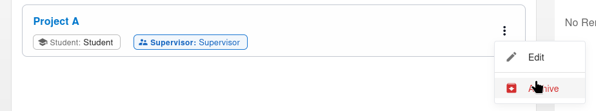Figure 158: Project CRUD – Before Project Archive
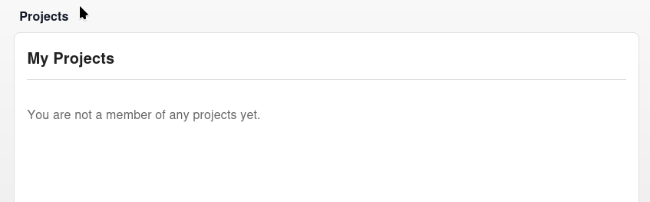Figure 159: Project CRUD – After Project Archive

Dashboard Navigation
Figure 160: Dashboard Navigation – Before Project Link Navigation
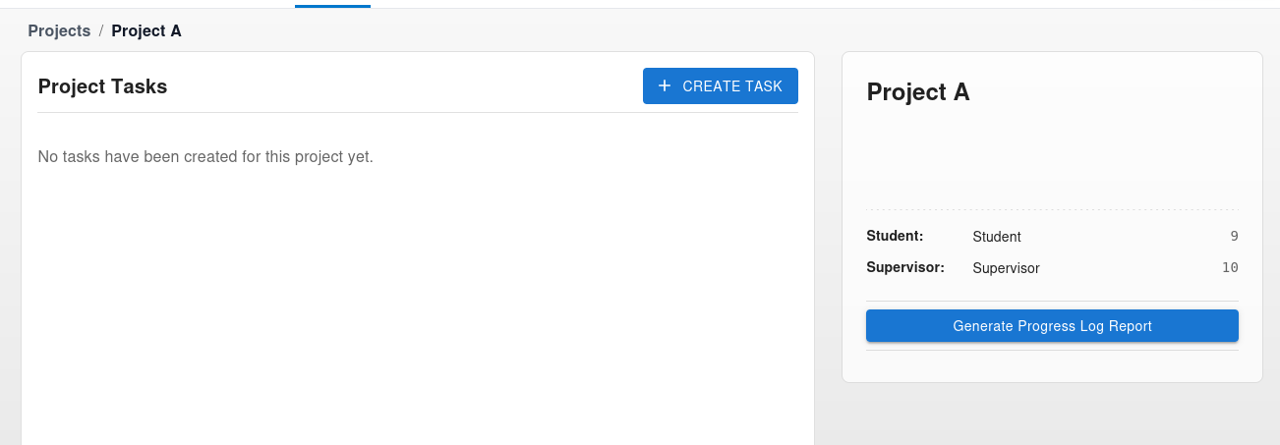Figure 161: Dashboard Navigation – After Project Link Navigation

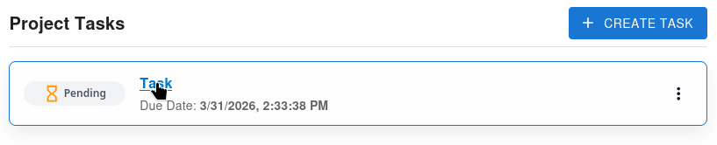Figure 162: Dashboard Navigation – Before Task Link Navigation

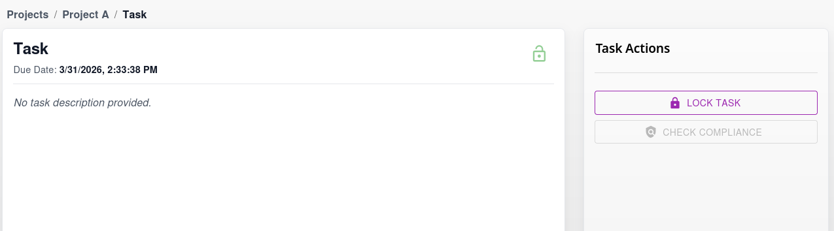Figure 163: Dashboard Navigation – After Task Link Navigation

Figure 164: Dashboard Navigation - Breadcrumbs 1

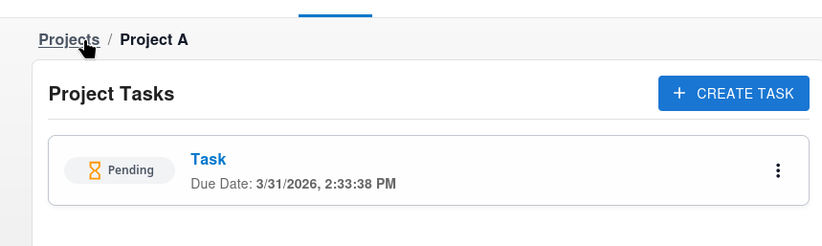Figure 165: Dashboard Navigation - Breadcrumbs 2 (After Breadcrumbs 1)

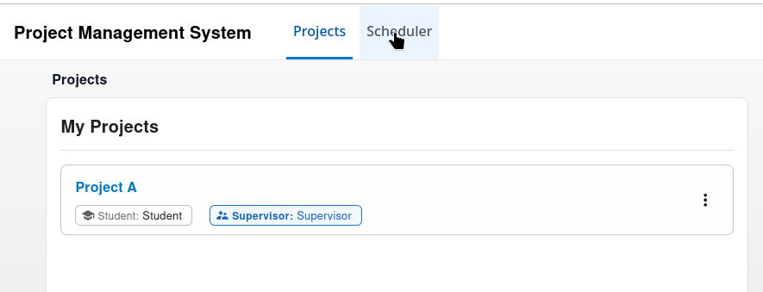Figure 166: Dashboard Navigation – Before Scheduler Navigation (After Breadcrumbs 2)
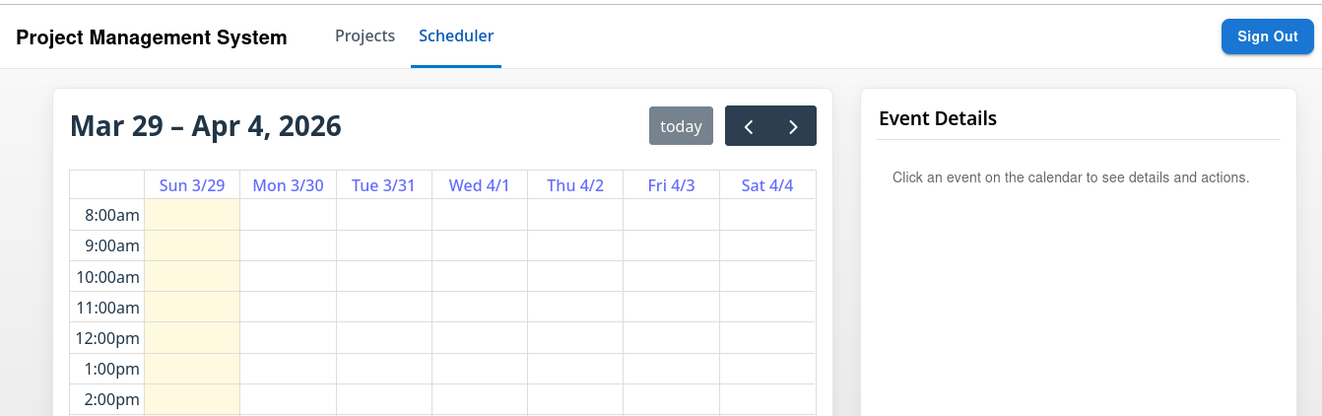Figure 167: Dashboard Navigation – After Scheduler Navigation

Task Creation Feature
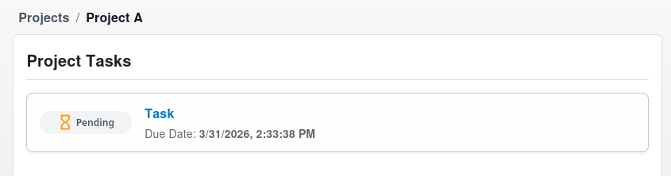Figure 168: Task Page – Student View (Menu + Create Button Disabled)
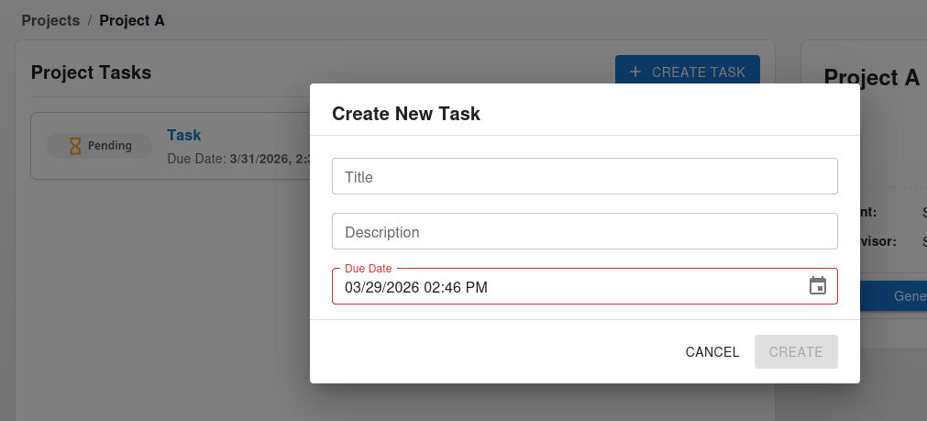Figure 169: Task Creation - Task Modal Partially Empty
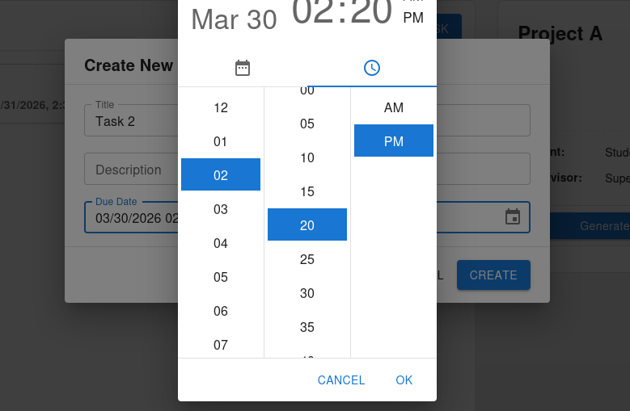Figure 170: Task Creation – Before Creation
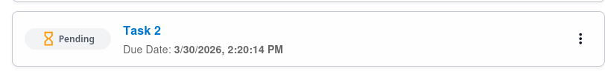Figure 171: Task Creation – After Creation
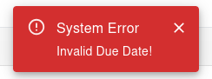Figure 172: Task Creation - Invalid Due Date (before current date)

Task Edit Feature
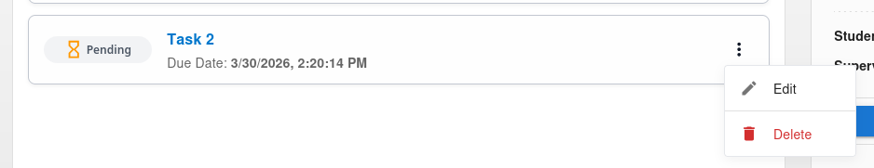Figure 173: Task Edit - Menu Button
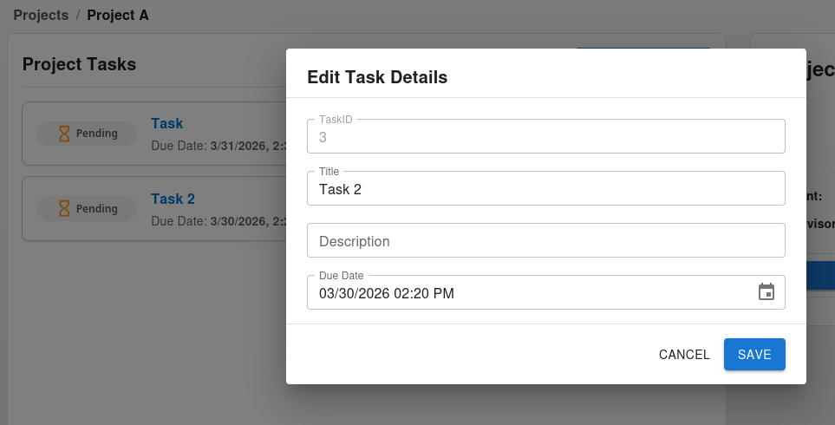Figure 174: Task Edit - Task Modal

Figure 175: Task Edit - Edit (Task 2 -> Task 1)
Figure 176: Task Edit - Invalid Due Date (before current date)

Task Deletion Feature
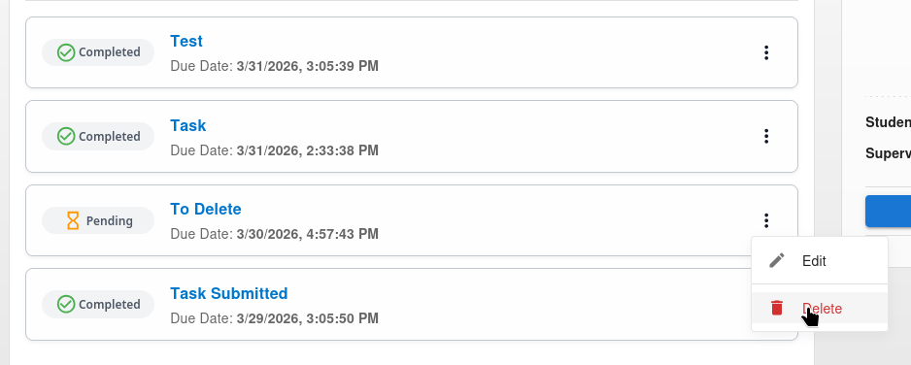Figure 177: Task Deletion - Before Task Deletion
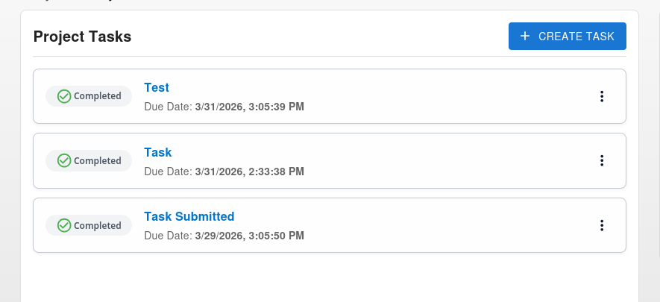Figure 178: Task Deletion - After Task Deletion

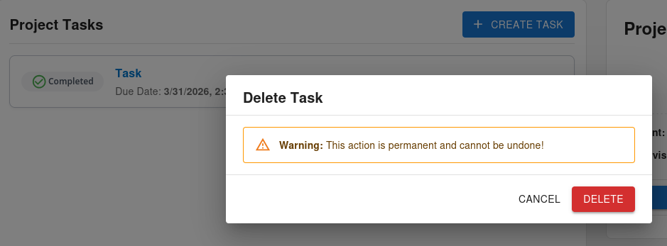Figure 179: Task Deletion – Before Deletion of Task with Submission
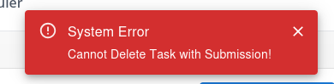Figure 180: Task Deletion – Attempted Deletion of Task with Submission

Automatic Task Updates
Figure 181: Automatic Task Updates – Pending Task Before Due Date
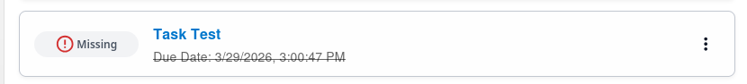Figure 182: Automatic Task Updates – Pending Task After Due Date
Note that since task list is refreshed every 5 minutes, the update will be visible either when the user performs another action or remains idle until the list is refreshed.
Figure 183: Automatic Task Updates – Completed Task After Due Date

Feedback CRUD Feature (Supervisor/Student)
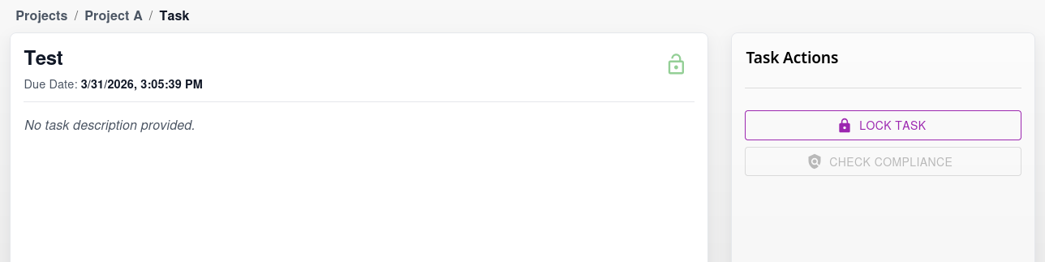Figure 184: Feedback CRUD - No Submission

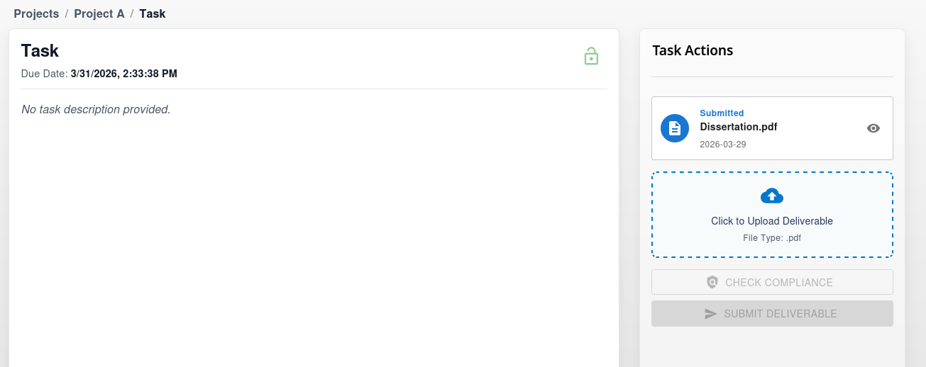Figure 185: Feedback CRUD - Submission and No Feedback (Student)
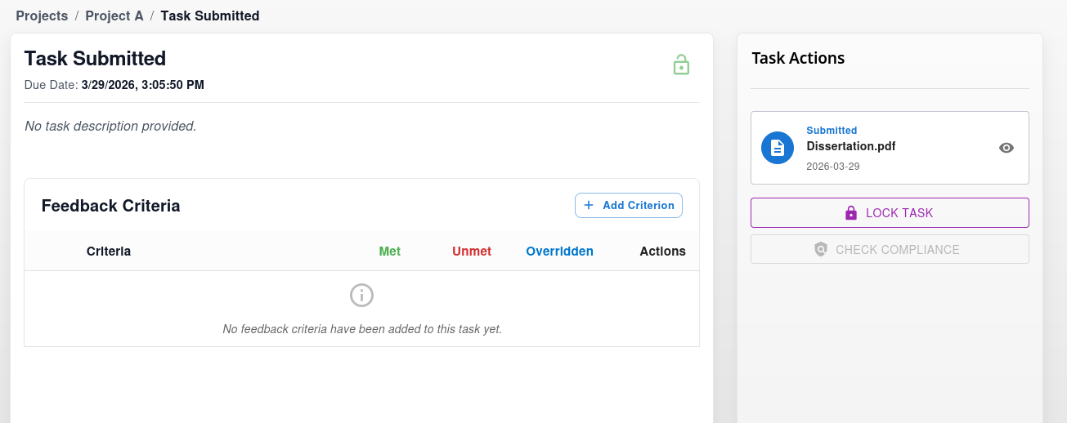Figure 186: Feedback CRUD - Submission and No Feedback (Supervisor)
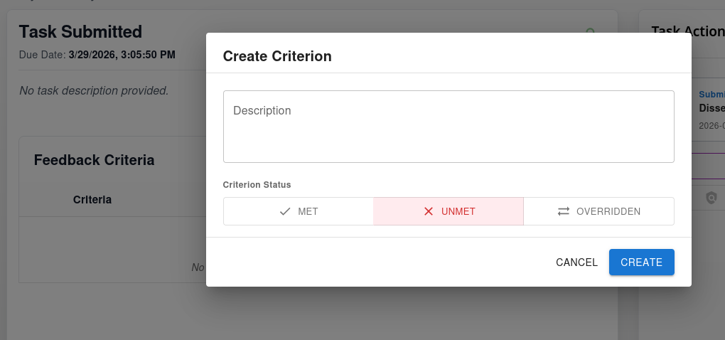Figure 187: Feedback CRUD - Feedback Modal

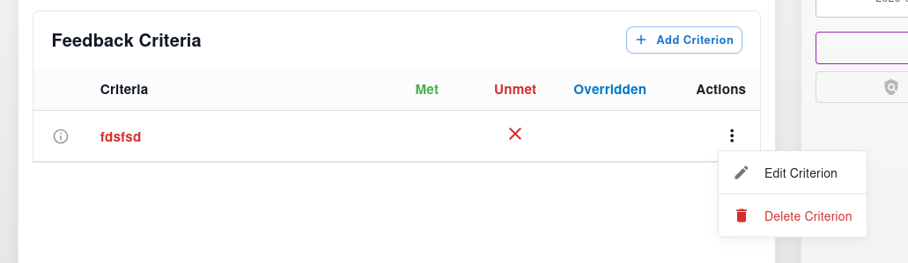Figure 188: Feedback CRUD - Criterion Menu Button

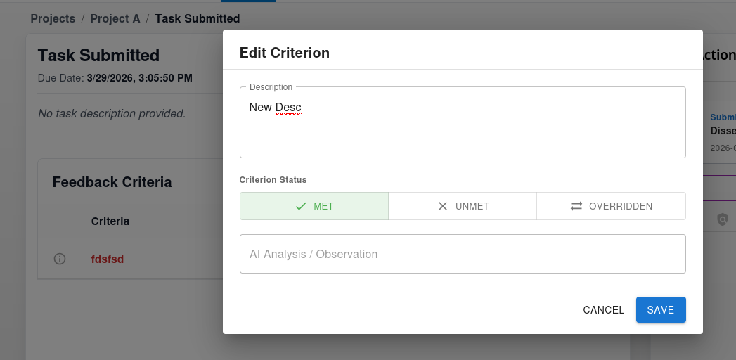Figure 189: Feedback CRUD - Feedback Modal (Edit)
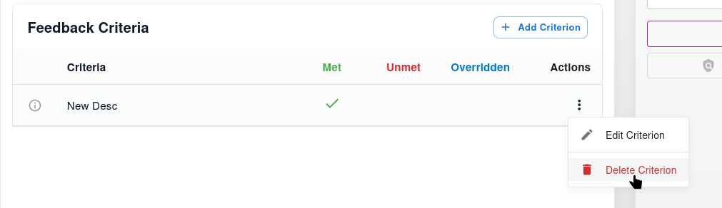Figure 190: Feedback CRUD – Before Delete Criterion
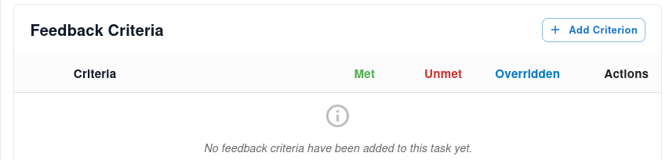Figure 191: Feedback CRUD – After Delete Criterion

Task Lock Feature
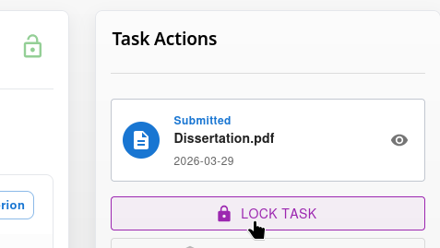Figure 192: Task Lock – Task Unlocked (Before Lock)

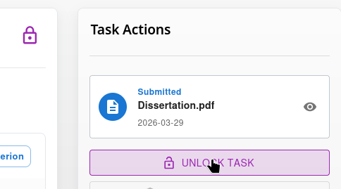Figure 193: Task Lock - Task Locked (After Lock)

Staged Deliverable Logic
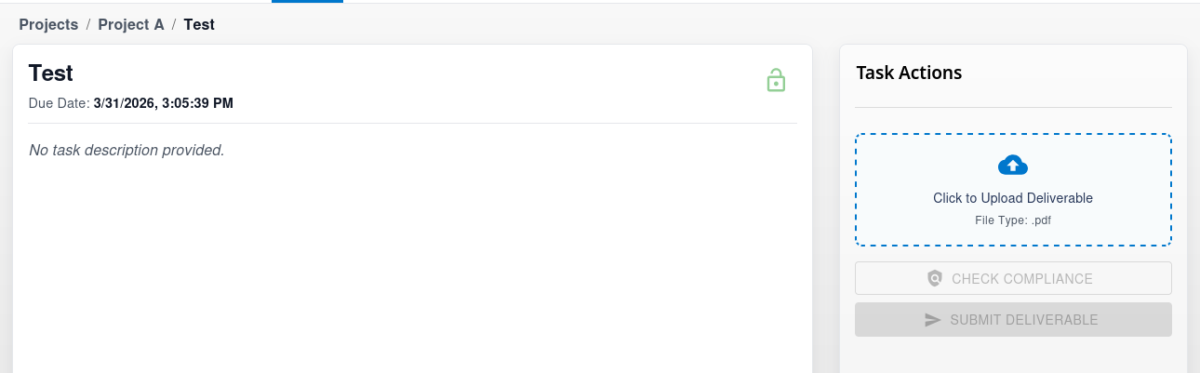Figure 194: Staged Deliverable Logic - No Deliverable In Staging Area

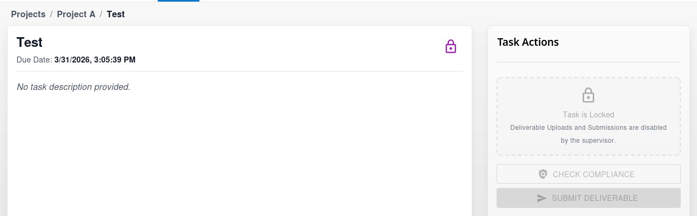Figure 195: Staged Deliverable Logic - Locked Task

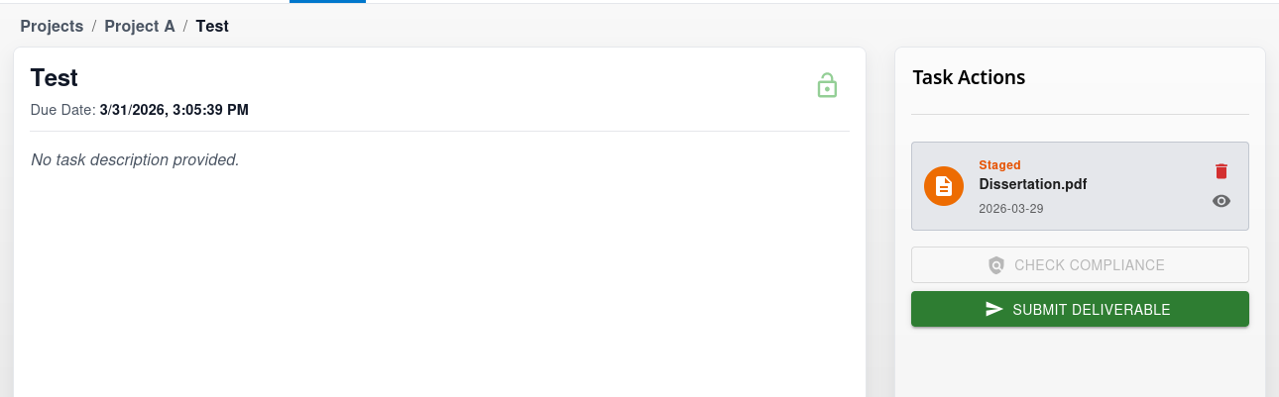Figure 196: Staged Deliverable Logic - Deliverable In Staging Area

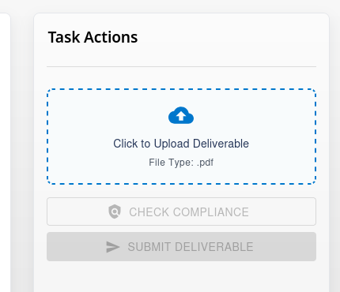Figure 197: Staged Deliverable Logic - Successful Deletion (Dissertation.pdf)

Deliverable Submission Logic
Figure 198: Deliverable Submission Logic - Unlocked Task and No Feedback
Figure 199: Deliverable Submission Logic - Locked Task and Staged Deliverable
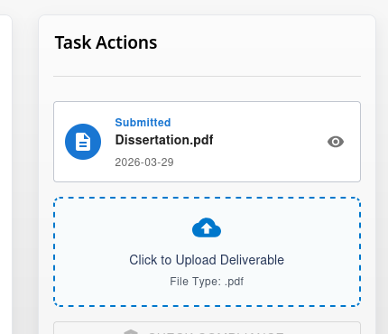Figure 200: Deliverable Submission Logic - Submit Button Clicked
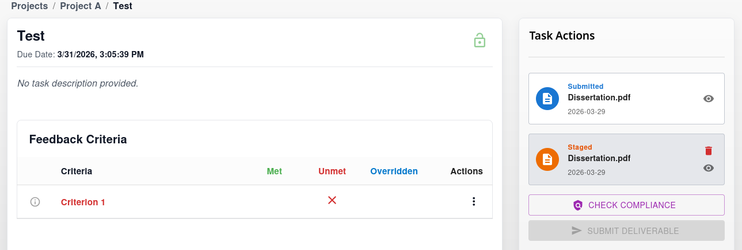Figure 201: Deliverable Submission Logic - Unmet Feedback Criterion

Feedback Criterion Override
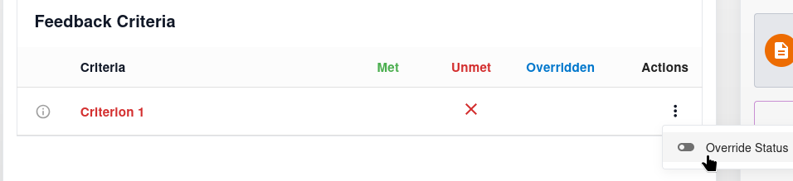Figure 202: Feedback Criterion Override
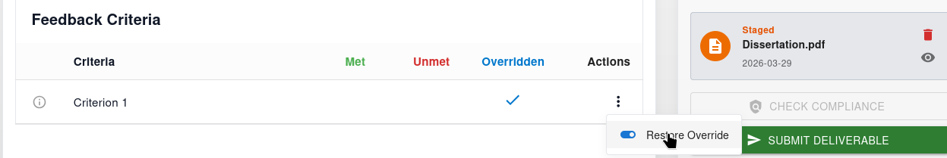Figure 203: Feedback Criterion Override (Successful)

AI Analysis
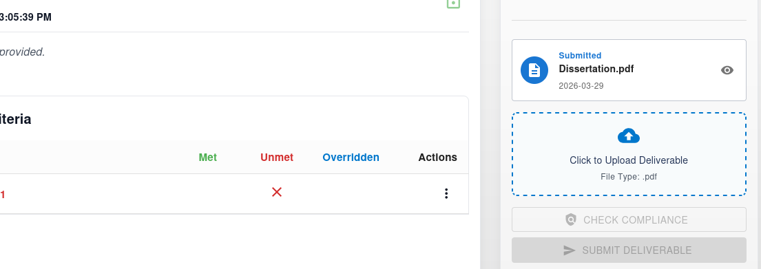Figure 204: AI Analysis - No Staged Deliverable
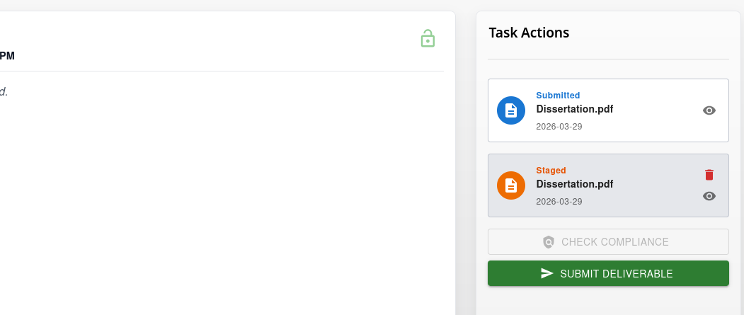Figure 205: AI Analysis - Staged Deliverable and No Feedback

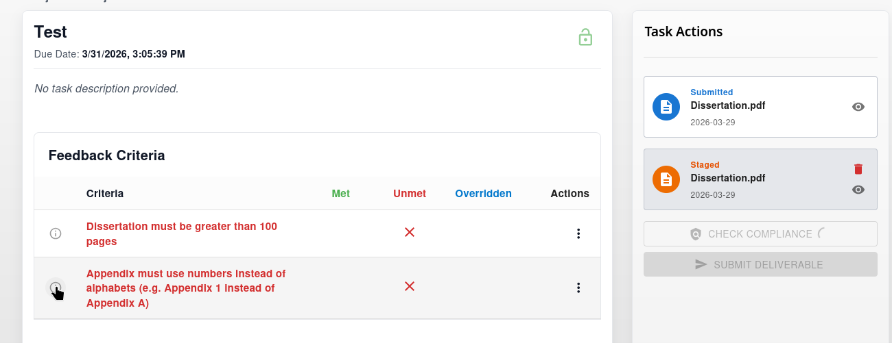Figure 206: AI Analysis - Before Compliance Check
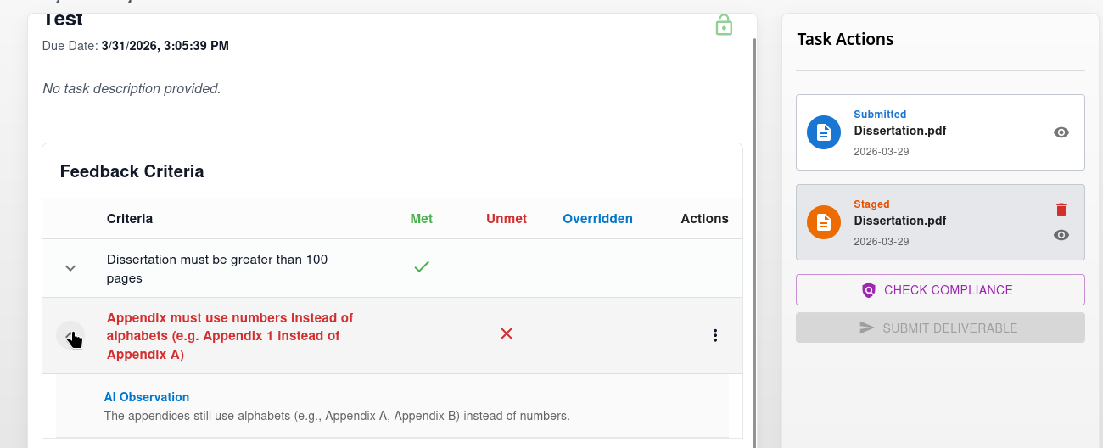Figure 207: AI Analysis - After Compliance Check

Meeting Participant RSVP Actions
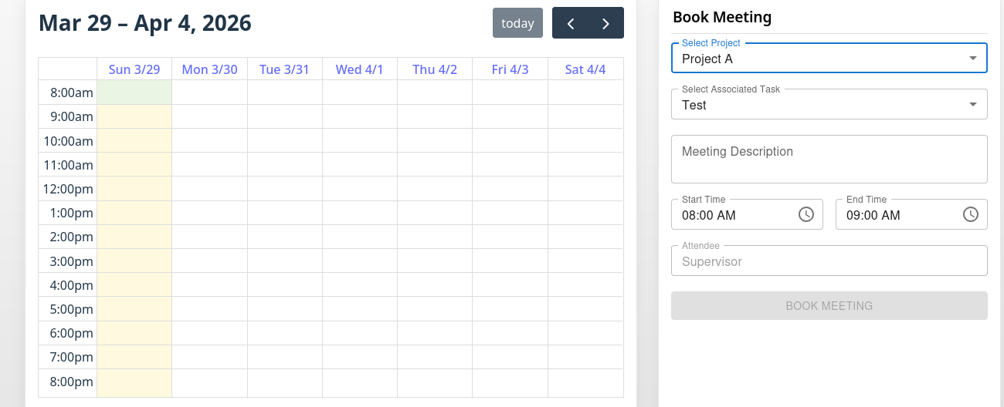Figure 208: Meeting Participant RSVP - Before Current Date Slot Selection
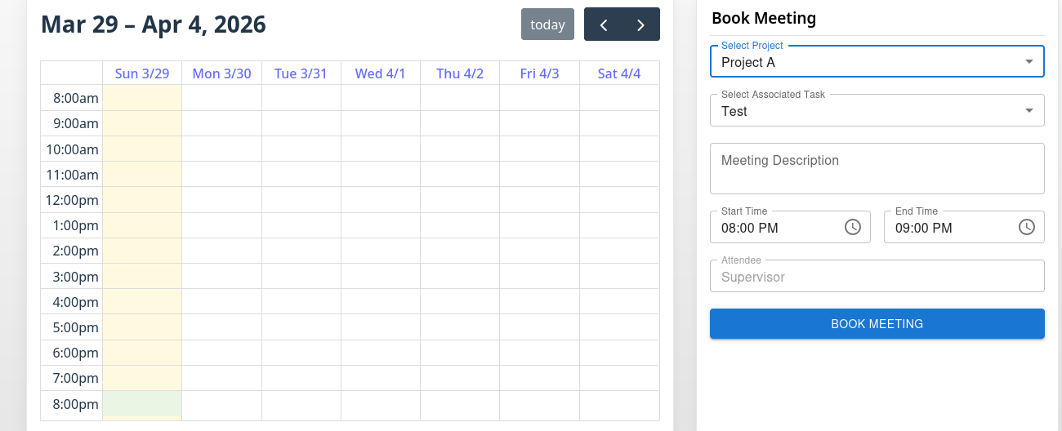Figure 209: Meeting Participant RSVP - After Current Date Slot Selection
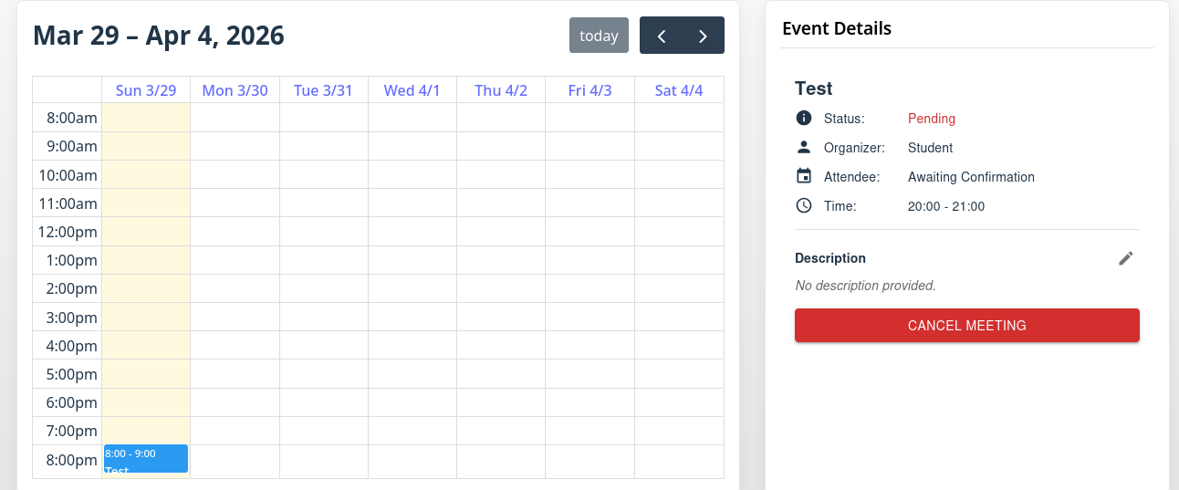Figure 210: Meeting Participant RSVP - Booked Meeting (Organizer)

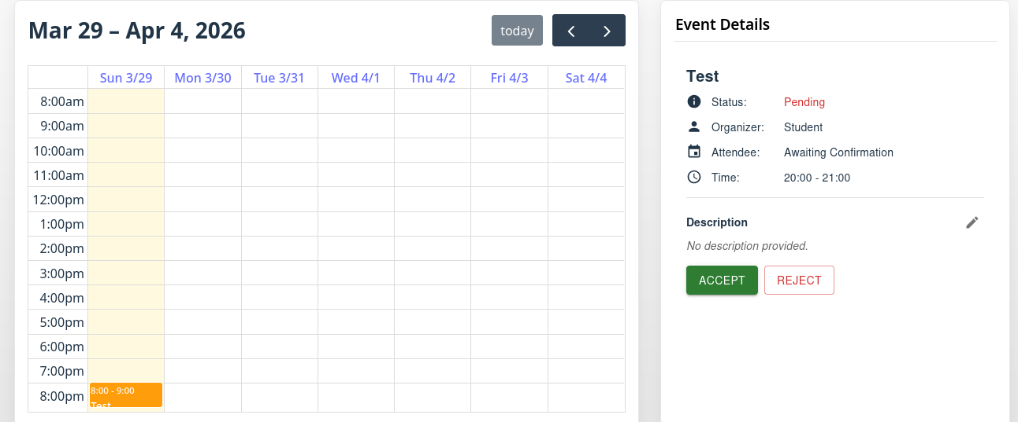Figure 211: Meeting Participant RSVP - Booked Meeting (Attendee)

Figure 212: Meeting Participant RSVP - Meeting Cancelled/Rejected

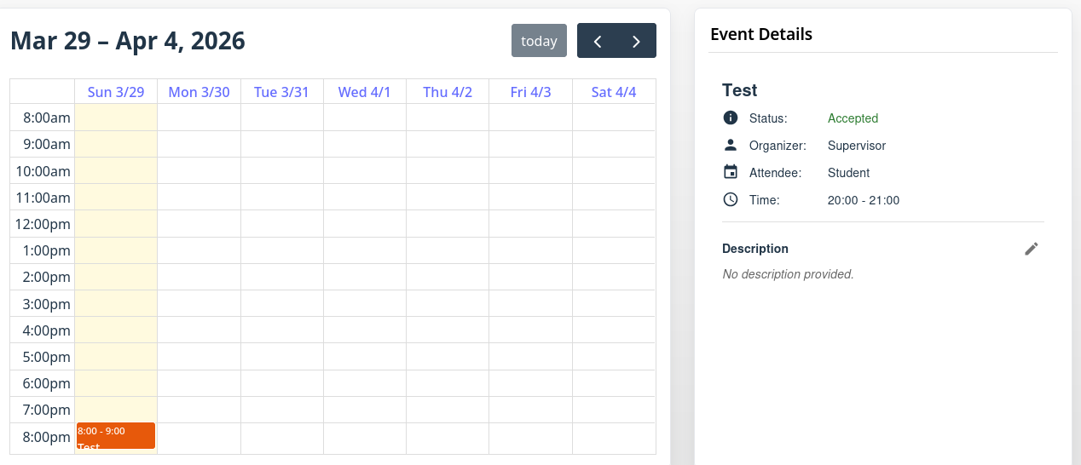Figure 213: Meeting Participant RSVP - Meeting Accepted (Attendee)
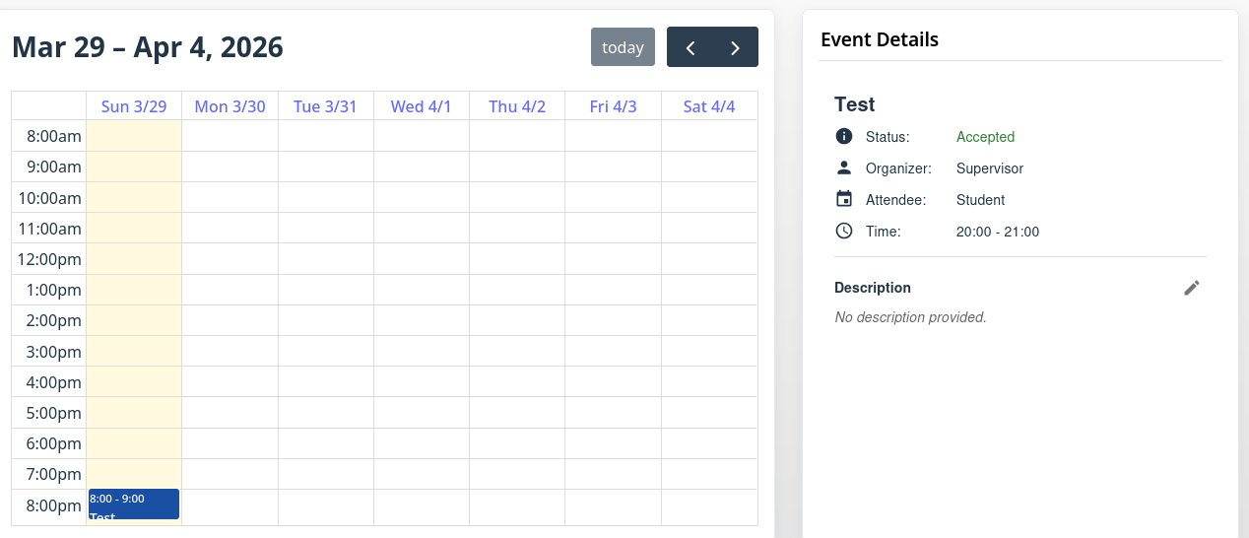Figure 214: Meeting Participant RSVP - Meeting Accepted (Organizer)

Meeting Non-Participant RSVP Actions
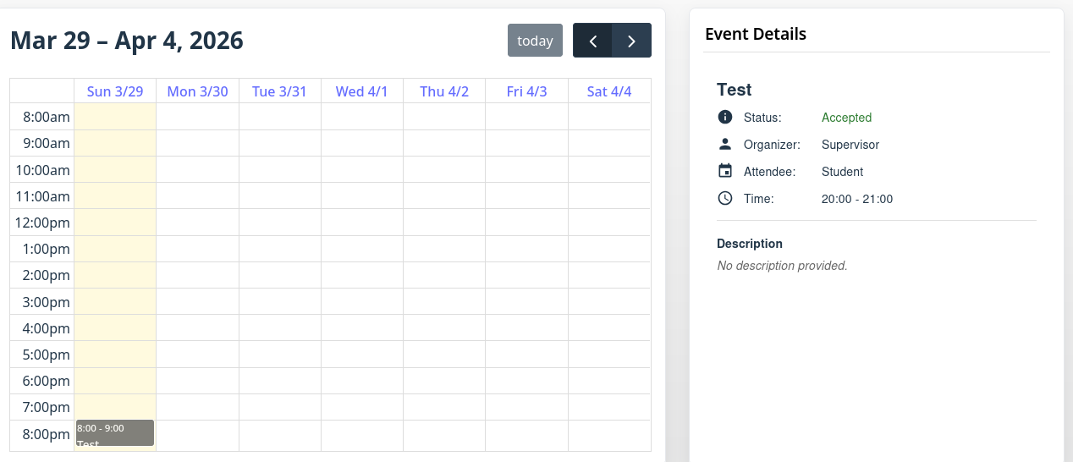Figure 215: Meeting Non-Participant - Unrelated Meetings

Notifications & Reminders
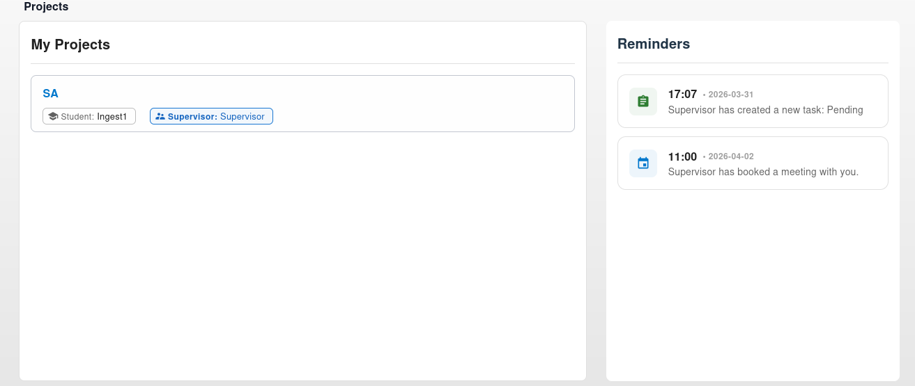Figure 216: Reminder Section - Pending Task & Booked Meeting
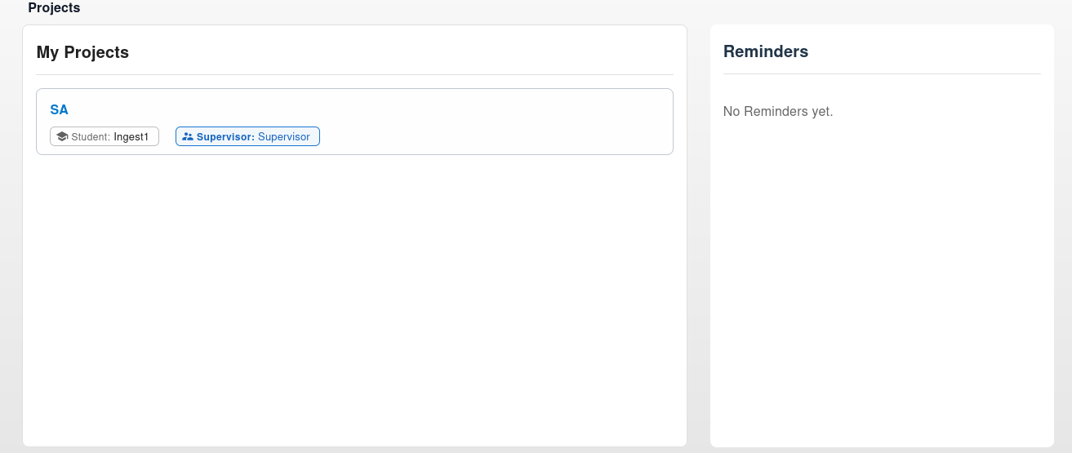Figure 217: Reminder Section - (Pending Task Completed + Meeting Rejected/Cancelled) Or Reminders Expired
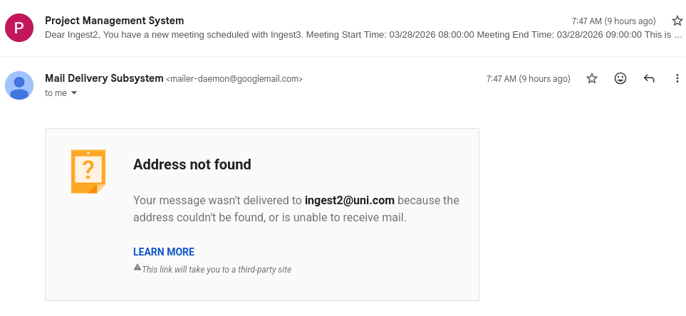Figure 218: Email Notification Example

Progress Log Report Generation
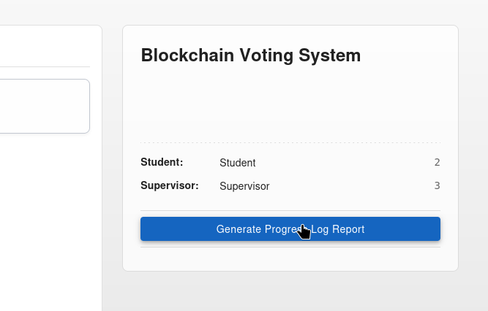Figure 219: Project Log Report - Before Generation
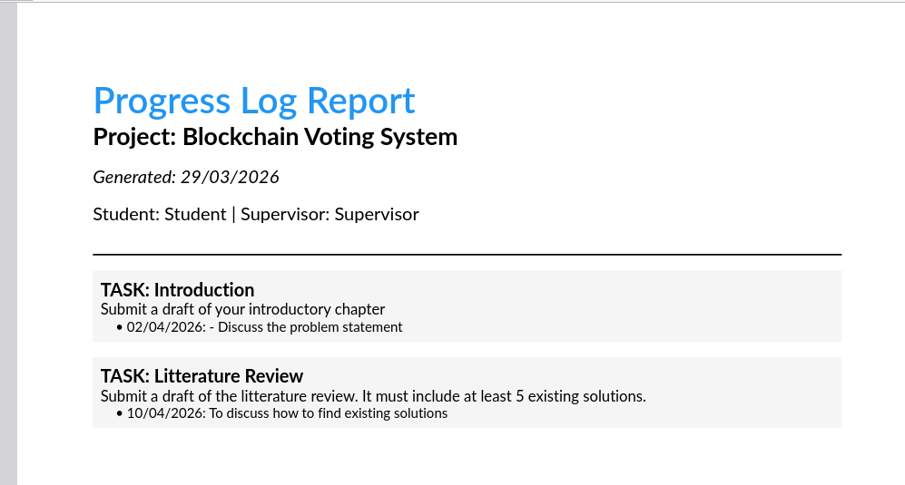Figure 220: Progress Log Report - After Generation

Appendix 4: Project Declaration Form


Appendix 5: Progress Log




Appendix 6: Project Submission Form


Appendix 7: Supervisor Statement


Appendix 8: Turnitin Receipt
