Introduction
The final year project is the cornerstone of any undergraduate academic program, serving as the final evaluation for the award of a degree. Its importance is further highlighted by the fact that it represents the crystallization of knowledge of a graduate throughout their academic journey so far, and hence serves as a tangible demonstration of their skills to industry recruiters or for the pursuit of higher graduate studies.

At the University of Mauritius (UoM), final year projects are traditionally proposed either by the faculty staff or by the students themselves, and are then allocated accordingly, to a supervisor-student pair. This supervision process is structured as a feedback loop whereby students are expected to iterate over their ‘Dissertation’ - a comprehensive document describing the project’s aims, literature review, methodology and its results – based on their supervisor’s feedback.

Therefore, it is imperative that every aspect of the supervision process, from the meetings conducted for communication between the supervisor and students to the feedback given remain as high as possible, for they shape not only the student’s academic success but also the metrics that determines the credibility and reputation of an institution.

Problem Statement
According to a recent paper on project supervision (Stynes, P. and Pathak, P., 2022), the traditional supervisory process for final year projects is not scalable. While the research focuses mainly on the postgraduate/masters level, its underlying principles – the supervisor’s finite time and attention, and one-on-one mentorship – are directly applicable for undergraduate programs as well. This lack of scalability leads to significant administrative burdens for academics and degrades the quality of the supervisory feedback, particularly within institutions with high enrollment numbers. As a result of these operational inefficiencies, the quality of final year projects may suffer, affecting the institution’s overall academic output and its credibility. This can be an emerging problem within the University of Mauritius’ (UOM) Faculty of Information and Communications Technology (FOICDT), whereby the total enrollment has increased from 916 in 2020 to 1339 in 2022 (University of Mauritius, 2025), representing an increase in 46.2%. This rapid growth places a significant strain on the academic staff, who have to adhere to the manual and inefficient processes.

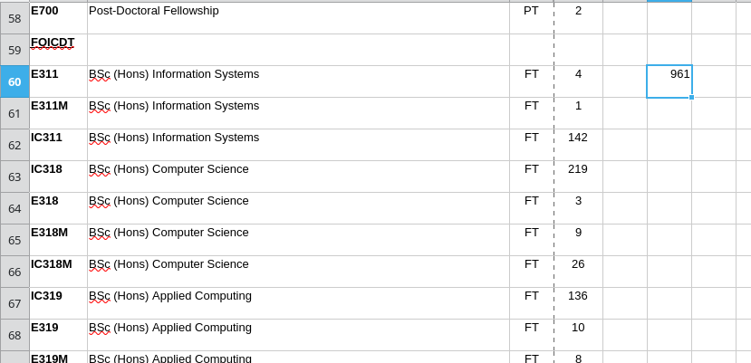Figure 1: Sum of Total Enrollment for UoM’s FOICDT 2019-2020

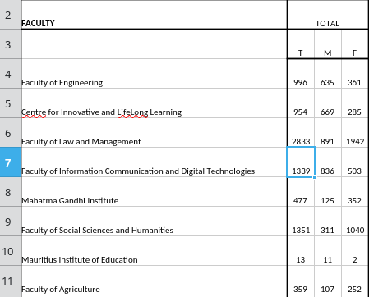Figure 2: Sum of Total Enrollment for UoM’s FOICDT 2021-2022

Supervisors who are already encumbered from managing multiple students, including different versions of each of their work, have seen their workload increase further. Much of it comprises of the menial tasks of managing communications via email, progress tracking, rescheduling meetings due to conflicting schedules and most notably, document management which includes the repetitive task of checking drafts, often consisting of thousands of words, for compliance with feedback.

Thus, a greater portion of the workload is dedicated to handling administrative overhead as opposed to their core responsibilities such as teaching, supervising and research, impacting the quantity and quality of feedback provided. Evidently, these affect the students as well since providing insufficient or vague feedback makes it more difficult to identify and resolve underlying issues, triggering a loss in motivation for both parties. Consequently, the probability that the project meets academic standards reduces significantly.

Proposed Solution
To address these inefficiencies and subsequently the challenges of scalability on the institutional level, this project proposes a web-based platform, Final Year Project Management System (FYPMS) which will be designed with the goal of automating unproductive and repetitive tasks and streamlining existing processes.

The core feature of the system will consist of project management - supervisors will be able to administer a list of their projects and their corresponding assignments. An assignment re-submission workflow will be built-in where re-submissions are checked for compliance with prior feedback using artificial intelligence. Furthermore, a meeting scheduling component will allow supervisors to import their calendar schedules in the system. It will then be used as a basis for scheduling meetings. For each project, the system will provide the functionality to generate a progress log report. Lastly, reminders for important events such as meeting dates and assignment submission deadlines will be sent.

Background Study
This chapter will consist of the literature review of the features and limitations of each solution. This will include a section on the evaluation of their features with respect to the proposed system features and an appraisal section. The background study will then end with a section that describes the proposed system and its constituent features in detail.

Literature review
The following solutions derived from both widely available commercial software and academic research from various universities, arranged in tabular form.
Existing Solutions | Features | Limitations
A Web Based Final Year Project Supervision System  (Beekhy, 2013) | - Appointment scheduling system which uses the supervisor’s calendar as a basis for scheduling meetings.  - Document management system where supervisors can set tasks for deliverable submissions/re-submissions and track document changes.  - Progress tracker with Gantt chart visualization to provide a complete picture of project’s progress. | - Lack of AI-powered feedback compliance checking  - Inability to send notifications to external services such as email or push notifications for important reminders
Creatrix Campus (Creatrix Campus, 2025:-b, Creatrix Campus, 2025:-c) | - Centralized document repository for change tracking and version control.  - Customizable review and approval workflows to streamline dissertation management (Low-code configurations).  - Reporting analytics for evaluating dissertation and thesis milestones for both students and supervisors.  - Meeting management software includes meeting scheduling with conflict avoidance and attendance tracking. | - No out-of-the-box solution for automated feedback checking; training is required for developers to implement and maintain custom review and approval workflows.  - Enterprise-level pricing may present a significant financial barrier.
Moodle as a Final Year Project Management System (Khamaruddin et al., 2018) | - The system re-purposes Moodle’s forum activity module to provide reminders with email notifications for important tasks and deadlines.  - Assignment activity module in Moodle allows supervisors to set assignments where students can submit drafts and final documents.  - Progress updates are tracked via the system’s course administration module. | - Assignment activity module does not provide change tracking between submissions.  - The system lacks a meeting planning and automatic feedback checking system.
Final Year Project Management System for Information Technology Programmes (Leung et al., 2018) | - The system has a File Sharing and Repository module to centralize document and code submissions.  - Project Management module provides students with a shared workspace and a scheduler for them to create tasks and set deadlines.  - Basic progress tracking feature for each student. | - The system lacks a meeting scheduling and automatic feedback checking system.  - Lack of a sophisticated version control system for managing documents and code.  - Group-based submission may obscure work accountability for individual students.
Google Workspace for Education (Google, 2025) | - Google Classroom acts as the core of the system where supervisors can make classes for project students and create assignments with deadlines.  - Google Classroom integrates seamlessly with Google Calendar, which can be used as a basis for meeting scheduling.  - Google Docs allows keeping track of different document versions for version control and overall change tracking using “Suggest” mode.  - Google Docs integrate with Google Assignment for feedback submission. | - Lack of customization flexibility to incorporate an AI solution for feedback compliance checking.  - Inadequate progress tracking capabilities to provide an overview of project’s progress.
Web-Based Final Year Project Supervision Management System (FYPSMS) (Adeniyi et al., 2024) | - Student home page for uploading project work documents and viewing progress.  - Supervisor dashboard to view progress for multiple students and project inspection page for viewing, downloading documents & providing feedback. | - The system lacks a dedicated meeting scheduling system and automatic feedback checking.  - There is no feature to track changes between document submissions.

Comparison between Existing Solutions

Solutions | Meeting Scheduling & Reminder Notification System | Deliverable Submission/ Re-Submission with Change Tracking | Automatic Feedback Compliance Checking | Progress Tracking (progress log or visual) | Specific Features
A Web Based FYP Supervision System | ✓ | ✓ | ✗ | ✓ | - Meeting scheduling on the basis of supervisor calendar.  - Gantt Chart visualization for progress tracking
Creatrix Campus | ✓ | ✓ | ? | ✓ | - Low code platform to create review and approval workflows for deliverables.  - Meeting Attendance tracking
Moodle as a FYP Management System | ✓ | ✗ | ✗ | ✓ | - Re-purposing existing open-source Moodle modules to provide specific features
FYP Management System for IT Programmes | ✗ | ✗ | ✗ | ✗ | - Architecture for streamlining group-based project supervision
Google Workspace for Education | ✓ | ✓ | ✗ | ✗ | - Document versioning for visible change tracking  - Prevent document editing/re-submission during feedback
Web-Based FYPSMS | ✗ | ✗ | ✗ | ✓ | - Dedicated dashboards for system administrators and external examiners

Appraisal
The ecosystem of digital solutions aimed at addressing the inefficiencies in academic management is already mature enough to justify their widespread adoption among colleges and universities around the globe. The extent of their integration with existing IT infrastructure vary significantly from one institution to another. For instance, some institutions use standard tools like Learning Management Systems for basic communication and deliverable handling. Others, however, adopt centralized full-fledged platforms to manage the entire supervision process from smart meeting scheduling to document management with progress tracking.

The University Of Mauritius currently uses Google Workspace for Education as a general education platform for a variety of courses in order to provide learning material, centralize assignment submissions or simply to broadcast reminders to particular cohorts. However, as Beekhy (2013) pointed out, there is no unanimously agreed upon methodology, and subsequently no centralized system supervisors use for the supervision process.

An evaluation of the project management systems listed so far shows that they tend to address areas concerning project allocation, meeting scheduling and managing deliverable submission. Most of them are adapted for the one-on-one supervision process although Leung et al. (2018) described a system that provides features dedicated for group-based supervision. Nonetheless, these systems have a clear functional gap – most of them lack some form of workflow automation for the deliverable submission. In that case, the feedback compliance checking process is absent in these solutions.

Proposed System Features

Role-Based Access Control
Firstly, the web platform will require a way to verify users of the system and determine which set of features of the system they will be allowed to access. For this, the system will have to provide authentication – verify users based on their credentials and categorize them as either one of the stakeholders below:
- Administrator(s)
- Supervisors
- Students
As an improvement over the authentication system of many of the academic solutions identified, the proposed system will support social login (see Appendix).

Administrator Dashboard
Since the system requires a secure way of determining the roles of users, they will be managed by an administrator (academic staff) via a dedicated dashboard inaccessible to the other users.

Project Management & Progress Log Generation
Supervisors and students, on the other hand, will be concerned with the final year project(s) and meeting scheduling. Hence, supervisors will be given the ability to create and manage projects that are assigned to them by the university, including adding the corresponding students to them, or archiving completed projects.
For administrative purposes, a progress log of project activities is required. Hence, a project progress log generation feature, based on prior meetings conducted and deliverable submissions, will be made available for individual projects and will be accessible by both the students and supervisors.

Deliverable Submission & Feedback
The supervision process is an iterative process where the supervisor reviews document drafts of the student’s research on the project, which altogether, will contribute to the overall dissertation. Therefore, for a given project, the system will provide supervisors with the feature to create deliverable submission tasks with deadlines.

These tasks will be based on the activity box of Google Classroom (Fig 3), where initially students will be able to submit their deliverables and supervisors will provide feedback on their work. Then, the given feedback will be made visible in the corresponding task from which the deliverable was submitted, and also be sent as a notification to the student via email.
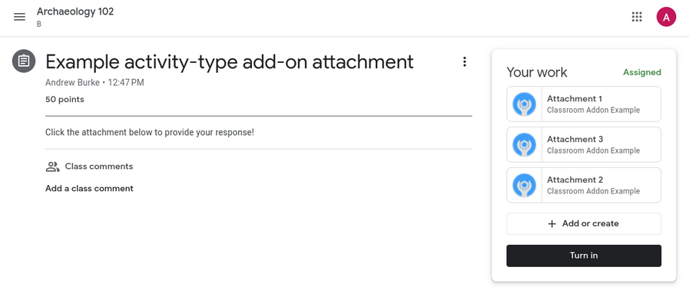Figure 3: Google Classroom Activity Example

AI Feedback Compliance Analysis
After providing feedback, the supervisor expects the student to iterate over it and produce a version of their work more aligned with the correct requirements. Unfortunately, this can rapidly spiral out of control and overwhelm the supervisor especially if they have to review feedback on multiple tasks for multiple projects.

The solution is to enhance the deliverable re-submission process by adding a workflow where the new deliverable version is checked for compliance with the previous feedback criteria through the use of artificial intelligence. Then, the list of feedback criteria is displayed as a list to the student, who may chose to either re-do their work or override certain feedback criteria and submit the new version.

Deliverable Version Control
Since each task may potentially support submissions of multiple versions of a deliverable, for performance and storage space utilization considerations, a version control system will be used. This is a fundamental limitation of the Moodle FYP and FYPSMS, where multiple document versions having repetitive text get stored separately and tend to waste storage space.
The different deliverable versions of a given task will be made accessible as a list of entries, each of which will made available for viewing or download.

Meeting Scheduling
Based on Bheeky’s (2013) meeting scheduling module, the meeting scheduling component aims to streamline the traditional way of scheduling appointments. Supervisors will have a calendar which is shared to all students under their supervision. This allows students to see available time slots before making appointments. These meeting appointments can then either be accepted or rejected by the supervisors. The improvement over the existing solution is that other students can request to be added to pending meeting appointments, catering for group-based meetings.

Notification & Reminder System
In order to keep the students and supervisors aware of important events, reminders will be sent as email notifications. Furthermore, these reminders will be displayed in a section visible when either user logs back into the system.

Analysis
This chapter will focus on the analysis of the system proposed in the previous chapter, evaluating the architectural considerations of the system and the technologies that will be used as the basis of their implementation.

List of Key Architectural Considerations
The following is a list of the system aspects that require a careful consideration of their underlying technology(s).
- Application Architecture
- Programming Language / Web Development Framework
- Database
- Authentication & Session Management Pattern
- Document Version Control
- Asynchronous Event Scheduling for Notifications
- Artificial Intelligence for Feedback Compliance Checking

Architectural Considerations

Application Architecture

Evaluation Criteria

Architectural Pattern Comparison

Architecture Choice

Programming Language / Web Development Framework

Evaluation Criteria
The choice of the development framework is dependent on the following criteria:
- Programming Language Features – Characteristics of the underlying language such as type safety, garbage collection for memory safety and automatic memory management, whether the language is compiled or interpreted.
- Ecosystem - Availability of third-party libraries for facilitating the development of custom application components, support for integration with external services such as databases and APIs and documentation quality.
- Built-in Abstractions – Provision of in-built features that handle tasks (such as sanitizing input to guard against XSS (see appendix)) without having to write the low level logic. This reduces development time and human error for critical code sections.
- Response Latency & Concurrency – If the framework offers a web server, response latency is the speed it can process requests. On the other hand, concurrency is the ability of the server to handle multiple simultaneous user requests.

Development Framework Comparison
The three most suitable web development frameworks have been identified and listed below for comparison:
 | .NET Core (C#) | Laravel (PHP) | Next.js (Javascript/Typescript)
Programming Language Features | Its underlying language, C# is a strongly-typed, memory-safe and compiled high level language with support for a wide variety of operations and features. | PHP is an interpreted language with optional type safety, built specifically for web development. It has libraries and language features to support tasks such as session management & input validation. | Javascript, officially known as ECMAScript, is an interpreted (JIT-compiled (see appendix)) language that is used for both client-side and server-side logic. Its flexible syntax allows for rapid prototyping. Type safety is provided by Typescript, which is a super set of Javascript.
Ecosystem | .NET offers an ecosystem of packages via Nuget package manager, including both community-developed and Microsoft-backed libraries. | Laravel provides an ecosystem of both official and community-developed packages through the Composer dependency manager for PHP. | Next.js makes use of the node package manager (npm) which manages the largest registry of packages and therefore, provides the largest ecosystem of readily available tools.
Built-in Abstractions | .NET has built-in middlewares for Authentication, logging and testing with built-in features against CSRF & XSS (see appendix) attacks. (ASP.NET Core, 2025)  It also provides .NET Entity Framework ORM (see appendix) for database abstraction. | Laravel has out-of-the-box CSRF (see appendix) protection and middlewares for request JSON schema validation and logging. (Laravel Docs, 2025)  It provides Eloquent ORM for database abstraction. | The built-in abstractions provided by Next.js are primarily concerned with optimizing performance for website rendering on the client.
Response Latency & Concurrency | C# is compiled into a highly optimized intermediate language and then executed, ensuring high performance. Furthermore, its multi-threaded nature allows it to efficiently handle multiple I/O requests simultaneously. As a result, it can tolerate high loads. | PHP has high overhead per request and thus a high response latency due to architectural considerations and blocking I/O operations.  Laravel Octane is required to achieve lower latencies and higher concurrency support via persistent memory and asynchronous processing. (Laravel Octane, 2025) | The underlying runtime, Node.js uses a single-threaded event loop for non-blocking IO, which is efficient for concurrent network requests (Node.js Docs, 2025)  Next.js improves website performance for the client by providing features such as Server-Side rendering (see appendix) (Next.js Docs, 2025)

Choice of Framework
.NET core will the be the most appropriate choice for the development framework based on the criteria given and the following additional justifications:
- The web platform must be designed handle thousands of concurrent users, especially when nearing the submission deadlines, during which deliverable submissions may soar considerably. This will be a common criteria in determining the most suitable technology to use. Buljić et al. (2025) showed that .NET Core consistently outperforms other web frameworks in response latency and handling concurrent HTTP requests.
- The ecosystem and built-in abstractions for .NET are more aligned with the requirements of the project – robust middlewares for authentication, testing and logging will reduce development time considerably while its ecosystem has official libraries for a range of tasks including LLM interactions and cron job scheduling.
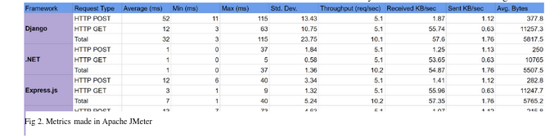Figure 4: Server Side Framework Performance Metrics (Buljić et al., 2025)

Database

Evaluation Criteria
The database to use will be selected based on the criteria:
- Performance
- Security & Reliability
- Scalability
- Cost & Licensing
- Development Framework Integration
- Large Object Storage & Retrieval

Database Comparison
 | PostgreSQL | Microsoft SQL Server | MySQL
Performance | PostgreSQL offers higher performance than MySQL for frequent update and delete operations.  It offers less performance than MySQL for frequent read operations. (AWS - PostgreSQL vs MySQL, 2025)  Supports more advanced indexing techniques as compared to MySQL. | SQL Server offers the highest performance due to several optimization capabilities.  Supports advanced indexing techniques | MySQL is less performative on for heavy update workloads than PostgreSQL.  It outperforms PostgreSQL in frequent read operations (AWS - PostgreSQL vs MySQL, 2025)
Security & Reliability | ACID (see appendix) compliant with support for advanced indexes for reliability | Extensive feature set for ensuring security and reliability including ACID compliance | ACID compliance depends on the storage engine used
Scalability | Scales both vertically (increasing resources for a single server) and horizontally (increasing number of servers) | Scales both vertically and horizontally | Scales better horizontally than vertically
Cost & Licensing | Free & Open-source | Requires licensing for large scale enterprise environments | Free & Open-source
Development Framework Integration | .NET Core support provided by Npgsql, which is an open-source data provider package. | Microsoft provides an official data provider for SQL Server and native libraries are specifically optimized for interaction with SQL Server. | .NET Core support provided by MySqlConnector, which is open-source.
Large Object Storage & Retrieval | PostgreSQL uses TOAST (PostgreSQL: Docs - TOAST) optimization to compress large objects before writing to disk.  TOAST also makes retrieval slightly faster than MySQL by making records cache-friendly. | Less storage compression efficiency offered as compared to PostgreSQL. | No inherent compression techniques for large objects and has less storage efficiency than PostgreSQL.

Choice of Database
In spite of SQL Server being the most advanced of the databases listed, PostgreSQL will be selected due to SQL Server’s expensive licensing costs. The decision is also based on the additional justifications:
- Although web applications predominantly feature a higher read-write ratio, incorporating a job scheduling service with the database as a persistent storage can significantly increase the number of write operations and hence favoring PostgreSQL over MySQL in order to achieve better performance.
- Since deliverables may often be text documents ranging from 5-150 pages long, PostgreSQL will be more suitable for handling large text objects due to its TOAST optimization features, optimizing storage utilization. Read operations will also be slightly more efficient.

Authentication & Session Management Pattern

Evaluation Criteria
The authentication & session management pattern of choice is selected based on the criteria:
- Implementation Complexity
- Performance & Scalability
- Security
- Convenience

Comparing Authentication & Session Management Patterns
 | Session-Based Authentication | Token-Based Authentication
Description
Implementation Complexity
Performance
Security
Convenience

https://learn.microsoft.com/en-us/nuget/what-is-nuget
https://learn.microsoft.com/en-us/aspnet/core/fundamentals/middleware/?view=aspnetcore-9.0
https://laravel.com/docs/12.x/csrf
Buljić, I., Kadusic, E., Cvijanovic, T., Hadzajlic, N. and Zivic, N. (2025) Comparative Performance Analysis of Leading Backend Frameworks for Developers. In: (Title of Conference/Proceedings/Book - Inferred) 2025 International Scientific Conference on Information Technology and Data Related Fields (INFOTEH). (Date/Month of Conference - Inferred) Tuzla, Bosnia and Herzegovina: INFOTEH, pp. 1–5. doi: 10.1109/INFOTEH64129.2025.10959250.
https://aws.amazon.com/compare/the-difference-between-mysql-vs-postgresql/
https://www.postgresql.org/docs/current/storage-toast.html

