Coordinate system M ranges:
- Xmin = -8, Xmax= 8,
- Ymin = -8, Ymax= 8.
Sta-ge | Augmented matrix | System of equations | Points, lines | Visualization
1 | (R1)/2 → R1 | 2x-3y=-9  3x-2y=-1  (E1)/2 → E1 | P = (3, 5) (blue)  L1 (red):  A1=(-8, -7/3), B1=(8, 25/3)  L2 (green):  A2=(-8, -11.5), B2=(8, 12.5) | 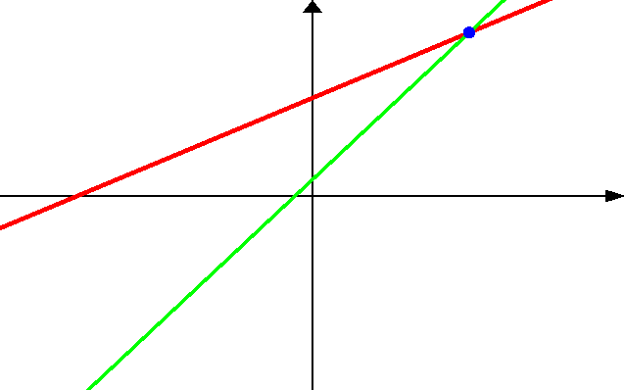
  2 | -3 | -9
  3 | -2 | -1
2 | R2 – 3R1 → R2 | x-1.5y=-4.5  3x-2y=-1  E2 – 3E1 → E2 | P = (3, 5) (blue)  L1 (red):  A1=(-8, -7/3), B1=(8, 25/3)  L2 (green):  A2=(-8, -11.5), B2=(8, 12.5)
  1 | -1.5 | -4.5
  3 | -2 | -1
3 | (R2)/2.5 → R2 | x-1.5y=-4.5  2.5y=12.5  (E2)/2.5 → E2 | P = (3, 5) (blue)  L1 (red):  A1=(-8, -7/3), B1=(8, 25/3)  L2 (green):  A2=(-8, 5),  B2=(8, 5) | 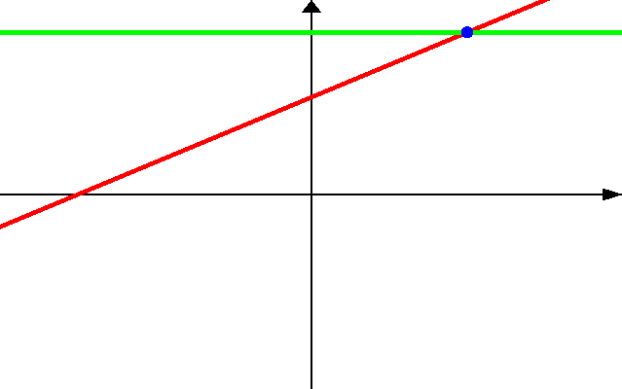
  1 | -1.5 | -4.5
  0 | 2.5 | 12.5
4 | R1 + 1.5R2 → R1 | x-1.5y=-4.5  y=5  E1 + 1.5E2 → E1 | P = (3, 5) (blue)  L1 (red):  A1=(-8, -7/3), B1=(8, 25/3)  L2 (green):  A2=(-8, 5),  B2=(8, 5)
  1 | -1.5 | -4.5
  0 | 1 | 5
5 |  | x=3  y=5 | P = (3, 5) (blue)  L1 (red):  A1=(3, -8),  B1=(3, 8)  L2 (green):  A2=(-8, 5),  B2=(8, 5) | 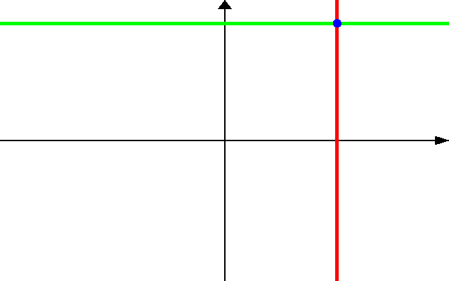
  1 | 0 | 3
  0 | 1 | 5

