Coordinate system M ranges:
- Xmin = -6, Xmax= 6,
- Ymin = -6, Ymax= 6.

Sta-ge | Augmented matrix | System of equations | Points, lines | Visualization
1 | (R1)/2 → R1 | 2x-3y=-14  3x+2y=5  (E1)/2 → E1 | P = (-1, 4) (blue)  L1 (red):  A1=(-6, 2/3), B1=(6, 26/3)  L2 (green):  A2=(-6, 11.5), B2=  (6, -6.5) | 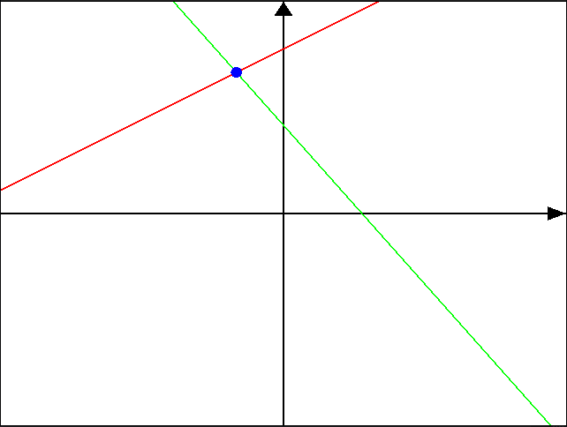
  2 | -3 | -14
  3 | 2 | 5
2 | R2 – 3R1 → R2 | x-1.5y=-7  3x+2y=5  E2 – 3E1 → E2 | P = (-1, 4) (blue)  L1 (red):  A1=(-6, 2/3), B1=(6, 26/3)  L2 (green):  A2=(-6, 11.5), B2=  (6, -6.5)
  1 | -1.5 | -7
  3 | 2 | 5
3 | (R2)/6.5 → R2 | x-1.5y=-7  6.5y=26  (E2)/6.5 → E2 | P = (-1, 4) (blue)  L1 (red):  A1=(-6, 2/3), B1=(6, 26/3)  L2 (green):  A2=(-6, 4), B2=  (6, 4) | 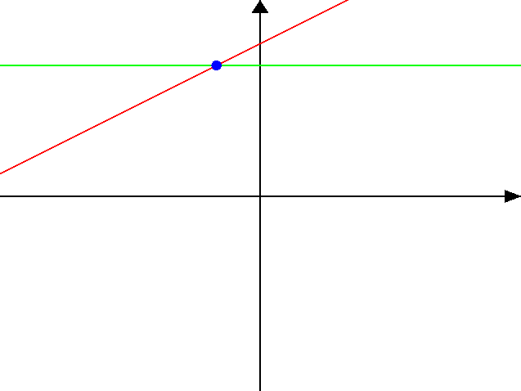
  1 | -1.5 | -7
  0 | 6.5 | 26
4 | R1 + 1.5R2 → R1 | x-1.5y=-7  y=4  E1 + 1.5E2 → E1 | P = (-1, 4) (blue)  L1 (red):  A1=(-6, 2/3), B1=(6, 26/3)  L2 (green):  A2=(-6, 4), B2=  (6, 4)
  1 | -1.5 | -7
  0 | 1 | 4
5 |  | x=-1  y=4 | P = (-1, 4) (blue)  L1 (red):  A1=(-1, -6),  B1=(-1,6)  L2 (green):  A2=(-6, 4), B2=  (6, 4) | 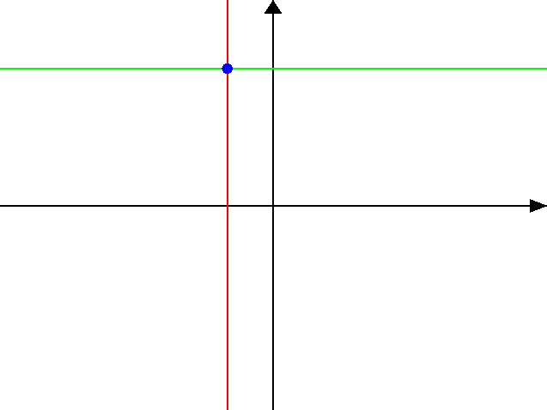
  1 | 0 | -1
  0 | 1 | 4

