
MIS 442 –Advance Database Systems Final Project Report
Begüm Özkan
211005050
Izmir Bakırçay Universtiy
Faculty Of Economics And Administrative Sciences
Management Information Systems

Instructor: Assoc. Prof. Emine UÇAR

Abstract:
This report details the process of designing and implementing a relational database for a gamified project management system. The main goal of this project was to develop an efficient database schema capable of managing core project data such as users, teams, projects, and tasks, along with gamification elements. The key deliverables include entity-relationship ER diagrams and the SQL queries used for the actual database creation. The database was implemented using SQL Server, and sample data was included to illustrate the initial structure and data entry process. To sum up, this database is intended to serve as a solid foundation for the future development of a fully functional gamified project management application.
Keywords: Relational Database Design, Database Design, Gamified Project Management, Entity-Relationship Diagram (ERD), SQL, Database Schema, Data Modeling, Normalization, Database Structures, Test Results

MIS 442 –Advance Database Systems Final Project Report
In today's data-driven world, a well-designed database is crucial for the effective management of information within any system. This report details the process and includes the creation and design of a relational database specifically tailored for a gamified project management system. The core objective of this project is to create a robust and scalable database schema that can efficiently handle the system's data requirements. The main purpose of the idea of a gamified project management database is to track projects by creating a more comfortable and competitive environment for users instead of tracking and working under pressure.

1.Table Structures
In the Gamified Project Management Database System, there are 12 tables and each table has related attributes, primary keys, and foreign keys.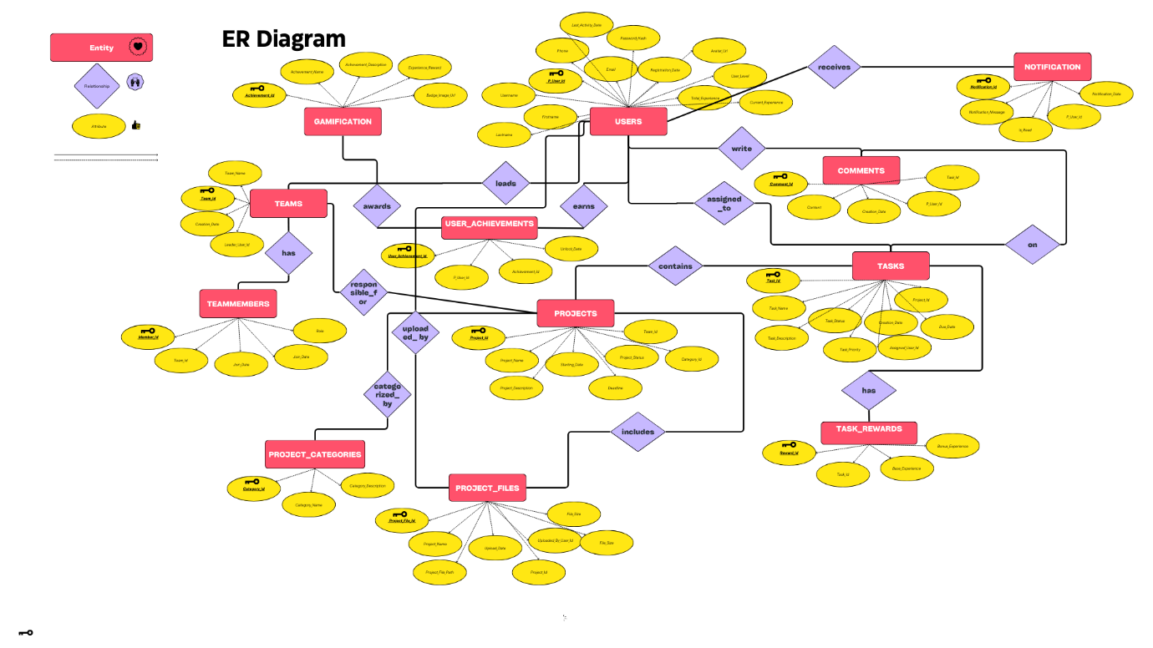
Figure1.1 including Gamified Project Management Database System entities and attributes also defines relationships between tables(entities).
1.1 USERS Table: It stores information about the system's all users. Each user has a unique ID, which allows this number to uniquely identify each row in the table. Also, with IDENTITY(1,1), this number automatically increments as new users are added. A username cannot be left blank and must be unique, which prevents username confusion in the system. Similarly, each user has an email address, and each email address belongs to only one user in the system such as Instagram, or Twitter(X).
Attributes | Data Type | Description
P_User_Id | INT, Primary Key, Identity | Unique identifier for each user.
Username | NVARCHAR 50, Not Null, Unique | User's login name.
First name | NVARCHAR 100, Not Null | User's first name.
Lastname | NVARCHAR 100, Not Null | User's last name.
Phone | NVARCHAR 20, Null | User's phone number.
Email | NVARCHAR 100, Not Null, Unique | User's email address.
Password_Hash | NVARCHAR 256, Not Null | Hashed password for security.
Registration_DATE | DATETIME, Default GETDATE | Date of user registration.
Avatar_Url | NVARCHAR 255, Null | URL for the user's profile picture.
User_Level | INT, Default 1 | User's level in the gamified system.
Total_Experience | INT, Default 0 | User's total experience points.
Current_Experience | INT, Default 0 | User's current experience points.
Last_Activity_Date | DATETIME | Last login date and time.

1.2 TEAMS Table: It defines information about project teams. Each team has a unique ID and this ID is automatically increased as new teams are added. This prevents confusion between teams. [By normalizing this table, I have established a relationship between them and the team member table, I will mention it in detail in the Normalization section.]Also, when a leader user is deleted, the team leader information is updated to NULL and the team continues to exist. (On delete set null)
Attributes | Data Type | Description
Team_Id | INT, Primary Key, Identity | Unique identifier for each team.
Team_Name | NVARCHAR 50, Not Null | Name of the team.
Creation_Date | DATETIME, Default GETDATE | Date of team creation.
Leader_User_Id | INT, Null, Foreign Key to USERS | User ID of the team leader.
FK_TEAMS_USERS A foreign key constraint ensuring that Leader_User_Id references a valid P_User_Id in the USERS table. If the leader is deleted from USERS, Leader_User_Id is set to NULL.

1.3 TEAM MEMBERS Table: The table manages the relationship between users and teams, indicating which users belong to which teams. With the ON DELETE CASCADE feature, when a team is deleted, all the records of the team members are automatically deleted. This preserves the data integrity of the database. In the code, I defined a uniqueness (UNIQUE) constraint called UQ_TEAM_MEMBER. This constraint ensures that the Team_Id and P_User_Id columns are unique together. That is, the same user cannot be a member of the same team more than once.
Attributes | Data Type | Description
Member_Id | INT, Primary Key, Identity | Unique identifier for each team member record.
Team_Id | INT, Foreign Key to TEAMS | Associated team ID.
P_User_Id | INT, Foreign Key to USERS | Associated user ID.
Join_Date | DATETIME, Default GETDATE | Date when the user joined the team.
ROLE | NVARCHAR(50), Not Null | Role of the user in the team.

1.4 PROJECT CATEGORIES Table: The table divides projects into limited categories. Only one of the specified options can be selected as a category; values ​​entered outside of this are not valid. The CHECK constraint is defined in the Category_Name column. This constraint ensures that only certain defined category names can be entered in the Category_Name column. This maintains the consistency and accuracy of project category data.
Attributes | Data Type | Description
Category_Id | INT, Primary Key, Identity | Unique identifier for each category.
Category_Name | NVARCHAR(50), Not Null | Name of the project category.
Category_Description | NVARCHAR(255), Null | Description of the category.

1.5 PROJECTS Table: It shows project information. With the ON DELETE CASCADE feature, when a team is deleted, all projects belonging to that team are automatically deleted. This ensures that the project and team relationship remain consistent. In addition, thanks to the ON DELETE SET NULL statement, when a category is deleted, the Category_Id value of the projects belonging to that category is updated to NULL and the projects are not deleted. The CHECK constraint is defined in the Project_Status column. This constraint ensures that only certain defined project statuses ('Not Started', 'In Progress', 'Completed', 'On Hold') can be entered into the Project_Status column. This way, we can filter the status of projects in a standard and consistent way.
Attributes | Data Type | Description
Project_Id | INT, Primary Key, Identity | Unique identifier for each project.
Project_Name | NVARCHAR(100), Not Null | Name of the project.
Project_Description | NVARCHAR(255), Null | Description of the project.
Starting_Date | DATETIME, Default GETDATE | Start date of the project.
Deadline | DATETIME, Null | Deadline of the project.
Project_Status | NVARCHAR(20), Not Null | Status of the project (e.g., Active, Completed).
Team_Id | INT, Foreign Key to TEAMS | Associated team ID.
Category_Id | INT, Foreign Key to PROJECT_CATEGORIES | Associated project category ID.

  - TASKS Table: It defines tasks. When a project is deleted, all tasks belonging to that project are automatically deleted as well. Tasks are linked to the projects they belong to. Only defined task statuses ('To Do', 'In Progress', 'Done', 'Blocked') should be entered in the Task_Status column, and only defined priority levels ('Low', 'Medium', 'High', 'Critical') should be entered in the Task_Priority column. This ensures that task data is consistent and easily filtered. (CHECK STATEMENT)
Attributes | Data Type | Description
Task_Id | INT, Primary Key, Identity | Unique identifier for each task.
Task_Name | NVARCHAR(100), Not Null | Name of the task.
Task_Description | NVARCHAR(255), Null | Description of the task.
Task_Status | NVARCHAR(20), Not Null | Status of the task (e.g., To Do, In Progress, Done).
Task_Priority | NVARCHAR(20), Not Null | Priority level of the task (e.g., Low, Medium, High).
Creation_Date | DATETIME, Default GETDATE | Date the task was created.
Due_Date | DATETIME, Null | Deadline for the task.
Project_Id | INT, Foreign Key to PROJECTS | Associated project ID.
Assigned_User_Id | INT, Foreign Key to USERS | Assigned user ID.

  - TASK REWARDS table: This table shows the points awarded for the tasks. When a task is deleted, the reward record for that task is also automatically deleted, so the rewards are associated with the current tasks. Each task has only one reward, so there is a one-to-one relationship between the task and the reward.
Attributes | Data Type | Description
Reward_Id | INT, Primary Key, Identity | Unique identifier for each reward.
Task_Id | INT, Unique, Foreign Key to TASKS | Associated task ID.
Base_Experience | INT, Not Null | Base experience points for completing the task.
Bonus_Experience | INT, Null | Additional bonus experience points.

  - GAMIFICATION table: It ensures that users are motivated in the system by earning various achievements and badges. In the Achievement_Id column, the PRIMARY KEY is defined as IDENTITY(1,1). In other words, each achievement has a unique ID and this ID is automatically increased as new achievements are added.
Attributes | Data Type | Description
Achievement_Id | INT, Primary Key, Identity | Unique identifier for each achievement.
Achievement_Name | NVARCHAR(100), Not Null | Name of the achievement.
Achievement_Description | NVARCHAR(255), Null | Description of the achievement.
Experience_Reward | INT, Not Null | Experience points are rewarded for unlocking the achievement.
Badge_Image_Url | NVARCHAR(255), Null | URL of the badge image.

1.9 USER ACHIEVEMENTS table: Keeps track of which user earned which achievement and when. When a user is deleted, all achievement records of that user are automatically deleted. When an achievement is deleted, all user records related to that achievement are also deleted. The same user cannot earn the same reward more than once.
Attributes | Data Type | Description
User_Achievement_Id | INT, Primary Key, Identity | Unique identifier for each user achievement record.
P_User_Id | INT, Foreign Key to USERS | User ID who unlocked the achievement.
Achievement_Id | INT, Foreign Key to GAMIFICATION | Achievement ID unlocked.
Unlock_Date | DATETIME, Default GETDATE | Date the achievement was unlocked.

1.10 PROJECT FILES table: It stores information about uploaded files related to projects (name, path, type, size) and which user uploaded them. When a project is deleted, all files belonging to that project are automatically deleted as well. This prevents unnecessary information pollution. When the user who uploaded the file is deleted, this information is updated to NULL and the file record is not deleted.
Attributes | Data Type | Description
Project_File_Id | INT, Primary Key, Identity | Unique identifier for each project file.
Project_File_Name | NVARCHAR(255), Not Null | Name of the file.
Project_File_Path | NVARCHAR(500), Not Null | File path or URL.
Upload_Date | DATETIME, Default GETDATE | Date the file was uploaded.
Project_Id | INT, Foreign Key to PROJECTS | Associated project ID.
Uploaded_By_User_Id | INT, Foreign Key to USERS | User ID who uploaded the file.
File_Size | BIGINT, Not Null | Size of the file in bytes.
File_Type | NVARCHAR(50), Not Null | Type of the file (e.g., PDF, DOCX, PNG).

1.11 COMMENTS table: Records user comments made on tasks and who wrote them. When a user attempts to be deleted, if there are comments belonging to that user, this action is blocked. The comments must be deleted first. This prevents accidents based on deletion. When a task is deleted, all comments for that task are automatically deleted as well. This ensures that comments remain associated with the tasks they belong to.
Attributes | Data Type | Description
Comment_Id | INT, Primary Key, Identity | Unique identifier for each comment.
Content | NVARCHAR(500), Not Null | Content of the comment.
Creation_Date | DATETIME, Default GETDATE | Date the comment was created.
P_User_Id | INT, Foreign Key to USERS | User ID who wrote the comment.
Task_Id | INT, Foreign Key to TASKS | Associated task ID.

1.12 NOTIFICATION table: Used to send notifications (messages, updates, alerts) to users in the system and track their read status. When a user is deleted, all notification records belonging to that user are automatically deleted. Comments are tied to specific tasks or topics and reflect contributions from users. This prevents accidental data loss. For user deletion, dependent data is managed first, which provides controlled data management.
Attributes | Data Type | Description
Notification_Id | INT, Primary Key, Identity | Unique identifier for each notification.
Notification_Message | NVARCHAR(255), Not Null | Notification message content.
Is_Read | BIT, Default 0 | Whether the notification has been read (0 = No, 1 = Yes).
Notification_Date | DATETIME, Default GETDATE | Date of the notification.
P_User_Id | INT, Foreign Key to USERS | User ID the notification is for.

Relationships
- One-to-Many Relationships:
USERS → TEAMS: A user can lead multiple teams.
USERS → TASKS: A user can be assigned many tasks.
USERS → PROJECT_FILES: A user can upload many files.
USERS → COMMENTS: A user can write many comments.
USERS → NOTIFICATION: A user can receive many notifications.
TEAMS → PROJECTS: A team can manage many projects.
PROJECTS → TASKS: A project can have many tasks.
PROJECTS → PROJECT_FILES: A project can have many files.
TASKS → COMMENTS: A task can have many comments.
- Many-to-Many Relationships
USERS ↔ TEAMS: A user can be in more than one team, and a team can have more than one user
USERS ↔ GAMIFICATION: A user can earn more than one achievement and an achievement can be earned by more than one user
- One-to-One Relationships
TASKS → TASK_REWARDS: Each task has exactly one reward entry.

NORMALIZATION
When I first designed the database system, the TEAMS table contained (Team_Id, Team_Name, Creation_Date, Leader_User_Id, Member_Id, Member_Name), and there were multiple values in member_id. Because it contained multiple values, 1 nf did not fit, so I first separated the comma-typed values contained in the Member_Id cells into rows. And I brought them into the form of atomic values.
First design: Multiple values of Member_ıd
Team_Id | Member_Id
1 | 1,2,3
(This table shows without 1NF)

Team_Id | Member_Id
1 | 1
1 | 2
1 | 3
(After 1 NF)
1NF, I created the TEAM MEMBERS table and associated and linked these tables using the id. TEAM MEMBERS include these attributes: Team_Id, Member_Id
2NF, I have added Member_Name, ROLE, and Join_Date attributes to the TEAM MEMBERS table and removed them from the TEAMS table.
At the 3NF part, using the Member_Id, Team_Id, and P_User_Id; I linked the user's table, the team's table, and the team members' table together.
I applied similar normalization procedures to the PROJECTS and PROJECT_FILES tables. Essentially, I separated the repeating data within the PROJECTS table to achieve the First Normal Form (1NF). Subsequently, I created the PROJECT_FILES table, Populating it with the necessary attributes and removing these attributes from the PROJECTS table. Finally, in the Third Normal Form (3NF) stage, I established a relationship between these tables using foreign keys, effectively linking them and ensuring optimization.

SQL QUERIES USED
This section has SQL queries about what am I using in the project:
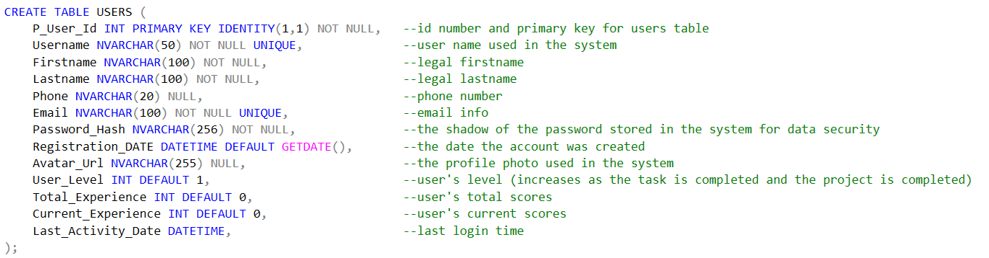
(Image1 shows how to create a USERS table)
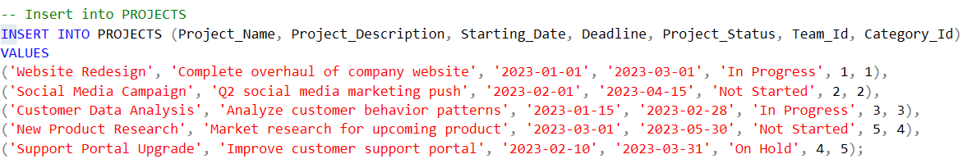
(Image2 is shown adding to projects)
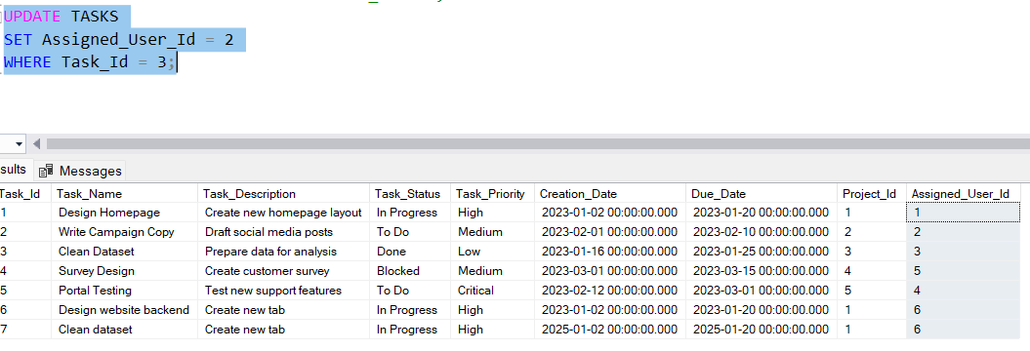
(Image 3:Assign the user with Id 2 to the task with Task_Id 3 query. )
Test Results
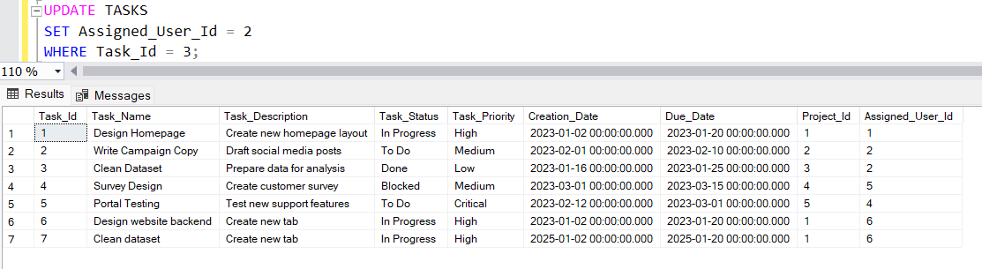
(Test results for image 3)
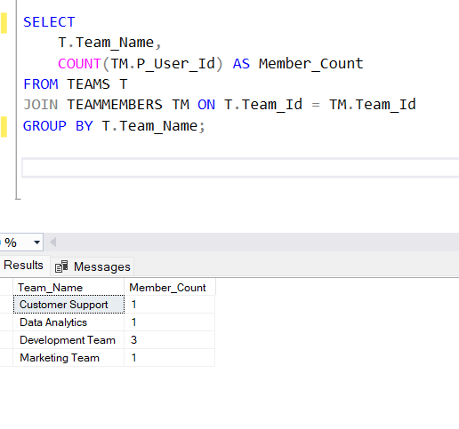
(Test results for counting the number of members in groups)
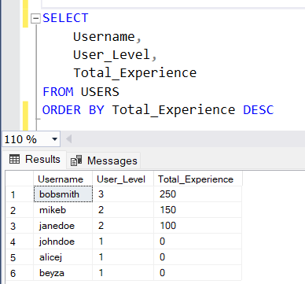
(Test results to calculate total experience for each user)
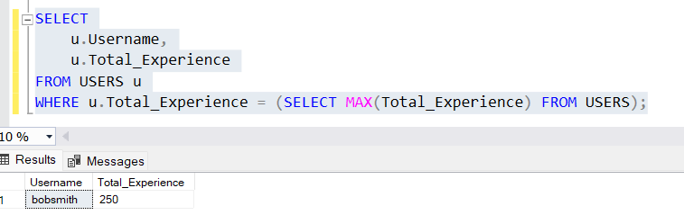
(Test results for finding who has maximum total experience on the system)
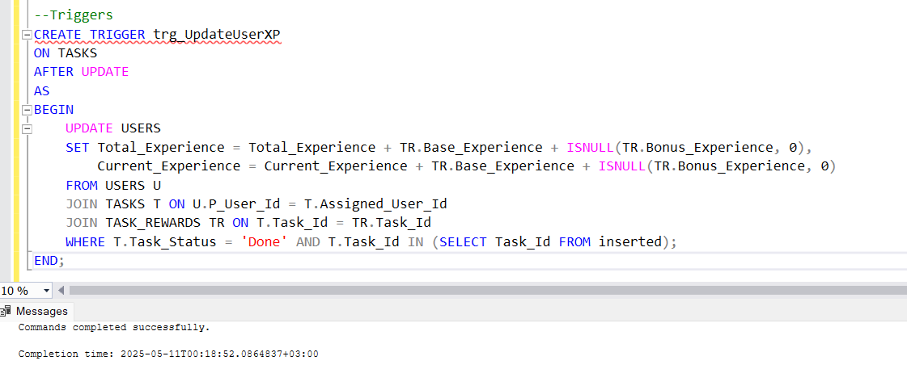(When a user completes a task (e.g. Task_Status = 'Done'), the corresponding XP is automatically added to the Total_Experience and Current_Experience columns in the USERS table.)
Test Results for trigger:
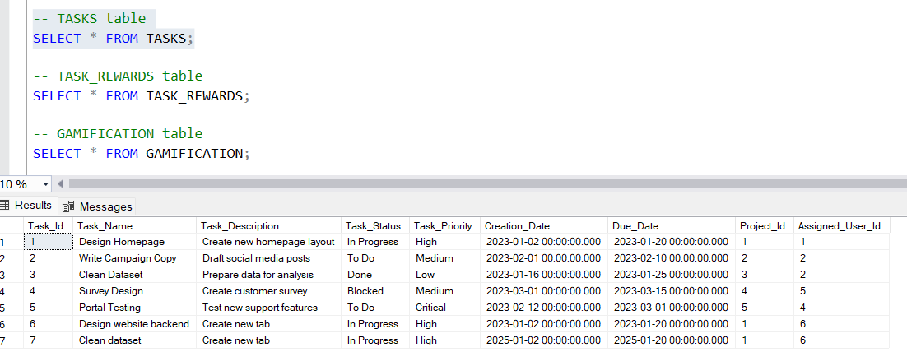
(Before from trigger)
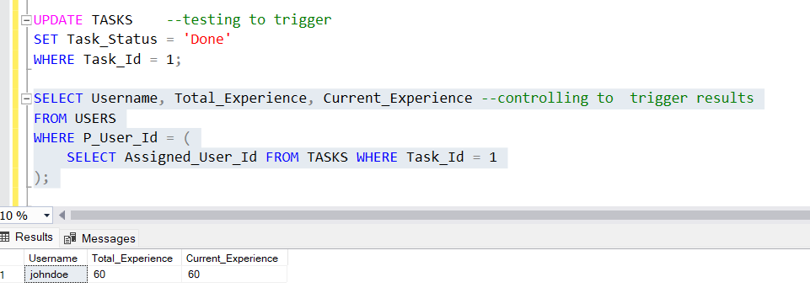
(after the trigger)

References
What is normalization? Explain 1NF,2NF, and 3NF with examples. Pr. . . | Filo. (2024, October 27). Filo. https://askfilo.com/user-question-answers-smart-solutions/what-is-normalization-explain-and-with-example-print-and-3132393731373935
GeeksforGeeks. (2025, April 8). Introduction of ER model. GeeksforGeeks. https://www-geeksforgeeks-org.translate.goog/introduction-of-er-model/?_x_tr_sl=en&_x_tr_tl=tr&_x_tr_hl=tr&_x_tr_pto=tc
Database normalization. (n.d.). https://www.w3schools.in/dbms/database-normalization
Entity Relationship(ER) model. (n.d.). https://www.w3schools.in/dbms/er-model
GeeksforGeeks. (2025a, January 6). Database testing software testing. GeeksforGeeks. https://www.geeksforgeeks.org/software-testing-database-testing/

