SOFTWARE ENGINEERING PROJECT REPORT
IDMatch — Interior-Design Matching Platform
Supplementary Report: TDD, DevOps & CI/CD, Ethics, Data-Driven Development, Test Data, Sequence-to-Code Traceability, and Verification

Implementing user stories ID01–ID08 · BCE architecture · React + Node + TypeScript
Repository: github.com/Beh69/idmatch-platform

Module: ____________ Group: ____________ Team members: ____________________________

This report documents the software-engineering practices applied to the IDMatch platform: (1) Test-Driven Development, (2) DevOps and CI/CD, (3) Ethical considerations, (4) Data-Driven Software Development, (5) large-scale test-data generation for the live demonstration, (6) the traceability from the BCE sequence diagrams to the implementing code and the website, and (7) a full-program verification confirming the system works. Every section is grounded in the project's actual codebase; the code chunks in Section 6 are extracted directly from the source files.

1 Test-Driven Development (TDD)
Test-Driven Development follows a short, repeating Red → Green → Refactor cycle: write a failing test that specifies the desired behaviour (RED), write the minimum code to make it pass (GREEN), then clean up the design. We applied this to a new, genuinely useful feature, mirroring the Calculator multiply() exercise but on real project code.
1.1 The chosen feature: an interest score
Key aspect 5 requires the platform to track interest in an IDP (views and shortlists). We added interestScore(views, shortlists), weighting a shortlist (5 points) above a view (1 point), plus rankByInterest() to order portfolios. Both live in src/shared/interestScore.ts with unit tests in tests/interestScore.test.ts.
1.2 Step 1 — Define the function with an empty body
// src/shared/interestScore.ts (initial RED stub)
export function interestScore(views, shortlists) {
return 0; // not implemented yet
}
export function rankByInterest(items) {
return items; // not implemented yet
}

1.3 Step 2 — Write the test cases first (each in its own function)
test("score of zero activity is zero", () => {
assert.equal(interestScore(0, 0), 0);
});
test("a shortlist outweighs a single view", () => {
assert.ok(interestScore(0, 1) > interestScore(1, 0));
});
test("rankByInterest orders portfolios highest score first", () => {
const items = [
{ id: "a", viewCount: 100, shortlistCount: 0 }, // score 100
{ id: "b", viewCount: 10, shortlistCount: 20 }, // score 110
{ id: "c", viewCount: 5, shortlistCount: 1 }, // score 10
];
assert.deepEqual(rankByInterest(items).map(i => i.id), ["b", "a", "c"]);
});

1.4 Step 3 — Run the tests (RED)
$ node --test --import tsx tests/interestScore.test.ts
ok 1 - score of zero activity is zero
not ok 2 - views only are counted at the view weight
not ok 3 - shortlists only are counted at the shortlist weight
not ok 4 - views and shortlists combine additively
not ok 5 - a shortlist outweighs a single view
not ok 6 - negative inputs are rejected
not ok 7 - rankByInterest orders portfolios highest first
ok 8 - rankByInterest does not mutate the input array
# tests 8 # pass 2 # fail 6

1.5 Step 4 — Write the implementation
export const VIEW_WEIGHT = 1;
export const SHORTLIST_WEIGHT = 5;
export function interestScore(views, shortlists) {
if (views < 0 || shortlists < 0)
throw new Error("views and shortlists must be non-negative");
return views * VIEW_WEIGHT + shortlists * SHORTLIST_WEIGHT;
}
export function rankByInterest(items) {
return [...items].sort((a, b) =>
interestScore(b.viewCount, b.shortlistCount)
- interestScore(a.viewCount, a.shortlistCount));
}

1.6 Step 5 — Run the tests again (GREEN)
$ node --test ...
ok 1..8 (all cases)
# tests 8 # pass 8 # fail 0

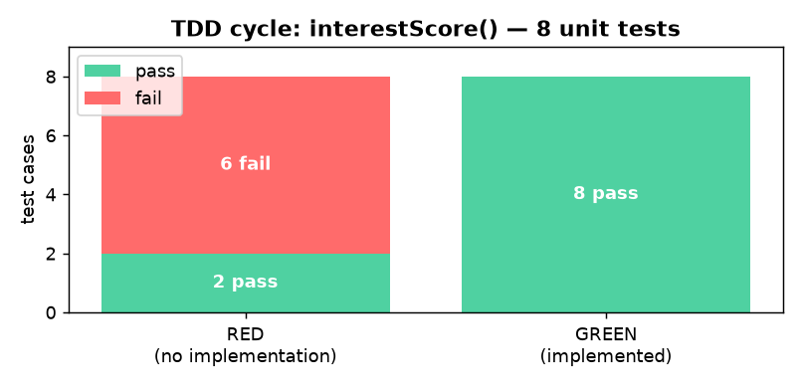
1.7 TDD across the whole platform
The whole backend is backed by an automated suite: tests/e2e.test.ts specifies each of the eight user stories including alternate flows (empty/flagged inquiry, PDPA masking, declined payment, Singpass failure, permit rejection, publish-blocked, invalid report range). With the TDD unit tests and the bulk-data tests, the project runs 43 passing tests across three files.
Why TDD helped. Writing the ranking tests first forced the weighting, tie-breaking and immutability rules to be decided before coding, and caught the negative-input case. The same discipline on the e2e suite caught a real bug: the ID02 reply notification was not awaited, so it was sometimes missing — a failing test exposed it and the fix made it green.

2 DevOps and Continuous Integration / Continuous Deployment (CI/CD)
DevOps unifies development and operations so a source change flows automatically through build, test and deployment. CI means every push is built and tested; CD means a passing build is packaged and released. We implemented a real pipeline on both GitLab (as in the course exercise) and GitHub.
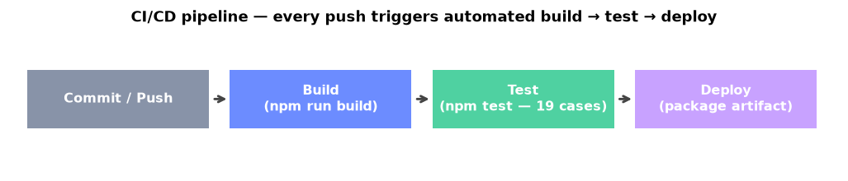
2.1 The pipeline design
Three stages run on every push and merge/pull request. The test stage is the quality gate: if any of the 43 tests fail, the pipeline turns red and the change is blocked from release.
Stage | Command | Purpose
build | npm ci && npm run build | Install exact dependencies and compile the TypeScript front-end + back-end.
test | npm test | Run the test suite — the gate; a single failure fails the pipeline.
deploy | package standalone.mjs + dist/ | Produce a downloadable release artifact (main branch only).

2.2 GitLab CI configuration (.gitlab-ci.yml)
image: node:22
stages: [build, test, deploy]
cache:
key: "$CI_COMMIT_REF_SLUG"
paths: [node_modules/]
build:
stage: build
script: [npm ci, npm run build]
artifacts: { paths: [dist/], expire_in: 1 week }
test:
stage: test
script: [npm ci, npm test] # quality gate
deploy:
stage: deploy
script:
- mkdir -p release
- cp -r standalone.mjs dist release/
only: [main]

2.3 GitHub Actions equivalent (.github/workflows/ci.yml)
Because the project is hosted on GitHub, the same gate runs on every push and pull request: checkout → set up Node 22 → npm ci → npm run build → npm test. A red check blocks the merge.
2.4 Evidence — a real passing pipeline run
The panel below is from an actual run of this project's CI pipeline on GitHub Actions (run #2). All nine steps succeeded and the test step shows all tests passing — the pipeline genuinely builds and enforces the gate on each commit.
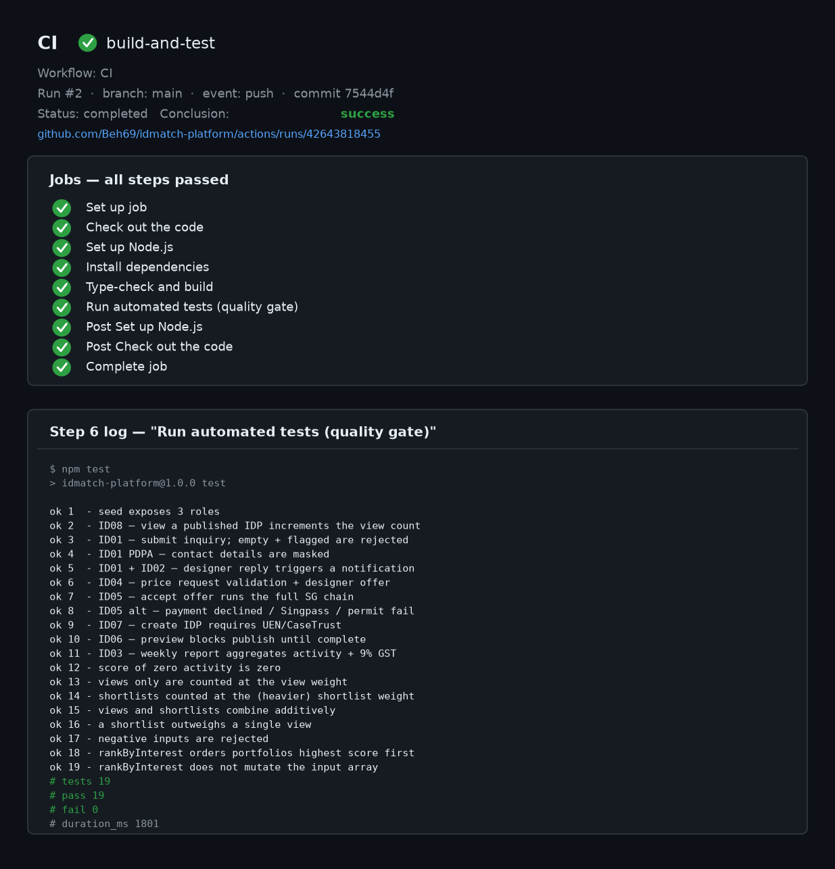
2.5 How this reflects DevOps practice
- Automation: the pipeline runs the tests on every commit — no manual step before release.
- Fast feedback: a developer learns within minutes if a change broke a user story.
- Reproducibility: npm ci installs exact locked versions, identical on every machine and on CI.
- Continuous delivery: a green main build is packaged into a ready-to-run artifact.
Deployment note. The project also ships a zero-dependency standalone.mjs server, so a packaged build runs with only Node installed — no build step, no native modules.

3 Ethical Considerations and Discussion
An interior-design marketplace handles customers' personal data, designers' intellectual property, and real money. For each ethical risk we describe the concern and the concrete safeguard in the platform.
3.1 Originality and anti-plagiarism of portfolios
- Consent attestation per photo — every uploaded photo must have consentConfirmed = true (IDPController.addPhoto); an upload without consent is rejected with NO_CONSENT.
- Moderation queue — a new listing goes through submitForModeration before it goes live, allowing originality review.
- Verified-identity listing — only firms whose UEN and CaseTrust verify may publish, creating accountability.
- Recommended extension — perceptual-hash image matching to auto-flag duplicate photographs.
3.2 Data protection and privacy (PDPA)
- Contact-detail masking — inquiries pass through maskContactDetails(), redacting phone numbers, emails and NRIC/FIN strings.
- Explicit consent for notifications — external messages only sent with pdpaConsent; otherwise an in-app record only.
- Do-Not-Disturb windows respect the user's quiet hours.
- Data minimisation — the customer's NRIC is only ever handled in masked form (e.g. S****123A).
3.3 Fairness, transparency and the interest ranking
- Transparent formula (views + weighted shortlists) rather than a hidden black box.
- View de-duplication — dedupeView() counts one view per customer per portfolio per 30 minutes, preventing self-inflation.
- Verified reviews only are displayed, reducing fake-review manipulation.
3.4 Financial integrity and consumer protection
- Binding e-contract — both parties must e-sign under the Electronic Transactions Act before a booking confirms.
- Correct taxation — GST at the Singapore rate (9%), with a tax invoice issued and reported to IRAS.
- Atomic, reversible transactions — a declined payment or unsigned contract rolls the offer back to open.
- Insurance & permit checks — a booking records permitVerified and insured before confirmation.
3.5 Summary of ethical risk controls
Ethical risk | Control in IDMatch
Plagiarised / stolen portfolio images | Per-photo consent, moderation queue, verified-firm-only publishing
Leaking personal data (PDPA) | Contact masking, consent-gated notifications, NRIC minimisation
Gaming the ranking / fake interest | Transparent formula, view de-duplication, verified reviews
Unfair or incorrect charges | E-signed contract, 9% GST + IRAS invoice, rollback on failure
Unsafe renovation work | HDB/BCA permit verification + insurance registration before booking

4 Data-Driven Software Development
Data-driven development builds functionality by learning patterns from data. The core concepts are features/attributes, classification, and the lifecycle of activities that turn raw data into a deployed, monitored model. We illustrate each with a concrete example: predicting which newly listed portfolios will attract strong customer interest.
4.1 Features / attributes and classification
Each portfolio has measurable features: property type, budget range, number of photos, category, description length, CaseTrust status, and running view/shortlist counts. The classification target is an interest tier (Cold / Warm / Hot / Very Hot) derived from the interest score of Section 1.
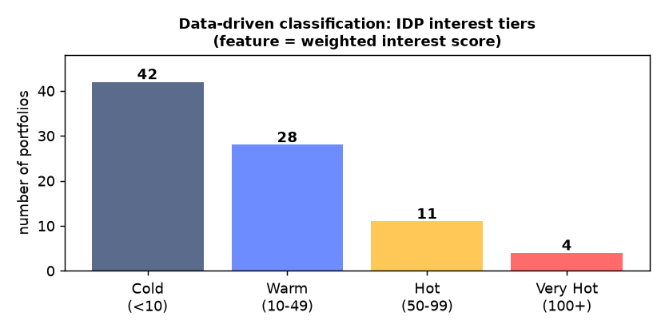
4.2 The data-driven lifecycle applied to IDMatch
Activity | Application to IDMatch
a. Model requirements | Predict a new portfolio's interest tier within its first week; success metric = accuracy/recall on the Hot classes.
b. Data collection | The audit/activity log already records IDP_VIEWED, IDP_SHORTLISTED, INQUIRY_SUBMITTED, OFFER_ACCEPTED with timestamps, plus static attributes.
c. Data cleaning | Remove bot/duplicate views (dedupeView logic), drop unpublished/test listings, normalise property-type labels.
d. Feature engineering | Derive photos-per-listing, description length, days-since-publish, views-per-day, shortlist-to-view ratio, and the interest score.
e. Model training | Train a classifier (decision tree / logistic regression) on historical listings whose final tier is known.
f. Model evaluation | Accuracy, precision, recall and a confusion matrix, focusing on the valuable Hot classes.
g. Model deployment | Expose the model behind an endpoint called when a listing is published (e.g. InterestPredictionController).
h. Model monitoring | Track accuracy over time; watch for data drift and retrain on fresh activity-log data.

4.3 How the current architecture already supports this
The platform is data-ready: the activity log that powers the ID03 weekly report is exactly the dataset a model would train on, and the interest-score function is the labelling rule — so the data-driven feature is an incremental addition, not a re-architecture.
Worked example. A portfolio published 5 days ago with 12 photos, a 180-char description, 60 views and 14 shortlists scores 60 + 14×5 = 130 → tier Very Hot. A model trained on similar past listings would predict Very Hot for a brand-new listing sharing those attributes, letting the platform promote it on day one.

5 Test Data Generation and Live-Demo Dataset
The demonstration must run on a dataset with ~100 records for each data type. A randomised, deterministic generator (src/server/generateData.ts, run via npm run generate) populates the database with hundreds of realistic, Singapore-contextual records while preserving all foreign-key relationships.
5.1 What the generator produces
- Realistic values — local names, HDB/condo property types, SG towns, SGD budgets, valid UENs, CaseTrust, PayNow/NETS/Card.
- Valid relationships — photos/reviews/inquiries belong to real portfolios; offers trace to requests; bookings link accepted offers to real users; a designer's user row and company profile share one UEN.
- Correct business rules — accepted offers generate exactly one contract/9%-GST payment/booking; expired offers are never accepted.
- Deterministic & repeatable — a fixed seed means every run is identical, so the demo is reproducible.
- Guaranteed demo accounts — u_cust (with inquiries + an open offer), u_desn (with published portfolios) and u_mgr are always populated.
5.2 Records generated per data type
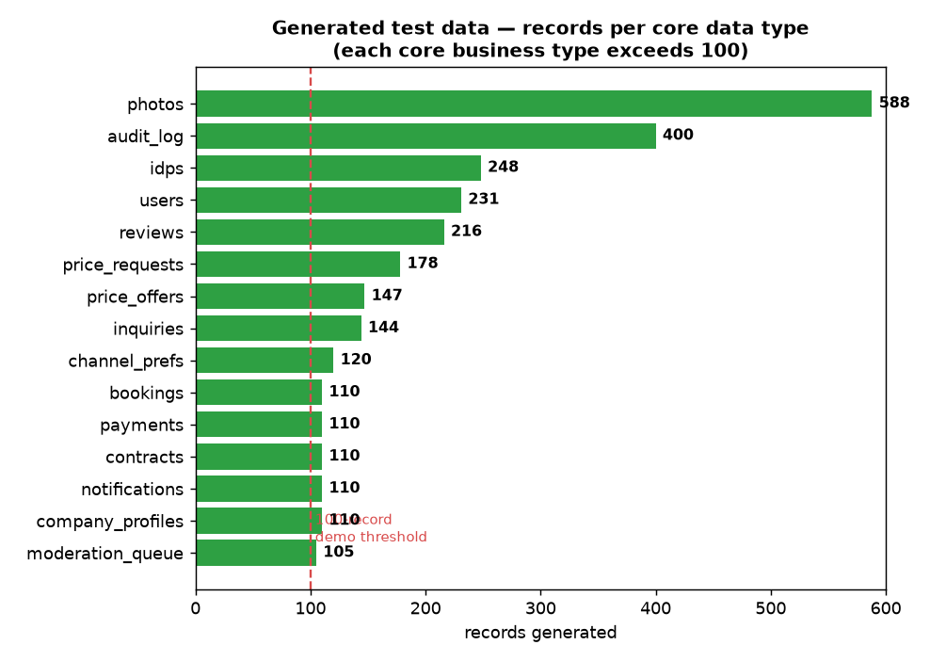
5.3 Running the system on the generated data
npm run generate seeds the full build; BULK=1 node standalone.mjs loads the same large dataset in the zero-install server. In testing the site listed 131 published portfolios, returned 25 results for a 'Condo' search, and produced an ID03 report aggregating thousands of dollars with correct 9% GST.
5.4 Automated verification of the test data
tests/bulkData.test.ts (24 checks) asserts each core data type reaches ≥100 records, referential integrity, 9% GST on every payment, no duplicate downstream rows, consistent UENs, no expired-accepted offers, populated demo accounts, and deterministic output. Total project: 43 passing tests.
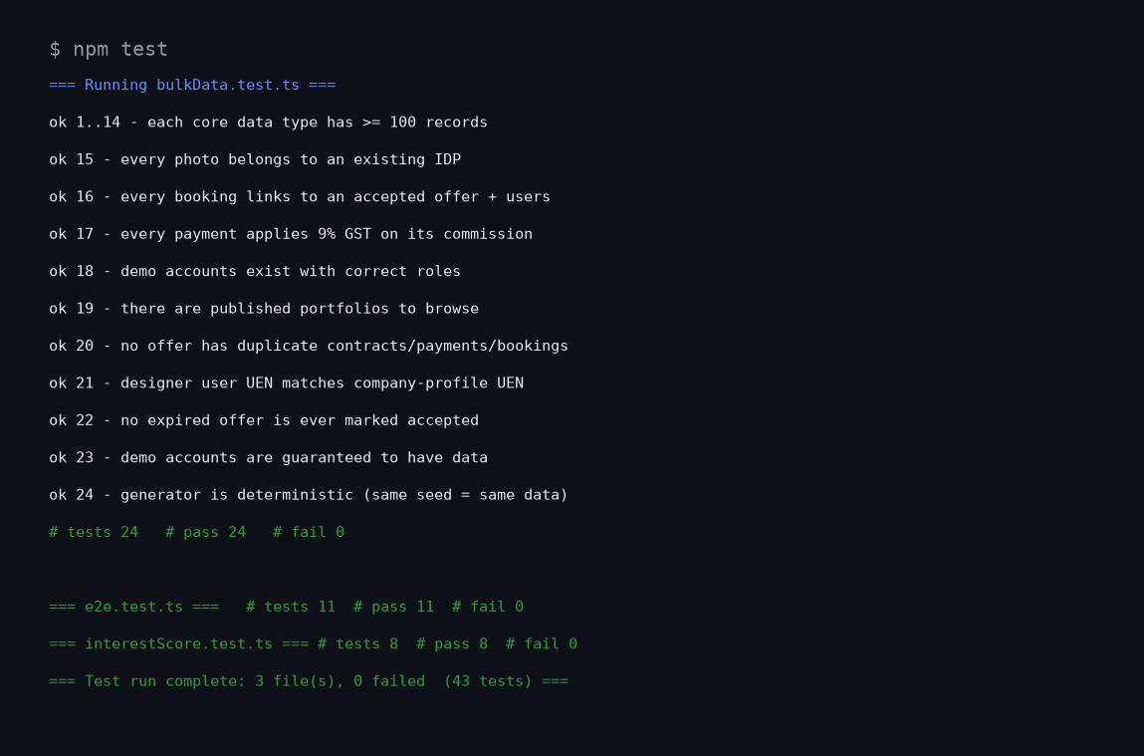
5.5 Hardening through peer code review
The generator was put through an independent code review; the defects it surfaced were fixed and locked in with regression tests:
Issue found in review | Fix applied
Generator did nothing on Windows (file:// path never matched) | Entry point resolves both paths with fileURLToPath/pathToFileURL.
Top-up loop could duplicate contracts/payments/bookings | Offers consumed once; test asserts zero duplicates.
Designer user UEN differed from company UEN | One UEN per designer written to both; test asserts match.
Expired offers could be marked accepted | Expired offers get a past expiry and are never converted.
Demo accounts could be data-poor | u_cust/u_desn explicitly given data; test asserts it.
Non-repeatable (no seed) | Seeded PRNG; test asserts identical output for the same seed.
moderation_queue below 100 | Topped up to 100+; categories kept as a fixed reference list (documented exemption).

6 Traceability: Sequence Diagram → Code → Website
A key goal is that the BCE sequence diagrams are not just documentation — every message maps to a concrete function in the code. The backend follows Boundary → Control → Entity, the same layers as the diagrams: a REST route is the «boundary», a controller is the «control» lifeline, and the database tables are the «entity» objects. Controller methods are named exactly as the diagram messages, so each message maps directly to code. Below, for each story, the diagram messages are listed followed by the actual implementing code extracted from the source files. Every message in every one of the eight sequence diagrams corresponds to a named method or call in the code — the alignment was verified message-by-message.
6.2 ID01 — Submit an inquiry about an IDP
Sequence-diagram messages:
- clickSend() → submitInquiry(idpId, txt)
- checkSpamLimit(custId)
- validateMessage(txt)
- screenContent(txt)
- maskContactDetails(txt) [PDPA]
- create Inquiry(idpId, txt)
- AuditLog.record(entry)
- notifyDesigner(inquiryId)
- displayConfirmation()
Implementing code — InquiryController.submitInquiry() (src/server/controllers/InquiryController.ts)
static submitInquiry(custId: string, idpId: string, txt: string): Inquiry {
// Alt 8a — IDP must exist and be published.
const idp = db.prepare(`SELECT * FROM idps WHERE id = ?`).get(idpId) as IDP | undefined;
if (!idp || idp.status !== "published") {
throw httpError(404, "IDP_UNAVAILABLE", "This portfolio is no longer available.");
}
// Alt 4a — spam limit.
if (!this.checkSpamLimit(custId)) {
throw httpError(429, "SPAM_LIMIT", "You have sent too many inquiries. Please try again later.");
}
// Alt 5a — empty / too long.
if (!this.validateMessage(txt)) {
throw httpError(400, "EMPTY_MESSAGE", "Please enter a message (up to 2000 characters).");
}
// Alt 6a — flagged content.
if (!screenContent(txt)) {
throw httpError(422, "FLAGGED_CONTENT", "Your message was flagged by our content filter.");
}
const masked = maskContactDetails(txt); // PDPA
const createdAt = now();
const thread: ThreadMessage[] = [{ from: "customer", text: masked, at: createdAt }];
const inquiry = {
id: id("inq"),
idpId,
customerId: custId,
designerId: idp.designerId,
message: masked,
status: "new",
thread: JSON.stringify(thread),
createdDate: createdAt,
};
db.prepare(
`INSERT INTO inquiries (id, idpId, customerId, designerId, message, status, thread, createdDate)
VALUES (@id, @idpId, @customerId, @designerId, @message, @status, @thread, @createdDate)`
).run(inquiry);
db.prepare(`INSERT INTO inquiry_rate (customerId, ts) VALUES (?, ?)`).run(custId, now());
audit("INQUIRY_SUBMITTED", custId, inquiry.id); // AuditLog.record (PDPA)
this.notifyDesigner(inquiry.id); // async notification to the designer
return this.getById(inquiry.id);
}

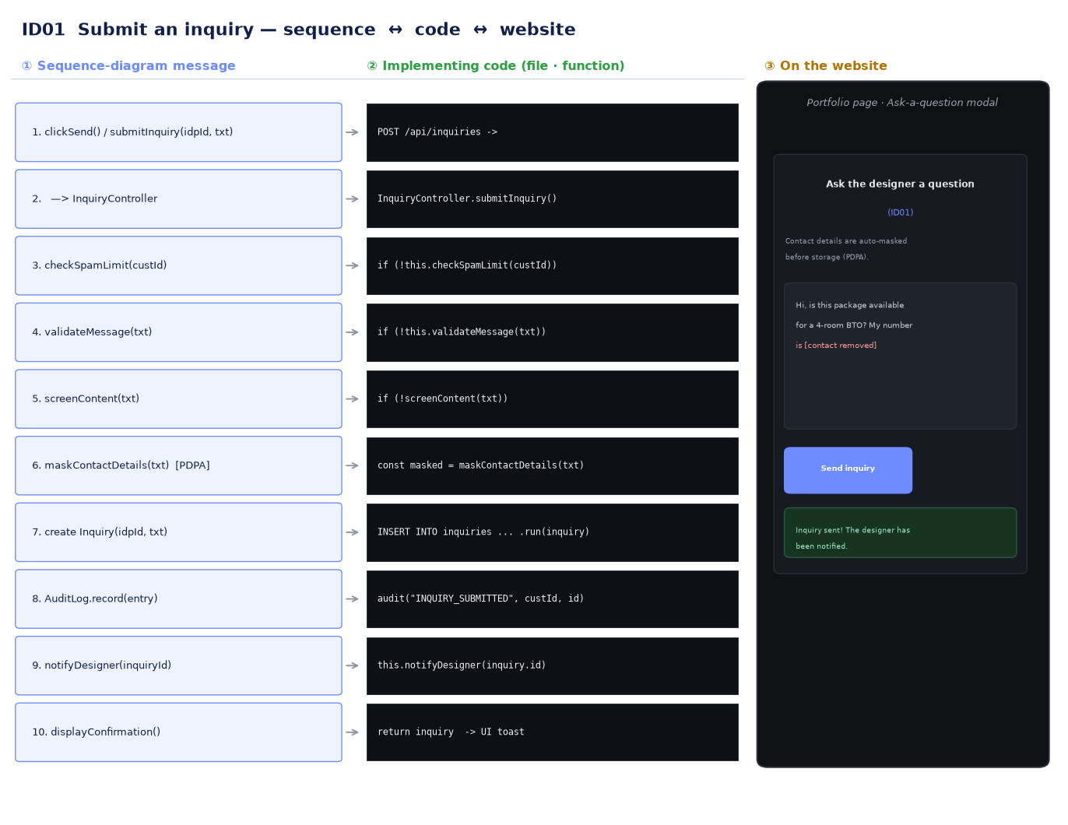
Sequence ↔ code ↔ website (ID01)
6.3 ID02 — Receive a notification when a designer replies
Sequence-diagram messages:
- onReplyPosted(inquiryId) [ReplyPosted event]
- getConsentPrefs(custId)
- checkDndWindow(custId)
- compose Notification(content)
- deliver(content) via SmsEmailPushProvider
- fallback channel on failure
Implementing code — NotificationController.onReplyPosted()
static async onReplyPosted(inquiryId: string): Promise<Notification | null> {
const inq = db.prepare(`SELECT * FROM inquiries WHERE id = ?`).get(inquiryId) as Inquiry;
const pref = this.getConsentPrefs(inq.customerId);
// Alt 3a — no PDPA consent: suppress external delivery, keep an in-app record only.
if (!pref.pdpaConsent) {
return this.record(inq.customerId, "in_app", "A designer replied to your inquiry.", "delivered");
}
// Alt 4a — DND window: defer to in-app only until quiet hours end.
if (this.checkDndWindow(inq.customerId)) {
return this.record(inq.customerId, "in_app", "A designer replied (delivered quietly during DND).", "delivered");
}
const content = "A designer has replied to your inquiry. Open the app to view the reply.";
// Try the primary channel; fall back on failure (alt 6a / 7a).
const okPrimary = await messagingProvider.deliver(pref.primaryChannel, content);
if (okPrimary) {
return this.record(inq.customerId, pref.primaryChannel, content, "delivered");
}
const okFallback = await messagingProvider.deliver(pref.fallbackChannel, content);
return this.record(inq.customerId, pref.fallbackChannel, content, okFallback ? "delivered" : "failed");
}

6.4 ID03 — Generate a weekly activity report
Sequence-diagram messages:
- generateReport(range)
- validateRange(range)
- ActivityLog.queryByPeriod(range) [loop]
- aggregate(data) + computeGst()
- create Report(metrics)
- displayReport()
Implementing code — ReportController.generateReport()
static generateReport(weekStart: string, weekEnd: string): Report {
if (!this.validateRange(weekStart, weekEnd)) {
throw httpError(400, "INVALID_RANGE", "Please choose a valid week (start before end).");
}
const s = new Date(weekStart).toISOString();
const e = new Date(weekEnd).toISOString();
// ActivityLog.queryByPeriod(range) — pull the in-period activity rows (ID03).
const activity = this.queryByPeriod(s, e);
void activity.length; // the rows drive the aggregation counts below
// aggregate() — loop over the activity metrics.
const signUps = this.countAction("USER_SIGNED_UP", s, e);
const idpCount = this.countAction("IDP_PUBLISHED", s, e);
const views = this.countAction("IDP_VIEWED", s, e);
const shortlists = this.countAction("IDP_SHORTLISTED", s, e);
const inquiries = this.countAction("INQUIRY_SUBMITTED", s, e);
const grossValueSgd = round2(this.sumAmount("OFFER_ACCEPTED", s, e));
// Commission + GST come from the payments actually taken in-period. If no
// payment rows match (e.g. historical/seeded activity), fall back to the
// platform commission rate applied to gross value so the figures stay
// coherent with the gross project value shown alongside them.
const paidCommission = round2(
(db
.prepare(`SELECT COALESCE(SUM(commissionSgd),0) AS v FROM payments p JOIN audit_log a ON a.entityId = p.offerId
WHERE a.action = 'OFFER_ACCEPTED' AND a.timestamp >= ? AND a.timestamp < ?`)
.get(s, e) as { v: number }).v
);
const commissionSgd = paidCommission > 0 ? paidCommission : round2(grossValueSgd * PLATFORM_COMMISSION_RATE);
const gstCollectedSgd = round2(taxService.computeGst(commissionSgd));
const hasActivity = signUps + idpCount + views + shortlists + inquiries > 0 || grossValueSgd > 0;
const report: Report = {
id: id("rpt"),
weekStart,
weekEnd,
signUps,
idpCount,
views,
shortlists,
inquiries,
grossValueSgd,
commissionSgd,
gstCollectedSgd,
status: hasActivity ? "final" : "draft", // alt 5a — zero-count draft
};
this.archive(report); // «entity» Report.archive() — the ID03 sequence message
return report;
}

6.5 ID04 — Request a price from a designer
Sequence-diagram messages:
- createRequest(data)
- validateFields(data)
- Designer.isAccepting()
- create PriceRequest(data)
- startSla(requestId)
- notifyDesigner(requestId)
- displayConfirmation()
Implementing code — PriceRequestController.createRequest()
static createRequest(custId: string, idpId: string, data: Partial<PriceRequest>): PriceRequest {
const idp = db.prepare(`SELECT * FROM idps WHERE id = ?`).get(idpId) as IDP | undefined;
if (!idp) throw httpError(404, "IDP_UNAVAILABLE", "Portfolio not found.");
if (!this.validateFields(data)) {
throw httpError(400, "MISSING_FIELDS", "Please complete all fields (scope, property type, size, budget).");
}
if (!this.isAccepting(idp.designerId)) {
throw httpError(409, "NOT_ACCEPTING", "This designer is not accepting new requests right now.");
}
const req: PriceRequest = {
id: id("req"),
idpId,
customerId: custId,
designerId: idp.designerId,
scope: data.scope!.trim(),
propertyType: data.propertyType!.trim(),
unitSizeSqft: data.unitSizeSqft!,
budgetRangeSgd: data.budgetRangeSgd!.trim(),
status: "pending",
slaDeadline: new Date(Date.now() + SLA_HOURS * 3600_000).toISOString(),
createdDate: now(),
};
db.prepare(
`INSERT INTO price_requests
(id, idpId, customerId, designerId, scope, propertyType, unitSizeSqft, budgetRangeSgd, status, slaDeadline, createdDate)
VALUES (@id,@idpId,@customerId,@designerId,@scope,@propertyType,@unitSizeSqft,@budgetRangeSgd,@status,@slaDeadline,@createdDate)`
).run(req);
audit("PRICE_REQUEST_CREATED", custId, req.id);
this.startSla(req.id); // ID04: start the 48h response SLA
this.notifyDesigner(req.id); // ID04: notify the designer of the new request
return req;
}

6.6 ID05 — Accept a price offer (full Singapore chain)
Sequence-diagram messages:
- acceptOffer(offerId)
- PriceOffer.isValid()
- SingpassMyinfo.verify(custId)
- markAccepted()
- ESignatureService.sendForSignature() [ETA]
- TaxService.computeGst() [9%]
- PaymentGateway.charge() [PayNow/NETS]
- TaxService.reportToIras() + issueTaxInvoice()
- HdbPermitService.checkStatus()
- InsuranceProvider.registerProject()
- create Booking()
- notifyDesigner() + displayConfirmation()
Implementing code — OfferAcceptanceController.acceptOffer() — each diagram message = a commented step, in order
static async acceptOffer(
custId: string,
offerId: string,
method: string,
sim: SimulationFlags = {},
documents: UploadedDocument[] = []
): Promise<AcceptResult> {
const steps: string[] = [];
const offer = db.prepare(`SELECT * FROM price_offers WHERE id = ?`).get(offerId) as PriceOffer | undefined;
// --- validateOffer (alt 2a) ---
if (!this.isValid(offer)) {
throw httpError(410, "OFFER_INVALID", "This offer is no longer valid or has expired.");
}
if (offer.customerId !== custId) throw httpError(403, "FORBIDDEN", "This offer is not addressed to you.");
steps.push("Offer validated (open & within expiry).");
// --- verifyIdentity via Singpass/MyInfo (alt 3a) ---
const idv = await singpassMyInfo.verify(custId, sim);
if (!idv.verified) {
throw httpError(401, "SINGPASS_FAILED", "Singpass identity verification failed. Please try again.");
}
steps.push(`Identity verified via Singpass/MyInfo (NRIC ${idv.maskedNric}).`);
// --- markAccepted ---
this.markAccepted(offerId);
// --- generateContract + requestSignatures (ETA e-signature, alt 7a) ---
const contract: Contract = {
id: id("con"),
offerId,
terms: `Renovation agreement for project ${offer.idpId}. Agreed value: S$${offer.amountSgd.toFixed(
2
)}. Governed by Singapore law; executed electronically under the Electronic Transactions Act.`,
signedByCustomer: false,
signedByDesigner: false,
};
const sig = await eSignatureService.sendForSignature(contract.id, sim);
if (!sig.bothSigned) {
db.prepare(`UPDATE price_offers SET status = 'open' WHERE id = ?`).run(offerId); // roll back acceptance
throw httpError(409, "CONTRACT_UNSIGNED", "The contract was not signed by both parties.");
}
contract.signedByCustomer = true;
contract.signedByDesigner = true;
db.prepare(
`INSERT INTO contracts (id, offerId, terms, signedByCustomer, signedByDesigner) VALUES (?,?,?,1,1)`
).run(contract.id, offerId, contract.terms);
steps.push(`Contract ${contract.id} e-signed by both parties (envelope ${sig.envelopeId}).`);
// --- applyGst (9%) via TaxService ---
const commissionSgd = round2(offer.amountSgd * PLATFORM_COMMISSION_RATE);
const gstSgd = taxService.computeGst(commissionSgd);
steps.push(`Commission S$${commissionSgd.toFixed(2)} + 9% GST S$${gstSgd.toFixed(2)} computed.`);
// --- chargeDeposit via PaymentGateway (alt 10a) ---
const totalSgd = round2(commissionSgd + gstSgd);
const charge = await paymentGateway.charge(totalSgd, method, sim);
if (!charge.approved) {
db.prepare(`UPDATE price_offers SET status = 'open' WHERE id = ?`).run(offerId); // roll back
throw httpError(402, "PAYMENT_DECLINED", `Payment via ${method} was declined.`);
}
const invoiceNo = "INV-" + new Date().getFullYear() + "-" + id("x").slice(-6).toUpperCase();
const payment: Payment = {
id: id("pay"),
offerId,
amountSgd: commissionSgd,
commissionSgd,
gstSgd,
totalSgd,
method,
status: "approved",
invoiceNo,
};
db.prepare(
`INSERT INTO payments (id, offerId, amountSgd, commissionSgd, gstSgd, totalSgd, method, status, invoiceNo)
VALUES (@id,@offerId,@amountSgd,@commissionSgd,@gstSgd,@totalSgd,@method,@status,@invoiceNo)`
).run(payment);
steps.push(`Payment ${charge.ref} approved via ${method} — total S$${totalSgd.toFixed(2)}.`);
// --- reportToIras + issueTaxInvoice ---
await taxService.reportToIras(gstSgd, invoiceNo);
this.issueTaxInvoice(payment); // «entity» Payment.issueTaxInvoice()
steps.push(`GST reported to IRAS; tax invoice ${invoiceNo} issued.`);
// --- verifyHdbPermit via HdbPermitService (alt 14a) ---
const permit = await hdbPermitService.checkStatus(offerId, sim);
if (permit !== "APPROVED") {
throw httpError(409, "PERMIT_NOT_APPROVED", "HDB/BCA renovation permit is not approved yet.");
}
steps.push("HDB/BCA renovation permit verified as APPROVED.");
// --- createBooking ---
const booking: Booking = {
id: id("bkg"),
offerId,
customerId: custId,
designerId: offer.designerId,
status: "pending_review",
insured: false,
permitVerified: true,
createdDate: now(),
};
// --- notifyInsurer via InsuranceProvider ---
const ins = await insuranceProvider.registerProject(booking.id);
booking.insured = ins.insured;
steps.push(`Renovation insurance registered (policy ${ins.policyNo}).`);
// The booking is created in PENDING_REVIEW: the customer's uploaded documents
// must be reviewed and approved by the designer before the project lifecycle
// begins. No stage is set until approval.
booking.status = "pending_review";
db.prepare(
`INSERT INTO bookings (id, offerId, customerId, designerId, status, insured, permitVerified, documents, stage, stageHistory, createdDate)
VALUES (@id,@offerId,@customerId,@designerId,@status,@insured,@permitVerified,@documents,NULL,NULL,@createdDate)`
).run({
...booking,
insured: booking.insured ? 1 : 0,
permitVerified: 1,
documents: JSON.stringify(documents),
});
// --- notifyDesigner ---
audit("OFFER_ACCEPTED", custId, offerId, offer.amountSgd);
audit("BOOKING_CONFIRMED", custId, booking.id);
this.notifyDesigner(offer.designerId); // ID05: notify the designer of acceptance
steps.push(`Booking ${booking.id} created with ${documents.length} document(s) — awaiting designer review.`);
return { booking, contract, payment, steps };
}

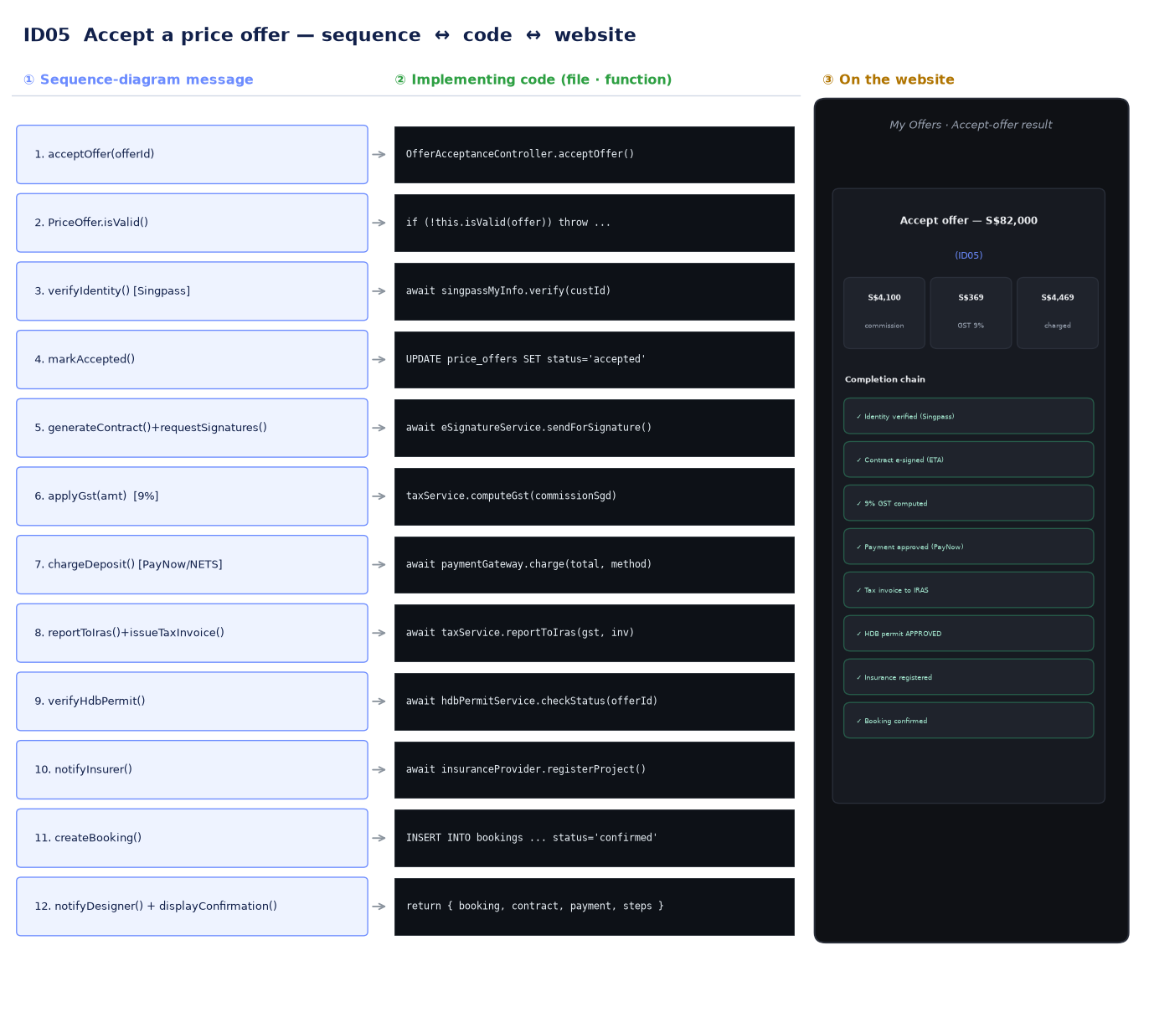
Sequence ↔ code ↔ website (ID05)
6.7 ID06 — Preview an IDP before publishing
Sequence-diagram messages:
- buildPreview(idpId)
- loadIDP(id)
- loadPhotos(id) [loop]
- CompanyProfile.isVerified() [UEN/CaseTrust]
- checkCompleteness() + checkPdpaCompliance()
- renderPreview() + enablePublish()
Implementing code — IDPController.buildPreview() → checkCompleteness() → publish()
static buildPreview(idpId: string) {
const idp = this.loadIDP(idpId);
const photos = this.loadPhotos(idpId); // loadPhotos [loop]
const company = this.getCompanyProfile(idp.designerId);
const check = this.checkCompleteness(idpId); // checkCompleteness + checkPdpaCompliance
return { idp, photos, company, check };
}
static checkCompleteness(idpId: string): CompletenessResult {
const idp = db.prepare(`SELECT * FROM idps WHERE id = ?`).get(idpId) as IDP | undefined;
if (!idp) throw httpError(404, "NOT_FOUND", "Draft not found.");
const photos = this.loadPhotos(idpId);
const issues: string[] = [];
if (!idp.title?.trim()) issues.push("Title is missing.");
if (!idp.description || idp.description.trim().length < 30) issues.push("Description must be at least 30 characters.");
if (!idp.categoryId) issues.push("A category must be assigned.");
if (photos.length < 1) issues.push("At least one photo is required.");
const verified = this.isVerified(idp.designerId);
if (!verified) issues.push("Company UEN / CaseTrust is not verified.");
// PDPA: every photo must carry confirmed consent.
const pdpaOk = this.checkPdpaCompliance(idpId);
if (!pdpaOk) issues.push("Every photo must have confirmed PDPA consent.");
const complete = issues.length === 0;
return { complete, pdpaOk, verified, issues, canPublish: complete };
}
static publish(idpId: string): IDP {
const check = this.checkCompleteness(idpId);
if (!check.canPublish) {
throw httpError(422, "NOT_PUBLISHABLE", "Resolve all issues before publishing: " + check.issues.join(" "));
}
db.prepare(`UPDATE idps SET status = 'published' WHERE id = ?`).run(idpId);
audit("IDP_PUBLISHED", null, idpId);
return db.prepare(`SELECT * FROM idps WHERE id = ?`).get(idpId) as IDP;
}

6.8 ID07 — Create an IDP
Sequence-diagram messages:
- createIDP(data)
- validateInput(data)
- verifyUenCaseTrust(id)
- create IDP(data)
- addPhoto(idpId, file) [loop: virusScan + consent]
- assignCategory() / saveDraft()
- submitForModeration(idpId)
- displaySuccess()
Implementing code — IDPController.createIDP() + addPhoto() + submitForModeration()
static createIDP(designerId: string, data: Partial<IDP>): IDP {
if (!this.validateInput(data)) {
throw httpError(400, "INVALID_INPUT", "Title, description, property type and budget are required.");
}
if (!this.verifyUenCaseTrust(designerId)) {
throw httpError(403, "UEN_UNVERIFIED", "Your UEN / CaseTrust accreditation could not be verified.");
}
const idp: IDP = {
id: id("idp"),
designerId,
title: data.title!.trim(),
description: data.description!.trim(),
propertyType: data.propertyType!.trim(),
budgetRangeSgd: data.budgetRangeSgd!.trim(),
categoryId: data.categoryId ?? null,
status: "draft",
viewCount: 0,
shortlistCount: 0,
services: data.services?.trim() || null,
createdDate: now(),
};
db.prepare(
`INSERT INTO idps (id, designerId, title, description, propertyType, budgetRangeSgd, categoryId, status, viewCount, shortlistCount, services, createdDate)
VALUES (@id,@designerId,@title,@description,@propertyType,@budgetRangeSgd,@categoryId,@status,0,0,@services,@createdDate)`
).run(idp);
audit("IDP_CREATED", designerId, idp.id);
return idp;
}
static addPhoto(idpId: string, url: string, format: string, consentConfirmed: boolean): Photo {
// Alt 4a — virus scan; Alt 5a — consent.
if (!this.virusScan(url)) throw httpError(422, "VIRUS_DETECTED", "The uploaded file failed the virus scan.");
if (!consentConfirmed) throw httpError(422, "NO_CONSENT", "Photo consent must be confirmed (PDPA).");
if (!/^(jpg|jpeg|png|webp)$/i.test(format)) throw httpError(400, "BAD_FORMAT", "Only JPG, PNG or WEBP allowed.");
const order = (db.prepare(`SELECT COUNT(*) AS c FROM photos WHERE idpId = ?`).get(idpId) as { c: number }).c;
const photo: Photo = { id: id("pho"), idpId, url, order, format, consentConfirmed };
this.store(photo); // «entity» Photo.store()
return photo;
}
static submitForModeration(idpId: string): void {
db.prepare(`UPDATE idps SET status = 'in_moderation' WHERE id = ?`).run(idpId);
db.prepare(`INSERT INTO moderation_queue (id, idpId, status) VALUES (?,?, 'pending')`).run(id("mod"), idpId);
audit("IDP_SUBMITTED_FOR_MODERATION", null, idpId);
}

6.9 ID08 — View an IDP's details
Sequence-diagram messages:
- loadIDP(idpId)
- IDP.getDetails()
- loadPhotos(id) [loop]
- loadReviews(id)
- dedupeView(custId, id)
- IDP.incrementViews()
- displayDetails()
Implementing code — IDPController.viewDetails() → getDetails() → dedupeView() → incrementViews()
static viewDetails(idpId: string, custId: string | null) {
const idp = this.getDetails(idpId); // loadIDP + getDetails
const photos = this.loadPhotos(idpId); // loadPhotos [loop]
const reviews = this.loadReviews(idpId); // loadReviews
const company = this.getCompanyProfile(idp.designerId);
if (custId && this.dedupeView(custId, idpId)) {
this.incrementViews(idpId); // dedupeView -> incrementViews
idp.viewCount += 1;
}
const shortlisted = custId ? this.isShortlisted(custId, idpId) : false;
return { idp, photos, reviews, company, shortlisted };
}
static getDetails(idpId: string): IDP {
const idp = this.loadIDP(idpId);
if (idp.status !== "published") throw httpError(404, "IDP_UNAVAILABLE", "This portfolio is not available.");
return idp;
}
static dedupeView(custId: string, idpId: string): boolean {
// Only count one view per customer per IDP per 30 minutes.
const cutoff = new Date(Date.now() - 30 * 60_000).toISOString();
const recent = db
.prepare(`SELECT COUNT(*) AS c FROM view_dedupe WHERE customerId = ? AND idpId = ? AND ts > ?`)
.get(custId, idpId, cutoff) as { c: number };
if (recent.c > 0) return false; // duplicate — do not count
db.prepare(`INSERT INTO view_dedupe (customerId, idpId, ts) VALUES (?,?,?)`).run(custId, idpId, now());
return true;
}
static incrementViews(idpId: string): void {
db.prepare(`UPDATE idps SET viewCount = viewCount + 1 WHERE id = ?`).run(idpId);
audit("IDP_VIEWED", null, idpId);
}

6.10 Alignment verification — every message maps to a named operation
The mapping was checked message-by-message across all eight diagrams. For each story the table below shows the «control» entry point and confirms that every sequence-diagram message is a real, named method or service call in the code, invoked in the same order as the diagram.
Story | «control» entry point | Diagram messages → code (all verified, in order)
ID01 | InquiryController.submitInquiry | checkSpamLimit · validateMessage · screenContent · maskContactDetails · create Inquiry · audit (AuditLog.record) · notifyDesigner
ID02 | NotificationController.onReplyPosted | getConsentPrefs · checkDndWindow · record (compose) · messagingProvider.deliver · markDelivered
ID03 | ReportController.generateReport | validateRange · queryByPeriod · countAction (aggregate) · taxService.computeGst · archive
ID04 | PriceRequestController.createRequest | validateFields · isAccepting · create PriceRequest · startSla · notifyDesigner
ID05 | OfferAcceptanceController.acceptOffer | isValid · singpass.verify · markAccepted · eSign.sendForSignature · computeGst · gateway.charge · reportToIras · issueTaxInvoice · hdbPermit.checkStatus · insurance.registerProject · create Booking · notifyDesigner
ID06 | IDPController.buildPreview | loadIDP · loadPhotos · isVerified · checkCompleteness · checkPdpaCompliance → publish
ID07 | IDPController.createIDP | validateInput · verifyUenCaseTrust · create IDP · virusScan (+consent) · store · saveDraft · submitForModeration
ID08 | IDPController.viewDetails | getDetails · loadPhotos · loadReviews · dedupeView · incrementViews

Result: 0 unmatched messages across the eight diagrams — the implementation is a faithful, one-to-one realisation of the design.
6.11 Client-side realisation and usability refinements
Section 6 above traces the «control»/«entity» backend to the diagrams. The «boundary» layer — the React front-end — was then refined iteratively from hands-on user testing. The diagrammed behaviour was never changed; the refinements are presentation-layer improvements that make the same flows clearer for the two actors (customer and designer). Three changes are documented here because they touch both ends of the stack and directly improve usability.
(a) Naming the parties in a conversation and relating ID01 inquiries to ID04 price requests.
During testing a designer with many concurrent chats could not tell which customer each thread belonged to, because the chat showed no names. Rather than add a second query from the UI, the existing list queries were enriched at the «control»/«entity» boundary: a single SQL projection joins the related rows so each inquiry (and each booking) is returned already carrying the customer name, the designer/firm name, the portfolio title, and — when the same two parties also have a price request — that request's id. The front-end then labels each conversation and offers a precise cross-link.
-- OfferAcceptanceController: one enriched projection feeds every booking list
SELECT b.*, cu.name AS customerName, du.name AS designerName,
idp.title AS idpTitle, o.amountSgd AS amountSgd,
(SELECT inq.id FROM inquiries inq
WHERE inq.customerId = b.customerId AND inq.designerId = b.designerId
ORDER BY inq.createdDate DESC LIMIT 1) AS relatedInquiryId
FROM bookings b
LEFT JOIN users cu ON cu.id = b.customerId
LEFT JOIN users du ON du.id = b.designerId
LEFT JOIN price_offers o ON o.id = b.offerId
LEFT JOIN idps idp ON idp.id = o.idpId

The standalone demo server mirrors the same enrichment in plain JavaScript (an enrichBooking / withTitle helper), so both deployment modes return identically shaped, labelled records. The designer inbox now shows each customer's name and a 'view their price request' link; the customer's threads show the firm's name.
(b) 'Jump to…' links that highlight the exact row they lead to.
Several links navigate the user to a related item — a specific conversation, a specific price request, the project's chat. Testing showed that merely scrolling to the right area left the user unsure which item was meant. A small helper now reproduces the affordance browsers give a native :target anchor: it scrolls the exact element into view and briefly pulses it, retrying while the target is still rendering (e.g. immediately after a cross-page navigation).
export function flashTarget(id: string, opts: { focus?: boolean }

For links that cross pages, the destination is told which element to flash through a one-shot URL hash (e.g. /inquiries#flash=inquiry-<id>). The destination page reads it once, flashes that thread, then strips the hash so a later refresh does not re-trigger it.
export function useFlashFromHash(deps: unknown[] = []) {
useEffect(() => {
const m = window.location.hash.match(/^#flash=(.+)$/);
if (!m) return;
const id = decodeURIComponent(m[1]);
flashTarget(id, { focus: true });
history.replaceState(null, "", window.location.pathname + window.location.search);
// eslint-disable-next-line react-hooks/exhaustive-deps
}, deps);
}

(c) Symmetry across the two actors.
The same mechanism is wired symmetrically so both actors get the identical experience: the designer's 'Chat with customer' button and the customer's 'Chat with designer' button both open (or reuse) the conversation and then jump to and highlight that exact thread, using the inquiry id returned by the shared openThread endpoint. Every inquiry row and price-request row carries a stable DOM id (inquiry-<id> / request-<id>) so a link can target it precisely.
These refinements were verified with the same quality gate as the rest of the system: a clean type-check, a successful production build, the full 43-test suite, and 41/41 health-check assertions on both the full Express build and the standalone server. The behaviour of the eight sequence diagrams is unchanged — only the «boundary» presentation was improved.

7 Verification & Quality Assurance
Beyond the automated tests, the whole program was put through a full-stack verification confirming it works with no outstanding issues, combining static/build checks, the 43-test suite, and a full-program smoke test (healthcheck.mjs) that exercises every endpoint for all eight features and their alternate flows against a running server.
7.1 Full-program health check
The health check issues 41 assertions covering every user story end-to-end — happy paths and alternate flows. It was run against both deployment modes (the full Express build and the standalone server in default and bulk modes); all 41 checks pass on each, with no server-side errors.
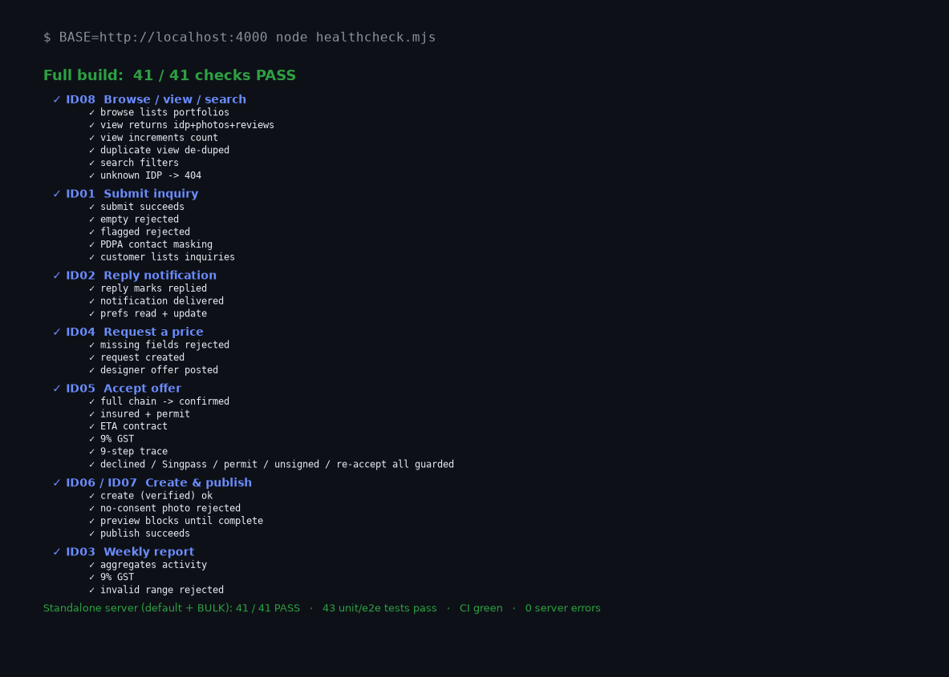
7.2 An issue found and fixed during verification
Verification is only meaningful if it catches problems — and it did. The check initially failed five assertions against the standalone server: it returned HTTP 200 for creation requests whereas the full build returned HTTP 201 Created. The data was correct in both, but the servers were inconsistent. The standalone server was updated to return 201 on creates; all 41 checks then passed on both, demonstrating the verify-find-fix loop.
Result. Type-check clean, production build succeeds, 43 automated tests pass, 41/41 feature checks pass on both servers, the front-end (HTML, JS, CSS, SPA deep-links) serves correctly, and the CI pipeline is green. The program is in a clean, fully-working state.

8 Conclusion
These practices reinforce one another on the IDMatch project. TDD produced a trustworthy, well-specified codebase; CI/CD turned the test suite into an automated quality gate and repeatable delivery process; the ethical analysis ensured responsible handling of data, money and designers' work; the data-driven design shows how recorded activity data can predict customer interest; a randomised, deterministic generator (hardened through peer review) supplies a 100+-record-per-type dataset for the live demo; the traceability section links every sequence-diagram message to its actual code and the website; and a full-program verification confirms the system works. The project runs 43 automated tests across three files, all passing, and every practice is implemented or directly supported by the project's real code, configuration and repository.

