BLDC Motor Drive Modelling for Automotive Application

Member, IEEE, Anirudha Behera
MS in EE, Dept. of Electrical & Computer Engineering
Illinois Institute of Technology, Chicago, USA
Abstract— Brushless DC Motor is widely used in many applications due to its several benefits. The development of BLDC motor control system requires reliable operation, excellent performance of control algorithm, low cost, and short development cycle. This paper proposes the speed control of BLDC motor for an electric vehicle. The flexibility of the drive system is increased using PID controller. The 3-phase inverter is implemented using Smart Power Module for feeding BLDC motor. The proposed system accepts Hall sensor signals from the motor and is programmed for desired speed. Experimental results verify the control nature of developed drive scheme.

Index Terms— BLDC Motor, PID controller, Hall-effect Sensor, MOSFET bridge, Gate logic

INTRODUCTION
The electric motor technology involves machine design, suitable controller, electronics, sensors and required control algorithm. A suitable converter and control techniques need to be developed for different kind of motors in order to generate a high-performance drive. The important aspect of various converter designs are the converter efficiency and its dynamic response. Low power loss in converters is due to high efficiency. The 3rd harmonic and its corresponding multiples component is eliminated in the output due to this feature three phase power system is used in DC drive systems. Comparing 1-phase system with that of 3-phase, the ripple voltage is significantly less. Now a days we are facing lot of different crises caused by high oil prices and obsolete designs which have prompted the search for more efficient road vehicles, possibly based on environment friendly sources located in politically stable areas. This has led to the development of electric vehicles.

In EV industry most preferred motor is BLDC or IPM motor. The reason is very simple; they are efficient, controllable, adaptive as per industry standards.

BLDC motor is highly reliable since it does not use any brushes (carbon) which need to be replaced or maintenance with time. When operated in rated conditions, the life expectancy of BLDC motor is over 10,000 hours. For long-term applications, this can be a great choice. Although a BLDC motor may cost more than a brushed DC motor, but often it will pay more than for itself in the amount of work time saved.

The machine is having three phase stators with three phase distributed winding and the torque of the BLDC motor depends on the respective position of the Back-emf. Usually the BLDCM has trapezoidal back-Emf waveform and stator is fed by rectangular stator current and theoretically it gives a constant torque but the torque ripple exists due to emf waveform imperfection, current ripple and phase current commutation. The phase shift in emf waveform results from variation in shapes of the slots, skew and magnet of BLDC Motor and all the above said factors are subjected for the design consideration. This below presented BLDC Model can be operate by trapezoidal and sinusoidal back-EMF waveform. Fig.1 below shows general block diagram of BLDC motor control.
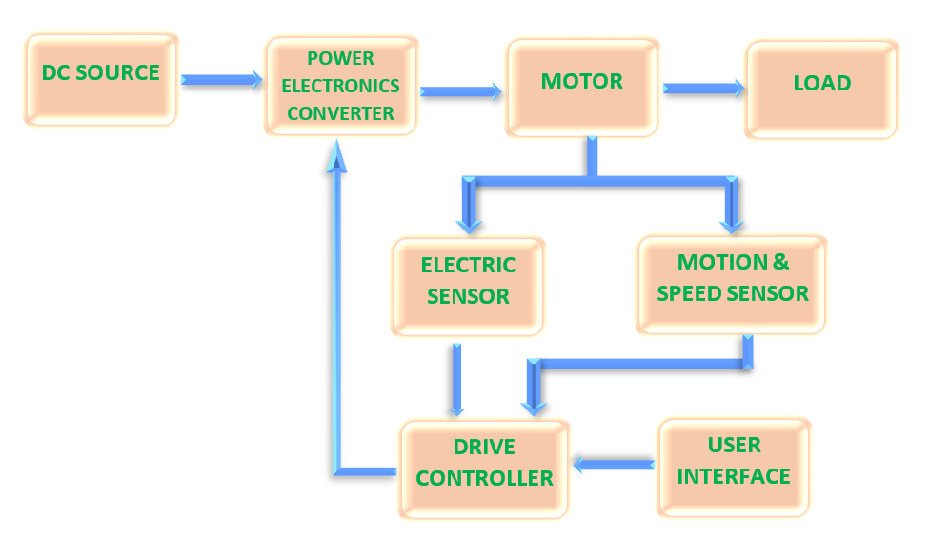
Fig.1: Block diagram of typical BLDC control cycle

The above shown typical block diagram of BLDC motor control cycle consists of power converter, permanent magnet-synchronous machine (PMSM) with trapezoidal back-emf, sensors, and control algorithm. Three phase inverter transforms power from the source to the motor which in turn converts electrical energy to mechanical energy. BLDC motor has rotor position sensors controlled by the command signals, the command signal may be classified as torque, voltage, speed command and so on. The type of the BLDC motor is determined by the structure of the control algorithms due to which there are two main types voltage source and current source-based drives. Permanent magnet synchronous machine with either sinusoidal or non-sinusoidal back-Emf waveforms is used by both voltage source and current source-based drive.

For starting and for providing proper commutation sequence to turn on the power devices in the inverter bridge the BLDC motor requires a rotor position sensor. The power devices are commutated after every sequentially 60 degrees rotation of rotor. Instead of commutating the armature current using brushes, electronic commutation is used for this reason it is an electronic motor. This eliminates the problems associated with the brush and the commutator arrangement, for example, sparking and wearing out of the commutator brush arrangement, thereby making BLDC more rugged as compared to a dc motor.

PROPOSED CONTROL SCHEME

In this paper, we have proposed variable dc link voltage control scheme for speed control of BLDC motor and the hysteresis current control and carrier-based control scheme are used for controlling the gate pulse of the inverter. BLDC Motor can also be controlled by other controlling schemes like; the dc bus voltage or by PWM method. Some designs utilize both to provide high torque at high load and high efficiency at low load. Such hybrid designs also allows the control of harmonic current. For the control of three phase Brushless DC (BLDC) motor we are using PID controller here. By using the proposed method, A smooth transition between the quadrants is achieved. The time taken to change the direction of rotation of BLDC motor is also comparatively reduced. In existed system, the frequent change of direction of rotation and hence the change of quadrants results in frequent braking. During braking time, the kinetic energy is wasted as heat energy. Brushless DC Motors are driven by DC voltage but current commutation is controlled by solid state switches. The commutation instants are determined by the rotor position. The rotor shaft position is sensed by a Hall Effect sensor, which provides signals to the respective switches. Whenever the rotor magnetic poles pass near the Hall sensors, they give a high or low signal, indicating either N or S pole is passing near the sensors. Based on the combination of these three Hall sensor signals, the exact sequence of commutation can be determined. These signals are decoded by combinational logic to provide the firing signals for 120 conductions on each of the three phases.
Hall Effect sensors are used to ascertain the rotor position and from the Hall sensor outputs, it is determined whether the machine has reversed its direction. This is the ideal moment for energizing the stator phase so that the machine can start motoring in the counter clockwise direction.

PID CONTROLLER

P controller, PI controller, PD controller and PID controller are the controller types which can be used in feedback or feedforward systems based on the system requirements. P and PD controller is directly proportional to incoming error; hence a little change in error can cause system instability. PI controller is an accurate and provides good system stability i.e., Less steady state error response. But the integral factor in controller takes more iteration to reduce error to zero.

Hence PID controller is widely implemented in closed-loop type of feedback control system for speed control of BLDC motors. PID controller is the most reliable, accurate and provides better system stability i.e., less steady state error response as well as helping to eliminate incoming error to zero with minimum iterations. Below Fig.2 will show you the block diagram of a typical system with PID controller and feedback-loop.

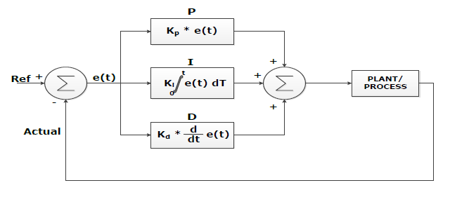

Fig.2 Block diagram of PID and feedback-loop of a system

The control algorithm PID controller works on the error generated from the difference between the reference speed and the actual speed. PID parameters Proportional gain Kp, Integral Gain Ki, and Derivative Gain Kd affects system’s overall performance. Hence choosing right parameters for a system is a difficult process and can be done by using several tuning methods which includes manual tuning, Ziegler-Nicholas tuning and Cohen-coon tuning. Normally a mathematical model of the system is designed along with PID controller and the system performance is observed with applied set of values of PID parameters to finalize the best suited values.
Following are the benefits of PID parameters (Kp, Ki, and Kd)
- System Rise time will be reduced by Kp, it provides faster response in variable load condition.
- Steady state error will be reduced by Ki; hence the motor speed is pushed near to reference speed.
- Settling time and overshoot will be reduced by Kd, hence provides faster response.

PID controller works on the following equation:

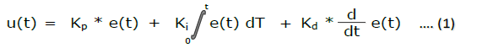

HALL-EFFECT SENSOR

The Hall-effect sensors determines when and how the coils are need to be energized. A pair of Hall-effect sensors is linked to each coil. A pair of Hall-effect sensors determines when the microcontroller energizes a coil. In this example, sensors H1 and H2 determine the switching of coil U. Below Fig.3 represents the operating modes of a Hall-effect sensor in BLDC motor control scheme.

When H2 detects a N magnet pole, coil U is positively energized; when H1 detects a N magnet pole, coil U is switched open; when H2 detects a S magnet pole coil U is switched negative, and finally, when H1 detects a S magnet pole, coil U is again switched open. Similarly, sensors H2 and H3 determine the energizing of coil V, with H1 and H3 looking after coil W. At each step, two phases are on with one phase feeding current to the motor, and the other providing a current return path. The other phase is open. The microcontroller controls which two of the switches in the three-phase inverter must be closed to positively or negatively energize the two active coils. For example, switching a+ in Fig.3 positively energizes coil U and switching b+ energizes coil V to provide the return path. Coil W remains open.

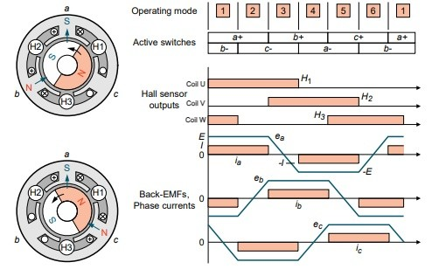

Fig.3 Hall-effect Sensor operation modes

POWER MOSFET

BLDC motors are mostly used for higher power and control complexity drives of different applications. These motors, unlike the Brushed DC motors, do not need a physical connection to the rotor.
This enables greater robustness, less maintenance, higher power and speed operations. Besides, as it can be seen from the drive configuration in below Fig.4; there are more MOSFETs employed in the drive compared to the Brushed DC motor. This enables current sharing across more devices, inherently increasing the power that can be delivered.
The switches of MOSFETs operate in sequence, so that one of the three switching pairs does not operate at any instant, allowing the devices to cool. Also, the roles of the switching MOSFET in one phase and the conducting MOSFET (not switching) in the other active phase can be swapped. Both of the afore mentioned methods allow for better distribution of losses across the six MOSFETs, in turn enabling higher power margin up to the maximum die temperature.

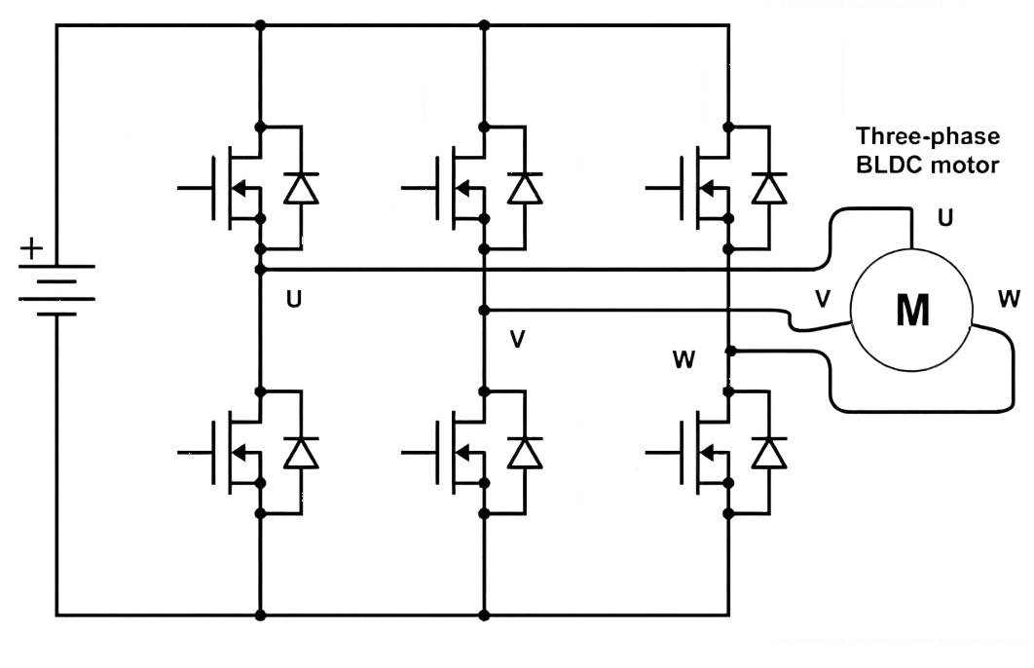
Fig.4 MOSFET bridge connected with 3Φ BLDC motor

MATHMATICAL MODELING.

The BLDC motor which we proposed in this paper is a 3Φ, 4-pole motor. Here we have taken a PMSM motor with trapezoidal back-emf configuration. All specifications of proposed motor are mentioned in Table no.1.

PARAMETER | VALUES | UNIT
STATOR PHASE RESISTANCE | 0.7 | Ω
STATOR PHASE INDUCTANCE | 0.027 | H
FLUX LINKAGE | 0.1194 | Wb
INERTIA (J) | 0.002 | Kg.m^2
VISCOUS DAMPING (F) | 0.0004924 | N.m. s
STATIC FRICTION (Tf) | 0 | N.m
POLES (P) | 4
Table no.1 Specification of proposed BLDC motor
The modeled equations for the armature winding are as follows: -
- 𝑉𝑎 = 𝑅𝑖𝑎 + 𝐿 𝑑𝑖𝑎/𝑑𝑡
- 𝑉𝑏 = 𝑅𝑖𝑏 + 𝐿 𝑑𝑖𝑏/𝑑𝑡
- 𝑉𝑐 = 𝑅𝑖𝑐 + 𝐿 𝑑𝑖𝑐/𝑑𝑡
Where,
L--armature self-induction in [H]
R--armature resistance in [Ω]
Va, Vb, Vc –terminal phase voltage in [V]
ia, ib, ic--motor input current in [A]
ea, eb, ec--motor back-Emf in [V]

Each phase of back-emf has a phase difference of 120 electrical degrees. Back- emf and rotor position are defined by below functions. So, the equation for each phase of back-Emf is as follows: -
- 𝑒a=(𝜃𝑒)𝜔
- 𝑒b=(𝜃𝑒 − 2𝜋/3)
- 𝑒c=(𝜃𝑒+2𝜋/3)
Where,
Kw - back-Emf constant of one phase [V/rads-1]
θe- rotor angle in electrical degree
ω- rotor speed [rad. S-1]

Rotor electrical angle [𝜃e] and Rotor mechanical angle [𝜃m] defined as follows: -
- 𝜃𝑒 = 𝑃/2𝜃𝑚
Where,
P- no of poles on rotor

Total electromagnetic torque [Te] in N-M is defined as follows: -
- 𝑇e = (𝑒𝑎𝑖𝑎+𝑒𝑏𝑖𝑏+𝑒𝑐𝑖𝑐)/ 𝜔

The mechanical torque transferred to the motor shaft is defined as follows: -
- 𝑇𝑒 − 𝑇𝑙= 𝐽𝑑𝑤/𝑑𝑡+ 𝐵𝜔
Where,
Tl = load torque [N-M]
J= inertia of the rotor shaft [Kgm2]
B = friction constant [Nms.rads-1]

SIMULINK MODEL

According to applications requirement we have taken three cases here.
Those are,
- Case-1: Change speed from 0 to 1000rpm.
- Case-2: Change speed from 1000rpm to 2500rpm.
- Case-3: Change speed from 2500 to 1250rpm.

As our purpose of designing this model is for better control over BLDC motor in basically automotive applications so our voltage input to the circuit will be 48V as major automotive companies are preferring to design their models on 48V standard due to less current feature.
By using high voltage and less current configuration they are able to eliminate losses, unnecessary heat from the powertrain and can design system with thinner wires. Below Fig.5 will show you our Simulink model of proposed BLDC drive system.

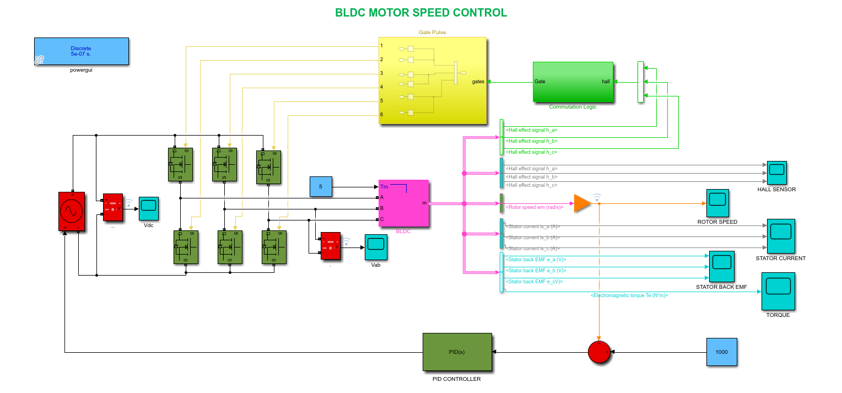
Fig.5 SIMULINK model of proposed BLDC motor drive

- Case-1: Change speed from 0 to 1000rpm:

In case-1 we gave 1000rpm input by our user interface which is basically nothing our constant block in Simulink model. Below you can see the output plots of rotor speed, torque, dc bus voltage (Vdc), line-line voltage (Vab), hall sensor signal, back-emf and stator current.

ROTOR SPEED (RPM):
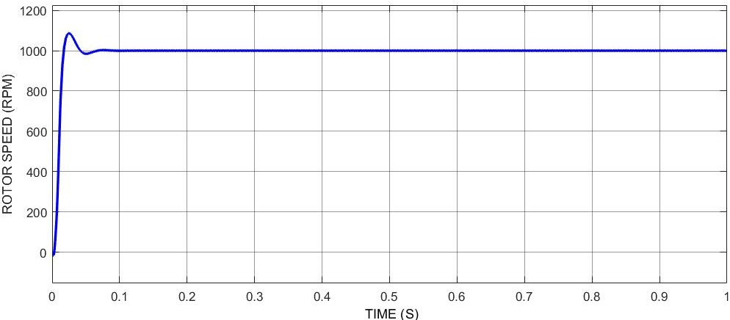
ELECTROMAGNETIC TORQUE (N*m):
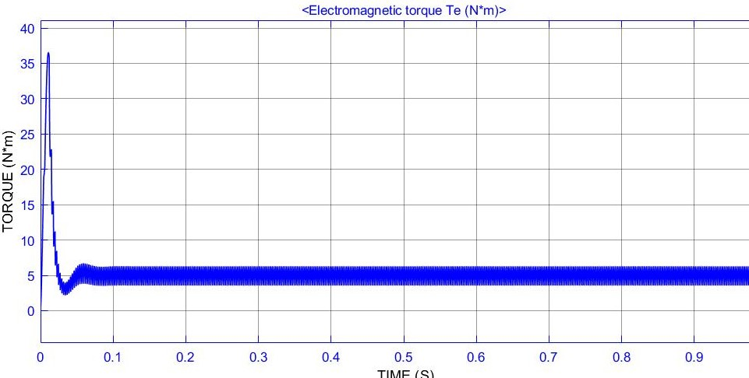
DC BUS VOLTAGE (Vdc):
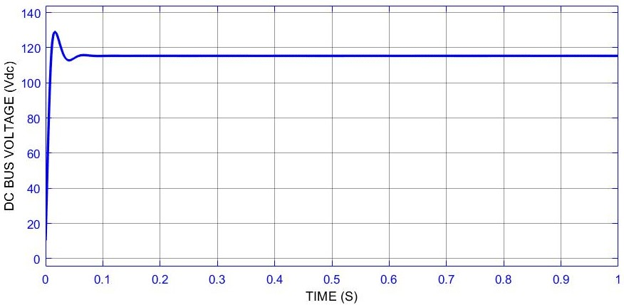LINE-LINE VOLTAGE (Vab):
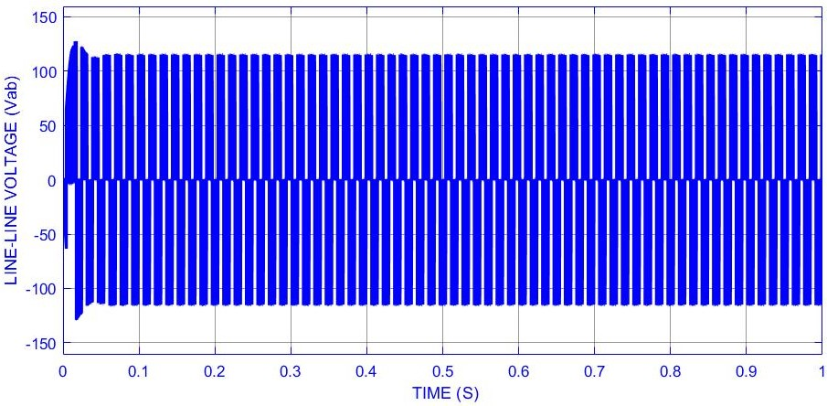HALL SENSOR SIGNAL:
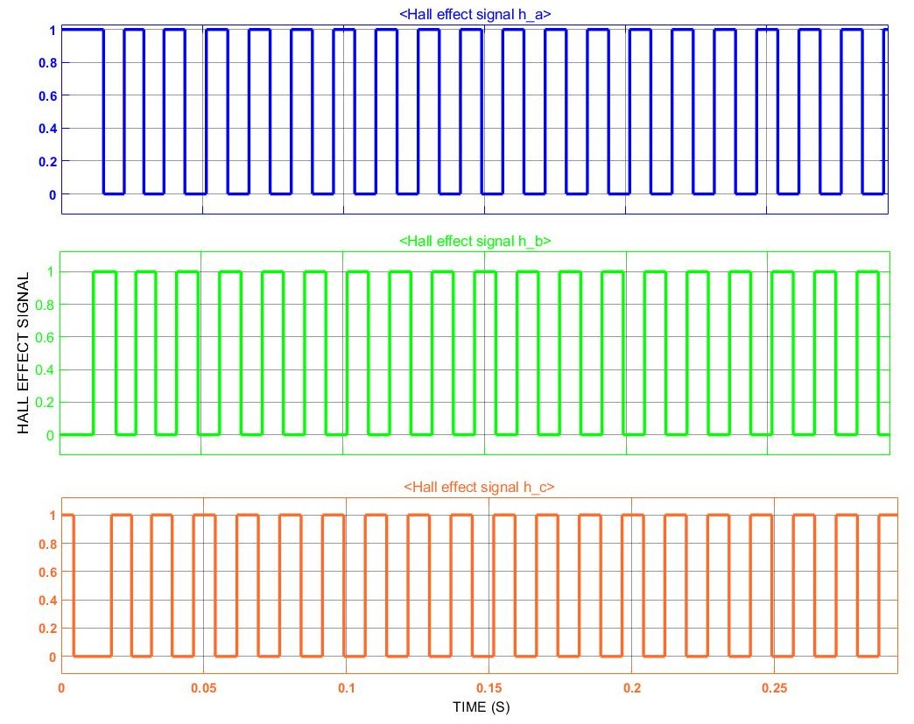STATOR BACK-EMF:
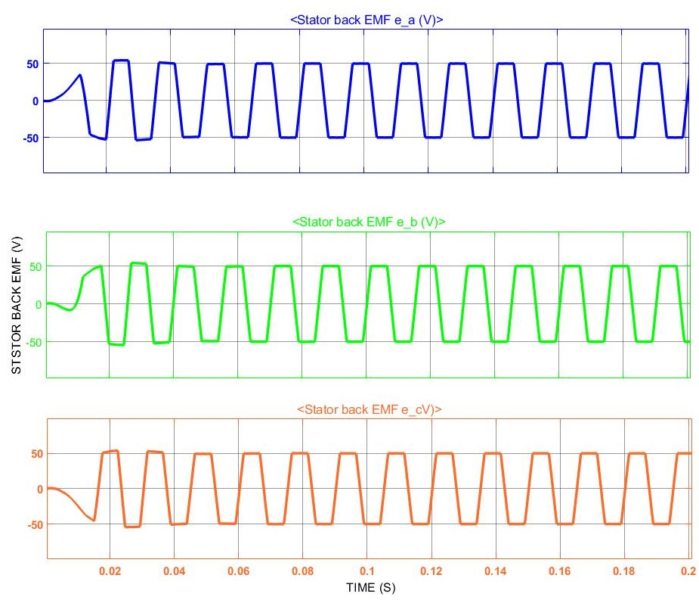
STATOR CURRENT:
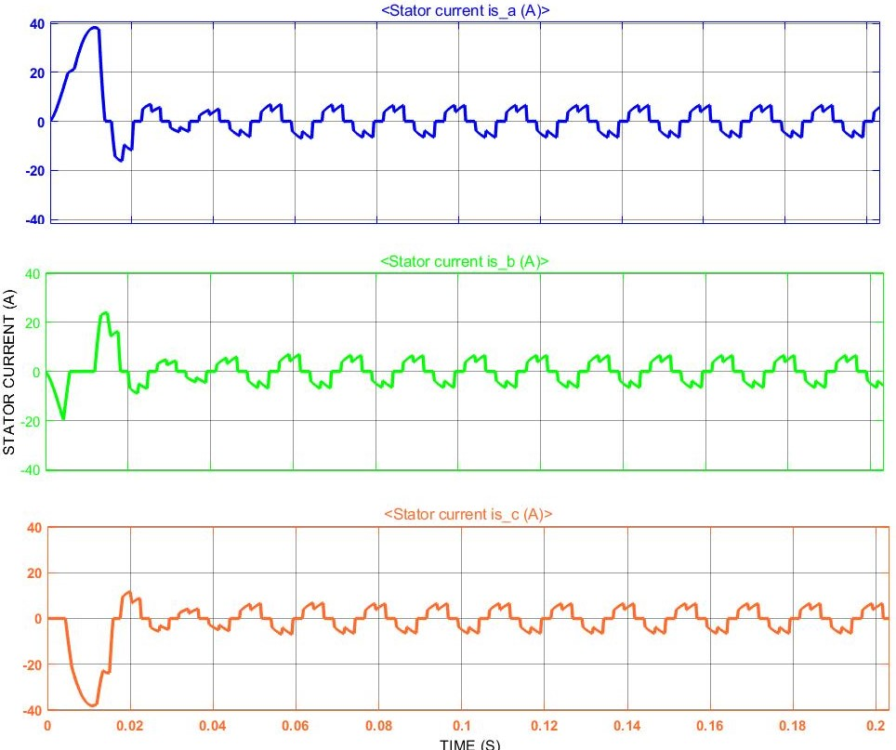

- Case-2: Change speed from 1000rpm to 2500rpm:

In case-2 we gave 2500rpm input by our user interface which is basically nothing our constant block in Simulink model. Below you can see the output plots of rotor speed, torque, dc bus voltage (Vdc), line-line voltage (Vab), hall sensor signal, back-emf and stator current.

ROTOR SPEED (RPM):
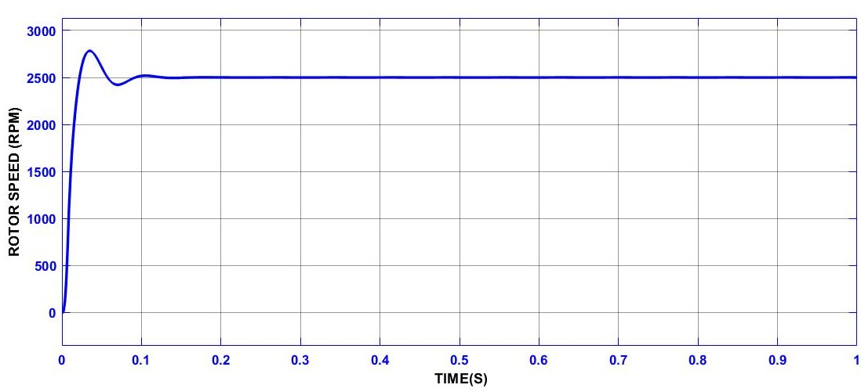
ELECTROMAGNETIC TORQUE (N*m):
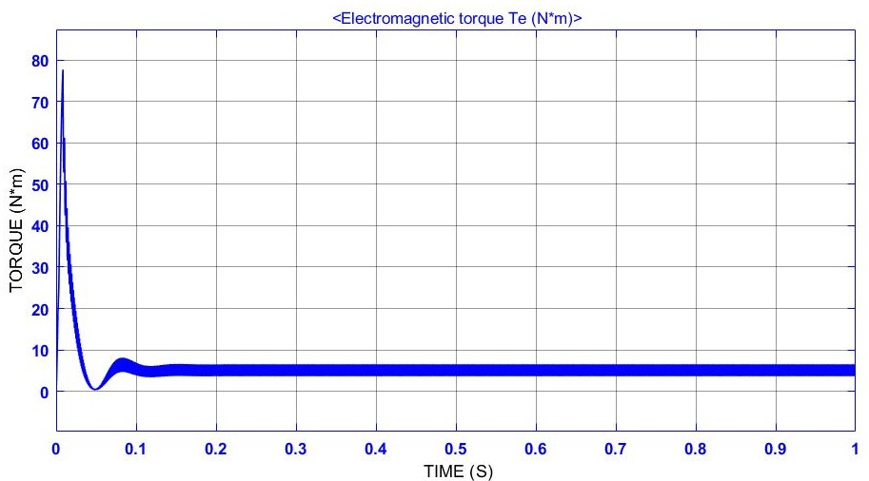

DC BUS VOLTAGE (Vdc):
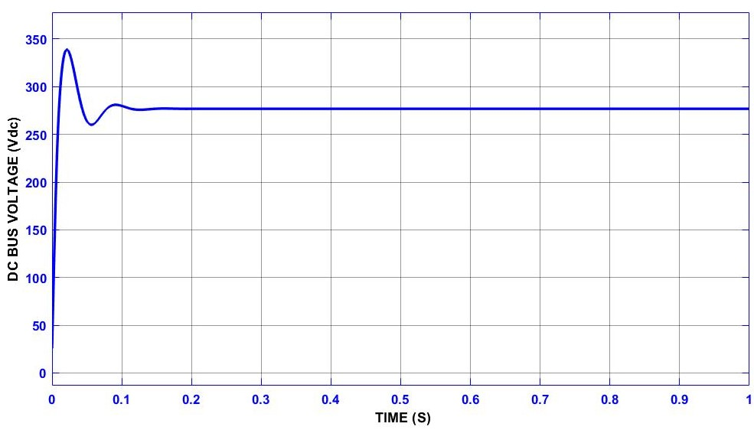LINE-LINE VOLTAGE (Vab):
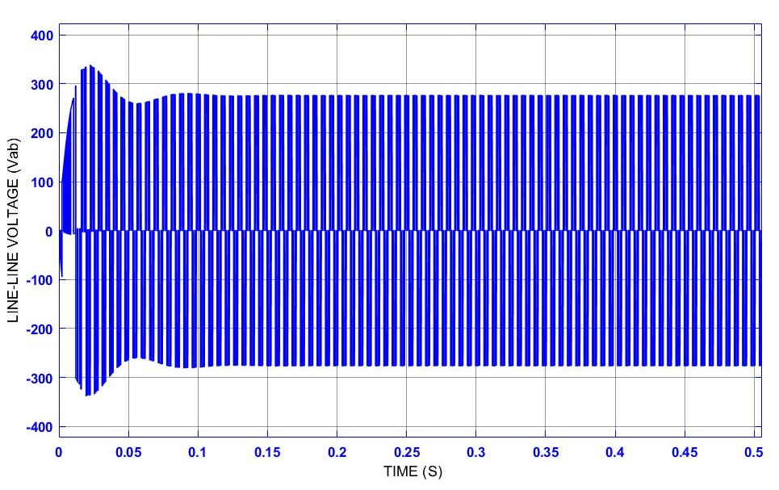HALL SENSOR SIGNAL:
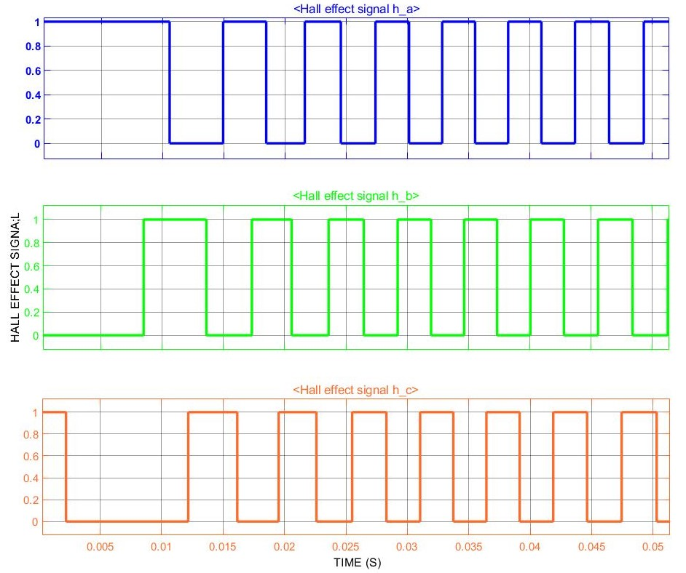STATOR BACK-EMF:
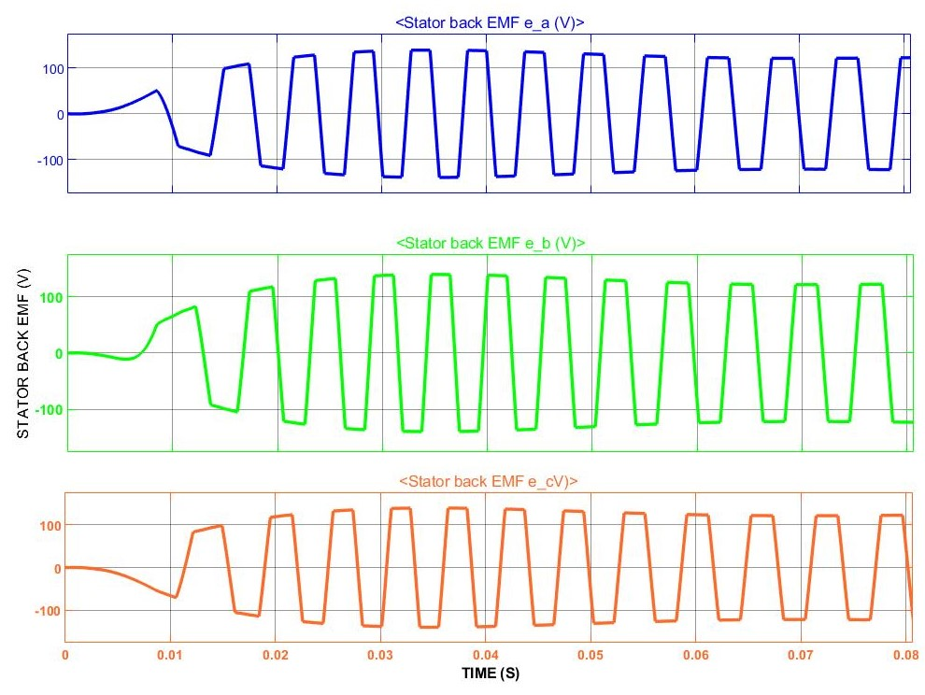
STATOR CURRENT:
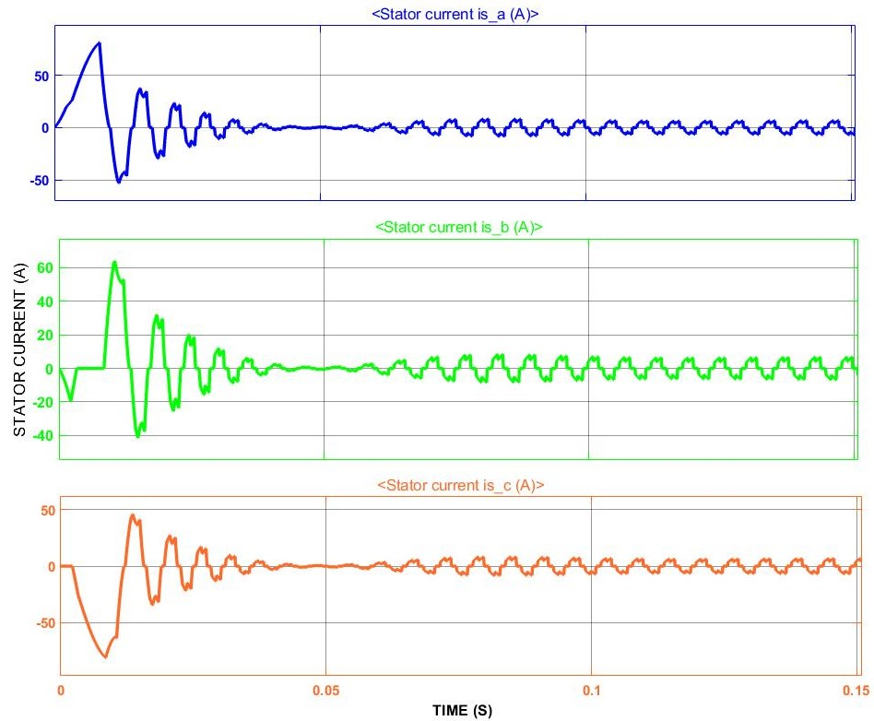

- Case-3: Change speed from 2500 to 1250rpm:

In case-3 we gave 1250rpm input by our user interface which is basically nothing our constant block in Simulink model. Below you can see the output plots of rotor speed, torque, dc bus voltage (Vdc), line-line voltage (Vab), hall sensor signal, back-emf and stator current.

ROTOR SPEED (RPM):
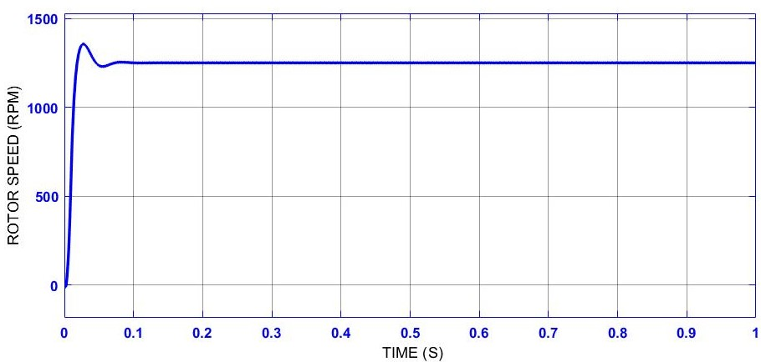

ELECTROMAGNETIC TORQUE (N*m):
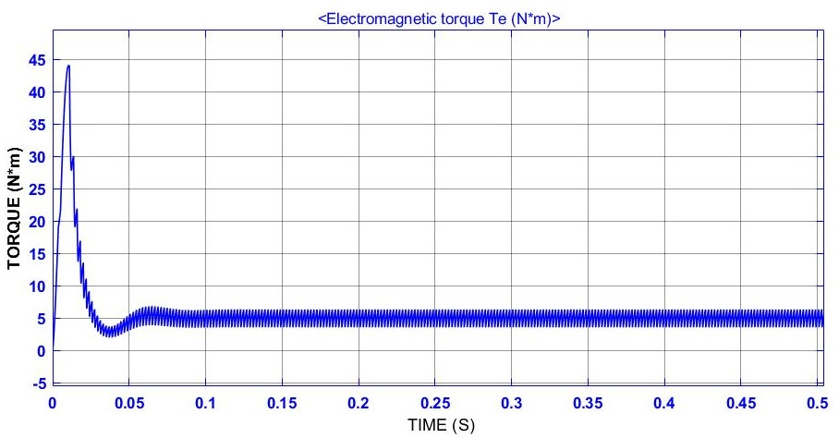
DC BUS VOLTAGE (Vdc):
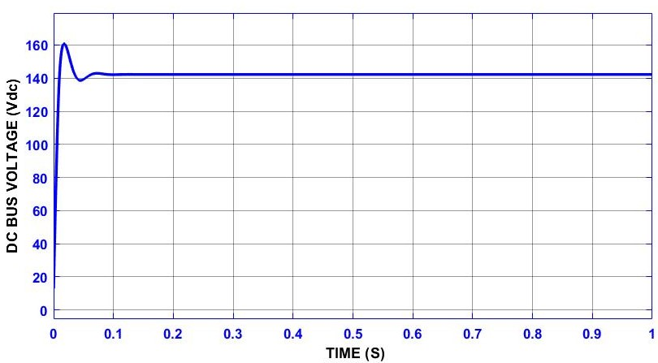
LINE-LINE VOLTAGE (Vab):
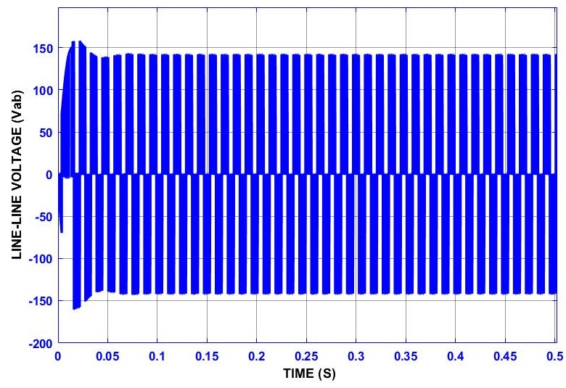
HALL SENSOR SIGNAL:
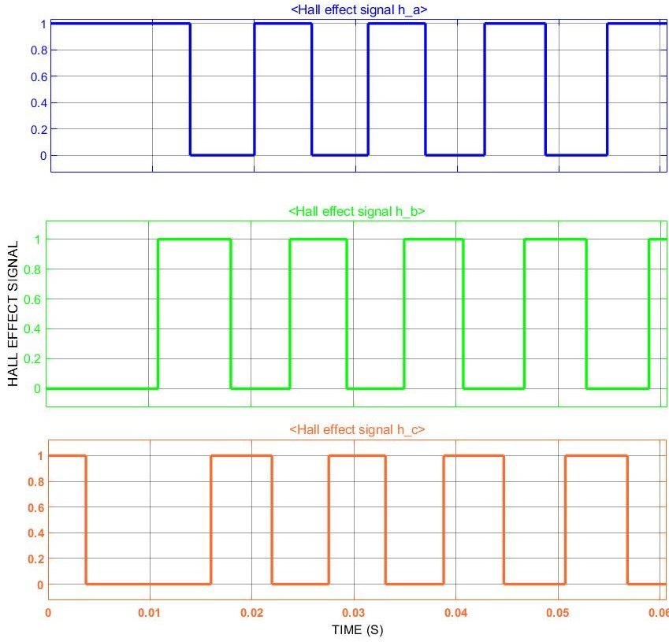
STATOR BACK-EMF:
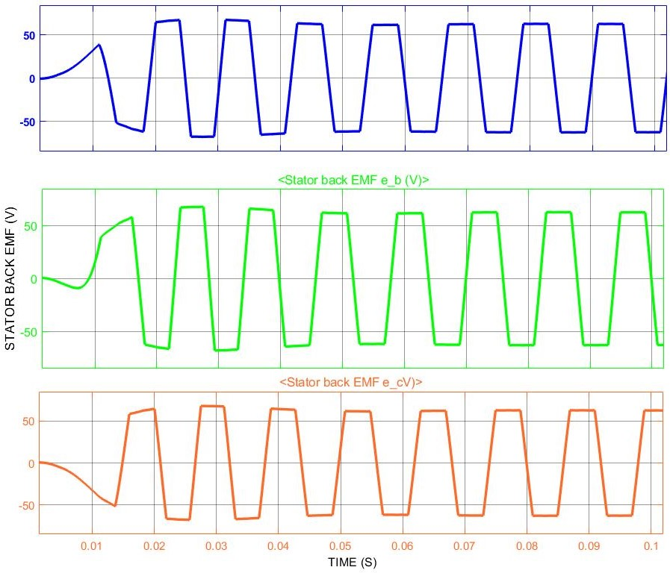
STATOR CURRENT:
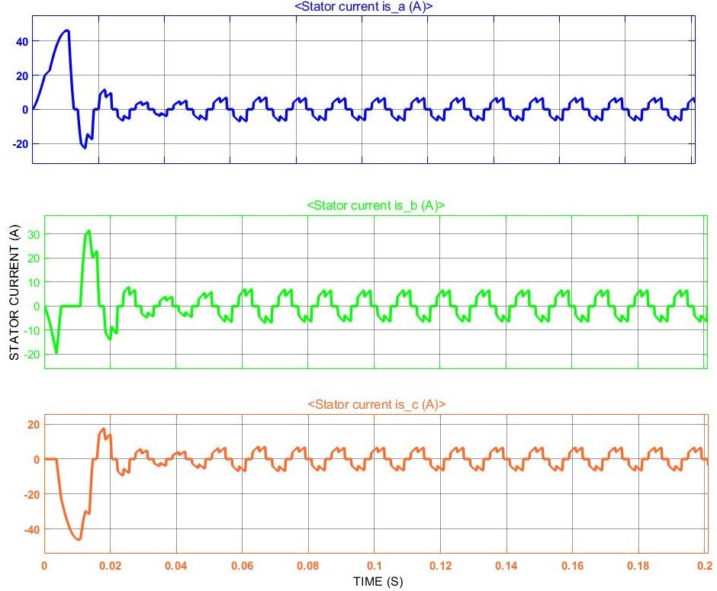

RESULT

After performing our BLDC motor drive at targeted speed levels, we observed our motor is fully capable and controllable to operate at those speed levels. Below Table no.2 will show the exact output result of Vdc, Vab and torque of three cases.

PARAMETERS |  | 1000RPM | 1250RPM | 2500RPM
Vdc | MAX | 129.1V | 160.8V | 338.7V
Vdc | MEDIAN | 115.4V | 142.3V | 276.8V
Vdc | MIN | 112.9V | 138.7V | 260.1V
Vab | MAX | 127.6V | 157.9V | 337.8V
Vab | MEDIAN | 114.4V | 141.3V | 276.8V
Vab | MIN | 111.9V | 137.9V | 259.9V
TORQUE | MAX | 36.53Nm | 44.06Nm | 76.1Nm
TORQUE | MEDIAN | 5.082Nm | 5.137Nm | 5.141Nm
TORQUE | MIN | 2.765Nm | 2.437Nm | 2.138Nm
Table no.2 Vdc, Vab and Torque output

CONCLUSION

A BLDC motor is highly reliable since it does not have any brushes to wear out and replace. When operated in rated conditions, the life expectancy is over 10,000 hours. For long term applications, this can be a great choice. Although a BLDC motor may cost more than a brushed DC motor, but often it will pay more than for itself in the amount of work time saved.
And here in this proposed scheme we have Successfully tested all required parameters and found this proposed model as a fully controllable and efficient BLDC drive scheme for not only automotive applications but all other applications as well by changing required specifications of motor and input voltage if needed.
All the simulation results are of theoretical aspects and can be utilized for practical implementation.

REFERENCES

[1] T. Raghu, S. Chandra Sekhar, J. Srinivas Rao, ―SEPIC Converter Based-Drive for Unipolar BLDC Motor‖, International Journal of Electrical and Computer Engineering (IJECE), Vol.2, No.2, April 2012, pp. 159-165.

[2] A. HalvaeiNiasar, AbolfazlVahedi, Hassan Moghbeli, ―Torque Control of Brushless DC Motor Drive based on DSP Technology‖, Proceeding of International Conference on Electrical Machines and Systems 2007, Oct. 8~11, Seoul, Korea.

[3] F. Rodriguez and A. Emadi, ―A novel digital control technique for brushless DC motor drives, ‖ IEEE Transaction Industrial Electronics., vol. 54, no. 5, pp. 2365–2373, Oct. 2007

[4] C. Gencer and M. Gedikpinar,” Modelling and Simulation of BLDC Motor Using MATLAB/SIMULINK”, Journal of Applied Sciences, vol. 6, issue 3, pp. 688-691, 2006.

[5] Vinod Kr Singh Patel, A.K. Pandey, “Modelling and Simulation of Brush less DC Motor Using PWM Control Technique”, IJERA Transaction, vol. 3, issue 3, May – jun 2013.

[6] G. Prasad, N. Sree Ramya,” Modelling and Simulation Analysis of the Brush less DC Motor by using MATLAB”, IJITEE Transaction, vol. 1, issue 5 October 2012.

[7] A. Purna Chandra Rao, Y.P. Obulesh and Ch. Sai Babu,” Mathematical modelling of BLDC Motor with closed loop speed control using PID controller under various loading conditions”, ARPN Journal of Engineering and Applied Sciences, vol. 7, no. 10 October2012.

[8] IJECSCSE, Digital Control of BLDC Motor Using Hall Sensor, G. Premkumar.

[9] P. Devendra, Madhavi TVVS, K Alice Mary, Ch.
Saibabu, “Microcontroller based control of three phase BLDC motor”, Journal of Engineering Research & Studies, Volume II, Issue IV, October-December 2011.

[10] Fang Lin & Hock Guan Yea,” Advanced PM Brushless DC Motor
Control & System for Electric Vehicles” IEEE, 2000.


Anirudha Behera received the Bachelor of Engineering degree (B.Tech) in Electrical Engineering from Biju Patnaik University of Technology (BPUT), Rourkela, India, in 2018, and currently perusing M.S. degree in Electrical Engineering from Illinois Institute of Technology (IIT), Chicago, USA. His current research interests include Electric Vehicle and first charging battery. He is a student member of Power and Energy Society (PES) and Control Engineering Society (CES) of IEEE, Zone-4, Chicago, USA. Also serving as General Secretary at Eta Kappa Nu Delta Chapter of Computer Engineering Department at Illinois Tech.

 Author- Anirudha Behera, MS in Electrical Engineering, Dept. of Electrical and Computer Engineering, Illinois Institute of Technology, Chicago. 60616 USA (phone: +13125398691; e-mail: abehera1@hawk.iit.edu).

