**INSTALLATION INSTRUCTIONS:**

**FRONT END:**

The project front end is developed using Django Framework which is free and open source web framework, written in python that follows MVC architecture. The framework allows to create website faster and easier that gives ready made component to use.

**Django Framework Installation Steps:**

Step 1: Open command prompt and check for python version if installed on your device or not

using: python --version

Step 2: If the python software is already installed then look for easy_install setup tools if

present using: easy_install --version

Step 3: Install django framework on your machine using: easy_install django

Step 4: Download the project folder (unzip). Using command prompt (terminal), go to the project location and simply execute the following command: python manage.py runserver

The command given above will start the django server and allow you to access the project web page located on: 127.0.0.1:8000/netflix/

**Note :** if you get error as TemplateDoesNotExist while loading the webpage then in the setting.py file under the template section , need to specify the path of the template directory as below.

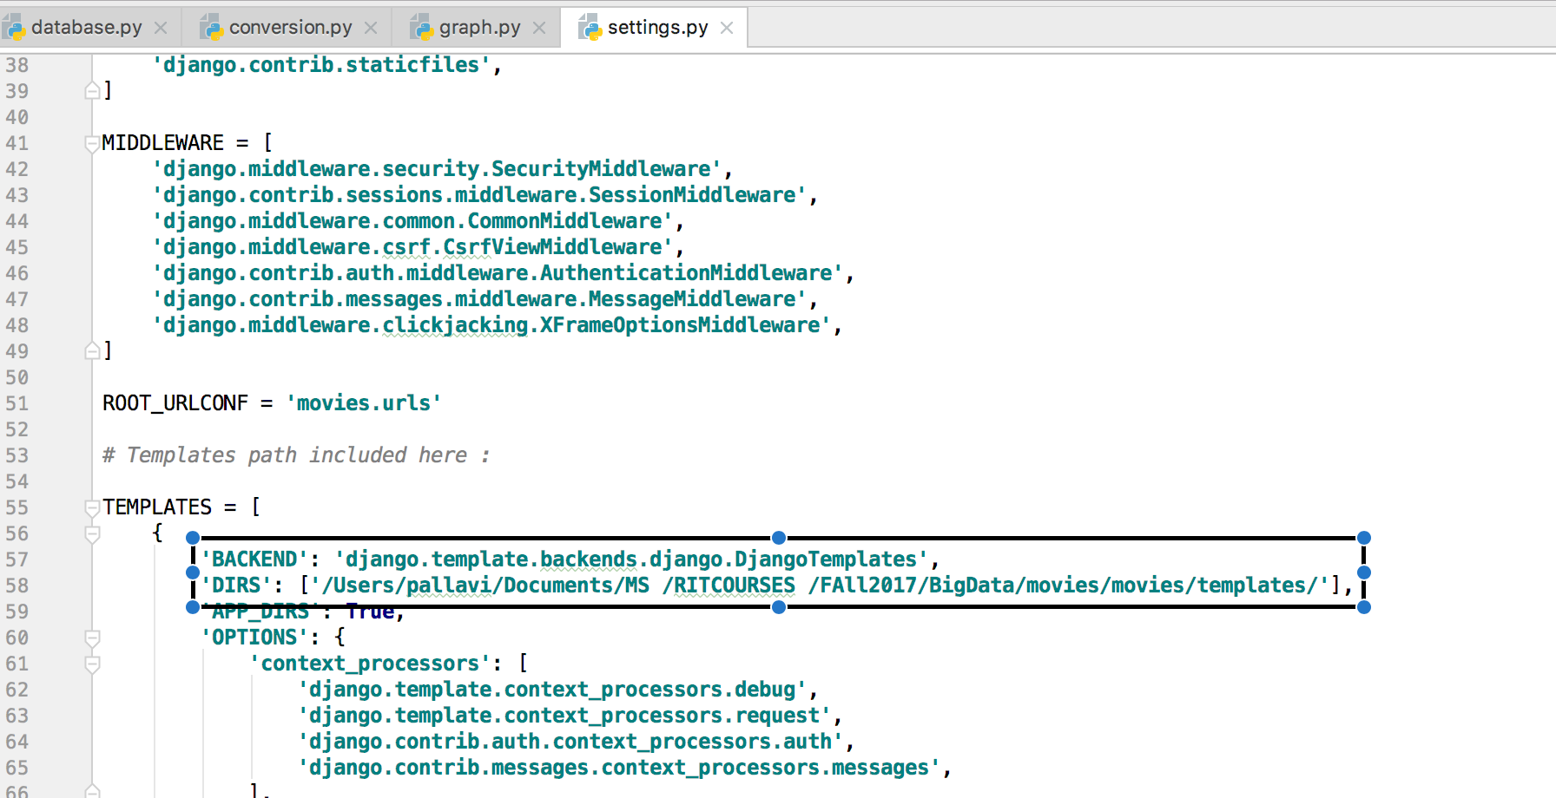

**BACK END:**

**PostgreSQL:**

For the backend part of this project, we are using PostgreSQL server for maintaining the database and handling incoming connections. PostgreSQL is a powerful, open source object-relational database system. It is fully ACID compliant, has full support for foreign keys, joins, views, triggers, and stored procedures (in multiple languages). It has native programming interfaces for C/C++, Java, .Net, Perl, Python, Ruby, Tcl, ODBC, among others.

Installation instructions:

Step 1: Download the latest version of PostgreSQL server from the link: <https://www.postgresql.org/download/> then click on the link under ‘Interactive installer by EnterpriseDB’ and download the installer

Step 2: Install PostgreSQL server by clicking next and when prompted, setting the user as ‘postgres’ which is the default, setting the port number to ‘5433’ and setting the password as ‘1’.

Step 3: Let the installation finish and when it’s done, you can run the program ‘pgAdmin 4’ to check whether everything is running fine.

**Psycopg2 and Sqlalchemy:**

Psycopg2 is a library which is used to connect to the PostgreSQL server and run normal SQL commands on the database. Sqlalchemy is a library that allows us to load and unload data from a particular database.

Assuming python is installed on the system, pip should be installed by default. We will be using pip to install psycopg2 and sqlalchemy libraries for python.

Installation instructions:

Step 1: In the search bar, type ‘cmd’, then right click on it and click on ‘Run as Administrator’

Step 2: After the command prompt/terminal opens, type in ‘pip install psycopg2’ and hit Enter. Let the installation process finish.

Step 3: Type in the command prompt/terminal ‘pip install sqlalchemy’ and hit Enter. Let the installation process finish.

**Pandas Installation Instructions:**

Using pip install Pandas as follows : pip install pandas

**Matplotlib Installation Instructions:**

Using pip install matplotlib as follows : pip install matplotlib

**Link to Dataset:**

Download from :<https://www.kaggle.com/tmdb/tmdb-movie-metadata/data>

Paste the downloaded files in the program directory where all Python files are present.

**INSTRUCTIONS TO RUN:**

Open Command Prompt or terminal

Step 1: Changing current directory: cd “project directory”

Step 2: Creating tmdb database: python movie/database.py

Step 3: Converting the CSV files and loading them into the ‘tmdb’ database: python movie/conversion.py

Step 4: Starting the Django server: python manage.py runserver

Step 5: Opening the webpage: 127.0.0.1:8000/netflix/

To view Graph visualization:

Run graphy.py file. It also saves the graphs in the directory it being run from.