* attempt 2

I had spent the time since submitting attempt one trying to wrap my head around passing variables in and out of functions. I was finally able to get the program working after realizing the df_init function is returning a tuple so our values passed should be as such. After assigning the tuple I run the train() method on the last param passed in, c. from there our train() method will populate the test_acc_df, populated into variable d. Finally d is passed into plot() where we are plotting out points in facet_grid type format. Here is the code with some changes from attempt 1 highlighted in yellow:

as well as the output of our file:

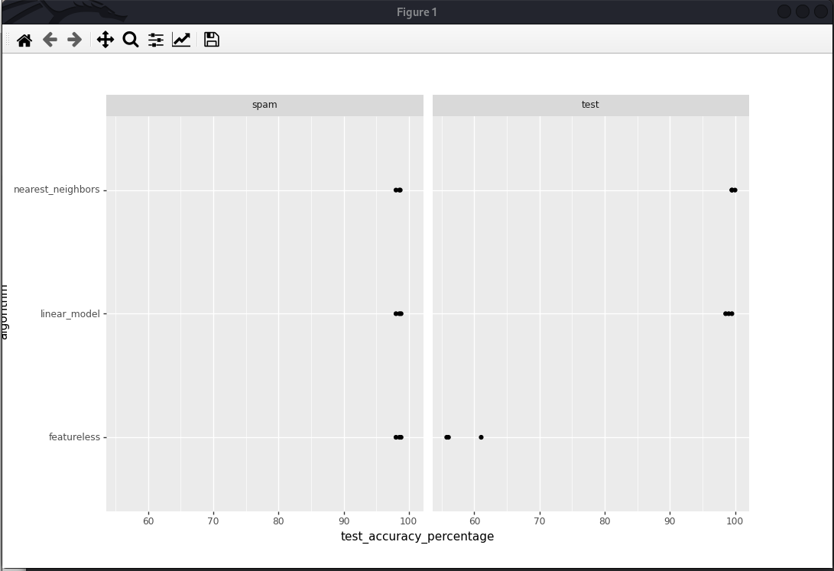

# lib for retrieving src file from web

import urllib.request

# lib for reading files on OS

import os

# lib used for copying src file info into destination

import shutil

import pandas as pd

import plotnine as p9

import numpy as np

# could not figure out how to calculate the mode of a list, using mode from lib

from statistics import mode

import sklearn

from sklearn.model_selection import KFold #train/test splits

from sklearn.model_selection import GridSearchCV #selecting best # of neighbors

from sklearn.neighbors import KNeighborsClassifier #nearest_neighbors prediction.

from sklearn.pipeline import make_pipeline # increase iteration sz

from sklearn.preprocessing import StandardScaler #

from sklearn.linear_model import LogisticRegression

# our src files we want to download. spam and test sets

test_url = 'https://hastie.su.domains/ElemStatLearn/datasets/zip.test.gz'

test_file = 'zip.test.gz'

spam_url = 'https://hastie.su.domains/ElemStatLearn/datasets/spam.data'

spam_file = 'spam.data'

# number of columns in test file (257) count from zero

test_cols = 257

# number of columns in spam file (56) count from zero

spam_cols = 57

"""

our last assignment was only downloading 1 file, to adhere to guidelines and

avoid repeatable code, created a method we will use to retrieve multiple files.

"""

def retrieve(src_file, src_url):

"""

check if a file exists in the current directory

retrieve a file given the url

"""

if not os.path.isfile(src_file):

urllib.request.urlretrieve(src_url, src_file)

print("Downloading " + src_file + " from " + src_url + "...\n")

else:

print(src_file + " already exists in this folder...continuing anyway\n")

"""

since we are initializing multiple dataframes for out multiple

sources of data, I wanted to try and minimize repeating code.

this method will

- take in src file

- create a dataframe

- drop specified rows of the src file

- convert our data into numpy

Hopefully this is allowed!

notice: (am repeating code) but spent too much time creating traveral

type solution going over a list of src_files and src_urls.

Wanted to seperate file into some seperate functions for the sake of

readability.

"""

def df_init(src1, src2, src1_cols, src2_cols, data_dict):

# read in downloaded src file as a pandas dataframe

# seperate dataframes because different manipulations will be done

df1 = pd.read_csv(src1, header=None, sep=" ")

df2 = pd.read_csv(src2, header=None, sep=" ")

# remove any rows which have non-01 labels

df1[0] = df1[0].astype(int)

df2[0] = df2[0].astype(int)

df1 = df1[df1[0].isin([0, 1])]

df2 = df2[df2[0].isin([0, 1])]

# initialize and convert outputs to a label vector

df1_labels = df1[0]

df2_labels = df2[0]

"""

Convert our dataframe to a dictionary with numpy array exlcuding the

first column; iloc for row and col specifying.

"""

data_dict = {

"test":(df1.loc[:,1:].to_numpy(), df1[0]),

"spam":(df2.loc[:,1:].to_numpy(), df2[0]),

}

# print our dataframes to visualize in tabular form

print(df1)

print(df2)

#print(data_dict)

return df1, df2, data_dict

"""

algorithm shown in class and from our demo.

"""

def train(data_dict):

test_acc_df_list = []

# increase the max iteration from default 100

pipe = make_pipeline(StandardScaler(), LogisticRegression(max_iter=1000))

for data_set, (input_mat, output_vec) in data_dict.items():

print(data_set)

kf = KFold(n_splits=3, shuffle=True, random_state=1)

for fold_id, indices in enumerate(kf.split(input_mat)):

print(fold_id)

index_dict = dict(zip(["train","test"], indices))

param_dicts = [{'n_neighbors':[x]} for x in range(1, 21)]

# does subtrain/validation splits.

clf = GridSearchCV(KNeighborsClassifier(), param_dicts)

# copy above for linear model. call cv=5 in initial pipe was not

# recognized; try a call here

linear_model = sklearn.linear_model.LogisticRegressionCV(cv=5)

set_data_dict = {}

for set_name, index_vec in index_dict.items():

set_data_dict[set_name] = (

input_mat [ index_vec ],

output_vec.iloc[index_vec]

)

# * is unpacking a tuple to use as the different positional arguments

# clf.fit(set_data_dict["train"][0], set_data_dict["train"][1])

# train models and stub out linear_model

clf.fit(*set_data_dict["train"])

# method 2: dict instead of tuple.

set_data_dict = {}

for set_name, index_vec in index_dict.items():

set_data_dict[set_name] = {

"X":input_mat[index_vec],

"y":output_vec.iloc[index_vec]

}

# ** is unpacking a dict to use as the named arguments

# train models and stub out linear_model and create algo for finding

# mode

# clf.fit(X=set_data_dict["train"]["X"], y=set_data_dict["train"]["y"]])

clf.fit(**set_data_dict["train"])

#mode = max(set(output_vec))

featureless_model = mode(output_vec)

linear_model.fit(**set_data_dict["train"])

clf.best_params_

cv_df = pd.DataFrame(clf.cv_results_)

cv_df.loc[:,["param_n_neighbors","mean_test_score"]]

pred_dict = {

"nearest_neighbors":clf.predict(set_data_dict["test"]["X"]),

#TODO add featureless and linear_model.

"featureless": featureless_model,

"linear_model": linear_model.predict(set_data_dict["test"]["X"])

}

for algorithm, pred_vec in pred_dict.items():

test_acc_dict = {

"test_accuracy_percentage":(

pred_vec == set_data_dict["test"]["y"]).mean()*100,

"data_set":data_set,

"fold_id":fold_id,

"algorithm":algorithm

}

test_acc_df_list.append(pd.DataFrame(test_acc_dict, index=[0]))

test_acc_df = pd.concat(test_acc_df_list)

return test_acc_df

"""

an attempt to modularize our code to improve readibility, this method

will make a ggplot to visually examine which learning algorithm is

best for each data set

"""

def plot(test_acc_df):

gg = (p9.ggplot(test_acc_df,

p9.aes(x='test_accuracy_percentage'

,y='algorithm'))

# .~ spreads vals across columns

+p9.facet_grid('.~ data_set')

# Use geom_point to create scatterplots

+p9.geom_point())

print(gg)

def main():

data_dict = {}

# retrieve our source files. Spam and test.

retrieve(test_file, test_url)

retrieve(spam_file, spam_url)

# call method to initialize our data frames, convert to numpy arrays,

(test, spam, _dict) = df_init(test_file, spam_file, test_cols,

spam_cols, data_dict)

# call method to perform our algorithm shown in class and the demo

trained_data = train(_dict)

# plot our values by passing in the previously filled variable d

plot(trained_data)

if __name__ == '__main__':

# run main

main()

* attempt 1

Overall the assignment did not stray too much from what was given in the demo. However, to

try and keep a modularized approach to how we implement code, I attempted to create different methods for some of the big functions we were passing around. In the end my code did not end up working how I wanted due to some python programming errors. I was unsure of how to pass variables around the program and which ones to pass and assign, etc. The final error I got was not able to concat test_acc_df_list. This has to be because of the data_dict not being seeing inside of the train method. Just like last time I am confident if I was given a bit more time I would be able to tackle this problem. The method for plotting our points was eventually not met so I am unsure if it was implemented correctly. Based off of the demos and my previous assignment, I decided to use the code for plotting and hoping it would work. This time I was able to find a decent documentation on plotting using the facet_grid but again, I am not sure if this was implemented correctly. In the coming days I might submit a new file that is working.

Here is my code:

# lib for retrieving src file from web

import urllib.request

# lib for reading files on OS

import os

# lib used for copying src file info into destination

import shutil

import pandas as pd

import plotnine as p9

import numpy as np

# could not figure out how to calculate the mode of a list, using mode from lib

import statistics

from sklearn.model_selection import KFold #train/test splits

from sklearn.model_selection import GridSearchCV #selecting best # of neighbors

from sklearn.neighbors import KNeighborsClassifier #nearest_neighbors prediction.

from sklearn.pipeline import make_pipeline # increase iteration sz

from sklearn.preprocessing import StandardScaler #

from sklearn.linear_model import LogisticRegression

# our src files we want to download. spam and test sets

test_url = 'https://hastie.su.domains/ElemStatLearn/datasets/zip.test.gz'

test_file = 'zip.test.gz'

spam_url = 'https://hastie.su.domains/ElemStatLearn/datasets/spam.data'

spam_file = 'spam.data'

# number of columns in test file (257) count from zero

test_cols = 257

# number of columns in spam file (56) count from zero

spam_cols = 57

# dataframe list

#test_acc_df_list = []

"""

our last assignment was only downloading 1 file, to adhere to guidelines and

avoid repeatable code, created a method we will use to retrieve multiple files.

"""

def retrieve(src_file, src_url):

"""

check if a file exists in the current directory

retrieve a file given the url

"""

if not os.path.isfile(src_file):

urllib.request.urlretrieve(src_url, src_file)

print("Downloading " + src_file + " from " + src_url + "...\n")

else:

print(src_file + " already exists in this folder...continuing anyway\n")

"""

since we are initializing multiple dataframes for out multiple

sources of data, I wanted to try and minimize repeating code.

this method will

- take in src file

- create a dataframe

- drop specified rows of the src file

- convert our data into numpy

Hopefully this is allowed!

notice: (am repeating code) but spent too much time creating traveral

type solution going over a list of src_files and src_urls.

Wanted to seperate file into some seperate functions for the sake of

readability.

"""

def df_init(src1, src2, src1_cols, src2_cols, data_dict):

# read in downloaded src file as a pandas dataframe

# seperate dataframes because different manipulations will be done

df1 = pd.read_csv(src1, header=None, sep=" ")

df2 = pd.read_csv(src2, header=None, sep=" ")

# remove any rows which have non-01 labels

df1[0] = df1[0].astype(int)

df2[0] = df2[0].astype(int)

df1 = df1[df1[0].isin([0, 1])]

df2 = df2[df2[0].isin([0, 1])]

# initialize and convert outputs to a label vector

df1_labels = df1[0]

df2_labels = df2[0]

"""

Convert our dataframe to a dictionary with numpy array exlcuding the

first column; iloc for row and col specifying.

"""

data_dict = {

"test":(df1.loc[:,1:].to_numpy(), df1[0]),

"spam":(df2.loc[:,1:].to_numpy(), df2[0]),

}

# print our dataframes to visualize in tabular form

print(df1)

print(df2)

#print(data_dict)

return df1, df2, data_dict

"""

algorithm shown in class and from our demo.

"""

def train(data_dict):

test_acc_df_list = []

# increase the max iteration from default 100

pipe = make_pipeline(StandardScaler(), LogisticRegression(max_iter=1000))

for data_set, (input_mat, output_vec) in data_dict.items():

print(data_set)

kf = KFold(n_splits=3, shuffle=True, random_state=1)

for fold_id, indices in enumerate(kf.split(input_mat)):

print(fold_id)

index_dict = dict(zip(["train","test"], indices))

param_dicts = [{'n_neighbors':[x]} for x in range(1, 21)]

# does subtrain/validation splits.

clf = GridSearchCV(KNeighborsClassifier(), param_dicts)

# copy above for linear model. call cv=5 in initial pipe was not

# recognized; try a call here

linear_model = sklearn.linear_model.LogisticRegression(cv=5)

set_data_dict = {}

for set_name, index_vec in index_dict.items():

set_data_dict[set_name] = (

input_mat [ index_vec ],

output_vec.iloc[index_vec]

)

# * is unpacking a tuple to use as the different positional arguments

# clf.fit(set_data_dict["train"][0], set_data_dict["train"][1])

# train models and stub out linear_model

clf.fit(*set_data_dict["train"])

# method 2: dict instead of tuple.

set_data_dict = {}

for set_name, index_vec in index_dict.items():

set_data_dict[set_name] = {

"X":input_mat[index_vec],

"y":output_vec.iloc[index_vec]

}

# ** is unpacking a dict to use as the named arguments

# train models and stub out linear_model and create algo for finding

# mode

# clf.fit(X=set_data_dict["train"]["X"], y=set_data_dict["train"]["y"]])

clf.fit(**set_data_dict["train"])

#mode = max(set(output_vec))

import statistics

MCE = mode(output_vec)

linear_model.fit(*set_data_dict["train"])

clf.best_params_

cv_df = pd.DataFrame(clf.cv_results_)

cv_df.loc[:,["param_n_neighbors","mean_test_score"]]

pred_dict = {

"nearest_neighbors":clf.predict(set_data_dict["test"]["X"]),

#TODO add featureless and linear_model.

"featureless": MCE,

"linear_model": linear_model.predict(set_data_dict["test"]["X"])

}

for algorithm, pred_vec in pred_dict.items():

test_acc_dict = {

"test_accuracy_percent":(

pred_vec == set_data_dict["test"]["y"]).mean()*100,

"data_set":data_set,

"fold_id":fold_id,

"algorithm":algorithm

}

test_acc_df_list.append(pd.DataFrame(test_acc_dict, index=[0]))

test_acc_df = pd.concat(test_acc_df_list)

return test_acc_df

"""

an attempt to modularize our code to improve readibility, this method

will make a ggplot to visually examine which learning algorithm is

best for each data set

"""

def plot(test_acc_df):

gg = (p9.ggplot(test_acc_df,p9.aes(x='test_accuracy_percent',y='algorithm'))

+p9.facet_grid('.~ data_set')

+p9.geom_point())

print(gg)

def main():

data_dict = {}

test_acc_df = []

# retrieve our source files. Spam and zip.

retrieve(test_file, test_url)

retrieve(spam_file, spam_url)

# call method to initialize our data frames, convert to numpy arrays,

df_init(test_file, spam_file, test_cols, spam_cols, data_dict)

# call method to perform our algorithm shown in class and the demo

train(data_dict)

plot(test_acc_df)

if __name__ == '__main__':

# run main

main()