[1]

Simulação de possível melhora de mobilidade e redução de custo ao construir uma ponte entre Itajaí e Navegantes próxima ao ferry boat

Adson Marques da Silva Esteves, Alisson Steffens Henrique e Augusto Pluschkat

*Abstract*—These instructions give you guidelines for preparing papers for IEEE Transactions and Journals*.* Use this document as a template if you are using Microsoft *Word* 6.0 or later. Otherwise, use this document as an instruction set. The electronic file of your paper will be formatted further at IEEE. Paper titles should be written in uppercase and lowercase letters, not all uppercase. Avoid writing long formulas with subscripts in the title; short formulas that identify the elements are fine (e.g., "Nd–Fe–B"). Do not write “(Invited)” in the title. Full names of authors are preferred in the author field, but are not required. Put a space between authors’ initials. Define all symbols used in the abstract. Do not cite references in the abstract. Do not delete the blank line immediately above the abstract; it sets the footnote at the bottom of this column.

*Index Terms*—Enter key words or phrases in alphabetical order, separated by commas. For a list of suggested keywords, send a blank e-mail to [keywords@ieee.org](mailto:keywords@ieee.org) or visit <http://www.ieee.org/organizations/pubs/ani_prod/keywrd98.txt>

# Introdução

C

OM o aumento do número de automóveis na cidade de Itajaí seja por habitantes comprando automóveis próprios, turistas que utilizam o aeroporto em Navegantes ou habitantes de Navegantes que vem trabalhar em Itajaí, certos pontos da cidade tendem a apresentar lentidão durante horários de pico, principalmente entre as rotas que conectam as cidades de Itajaí e Navegantes.

Duas rotas principais são utilizadas nessa travessia, a via pela BR-101 e BR-470, e a via pela Avenida Santos Dumont, o primeiro trajeto porém percorre uma distância de 24 Km, enquanto no segundo trajeto, a distância é de apenas 2,7 Km, contando com uma Balsa intermediária, que atravessa o Rio Itajaí-Açu, cuja travessia é cobrada uma quantia de R$ 8,75.

Este documento tenta demonstrar os problemas relacionados a conexão entre as cidades, utilizando custo e eficiência do caminho e comparando com outras cidades gêmeas.

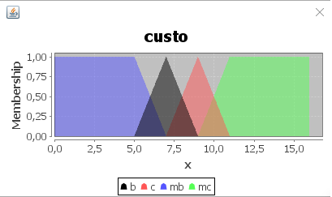

Fig. 1. Exemplo de gráfico gerado pela lógica Fuzzy. Eixo X graus de verdade, eixo Y variáveis, cores são as variáveis linguísticas.

# Método Escolhido

Para provar a nossa hipótese, foram discutidos alguns métodos que utilizaríamos no projeto (lembrar aqui de algumas discussões).

Por fim, foi decidida a utilização do método da lógica Fuzzy (ou lógica difusa), pois as variáveis de custo e eficiência que utilizamos para o projeto, produzem resultados qualitativos, e tal método é capaz de analisar quantitativamente estas qualidades e transformá-las em resultados numéricos. A intenção é que a lógica Fuzzy nos permita retirar entre os resultados, qual seria a rota mais viável.

## Definição de Lógica Fuzzy

A lógica Fuzzy aplica um conceito onde nem tudo pode ser definido como a lógica booleana a qual os valores se diferem apenas entre 0 ou 1, verdadeiro ou falso. Dentro das duas possibilidades da lógica booleana podem conter “graus de verdade”, ou seja, o quanto a variável é verdadeira, a partir de valores reais entre 0 e 1.

A lógica Fuzzy foi proposta em 1965 pelo Dr. Lofti A. Zadeh na Universidade da Califórnia. Dr. Zadeh trabalhava no problema de um computador entender a linguagem natural, visto que no cotidiano nem tudo pode ser definido apenas como verdadeiro e falso.

Com isso em mente, a lógica Fuzzy, consegue quantificar dados qualitativos e expressões linguísticas, como por exemplo, uma pessoa pode não ser apenas definida como criança ou velha, mas existem transições entre ambas que definem outros estados, como adolescente, jovem, adulto etc...

Dentre outras possibilidades podemos quantificar temperaturas (quente, morno, frio), altura (alto, médio, baixo), inteligência (inteligente, acima da média, mediando etc..).

A utilização desta lógica é representável por um gráfico entre as variáveis e o quanto de verdade podem elas ser (entre 0 e 1).

## Implementação da Lógica Fuzzy

Para a implementação desta lógica com nosso projeto, um projeto foi feito em JAVA. O programa utiliza os dados coletados e aplica-os em uma biblioteca que calcula resultados a partir da lógica Fuzzy, chamada jFuzzyLogic.

jFuzzyLogic é uma biblioteca em JAVA *open source* que implementa e simplifica a lógica Fuzzy para desenvolvimento de sistemas. Ela implementa a Fuzzy Control Language(FCL) especificação IEC 61131 parte 7.

FLC....(Alisson plis)

# Dados Utilizados

Nesta seção serão apresentados os dados utilizados e os métodos de escolha e captura dos dados utilizados na pesquisa.

## Locais Escolhidos

O primeiro local selecionado, e objeto de estudo do projeto, são os bairros Centro das cidades de Navegantes e Itajaí. Após presenciar a lentidão no trânsito nas duas vias que ligam ambos os Centros durante os horários de pico, foi discutido se seria possível comprovar uma falha no plano de mobilidade urbana das duas cidades gêmeas, assim sendo escolhido este tópico como tema de nosso trabalho.

Para servirem de parâmetro de comparação com o caso de Itajaí e Navegantes, foram escolhidas cidades que tenham uma situação parecida, dentro do termo “Cidades Gêmeas”.

Cidades Gêmeas é um termo utilizado para definir cidades geograficamente vizinhas que possuem um crescimento parecido e tende a haver uma grande movimentação entre ambas. Não existe um critério específico que defina quais cidades seriam gêmeas, mas dentro da lista das mais conhecidas muitas contêm uma divisão fluvial entre elas e pontes que conectam ambas em maioria.

Com este termo em mente, o segundo local escolhido foi os bairros Centro das cidades gêmeas Florianópolis e São José. Primeiramente este local foi escolhido por proximidade com o caso de Itajaí e Navegantes, porém ao analisarmos melhor o local, percebemos que existe apenas uma maneira para realizar a travessia entre as cidades, a ponte Pedro Ivo Campos, a outra ponte de ligação, a ponte Hercílio Luz, encontra-se atualmente desativada devido medidas de segurança. Esse fato nos fez perceber que esse local pode nos dar perspectivas que talvez uma ponte apenas não resolva.

O terceiro local escolhido, também dentro dos parâmetros de “cidades gêmeas”, foram as cidades de Cambridge e Boston nos EUA. Este local foi escolhido primariamente, por nosso Profº André Maciel Santana, já ter viajado para o local selecionado, assim nos dando um parecer real sobre o trânsito local, outro motivo foi que um parâmetro de comparação como cidades dos EUA, pode nos dar ideias de como o trânsito pode melhorar aqui em Itajaí também. As duas cidades em muito se assemelham as cidades foco da pesquisa, tendo uma delas grandes universidades e a outra um aeroporto internacional. O Rio Charles que as divide conta com várias pontes que as interligam durante seu percurso, isso já causa uma diferença de trânsito.

## Método de Captura dos Dados de Trânsito

Os dados foram recolhidos a partir da ferramenta do Google chamada GoogleMaps.

A ferramenta permite verificar o trânsito de qualquer rota desejada em tempo real, como também verificar o trânsito típico durante a semana em um horário específico.

Foi decidido que ao invés de se verificar o trânsito típico, seria escolhido um horário específico, pois ao selecionar uma rota no googlemaps, os gráficos de transito atual se sobrepunham o de transito típico, o que dificultava saber quais eram os dados típicos.

Uma vez escolhido o método, foi escolhido um dia e um horário em meio a semana para obter os dados que seriam utilizados no projeto. Em busca de um horário em que as cidades estivessem no “rush”, ou seja, quando o trânsito estivesse mais lento normalmente, então utilizamos o horário de 18h, que é o horário que normalmente a maioria das pessoas vão de seus trabalhos para suas casas.

Por volta de 18h do dia 30/11/2016 (Quarta feita), foi realizada a coleta dos dados sobre o trânsito das três duplas de cidades gêmeas escolhidas.

O horário da cidade de Boston foi reavaliado após percebemos que há uma diferença de 3h entre Brasília e Boston, portando no dia 02/12/2016 foi refeita a análise de trânsito de Boston por volta das 21h00min horário de Brasília (18h no horário EST).

Seguem abaixo os dados obtidos.

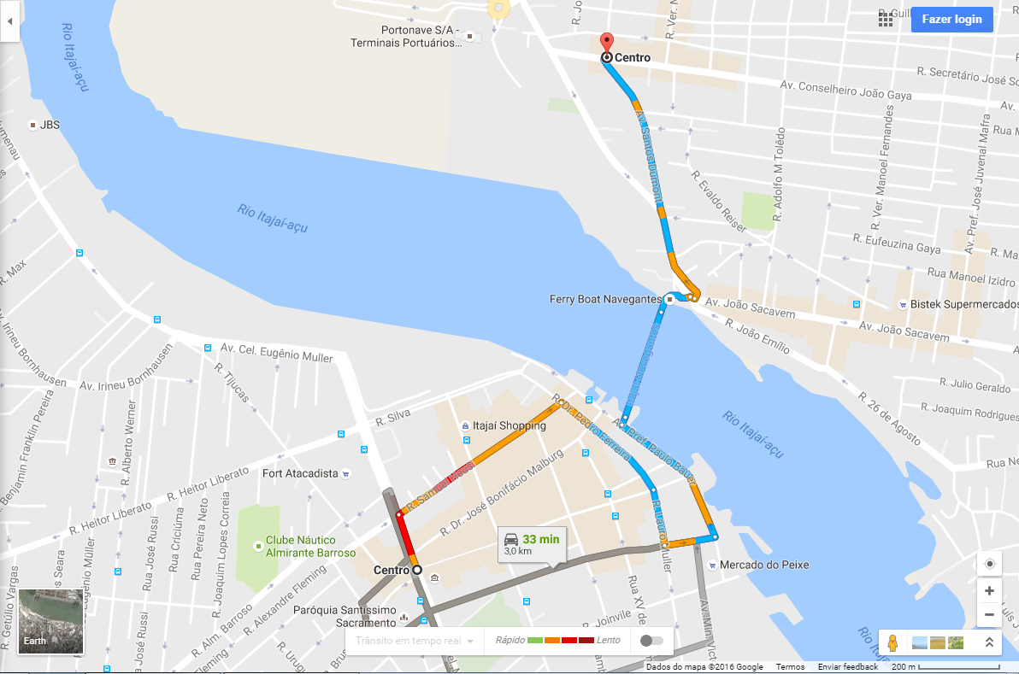

Fig. 2. Rota mais rápida gerada pelo googlemaps entre Navegantes e Itajaí

Comentario Aleatorio sobre a imagem.

Comentario Aleatório sobre imagem

Comentário Aleatório sobre imagem

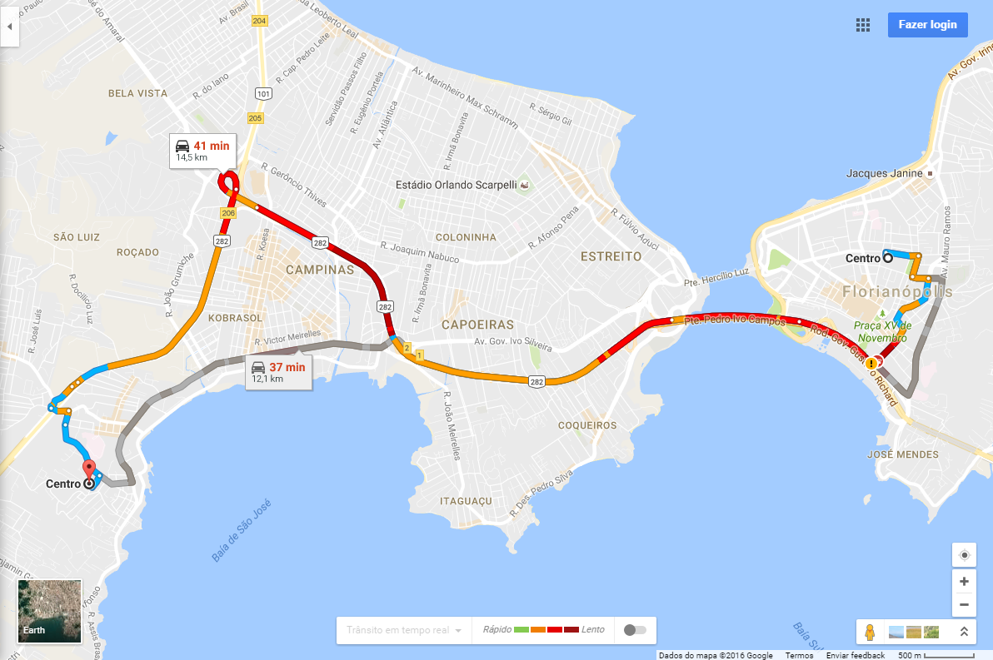

Fig. 5. Rota mais lenta gerada pelo googlemaps entre São José e Florianópolis

Comentário Aleatório sobre imagem

Comentário Aleatório sobre imagem

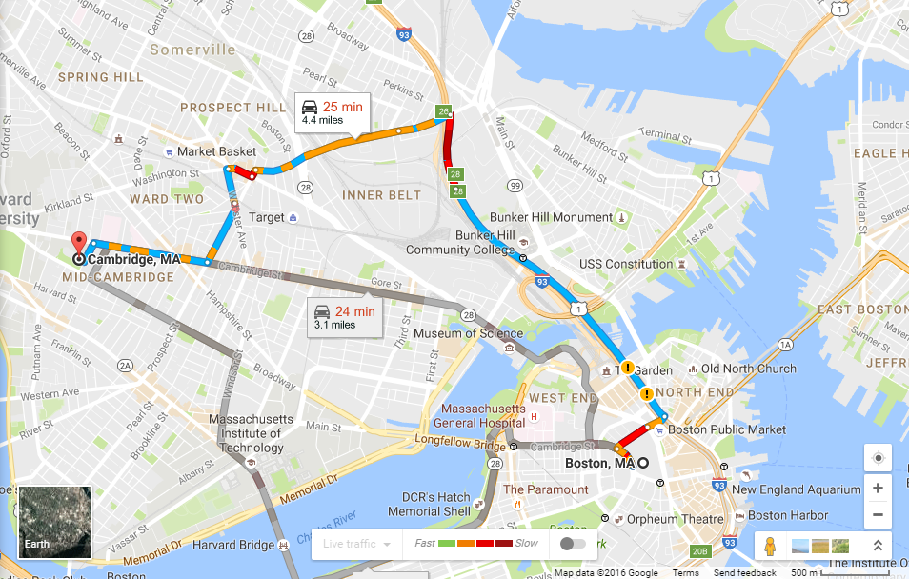

Fig. 7. Rota mais lenta gerada pelo googlemaps entre Cambridge e Boston

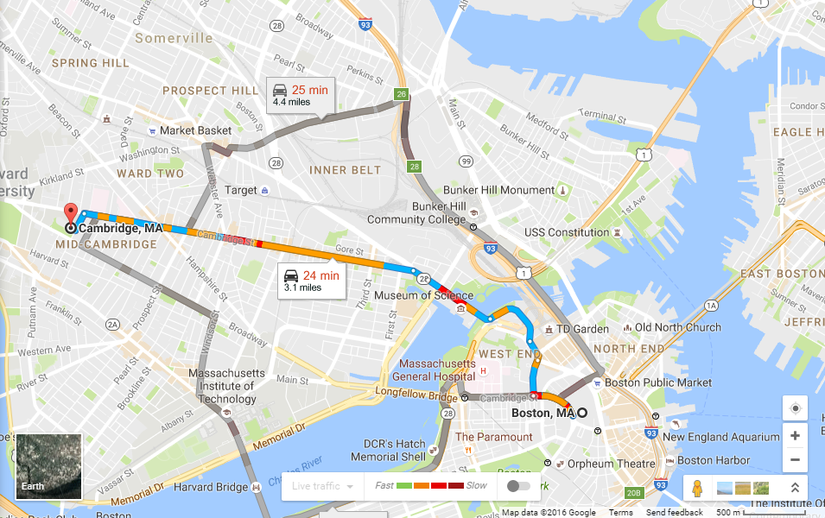

Fig. 6. Rota mais rápida gerada pelo googlemaps entre Cambridge e Boston

Comentário Aletório sobre imagem

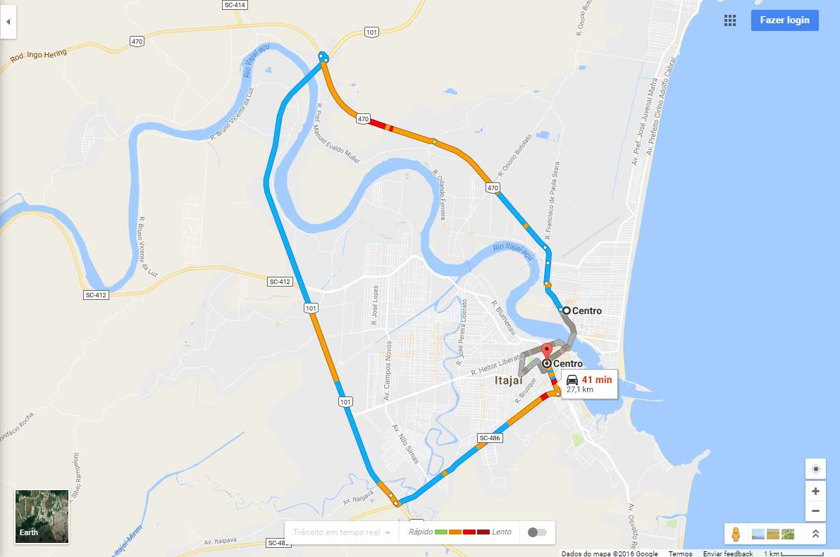

Fig. 3. Rota mais lenta gerada pelo googlemaps entre Navegantes e Itajaí

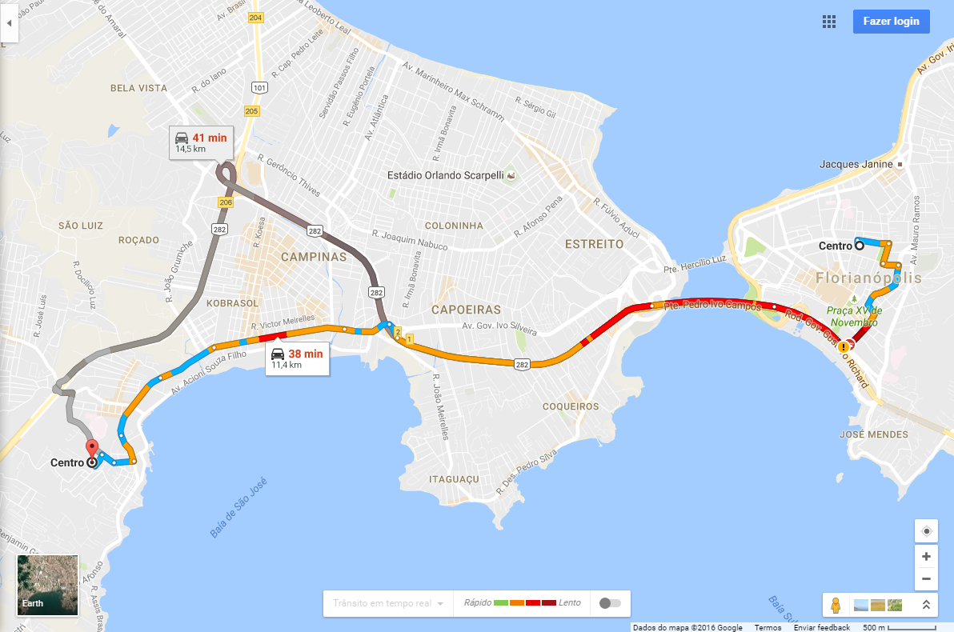

Fig. 4. Rota mais rápida gerada pelo googlemaps entre São José e Florianópolis

## Método de Seleção de Dados de Custo

Para o cálculo de gasto médio das vias, foi utilizado como base o carro mais vendido de 2016 segundo o site da revista quatro rodas. De acordo com a tal, este carro seria Chevrolet Onix.

Então para utilizamos em nossa simulação, o custo de um Chevrolet Onix 1.4 LT e LTZ, com câmbio automático de 6 velocidades. O custo de gasolina deste carro é de 11,7 km/l na cidade e 13,9 km/l na estrada, esses dados foram verificados no site da revista auto esporte.

O preço da gasolina foi utilizado de R$ 3,3 o litro, que é o preço atual da gasolina em Itajaí de acordo com o site preço dos combustíveis.

O preço da balsa em Itajaí foi considerado também, e é de 8,75 hoje dia 01/12/2016.

Os cálculos para descobrir os parâmetros de gasto, foram duas regras de três.

A primeira calcula quantos litros de gasolina foram gastados no trajeto e a segunda quanto custaria essa gasolina utilizada no trajeto.

**Consumo Itajaí – Navegantes por Ferry boat**

$$\frac{11,7 km }{2,45 km}= \frac{1 L}{0,21 L}$$

$$\frac{1 L }{0,21 L}= \frac{R\$ 3,30}{R\$ 0,70}$$

**Consumo Itajaí – Navegantes pela BR**

$$\frac{11,7 km }{27,1 km}= \frac{1 L}{2,32 L}$$

$$\frac{1 km}{2,32 km}= \frac{R\$ 3,30}{R\$ 7,66}$$

**Consumo São José – Florianópolis caminho lento**

$$\frac{11,7 km }{14,5 km}= \frac{1 L}{1,24 L}$$

$$\frac{1 km}{1,24 km}= \frac{R\$ 3,30}{R\$ 4,10}$$

**Consumo São José – Florianópolis caminho rápido**

$$\frac{11,7 km }{11, 4 km}= \frac{1 L}{0,97 L}$$

$$\frac{1 km}{0,97 km}= \frac{R\$ 3,30}{R\$ 3,20}$$

**Consumo Boston – Cambridge caminho lento**

$$\frac{11,7 km }{10,8 km}= \frac{1 L}{0,92 L}$$

$$\frac{1 km}{0,92 km}= \frac{R\$ 3,30}{R\$ 3,04}$$

**Consumo Boston – Cambridge caminho rápido**

$$\frac{11,7 km }{9,17 km}= \frac{1 L}{0,78 L}$$

$$\frac{1 km}{0,78 km}= \frac{R\$ 3,30}{R\$ 2,57}$$

Portando os dados finais de custo mais as tarifas de pedágio e/ou balsa das rotas entre as cidades escolhidas foram:

**Itajaí – Navegantes por Ferry boat:** 8,75+0,7 = R$ 9,45

**Itajaí – Navegantes pela BR:** R$ 7,66

**São José – Florianópolis caminho lento:** R$ 4,10

**São José – Florianópolis caminho rápido:** R$ 3,20

**Boston – Cambridge caminho lento:** R$ 2,01

**Boston – Cambridge caminho rápido:** R$ 1,42

# Resultados

Use either SI (MKS) or CGS as primary units. (SI units are strongly encouraged.) English units may be used as secondary units (in parentheses). This applies to papers in data storage**.** For example, write “15 Gb/cm2 (100 Gb/in2).” An exception is when English units are used as identifiers in trade, such as “3½-in disk drive.” Avoid combining SI and CGS units, such as current in amperes and magnetic field in oersteds. This often leads to confusion because equations do not balance dimensionally. If you must use mixed units, clearly state the units for each quantity in an equation.

The SI unit for magnetic field strength *H* is A/m. However, if you wish to use units of T, either refer to magnetic flux density *B* or magnetic field strength symbolized as µ0*H*. Use the center dot to separate compound units, e.g., “A·m2.”

# Some Common Mistakes

The word “data” is plural, not singular. The subscript for the permeability of vacuum µ0 is zero, not a lowercase letter “o.” The term for residual magnetization is “remanence”; the adjective is “remanent”; do not write “remnance” or “remnant.” Use the word “micrometer” instead of “micron.” A graph within a graph is an “inset,” not an “insert.” The word “alternatively” is preferred to the word “alternately” (unless you really mean something that alternates). Use the word “whereas” instead of “while” (unless you are referring to simultaneous events). Do not use the word “essentially” to mean “approximately” or “effectively.” Do not use the word “issue” as a euphemism for “problem.” When compositions are not specified, separate chemical symbols by en-dashes; for example, “NiMn” indicates the intermetallic compound Ni0.5Mn0.5 whereas “Ni–Mn” indicates an alloy of some composition NixMn1-x.

Be aware of the different meanings of the homophones “affect” (usually a verb) and “effect” (usually a noun), “complement” and “compliment,” “discreet” and “discrete,” “principal” (e.g., “principal investigator”) and “principle” (e.g., “principle of measurement”). Do not confuse “imply” and “infer.”

Prefixes such as “non,” “sub,” “micro,” “multi,” and “ultra” are not independent words; they should be joined to the words they modify, usually without a hyphen. There is no period after the “et” in the Latin abbreviation “*et al.*” (it is also italicized). The abbreviation “i.e.,” means “that is,” and the abbreviation “e.g.,” means “for example” (these abbreviations are not italicized).

A general IEEE styleguide is available at <http://www.ieee.org/web/publications/authors/transjnl/index.html>

TABLE I

Units for Magnetic Properties

|  |  |  |
| --- | --- | --- |
| Symbol | Quantity | Conversion from Gaussian and  CGS EMU to SI a |
| Φ | magnetic flux | 1 Mx → 10−8 Wb = 10−8 V·s |
| *B* | magnetic flux density,  magnetic induction | 1 G → 10−4 T = 10−4 Wb/m2 |
| *H* | magnetic field strength | 1 Oe → 103/(4π) A/m |
| *m* | magnetic moment | 1 erg/G = 1 emu  → 10−3 A·m2 = 10−3 J/T |
| *M* | magnetization | 1 erg/(G·cm3) = 1 emu/cm3  → 103 A/m |
| 4π*M* | magnetization | 1 G → 103/(4π) A/m |
| σ | specific magnetization | 1 erg/(G·g) = 1 emu/g → 1 A·m2/kg |
| *j* | magnetic dipole  moment | 1 erg/G = 1 emu  → 4π × 10−10 Wb·m |
| *J* | magnetic polarization | 1 erg/(G·cm3) = 1 emu/cm3  → 4π × 10−4 T |
| χ*,* κ | susceptibility | 1 → 4π |
| χρ | mass susceptibility | 1 cm3/g → 4π × 10−3 m3/kg |
| μ | permeability | 1 → 4π × 10−7 H/m  = 4π × 10−7 Wb/(A·m) |
| μr | relative permeability | μ → μr |
| *w, W* | energy density | 1 erg/cm3 → 10−1 J/m3 |
| *N, D* | demagnetizing factor | 1 → 1/(4π) |

Vertical lines are optional in tables. Statements that serve as captions for the entire table do not need footnote letters.

aGaussian units are the same as cg emu for magnetostatics; Mx = maxwell, G = gauss, Oe = oersted; Wb = weber, V = volt, s = second, T = tesla, m = meter, A = ampere, J = joule, kg = kilogram, H = henry.

# Guidelines for Graphics Preparation and Submission

## Types of Graphics

The following list outlines the different types of graphics published in IEEE journals. They are categorized based on their construction, and use of color / shades of gray:

### *Color/Grayscale figures*

### Figures that are meant to appear in color, or shades of black/gray. Such figures may include photographs, illustrations, multicolor graphs, and flowcharts.

### *Lineart figures*

### Figures that are composed of only black lines and shapes. These figures should have no shades or half-tones of gray. Only black and white.

### *Author photos*

### Head and shoulders shots of authors which appear at the end of our papers.

### *Tables* Data charts which are typically black and white, but sometimes include color.

## Multipart figures

Figures compiled of more than one sub-figure presented side-by-side, or stacked. If a multipart figure is made up of multiple figure types (one part is lineart, and another is grayscale or color) the figure should meet the stricter guidelines.

## File Formats For Graphics

Format and save your graphics using a suitable graphics processing program that will allow you to create the images as PostScript (PS), Encapsulated PostScript (.EPS), Tagged Image File Format (.TIFF), Portable Document Format (.PDF), or Portable Network Graphics (.PNG) sizes them, and adjusts the resolution settings. If you created your source files in one of the following programs you will be able to submit the graphics without converting to a PS, EPS, TIFF, PDF, or PNG file: Microsoft Word, Microsoft PowerPoint, or Microsoft Excel. Though it is not required, it is recommended that these files be saved in PDF format rather than DOC, XLS, or PPT. Doing so will protect your figures from common font and arrow stroke issues that occur when working on the files across multiple platforms. When submitting your final paper, your graphics should all be submitted individually in one of these formats along with the manuscript.

## Sizing of Graphics

Most charts, graphs, and tables are one column wide (3.5 inches / 88 millimeters / 21 picas) or page wide (7.16 inches / 181 millimeters / 43 picas). The maximum depth a graphic can be is 8.5 inches (216 millimeters / 54 picas). When choosing the depth of a graphic, please allow space for a caption. Figures can be sized between column and page widths if the author chooses, however it is recommended that figures are not sized less than column width unless when necessary.

There is currently one publication with column measurements that don’t coincide with those listed above. Proceedings of the IEEE has a column measurement of 3.25 inches (82.5 millimeters / 19.5 picas).

The final printed size of author photographs is exactly   
1 inch wide by 1.25 inches tall (25.4 millimeters x 31.75 millimeters / 6 picas x 7.5 picas). Author photos printed in editorials measure 1.59 inches wide by 2 inches tall (40 millimeters x 50 millimeters / 9.5 picas x 12 picas).

## Resolution

The proper resolution of your figures will depend on the type of figure it is as defined in the “Types of Figures” section. Author photographs, color, and grayscale figures should be at least 300dpi. Lineart, including tables should be a minimum of 600dpi.

## Vector Art

While IEEE does accept, and even recommends that authors submit artwork in vector format, it is our policy is to rasterize all figures for publication. This is done in order to preserve the figures’ integrity across multiple computer platforms.

## Color Space

The term color space refers to the entire sum of colors that can be represented within the said medium. For our purposes, the three main color spaces are Grayscale, RGB (red/green/blue) and CMYK (cyan/magenta/yellow/black). RGB is generally used with on-screen graphics, whereas CMYK is used for printing purposes.

All color figures should be generated in RGB or CMYK color space. Grayscale images should be submitted in Grayscale color space. Line art may be provided in grayscale OR bitmap colorspace. Note that “bitmap colorspace” and “bitmap file format” are not the same thing. When bitmap color space is selected, .TIF/.TIFF is the recommended file format.

## Accepted Fonts Within Figures

When preparing your graphics IEEE suggests that you use of one of the following Open Type fonts: Times New Roman, Helvetica, Arial, Cambria, and Symbol. If you are supplying EPS, PS, or PDF files all fonts must be embedded. Some fonts may only be native to your operating system; without the fonts embedded, parts of the graphic may be distorted or missing.

A safe option when finalizing your figures is to strip out the fonts before you save the files, creating “outline” type. This converts fonts to artwork what will appear uniformly on any screen.

## Using Labels Within Figures

### Figure Axis labels

Figure axis labels are often a source of confusion. Use words rather than symbols. As an example, write the quantity “Magnetization,” or “Magnetization *M*,” not just “*M*.” Put units in parentheses. Do not label axes only with units. As in Fig. 1, for example, write “Magnetization (A/m)” or “Magnetization (Am−1),” not just “A/m.” Do not label axes with a ratio of quantities and units. For example, write “Temperature (K),” not “Temperature/K.”

Multipliers can be especially confusing. Write “Magnetization (kA/m)” or “Magnetization (103 A/m).” Do not write “Magnetization (A/m) × 1000” because the reader would not know whether the top axis label in Fig. 1 meant 16000 A/m or 0.016 A/m. Figure labels should be legible, approximately 8 to 10 point type.

### Subfigure Labels in Multipart Figures and Tables

Multipart figures should be combined and labeled before final submission. Labels should appear centered below each subfigure in 8 point Times New Roman font in the format of (a) (b) (c).

## File Naming

Figures (line artwork or photographs) should be named starting with the first 5 letters of the author’s last name. The next characters in the filename should be the number that represents the sequential location of this image in your article. For example, in author “Anderson’s” paper, the first three figures would be named ander1.tif, ander2.tif, and ander3.ps.

Tables should contain only the body of the table (not the caption) and should be named similarly to figures, except that ‘.t’ is inserted in-between the author’s name and the table number. For example, author Anderson’s first three tables would be named ander.t1.tif, ander.t2.ps, ander.t3.eps.

Author photographs should be named using the first five characters of the pictured author’s last name. For example, four author photographs for a paper may be named: oppen.ps, moshc.tif, chen.eps, and duran.pdf.

If two authors or more have the same last name, their first initial(s) can be substituted for the fifth, fourth, third... letters of their surname until the degree where there is differentiation. For example, two authors Michael and Monica Oppenheimer’s photos would be named oppmi.tif, and oppmo.eps.

## Referencing a Figure or Table Within Your Paper

When referencing your figures and tables within your paper, use the abbreviation “Fig.” even at the beginning of a sentence. Do not abbreviate “Table.” Tables should be numbered with Roman Numerals.

## Checking Your Figures: The IEEE Graphics Checker

The IEEE Graphics Checker Tool enables authors to pre-screen their graphics for compliance with IEEE Transactions and Journals standards before submission. The online tool, located at <http://graphicsqc.ieee.org/>, allows authors to upload their graphics in order to check that each file is the correct file format, resolution, size and colorspace; that no fonts are missing or corrupt; that figures are not compiled in layers or have transparency, and that they are named according to the IEEE Transactions and Journals naming convention. At the end of this automated process, authors are provided with a detailed report on each graphic within the web applet, as well as by email.

For more information on using the Graphics Checker Tool   
or any other graphics related topic, contact the IEEE Graphics Help Desk by e-mail at [graphics@ieee.org](mailto:graphics@ieee.org).

## Submitting Your Graphics

Because IEEE will do the final formatting of your paper,   
you do not need to position figures and tables at the top and bottom of each column. In fact, all figures, figure captions, and tables can be placed at the end of your paper. In addition to, or even in lieu of submitting figures within your final manuscript, figures should be submitted individually, separate from the manuscript in one of the file formats listed above in section VI-J. Place figure captions below the figures; place table titles above the tables. Please do not include captions as part of the figures, or put them in “text boxes” linked to the figures. Also, do not place borders around the outside of your figures.

## Color Processing / Printing in IEEE Journals

All IEEE Transactions, Journals, and Letters allow an author to publish color figures on IEEE *Xplore*® at no charge, and automatically convert them to grayscale for print versions. In most journals, figures and tables may alternatively be printed in color if an author chooses to do so. Please note that this service comes at an extra expense to the author. If you intend to have print color graphics, include a note with your final paper indicating which figures or tables you would like to be handled that way, and stating that you are willing to pay the additional fee.

# Conclusion

## A conclusion section is not required. Although a conclusion may review the main points of the paper, do not replicate the abstract as the conclusion. A conclusion might elaborate on the importance of the work or suggest applications and extensions.

Appendix

Appendixes, if needed, appear before the acknowledgment.

Acknowledgment

The preferred spelling of the word “acknowledgment” in American English is without an “e” after the “g.” Use the singular heading even if you have many acknowledgments. Avoid expressions such as “One of us (S.B.A.) would like to thank ... .” Instead, write “F. A. Author thanks ... .” In most cases, sponsor and financial support acknowledgments are placed in the unnumbered footnote on the first page, not here.

References and Footnotes

## References

References need not be cited in text. When they are, number citations on the line, in square brackets inside the punctuation. Multiple references are each numbered with separate brackets. When citing a section in a book, please give the relevant page numbers. In text, refer simply to the reference number. Do not use “Ref.” or “reference” except at the beginning of a sentence: “Reference [3] shows ... .” Please do not use automatic endnotes in *Word*, rather, type the reference list at the end of the paper using the “References” style.

Reference numbers are set flush left and form a column of their own, hanging out beyond the body of the reference. The reference numbers are on the line, enclosed in square brackets. In all references, the given name of the author or editor is abbreviated to the initial only and precedes the last name. Use them all; use *et al*. only if names are not given. Use commas around Jr., Sr., and III in names. Abbreviate conference titles. When citing IEEE transactions, provide the issue number, page range, volume number, year, and/or month if available. When referencing a patent, provide the day and the month of issue, or application. References may not include all information; please obtain and include relevant information. Do not combine references. There must be only one reference with each number. If there is a URL included with the print reference, it can be included at the end of the reference.

Other than books, capitalize only the first word in a paper title, except for proper nouns and element symbols. For papers published in translation journals, please give the English citation first, followed by the original foreign-language citation See the end of this document for formats and examples of common references. For a complete discussion of references and their formats, see “The IEEE Style Manual,” available as a PDF link off the *Author Digital Toolbox* main page.

## Footnotes

Number footnotes separately in superscripts (Insert | Footnote).[2] Place the actual footnote at the bottom of the column in which it is cited; do not put footnotes in the reference list (endnotes). Use letters for table footnotes (see Table I).

# Submitting Your Paper for Review

## Review Stage Using Word 6.0 or Higher

If you want to submit your file with one column electronically, please do the following:

--First, click on the View menu and choose Print Layout.

--Second, place your cursor in the first paragraph. Go to the Format menu, choose Columns, choose one column Layout, and choose “apply to whole document” from the dropdown menu.

--Third, click and drag the right margin bar to just over 4 inches in width.

The graphics will stay in the “second” column, but you can drag them to the first column. Make the graphic wider to push out any text that may try to fill in next to the graphic.

## Final Stage Using Word 6.0

When you submit your final version (after your paper has been accepted), print it in two-column format, including figures and tables. You must also send your final manuscript on a disk, via e-mail, or through a Web manuscript submission system as directed by the society contact. You may use *Zip* for large files, or compress files using *Compress, Pkzip, Stuffit,* or *Gzip.*

Also, send a sheet of paper or PDF with complete contact information for all authors. Include full mailing addresses, telephone numbers, fax numbers, and e-mail addresses. This information will be used to send each author a complimentary copy of the journal in which the paper appears. In addition, designate one author as the “corresponding author.” This is the author to whom proofs of the paper will be sent. Proofs are sent to the corresponding author only.

## Review Stage Using ScholarOne® Manuscripts

Contributions to the Transactions, Journals, and Letters may be submitted electronically on IEEE’s on-line manuscript submission and peer-review system, ScholarOne® Manuscripts. You can get a listing of the publications that participate in ScholarOneat <http://www.ieee.org/publications_standards/publications/authors/authors_submission.html> First check if you have an existing account. If there is none, please create a new account. After logging in, go to your Author Center and click “Submit First Draft of a New Manuscript.”

Along with other information, you will be asked to select the subject from a pull-down list. Depending on the journal, there are various steps to the submission process; you must complete all steps for a complete submission. At the end of each step you must click “Save and Continue”; just uploading the paper is not sufficient. After the last step, you should see a confirmation that the submission is complete. You should also receive an e-mail confirmation. For inquiries regarding the submission of your paper on ScholarOne Manuscripts, please contact oprs-support@ieee.org or call +1 732 465 5861.

ScholarOne Manuscripts will accept files for review in various formats. Please check the guidelines of the specific journal for which you plan to submit.

You will be asked to file an electronic copyright form immediately upon completing the submission process (authors are responsible for obtaining any security clearances). Failure to submit the electronic copyright could result in publishing delays later. You will also have the opportunity to designate your article as “open access” if you agree to pay the IEEE open access fee.

## Final Stage Using ScholarOne Manuscripts

Upon acceptance, you will receive an email with specific instructions regarding the submission of your final files. To avoid any delays in publication, please be sure to follow these instructions. Most journals require that final submissions be uploaded through ScholarOne Manuscripts, although some may still accept final submissions via email. Final submissions should include source files of your accepted manuscript, high quality graphic files, and a formatted pdf file. If you have any questions regarding the final submission process, please contact the administrative contact for the journal.

In addition to this, upload a file with complete contact information for all authors. Include full mailing addresses, telephone numbers, fax numbers, and e-mail addresses. Designate the author who submitted the manuscript on ScholarOne Manuscripts as the “corresponding author.” This is the only author to whom proofs of the paper will be sent.

## Copyright Form

An IEEE copyright form should accompany your final submission. You can get a .pdf, .html, or .doc version at <http://www.ieee.org/copyright>*.* Authors are responsible for obtaining any security clearances.

# Editorial Policy

Submission of a manuscript is not required for participation in a conference. Do not submit a reworked version of a paper you have submitted or published elsewhere. Do not publish “preliminary” data or results. The submitting author is responsible for obtaining agreement of all coauthors and any consent required from sponsors before submitting a paper. The IEEE Transactions and Journals Department strongly discourages courtesy authorship. It is the obligation of the authors to cite relevant prior work.

The IEEE Transactions and Journals Department does not publish conference records or proceedings. The department does publish papers related to conferences that have been recommended for publication on the basis of peer review. As a matter of convenience and service to the technical community, these topical papers are typically collected and published in one special issue of mosttransactions publications.

At least two reviews are required for every paper submitted. For conference-related papers, the decision to accept or reject a paper is made by the conference editors and publications committee; the recommendations of the referees are advisory only. Indecipherable English is a valid reason for rejection. There is a service available that will help you improve your English for a fee, and the link to that service can be found at <http://www.ieee.org/web/publications/authors/transjnl/index.html>. Authors of rejected papers may revise and resubmit them as regular papers, whereupon they will be reviewed by two new referees.

# Publication Principles

The two types of contents of that are published are; 1) peer-reviewed and 2) archival. The Transactions and Journals Department publishes scholarly articles of archival value as well as tutorial expositions and critical reviews of classical subjects and topics of current interest.

Authors should consider the following points:

1. Technical papers submitted for publication must advance the state of knowledge and must cite relevant prior work.
2. The length of a submitted paper should be commensurate with the importance, or appropriate to the complexity, of the work. For example, an obvious extension of previously published work might not be appropriate for publication or might be adequately treated in just a few pages.
3. Authors must convince both peer reviewers and the editors of the scientific and technical merit of a paper; the standards of proof are higher when extraordinary or unexpected results are reported.
4. Because replication is required for scientific progress, papers submitted for publication must provide sufficient information to allow readers to perform similar experiments or calculations and use the reported results. Although not everything need be disclosed, a paper must contain new, useable, and fully described information. For example, a specimen’s chemical composition need not be reported if the main purpose of a paper is to introduce a new measurement technique. Authors should expect to be challenged by reviewers if the results are not supported by adequate data and critical details.
5. Papers that describe ongoing work or announce the latest technical achievement, which are suitable for presentation at a professional conference, may not be appropriate for publication.

References

*Basic format for books:*

1. J. K. Author, “Title of chapter in the book,” in *Title of His Published Book, x*th ed. City of Publisher, Country if not
2. USA: Abbrev. of Publisher, year, ch. *x*, sec. *x*, pp. *xxx–xxx.*

*Examples:*

1. G. O. Young, “Synthetic structure of industrial plastics,” in *Plastics,* 2nd ed., vol. 3, J. Peters, Ed. New York: McGraw-Hill, 1964, pp. 15–64.
2. W.-K. Chen, *Linear Networks and Systems.* Belmont, CA: Wadsworth, 1993, pp. 123–135.

*Basic format for periodicals:*

1. J. K. Author, “Name of paper,” *Abbrev. Title of Periodical*, vol. *x,* no. *x,* pp*. xxx-xxx,* Abbrev. Month, year.

*Examples:*

1. J. U. Duncombe, “Infrared navigation—Part I: An assessment   
   of feasibility,” *IEEE Trans. Electron Devices*, vol. ED-11, no. 1, pp. 34–39, Jan. 1959.
2. E. P. Wigner, “Theory of traveling-wave optical laser,” *Phys. Rev*.,   
   vol. 134, pp. A635–A646, Dec. 1965.
3. E. H. Miller, “A note on reflector arrays,” *IEEE Trans. Antennas Propagat*., to be published.

*Basic format for reports:*

1. J. K. Author, “Title of report,” Abbrev. Name of Co., City of Co., Abbrev. State, Rep. *xxx*, year.

*Examples:*

1. E. E. Reber, R. L. Michell, and C. J. Carter, “Oxygen absorption in the earth’s atmosphere,” Aerospace Corp., Los Angeles, CA, Tech. Rep. TR-0200 (4230-46)-3, Nov. 1988.
2. J. H. Davis and J. R. Cogdell, “Calibration program for the 16-foot antenna,” Elect. Eng. Res. Lab., Univ. Texas, Austin, Tech. Memo. NGL-006-69-3, Nov. 15, 1987.

*Basic format for handbooks:*

1. *Name of Manual/Handbook*, *x* ed., Abbrev. Name of Co., City of Co., Abbrev. State, year, pp. *xxx-xxx.*

*Examples:*

1. *Transmission Systems for Communications*, 3rd ed., Western Electric Co., Winston-Salem, NC, 1985, pp. 44–60.
2. *Motorola Semiconductor Data Manual*, Motorola Semiconductor Products Inc., Phoenix, AZ, 1989.

*Basic format for books (when available online):*

1. Author. (year, month day). *Title.* (edition) [Type of medium]. *volume (issue).* Available: site/path/file

*Example:*

1. J. Jones. (1991, May 10). *Networks.* (2nd ed.) [Online]. Available: [http://www.atm.com](http://www.atm.com/)

*Basic format for journals (when available online):*

1. Author. (year, month). Title. *Journal.* [Type of medium]. *volume (issue),* pages. Available: site/path/file

*Example:*

1. R. J. Vidmar. (1992, Aug.). On the use of atmospheric plasmas as electromagnetic reflectors. *IEEE Trans. Plasma Sci.* [Online]. *21(3),* pp. 876–880. Available:<http://www.halcyon.com/pub/journals/21ps03-vidmar>

*Basic format for papers presented at conferences (when available online):*

1. Author. (year, month). Title. Presented at Conference title. [Type of Medium]. Available: site/path/file

*Example:*

1. PROCESS Corp., MA. Intranets: Internet technologies deployed behind the firewall for corporate productivity. Presented at   
   INET96 Annual Meeting. [Online]. Available: <http://home.process.com/Intranets/wp2.htp>

*Basic format for reports and handbooks (when available online):*

1. Author. (year, month). Title. Comp an y . C ity, State or Country. [Type of Medium]. Available: site/path/file

*Example:*

1. S. L. Tall een. (1996 , Apr . ). The In t r an et Archi -tecture: M a nagi ng i n f o rm at i on i n t h e ne w paradigm. Amdahl Corp., CA. [Online]. Available:<http://www.amdahl.com/doc/products/bsg/intra/infra/html>

*Basic format for computer programs and electronic documents (when available online):* ISO recommends that capitalization follow the accepted practice for the language or script in which the information is given.

*Example:*

1. A. Harriman. (1993, June). Compendium of genealogical software. *Humanist.* [Online]. Available e-mail: [HUMANIST@NYVM.ORG](mailto:HUMANIST@NYVM.ORG) Message: get GENEALOGY REPORT

*Basic format for patents (when available online):*

1. Name of the invention, by inventor’s name. (year, month day). *Patent Number* [Type of medium]. Available: site/path/file

*Example:*

1. Musical toothbrush with adjustable neck and mirror, by L.M.R. Brooks. (1992, May 19). *Patent D 326 189*

[Online]. Available: NEXIS Library: LEXPAT File: DESIGN

*Basic format for conference proceedings (published):*

1. J. K. Author, “Title of paper,” in *Abbreviated Name of Conf.*, City of Conf., Abbrev. State (if given), year, pp. *xxxxxx.*

*Example:*

1. D. B. Payne and J. R. Stern, “Wavelength-switched pas- sively coupled single-mode optical network,” in *Proc. IOOC-ECOC,* 1985,   
   pp. 585–590.

*Example for papers presented at conferences (unpublished):*

1. D. Ebehard and E. Voges, “Digital single sideband detection for interferometric sensors,” presented at the 2nd Int. Conf. Optical Fiber Sensors, Stuttgart, Germany, Jan. 2-5, 1984.

*Basic format for patents:*

1. J. K. Author, “Title of patent,” U.S. Patent *x xxx xxx*, Abbrev. Month, day, year.

*Example:*

1. G. Brandli and M. Dick, “Alternating current fed power supply,”   
   U.S. Patent 4 084 217, Nov. 4, 1978.

*Basic format**for theses (M.S.) and dissertations (Ph.D.):*

1. J. K. Author, “Title of thesis,” M.S. thesis, Abbrev. Dept., Abbrev. Univ., City of Univ., Abbrev. State, year.
2. J. K. Author, “Title of dissertation,” Ph.D. dissertation, Abbrev. Dept., Abbrev. Univ., City of Univ., Abbrev. State, year.

*Examples:*

1. J. O. Williams, “Narrow-band analyzer,” Ph.D. dissertation, Dept. Elect. Eng., Harvard Univ., Cambridge, MA, 1993.
2. N. Kawasaki, “Parametric study of thermal and chemical nonequilibrium nozzle flow,” M.S. thesis, Dept. Electron. Eng., Osaka Univ., Osaka, Japan, 1993.

*Basic format for the most common types of unpublished references:*

1. J. K. Author, private communication, Abbrev. Month, year.
2. J. K. Author, “Title of paper,” unpublished.
3. J. K. Author, “Title of paper,” to be published.

*Examples:*

1. A. Harrison, private communication, May 1995.
2. B. Smith, “An approach to graphs of linear forms,” unpublished.
3. A. Brahms, “Representation error for real numbers in binary computer arithmetic,” IEEE Computer Group Repository, Paper R-67-85.

*Basic format for standards:*

1. *Title of Standard*, Standard number, date.

*Examples:*

1. IEEE Criteria for Class IE Electric Systems, IEEE Standard 308, 1969.
2. Letter Symbols for Quantities, ANSI Standard Y10.5-1968.

**First A. Author** (M’76–SM’81–F’87) and the other authors may include biographies at the end of regular papers. Biographies are often not included in conference-related papers. This author became a Member (M) of IEEE in 1976, a Senior Member (SM) in 1981, and a Fellow (F) in 1987. The first paragraph may contain a place and/or date of birth (list place, then date). Next, the author’s educational background is listed. The degrees should be listed with type of degree in what field, which institution, city, state, and country, and year the degree was earned. The author’s major field of study should be lower-cased.

The second paragraph uses the pronoun of the person (he or she) and not the author’s last name. It lists military and work experience, including summer and fellowship jobs. Job titles are capitalized. The current job must have a location; previous positions may be listed without one. Information concerning previous publications may be included. Try not to list more than three books or published articles. The format for listing publishers of a book within the biography is: title of book (city, state: publisher name, year) similar to a reference. Current and previous research interests end the paragraph.

The third paragraph begins with the author’s title and last name (e.g., Dr. Smith, Prof. Jones, Mr. Kajor, Ms. Hunter). List any memberships in professional societies other than the IEEE. Finally, list any awards and work for IEEE committees and publications. If a photograph is provided, the biography will be indented around it. The photograph is placed at the top left of the biography, and should be of good quality, professional-looking, and black and white (see above example). Personal hobbies will be deleted from the biography. Following are two examples of an author’s biography.

**Second B. Author** was born in Greenwich Village, New York City, in 1977. He received the B.S. and M.S. degrees in aerospace engineering from the University of Virginia, Charlottesville, in 2001 and the Ph.D. degree in mechanical engineering from Drexel University, Philadelphia, PA, in 2008.

From 2001 to 2004, he was a Research Assistant with the Princeton Plasma Physics Laboratory. Since 2009, he has been an Assistant Professor with the Mechanical Engineering Department, Texas A&M University, College Station. He is the author of three books, more than 150 articles, and more than 70 inventions. His research interests include high-pressure and high-density nonthermal plasma discharge processes and applications, microscale plasma discharges, discharges in liquids, spectroscopic diagnostics, plasma propulsion, and innovation plasma applications. He is an Associate Editor of the journal *Earth*, *Moon*, *Planets*, and holds two patents.

Mr. Author was a recipient of the International Association of Geomagnetism and Aeronomy Young Scientist Award for Excellence in 2008, the IEEE Electromagnetic Compatibility Society Best Symposium Paper Award in 2011, and the American Geophysical Union Outstanding Student Paper Award in Fall 2005.

**Third C. Author, Jr. (M’87)** received the B.S. degree in mechanical engineering from National Chung Cheng University, Chiayi, Taiwan, in 2004 and the M.S. degree in mechanical engineering from National Tsing Hua University, Hsinchu, Taiwan, in 2006. He is currently pursuing the Ph.D. degree in mechanical engineering at Texas A&M University, College Station.

From 2008 to 2009, he was a Research Assistant with the Institute of Physics, Academia Sinica, Tapei, Taiwan. His research interest includes the development of surface processing and biological/medical treatment techniques using nonthermal atmospheric pressure plasmas, fundamental study of plasma sources, and fabrication of micro- or nanostructured surfaces.

Mr. Author’s awards and honors include the Frew Fellowship (Australian Academy of Science), the I. I. Rabi Prize (APS), the European Frequency and Time Forum Award, the Carl Zeiss Research Award, the William F. Meggers Award and the Adolph Lomb Medal (OSA).

1.
2. It is recommended that footnotes be avoided (except for the unnumbered footnote with the receipt date on the first page). Instead, try to integrate the footnote information into the text.