# Assumption:

Due to time constraint I did not write test for boundary testing nor negative testing such as:

* Empty data
* Invalid data
* More than max character

I did not comment all the code parts

## Framework:

* Nunit: pen source framework designed for writing and running tests in Microsoft .NET programming languages
* Selenium: framework for it is for automating web applications
* Specflow: Behaviour-Driven Development unit testing
* Page object Model: Object Repository design pattern in Selenium WebDriver
* XML: Saving/Loading registered data
* Log4net: Logging mechanism saved in bin/debug/log

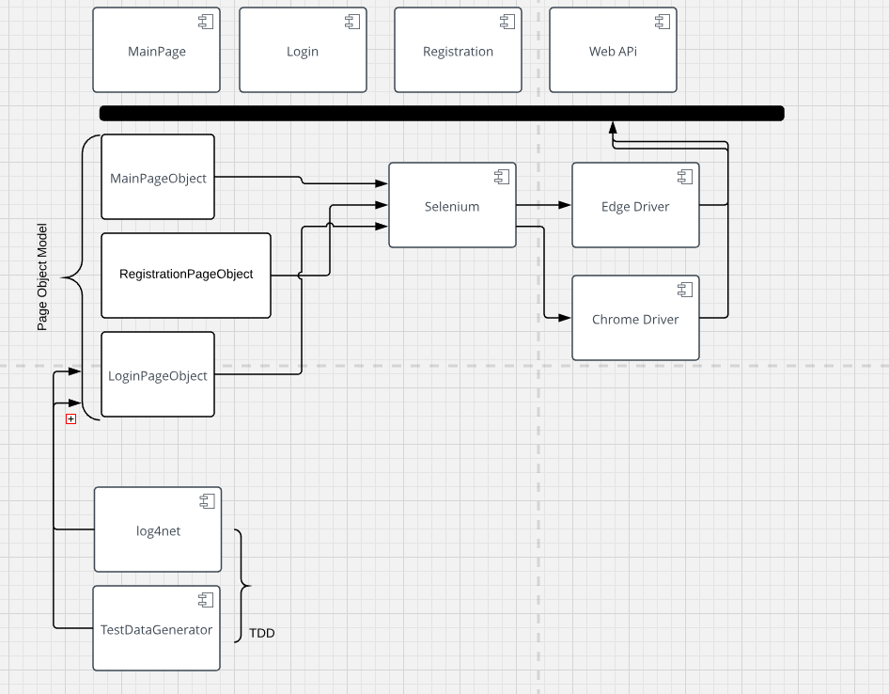

# Test Execution:

* Visual Studio Test Runner
* Resharper Runner
* AutomationTrial\AutomationTrial and run the bat file RunTests.bat