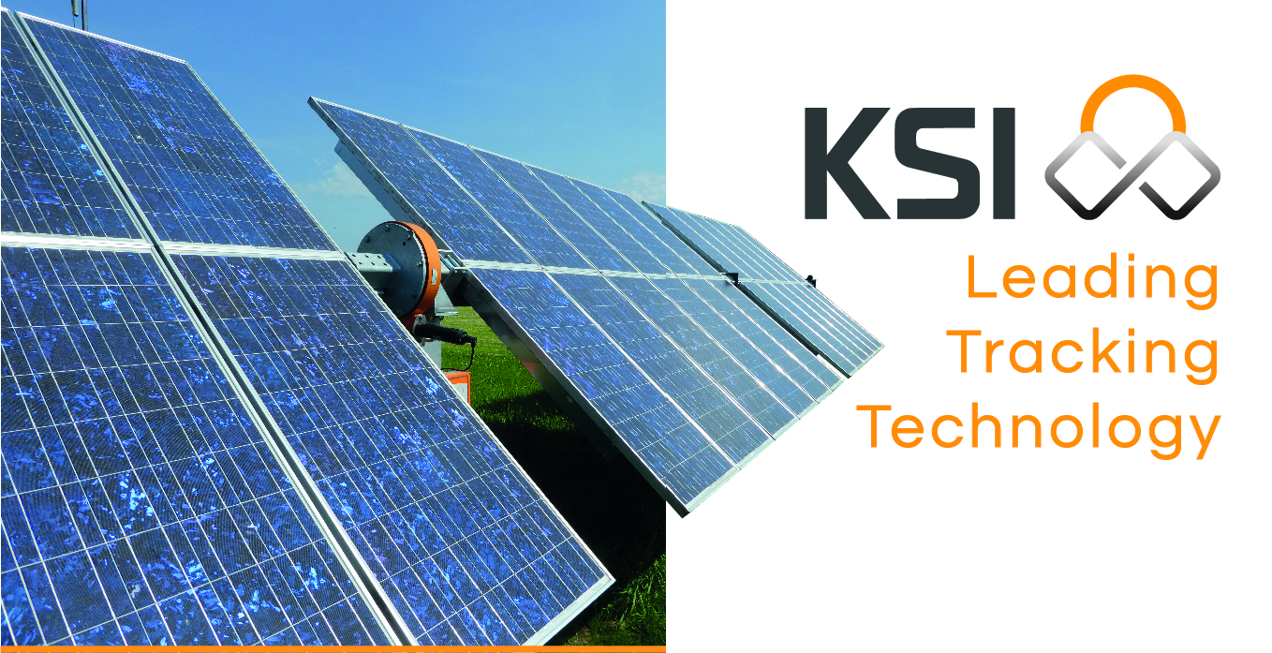
Quotation for
NAME COMPANY/CLIENT
Material for photovoltaic installation of XXXX MWp on Single-axis Tracker - Location

Dear MR/MRs
XXXXX XXXXXX
Address
Postal code - City
Country

Number/version:
XXXX-XXXX_ksi1.0
date: XX/XX/2026

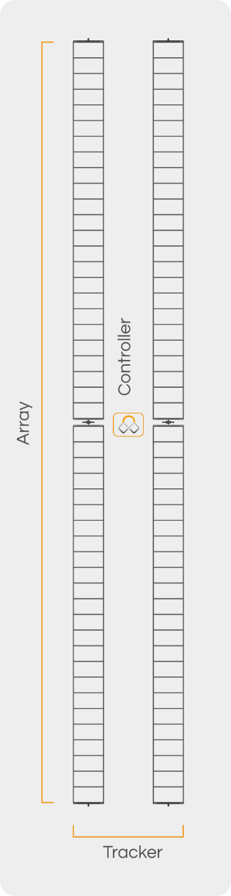
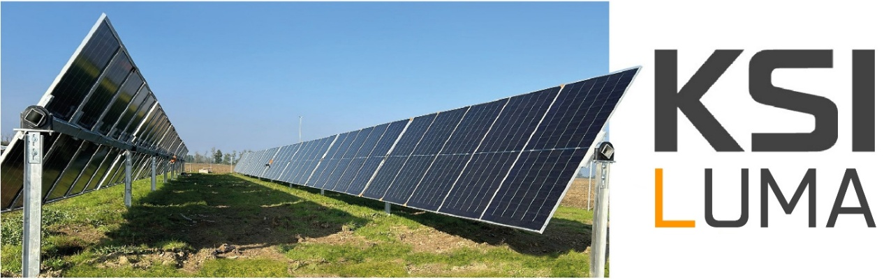

Our structure leverages our extensive experience with dual-axis tracking systems and, combined with the simplicity of the 0° azimuth tracker concept, provides the best solution in terms of energy yield and production while achieving the lowest possible CAPEX, without compromising the exceptionally high standards of robustness and quality. At the same time, it drastically reduces OPEX thanks to its outstanding reliability.
The system can accommodate up to 56 photovoltaic modules with a form factor exceeding one meter in width. The modules are driven as two arrays by a single SolTrk electronic controller. This unique KSI tracker design allows our structure to invert the module surface (optional) to prevent the accumulation of dirt, dust, snow, or other deposits on the glass overnight, or to position the modules perpendicular to the ground to facilitate maintenance operations.
The SolTrk electronic controller is one of the key factors behind the success of the VEON tracker. This robust and highly reliable control board has been continuously tested since the beginning of our tracker production, and today more than 26,000 units are operating worldwide. We now have a 20-year track record demonstrating that it performs flawlessly even under the most demanding operating conditions.

These are the reasons behind LUMA’s success and its exceptional reliability.
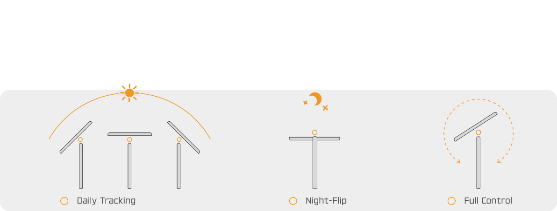
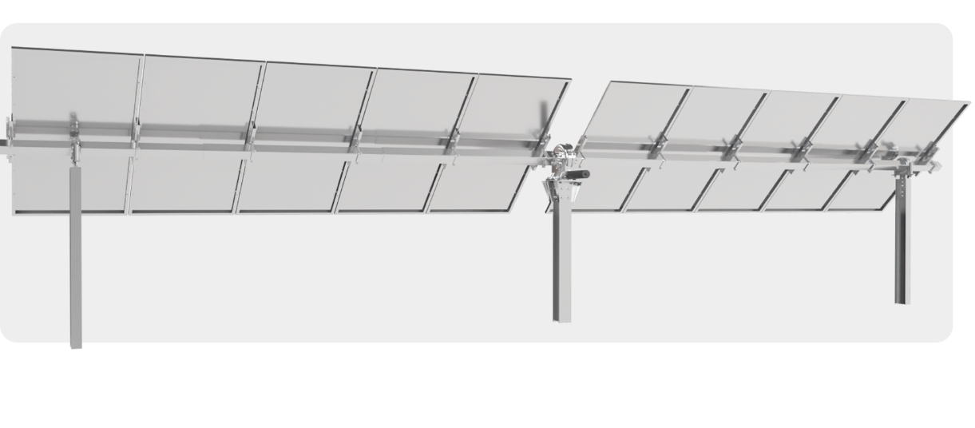
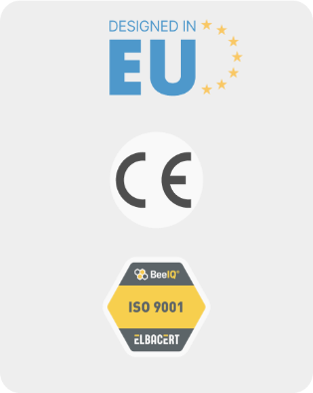
Offer

Item | Qty | Price €/kW | Total
KSI Single Axis Tracker VEON | kWp | XXX,00 € | 0,00 €
- Single-axis tracker
- Slew Drive with 24V DC motor
- Hot-deep Galvanized steel structure
- Electronic control Board Soltrk
Configuration
- N. of structures with XX panels: XX
- N. piles: XXXX
- Panels configurations
  - XXXX modules
  - Dimensions: XXXXxXXXX mm
  - Power: XXX Wp
- Length up to XX m
- Height with flat panels: 1,50 m
- Ramming depth: 1,50 m
- Max tracking tilt: 60°
- Ground clearance at 60°: 0,50 m
- Pitch distance: XX,XX m/as per project
Safeguard | X | 2.500,00 € | 0,00 €
- 48V DC power and safety panel
- Battery back-up system
- wind control unit
- Back-up battery monitoring
- master and slave system
KSI Monitoring System by Higeco | X | 1,800,00 € | 0,00 €
- Complete control and Management of the tracker
- Datalogger GWC 4DIN
- dedicated access to KSI_{by Higeco} portal
Engineering services | 1 | 3.500,00 € | 0,00 €
- Preparation of document for filing with the Local Authorities such as:
  - Maintenance Plan
  - Structural report
  - Geotechnical report with calculation of the driving depth
  - Materials Report
Commissioning and testing | 1 | XXXX,00 € | 0,00 €
- Soltrk boards detection and programming
- Motion control and start-up
- Functional testing
- Spot check of correct installation of trackers
- N. 1 technician for XX working days for the operations described above
TOTAL |  |  | 0,00 €
Prices in EURO – VAT not included

Supplements
Item |  | Total
Piles | Price per MWp | 550,00 €
- Increase in length of driving piles to be established after structural calculation
- Price for every 10 cm added to the expected foundation depth of 1.90 m
- Payment with dedicated invoice
Manworks | Prezzo per day
- Assistance from KSI Solar staff during installation |  | 500,00 €
- KSI Solar technical staff after the days foreseen for commissioning have elapsed if it cannot be carried out regularly for reasons not related to or under the responsibility of KSI Solar |  | 600,00 €
- Food and lodging reimbursement excluded
Prices in EURO – VAT not included

Terms and Conditions
- Payment Terms
Payments
At order – Contract Signature | 35%
Notification of foundation piles ready | 30%
Notification of steel structure ready | 30%
Notification of electromechanical components ready (Slew Drives, Bearings, Soltrk, Safeguard) | 5%

- Payments:
  - At order – Contract Signature: bank transfer to the details on the issued invoice, against invoice;
  - Rest of payments: Payment of the fees due under this contract will be made by electronic bank receipt (Ri.Ba.), issued by the Supplier on the due dates indicated in the relevant invoices;
- o The Customer undertakes to:
  - Provide in advance all the banking information required to issue the Ri.Ba.;
  - Maintain the indicated current account active for the entire duration of the contractual relationship;
  - Ensure the availability of funds at the respective due dates.
- The invoice will be issued in electronic format, in compliance with current legislation, and sent to SDI or PEC;
- The buyer has the right to dispute the invoice issued within 3 days of receipt; if no disputes are raised, the invoice will be considered accepted;
- Delivery time: up to 20 weeks
- Delivery terms begin only upon complete definition and approval of the technical solution, receipt of the initial payment due, and provision by the Customer of all necessary information, approvals, authorizations, documents, areas, and operating conditions.
- The technical solution must be validated in writing by the Parties. Delivery or performance terms will begin from the date of complete definition of the technical solution, receipt of the first payment due, and receipt of all information, approvals, authorizations, and documents required by the Customer.
- KSI Solar shall not be held liable or subject to any penalties for delays in the delivery of materials, execution of work, or completion of construction activities if such delays are directly or indirectly caused by actions, omissions, delays, breaches, or other circumstances attributable to the Client, its agents, or third parties designated by the Client, as well as by force majeure events or events beyond the Contractor's reasonable control, such as, but not limited to, exceptional weather events, natural disasters, strikes, supply disruptions, unavailability of materials, government measures, health emergencies, wars, riots, or other extraordinary events. In such cases, the contractual performance deadlines will be automatically extended for a period corresponding to the delay actually suffered and the related organizational and production effects, without this entailing any right of the Client to the application of penalties, termination of the contract for delay, or claims for compensation against the Contractor.
- Incoterms: DAP on site;
- No shipment or delivery will be released unless full payment has been received by the Supplier.
- Payments will be deemed due upon notification of readiness for delivery, regardless of the customer's availability to receive the goods;
- This offer is valid for 7 days from the cover date;
- Due to global market volatility and circumstances beyond its control, KSI reserves the right to adjust quoted prices if, during the offer's validity period, there are significant and unforeseeable increases in raw material, supply chain, and/or transportation costs.
- This offer is deemed to be formulated with reference to the general supply conditions and general service provision conditions set forth in the attached KSI Solar General Terms and Conditions. The supply and related services always constitute separate and independent contracts.

- Exclusions:

- Geological and geotechnical report to be provided by the customer;
- Pull-out test;
- All DC and AC cables and wiring, excluding motor cables from the motor to the electronics/junction box;
- Signal and communication cables;
- Annual monitoring system fees;
- Hardware for securing the modules to the structure;
- Engineering services, in addition to those described and included in this quote;
- On-site labour, excluding the operations listed in the Commissioning and Testing section;
- On-site unloading costs and operations;
- Anything not expressly included in the quote.

- Retention of Title
- Notwithstanding the delivery of the Materials and the transfer of the risk relating thereto to the Customer, the legal and beneficial title to all materials, equipment, goods, documentation, software, deliverables, and any other items supplied by KSI Solar under this Agreement (collectively, the “Materials”) shall remain vested in KSI Solar until KSI Solar has received full and effective payment of all amounts due under this Agreement, including any applicable interest, costs, expenses, charges, or fees.
- Until title to the Materials has passed to the Customer:
  - the Customer shall hold the Materials as a fiduciary bailee on behalf of KSI Solar;
  - the Customer shall keep the Materials separate from its own property and from the property of any third party, in such a manner as to ensure that they are readily identifiable as the property of KSI Solar;
  - the Customer shall not sell, transfer, assign, pledge, encumber, or otherwise dispose of the Materials without the prior written consent of KSI Solar;
  - KSI Solar shall be entitled, without prejudice to any other right or remedy available under applicable law or this Agreement, to enter the Customer's premises or the premises of any third party where the Materials are stored, for the purpose of inspecting, repossessing, or recovering the Materials if payment has become overdue or the Customer is in breach of this Agreement;
  - the Customer shall maintain adequate insurance covering the Materials against loss or damage for their full replacement value until title has passed to the Customer.
- For the avoidance of doubt, title to the Materials shall pass to the Customer only upon KSI Solar's receipt of full and final payment of all sums due under this Agreement.

- Terms and Conditions of Supply

- Technical Specifications: the supply shall conform to the technical specifications set out in this document. Any modifications requested by the Customer shall be subject to KSI Solar's review and approval and may result in adjustments to the price and/or delivery schedule.
- Packaging: The Materials shall be supplied in standard packaging suitable for the most appropriate mode of transportation, whether by road and/or by sea.
- Transportation and Shipment: KSI Solar shall coordinate the logistics necessary for the proper delivery of the Materials covered by this offer but shall not be liable for any delays, damage, or loss attributable to the carrier.
- Technical Support: Remote technical support shall be provided at no additional cost for the purpose of defining the final technical solution. On-site technical assistance shall be quoted separately, where applicable and requested, if it falls outside the scope of KSI Solar's responsibilities under this offer.
- Technical Support: Remote technical support shall be provided at no additional cost for the purpose of defining the final technical solution. On-site technical assistance shall be quoted separately, where applicable and requested, if it falls outside the scope of KSI Solar's responsibilities under this offer.
- Exclusions from the Supply: Unless expressly stated otherwise in this document, any material, component, accessory, work, service, or performance shall be deemed excluded from this offer. No supply or activity not expressly described herein shall be considered included, even if necessary for the completion of the works or for the use of the supplied products. Any additional requests made by the Customer shall be subject to KSI Solar's specific approval and to a separate commercial quotation.

- Regulatory Changes and Associated Costs
- The prices set out in this offer have been calculated based on the laws, regulations, customs duties, taxes, levies, and environmental or import charges in force in Italy and the European Union as of the date of this proposal.
- Should, after such date, any new law, regulation, ordinance, administrative directive, or amendment to existing legislation come into force—including, without limitation, the introduction or modification of customs duties, tariffs, environmental levies, carbon taxes, energy taxes, or any other charges imposed by governmental or supranational authorities—and such change directly or indirectly results in an increase in the Supplier's costs of procurement, manufacturing, importation, or delivery of the Materials (including, without limitation, steel or other raw materials), the Supplier shall be entitled to revise the Contract Price accordingly.
- In such circumstances, KSI Solar shall notify the Customer in writing, providing adequate supporting documentation evidencing the economic impact, and the corresponding adjustment shall be deemed automatically incorporated into the terms and conditions of payment of this offer. Any delays or suspension in the performance of the order resulting from such regulatory changes shall not constitute a breach of contract or default by KSI Solar.

- Proportional Accrual of Payments

- The Parties agree that the portions of the Contract Price associated with specific stages of production, availability, delivery, or Supply shall accrue proportionally to the quantity of Materials actually produced, made available, delivered, or otherwise attributable to the relevant stage, even if the entire Supply contemplated for such stage has not been fully completed or delivered.
- Where an instalment payment is conditional upon the delivery or availability of a specific category of goods or components, the Supplier shall be entitled to issue an invoice and request payment of the portion corresponding to the percentage of Materials actually delivered or made available in relation to the total quantity envisaged.
- The determination of the accrued percentage shall be made by the Supplier based on transport documents, delivery reports, notices of goods ready for collection or shipment, logistics documentation, production records, or other equivalent documentation.
- Any objections shall be submitted in writing, with specific grounds and supporting reasons, within three (3) Business Days of receipt of the relevant invoice or supporting documentation. Upon expiry of such period, the percentage communicated by the Supplier shall be deemed final and accepted.
- Payment of accrued amounts shall not be suspended, delayed, or made conditional upon completion of the remaining portion of the Supply, subsequent batches, or any other project activities.

- Late Payment and Suspension of the Supply

- In the event of late payment, including the late payment of a single instalment, the Customer shall pay the Supplier statutory default interest, together with recovery costs, expenses, banking charges, and any other amounts due.
- If payment is delayed by more than five (5) Business Days, the Supplier shall be entitled to suspend production, deliveries, shipment, the delivery of documentation, and any further performance until all outstanding amounts have been paid in full, without such suspension constituting a breach by the Supplier.
- If payment is delayed by more than twenty (20) Business Days, the Supplier shall be entitled to withdraw from and/or terminate the Agreement for the Customer's default, without prejudice to its right to receive payment of all accrued amounts and to recover any damages suffered.
- The contractual delivery schedule shall automatically be extended by a period corresponding to the duration of the payment delay and to the resulting organizational, production, and logistical consequences.

- Liquidated Damages for Delay in Delivery

- The Parties agree to a grace period of fifteen (15) Business Days, during which no liquidated damages shall be payable in respect of any delay in delivery.
- Should any delay exclusively attributable to the Supplier exceed such grace period, the Customer shall be entitled to liquidated damages equal to 0.1% (zero-point one percent) of the Contract Price for each Business Day of delay, calculated from the scheduled delivery date, net of any extensions, suspensions, or causes not attributable to the Supplier.
- Liquidated damages shall apply solely to delays directly attributable to the Supplier and shall not be payable in respect of delays resulting from force majeure, causes beyond the Supplier's reasonable control, delays attributable to the Customer or its representatives, or the Customer's failure to perform its obligations.
- Under no circumstances shall the aggregate amount of liquidated damages exceed 5% (five percent) of the Contract Price.
- The payment of liquidated damages shall constitute the Customer's sole and exclusive remedy for delay, to the exclusion of any claim for direct, indirect, consequential, or special damages, including, without limitation, loss of production, loss of profit, plant downtime, or any other claim for compensation, except in cases of the Supplier's wilful misconduct or gross negligence.

- Signatures

Client’s signature for acceptance | Data: _______________
_______________________________________

KSI Solar’s signature for acknowledgement and confirmation | Data: _______________
The Legal Representative

_______________________________________

- Attachments

- General layout –XXXXXXX;
- General Terms and Conditions – KSI Solar General Terms and Conditions;
- Product/s Datasheet/s.

The structure is designed for two angular positions: horizontal and maximum inclination. The horizontal position is calculated based on the loads established in the Eurocode 1991; the maximum inclination position is calculated with a wind load of 250N/m².
Delivery times may be subject to change due to uncertainty regarding maritime transport caused by recent international events.
By signing this Offer, the Customer agrees to the terms and conditions listed above and the Terms and Conditions listed in the attached document KSI Solar General Terms and Conditions.

