In The Name Of God

Cost Function: F1(x) = |x| + Cos(x)

First Name: Behzad

Last Name: Khosravifar

Email: Behzad.khosravifar@gmail.com

Delivery Date: 2009

Flow Chart

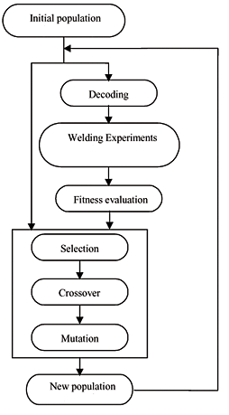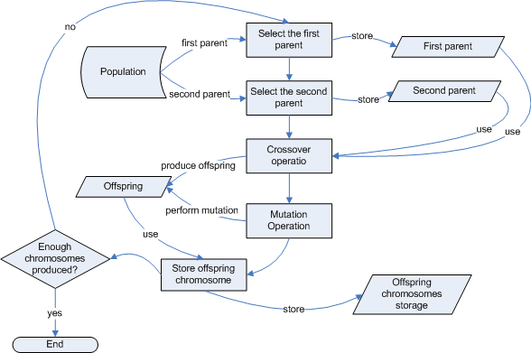

In function F1 :

**(Theory)**

Best fitness = 1

Best Elite Chromosome Value = 0

(**Objectivity)**

Best fitness = 1.1019984

Best Elite Chromosome Value = 0.102

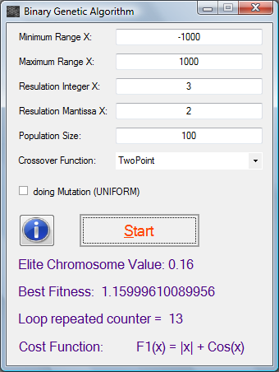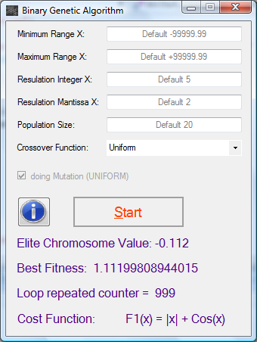 BGA with Mutation (Uniform) BGA without Mutation (Two Point)

**Program Name: Binary Genetic Algorithm**

**Assembly Version: 2.0.0.0**

**Creation Date: 10 dec (12) 2009**

**Creator Name: Mr. Behzad Khosravifar**

**Platform: Windows Application**

**Target Framework Version: .Net Frame worker 3.5**

**Programmer Language: C#.net 3.5**