**Figure 1: Behavioral performance in an orientation change detection task is related to the alignment of the representation of the orientation in V4 with the axis of correlated variability.**

**A.** Schematic of the change detection task in which two gratings of the same orientation are flashed repeatedly, and monkeys must report the location of the orientation change by making a saccade to that location. (AMY REFS XX) The starting orientations of the two gratings varied between 0° and 180°, but the change amount was constant across all starting orientations. We analyzed trials in which the change occurred at the cued location. The population receptive fields of V4 neurons overlapped with the cued location.

**B.** We defined the *axis of correlated variability* as the linear combination of neural responses that explained the most variability during the gray screen period preceding the first stimulus flash, or the first principal component of baseline spontaneous activity. This is depicted in this schematic with the gray dots (baseline responses) and the axes at the bottom. The black dots represent the V4 responses evoked by the various oriented gratings. According to our central hypothesis, the monkey’s behavioral performance on the orientation change that most aligns with the axis of correlated variability (orange arrow) will be better than on the least aligned orientation change (green arrow).

**C.** Validation of the hypothesis in B. The average behavioral performance (hits/total trials) for the most aligned orientation change is greater than that of the least aligned orientation change (STATS XX). Each dot represents one experimental session (n=XX). The marginal histograms are shown at the top and right. Mean behavioral performance is indicated by the red plus marker and the red dashed lines.

**Figure 2. Alignment of stimulus information with the axis of correlated variability makes the “noise axis’’ the optimal read-out direction.**

**A.** Recurrently connected network with rank-one feed-forward weights (blue), recurrent weights (grey), and linear read-out weights (orange). A stimulus enters through (; independent private noise is injected at each neuron and is shaped only by .

**B.** In a generic rank-one network the *stimulus axis* (blue arrow) can lie at an arbitrary angle to the principal component of baseline activity (PC1, grey dots). However, theory and data show that learning tunes the recurrent weights ​so that their slowest dynamical mode aligns with the feed-forward drive conveyed by (Chadwick et al., 2023). After this tuning, stimulus-evoked activity rotates onto PC1, making the *noise axis* and *coding axis* one and the same.

**C.** Once this alignment is achieved, fluctuations along PC1 decay much more slowly than along any orthogonal mode: power on the slow mode (black curve) persists, whereas power on PC2 (light grey) vanishes rapidly. Assigning the task-relevant input to the slowest decaying eigen-direction enables the circuit to integrate information over time, providing a normative rationale for the recurrent tuning described in B.

**D.** We examine a linear read-out whose axis (orange) forms an angle with the recurrent / noise axis (blue).

**E.** Normalized signal (blue) and noise (grey) variances delivered to the read-out as a function of . Signal power decreases more steeply than noise variance as the read-out is rotated away from the noise axis.

**F.** Fisher discriminability peaks at demonstrating that, once stimulus and noise axes are aligned by tuning, the optimal linear decoder is to read out along the noise axis.

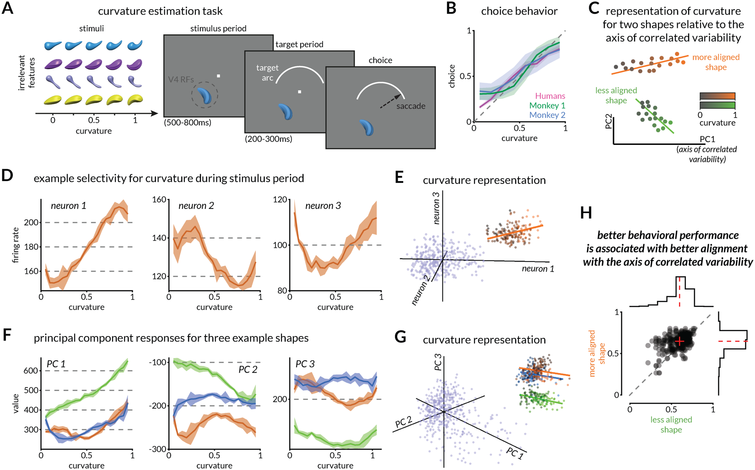

**Figure 3: Behavioral performance in a curvature estimation task is related to the alignment of the representation of curvature in V4 with the axis of correlated variability.**

**A.** Schematic of the continuous curvature estimation task in which monkeys reported their estimate of the medial axis curvature of the displayed random 3D shape while ignoring all other shape features like color, orientation, thickness profile, etc. (FLEXIGAIN REF XX). After the stimulus was shown in the joint receptive fields of V4 neurons, the target arc was displayed in the upper hemifield. Monkeys were rewarded for making a saccade to a location on the arc such that the left end of the arc corresponded to straight stimuli (curvature=0) and the right end to curved stimuli (curvature=1). Monkeys were rewarded in inverse proportion to the error in curvature estimation.

**B.** Behavioral responses (saccades on the target arc, normalized to 0-1 curvature values) of two monkeys (green and blue) are shown, averaged across various shape, color, and orientation variants. The shaded portion shows the standard deviation. In an independent experiment, humans were asked to select the curvature of the same shape stimuli using a slider (pink) and performed comparably to the two monkeys (STATS XX).

**C.** According to our central hypothesis, the average behavioral performance for a shape with a curvature representation that aligns with the axis of correlated variability is better than one that does not.

**D.** An example set of curvature sensitivities (or “tuning” XX) for three neurons for one shape. The shaded region depicts the standard error of the mean of firing rates.

**E.** The curvature responses of neurons in D relative to each other (black to orange dots are curvature responses to low to high curvatures) and relative to their respective baseline responses (blue dots).

**F.** An example set of curvature sensitivities (or “tuning” XX) for the first three principal components for three shapes (orange, green, and blue). The shaded region represents the standard error of the mean of the eigenvalues for each component.

**G**. As in E, the eigenvalues of each of the three PCs in F are plotted relative to each other (black to color dots are values for low to high curvatures for each of the three shapes). Baseline responses are shown in blue.

**H.** Validation of the hypothesis in C. Each dot represents the behavioral performance (1-average error across curvatures) for a pair of shapes tested during an experimental session. The shape that happened to be better aligned to the axis of correlated variability had better behavioral performance than the other (STATS XX). Conventions as in Figure 1C.

**Figure 4: Axis of correlated variability aligns with pre-motor related signals in V4.**

**A.** In a subset of sessions, the length and angular position of the target arc were varied across trials.

**B.** Across arc conditions, monkeys reconfigured their mapping between stimulus curvature and saccade direction. Mean choice behavior across three arc conditions (dotted arc condition is the same across the two panels for comparison). Left: across two conditions with shared mapping for lower curvatures (-70°) but different mapping for higher curvatures (+70° vs +30°), we observe a diverging pattern for both monkeys. Right: across two conditions with the same arc length (100°) but different angular positions (midpoint at 0° vs -20°), we observe a vertical offset for both monkeys (XX shapes for monkey 1, XX shapes for monkey 2).

**C.** After the onset of the arc during the trial, the planned saccade direction is the most pertinent information. According to our central hypothesis, if the V4 neural population response is modulated by the arc such that it can signal the saccade direction (FLEXIGAIN REF XX), then the axis that predicts the saccade would be better aligned with the axis of correlated variability.

**D.** Validation of the prediction in C: the saccade decoding axis is better aligned with the axis of correlated variability compared to the curvature axis. The projection of V4 responses on the axis of correlated variability (green dashed) is not predictive of the actual curvature compared to the linear combination of neural responses that best predicts the actual curvature (curvature axis; green). Instead, those projections are more predictive of the planned saccade direction (orange dashed), though not as well as the linear combination of responses that best predicts the saccade direction (saccade axis; orange). STATS XX N shapes/sessions.

**E.** Data split per session underscores the test in D. The difference in curvature prediction accuracy between the curvature axis and the axis of correlated variability (y-axis) is much larger than the difference in the saccade prediction accuracy between the saccade axis and the axis of correlated variability (x-axis). STATS XX N shapes/sessions

**Figure 5: The axis of correlated variability aligns with the visual feature that is relevant for behavior.**

**A.** Schematic of a two-alternative forced choice task in which monkeys make either curvature-based or color-based choices (FLEXIGAIN REF). If the two stimuli have the same color, then the monkeys are rewarded if they make a saccade to the more circular shape. If the two stimuli have the same shape, then the monkeys are rewarded if they make a saccade to the bluer stimulus. One of the stimuli is presented in the joint receptive fields of V4 neurons.

**B.** Pairs of stimuli are selected from either the same row (curvature axis) or the same column (color axis).

**C.** According to our central hypothesis, since the curvature of the stimulus is more pertinent when the monkey needs to make a curvature-based choice, the curvature axis in V4 will be more aligned with the axis of correlated variability.

**D.** Both monkeys make feature-based choices (XX sessions; XX trials on average).

**E.** Validation of the hypothesis in C. During trials when the monkey makes curvature-based choices, the projection of neural responses onto the axis of correlated variability predicts the curvature of the stimulus more accurately compared to trials when the monkey makes color-based choices (STATS XX). Each dot corresponds to a session (XX for monkey 1, XX for monkey 2) and represents the correlation between the actual stimulus curvature and the projection of V4 responses onto the axis of correlated variability, averaged across trials when the monkey makes curvature-based choices (x-axis) versus color-based choices (y-axis).

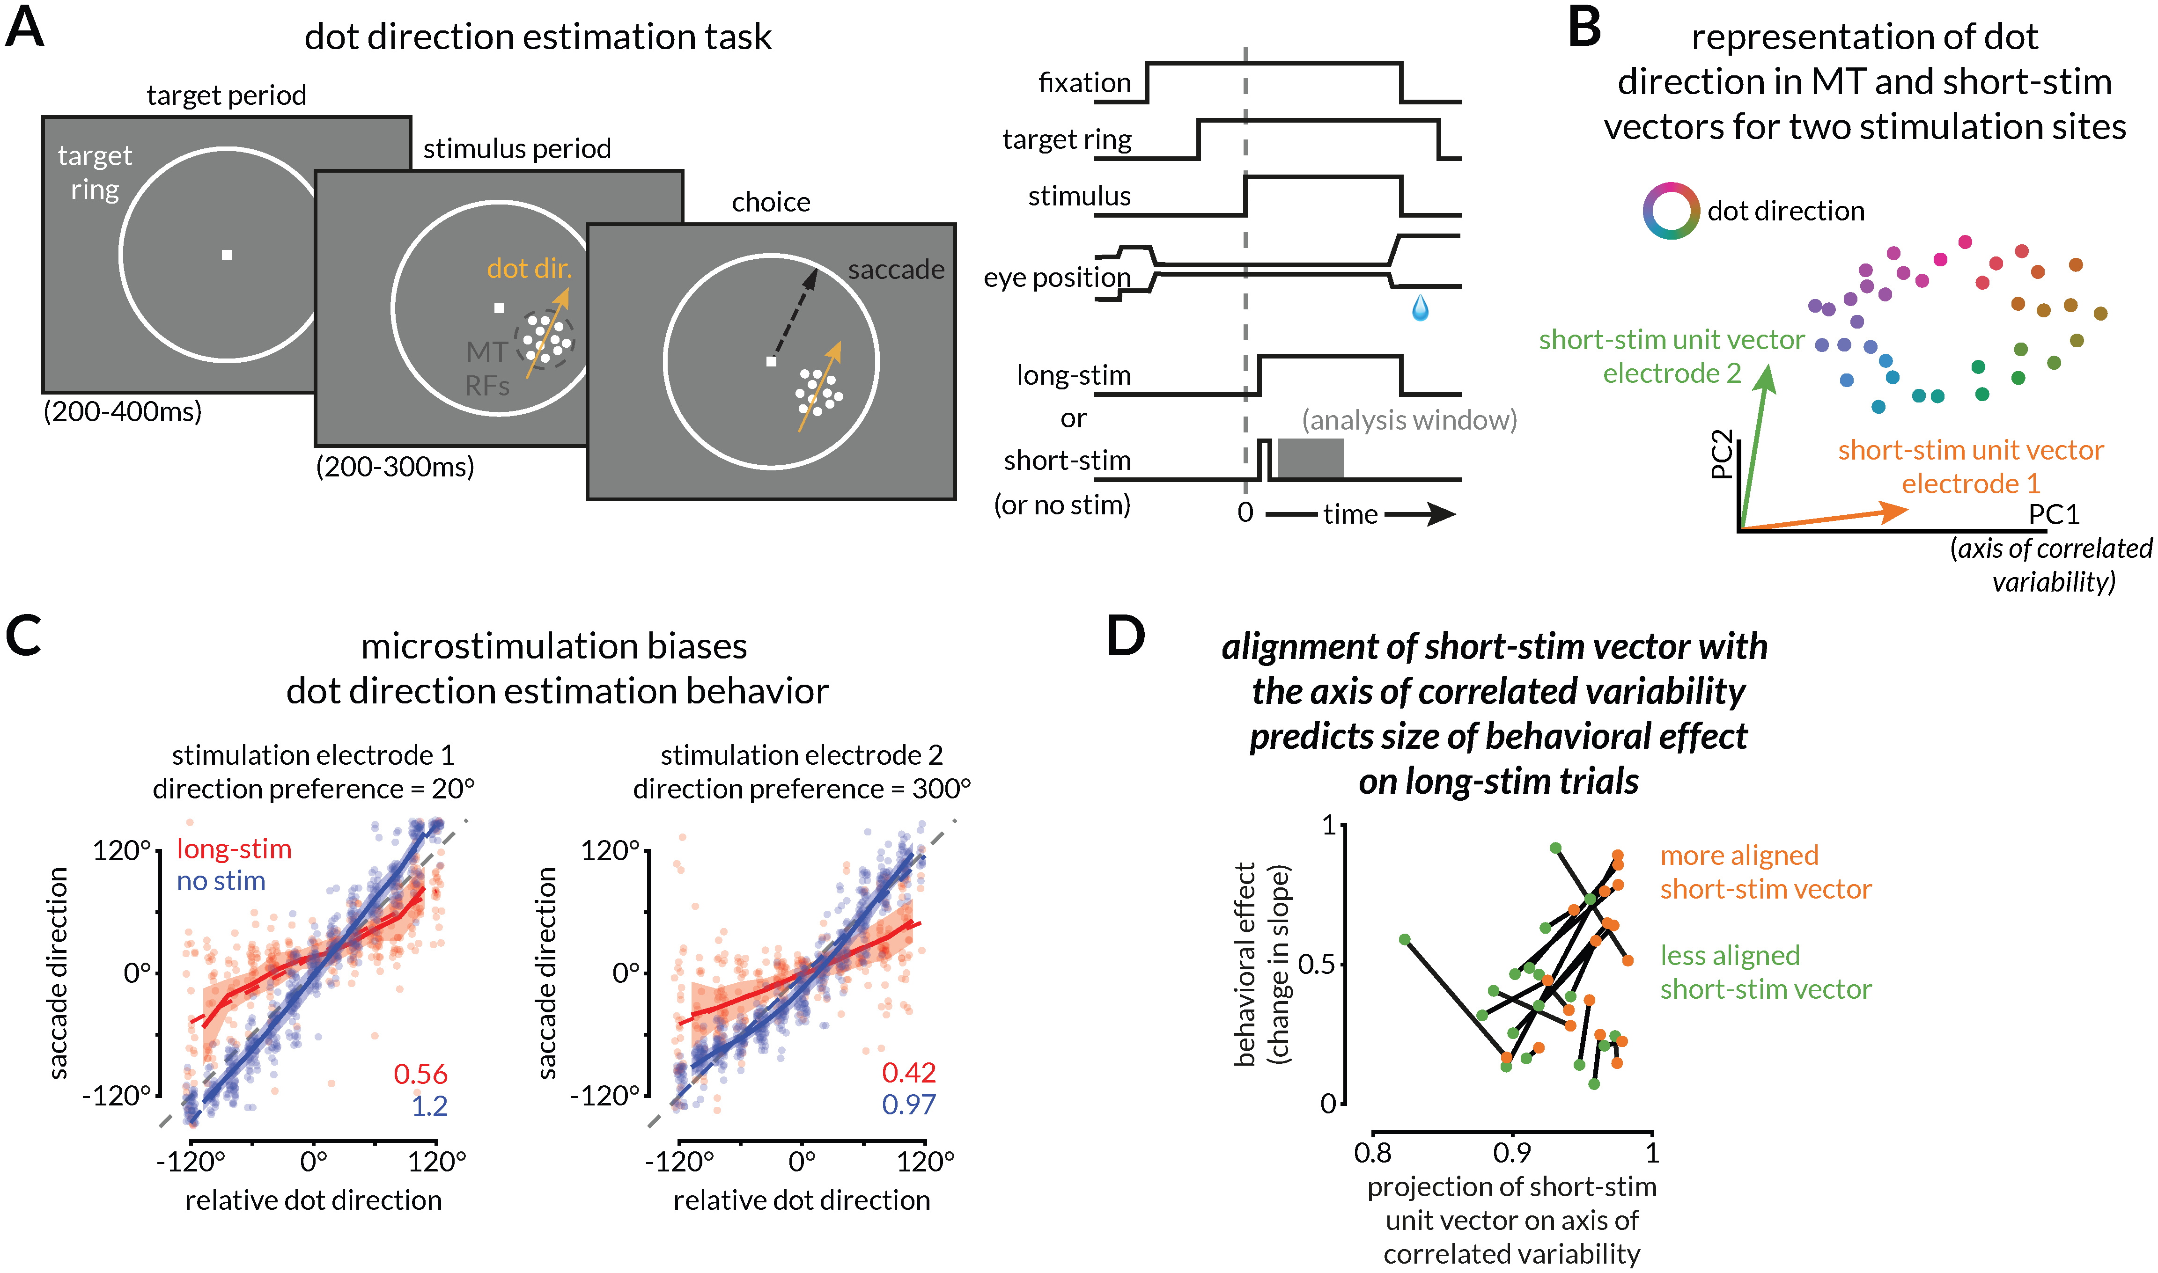

**Figure 6: Causal test for the central hypothesis: the behavioral effect of electrical microstimulation will be largest when it is aligned with the axis of correlated variability.**

**A.** Schematic of a dot direction estimation task in which monkeys were rewarded to estimate the motion direction of a random dot kinematogram displayed in the joint receptive fields of MT neurons (DOUG REF XX). The time course of a sample trial is schematized on the right. After assessing the direction selectivity of recording sites in an independent mapping experiment, we chose two electrodes for biphasic electrical microstimulation. The kinematogram was presented after the fixation spot and target ring, after which either a short (XX ms) or long (XX ms) microstimulation was delivered on one of those two selected electrodes. We used the marked analysis window in gray (XX to XX ms) to analyze the effect of microstimulation on population responses during short-stim trials. We compared the monkey’s behavior on no-stim and long-stim trials. We selected the short-stim parameters to minimize the behavioral effect of stimulation (Figure S XX).

**B.** According to our central hypothesis, the monkey’s choices will be most affected by electrical microstimulation if the effect of the microstimulation on the neural responses is aligned with the axis of correlated variability.

**C.** Example dot direction estimation behavior in no-stim and long-stim trials for one session. The two chosen electrodes had direction selectivities of 20° and 300°, respectively, and when stimulated, the monkey’s choices were biased towards those directions. We quantified the behavioral effect as the difference in the slope of the linear fits between the no-stim and long-stim conditions (the slopes are indicated in the labels at the bottom right).

**D.** Validation of the hypothesis introduced in B. For each session (two dots connected by a line), we identified the short-stimulus vector that is more aligned with the axis of correlated variability (orange dots are to the right of their respective green dots). The size of the behavioral effect (change in slope) on long-stim trials is larger for better-aligned stimulation vectors (a majority of orange dots are above their respective green dots). STATS XX