

INTERNATIONAL UNIVERSITY

**Laboratory work 5.**

**Web Database**

MAJOR 5B070400 – COMPUTER SCIENCE SYSTEMS AND SOFTWARE ENGINEERING

|  |  |  |  |
| --- | --- | --- | --- |
|  | **STUDENTS:** | **CSSE-1702**  **Tursynbek Beibarys,Yerbosyn Azamat ,Danara Smadiyarova** | **_____________**  (signatures) |
|  | **SUPERVISOR:** | **Adlet Alipbekov** | **_____________**  (signature) |

Almaty 2020

Content

1. *Introduction*
2. *Main part*
   1. *Part_1*
   2. *Part_2*
3. *Conclusion*
4. *References*
5. *Introduction*

**Hibernate** ORM (or simply **Hibernate**) is an object-relational mapping tool for the **Java programming** language. It provides a framework for mapping an object-oriented domain model to a relational database. ... **Hibernate** also provides data query and retrieval facilities.

1. *Main part (Solutions and descriptions of the laboratory work tasks)*

***2.1Part_1****:* **To create web database for course project.**

We connect to db with hibernate in Spring boot app.

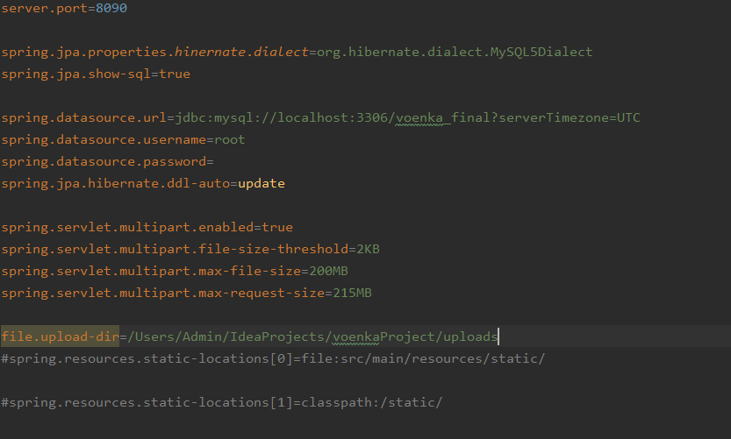

Picture 1.

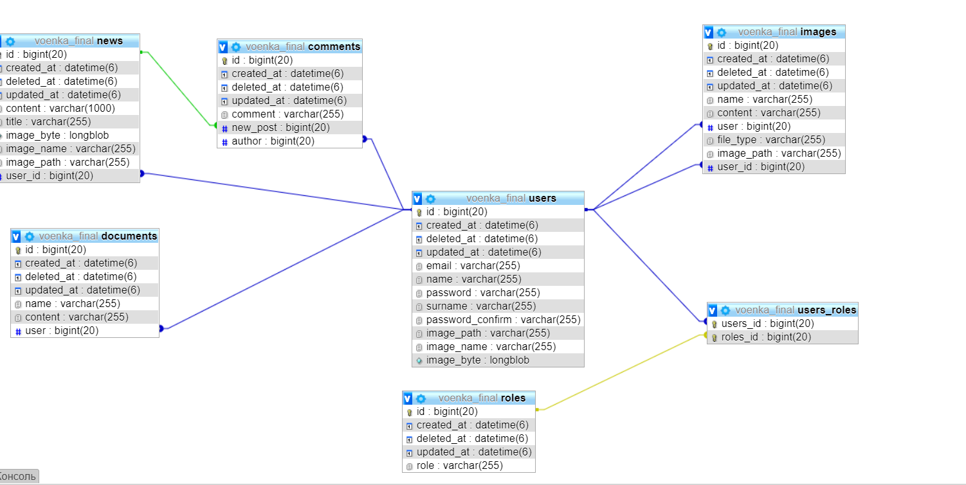

Picture 2 - relation between tables.

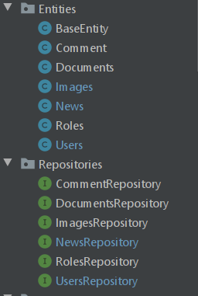

Picture 3 - entities have data about project.

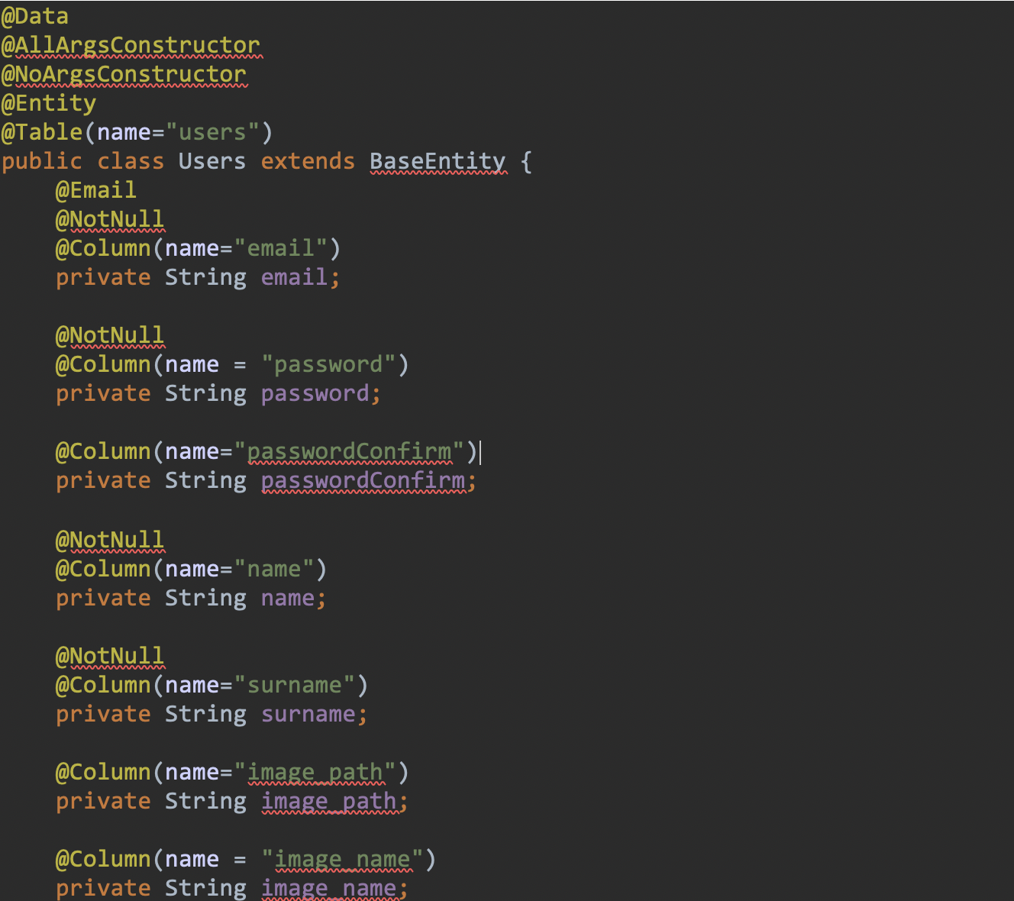

Picture 4 - example: Users.

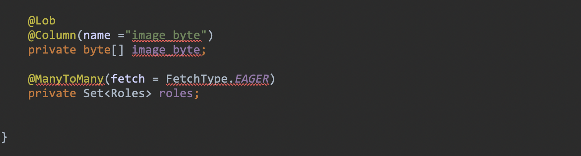

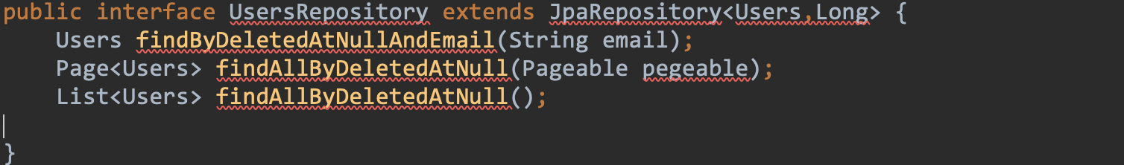

Picture 5 - UserRepository.

We use very easy way to write sql codes with Lombok library in java.

Project Lombok. Project Lombok is a java library that automatically plugs into your editor and build tools, spicing up your java. Never write another getter or equals method again, with one annotation your class has a fully featured builder, Automate your logging variables, and much more. Lombok is an annotation processor - it has full access to the generated source tree. While annotation processors usually generate new source files, Lombok modifies existing ones by adding new fields or methods. To answer the question: Lombok annotations do not generate the code in development time. We use Lombok when write @Data in users.java.

***2.2Part_2:* Database and web applications.**

*We use services to implement add to db and other processes*

*Like this view my services:*

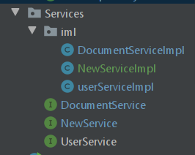

Picture 6 - userService.

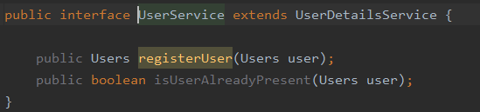

Picture 7- userService implementation.

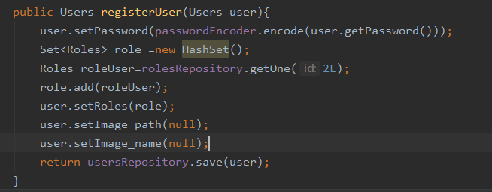

Picture 8- After that all changes will write to db.

*In frontend it look like this:*

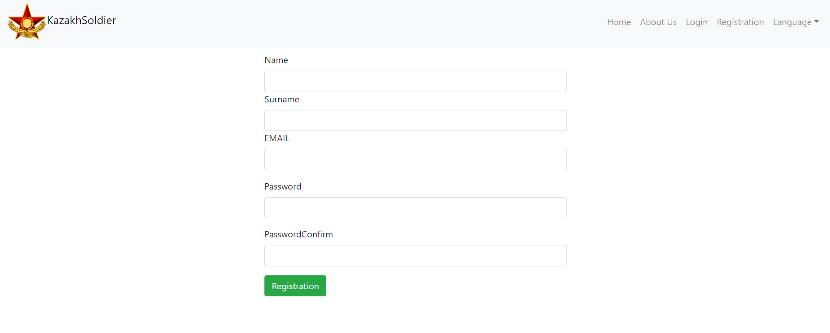

Picture 9- registration page.

*It is only registration , our project in process of creating .*

1. *Conclusion*

*For us, developing this project was a good experience.*

*We will show all things which connect with data base after ending the project.*

*References*

* + - 1. https://metanit.com/sql/mysql/