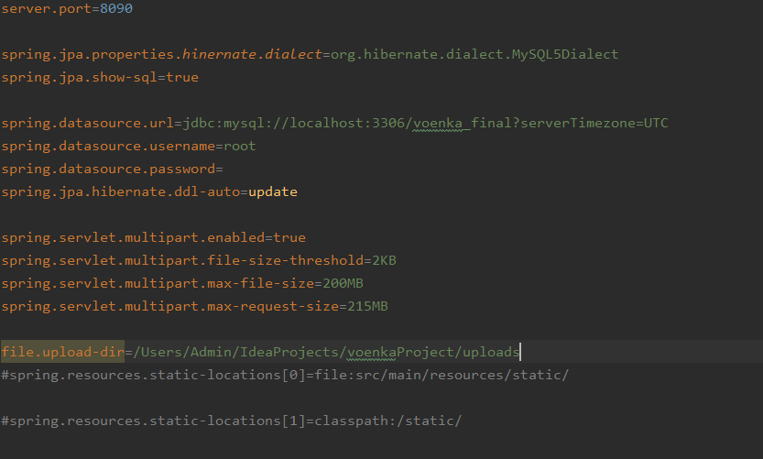

We connect to db with hibernate in Spring boot app.

**Hibernate** ORM (or simply **Hibernate**) is an object-relational mapping tool for the **Java programming** language. It provides a framework for mapping an object-oriented domain model to a relational database. ... **Hibernate** also provides data query and retrieval facilities.

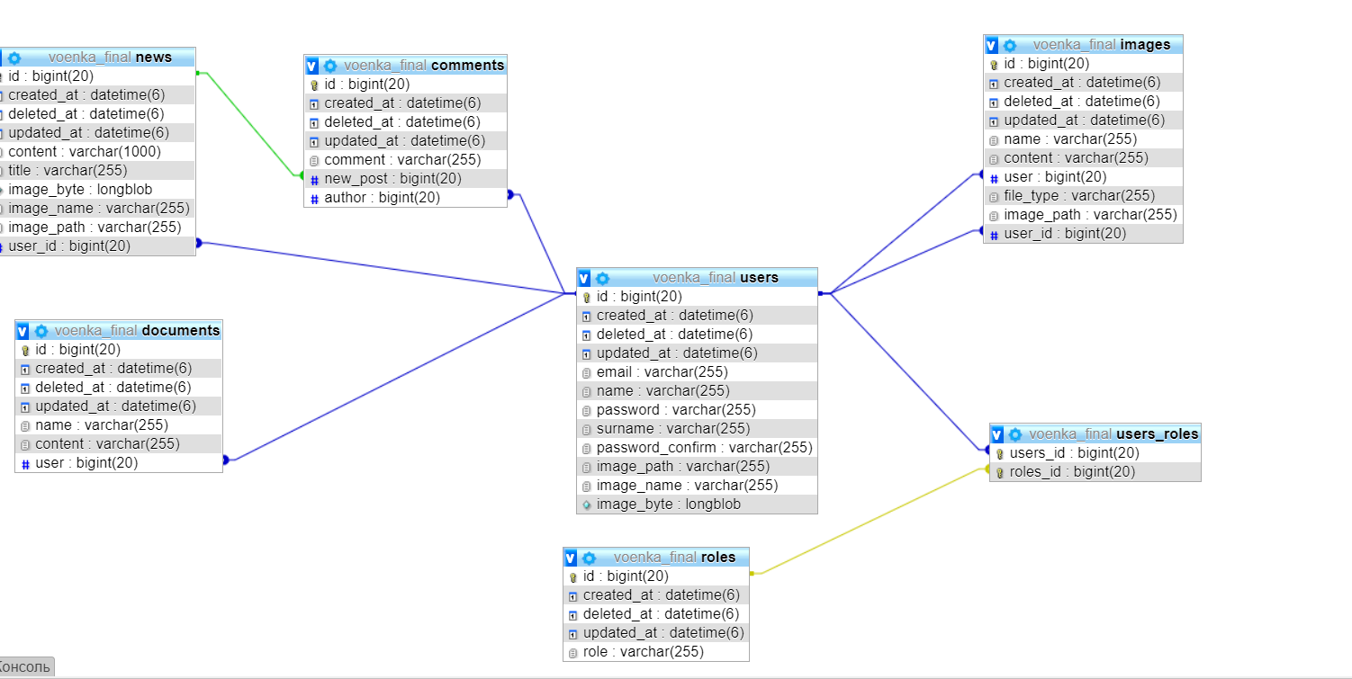

Relation between tables

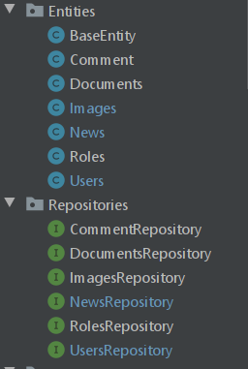

Entities have data about project

For example: Users

@Data  
@AllArgsConstructor  
@NoArgsConstructor  
@Entity  
@Table(name="users")  
public class Users extends BaseEntity {  
 @Email  
 @NotNull  
 @Column(name="email")  
 private String email;  
  
 @NotNull  
 @Column(name = "password")  
 private String password;  
  
 @Column(name="passwordConfirm")  
 private String passwordConfirm;  
  
 @NotNull  
 @Column(name="name")  
 private String name;  
  
 @NotNull  
 @Column(name="surname")  
 private String surname;  
  
 @Column(name="image_path")  
 private String image_path;  
  
 @Column(name = "image_name")  
 private String image_name;  
  
 @Lob  
 @Column(name ="image_byte")  
 private byte[] image_byte;  
  
 @ManyToMany(fetch = FetchType.*EAGER*)  
 private Set<Roles> roles;  
  
  
}

At now UserRepository:

public interface UsersRepository extends JpaRepository<Users,Long> {  
 Users findByDeletedAtNullAndEmail(String email);  
 Page<Users> findAllByDeletedAtNull(Pageable pegeable);  
 List<Users> findAllByDeletedAtNull();  
  
}

we use very easy way to write sql codes with Lombok library in java

Project **Lombok**. Project **Lombok** is a **java** library that automatically plugs into your editor and build tools, spicing up your **java**. Never write another getter or equals method again, with one annotation your class has a fully featured builder, Automate your logging variables, and much more. **Lombok is** an annotation processor - it has full access to the generated source tree. While annotation processors usually generate new source files, **Lombok** modifies existing ones by adding new fields or methods. To answer the question: **Lombok** annotations **do** not generate the code in development time

We use Lombok when write @Data in users.java

2.

We use services to implement add to db and other processes

Like this view my services

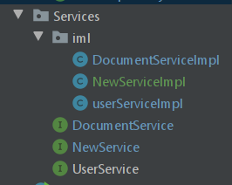

userService

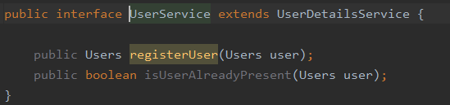

userService implementation

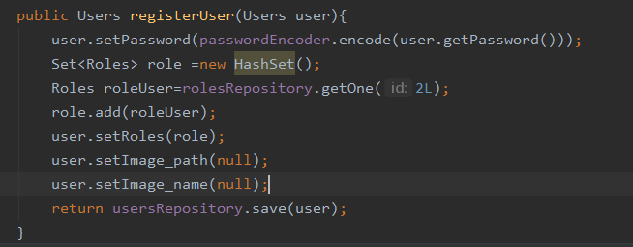

After that all changes will write to db

In frontend it look like this

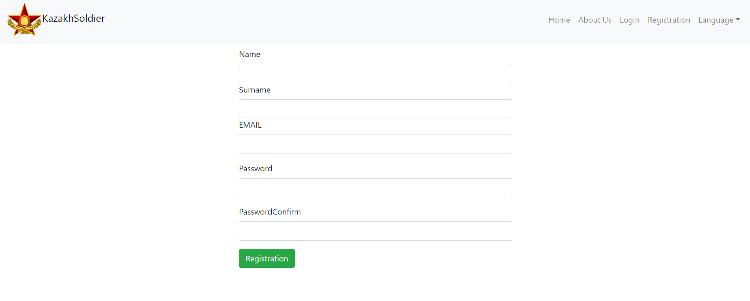

It is only registration , our project in process of creating .

We will show all things which connect with db after ending the project inshaAllah)