|  |  |
| --- | --- |
|  | **GAILUNWEN Language Editor Registration** |
|  |  |

* Please fill in this form
* Please mail the form plus required documents to register-gailunwen@hotmail.com
* We will email your registration and provide you login credentials
* We will decide on a method of payment when a job is assigned to you

**Personal Information**

* First Name: ______________________________________________
* Family Name: ______________________________________________
* Email: ______________________________________________
* Mobile: ______________________________________________ Example: +1-(123)-123-1234

* Address: ______________________________________________ Number and street name

* City & Country: ______________________________________________

**Professional Information**

* Degree: ______________________________________________ Current students only

* University: ______________________________________________ Current students only

* Major: ______________________________________________ Current students only

**Next Page** ->

* Degree: ______________________________________________ Highest already earned

* University: ______________________________________________ Highest already earned

* Major: ______________________________________________ Highest already earned

* Position: ______________________________________________ If employed currently

* Institution: ______________________________________________ If employed currently

**Field(s) of Expertise**

* Primary: ______________________________________________ Choose from list below

* Secondary: ______________________________________________ Choose from list below

* More: ______________________________________________ Choose from list below

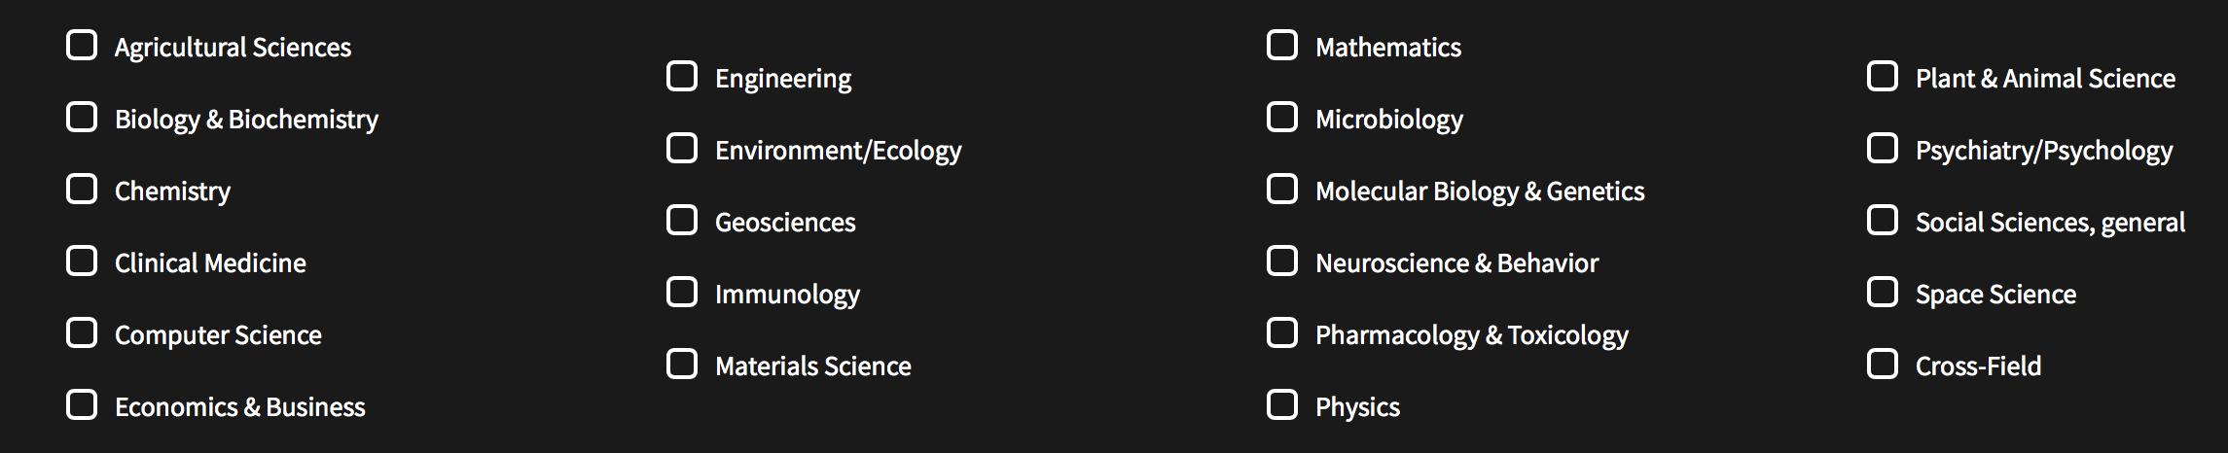

**Required Documentation**

* Transcript (most recent completed term) – Current students only
* Scan of highest degree earned – All except current undergraduate students
* CV
* Proof of employment (if employed currently) – Optional