|  |  |
| --- | --- |
|  | **GAILUNWEN Service Level Choice** |
|  |  |

* Please fill in this form
* Please mail the form together with your article to submit-gailunwen@hotmail.com
* A Managing Editor will contact via email to discuss next steps

**Document Information**

* Title: __________________________________________________________________________________________

_________________________________________________________________________________________________

_________________________________________________________________________________________________

* Journal Name: ______________________________________________
* Journal Website: ______________________________________________

**Your Personal Information**

* First Name: ______________________________________________
* Family Name: ______________________________________________
* Email: ______________________________________________
* Mobile: ______________________________________________ Example: +1-(123)-123-1234

* Address: ______________________________________________ Number and street name

* City & Country: ______________________________________________

**Next Page ->**

**Your Professional Information**

* Prefix: ______________________________________________ Dr. or Prof.

* Job Title: ______________________________________________ Prof. or Senior Researcher etc.

* Department: ______________________________________________ Or, Division or Section name

* Institution: ______________________________________________ Univ. or company name

**Your Research Field**

* Primary: ______________________________________________ Choose from list below

* Secondary: ______________________________________________ Choose from list below

* More: ______________________________________________ Choose from list below

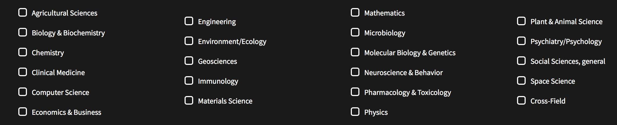

**Choice of Service Level**

* Level: _______________________________ Silver or Gold or Platinum or Diamond or Diamond Plus

The charge for correcting and polishing the English language of your scientific document depends on the level of service it needs and the length of the document (in words).  Word count refers to the number of words in the text, figure and table captions. References are not included in the word count. Currently, we can accept Microsoft Word documents only. We use the word count function of this software to count the number of words in your document. The Managing Editor assigned to your document will contact you to recommend one of the following pricing levels for your document. You make the final decision. All prices below are in US dollars and cents.

**Next Page ->**

**Silver**: Five (5) U.S. cents per word. Processing time is 10 days after payment.

**Gold**: Seven and half (7.5) U.S. cents per word. You will receive a video from your Language Editor explaining the major corrections to the text. The goal is to help improve your English writing skills. Processing time is 7 days after payment.

**Platinum**: Ten (10) U.S. cents per word. Your Language Editor will contact you to set up a 1 hour video chat (e.g. Skype) to explain in detail the changes made to the manuscript. The goal is to help improve your English writing skills. The conversation with Native English speakers will help improve your spoken English. Processing time is 5 days after payment.

**Diamond**: A fixed charge of $1,500 per document (less than 10,000 words). This is submission-to-publication service. That is, the Language Editor will correct your document prior to submission to a journal. Most articles need to be revised based on peer-reviews. The Language Editor will correct your revised article plus your responses to referee's comments. If a second and third round of reviews happen, the Language Editor will continue to correct your revised article. This process ends when your article is either accepted or rejected for publication by the journal. This service is limited to one article only. You can interact with your Language Editor throughout this process via video (e.g. Skype). Processing time is 5 days for each iteration.

**Diamond Plus**: Same as Diamond service above but for documents longer than 10,000 words. The Managing Editor will negotiate a price with you prior to processing.

**Who Recommended You to Gailunwen\***

* First Name: ______________________________________________
* Family Name: ______________________________________________
* Email: ______________________________________________
* Mobile: ______________________________________________ Example: +1-(123)-123-1234

* Address: ______________________________________________ Number and street name

* City & Country: ______________________________________________

*This person will get a honorarium (money) from us. If you recommend another author to use our service you will similarly receive an honorarium.