Nach_OS作業
Github鏈接: https://github.com/Beim/NCU_OS-.git
分組
刘星焜 104502909
- Finish installation of NachOS(完成)
- 1. Solve share memory problem of thread (完成)
- 2.Implement Sleep system call(未完成)
1. Solve share memory of problem of thread without synchronized or Mutex
現狀:
兩個thread分配到重複的page,導致執行出錯.
目標:
分配page時,記錄被佔用的page,只將空閒的page分配給thread.
方法:
修改addrspace.h 和 addrspace.cc
addrspace.h中增加
//記錄被佔用的page
static bool usedPhysPage[ NumPhysPages];
//記錄佔用的page數量
static int usedPhysPageNum;
addrspace.cc中
- 修改 AddrSpace() 註釋原有的代碼
- 修改 ~AddrSpace() 在運行結束之後還原改變
- 修改 bool AddrSpace::Load(char *fileName) 將可用的page分配給thread,並記錄狀態
完整代碼:
// addrspace.cc
// Routines to manage address spaces (executing user programs).
//
// In order to run a user program, you must:
//
// 1. link with the -n -T 0 option
// 2. run coff2noff to convert the object file to Nachos format
// (Nachos object code format is essentially just a simpler
// version of the UNIX executable object code format)
// 3. load the NOFF file into the Nachos file system
// (if you haven't implemented the file system yet, you
// don't need to do this last step)
//
// Copyright (c) 1992-1996 The Regents of the University of California.
// All rights reserved. See copyright.h for copyright notice and limitation
// of liability and disclaimer of warranty provisions.

#include "copyright.h"
#include "main.h"
#include "addrspace.h"
#include "machine.h"
#include "noff.h"

//----------------------------------------------------------------------
// SwapHeader
// Do little endian to big endian conversion on the bytes in the
// object file header, in case the file was generated on a little
// endian machine, and we're now running on a big endian machine.
//----------------------------------------------------------------------

static void
SwapHeader (NoffHeader *noffH)
{
noffH->noffMagic = WordToHost(noffH->noffMagic);
noffH->code.size = WordToHost(noffH->code.size);
noffH->code.virtualAddr = WordToHost(noffH->code.virtualAddr);
noffH->code.inFileAddr = WordToHost(noffH->code.inFileAddr);
noffH->initData.size = WordToHost(noffH->initData.size);
noffH->initData.virtualAddr = WordToHost(noffH->initData.virtualAddr);
noffH->initData.inFileAddr = WordToHost(noffH->initData.inFileAddr);
noffH->uninitData.size = WordToHost(noffH->uninitData.size);
noffH->uninitData.virtualAddr = WordToHost(noffH->uninitData.virtualAddr);
noffH->uninitData.inFileAddr = WordToHost(noffH->uninitData.inFileAddr);
}

//----------------------------------------------------------------------
// AddrSpace::AddrSpace
// Create an address space to run a user program.
// Set up the translation from program memory to physical
// memory. For now, this is really simple (1:1), since we are
// only uniprogramming, and we have a single unsegmented page table
//----------------------------------------------------------------------

AddrSpace::AddrSpace()
{
/*
pageTable = new TranslationEntry[NumPhysPages];
for (unsigned int i = 0; i < NumPhysPages; i++) {
pageTable[i].virtualPage = i; // for now, virt page # = phys page #
pageTable[i].physicalPage = i;
// pageTable[i].physicalPage = 0;
pageTable[i].valid = TRUE;
// pageTable[i].valid = FALSE;
pageTable[i].use = FALSE;
pageTable[i].dirty = FALSE;
pageTable[i].readOnly = FALSE;
}
*/
// zero out the entire address space
// bzero(kernel->machine->mainMemory, MemorySize);
}

//----------------------------------------------------------------------
// AddrSpace::~AddrSpace
// Dealloate an address space.
//----------------------------------------------------------------------

AddrSpace::~AddrSpace()
{
for(unsigned int i = 0; i < numPages; i++)usedPhysPage[pageTable[i].physicalPage]=FALSE;
usedPhysPageNum-=numPages;
delete pageTable;
}

//----------------------------------------------------------------------
// AddrSpace::Load
// Load a user program into memory from a file.
//
// Assumes that the page table has been initialized, and that
// the object code file is in NOFF format.
//
// "fileName" is the file containing the object code to load into memory
//----------------------------------------------------------------------

bool
AddrSpace::Load(char *fileName)
{
OpenFile *executable = kernel->fileSystem->Open(fileName);
NoffHeader noffH;
unsigned int size;

if (executable == NULL) {
cerr << "Unable to open file " << fileName << "\n";
return FALSE;
}
executable->ReadAt((char *)&noffH, sizeof(noffH), 0);
if ((noffH.noffMagic != NOFFMAGIC) &&
(WordToHost(noffH.noffMagic) == NOFFMAGIC))
SwapHeader(&noffH);
ASSERT(noffH.noffMagic == NOFFMAGIC);

// how big is address space?
size = noffH.code.size + noffH.initData.size + noffH.uninitData.size
+ UserStackSize; // we need to increase the size
// to leave room for the stack
numPages = divRoundUp(size, PageSize);
// cout << "number of pages of " << fileName<< " is "<<numPages<<endl;

size = numPages * PageSize;

ASSERT(usedPhysPageNum+numPages <= NumPhysPages);
//numpage is the page size of this threads
//now we're not trying vm so used page + numpage must smaller then total page
// check we're not trying
// to run anything too big --
// at least until we have
// virtual memory
usedPhysPageNum+=numPages;

//------------------------------------------------------
//
pageTable = new TranslationEntry[numPages]; // create an enthough big pagetable
for (unsigned int i = 0, j = 0; i < numPages; i++)
{
pageTable[i].virtualPage = i; // for now, virt page # = phys page #

while(usedPhysPage[j++]){} //If usedPhysPage[j++] is True
// It's means this page is occupy by other threads
// so j++ to find next page

usedPhysPage[j-1]=TRUE; //turn it to occupy

pageTable[i].physicalPage = j-1;
// pageTable[i].physicalPage = i;

pageTable[i].valid = TRUE;
pageTable[i].use = FALSE;
pageTable[i].dirty = FALSE;
pageTable[i].readOnly = FALSE;
}

//------------------------------------------------------

DEBUG(dbgAddr, "Initializing address space: " << numPages << ", " << size);

// then, copy in the code and data segments into memory
if (noffH.code.size > 0) {
DEBUG(dbgAddr, "Initializing code segment.");
DEBUG(dbgAddr, noffH.code.virtualAddr << ", " << noffH.code.size);
/*
executable->ReadAt(
&(kernel->machine->mainMemory[noffH.code.virtualAddr]),
noffH.code.size, noffH.code.inFileAddr);
*/
executable->ReadAt(
&(kernel->machine->mainMemory[pageTable[noffH.code.virtualAddr/PageSize].physicalPage*PageSize+(noffH.code.virtualAddr%PageSize)]),
noffH.code.size, noffH.code.inFileAddr);

}
if (noffH.initData.size > 0) {
DEBUG(dbgAddr, "Initializing data segment.");
DEBUG(dbgAddr, noffH.initData.virtualAddr << ", " << noffH.initData.size);
/*
executable->ReadAt(
&(kernel->machine->mainMemory[noffH.initData.virtualAddr]),
noffH.initData.size, noffH.initData.inFileAddr);
*/
executable->ReadAt(
&(kernel->machine->mainMemory[pageTable[noffH.initData.virtualAddr/PageSize].physicalPage*PageSize+(noffH.initData.virtualAddr%PageSize)]),
noffH.initData.size, noffH.initData.inFileAddr);

}

delete executable; // close file
return TRUE; // success
}

//----------------------------------------------------------------------
// AddrSpace::Execute
// Run a user program. Load the executable into memory, then
// (for now) use our own thread to run it.
//
// "fileName" is the file containing the object code to load into memory
//----------------------------------------------------------------------

void
AddrSpace::Execute(char *fileName)
{
if (!Load(fileName)) {
cout << "inside !Load(FileName)" << endl;
return; // executable not found
}

//kernel->currentThread->space = this;
this->InitRegisters(); // set the initial register values
this->RestoreState(); // load page table register

kernel->machine->Run(); // jump to the user progam

ASSERTNOTREACHED(); // machine->Run never returns;
// the address space exits
// by doing the syscall "exit"
}

//----------------------------------------------------------------------
// AddrSpace::InitRegisters
// Set the initial values for the user-level register set.
//
// We write these directly into the "machine" registers, so
// that we can immediately jump to user code. Note that these
// will be saved/restored into the currentThread->userRegisters
// when this thread is context switched out.
//----------------------------------------------------------------------

void
AddrSpace::InitRegisters()
{
Machine *machine = kernel->machine;
int i;

for (i = 0; i < NumTotalRegs; i++)
machine->WriteRegister(i, 0);

// Initial program counter -- must be location of "Start"
machine->WriteRegister(PCReg, 0);

// Need to also tell MIPS where next instruction is, because
// of branch delay possibility
machine->WriteRegister(NextPCReg, 4);

// Set the stack register to the end of the address space, where we
// allocated the stack; but subtract off a bit, to make sure we don't
// accidentally reference off the end!
machine->WriteRegister(StackReg, numPages * PageSize - 16);
DEBUG(dbgAddr, "Initializing stack pointer: " << numPages * PageSize - 16);
}

//----------------------------------------------------------------------
// AddrSpace::SaveState
// On a context switch, save any machine state, specific
// to this address space, that needs saving.
//
// For now, don't need to save anything!
//----------------------------------------------------------------------

void AddrSpace::SaveState()
{
pageTable=kernel->machine->pageTable;
numPages=kernel->machine->pageTableSize;
}

//----------------------------------------------------------------------
// AddrSpace::RestoreState
// On a context switch, restore the machine state so that
// this address space can run.
//
// For now, tell the machine where to find the page table.
//----------------------------------------------------------------------

void AddrSpace::RestoreState()
{
kernel->machine->pageTable = pageTable;
kernel->machine->pageTableSize = numPages;
}
执行结果:
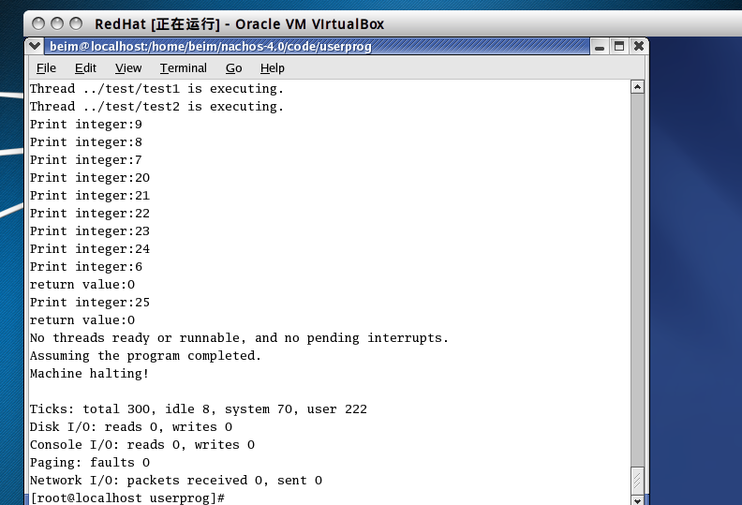
遇到的困難
在對load()函數的executable->ReadAt(...)部分作了修改之後出現segmentfault錯誤
如何解決
改正爲正確的內存地址.
心得
仔細讀代碼,多查資料.

