🕵️
PROJECT SYNOPSIS
OSINT SANDBOX
A Zero-Cost OSINT Investigation Simulation Platform

A B.Tech (Computer Science & Engineering) Final-Year Major Project
Full-Stack Web Application · Cyber-Security Education
Submitted by | ____________________________
Enrolment / Roll No. | ____________________________
Guide / Supervisor | ____________________________
Department | Computer Science & Engineering
Session | 2025 – 2026

Table of Contents
This table of contents updates automatically. If it still shows this line, right-click it and choose “Update Field” (or select all and press F9) to fill in the sections and correct page numbers.

Chapter 1 — Introduction of Project

1.1 Introduction to the Project
OSINT Sandbox is a controlled, browser-based OSINT (Open-Source Intelligence) investigation simulation in which players crack fictional cyber-security mysteries. Each case begins with a small evidence package; the player must discover related digital identities, correlate evidence, reconstruct the incident timeline, draw a relationship graph between entities, and finally defend a written conclusion naming the responsible actor and attack vector.
The platform is designed as a safe, sandboxed teaching tool. Every identity, username, email address, domain, IP address, organisation and profile used in the game is entirely fictional or a reserved documentation value — e.g. *.example domains and RFC-5737 documentation IP ranges such as 203.0.113.42. The application performs no real reconnaissance, scraping or scanning of any real person; it teaches the analytical methodology of investigation, not its execution against live targets.
A defining engineering constraint is that the project is zero-cost by design. The entire stack — database, backend API and frontend — builds, runs, tests and demonstrates on a single laptop with one command (docker compose up). There is no paid API, no cloud account, no managed database and no API key. The recurring running cost of the project is ₹0.
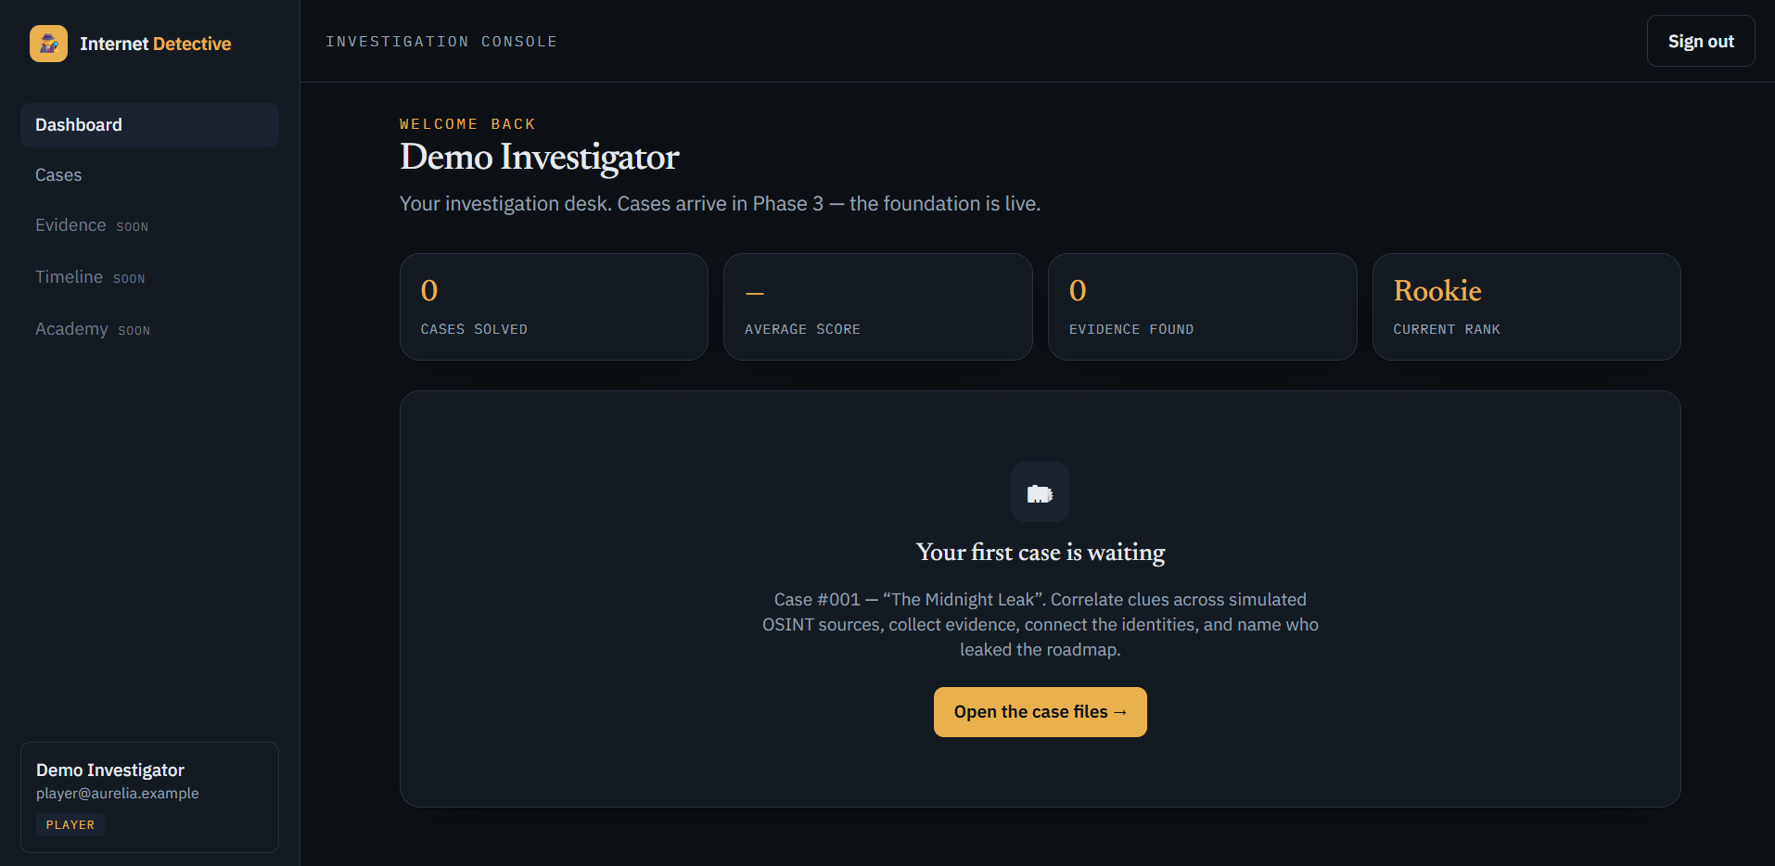
fig 1.1 — OSINT Sandbox dashboard (SOC / case-dossier home screen)

1.2 Problem Statement
Cyber-security education has a persistent gap: students learn about phishing, credential compromise, insider threats and log analysis in theory, but rarely get to practise the reasoning that connects scattered clues into a defensible conclusion. Real OSINT training platforms are expensive, require cloud infrastructure, or risk exposing learners to real personal data and legal grey areas.
The problem this project addresses can be stated as:
“How can we teach OSINT investigation and analytical reasoning through hands-on, gamified practice — safely, offline, at zero cost, and without ever touching real people's data?”
The answer is a deterministic, data-driven simulation where the server owns a complete fictional case graph and the player uncovers it piece by piece through simulated investigation tools — reproducing the feel of a Security Operations Centre (SOC) case dossier without any of the cost or risk.

1.3 Objectives of the Project
The clearly defined objectives of the project are:
- To build a full-stack web application that simulates OSINT investigation in a completely fictional, safe sandbox.
- To design a data-driven case engine where a new mystery is added as data (a JSON file), not new code.
- To implement a realistic "fog-of-war" mechanic: the server holds the full truth, and players progressively discover only the subset they earn through investigation.
- To provide simulated OSINT tools (username search, email intelligence, identity lookup, domain, IP and file analysis) that reveal new leads only when used on already-discovered entities.
- To let players collect and annotate evidence, draw a relationship graph, reconstruct a timeline, and submit a defended conclusion (actor + attack vector + cited evidence).
- To enforce production-grade security: Argon2id password hashing, JWT access tokens, rotating and revocable refresh tokens, role-based access control and an append-only audit log.
- To keep the entire system reproducible and zero-cost — one-command Docker startup, tests that need no external services.

1.4 Scope of the Project
The delivered system covers the complete player journey end-to-end: account registration and login, browsing a catalogue of multiple playable cases, starting an investigation, using OSINT tools to discover entities and evidence, building the relationship graph on an interactive canvas, and submitting a final verdict that produces a debrief comparing the player's conclusion against the hidden solution.
The project is organised in phases. The foundation (authentication, RBAC, audit log) and the investigation engine (cases, discovery, evidence, relationship graph, timeline, submission and debrief) are implemented and tested. A full deterministic six-dimension scoring engine and a Watson AI mentor are documented in the roadmap as the next phase.
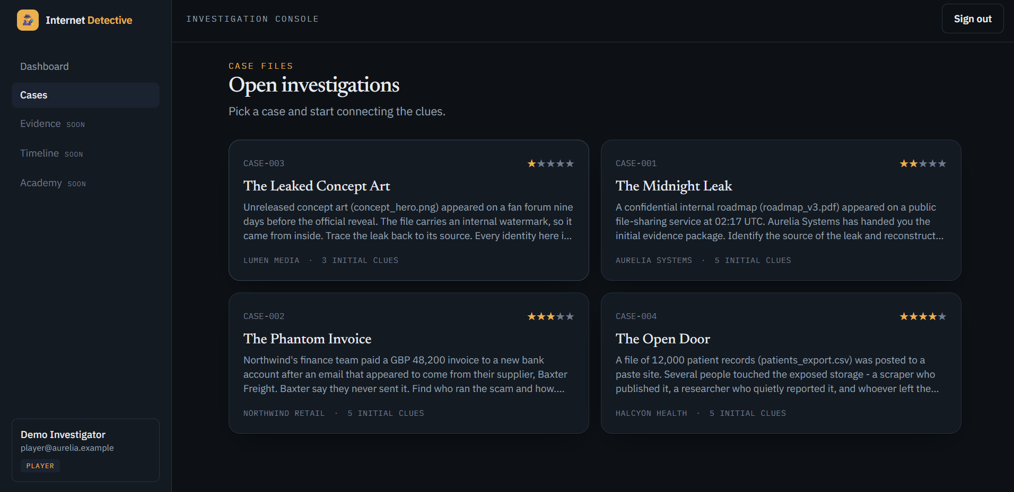
fig 1.2 — Case catalogue screen showing the four available cases with difficulty ratings

1.5 Salient Features
- Zero-cost: runs entirely on one laptop with docker compose up — no cloud, no API keys, ₹0 recurring cost.
- Safe by design: 100% fictional data — domains and RFC-5737 documentation IPs; no real-world reconnaissance.
- Data-driven engine: one engine renders any case; authors add a case by writing a JSON file, validated on import.
- Fog-of-war gameplay: the server never leaks the solution; players receive only their discovered subset of the graph.
- Interactive graph workspace: an entity-relationship canvas built on React Flow where players connect the clues they find.
- Anti-brute-force investigation: a lookup only works on a lead the player has already surfaced, so guessing is not rewarded.
- Production-grade security: Argon2id hashing, JWT + rotating refresh tokens, RBAC, security headers, rate limiting and an append-only audit log.

Chapter 2 — Technology Used
OSINT Sandbox is a modern, decoupled client–server web application. The frontend is a single-page React application; the backend is an asynchronous Python REST API; the two communicate over JSON. Every technology chosen is free and open-source, in keeping with the zero-cost objective, and all are current, industry-standard tools.

2.1 Technology Stack at a Glance
Table 2.1: Technology stack at a glance
Layer | Technology | Version
Frontend UI | React + TypeScript + Vite | 18.3 / 5.6 / 5.4
Styling | Tailwind CSS | 3.4
Graph canvas | React Flow (@xyflow/react) | 12.3
State / data | Zustand + TanStack React Query | 5.0 / 5.62
Backend API | FastAPI (Python 3.12) | 0.115
ORM / migrations | SQLAlchemy (async) + Alembic | 2.0 / 1.14
Database | PostgreSQL (SQLite for tests) | 16
Security | Argon2id + PyJWT | 23.1 / 2.10
Containerization | Docker + Docker Compose | —
fig 2.1 — High-level technology stack of the application

2.2 Frontend Technologies
- React 18.3 + TypeScript 5.6 — component-based UI with static typing for reliability across a large feature surface (auth, dashboard, cases, workspace).
- Vite 5.4 — lightning-fast dev server and build tool; proxies /api to the backend during development.
- Tailwind CSS 3.4 — utility-first styling that produces the product's distinctive "SOC / case-dossier" dark look.
- React Flow 12.3 (@xyflow/react) — powers the interactive entity-relationship graph canvas where players connect discovered clues.
- Zustand 5.0 — minimal global state store for the authenticated session (auth slice).
- TanStack React Query 5.62 — server-state caching and synchronisation for cases and investigation data.
- React Router 6.28 — client-side routing with protected routes for authenticated pages.
- Framer Motion 11.15 — smooth animations and transitions across dialogs and panels.

2.3 Backend Technologies
- FastAPI 0.115 — high-performance asynchronous Python web framework with automatic OpenAPI/Swagger docs at /docs.
- Uvicorn 0.32 — ASGI server that runs the async FastAPI application.
- SQLAlchemy 2.0 (async) — modern typed ORM; all database access is fully asynchronous via asyncpg.
- Alembic 1.14 — database schema migrations, applied automatically on startup (three revisions to date).
- Pydantic 2.10 — request/response validation and settings management, guaranteeing type-safe API contracts.
The backend follows a clean, layered architecture — routers → services → repositories → models — that keeps HTTP concerns, business logic and data access cleanly separated and independently testable.

2.4 Database & Persistence
PostgreSQL 16 is the production database, run as an Alpine container. It stores users, cases and their normalized child rows (entities, relationships, evidence, OSINT records, timeline events, hints), per-player investigation state and the append-only action log. For the automated test suite, the same code runs against an in-memory SQLite database (aiosqlite) so that tests need no database server at all.

2.5 Security & Authentication
- Argon2id (argon2-cffi 23.1) — memory-hard password hashing; plaintext passwords are never stored or logged.
- PyJWT 2.10 — short-lived JWT access tokens for stateless authentication.
- Rotating refresh tokens — opaque, stored only as SHA-256 hashes, rotated on every use, revocable on logout, delivered as an httpOnly cookie.
- Role-Based Access Control (RBAC) — PLAYER and ADMIN roles enforced server-side on every protected route (never trusted from the client).
- Defence in depth — security headers, strict CORS to the frontend origin, in-process rate limiting on auth endpoints, and an append-only audit log.

2.6 Containerization & DevOps
Docker and Docker Compose orchestrate three services — postgres, backend and frontend — with a health-checked database, automatic migrations and seeding on startup. A single docker compose up --build produces a running application at localhost:5173 (app) and localhost:8000/docs (API).

2.7 Testing Tools
The backend ships 38 automated tests (pytest 8.3 + pytest-asyncio + httpx) covering the auth flow, RBAC, security primitives, the case importer, the investigation engine, submission and case validation. The frontend adds 4 tests (Vitest + Testing Library + jsdom). All tests run offline, with no external services.
Table 2.2: Automated backend test suite (38 tests)
Test module (backend) | Focus | Tests
test_auth.py | Registration, login, refresh, logout | 8
test_investigation.py | Discovery, evidence, edges, state | 9
test_case_importer.py | JSON case import & validation | 6
test_submission.py | Verdict & debrief logic | 5
test_security.py | Hashing, tokens, headers | 5
test_rbac.py | Role enforcement | 3
test_all_cases_valid.py | All authored cases are valid | 2

Chapter 3 — Flowchart, Methodology & Code Snippets

3.1 System Architecture
The application uses a decoupled three-tier architecture. The React SPA calls the FastAPI backend over a versioned REST API (/api/v1). The backend is layered: API routers handle HTTP and authentication, services hold the framework-agnostic business logic, repositories perform data access, and SQLAlchemy models map to PostgreSQL tables. The server owns the complete case graph; players only ever receive their discovered subset.
React SPA (browser · localhost:5173)
▼
FastAPI · /api/v1 routers (auth · cases · investigations · admin)
▼
Service layer (business logic · fog-of-war · scoring)
▼
Repository layer (async data access)
▼
PostgreSQL 16 (SQLite for tests)

fig 3.1 — Three-tier system architecture of OSINT Sandbox

3.2 Flowchart for the Problem Statement
The core gameplay loop — the algorithm a player follows to solve a case — is shown below. It captures the fog-of-war discovery cycle and the final defended submission.
START — Register / Log in
▼
Browse case catalogue → open case brief
▼
Start investigation → receive initial clues
▼
Run an OSINT tool on a discovered entity
▼
◆ New leads surfaced? (lead must be already discovered)
▼
Reveal new entities & evidence → collect + tag evidence
▼
Draw relationships on graph · reconstruct timeline
▼
◆ Enough evidence to accuse?
▼
Submit verdict: actor + attack vector + cited evidence + summary
▼
Debrief: compare with hidden solution → END

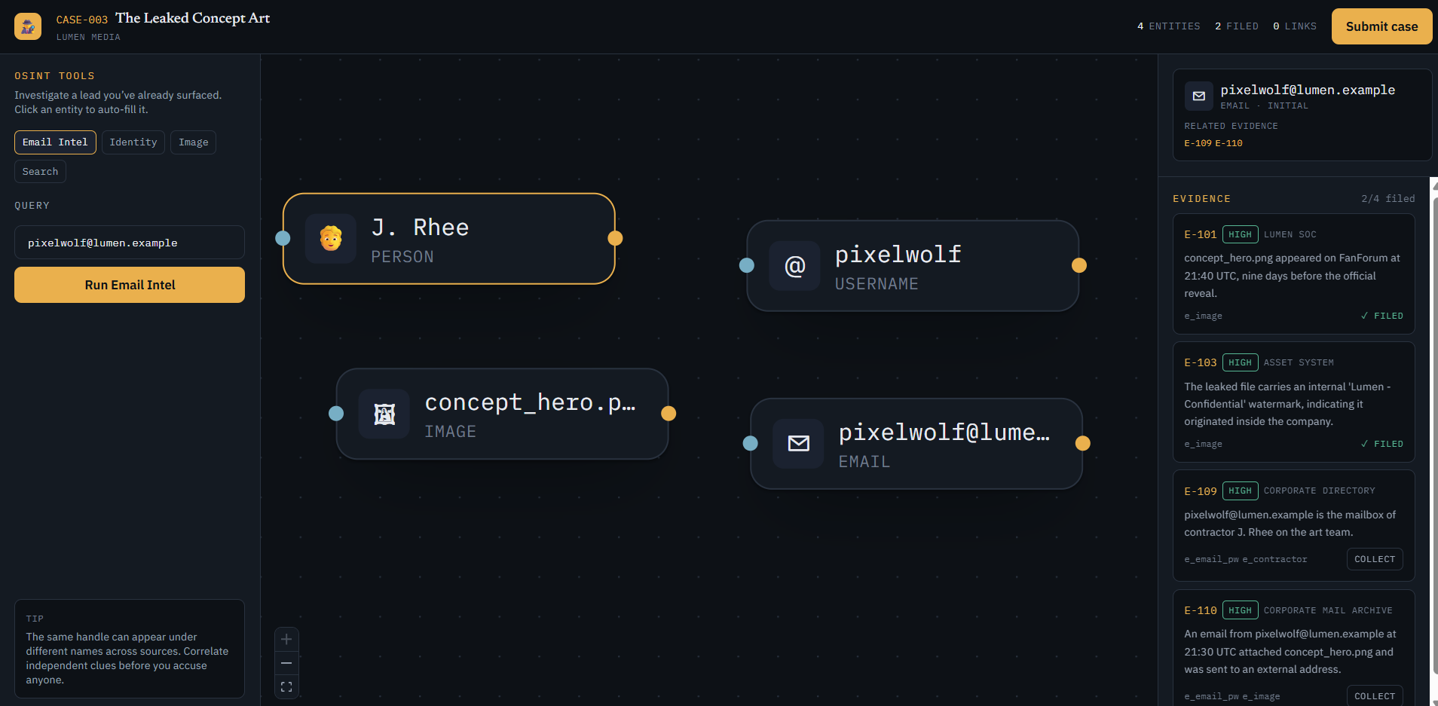
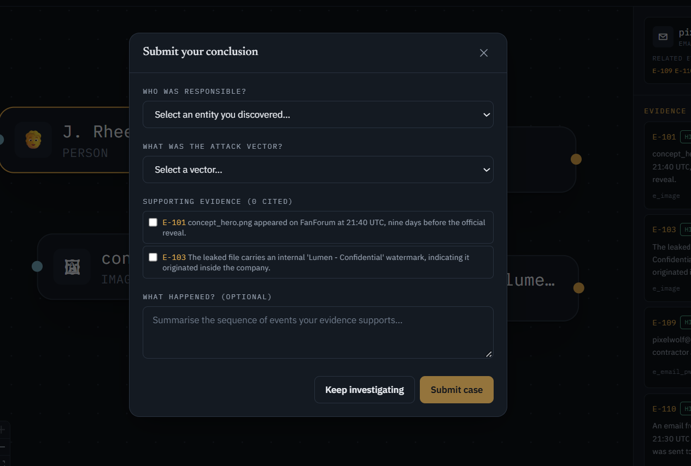

fig 3.2 — Gameplay / investigation flowchart

3.3 Methodology
The project follows an iterative, phased development methodology with a data-driven core. The guiding principle is: the same engine renders any case; adding a case means adding data, not code.

3.3.1 Data-driven case authoring
A case is authored as a single JSON file describing its entities, relationships, evidence, OSINT tool responses, timeline events, hints and a hidden solution rubric. On import, the file is validated and normalized into database rows. Four cases are authored today:
Table 3.1: The four authored cases and their difficulty
Code | Title | Fictional Org | Difficulty
CASE-001 | The Midnight Leak | Aurelia Systems | 2 / 5
CASE-002 | The Phantom Invoice | Northwind Retail | 3 / 5
CASE-003 | The Leaked Concept Art | Lumen Media | 1 / 5
CASE-004 | The Open Door | Halcyon Health | 4 / 5

3.3.2 Fog-of-war discovery
When an investigation starts, only the entities and evidence flagged initial are revealed. Player-hidden fields — the solution actor, red-herring flags and relationship correctness — are stored on the server but never serialized to the client. A player pivots by running an OSINT tool on a lead they have already discovered; matching a simulated source record reveals the next batch of entities and evidence. This is the anti-brute-force rule that keeps the game about reasoning, not guessing.

3.3.3 Defended conclusion & debrief
To close a case the player must accuse a discovered entity, choose one of seven attack vectors (compromised_credentials, phishing, insider_threat, misconfiguration, malware, accidental_disclosure, supply_chain), cite supporting evidence and write a summary. The submission service compares the answer against the hidden rubric and returns a debrief: whether the actor and vector were correct, how much required evidence was collected, and which red herrings were mistakenly filed.

3.3.4 Deterministic scoring rubric
Each case carries a weighted rubric that the scoring engine uses. For CASE-001 the weights sum to 100 across six reasoning dimensions, rewarding sound analysis over lucky guesses:
Table 3.2: Deterministic scoring rubric — six reasoning dimensions
Dimension | Weight | Dimension | Weight
Evidence collection | 20 | Relationship graph | 15
Evidence relevance | 20 | Hypothesis (actor+vector) | 15
Timeline reconstruction | 20 | Written reasoning | 10

3.4 Database Design (ER Model)
The schema is normalized into three logical groups: identity/auth, authored case content, and per-player runtime state. Sixteen tables are created across three Alembic migrations.
Table 3.3: Database tables grouped by concern
Group | Tables
Identity & Auth | users · refresh_tokens · audit_log
Case content (authored) | cases · case_entities · relationships · evidence · osint_records · timeline_events · hints
Investigation runtime | investigations · discovered_entities · discovered_evidence · player_edges · investigation_actions · submissions

Key relationships: a user starts many investigations; each investigation belongs to one case; discovered_entities and discovered_evidence record the player's fog-of-war progress; player_edges store the graph the player draws; and every action is appended to investigation_actions — the substrate for scoring, analytics and anti-cheat.

3.5 REST API Design
All endpoints are versioned under /api/v1. Every investigation route is ownership-checked to be IDOR-proof — a player can only touch their own investigation, and unknown ids return 404 (not 403) so ids are not enumerable.
Table 3.4: Core REST API endpoints
Method & Path | Purpose
GET /health | Service health check
POST /auth/register · /login · /refresh · /logout | Account & session lifecycle
GET /users/me | Current authenticated user
GET /cases · /cases/{code} | List cases · case brief
POST /cases/{code}/start | Begin an investigation
GET /investigations/{id} | Fog-of-war state (discovered subset)
POST /investigations/{id}/lookup | Run an OSINT tool (discovery)
POST /investigations/{id}/evidence | Collect / annotate evidence
POST /investigations/{id}/edges | Draw a relationship
POST /investigations/{id}/submit | Submit verdict → debrief
GET /meta/attack-vectors | Allowed attack vectors

3.6 Code Snippets
Snippet 3.1 — The anti-brute-force discovery rule: a lookup only surfaces new leads if the queried entity has already been discovered (from investigation_service.py).
record = await case_repo.match_osint(db, case_id, tool, q)
# Anti-brute-force: you can only investigate a lead
# you've already surfaced.
unlocked = q in discovered_labels

if record is None or not unlocked:
inv_repo.log_action(db, investigation.id,
"search_performed",
{"tool": tool, "query": query, "hit": False})
return {"hit": False,
"message": "No new leads surfaced from that lookup."}
Snippet 3.2 — Building the debrief verdict by comparing the player's collected evidence against the hidden solution (from submission_service.py).
solution = case.solution or {}
required = set(solution.get("required_evidence", []))
red_herrings = set(solution.get("red_herring_evidence", []))

result = {
"correct_actor": actor_ext_id == solution.get("actor"),
"correct_vector": attack_vector == solution.get("attack_vector"),
"required_collected": sorted(required & collected),
"red_herrings_collected": sorted(red_herrings & collected),
"evidence_collected": len(collected),
}
Snippet 3.3 — Security headers applied to every response via middleware (from main.py).
class SecurityHeadersMiddleware(BaseHTTPMiddleware):
async def dispatch(self, request, call_next):
response = await call_next(request)
response.headers["X-Content-Type-Options"] = "nosniff"
response.headers["X-Frame-Options"] = "DENY"
response.headers["Referrer-Policy"] = "no-referrer"
return response

Chapter 4 — Timeline, Justification & Deployment

4.1 Project Timeline (Gantt Chart)
The project is currently at the demo stage: the foundation and the core investigation engine described in this synopsis are complete and demonstrable today. The remaining work is planned to be built in full force over the next three to five months. The Gantt chart below shows this schedule — the first column marks the demo already delivered, and the shaded cells show the active build window for each work stream across the five months that follow.
Work stream | Demo | M1 | M2 | M3 | M4 | M5
Demo & foundation build (completed)
Deterministic 6-dimension scoring engine
“Watson” AI investigation mentor & hints
Case-authoring studio & new cases
Leaderboards & multiplayer co-investigation
Analytics dashboard (from the action log)
Security hardening & cloud deployment
Final testing & documentation
■ delivered (demo) ■ planned build window | Demo = current stage, M1–M5 = the next five months

fig 4.1 — Project timeline (Gantt chart): demo delivered, full build planned across the next five months
Table 4.1: Project milestones and deliverables for the three-to-five-month build plan
Milestone | Timeframe | Key deliverable | Status
Demo & Foundation | Now (done) | Auth, RBAC, case engine, 4 cases, graph workspace — live demo | ✓ Delivered
Month 1 | Weeks 1–4 | Deterministic six-dimension scoring engine | Planned
Month 2 | Weeks 5–8 | “Watson” AI investigation mentor + hint system | Planned
Month 3 | Weeks 9–12 | Case-authoring studio + additional cases | Planned
Month 4 | Weeks 13–16 | Leaderboards, multiplayer, analytics dashboard | Planned
Month 5 | Weeks 17–20 | Security hardening, deployment & documentation | Planned

4.2 Justification of the Flowchart
The gameplay flowchart in §3.2 is directly justified by the implemented engine. The decision node "lead must be already discovered" maps to the unlocked = q in discovered_labels check in Snippet 3.1 — the server refuses to surface leads for entities the player has not earned, which is exactly the fog-of-war loop. The "Submit verdict" step maps to the /submit endpoint and the debrief logic in Snippet 3.2. Each box in the chart therefore corresponds to a real, tested route in the API, so the diagram is an accurate model of the running system rather than an idealised sketch.

4.3 Deployment Screenshots
The application is deployed locally via docker compose up --build, which starts PostgreSQL, the FastAPI backend (with automatic migrations and demo-account seeding) and the React frontend. The surfaces below should be captured from the running deployment.
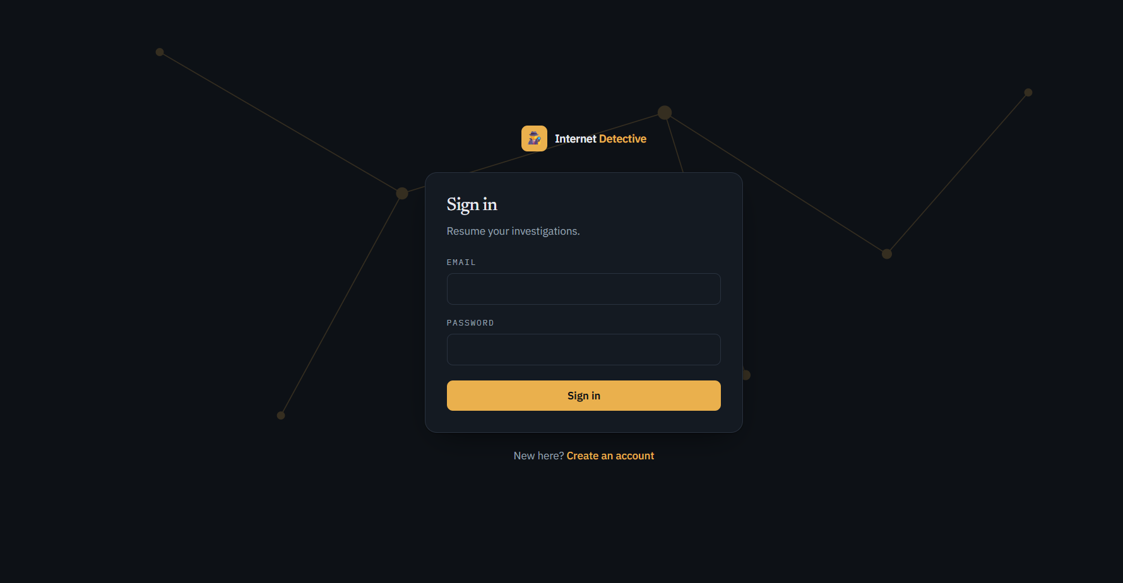
Fig 4.2 — Login / registration screen of the deployed application

4.4 Conclusion & Future Scope
OSINT Sandbox successfully demonstrates that engaging, production-quality cyber-security education can be delivered safely and at zero cost. The project delivers a complete, tested, data-driven OSINT simulation with real security engineering — Argon2id hashing, JWT and rotating refresh tokens, RBAC and an append-only audit log — inside a fully containerized, one-command deployment.
Future scope: the documented roadmap adds a full deterministic six-dimension scoring engine, a "Watson" AI investigation mentor, a public case-authoring studio, leaderboards and multiplayer co-investigation, and richer analytics built on the append-only action log already being captured.

