🧠 1. flex: 1;
👉 Meaning:

Each image will take equal available space inside the flex container.

🔍 How it works:
Your .box has display: flex
So all <img> become flex items

flex: 1 means:

“Give me equal share of space with others”

💡 Example:

If you have 3 images:

Each gets 1/3 width
If 4 images → each gets 1/4 width

👉 No need to manually write width: 33.33%

🧠 2. height: 100%;
👉 Meaning:

Image height = 100% of parent (.box) height

🔍 Example:
.box {
height: 200px;
}

👉 So each image becomes:

Height = 200px
⚠️ Important:

Without this, images will use their natural height, and layout may look uneven.

🧠 3. object-fit: contain; ⭐ (Most Important)
👉 Meaning:

“Fit the image inside the box WITHOUT cutting or stretching”

🔍 What it does:
Keeps original aspect ratio
Prevents distortion
Shows full image always
🎯 Real-life Analogy

Imagine putting photos inside frames:

flex: 1 → All frames are equal size
height: 100% → Frames have fixed height
object-fit: contain → Photo shrinks or grows to fit inside frame without cutting
📊 Visual Understanding
Property What happens
flex: 1 Equal width distribution
height: 100% Same height as container
object-fit: contain No crop, no stretch, full image visible
⚠️ One Important Side Effect

Because of object-fit: contain:

You may see empty space (top/bottom or left/right)

👉 That’s normal — it’s the price for perfect image scaling

🔥 Quick Tip (Pro Insight)

If you ever want:

No empty space → use cover
No distortion → use contain

👉 You choose based on design priority.

If you want, next I can show:

Why images stretch when object-fit is missing (very important concept)
Or how big websites handle this problem perfectly

Just tell me 👍

When to Use object-fit: cover
👉 Use cover when your priority is layout/design, not showing the full image.
.box img {
object-fit: cover;
}

🧠 What cover actually does
“Fill the entire container, even if some part of the image gets cut.”
- ✅ No empty space
- ✅ Looks clean and professional
- ❌ Some part of image may be cropped

📍 Where You SHOULD Use cover

1. 🖼️ Image Galleries / Product Cards
- Example: e-commerce websites
- All images must look same size and aligned
👉 Even if images have different shapes, cover makes them uniform

2. 🎬 Hero Sections / Banners
.hero img {
width: 100%;
height: 400px;
object-fit: cover;
}
- Used in top banners of websites
- Background-like images
- You care about filling space, not full image visibility

3. 👤 Profile Cards / Thumbnails
- Social media posts
- User profile previews
- Blog cards
👉 Clean grid > full image

4. 📱 Responsive Layouts
- When screen size changes
- You don’t want awkward empty gaps

❌ When NOT to Use cover
Avoid cover when:
- 📄 Important content may get cut
(documents, text images, certificates)
- 🛍️ Product must be fully visible
- 🖼️ Logos or diagrams
👉 In these cases, use contain

⚖️ Quick Decision Rule
Situation | Use
Want full image visible | contain
Want perfect layout | cover

🔥 Real-world Insight
Most modern websites:
- Use cover for UI consistency
- Use contain for important visuals

If you want, I can show you:
👉 how to control which part gets cropped (very powerful trick using object-position)


The below image Is the result of object:contain;


Perfect — now I clearly understand what you want 👍
👉 All 3 boxes together should sit exactly in the center of the container (both horizontally + vertically) like a group.

✅ Correct Solution (Flexbox – center group)

🔹 HTML
<div class="box">
<div class="item">1</div>
<div class="item">2</div>
<div class="item">3</div>
</div>

🔹 CSS
.box {
height: 300px;
border: 2px solid black;
display: flex;
justify-content: center; /* ✅ center horizontally */
align-items: center; /* ✅ center vertically */
gap: 20px; /* space between boxes */
}
.item {
height: 120px;
width: 120px;
border: 3px solid black;
background-color: yellow;
display: flex;
justify-content: center;
align-items: center;
}

🧠 What’s happening here
- justify-content: center
👉 moves the whole group to the center (left ↔ right)
- align-items: center
👉 moves the whole group to middle (top ↕ bottom)
- gap
👉 adds space between the 3 boxes

⚠️ Important difference (very important)
Earlier you used:
justify-content: space-between;
❌ That spreads items across full width
Now:
justify-content: center;
✅ keeps them together in center (what you want)

🔥 Result (visual idea)
|--------------------------------|
| |
| [ ] [ ] [ ] |
| |
|--------------------------------|

If you want next level:
👉 I can show how to make it perfect center of full screen (like login page UI)
👉 Or how to animate them when hovering (very cool effect)
why display flex is applied to coaniner and box items both
Great question 👍 — this is where many people get confused, but once you get it, layouts become super easy.

🔥 Short Answer
We use display: flex on both because they do different jobs:
- .box → controls position of items
- .item → controls content inside each item

🧠 Step-by-step understanding

✅ 1. display: flex on .box (PARENT)
.box {
display: flex;
}
👉 This makes .box a flex container
👉 Its children (.item) become flex items
Now you can control:
- horizontal alignment → justify-content
- vertical alignment → align-items
- spacing → gap
✔ Example:
justify-content: center;
align-items: center;
➡️ This centers the 3 boxes as a group

✅ 2. display: flex on .item (CHILD)
.item {
display: flex;
}
👉 Now each .item becomes a flex container too
So you can center its own content (like text or icon inside)
✔ Example:
justify-content: center;
align-items: center;
➡️ This centers the text "1", "2", "3" inside each box

🎯 Visual Understanding

Without flex on .item
[ 1 ] ❌ text stuck in corner

With flex on .item
[ 1 ] ✅ perfectly centered

⚡ Final Summary
Where applied | Purpose
.box { display:flex } | Arrange & center boxes
.item { display:flex } | Center content inside box

💡 Simple rule to remember
Flexbox works one level at a time
- Parent → controls children
- Child → controls its own content

If you want, I can show you:
👉 same layout using CSS Grid (even more powerful)
👉 or how big websites use this in real UI layouts
where to alter when i want to change the size and height of the boxes inside the conainer
Great question 👍 — this is exactly where control becomes clear.

🎯 Where to change box size?
👉 You should change it in .item, NOT .box

✅ Example
.item {
height: 120px; /* 🔹 change height here */
width: 120px; /* 🔹 change width here */
border: 3px solid black;
background-color: yellow;
}

🧠 Why?
- .box = container (parent) → controls layout/position
- .item = boxes (children) → controls size of each box

⚠️ Important mistakes to avoid

❌ 1. Don’t use flex: 1 if you want fixed size
flex: 1; /* ❌ this overrides width */
👉 It makes boxes stretch automatically

❌ 2. Don’t try to control size from .box
.box {
width: ??? ❌ doesn't control inner box size
}

🔥 Want different sizes for each box?
.item:nth-child(1) {
width: 100px;
height: 100px;
}
.item:nth-child(2) {
width: 150px;
height: 120px;
}
.item:nth-child(3) {
width: 120px;
height: 140px;
}

💡 Quick rule (remember this)
If you want to change the boxes → go to .item
If you want to change the layout → go to .box

If you want next step, I can show:
👉 how to make boxes responsive (auto resize on mobile)
👉 or how to keep them fixed but container flexible (real-world UI trick)

🧠 1. justify-content
justify-content: center;

👉 What it does
Controls alignment of CHILD ELEMENTS inside a container along the main axis
- In flex-direction: row (default) → horizontal
- In flex-direction: column → vertical

✅ Example (Flexbox)
.box {
display: flex;
justify-content: center;
}
➡️ Moves all .item boxes to the center horizontally

🧠 2. align-items
align-items: center;

👉 What it does
Controls alignment of CHILD ELEMENTS along the cross axis
- In flex-direction: row → vertical
- In flex-direction: column → horizontal

✅ Example
.box {
display: flex;
align-items: center;
}
➡️ Moves all .item boxes to the center vertically

🧠 3. justify-items
justify-items: center;

👉 What it does
Controls alignment of content INSIDE each grid item
⚠️ Important:
- ❌ DOES NOT work in Flexbox
- ✅ Works in CSS Grid

✅ Example (Grid)
.box {
display: grid;
justify-items: center;
}
➡️ Centers content inside each grid cell

⚠️ In YOUR case (Flexbox)
You wrote:
justify-items: center; ❌
justify-content: center; ✅
align-items: center; ✅
👉 So:
- justify-items → useless here (ignore it)
- justify-content → centers boxes left ↔ right
- align-items → centers boxes top ↕ bottom

🎯 Visual Summary

Flexbox (your layout)
Main Axis (→) = justify-content
Cross Axis (↓) = align-items

💡 Bonus (important concept)
If you want to center content inside each box, use:
.item {
display: flex;
justify-content: center;
align-items: center;
}

🔥 Final Rule (remember this)
Property | Works in | Controls
justify-content | Flex + Grid | Position of children
align-items | Flex + Grid | Cross-axis alignment
justify-items | Grid only | Content inside items

The flexbox, also known as the flexible box layout module, helps you efficiently design and build responsive webpages without using many positioning and float properties. Even when the size of flex items is unknown, you can easily resize and reposition the flex container and its items one-dimensionally and lay out the items to best fit the space available in the container.
According to caniuse.com, all modern browsers support the CSS flexible box layout module.
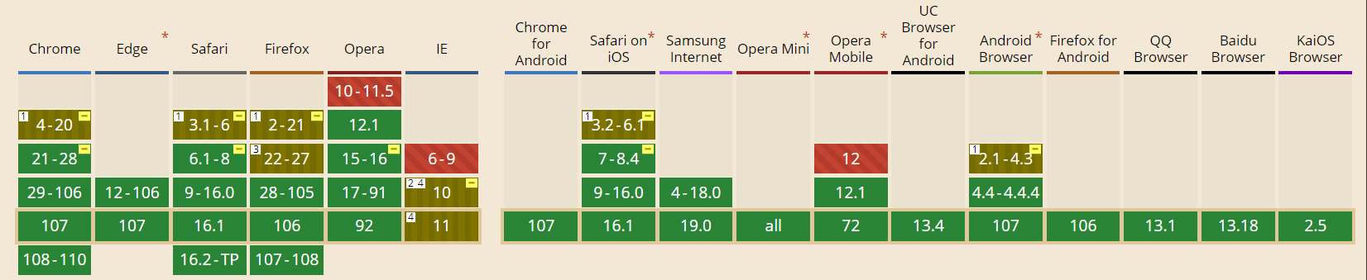

Basics and Terminology
First, let’s familiarize ourselves with the key terms commonly used in flexbox:
- Flex line: Flex items are aligned along a flex line inside the flex container. By default, in a flex container, there’s only one flex line.
- Main axis: The primary axis along which the flexible components are arranged. Depending on the flex-direction property, this can be either vertical or horizontal.
- main-start edge and main-end edge: Flex items are arranged in the flex container from the main-start edge toward the main-end edge.
- Cross axis: Axis perpendicular to the main axis.
- cross-start edge and cross-end edge: In the container, flex lines start at the cross-start edge and end at the cross-end edge.


Syncfusion JavaScript UI controls are the developers’ choice to build user-friendly web applications. You deserve them too.
Explore Now

Getting Started
To start using the flexbox layout module, you first need to define the container as a flex container. Take a look at the following example.
<div class="flex-container">
<div class="flex-item">1</div>
<div class="flex-item">2</div>
<div class="flex-item">3</div>
<div class="flex-item">4</div>
<div class="flex-item">5</div>
</div>
What you have to do is to set the container’s display property to flex. Then, it automatically converts the flex container’s direct child elements to flex items.
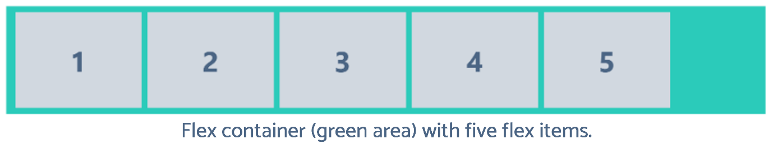

Flex Container Properties
Flex container properties define how browsers should lay out the items within the flexible box. There’re six flex container properties. Let’s walk through them:
- flex-direction: Specifies the direction in which the flex items should be positioned inside the flexible container. Flexbox is a single-direction layout concept. Therefore, the flex items can only be stacked in vertical columns or horizontal rows. The flex-direction property accepts four values:
  - row (default): Stacks the flexible items horizontally, from left to right.
  - column: Stacks the flexible items vertically, from top to bottom.
  - row-reverse: Stacks flex items horizontally, from right to left.
  - column-reverse: Stacks flex items vertically, from bottom to top.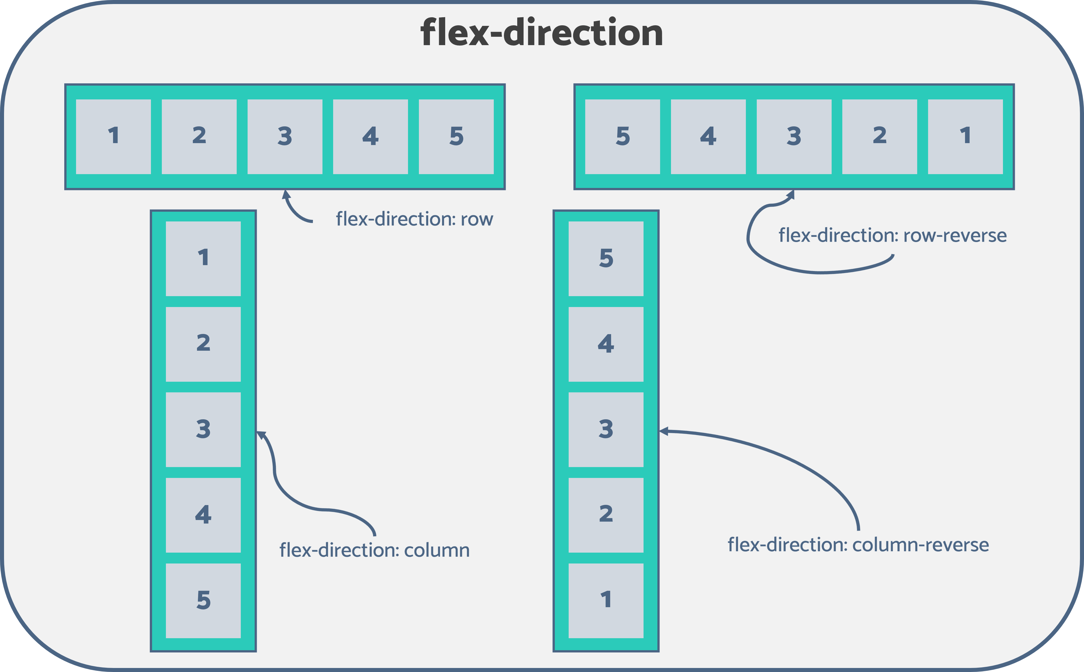
- flex-wrap: Flex items will attempt to fit into a single line by default. Thus, the excess items will overflow the container if all the flex items’ combined height (or width) is greater than the flexbox’s height (or width). flex-wrap indicates whether the overflowing flex items should be wrapped across multiple lines or not. The flex-wrap property accepts the following three values:
  - nowrap (default): Forbids wrapping the flex items and forces all the items to be on a single line. This may cause an overflow of flex items out of the container.
  - wrap: Wraps the flex items into multiple lines, if necessary.
  - wrap-reverse: Functions similarly to wrap but in reverse order.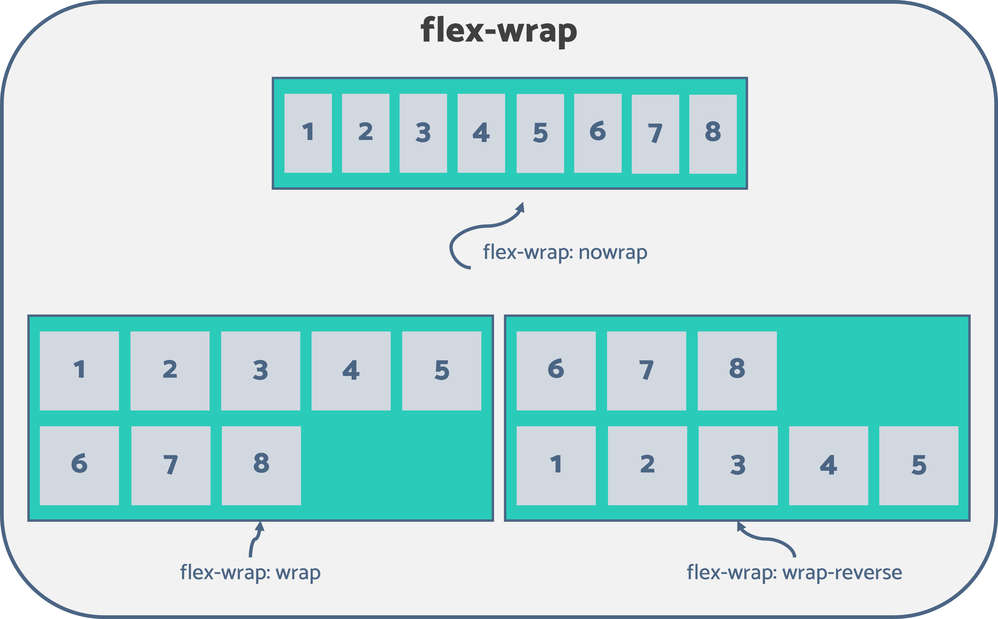
- flex-flow: This is the shorthand property to simultaneously set both flex-direction and flex-wrap properties. Refer to the following code example.
- .flex-container {
- display: flex;
- flex-direction: row-reverse;
- flex-wrap: wrap;
- }


Every property of the Syncfusion JavaScript controls is completely documented to make it easy to get started.
Read Now

You can alternatively use the following.
.flex-container {
display: flex;
flex-flow: row-reverse wrap;
}
- justify-content: Used to specify how the browser should align the flex items along the main axis of the flexbox. It defines how the space between and around the flexible items is distributed along the container’s main axis. The following values are accepted for this property:
  - flex-start (default): Aligns the flex items to the beginning (main-start edge) of the flexbox’s main axis.
  - flex-end: Aligns the flex items to the end (main-end edge) of the flexbox’s main axis.
  - center: Flexible items are centered along the flexbox’s main axis.
  - space-around: Flex items are evenly distributed along the main axis by allocating equal space to both sides of an item. Here, the space between the container’s main-start (or main-end) edge and the first (or last) flex item is half the width of the area compared to the distance between the two items.
  - space-between: Aligns the first item to the main-start edge and the last item to the main-end edge of the main axis and creates even spacing between each adjacent flexible item.
  - space-evenly: Within the container, flex items are distributed uniformly along the main axis. The space between each pair of subsequent items is equivalent to the distance between the first (or last) flex item and the container’s main-start (or main-end) edge.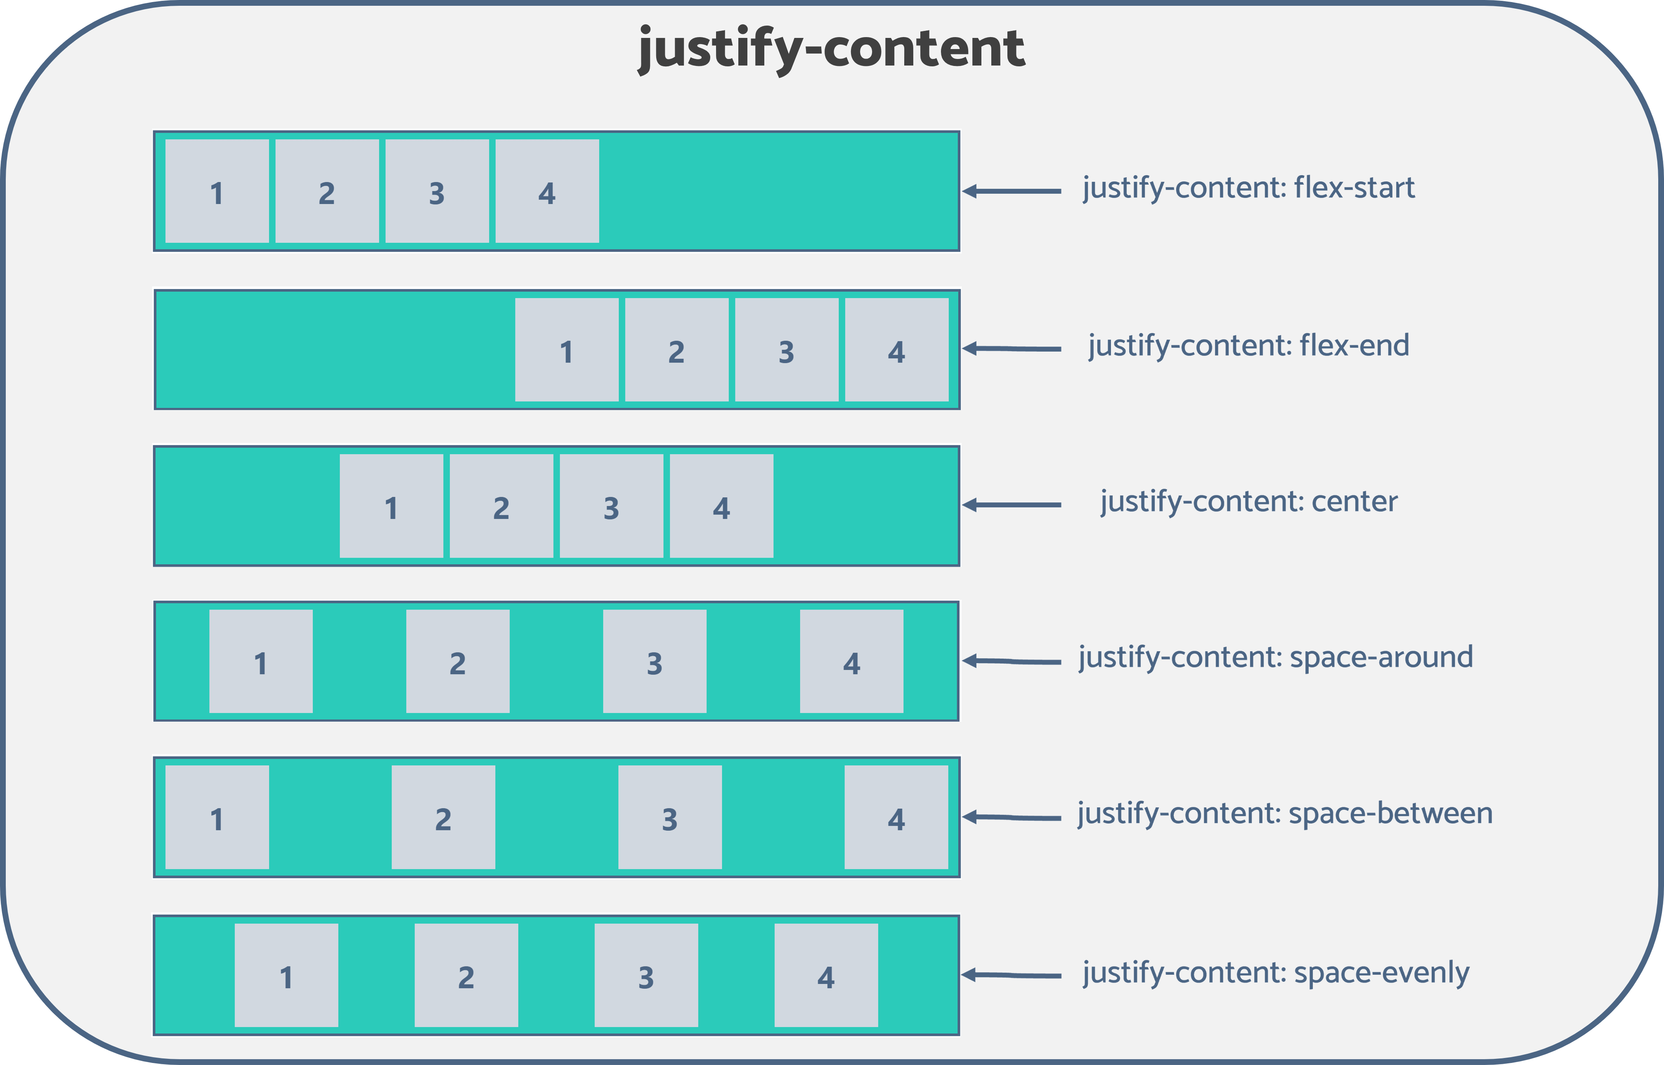
  - align-items: Used to specify how the browser should position the flex items along the cross-axis of the flexbox. Its behavior is similar to justify-content but perpendicular to the main axis. The following values are accepted for this property:

      - stretch (default): Stretches the flex items to fill the container’s vertical space while respecting the height and width constraints.
      - center: Aligns the flex items to the middle of the container, or in other words, to the center of the container’s cross-axis.
      - flex-start: Aligns the flex items at the cross-start edge. This means flexible items are aligned vertically at the top of the container.
      - flex-end: Aligns the flex items at the cross-end edge. This means flexible items are vertically aligned at the bottom of the container.
      - baseline: Aligns the flex items at the baseline of the cross-axis.
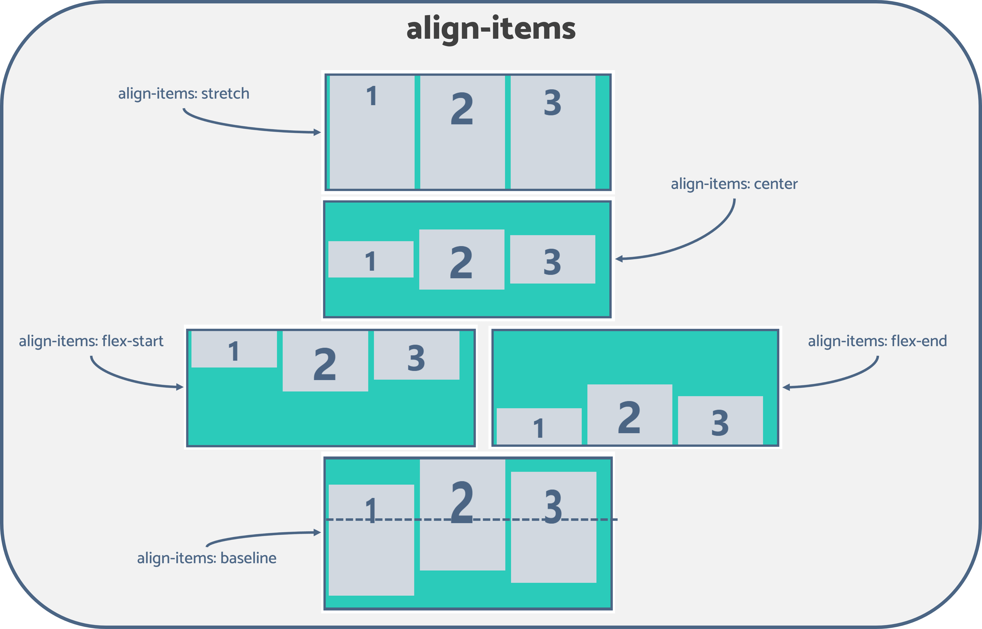


To make it easy for developers to include Syncfusion JavaScript controls in their projects, we have shared some working ones.
Try Now

- align-content: Its behavior is similar to how the justify-content aligns flex items along the main axis when there’s extra space available in the main axis. But instead of the items, align-content aligns the flex lines and tells the browser how to position the flex container’s lines along the cross-axis. The following values are accepted for this property:
  - stretch (default): Fills up the vertical space by equally distributing the remaining space amongst the flex lines.
  - space-between: The first and last flex lines are aligned to the cross-start and the cross-end edges of the container, respectively, while creating equal spacing between each pair of lines between the first and last lines.
  - space-evenly: Flex items are equally distributed by assigning even space above the first line, between two flex lines, and below the last line.
  - space-around: Similar to space-evenly, but here it adds equal spacing around each line. Therefore, the space before (or after) the first (or last) line is half the width of the distance between two adjacent lines.
  - flex-start: Each flex line will only fill the space it needs and move toward the cross-start edge of the container.
  - flex-end: Each line will only fill the space it needs and move toward the container’s cross-end edge.
  - center: Similar to flex-start and flex-end, but the flex lines are aligned to the center of the container’s cross-axis.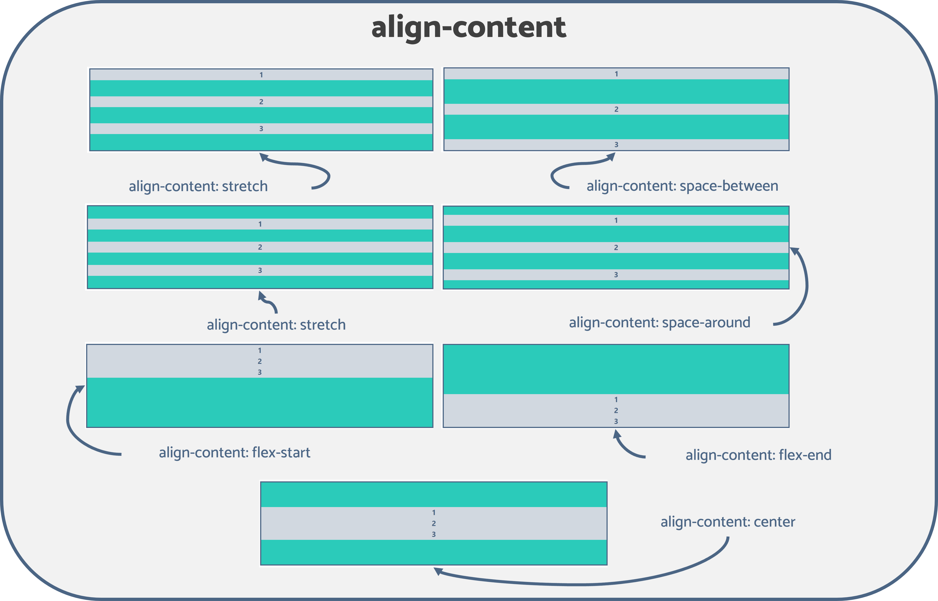
Note: align-content doesn’t work on single-line flex containers. To have an effect, the flexbox must be a multiline container with the flex-wrap property set to either wrap or wrap-reverse.


Syncfusion JavaScript controls allow you to build powerful line-of-business applications.
Try Now

Flex Item Properties
Flex item properties define how browsers should lay out a specific item within the flexible box. There are six types of flex container properties. Let’s walk through them:
- order: By default, flex items are positioned based on the order defined in the HTML code. The order property specifies the order in which the flex items should appear in the flex container. The value must be a number, and by default, it is 0.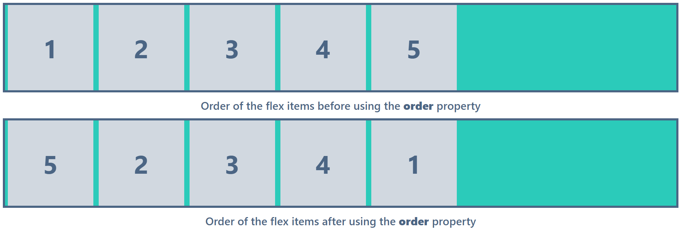
Take a look at the previous example. I’ve set the order property value of the first and last items to order: 5 and order: 1, respectively, to swap the two elements.
Note: Try to rearrange the HTML code and use the order property only if it’s actually required, as it can confuse the readers of the HTML document.
- flex-grow: Defines how much a flex item should grow relative to the other flex items inside the same container to fill up the excess space of the container. The value should be unitless, and the default is 0. If the flex-grow property is set to an equal value for all flex items, the remaining space of the flexbox will be distributed evenly among all items.
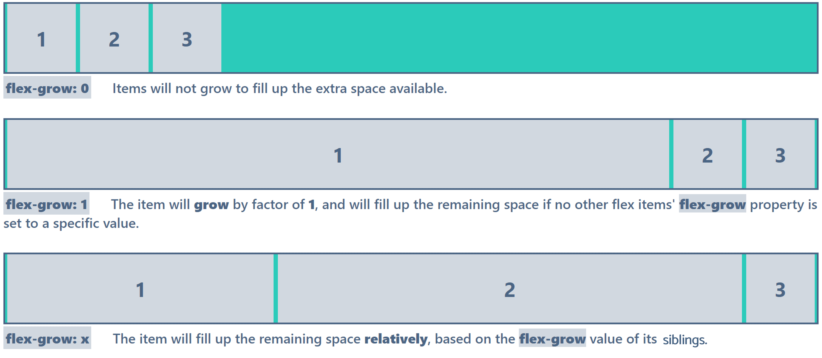
- flex-shrink: Defines how much a flex item should shrink relative to the other flex items when there’s not enough space in the container. The default value is 1.
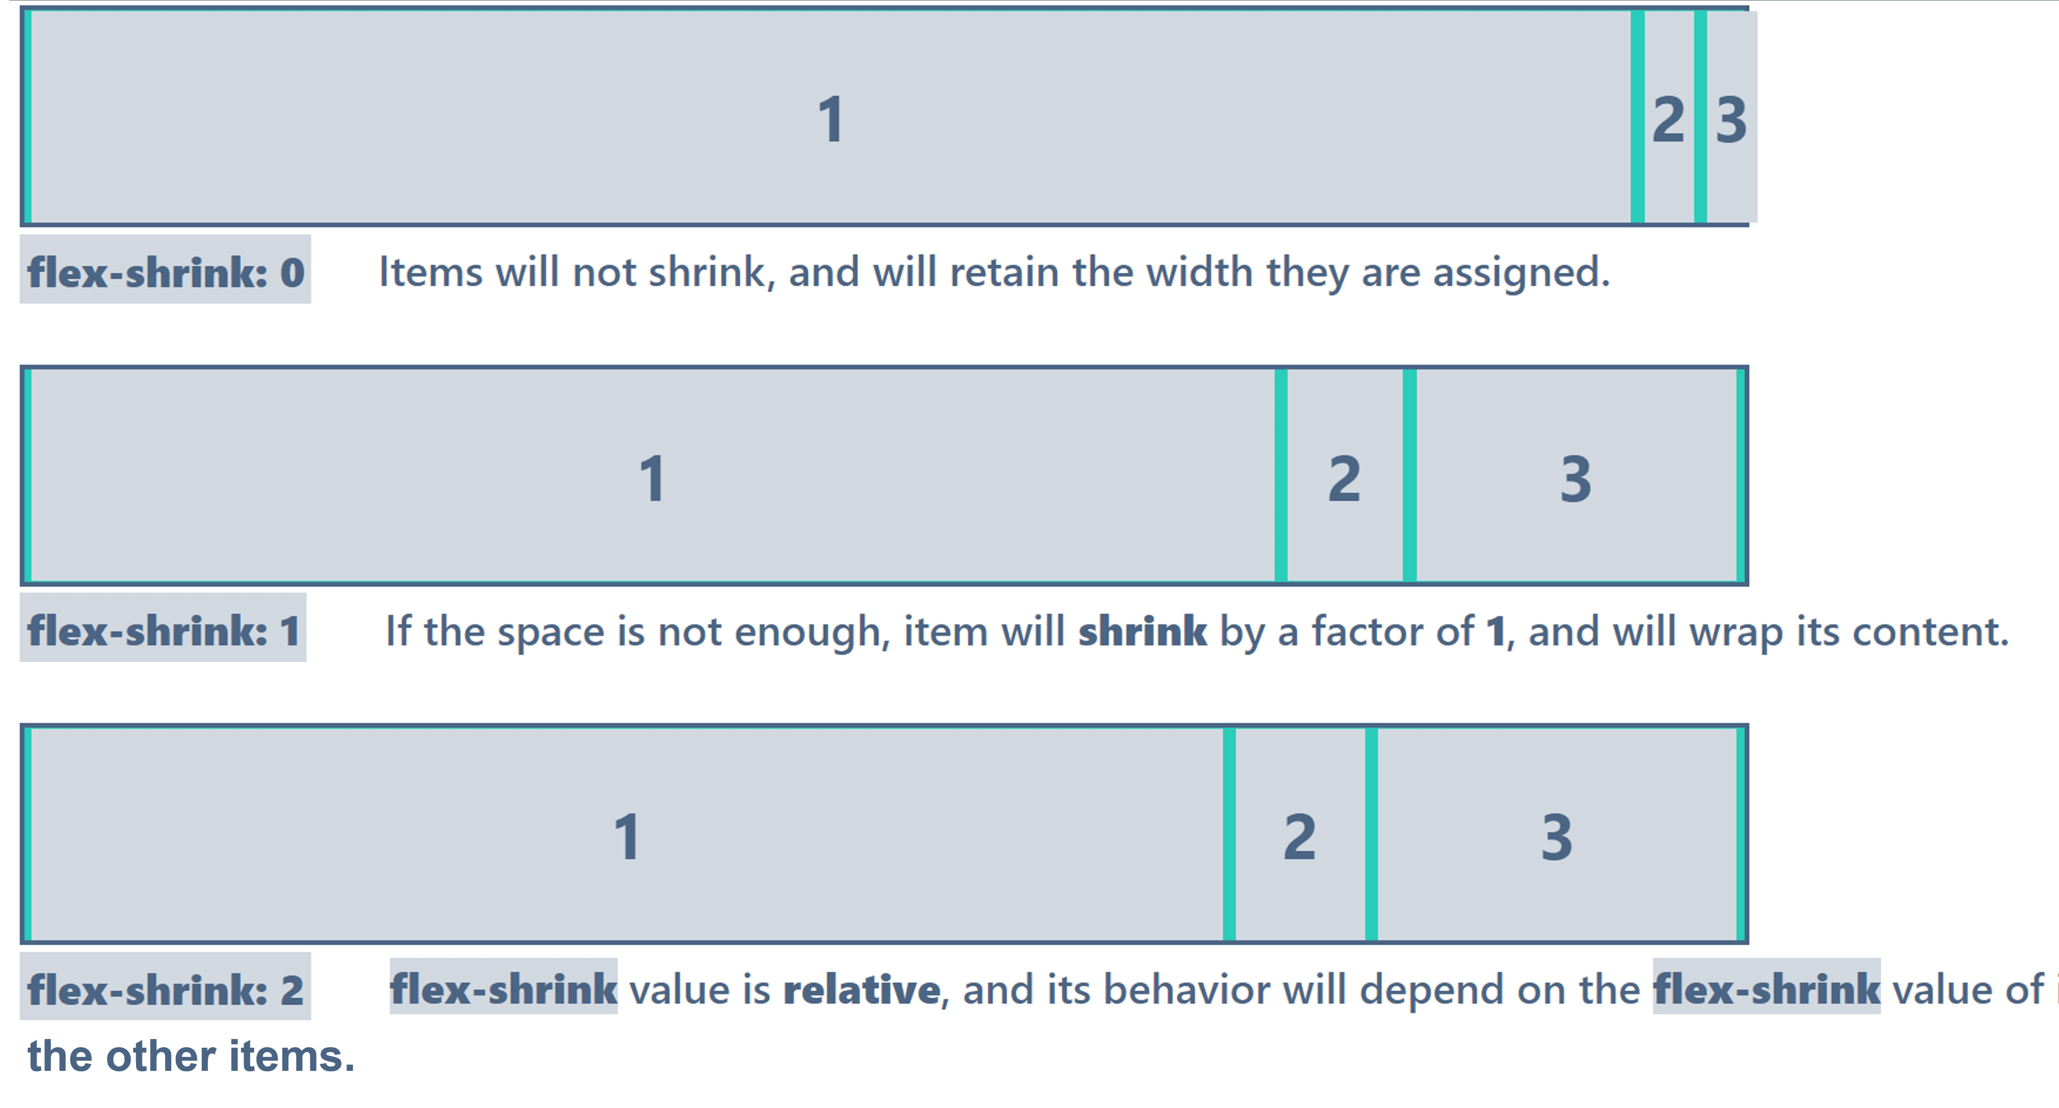
- flex-basis: Defines the initial length of a flex item.
- flex: The shorthand property to set the flex-grow, flex-shrink, and flex-basis values at once. The default is flex: 0 1 auto.
Note: flex: initial (default) is equivalent to flex: 0 1 auto; flex: auto is equivalent to flex: 1 1 auto; flex: none is equal to flex: 0 0 auto; flex: inherit inherits the flex property values of its parent element, as the name suggests.
- align-self: This works similarly to the align-items property. However, the align-self doesn’t impact every flexible item in the container but only a selected item. Furthermore, it overrides the align-items property and defines the alignment of a selected item inside the flexbox.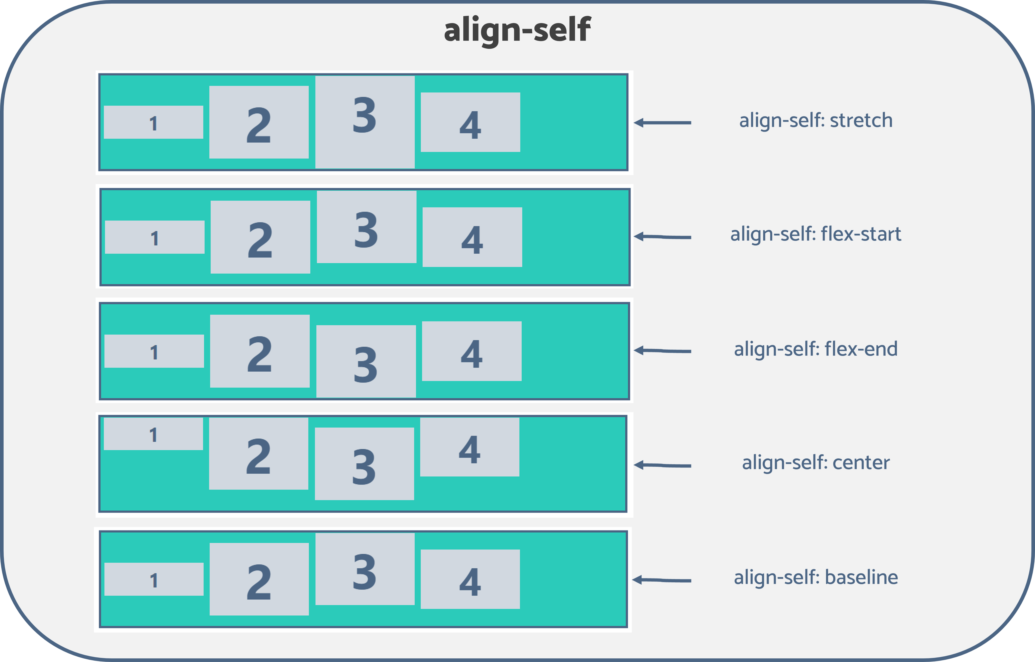

Conclusion
This article discussed everything you need to know about the flexbox layout module to create a responsive website layout. However, it is vital to note its shortcomings. Although the flexbox layout works well for pages, it needs more flexibility in large and complex applications, especially when resizing, shrinking, stretching, or changing orientation.
The Syncfusion JavaScript suite will be the only suite you will ever need to build an application. It contains over 65 high-performance, lightweight, modular, and responsive UI components in a single package. Download the free trial and evaluate the controls today.
If you have any questions or comments, you can contact us through our support forums, support portal, or feedback portal. We are always happy to assist you

