2.55.

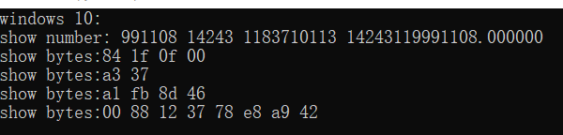

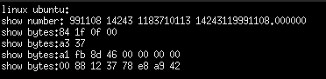

2.59. (x&0x000000ff)|(y&0xffffff00)

2.63.

unsigned srl(unsigned x, int k){

unsigned xsra = (int) x >> k;

unsigned x = ~0 << (8 * sizeof(int) – k);

return xsra & (~x);

}

unsigned sra(int x, int k){

int xsrl = (unsigned) x >> k;

unsigned flag = (xsrl & (1 << (8 * sizeof(int) - k-1)));

if(flag) return xsrl & (~0 << (8 * sizeof(int) – k));

else return xsrl;

}

2.67.

A.在移位时超过sizeof(x)，发生未定义行为；

B.将代码第6行改为int beyond_msb = 2 << 31;

C.int int_size_is_32()

{

int x = 1 << 15 << 1;

int set_msb = x << 15;

int beyond_msb = set_msb << 1;

return set_msb && !beyond_msb;

}

2.71.

A.xbyte函数的返回值是int，但实际返回的却是unsigned

B.int xbyte(packed_t word, int bytenum)

{

unsigned x = word << (3 - bytenum) * 4 << 12;

return (int)(x>>24);

}

2.75. 见75题.c

2.79.

int mul3div4(int x){

int pro=(((x<<1) & 0x3)+(x & 0x3)) >> 2;

return (x>>2)+(x>>1)+pro;

}

2.83

A. x=Y/(2^k-1)

B.(a) 5/7 (b)2/5 (c)19/63

2.87.

|  |  |  |  |  |  |
| --- | --- | --- | --- | --- | --- |
| 描述 | Hex | M | E | V | D |
| -0 | 8000 | 0 | -15 | -0 | -0.0 |
| 最小的>2的值 | 4001 | 1025/1024 | 1 | 1025*2^(-9) | 2.00195315 |
| 512 | 6000 | 1 | 9 | 512 | 512.0 |
| 最大的非规格化数 | 03FF | 1023/1024 | -14 | 1023*2^(-24) | 0.000060976 |
| -∞ | FC00 | — | — | -∞ | -∞ |
| 十六进制表示为3BB0的数 | 3BB0 | 955/512 | 13 | 955*2^(4) | 15280 |

2.91.

A. 11.0010 0100 0011 1111 0110 11

B.11.001001001……

C.9

2.95. 见95题.c