Associate Rule: coffeeshop why there are several bottles of water right in front of the cashier / were places in the most obvious location in the store

Supervised learning:

Classification / categorization: labels are a set of values (eye colors: blue, green, brown, black.)

Regression: real number / numerical values: temperature in Las Vegas; the stock price



Unsupervised learning

* clustering

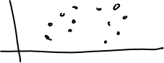

array (fix size + element is in order with the corresponding index)



|  |  |  |  |  |  |  |  |  |  |
| --- | --- | --- | --- | --- | --- | --- | --- | --- | --- |
| 1 | 2 | 4 | 5 | 2 | 3 | 5 | 2 | 4 | 1 |

