**Supervised learning**: classification

Similarity measure and distance measure (Euclidean, city block, and supreme)

Binary: jaccard coefficient and simple matching coefficient

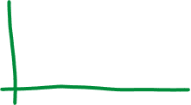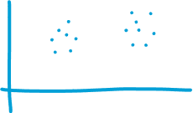

**Unsupervised learning**: clustering

Distance measures of different group

