**Topics in CS: Behavior Modeling**

**6370-91L / 434190L Spring 2021**

**Dr. Beiyu Lin**

**Tue 6:30 – 9:00 pm**

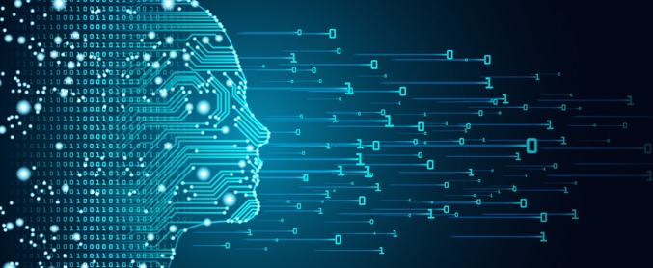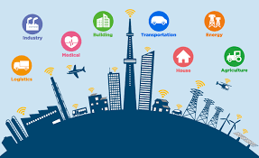

**We will explore state-of-art algorithms to train systems to learn/mimic behavior from experts (e.g., human) based on ambient data (e.g., data collected from smart phones, fitbit, web browser, and GPS). Now, you can design and make your own home/phone/fitbit/computer mouse smarter!**