**Lab 7:** Value-returning functions

**Problem:** Suppose your geometry professor asks you to create a program that calculates the surface areas of a cube and a sphere.

In order to find these two values, your program needs to get the side of the cube and the radius of the sphere first and then, using them, calculate the corresponding areas using the formulas shown below.

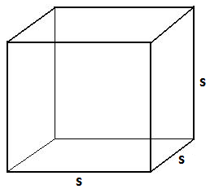 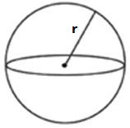

**Surface area of cube: 6** x **s 2 Surface area of sphere: 4** x **π** x **r 2**

The values corresponding to **s** (side of the cube), **r** (radius of the sphere), and the calculated areas must be **double precision real** numbers.

**Your task:** implement in C++ the algorithm solution shown below.

------------------------------------------------------------------------------------------------------------------------

**Algorithm solution (in pseudocode)**:

To solve this problem your program must perform the following tasks:

1. 2 points. Declare a global constant variable named PI that holds value 3.141592
   1. #define PI 3.1415825
2. 2 points. Declare variables named side, radius, s_cube, and s_sphere that hold double precision real numbers
3. 2 points. Prompt the user to "Enter side of cube : "
4. 2 points. Read from keyboard the value entered by the user and assign it to side
5. 2 points. Prompt the user to "Enter radius of sphere : "
6. 5 points. Read from keyboard the value entered by the user and assign it to radius
7. 5 points. Call cube_surf() to calculate the surface area of the cube and assign the result to s_cube
8. 5 points. Call sphere_surf() to calculate the surface area of the sphere and assign the result to s_sphere
9. 5 points. Clear the screen
10. 5 points. Format the output to display the numbers in fixed format with two decimal digits
11. 5 points. Display on the screen the message

"The surface of a cube of sides ", side, " is ", s_cube

"The surface of a sphere of radius ", radius, " is ", s_sphere

You need to define four value-returning functions to implement this solution:

1) 15 points. To calculate the square of a number you **must** define a **value-returning** function named **square**( ). It receives a real number and returns its squared value (a real number). You must use it to calculate the

squares of side and radius. ***Do NOT use pow() in this function to determine the square of the value received.***

2) 15 points. To calculate the surface area of the cube you **must** define a **value-returning** function named **cube_surf( )**. It receives the side of the cube (a real number) and returns the calculated area (a real number) rounded to the second decimal digit. To round this and next area use the round_off() function that you created for lab 6 (see below please).

3) 15 points. To calculate the surface area of the sphere you **must** define a **value-returning** function named **sphere_surf( )**. It receives the radius of the sphere (a real number) and returns the calculated area (a real number) rounded to the second decimal digit.

4) 15 points. To round a number define a **value-returning** function named **round_off( )**. It receives the number to be rounded (a real number) and the number of decimal digits that the number should be rounded to (a whole number), and returns the number rounded to the specified number of decimal digits.

The program must compile without errors or warnings.

Create a project if necessary (or use one that is already open) and **add the existing item** named **lab07_FML.cpp** (provided with this handout).

Implement the above algorithm (already provided in the source code as comments).

**Note:**

* Do NOT remove or modify the statements that I use to test certain things in your program.
* Run my sample solution to know how your program must behave. Pay attention to the input and the output formats. Your solution must behave exactly like mine.
* Carefully analyze the following figure and use it as a reference to ensure you do the right things.

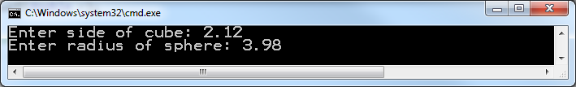Input

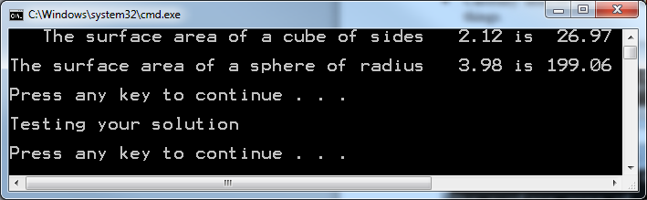Output

* Test and compare your solution with mine for different values of side and radius to ensure they always produce the same outputs. Pay attention to the output format.
* Ensure your formulas do not use mixed data types.

To write your program, review the concepts learned in class (review examples discussed in class) and read the book (analyze the examples in it).

I am posting my solution for your reference. Please run it and ensure that your program works like mine. If you get an error message on the output, read the comment on the line specified in the message to find out what is wrong. If you have concerns or specific questions, post them on the Discussion Board of Blackboard.

Don't forget to include at the top of the program the comments shown below with your information (name, class and section number, etc.)

/////////////////////////////////////////////////////////////////////

//

// Name: <Put your name here>

// Date: <Today's date>

// Class: <Your class number and section number, like: CSCI 1370>

// Semester: <This semester, like: Fall 2012>

// CSCI/CMPE 1370 Instructor: <Your lecture instructor's name>

//

// Program Description: Enter here **your** description of what the program does

//

/////////////////////////////////////////////////////////////////////

Please rename your file **lab07_FML.cpp** (replace F, M. and L with the initials of your first, middle (if any), and last names). Do not include blank spaces in the name of the file please.

***When done, submit your solution through Blackboard using the “Assignments” tool. Do Not email it.***

The following is the basic criteria to be used to grade your submission:

You start with 100 points and then lose points as you don't do something that is required.

-6: no declaration/use of the constant

-3: incorrect declaration of the constant

-5: wrong variable names

-5: wrong data types

-5: no/too few comments

-5: mixed data types in expression

-5: did not display two decimal digits

-10: didn't round the value off

-5: incorrect way to round the value off

-20: didn't implement the required functions (each)

-10: incorrect implementation of the function (each)

-7: incorrect function call (each)

-5: incorrect input format

-5: incorrect output format

-50: program doesn't compile

-10: Late

**Important:** more points may be lost for other reasons not specified here.

The following are sample runs of the program.

