**Lab 8:** Value-returning and void functions

**Problem:** Suppose your math professor asks you to create a calculator to determine the volume of a cone based on its height and radius. To make it more charming you decide that your program will ask the user’s name before asking for the needed data to calculate the volume. You must use the formula shown below where r is the radius and h is the height of the cone.

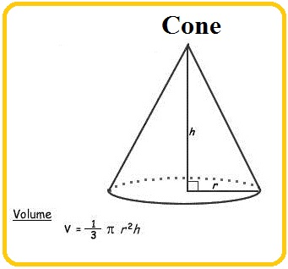

The **height** and the **radius** must be **whole** numbers but the **volume** must be a **double precision real** number with three decimal digits.

**Your task:** implement in C++ the algorithm solution shown below.

------------------------------------------------------------------------------------------------------------------------

**Algorithm solution (in pseudocode)**:

To solve this problem your program must perform the following tasks:

5 points. Declares a global **constant variable** called **PI** that holds value **3.141592**

5 points. Declares a variable named **name** that holds text.

5 points. Declares variables named **height** and **radius** that hold **whole** numbers.

5 points. Declares a variable named **volume** that holds **double** precision **real** numbers.

5 points. Prompts the user "May I get your first name please?: ".

10 points. Reads the value from the keyboard and stores it in **name**.

5 points. Prompts the user "Thanks ", name, " , now enter height and radius of the cone please: ".

10 points. Reads the values from the keyboard and stores them in **height** and **radius** respectively.

35 points. Calculates the volume using the formula shown in the figure above*.

5 points. Rounds the volume to the nearest thousandths (three decimal digits) and reassigns it to **volume.**

5 points. Formats the output to display the volume in **fixed** format with **three** decimal digits.

5 points. Prints a message like the one below:

"Ok ", **name** , “ the cone's volume is ", **volume**

*Implement this formula exactly as it is displayed.

You need to define three value-returning and one void functions to implement this solution:

1) To calculate the square of a number you **must** define a **value-returning** function named **square**( ). It receives a real number and returns its squared value (a real number). You must use it to calculate the square of the radius. ***Do NOT use pow() in this function to determine the square of the value received.***

2) To calculate the volume of the cone you **must** define a **value-returning** function named **volume_cone( )**. It receives the radius and the height of the cone (whole numbers), and returns the calculated volume (a real number) rounded to the third decimal digit. To round the volume use the round_off() function that you created for lab 6 (see below please).

3) To round a number define a **value-returning** function named **round_off( )**. It receives the number to be rounded (a real number) and the number of decimal digits that the number should be rounded to (a whole number), and returns the number rounded to the specified number of decimal digits.

4) To print the data you **must** define a **void** function named **print_data( )**. It receives the name (text), the radius of the cone (a whole number), the height of the cone (a whole number), and the volume of the cone (a real number). After formatting the output to display the volume in fixed format with three decimal digits it displays the following message (n, r, h, and v are the name, the radius, the height, and the volume respectively):

"Ok ", n

"For a radius: ", r, " and a height: ", h, " the cone's volume is ", v

The program must compile without errors or warnings.

Create a project if necessary (or use one that is already open) and **add the existing item** named **lab08_FML.cpp** (provided with this handout).

Implement the above algorithm (already provided in the source code as comments).

**Note:**

* Do NOT remove or modify the statements that I use to test certain things in your program.
* Run my sample solution to know how your program must behave. Pay attention to the input and the output formats. Your solution must behave exactly like mine.
* Carefully analyze the following figure and use it as a reference to ensure you do the right things.

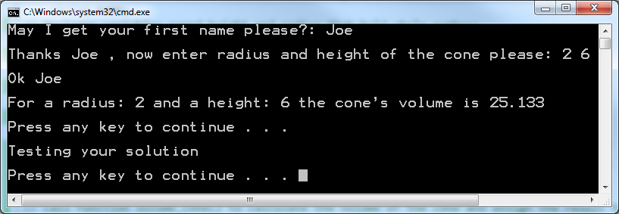

* Test and compare your solution with mine for different values of radius and height to ensure they always produce the same outputs. Pay attention to the output format.
* Ensure your formula does not use mixed data types by defining your literal values appropriately and using the static_cast operator where needed.

I am posting the executable of my solution for your reference. Please run it and ensure that your program works like mine. Try different values for the height and radius (for example, 3 and 4 respectively) and compare the results returned by your solution with mine. If you have concerns or specific questions, post them on the Discussion Board of Blackboard.

Don't forget to include at the top of the program the comments shown below with your information (name, class and section number, etc.)

/////////////////////////////////////////////////////////////////////

//

// Name: <Put your name here>

// Date: <Today's date>

// Class: <Your class number and section number, like: CSCI 1370.02>

// Semester: <This semester, like: Spring 2012>

// CSCI/CMPE 1370 Instructor: <Your lecture instructor's name>

//

// Program Description: Enter here **your** description of what the program does

//

/////////////////////////////////////////////////////////////////////

Please name your file **lab8_FML.cpp** (replace F, M. and L with the initials of your first, middle (if any), and last names). Do not include blank spaces in the name of the file please.

***When done, submit your solution through Blackboard using the “Assignments” tool. Do Not email it.***

The following is the basic criteria to be used to grade your submission:

You start with 100 points and then lose points as you don't do something that is required.

-6: no declaration/use of the constant

-3: incorrect declaration of the constant

-5: wrong variable names

-5: wrong data types

-5: no/too few comments

-5: mixed data types in expression

-5: did not display three decimal digits

-5: didn't round the value off

-5: incorrect way to round the value off

-20: didn't implement the required functions (each)

-10: incorrect implementation of the function (each)

-7: incorrect function call (each)

-5: incorrect input format

-5: incorrect output format

-50: program doesn't compile

-10: Late

**Important:** more points may be lost for other reasons not specified here.

The following are sample runs of the program.

