Note:
1). HW1: It’s okay not to do the floor function (no points will be toke off); for those who did it, extra credits will be added to Team Work Incentive (as listed on syllabus).

Lab 3: Rounding values and formatting the output Due: 9/11/20

Problem: Calculate the total cost of a product and display the result on the screen.
Your solution must ask the user to enter the price followed by the percentage corresponding to taxes (in this order) at the keyboard and then calculate and display the resulting cost.

------------------------------------------------------------------------------------------------------------------------
Your task: implement in C++ the algorithm solution shown below.

------------------------------------------------------------------------------------------------------------------------

Algorithm solution (in pseudocode):

Total = Price x (1 + Taxes)
100

To solve this problem your program must perform the following tasks:

Declare variables named price, tax, and total that hold single precision real numbers.
Prompt the user to "Enter the price and tax (%) please: ".
Read the values from the keyboard and store them in price and tax respectively.
Calculate the total cost using the expression shown above and assign the resulting value to total.
Round the value of total to integer and reassign the rounded value to total
Format the output to display the values in fixed format with integer.
Print a message like the one below:

“For a price $”, P, “and “, X “% tax, the total cost of the product is $”, T

where P, X, and T are the values corresponding to variables price, tax, and total respectively.

Note: ensure your expression does not use mixed data types by defining your literal values appropriately (pay attention to the data type of the variables you are using in the expression).

------------------------------------------------------------------------------------------------------------------------

The program must compile without errors or warnings.

Create a project if necessary (or use one that is already open) and add the existing item named lab03_FML.cpp (provided with this handout).
Implement the above algorithm (already provided in the source code as comments). Your C++ statements MUST be right below EACH step they implement.
Note:
- Do NOT remove or modify the statements that I use to test certain things in your program.
- Run my sample solution to know how your program must behave. Pay attention to the input and the output formats. Your solution must behave exactly like mine.
- Carefully analyze the following figure and use it as a reference to ensure you do the right things.

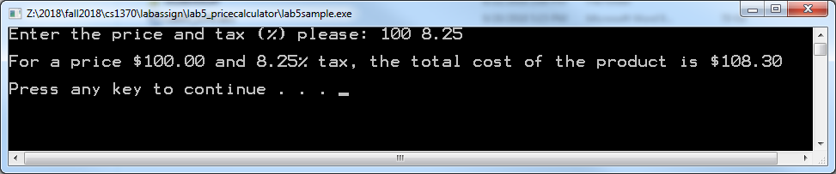

- Test and compare your solution with mine for different values of price and tax to ensure they always produce the same outputs.

To write your program, review the concepts learned in class (review examples discussed in class) and read the book (analyze the examples in it).

I am posting my solution for your reference. Please run it and ensure that your program works like mine. Try the values 100 and 8.25 for price and tax and check if you get the right result (compare with my solution). If you get an error message on the output, read the comment on the line specified in the message to find out what is wrong. Next, try different values for price and tax and compare the results returned by your solution with mine. If you have concerns or specific questions, post them on the Discussion Board of Blackboard.
Don't forget to include at the top of the program the comments shown below with your information (name, class and section number, etc.)
/////////////////////////////////////////////////////////////////////
//
// Name: <Put your name here>
// Date: <Today's date>
// Class: <Your class number and section number, like: CSCI 1370.02>
// Semester: <This semester, like: Spring 2012>
// CSCI/CMPE 1370 Instructor: <Your lecture instructor's name>
//
// Program Description: Enter here your description of what the program does
//
/////////////////////////////////////////////////////////////////////

Please rename your file lab03_FML.cpp (replace F, M. and L with the initials of your first, middle (if any), and last names). Do not include blank spaces in the name of the file please.

When done, submit your solution through Blackboard using the “Assignments” tool. Do Not email it.

The following is the basic criteria to be used to grade your submission:

You start with 100 points and then lose points as you don't do something that is required.

- -10: wrong identifiers (price, tax, and total )
- -10: wrong variable types
- -10: mixed data types in expression
- -10: no comments or too few comments in source code
- -10: didn't round total to integer
- -5: incorrect rounding of total to integer
- -10: didn't display the output as specified on handout
- -20: program does not implement the provided algorithm
- -20: program does not pass all tests
- -50: program does not compile
- -10: incorrect file name
- -10: Late

Important: more points may be lost for other reasons not specified here.

To avoid losing more points please ensure that:

You have no warnings in your program.
Your comments do match the C++ statements and vice versa.
Your program does not have a wrong output formatting (run my sample solution for a reference).
You don't forget to include name and other requested information.

