CSCI/CMPE 1170/1370
while Loops
In this lab you will practice using a few different while loops to perform repetitive tasks.

Program 1: Flag-controlled while Loops
In a flag-controlled while loop a boolean variable is used as the loop condition. That means you need to declare a boolean variable for each while loop and use that variable as the condition.
For your program you will ask for user input and loop until the user enters valid input. This sort of input validating is necessary for any real user input.
First ask the user a yes/no question of your choice and ask them to input y or n as their answer. Check to make sure the input is valid (y or n). Then ask the user to enter her age and make sure that input is valid. If the user does not enter a number, then the input stream goes into the fail state and the variable is unchanged. You need to reset the input stream, clear whatever is on the input stream, then ask the user to try again. This is how you check the input stream and reset it back into working order:
if ( !cin )
{ cin.clear(); cin.ignore(2000, '\n');
}
Here is some code to get you started: flag-while-input.cpp. Download this starter program, create a project in Visual C++ using this starter program, and complete the program. Your output should look similar to the 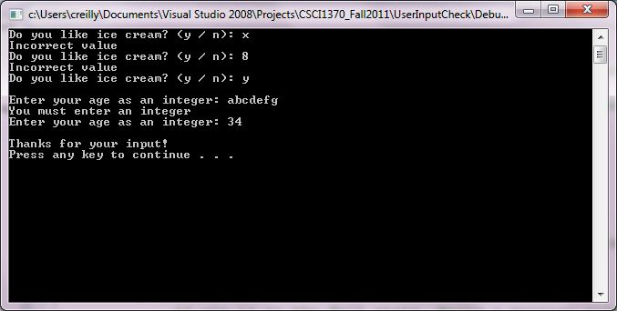following figure. Turn in your completed program.

Program 2: Sentinal-controlled while Loops
A sentinal controlled while loop keeps looping until the user enters a specific value. We call this value the sentinal value.
Your program will ask the user to input a series of grades, and to input -1 (a sentinal value) when finished. You will take the average of the grades, being careful to not include the sentinal value (-1) in the average.
Here is some code to get you started: avgGradesSentinal.cpp. Download this starter program, create a project for it in Visual C++, and complete the program. Your output should look like the following figure. Turn in your completed program.
