## Regression Report

*Name* *November 12, 2014*

### Summary Statistics

This report was created using the mlb11 data set. The dependent variable in my analysis is runs and independent variable in my analysis is at_bats.

The summary statistics of runs and at_bats appear below.

## runs at_bats   
## Min. :556 Min. :5417   
## 1st Qu.:629 1st Qu.:5448   
## Median :706 Median :5516   
## Mean :694 Mean :5524   
## 3rd Qu.:734 3rd Qu.:5575   
## Max. :875 Max. :5710

Enter text...

### Histograms

The histograms of runs and at_bats appear below. 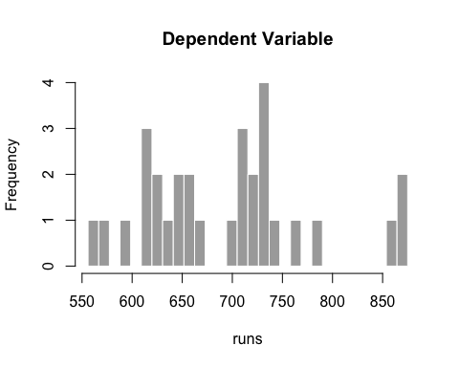

Enter text...

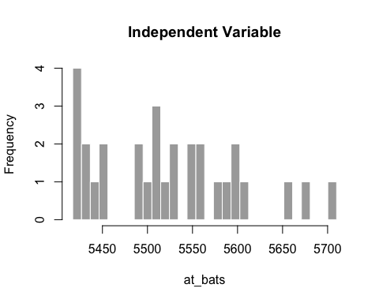

Enter text...

### Scatter Plot

A scatter plot of runs and at_bats appears below. 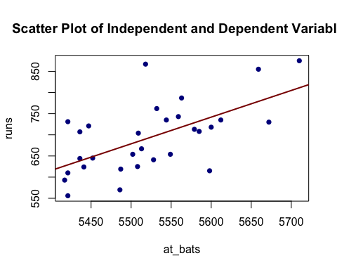

Enter text...

### Correlations

A correlation matrix of all of the variables in mlb11 appears below.

## runs at_bats hits homeruns bat_avg strikeouts stolen_bases  
## runs 1.00 0.61 0.80 0.79 0.81 -0.41 0.05  
## at_bats 0.61 1.00 0.85 0.38 0.76 -0.46 -0.11  
## hits 0.80 0.85 1.00 0.47 0.99 -0.62 -0.13  
## homeruns 0.79 0.38 0.47 1.00 0.47 -0.17 -0.12  
## bat_avg 0.81 0.76 0.99 0.47 1.00 -0.63 -0.12  
## strikeouts -0.41 -0.46 -0.62 -0.17 -0.63 1.00 0.09  
## stolen_bases 0.05 -0.11 -0.13 -0.12 -0.12 0.09 1.00  
## wins 0.60 0.06 0.30 0.66 0.35 -0.28 -0.06  
## new_onbase 0.92 0.60 0.85 0.62 0.88 -0.49 -0.03  
## new_slug 0.95 0.62 0.82 0.86 0.83 -0.41 -0.07  
## new_obs 0.97 0.63 0.85 0.81 0.87 -0.44 -0.06  
## wins new_onbase new_slug new_obs  
## runs 0.60 0.92 0.95 0.97  
## at_bats 0.06 0.60 0.62 0.63  
## hits 0.30 0.85 0.82 0.85  
## homeruns 0.66 0.62 0.86 0.81  
## bat_avg 0.35 0.88 0.83 0.87  
## strikeouts -0.28 -0.49 -0.41 -0.44  
## stolen_bases -0.06 -0.03 -0.07 -0.06  
## wins 1.00 0.55 0.61 0.61  
## new_onbase 0.55 1.00 0.87 0.94  
## new_slug 0.61 0.87 1.00 0.99  
## new_obs 0.61 0.94 0.99 1.00

Enter text...

### Regression Model

A bivariate regression model predicting runs with at_bats appears below.

options(digits = 4)  
  
m1 <- lm(regFormula(), data = mlb11)  
b <- coef(m1)  
summary(m1)  
##   
## Call:  
## lm(formula = regFormula(), data = mlb11)  
##   
## Residuals:  
## Min 1Q Median 3Q Max   
## -125.6 -47.0 -16.6 54.4 176.9   
##   
## Coefficients:  
## Estimate Std. Error t value Pr(>|t|)   
## (Intercept) -2789.243 853.696 -3.27 0.00287 **   
## at_bats 0.631 0.155 4.08 0.00034 ***  
## ---  
## Signif. codes: 0 '***' 0.001 '**' 0.01 '*' 0.05 '.' 0.1 ' ' 1  
##   
## Residual standard error: 66.5 on 28 degrees of freedom  
## Multiple R-squared: 0.373, Adjusted R-squared: 0.35   
## F-statistic: 16.6 on 1 and 28 DF, p-value: 0.000339

The fitting result is $runs=−2789.2429+0.6305at_{b}ats$.

Enter text...

### Residuals

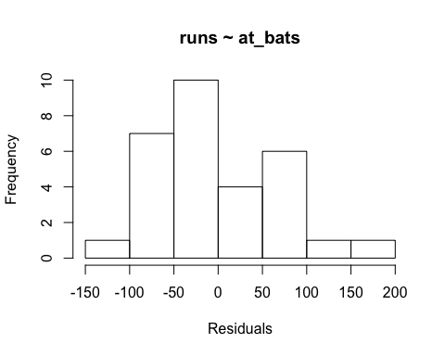

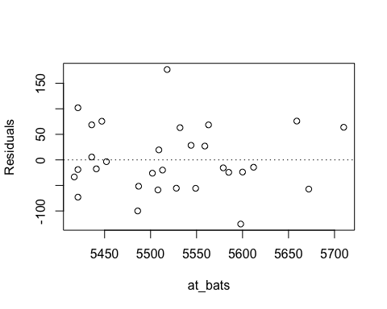

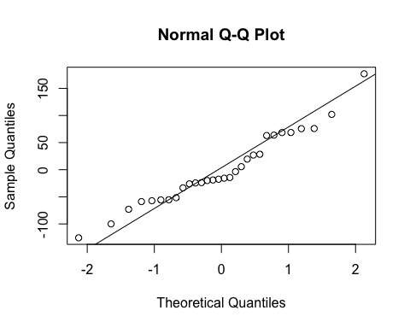

Enter text...