StoryTelling Studios
A Static website for photo studios
By Archana
This website is designed using the technologies:
- HTML5
- CSS3
- BOOTSTRAP4.6.2

Index page:
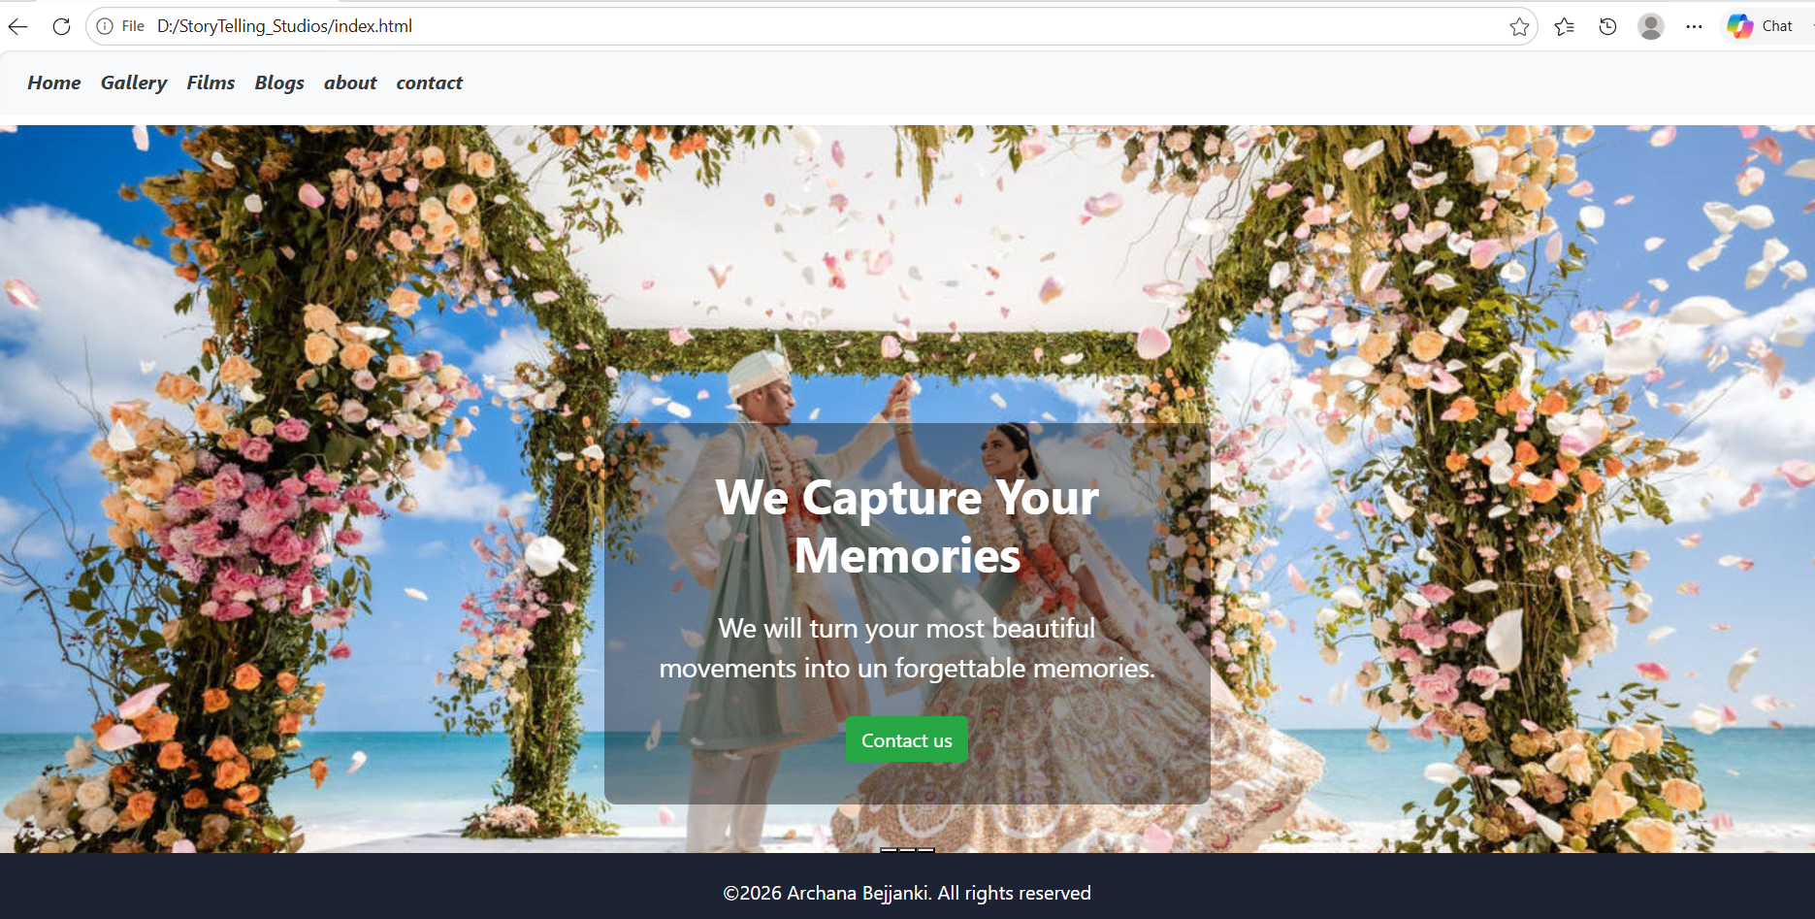
The below screen shot is my website home page having responsive nav bar where each directing to their individual pages and it is having carousel having 3 slides and on the first image of carousel I have created like hero image having a content box above it redirecting to contact page by using anchor tag.

Gallery page:
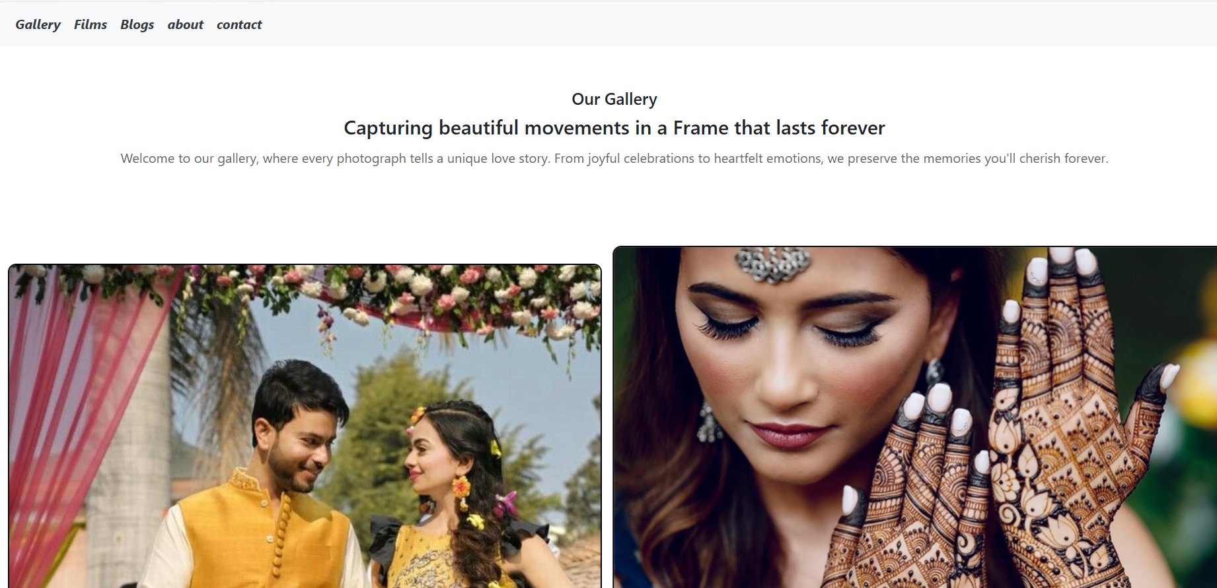
This page is divided page into 2 columns and added images

Films page:
t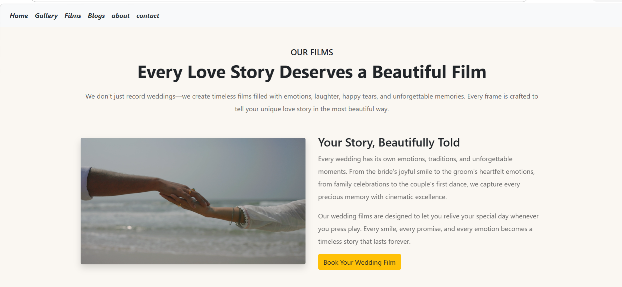
This page is having

Blogs page:
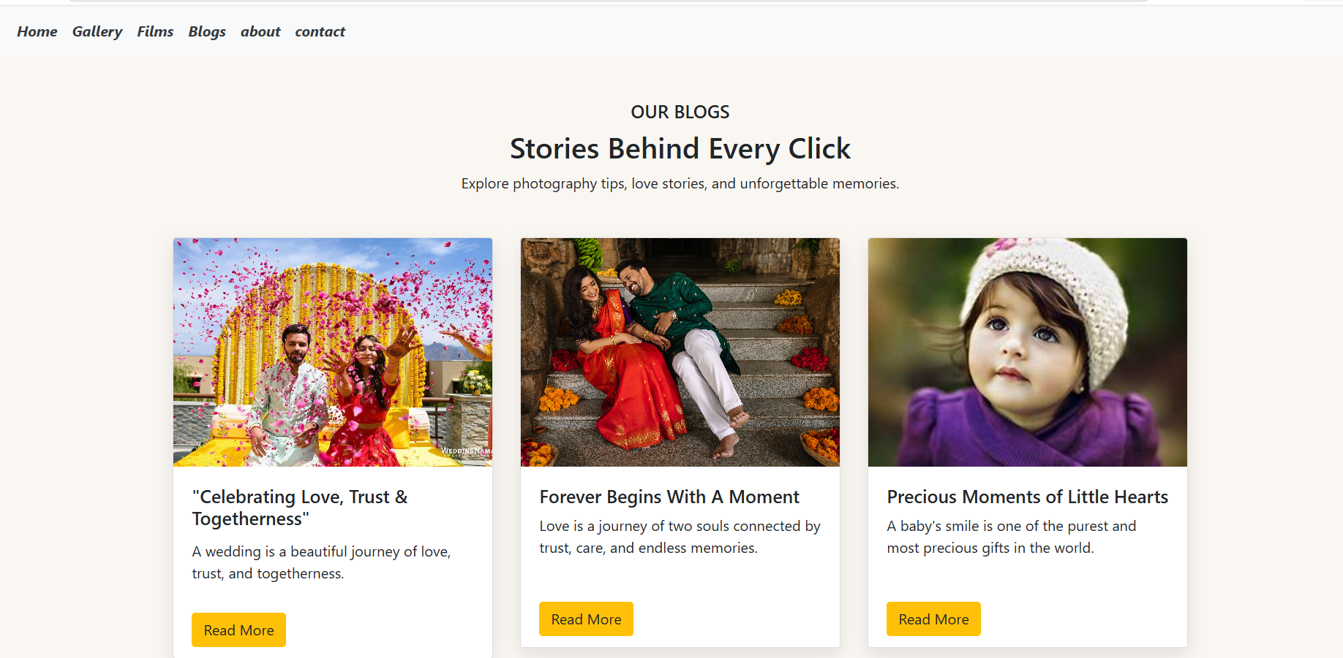

Blogs page:

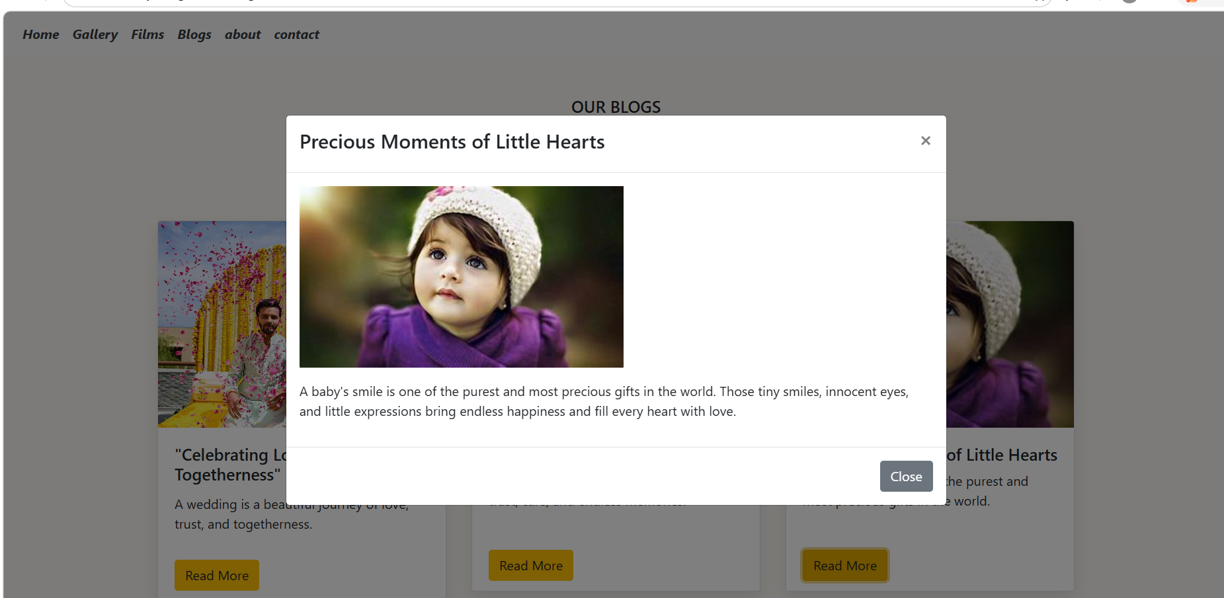

About page:
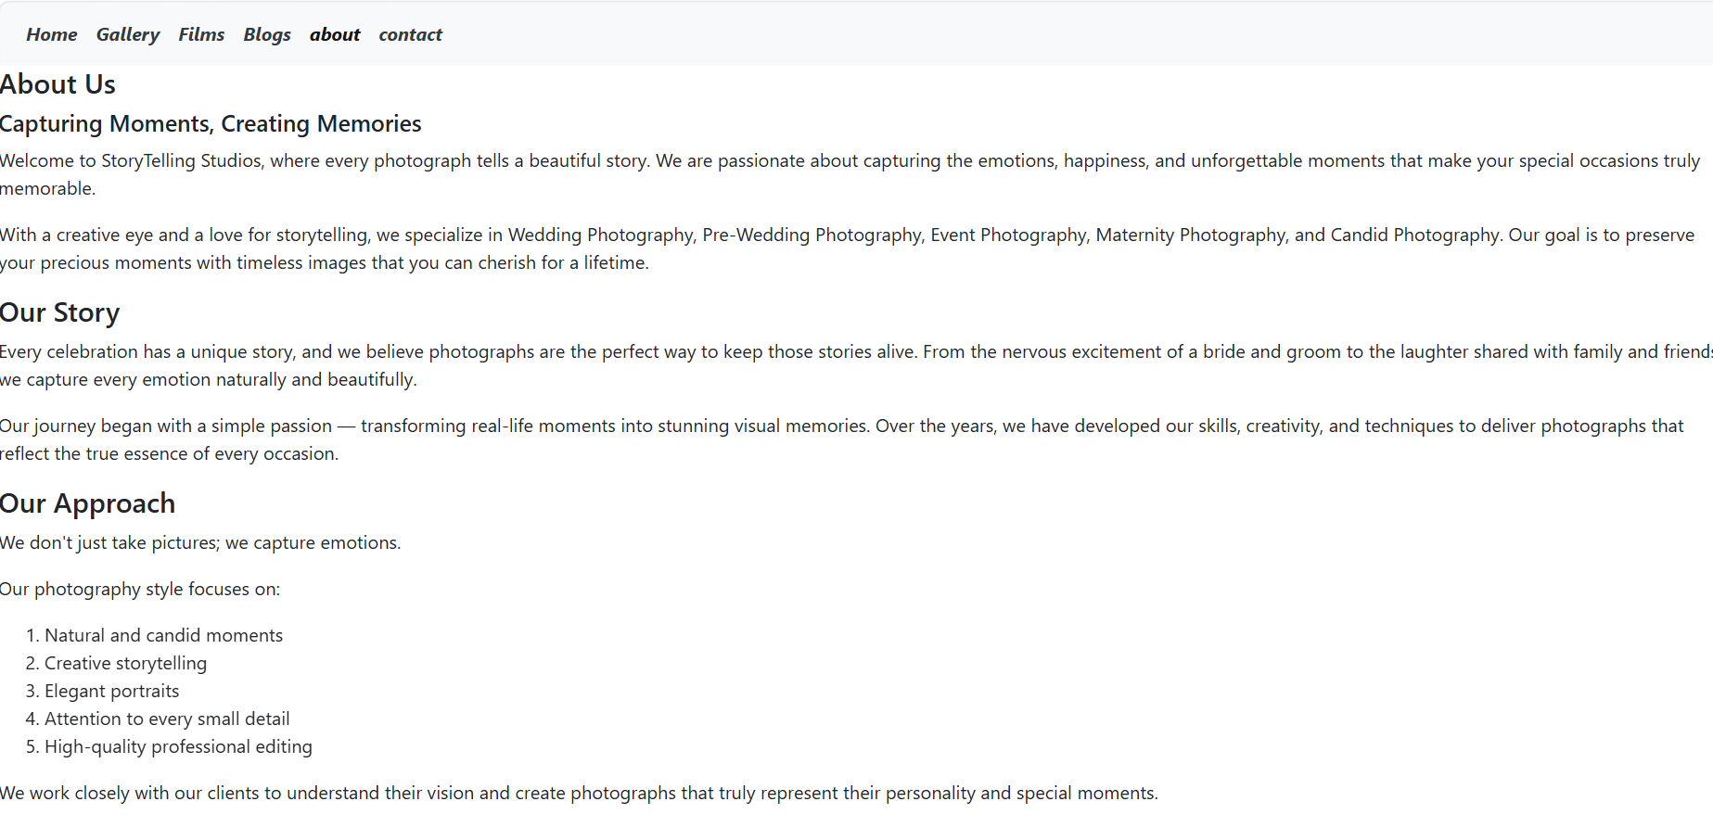

Contact page:

