**THE 2048 GAME**

*A*

*Mini Project Report*

*Submitted in partial fulfilment of the*

*Requirements for the award of the Degree of*

**BACHELOR OF ENGINEERING**

IN

**INFORMATION TECHNOLOGY**

By

B.BHAVANA- 1602-19-737-070

B.SATHVIKA– 1602-19-737-100



**Department of Information Technology**

**Vasavi College of Engineering (Autonomous)**

**(Affiliated to Osmania University)**

**Ibrahimbagh, Hyderabad-31**

**2020**

**Vasavi College of Engineering (Autonomous)**

**Affiliated to Osmania University)**

**Hyderabad-500 031**

** Department of Information Technology**

**DECLARATION BY THE CANDIDATE**

We, B.BHAVANA and B. SATHVIKA bearing hall ticket numbers, 1602-19-737-070, and 1602-19-737-100 respectively, hereby declare that the project report entitled “THE 2048 GAME” is submitted in partial fulfilment of the requirement for the award of the degree of Bachelor of Engineering in Information Technology.

This is a record of bonafide work carried out by us and the results embodied in this project report have not been submitted to any other university or institute for the award of any other degree or diploma.

B.BHAVANA

1602-19-737-070

B.SATHVIKA

1602-19-737-100

(Faculty In-Charge) (Head, Dept. of IT)

**AKNOWLEDGEMENTS**

Our Mini Project would not have been successful without the help of several people. We are extremely thankful to our college, Vasavi College of Engineering, for providing the opportunity to implement our project, “THE 2048 GAME”.

We would like to express our gratitude to Mrs.Prasanna, Department of Information Technology, Vasavi College of Engineering, for their esteemed guidance, moral support and invaluable advice provided by them for the success of the Mini Project.

We consider ourselves privileged to express gratitude and respect towards all those who guided us through the completion of this project.

**ABSTRACT**

2048 is a game which is very well known by everyone.When you press the enter key ,

you will be entered into the game. There you will see all the keys and the numbers.

Your score will be displayed on the right side. With the help of the keys on your keyboard

you can play the game.There are left,right,upward,and downward keys that you will be

needed.with the help of that you can select the blocks as you wish.After all the blocks are

filled you automatically be out of the game.If your score is 2048 then that means that you

have won the game.

**TABLE OF CONTENTS**

* 1. 1. Introduction 6
  2. About The Project 6
  3. What we prioritized……………………………………………………………..6
  4. Objective of our project…………………………………………………………6

2. Technology 7

* 1. Software Requirements 7
  2. Hardware Requirements 7

3. Proposed Work 8

* 1. Design 8
     1. Use case Diagram…………………………………………………………8
  2. FlowChart…………………………………………………………………9
  3. Implementation 10
     1. Description of main modules…………………………………………….10
     2. Logic …………………………………………………………………….11
     3. Github?Folder Sructure…………………………………………………..13
  4. Testing 14

4. Results 15

5. Additional Knowledge Acquired 21

6.Discussion and future work…………………………………………………………22

7. References ……23

# 1.INTRODUCTION

## 

## ABOUT THE PROJECT

Our project is “The 2048 Game”.Our game allows the user to enter into the game or to exit from the game.The game helps the users to be stress free and this game is very easy to play.User can win the game if user scores 2048 .User can also quit from the game when he wants to exit.

**WHAT WE PRIORITIZED**

For playing the game the movement of the numbers is very very important.So,we first found the logic for the up arrow key,down arrow key,right arrow key and left arrow key.Then we asked the user whether he wants to enter or to exit from the game.And at lst we display the score of the user.

**OBJECTIVE OF OUR PROJECT**

The main aim of our project is to allow the user to play a good game without any disturbances and displaying the score.

.

# 2.TECHNOLOGY

All computer software needs certain hardware components or other software resources to be present, in order for computers to be used efficiently. These prerequisites are known as System Requirements. Within this, we have two types – Software Requirements and Hardware Requirements.

## SOFTWARE REQUIREMENTS

Software Requirements deal with defining the software resource requirements and prerequisites that need to be installed on a computer to provide optimal functioning of an application. These preconditions are generally not included in the software installation package and need to be installed separately.

In order to use 2048 GAME , one should have the following:

* **Operating System:** Windows 7 and above
* **C Compiler:** GCC compiler
* **Editor:** Any text editor (preferably VIM)

## HARDWARE REQUIREMENTS

Hardware requirements refer to the common set requirements defined by any operating system or software application and are usually the physical computer resources. In this, we look into the architecture, processing power, memory, secondary memory, display adapter and peripherals.

In order to use 2048 GAME, one should have the following:

* + - **Processor:** Intel Core i5 and above
    - **Memory:** 4 GB RAM and above

3.PROPOSED WORK

**3.1 DESIGN**

**3.1.1 Use Case diagram**

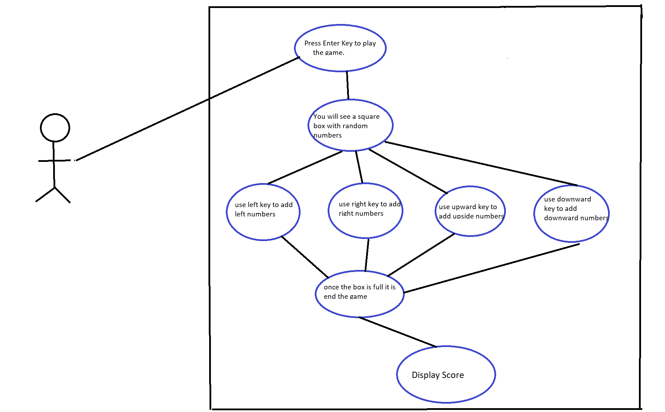

3.1.2 FLOW CHART

## mini.PNG

## 3.2 IMPLEMENTATION

## 3.2.1 DESCRIPTION OF MAIN MODULES

Based on the use cases, we have implemented this project by dividing the work into will do their respective work.

3.2.1.1 LEFT

Once the user entered into the game ,user can enter left key in the keyboard to navigate

all the numbers present in the box towards left side and add the numbers which are similar and display them at left side.

3.2.1.2 RIGHT

Once the user entered into the game ,user can enter right key in the keyboard to navigate

all the numbers present in the box towards right side and add the numbers which are similar and display them at right side.

3.2.1.3 DOWN

Once the user entered into the game ,user can enter down key in the keyboard to navigate

all the numbers present in the box towards down side and add the numbers which are similar and display them at down side.

3.2.1.4 UP

Once the user entered into the game ,user can enter leup key in the keyboard to navigate

all the numbers present in the box towards up side and add the numbers which are

similar and display them at up side.

**3.2.2 ALGORITHM/LOGIC**

CODE FOR RANDOM VALUES GENERATOR

void Random_Values_creater()

{

int temp1,temp2,add,i,j;

srand(time(NULL));

temp1=rand()%SIZE;

srand(time(NULL));

temp2=rand()%SIZE;

if((temp1+temp2)%2==0)

add=2;

else

add=4;

for(i=0;i<temp1;i++)

{

for(j=temp2;j<SIZE;j++)

{

if(Matrix[i][j]==0)

{

Matrix[i][j]=add;

return;

}

}

}

}

ALGORITHM

1.If there are no numbers in the box to get added the we call random_value_creater()

function.

2.This function creates random values 2 and 4 at random places.

3.The function will give us random value 2 if sum of adjancent numbers in the box are divisible by 2 and give random number as 4 if the adjancent numbers in the box are not divisible by 2.

4.Random number is generated when there is no number at that place in the box.(In our

project matrix[i][j]==0 indicates no number at that particular place).

**3.2.3GITHUB/FOLDER STRUCTURE**

We have segregated the files we have used based on the usage. We also created a README which has a brief description of our project. The Main C file is not part of any folder.We have both our final presentation and documentation of the project which are not part of any folder.

GITHUB LINK: <https://github.com/BejugamSathvika/mini-project>

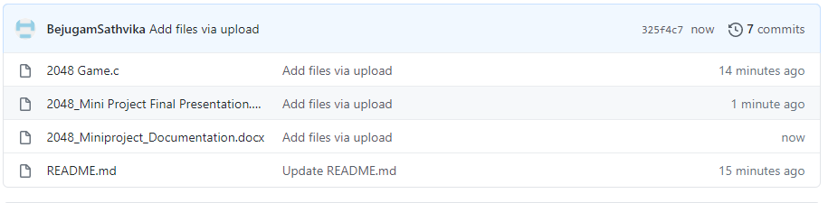

## 3.3TESTING

Testing is a method to check whether the actual product matches the expected requirements and to ensure that the product is defect-free. This process involves execution of various parts of the product either using manual or automated tools. The purpose is to identify errors,missing requirements in contrast to the actual requirements.

TEST CASE 1

If the user want to quit from the game then user can enter ESC in the keyword to quit from the game.

TEST CASE 2

If the user enter any unwanted keys other than left,right,down,up and ESC keys then there is no change in the score.

TEST CASE 3

If the boxes are totally filled with numbers and if u have no chance to play the game then you will be automatically exit from the game.

# 

# 4.RESULTS

We have successfully developed a platform for users of all age groups to utilize and improve their skill-set. Below are the output screenshots of the testcases mentioned.

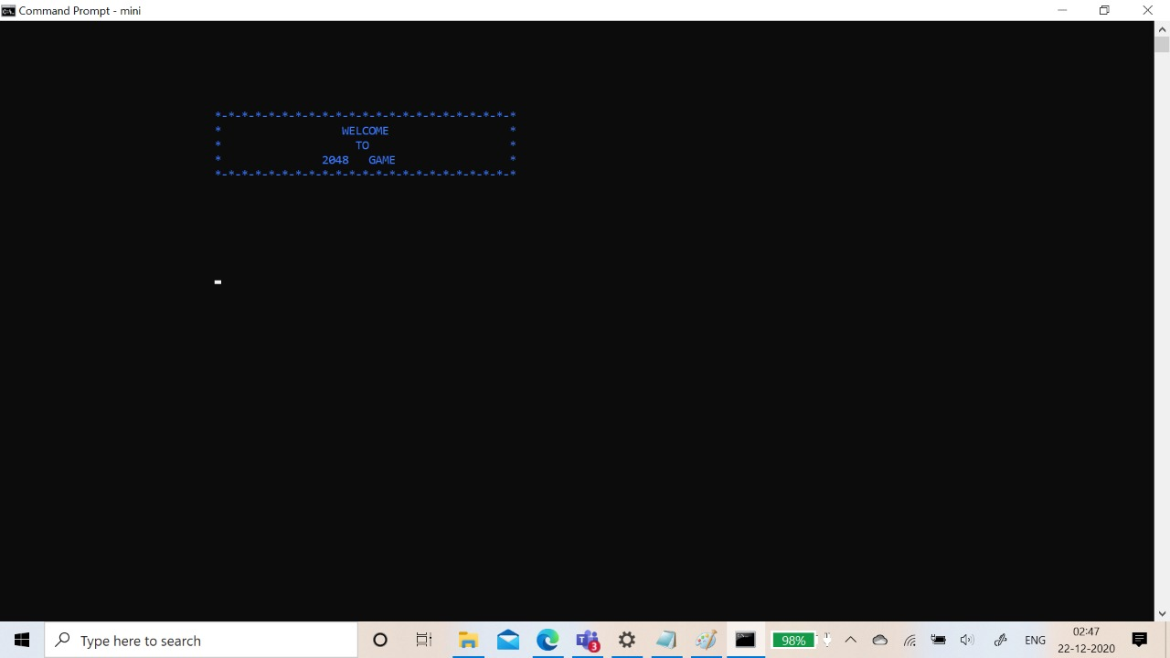

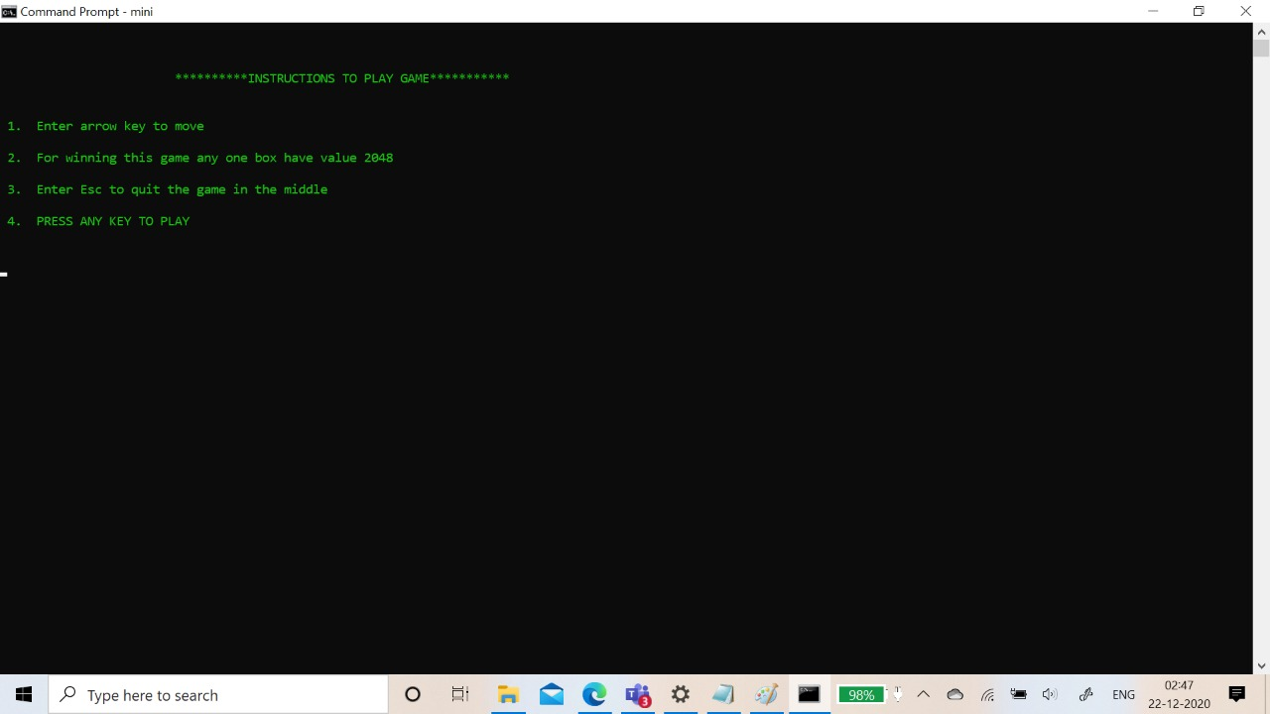

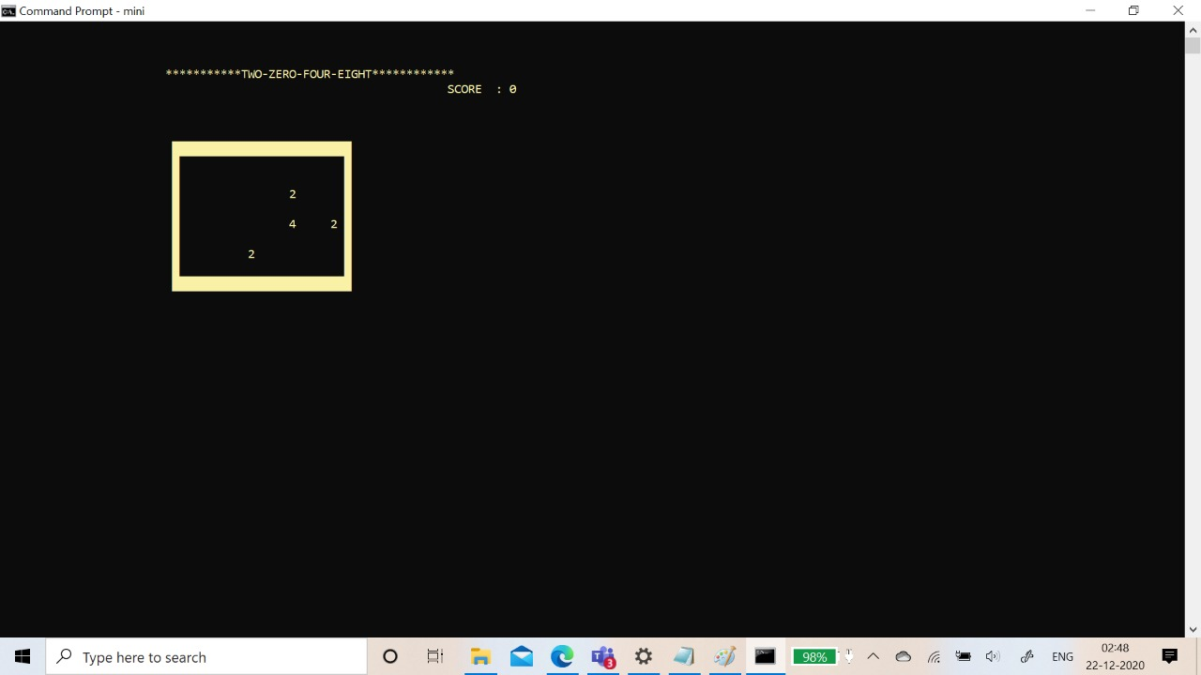

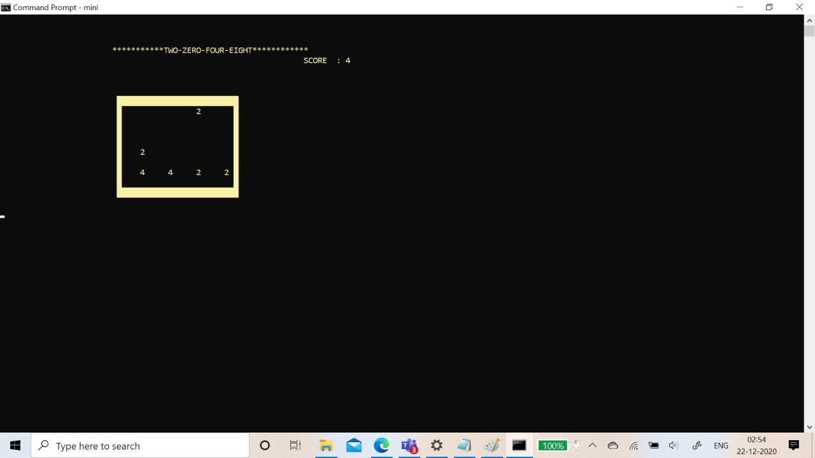

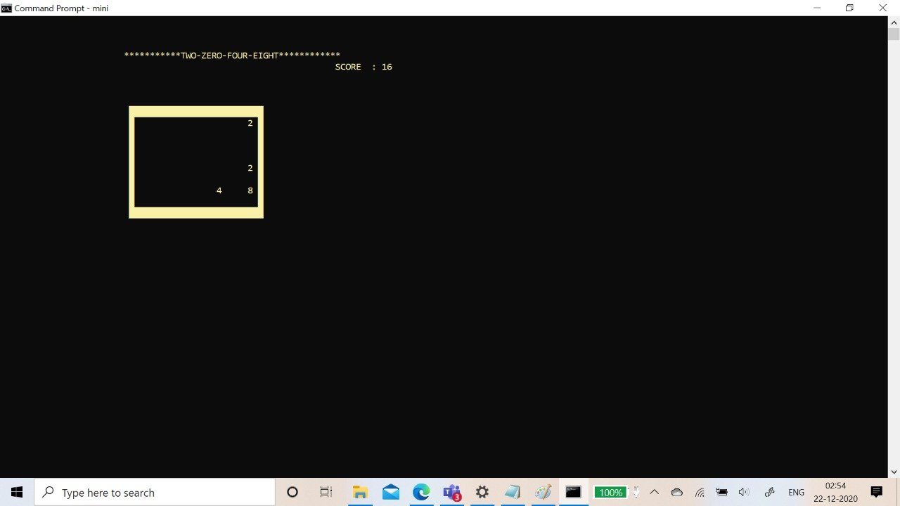

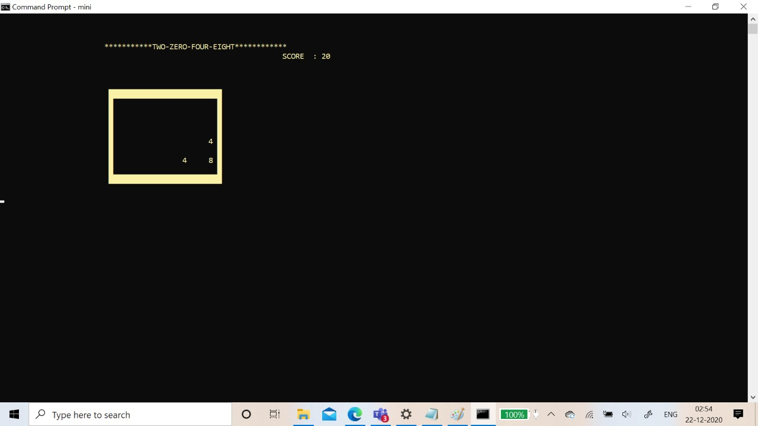

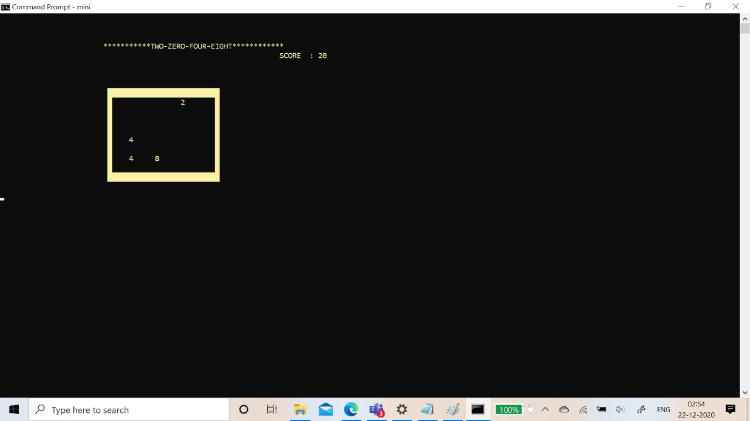

**When the user enters ESC key**

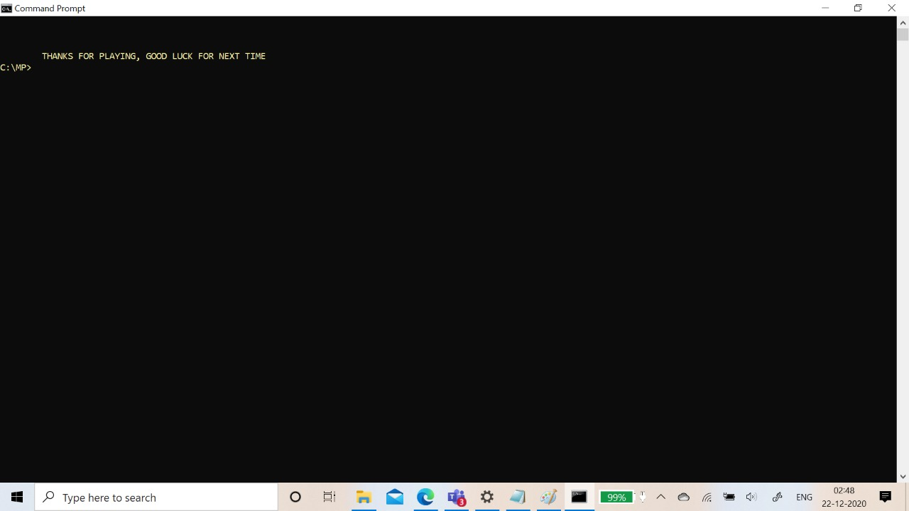

**While playing the game if the box gets filled**

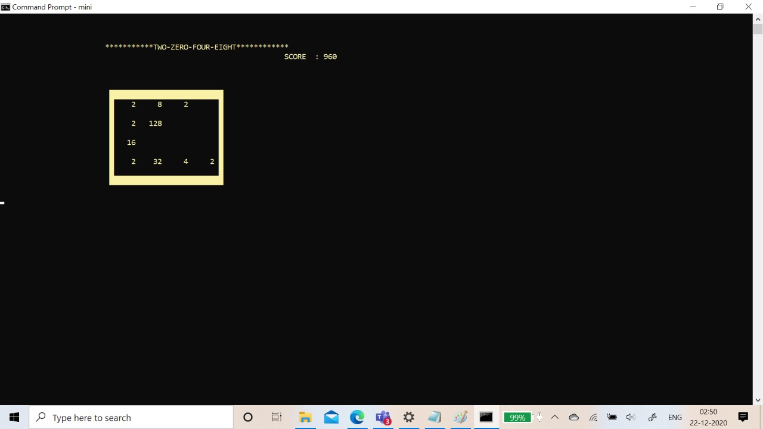

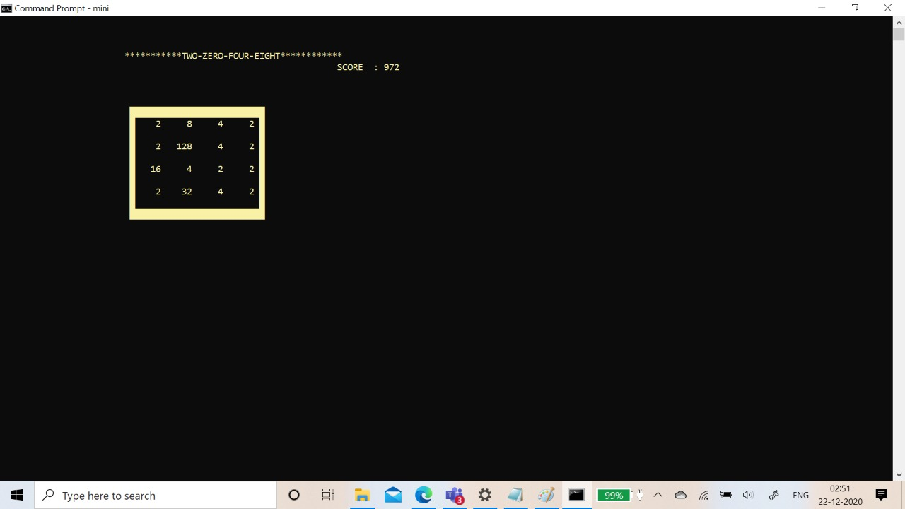



# 5.ADDITIONAL KNOWLEDGE ACQUIRED

Implementing this project in C Language has introduced us to different libraries such as:’conio.h’, ‘process.h’, ‘time.h’ and ‘windows.h’. We were able to use the knowledge to execute it as a real-time application. We used the ‘windows.h’ library for controlling the display colours in a controlled manner. We explored the ‘time.h’ and ‘conio.h’ libraries for achieving a look-and-feel of an actual window application by constructing our own time delay function.

We gained some more knowledge in c programming language by knowing wide variety of header files and some built in functions.

Other than this, we have learnt the value of team spirit and have understood the intention behind working in teams.

# 6.DISCUSSION AND FUTURE WORK

Our future work includes levels like user can select whether he wants to play 3X3 or 3X4 or 4X4 and many more levels.This project can be further improved by converting it into a Web Application using Python and the Django Framework or a Mobile Application using Flutter or React Native.

# 7.REFERENCES

1. C Language Documentation: [https://docs.microsoft.com/en-us/cpp/c- language/?view=msvc-160](https://docs.microsoft.com/en-us/cpp/c-language/?view=msvc-160)
2. Visual Studio Code
3. Stack Overflow (for debugging errors): <https://stackoverflow.com/>