Beka Kutsurua

ART157: Introduction to Art

*Part 1: Describing Art*

Andy Warhol’s Campbell’s Soup Can Portfolio II is a striking example of Pop Art that utilizes line, shape, color, and contrast to transform an everyday object into an iconic image. The crisp, clean lines define the edges of the can, reinforcing its mass and volume while maintaining a flat, graphic quality. The shape of the can is simple and symmetrical, with a clear division between the red and white halves, creating visual balance and unity. The circular emblem in the center adds a contrasting element, drawing the viewer’s eye to its intricate details.

Color plays a crucial role in Warhol’s design. The bold red and white contrast makes the image immediately recognizable. The use of gold and black lettering in the emblem and text creates additional contrast, emphasizing the branding. Like in Warhol’s other works, the deliberate color choice reflects Warhol’s commentary on consumer culture, as the bright and appealing colors mimic advertising techniques.

Repetition and pattern are also evident in the typeface and arrangement of the text, contributing to a sense of rhythm. The placement of “Campbell’s” in a flowing script contrasts with the blocky, printed text below, creating variety while maintaining cohesion. The emphasis on branding is further enhanced by the prominent placement of the logo and the decorative gold medallion, reinforcing the commercial aesthetic.

Warhol’s use of scale and proportion mimics mass production, emphasizing the cultural significance of consumer goods. By enlarging a familiar object and stripping it of its three-dimensional context, he transforms it into an emblem of modern consumption, making the viewer engage with the piece beyond its surface.

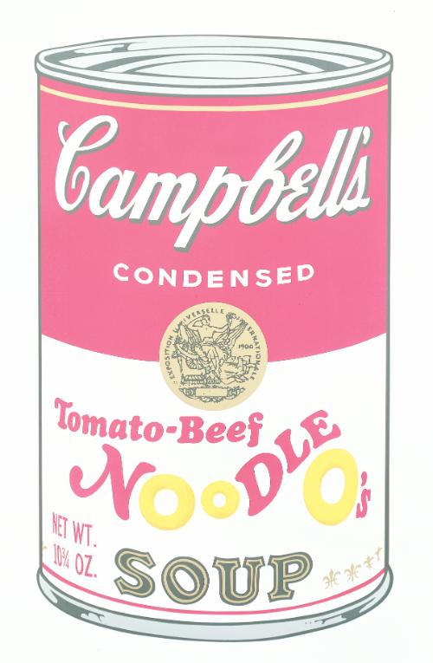

Andy Warhol, Campbell's Soup Can Portfolio II, 1969, ten silkscreens, edition 211 of 250