Beka Kutsurua

ART157: Introduction to Art

Part 1: Processes of Art

Andy Warhol’s Campbell’s Soup Can Portfolio II is first and foremost a work of printmaking. Warhol used the silkscreen process, a technique in which ink is pushed through a mesh screen onto paper. This method allowed him to produce multiple, near-identical images of the Campbell’s soup cans, mimicking the mass production of consumer goods. While printmaking traditionally emphasizes craftsmanship and the artist’s hand, Warhol intentionally embraced mechanical reproduction, challenging ideas about originality and authenticity in art.

Although the portfolio is a series of prints, its flat areas of color and simplified shapes reflect techniques found in painting. Warhol’s use of bright, commercial colors and clean lines echoes advertising design, making the cans feel both familiar and iconic. In this way, the work also engages with visual communication design—he appropriated a recognizable commercial product and elevated it to the status of fine art, blurring the boundaries between branding and artistic expression.

The repetitive display of the soup cans, especially when presented in gallery spaces, hints at sculpture and installation practices. When first exhibited, Warhol arranged the works in rows, resembling supermarket shelves. This display method transformed the prints into an immersive, spatial experience.

Warhol’s process, often described as factory-like, subverts traditional ideas of craft by prioritizing concept over hand-made skill. His work anticipated later movements in alternative media and digital art, where reproduction and mass communication play central roles. Ultimately, Warhol’s Campbell’s Soup Can Portfolio II questions the value systems of both art and commerce.

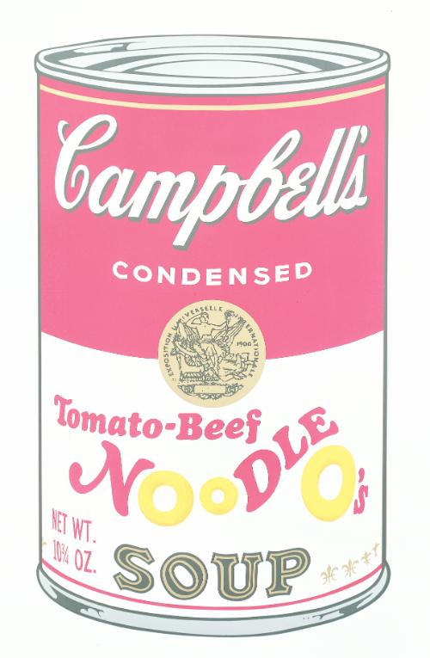

Andy Warhol, Campbell's Soup Can Portfolio II, 1969, ten silkscreens, edition 211 of 250