**Figure 1** Changes in macroalgae amount (% lab tray coverage) from each quadrat **(A)** demonstrate shifts in abundance across an environmental gradient ranging from pH 8.1 to 6.7. Plot shading delineates environmental conditions, pH = 8.14 ± 0.01 (green), pH = 7.83 ± 0.06 (yellow), pH = 6.57 ± 0.06 (orange). The mean abundance (% lab tray coverage) of each species in quadrats A-C compared with quadrats G-I **(B)** show that several species of macroalgae are absent from the most acidic environments (e.g. Jania rubens, Valonia utriclaris, Flabelia petiolate) as new species arise or increase in abundance (e.g. Dictyota dichotoma, Sarcassum vulgare, Chondracanthus acicularis).

Figure 2 Mixing Models asdlf asdlkf;jasd f;

**Figure 2** Data used in stable isotope mixing models for each lake show the carbon and nitrogen stable isotope composition of rainbow trout muscle tissue (brown) and primary producers from littoral (light blue), pelagic (dark blue), and terrestrial (green) habitats of each lake. Rainbow trout are plotted before (black) and after (brown) correcting for trophic enrichment, assumed to be 6.4 ‰ for nitrogen and 0.4 ‰ for carbon (Post 2002). Triangular resource polygons (Brett 2017) are shown in dark gray. Trout with pairs of stable isotope values that fell within the one standard deviation of the resource polygon were included in a conventional algebraic and Monte Carlo simulation approach that solve for proportional source contributions.

end

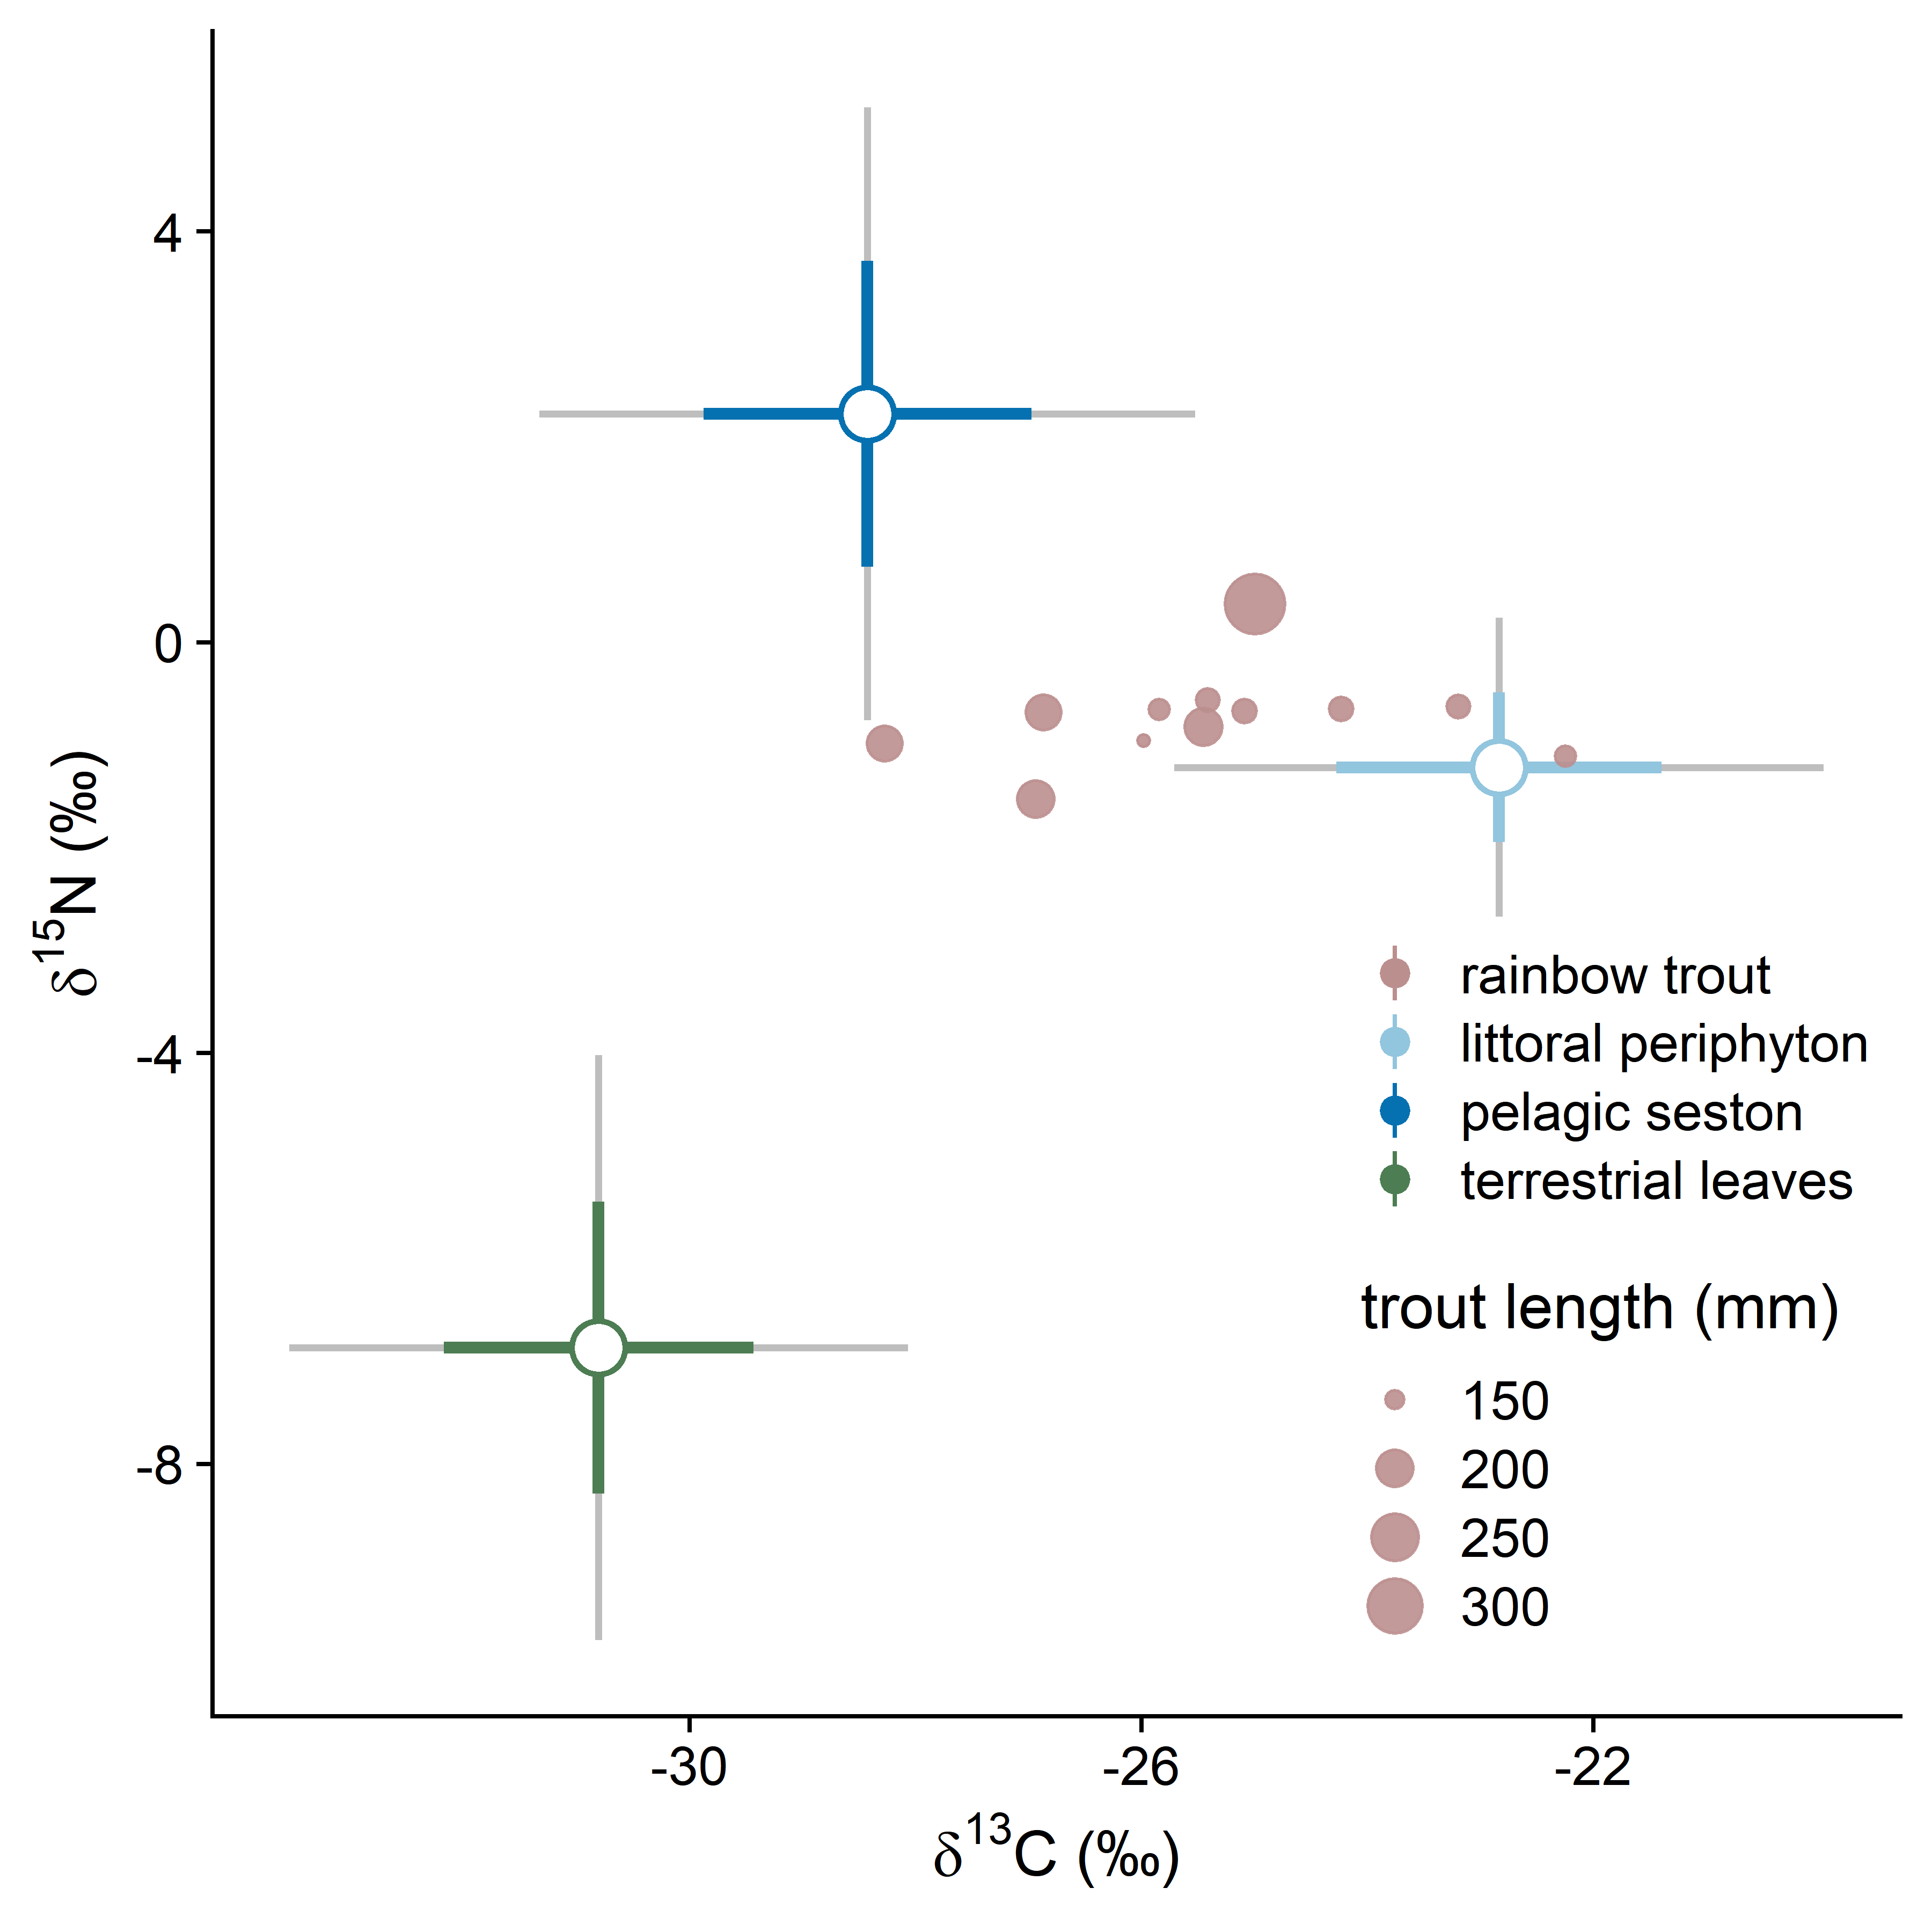

**Figure 3** Carbon and nitrogen stable isotope composition of rainbow trout muscle tissue (brown) and primary producers from the littoral (light blue), pelagic (dark blue), and terrestrial (green) habitats of Kulla Kulla Lake demonstrate principal reliance by rainbow trout on resources stemming from the littoral and pelagic pathways, and minimal reliance on terrestrial derived resources. Rainbow trout lengths range from 146.3- 341.0 mm (point size). Solid and grey error bars reflect the 68% and 95% confidence intervals of the mean sources values from the samples collected in each habitat. Rainbow trout are plotted after correcting for fractionation, assumed to be 6.4 ‰ for nitrogen and 0.4 ‰ for carbon (Post 2002).

**Figure 4** For each lake, littoral-benthic primary production is assumed to occur along the lake edge to depths where light attenuates to 1% of the surface intensity. Differing light environments among lakes was obtained by taking vertical light profiles and calculating the light extinction coefficient for each lake. The light extinction coefficient was then used to determine the depths at which light reached 1% of the surface intensity. The maximum depth for each lake where primary production occurs primary fell between 10-17 meters, however Little Mason Lake and Scout Lake, two lakes with high dissolved organic carbon concentrations, had shallower depths, and four high elevation mountain lakes (Denny Lake, Lower Melakwa Lake, Annette Lake, Upper Tuscohatchie Lake) each had light reach depths between 20-26 meters.