2 DESIGN AND ARCHITECTURE OF THE CRM PLATFORM

Having established the theoretical foundations, problem statement and system requirements in Chapter 1, the present chapter proceeds to the design and architectural specification of the CRM platform for training with an integrated AI assistant. In the context of this diploma project, design is understood not merely as the definition of technical components, but as the systematic translation of identified requirements, conceptual assumptions and process-related needs into a coherent architectural model, structural decomposition and implementation-oriented specifications. Such an approach is consistent with established practices of information systems design, where architecture serves as an intermediate layer between conceptual analysis and practical development, ensuring that the future system remains aligned with its intended organisational and functional objectives [19], [24].
The purpose of this chapter is therefore to define how the proposed platform should be structured, how its core modules should interact, what data model should underpin its operation, and how the AI assistant should be embedded into the overall system logic. Particular attention is given to the relationship-oriented nature of the platform, since the system is intended not only to manage isolated educational functions, but also to maintain a unified and lifecycle-based view of learners, instructors, courses and interactions across the training process.
The chapter is organised as follows. Section 2.1 introduces the conceptual design of the platform and the key business processes that it is expected to support. Section 2.2 describes the overall system architecture, including its major subsystems and their responsibilities. Section 2.3 addresses data modelling and the design of the core functional modules. Section 2.4 focuses on the AI assistant subsystem, its architectural role, integration logic and typical interaction patterns. Finally, Section 2.5 presents the requirements for the user interface, the main user journeys and the technological stack selected for prototype implementation.

2.1 Conceptual design and business processes of the system

The starting point of information system design is the formulation of a clear conceptual model that defines the place of the system within its organisational and digital environment and determines the business processes that the system must support [24]. In the case of the CRM platform for training, this involves identifying the position of the platform within the broader digital ecosystem of an educational or training organisation and specifying the major functional interactions between user roles, institutional data and system services.
As shown in Chapter 1, current training environments are characterised by fragmented information flows, multiple stakeholder groups and the coexistence of several partially overlapping digital tools. Consequently, the conceptual design of the proposed platform is guided by the need to overcome this fragmentation and to provide a unified, process-oriented and relationship-oriented infrastructure for managing training activities. On the basis of the analysis of stakeholder needs, existing tools and information flows presented earlier, the conceptual design is built around three core principles.
First, the platform is conceived as an integrating layer that connects data and processes which are typically distributed across isolated systems. Rather than functioning as a narrowly specialised application, it is intended to provide a common operational space where information about learners, training programmes, educational activities and interactions can be consolidated and used in a coordinated manner.
Second, the platform is based on a consistent and lifecycle-oriented representation of key entities. Learners, courses, lessons, materials, assignments and interactions are not treated as disconnected records, but as interrelated elements within a broader model of training participation and learner development. This principle ensures that the system supports not only operational tasks, but also a more holistic understanding of the learner’s trajectory within the organisation.
Third, the AI assistant is incorporated into the platform as an integral subsystem rather than as an external add-on. Its operation is therefore grounded in the same contextual data model as the rest of the platform, while its access to information is constrained by role-based logic, system rules and controlled conversation logging. This makes it possible to combine the usability benefits of conversational interaction with the reliability and traceability required in an educational CRM environment.

2.1.1 Place of the CRM platform in the digital ecosystem and target business processes “to be”

As discussed in Section 1.2, current training management is usually based on several specialised systems: LMS platforms for course delivery, student or HR systems for official records, communication tools for operational interaction and, in some cases, CRM systems for recruitment or selected front-office tasks. Since these systems are often weakly integrated, organisations face data fragmentation, duplicated records and limited visibility of the learner lifecycle.
The proposed CRM platform is designed to occupy a central position within this digital ecosystem. Its role is not to replace existing institutional systems, but to complement them by acting as a relationship-oriented coordination layer. Within the scope of the project, the platform consolidates learner, programme and interaction data, provides a shared operational context for administrators, instructors and learners, and introduces an AI assistant that uses this integrated context to support user requests.
From the perspective of the target “to be” model, the platform supports several interrelated business processes:
- user and access management, including registration, authentication, role-based authorisation, e-mail verification and invitation-based onboarding.
- course and programme management, covering the creation, configuration and administration of training courses, enrolment settings and payment-related rules.
- learner enrolment and lifecycle tracking, including enrolment status, attendance history, homework submissions, grades and other progress-related information.
- lesson scheduling and delivery, supporting lesson planning, publication, monitoring and status management through states such as SCHEDULED, COMPLETED and CANCELLED.
- material management and homework administration, including the upload of learning materials, creation of assignments, submission of learner work and grading.
- interaction and notification management, covering in-platform notifications and Telegram bot integration for timely communication.
- AI-assisted support, enabling learners and instructors to interact with the platform in natural language using controlled, context-aware assistance.
- reporting and analytics, providing dashboards and statistical views for monitoring participation, performance and operational activity [25].
Taken together, these processes define the target business-process landscape of the platform in its intended “to be” state. They demonstrate that the proposed system is not a narrow educational tool, but an i ntegrated CRM-oriented environment that combines learner management, training process coordination, communication support and AI-assisted interaction within a single architectural framework. Table 2.1 summarises the identified business processes and their role in the system.

Table 2.1 – Target business processes of the CRM platform and their primary users
Business process | Primary users | Key outcome
User and access management | SUPER_ADMIN, ADMIN | Secure, role-separated access for all stakeholders
Course and programme management | ADMIN, INSTRUCTOR | Structured catalogue of courses with schedules and parameters
Learner enrolment and lifecycle tracking | ADMIN, INSTRUCTOR, STUDENT | Unified learner profile with enrolment and progress history
Lesson scheduling and delivery | INSTRUCTOR, STUDENT | Published lesson plan with status tracking and materials
Material management and homework | INSTRUCTOR, STUDENT | File-based materials and graded homework with submission history
Interaction and notification management | All roles | Consolidated notification feed and Telegram integration
AI-assisted support | INSTRUCTOR, STUDENT | Context-aware conversational support with logged conversation history
Reporting and analytics | ADMIN, INSTRUCTOR | Dashboards for enrolment, attendance, grades and completion

As Table 2.1 shows, the platform serves all stakeholder roles identified in Section 1.1.1, with each process targeting a specific set of users and delivering a concrete outcome that contributes to the integrated management of the learner lifecycle [25]. The processes are not independent but form a coherent flow: user management provides the foundation for all other processes; course creation enables enrolment; enrolment enables lesson scheduling and material management; and data from all these processes feeds into reporting, analytics and the context provided to the AI assistant.

2.1.2 Use case model for main user roles and alignment with system functionality

An important stage of conceptual system design is the construction of a use case model that describes how the main user roles interact with the platform and how these interactions correspond to specific functional modules. In the context of the proposed CRM platform for training, the use case model serves as an intermediate representation between the organisational needs identified earlier and the concrete system functionality to be implemented. It makes it possible to clarify which platform capabilities are required by different categories of users and how these capabilities are aligned with the platform’s role-based logic. Table 2.2 summarises the relationship between the main user roles, their key use cases and the corresponding platform modules.
As established in Chapter 1, the system is intended to support several stakeholder roles whose responsibilities, information needs and expected system interactions differ significantly. These roles were initially introduced in Table 1.8 and can now be refined in relation to the target business processes defined in Section 2.1.1. In this respect, the use case model reflects not only access differentiation, but also the broader principle of lifecycle-oriented and role-sensitive system design.

Table 2.2 – Alignment between user roles, use cases and platform modules
Role | Primary use cases | Platform module(s)
STUDENT | View profile and schedule, access materials, submit homework, track grades and deadlines, use AI assistant | Enrolment, Lesson, Homework, Grades, AI Assistant
INSTRUCTOR | Manage lessons and materials, grade submissions, mark attendance, view analytics, use AI assistant | Lesson, Homework, Attendance, Analytics, AI Assistant
ADMIN | Manage users, enrol students, configure payments, invite users, view dashboard | User Management, Enrolment, Payment, Dashboard
SUPER_ADMIN | All admin functions plus global settings and role management | All modules + System Configuration

For the STUDENT role, the platform is primarily oriented towards participation in training activities, access to relevant information and communication-based support. The main use cases include viewing a personal profile and enrolled courses, accessing the lesson schedule, downloading materials and recordings, submitting homework, checking grades and feedback, monitoring deadlines, reviewing payment-related records and interacting with the AI assistant. These use cases form the learner-facing part of the platform and support the student’s navigation through the training process in a structured and transparent manner.
For the INSTRUCTOR role, the system provides functionality related to course management and academic supervision. The instructor can create, edit and cancel lessons, manage lesson plans, upload materials and recording links, create homework assignments, grade submissions, provide feedback, record attendance, review individual student profiles, use the AI assistant for analytical support and access course-level analytics. Thus, this role combines content-related, organisational and evaluative responsibilities within the platform.
For the ADMIN and SUPER_ADMIN roles, the use case model is focused on administrative coordination, user management and system-level control. Their main responsibilities include:
- managing user accounts and role-based access;
- activating and deactivating users;
- enrolling students in courses;
- sending invitation-based registration links;
- configuring payment rules and managing payment records;
- monitoring system-level statistics through the administrative dashboard;
- supervising platform configuration and role assignment at the SUPER_ADMIN level.
In comparison with students and instructors, these roles are less focused on individual courses and more concerned with operational continuity, institutional control and governance of the platform.
Thus, the use case model confirms that the platform is not designed around a single generic user, but around a differentiated set of roles whose functional interactions correspond to distinct organisational responsibilities. This role-based alignment is essential for preserving security, usability and functional clarity, while also ensuring that the system reflects the actual division of responsibilities within a training organisation.

2.2 System architecture of the CRM platform

The system architecture of the CRM platform defines the high-level structure of the solution, including the way its components are organised, how they interact with one another, and how users and external systems access the platform. In software engineering, architectural decisions are particularly important because they shape not only the current implementation, but also the future extensibility, maintainability, security and overall usability of the system [19], [22]. For a platform that combines CRM-oriented training management with AI-assisted interaction, these decisions are especially significant, since the system must support several user roles, integrate heterogeneous functional modules and interact with external services in a controlled and reliable manner.
The purpose of this section is therefore to describe the chosen architectural style of the platform, its main subsystems and modules, and the principles governing internal and external communication, access control and integration. The section first presents the architectural style and structural decomposition of the system, and then explains how the modules interact with each other and with external services.

2.2.1 Architectural style, main subsystems and modules of the platform

The proposed CRM platform is implemented using a client-server architectural style, with a clear separation between the frontend and backend parts of the system. The frontend is developed as a React-based single-page application (SPA), while the backend is implemented as a Spring Boot application exposing a RESTful API. This architectural style is well aligned with the functional and organisational requirements of the project, since it allows the frontend and backend to be developed and deployed independently, supports web-based access from different devices, and provides a stable API layer that can serve both the existing user interface and future integrations or third-party connectors [19].
Within the backend, a layered architecture is applied in order to ensure a structured separation of concerns. The main layers include API controllers, application services, domain entities and data repositories. Such an arrangement supports maintainability and reduces coupling between presentation logic, business logic and persistence. On the frontend side, the system is organised around role-specific page modules corresponding to the main user roles (admin, instructor and student), combined with shared interface components and a centralised state management mechanism based on Zustand stores.
The Authentication and Security subsystem provides the mechanisms for user registration, login, e-mail verification, JWT-based authentication and role-based authorisation. The authentication model is based on access and refresh tokens, with expiration periods of fifteen minutes and seven days respectively. Security on the backend is enforced using Spring Security, while the authenticated state on the frontend is maintained through the Zustand-based authStore. This subsystem forms the basis for controlled and secure access to all protected platform functionality.
The User and Profile Management module is responsible for the storage and modification of user-related information. It supports profile updates, password changes and profile photo uploads, with file storage handled through MinIO object storage. The module is designed to serve all four main user roles, while access to specific operations remains restricted according to role-based rules.
The Course Management module represents the CRM-oriented catalogue of training programmes and courses. Through this module, administrators and instructors are able to create and manage courses, define their start and end dates, and configure the total number of planned lessons. In this sense, the module provides the formal structure within which educational activities and learner participation are organised.
The Enrolment module supports the association between learners and courses. Technically, it manages the many-to-many relationship between users and courses, while also maintaining per-student indicators such as average grade, attendance rate and homework completion rate. This makes the module important not only for operational enrolment handling, but also for lifecycle-oriented learner tracking.
In terms of subsystem decomposition, the architecture of the platform includes several major modules, each responsible for a specific group of functions (Fig 2.1).

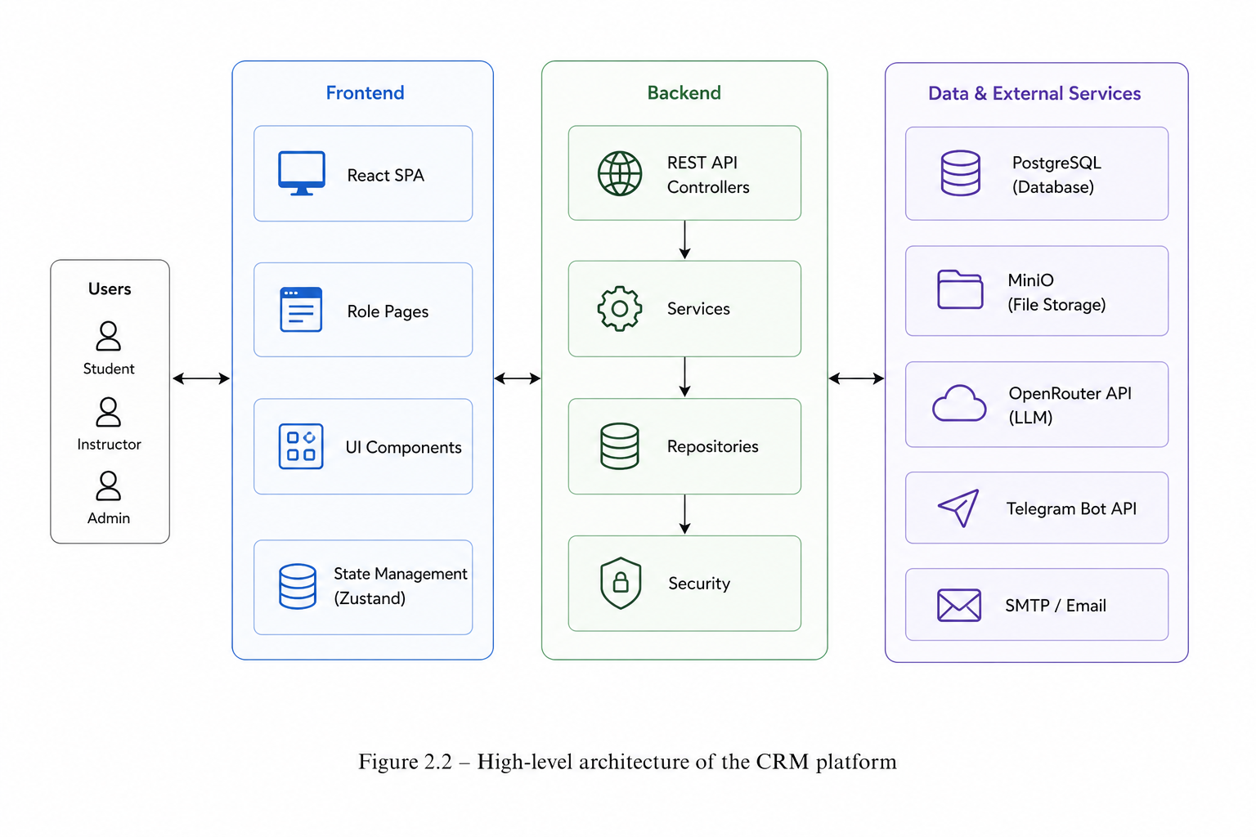
Figure 2.2 – High-level architecture of the CRM platform

The Lesson Management module supports the complete lifecycle of lessons within a course. Its functions include lesson creation, scheduling, status tracking, storage of recording links and conflict detection. In particular, the module prevents overlapping lessons within the same course, thereby contributing to schedule consistency and operational control.
The Homework and Submission module enables instructors to create assignments with deadlines and allows students to submit their work, including through GitHub links where appropriate. It also supports instructor-side grading and annotation, thereby linking assignment management with performance evaluation.
The Attendance module records learner attendance at the lesson level. It supports four attendance statuses — PRESENT, ABSENT, LATE and EXCUSED — and allows both individual updates and bulk marking operations. This provides a structured basis for subsequent reporting and learner performance analysis.
The Material Management module is responsible for the storage and association of learning materials with specific lessons. It supports the upload of files such as PDFs, presentations and archives to MinIO object storage and ensures that these resources are linked to the relevant elements of the training process.
The Payment module covers financial rules and payment records related to courses. Through this module, administrators can define payment rules for each course, including amount, currency, frequency and due date logic, and can manage individual payment records for students. This functionality extends the CRM platform beyond purely academic administration into operational aspects of training management.
The Notification module provides both in-platform notifications and out-of-platform alerting through Telegram integration. Users who link their accounts to the Telegram bot can receive notifications outside the main web interface, thereby improving communication responsiveness.
The AI Assistant subsystem integrates the platform with an external large language model provider via the OpenRouter API. It provides context-aware conversational support for both students and instructors, while maintaining different contextual models according to the role of the user. Because of its role-sensitive and integrated design, this subsystem constitutes one of the key differentiating elements of the proposed platform.
Finally, the Analytics and Reporting module exposes aggregated data through dedicated backend endpoints that are consumed by the administrative dashboard, instructor analytics pages and the context-building logic of the AI assistant. This module therefore serves both human-facing analytical tasks and internal platform intelligence.
Taken together, these subsystems and modules form the core structural architecture of the CRM platform. Their separation supports clarity of responsibilities, while their coordinated interaction enables the platform to function as an integrated environment for training management, learner relationship tracking and AI-assisted support.

Table 2.3 – Main modules and subsystems of the CRM platform
Module / Subsystem | Layer | Key responsibilities
Authentication & Security | Backend + Frontend | JWT auth, email verification, role-based access control
User & Profile Management | Backend + Frontend | User CRUD, profile photos via MinIO, password management
Course Management | Backend + Frontend | Course catalogue, instructor assignment, schedule parameters
Enrolment | Backend + Frontend | Student-course enrolment, per-student statistics tracking
Lesson Management | Backend + Frontend | Lesson lifecycle, status, conflict detection, recording links
Homework & Submission | Backend + Frontend | Assignment creation, student submissions, grading, feedback

Table 2.3 continued.
Attendance | Backend + Frontend | Per-lesson attendance marking, status types, bulk operations
Material Management | Backend + MinIO | File upload/download, lesson-material association
Payment | Backend + Frontend | Payment rules per course, per-student payment records
Notification | Backend + Telegram Bot | In-platform notifications, Telegram bot integration
AI Assistant | Backend + Frontend + OpenRouter | Context-aware LLM chat for students and instructors
Analytics & Reporting | Backend + Frontend | Aggregate dashboards for admin and instructor roles

2.2.2 Interaction between modules, external systems, security and access control

The functional modules of the CRM platform interact primarily through the RESTful API layer, which serves as the central communication mechanism between the frontend and backend parts of the system. On the client side, the frontend communicates with backend endpoints through a centralised Axios-based API client configured to automatically inject JWT Bearer tokens into requests and to perform token refresh when a 401 Unauthorized response is received. This design ensures that authentication is consistently applied across requests and that token expiration is handled transparently from the user’s point of view [22].
Inside the backend, business logic is concentrated in service classes, which are injected into controllers using Spring’s dependency injection mechanism. Service classes communicate with the persistence layer through JPA repositories, thereby preserving a clear separation between API handling, business operations and data access. At the same time, cross-cutting concerns such as security, transaction management and exception processing are handled through framework-level mechanisms, including Spring Security, @Transactional annotations and a global @ControllerAdvice exception handler. This combination supports architectural consistency and reduces the duplication of infrastructural logic.
The platform interacts with three main categories of external systems. The first is MinIO, an S3-compatible object storage service used for uploaded files, including educational materials and profile photos. The backend communicates with MinIO through the MinIO Java SDK and generates pre-signed URLs that allow secure and time-limited access to stored objects.
The second category is the OpenRouter API, which provides access to the large language model backend currently used by the AI assistant, namely the google/gemma-3n-e2b-it:free model. Through HTTP-based communication, the backend sends contextualised prompts to the OpenRouter service and processes the returned structured JSON responses. This integration makes it possible to embed AI-based conversational support into the platform without implementing a custom model.
The third category is the Telegram Bot API, integrated through the TelegramBots library. This service enables out-of-platform notifications to be delivered through a Telegram bot. User accounts can be linked to the bot through a secure pairing-code mechanism, thereby extending the communication capabilities of the platform beyond the web interface itself.
Security and access control are implemented at several complementary levels. At the network and API level, all protected endpoints require a valid JWT access token, with the exception of registration, login and e-mail verification endpoints. At the application level, role-based access control is enforced through Spring Security, including method-level @PreAuthorize annotations and URL-level security rules, ensuring that each endpoint is accessible only to the roles for which it is intended.
At the data level, additional ownership and scope checks are performed within service classes. For example, an instructor is allowed to access data only for the courses under their responsibility, while a student is limited to their own enrolment-related records. This additional verification layer is important because it complements role-based access with context-sensitive business restrictions.
Password protection is implemented using bcrypt hashing, thereby ensuring that sensitive authentication data is not stored in plaintext form. In addition, when platform data is passed to the AI assistant, only the minimum necessary personal and contextual information is included, in accordance with the principle of data minimisation [22]. This is particularly important given the external and partially opaque nature of LLM-based services.
From the perspective of persistence and schema evolution, database migrations are managed using Flyway, which ensures that changes to the relational schema occur in a controlled, explicit and reproducible way. The JPA/Hibernate layer is configured in validate mode, which means that the application does not attempt to modify the database schema automatically during startup. This decision reduces the risk of unintended structural changes and is therefore more appropriate for stable or production-like environments.
Overall, the interaction model of the CRM platform reflects the broader architectural principles identified earlier: clear separation of concerns, controlled integration with external services, strong role-based access control, and careful treatment of sensitive data. These principles are essential for ensuring that the platform remains usable, secure and extensible while supporting a wide range of organisational and learner-oriented functions.

2.3 Data and core functionality design

The data model constitutes the structural backbone of the CRM platform. A well-defined and internally consistent data model is essential for representing all relevant entities and their relationships in a way that supports both everyday operational processes and higher-level analytical functions, including reporting and AI context provision [19], [25]. Because the proposed system is designed as an integrated and lifecycle-oriented platform, the data model must not only store isolated records, but also capture the relationships between learners, courses, lessons, assignments, interactions and administrative events in a coherent and extensible manner.
For this reason, the present section focuses first on the core entities of the system and the relationships between them, and then on the design of the main functional modules that are built upon this data structure. The goal is to show how conceptual assumptions about learner relationship management are translated into concrete data representations and implementation-oriented functional design.

2.3.1 Data model and physical database schema

The physical database schema of the CRM platform is implemented in PostgreSQL and managed through Flyway migrations, which provide controlled, versioned and reproducible evolution of the database structure throughout the development lifecycle. In accordance with the architectural principles formulated earlier, the schema is organised around a set of core entities that reflect the main objects, relationships and operational events of the training process. Its overall structure (Fig. 2.2) supports both the transactional needs of the platform and the broader CRM-oriented objective of maintaining an integrated, lifecycle-based view of learners, courses, interactions and administrative processes.

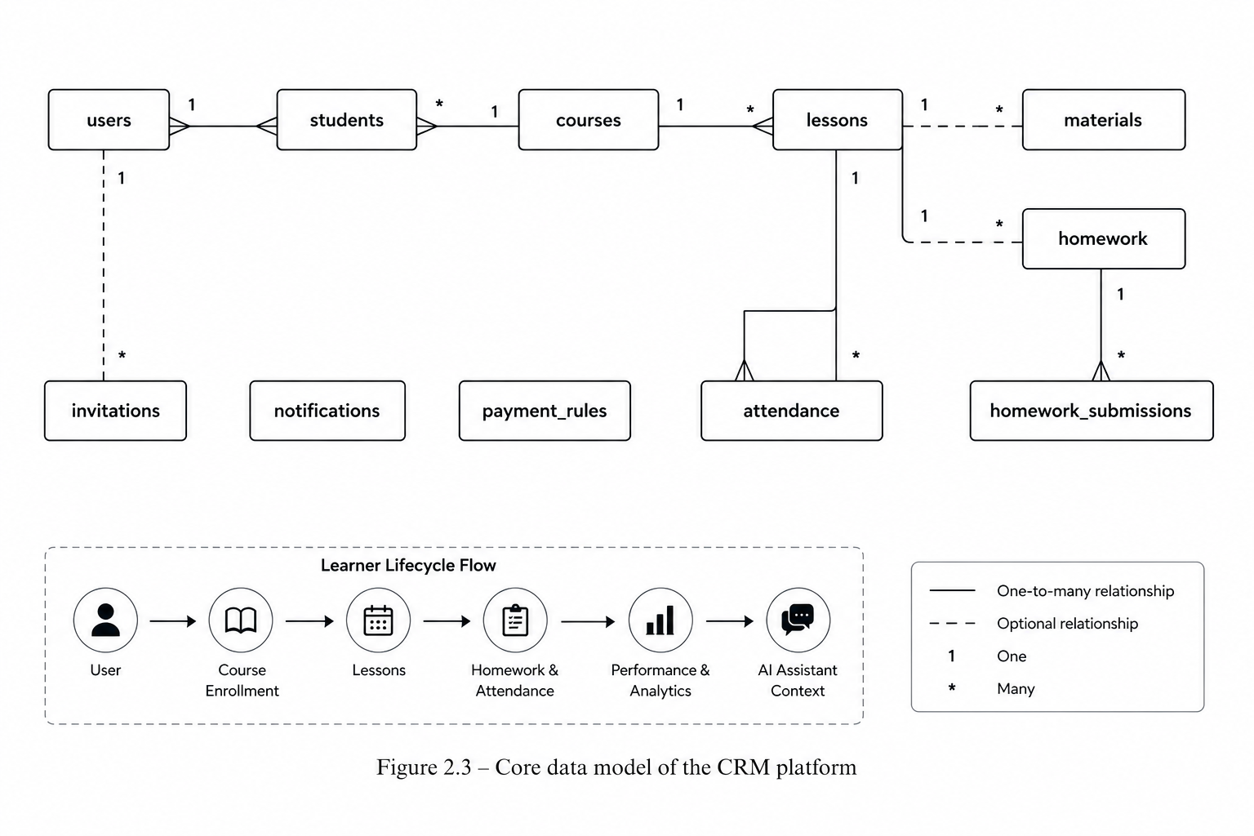

Figure 2.3 – Core data model of the CRM platform

At the centre of the schema is the users table, which acts as the main identity entity of the platform. It stores personal, authentication and status-related information for all users, regardless of their role in the system. Its key attributes include identification data, e-mail and password fields, role and status values, contact information, profile photo reference and audit timestamps. This design allows all role-specific functionality to be built on top of a single identity model, which is consistent with CRM principles requiring a unified user record as the central object of interaction and system logic [24].
The remaining entities extend this identity model and represent the main operational areas of the platform:
- The courses table stores course data, instructor references, dates and enrolment indicators.
- The students table links users to courses and stores learner performance indicators.
- The lessons table stores lesson schedules, locations, links, recordings and status values.
- The homework and homework_submissions tables manage assignments, submissions, grades and feedback.
- The attendance table records student attendance for each lesson.
- The materials table stores metadata for lesson resources, while files are kept in MinIO.
- The payment_rules table defines course-specific payment parameters.
- The notifications table stores system messages and read/unread status.
- The invitations table supports e-mail-based onboarding and invitation status tracking.
Taken together, these entities form the core physical database schema of the platform and provide the persistence layer for its main functional capabilities. Their structure reflects the conceptual requirements identified in earlier sections: unified user identity, lifecycle-oriented learner tracking, structured course and lesson management, interaction recording, administrative control and support for AI-relevant contextual data. Table 2.4 summarises the principal entities and their key attributes.

Table 2.4 – Core entities of the CRM platform data model
Entity (table) | Key attributes | Main relationships
users | id, email, role, status, first_name, last_name, phone, profile_photo_url, is_email_verified | Referenced by courses, students, attendance, notifications
courses | id, name, description, instructor_id, start_date, end_date, total_lessons, enrolled_students | FK to users (instructor); referenced by students, lessons, payment_rules
students | id, user_id, course_id, average_grade, attendance_rate, homework_completion_rate, enrolled_at | FK to users and courses; unique (user_id, course_id)
Table 2.4 continued.
lessons | id, course_id, title, scheduled_at, duration_minutes, location, online_meeting_url, recording_url, status | FK to courses; referenced by homework, attendance, materials
homework | id, lesson_id, title, description, deadline | FK to lessons; referenced by homework_submissions
homework_submissions | id, homework_id, student_id, github_url, submitted_at, grade, feedback, is_late | FK to homework and users (student)
attendance | id, lesson_id, student_id, status, notes, marked_by, marked_at | FK to lessons and users; unique (lesson_id, student_id)
materials | id, lesson_id, name, file_url, file_type | FK to lessons; content in MinIO
payment_rules | id, course_id, amount, currency, frequency, due_day, is_active | FK to courses
notifications | id, user_id, title, message, type, is_read, created_at | FK to users
invitations | id, email, role, token, expires_at, status | Independent; used for onboarding flow

The relationships between these entities form an interconnected graph that mirrors the learner lifecycle described in Section 1.3.1. A user is enrolled as a student in a course; the course contains lessons; lessons have homework and materials; students submit homework and their attendance is marked per lesson. All of these events contribute to the student's performance record and to the context available to the AI assistant. This design directly addresses the requirement for a unified learner profile (Section 1.5.1) by centralising all relevant data in a single, coherently structured schema.

2.3.2 Design of core modules: learners, training programmes, interactions and reporting

The design of the core functional modules translates the data model and use case requirements into concrete API contracts, service logic and frontend views. In accordance with the architectural decisions described earlier, the platform is organised around several interrelated modules that support the main stages of training management: user and learner administration, course and enrolment management, lesson scheduling, homework submission, attendance tracking and reporting. Together, these modules provide the operational layer through which the CRM-oriented data model is exposed to different user roles.
The User and Learner Management module exposes REST endpoints under /api/users and role-specific paths such as /api/student and /api/instructor. A key design decision in this module is the separation of identity data, represented by the users table, from enrolment data, represented by the students table. This separation allows a single user to participate in several courses simultaneously while preserving one unified user profile. Admin-facing views provide paginated user lists with search and filtering capabilities, whereas student-facing views expose only the data related to the currently authenticated user. This distinction supports both administrative control and role-based data limitation.
The Course and Enrolment module is designed around CourseService, which manages course creation, retrieval and update, as well as student enrolment performed by the administrator role. On the frontend side, CourseManagementPage.tsx provides instructors with a structured view of their courses, including enrolled students, lesson counts and aggregate performance indicators. The administrator role has additional capabilities through AdminDashboardController and the enrolment endpoint, which makes it possible to manage the connection between learners and training programmes at the system level.
The Lesson and Schedule module is one of the more complex components of the platform, since it manages temporal entities and must prevent scheduling inconsistencies. The backend LessonService performs conflict detection before creating or updating a lesson. If a new lesson overlaps with an existing lesson within the same course, the system returns a conflict response instead of creating an invalid schedule entry. On the frontend, lessons are presented both in calendar views (InstructorCalendarPage.tsx, CalendarPage.tsx) and in list format. The LessonDetailModal.tsx component gives instructors a detailed view of a lesson, including attendance records, homework submissions, materials and links to recordings or online meetings.
The Homework and Submission module follows a request-response interaction model. Instructors create homework assignments through HomeworkController by specifying the related lesson, title, description and deadline. Students submit their work through HomeworkSubmissionController, where the submission is represented by a GitHub URL. When a submission is graded, the system updates the learner’s average_grade in the students table. On the frontend, DeadlinesPage.tsx aggregates upcoming deadlines across all courses in which the student is enrolled, thereby supporting individual planning and timely completion of assignments.
Attendance tracking is implemented through the Attendance module, which uses a bulk marking approach. Instructors can submit attendance for all students in a lesson through a single API request, represented by MarkAttendanceRequest with a list of student-status pairs. Individual attendance records can later be updated if corrections are required. After each marking operation, the attendance_rate in the students table is recalculated, ensuring that learner performance indicators remain consistent with the latest lesson-level data.
The Reporting and Analytics module is implemented through AdminDashboardService and CourseAnalyticsService. The administrator dashboard provides system-level statistics, including the total number of users, students, instructors, courses and recent activity. The instructor analytics page provides course-level aggregates such as grade distribution, attendance trends and homework completion rates, which are rendered as interactive charts in InstructorAnalyticsPage.tsx. In this way, reporting functions transform operational data into indicators that support monitoring, decision making and early identification of potential learner difficulties.

2.4 Design of the AI assistant subsystem

The AI assistant is one of the defining features of the proposed CRM platform, since it distinguishes the system from a conventional LMS or administrative application. As discussed in Section 1.3.3, effective AI assistants in CRM and educational contexts depend on access to reliable and structured institutional data, as well as on governance mechanisms that define what the assistant may and may not do [35]. This section describes the design of the AI assistant subsystem, including its role and architecture, knowledge sources, context-building logic and typical dialogue scenarios.

2.4.1 Role, architecture and knowledge sources of the AI assistant

The AI assistant in the CRM platform serves two main roles depending on the user who initiates the interaction. This role-sensitive design allows the same subsystem to support both learners and instructors while relying on different contextual data and different types of expected output.
For students, the assistant functions as a personalised AI tutor. It has access to the student’s performance data within a specific course enrolment, including the student’s name, course name, average grade, attendance rate, homework completion rate and lesson-by-lesson information about attendance and homework grades. Using this context, the assistant can answer questions about progress, explain topics related to weak areas, such as grades below 70 out of 100, and provide motivational or organisational guidance. In this configuration, the assistant supports the learner as an individual participant in the training process.
For instructors, the assistant functions as an analytical assistant. It has access to course-level data, including the course name, the list of enrolled students with their performance metrics, average grade, attendance rate and homework completion rate, as well as summary indicators such as mean grade, mean attendance and the number of at-risk students, defined as students with grades below 60 out of 100. Using this context, the assistant helps instructors analyse class performance, identify learners who may require additional support and receive teaching recommendations based on the available course data.
Architecturally, the AI assistant subsystem consists of three main components. The GeminiService backend service is responsible for context assembly and communication with the large language model. For each request, it retrieves relevant data from the platform database through StudentService and CourseRepository, constructs a structured system prompt and sends a combined payload consisting of system context and the user message to the external LLM provider. The OpenRouter API acts as a gateway to the LLM backend. In the current implementation, the platform uses the google/gemma-3n-e2b-it:free model through OpenRouter, which allows the model to be changed later without redesigning the integration logic. The frontend AI chat interface provides the user-facing dialogue environment and supports Markdown rendering for richer responses.
The knowledge sources available to the AI assistant are deliberately limited to the data stored within the CRM platform. The assistant does not access the open internet, external knowledge bases or data outside the current enrolment or course context. This design choice follows the principle of minimum necessary context [22]: limiting the data exposed to the AI service reduces privacy risks, makes responses more focused and improves the controllability of assistant behaviour. Table 2.5 compares the two assistant configurations.

Table 2.5 – Comparison of student and instructor AI assistant configurations
Aspect | Student AI assistant | Instructor AI assistant
API entry point | /student/ai/chat?enrollmentId={id} | /instructor/ai/chat?courseId={id}
Context scope | Single student × single course enrolment | All enrolled students in a course
Data provided to LLM | Name, per-lesson grades and attendance, HW completion rate | Per-student: name, avg grade, attendance rate, HW rate; course summary stats
Primary use cases | Progress questions, topic explanations, homework status | Class analysis, at-risk identification, teaching recommendations
At-risk threshold | Grade < 70 triggers help offer | Grade < 60 counted as at-risk student
Response language | Russian (ru) | Russian (ru)
LLM model | google/gemma-3n-e2b-it via OpenRouter | google/gemma-3n-e2b-it via OpenRouter

2.4.2 Typical dialogue scenarios and control of AI responses

The AI assistant supports a defined set of dialogue scenarios that correspond to practical user needs identified during the analysis of information flows and stakeholder requirements in Sections 1.1.3 and 1.2.2. These scenarios are not treated as unrestricted conversation paths, but as controlled forms of interaction in which the assistant uses the available platform data to provide relevant, role-specific support (Fig. 2.3).
For students, the main scenarios are connected with individual progress, learning difficulties and organisational guidance. The first scenario is a progress enquiry, where the student asks about overall performance and the assistant summarises grades, attendance and homework completion on the basis of the available enrolment context. The second scenario is topic-specific help, where the student refers to a lesson or topic and requests an explanation or additional clarification. The third scenario is homework status enquiry, where the assistant helps the student understand which assignments have been submitted, graded or are overdue. The fourth scenario is motivational support, where the assistant responds to expressions of difficulty by using concrete performance data and offering practical, data-grounded encouragement rather than generic advice.
For instructors, the main scenarios are oriented towards analysis, monitoring and decision support. The first scenario is a class performance summary, where the instructor requests an overview of a course and the assistant presents mean grades, attendance indicators and the number of at-risk students. The second scenario is individual student analysis, where the instructor asks about a particular learner and receives a concise summary of that learner’s progress, attendance and homework completion. The third scenario is recommendation for intervention, where the assistant identifies learners with low grades or poor attendance and suggests possible actions. The fourth scenario is comparative analysis based on course-level summary statistics, allowing the instructor to understand differences between learners or groups of indicators within the same course.

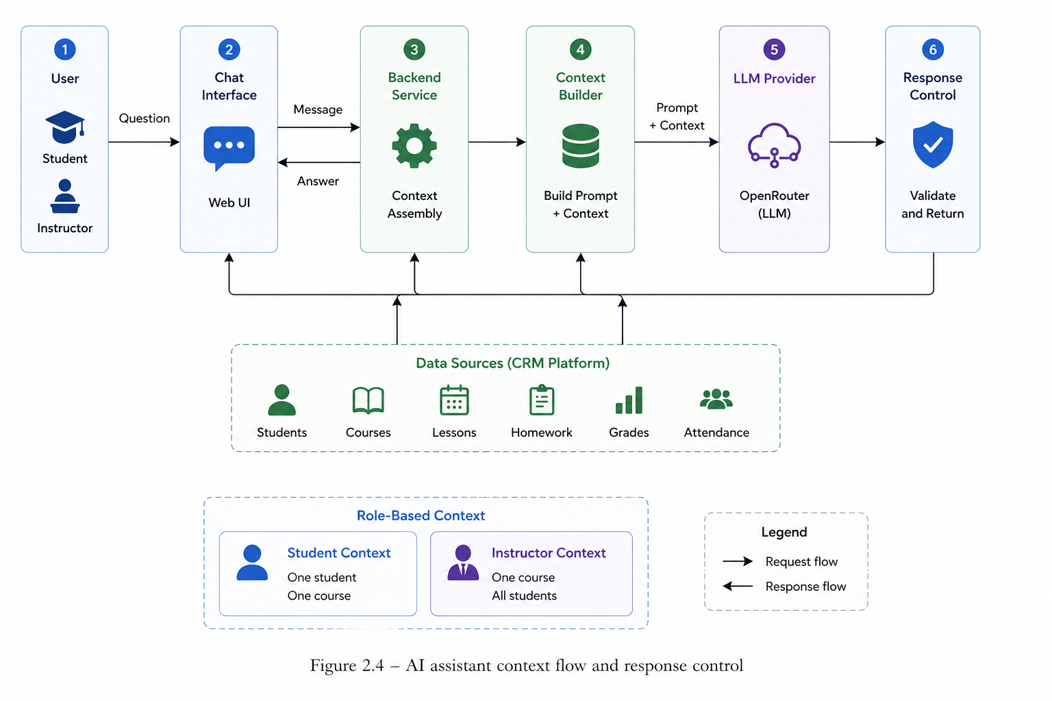

Figure 2.3 – AI assistant context flow and response control

Control of AI responses is implemented primarily at the prompt level. The system prompt contains explicit instructions about the assistant’s role, the required response language, which is Russian in the current implementation, and the boundaries of available knowledge . In particular, the assistant is instructed to rely only on the data provided by the platform and not to present itself as having access to external internet information. For student-oriented interactions, the prompt requires the model to use only the provided performance data and to offer support when grades or attendance indicators are low. For instructor-oriented interactions, the analytical role of the assistant and the available course-level data are defined explicitly.
Additional control is provided at the interface and service levels. On the frontend, predefined quick-question buttons guide users towards the most useful and supported dialogue scenarios. On the backend, error handling mechanisms catch failures of the external LLM provider and return a user-friendly message instead of exposing technical details. This approach corresponds to the reliability requirement defined in Section 1.5.1 and supports safer, more predictable use of AI within the platform [35].

2.5 User interface, UX and technological support

The design of the user interface and user experience directly influences how effectively different stakeholder roles can accomplish their tasks within the CRM platform. According to the non-functional requirements defined in Section 1.5.1, the system must provide an interface that is understandable, navigable and role-appropriate for learners, instructors and administrators. For this reason, the frontend is not only a visual layer of the application, but also an important mechanism for organising access to platform functions, reducing user effort and presenting complex training-related data in a structured form.
This section describes the UX requirements, main user journeys and key screens for each role, followed by the technology stack and deployment environment. The description focuses on how the interface supports the operational scenarios of the system and how technological choices contribute to usability, maintainability and future extensibility.

2.5.1 UX requirements, main user journeys and key screens for each role

The UX design of the platform is guided by several principles derived from the requirements analysis and from established practices of modern web application design. These principles define how information is organised, how users move through the application and how the system communicates the result of user actions.
The first principle is role-separated navigation. After authentication, each user is routed to a section of the application that corresponds to their role. A persistent sidebar provides role-appropriate navigation links: students see pages related to their courses, lessons, deadlines, notifications and AI assistant; instructors access course management, lesson scheduling, analytics and student-related tools; administrators work with user management, invitations and system-level dashboards. This separation prevents unnecessary exposure of unrelated functions and reduces cognitive load for each user category.
The second principle is progressive disclosure. Complex information, such as lesson details containing attendance records, homework submissions, materials and recordings, is not placed directly on the main page. Instead, it is opened through modal dialogs or detailed views when the user explicitly needs it. This approach keeps primary screens visually clear while preserving access to detailed operational data.
The third principle is responsive feedback. Loading states, skeleton screens, animated spinners, success toasts and error messages are used to provide immediate feedback for user actions. These elements help users understand whether the system is processing a request, whether an operation has been completed successfully or whether an error requires attention. This contributes to the user’s sense of control and improves the overall reliability perception of the platform.
The fourth principle is personalisation of visual and language preferences. The platform supports both light and dark themes, which can be changed from the settings page and help accommodate user preferences during extended work sessions. In addition, the frontend is internationalised using react-i18next and supports Russian, Kazakh and English. UI labels and messages are externalised as translation keys, which makes it possible to switch the interface language without changing the application logic.
Dashboard screens play a particularly important role in the overall user experience because they provide a compact overview of the most relevant information for each role. The InstructorDashboard presents animated summary statistics, including total courses, total students, lessons this month and pending submissions, together with upcoming lessons and recent homework submissions. This gives the instructor an immediate operational overview without requiring navigation to several sub-pages. The StudentDashboard shows enrolled courses, nearest upcoming lessons and recent notifications, helping the learner understand current responsibilities and upcoming activities. The AdminDashboard provides system-wide metrics and recent activity, supporting administrative monitoring of the platform. Table 2.6 summarises the main user journeys and key screens by role.

Table 2.6 – Main user journeys and key screens by role
Role | Main user journey | Key screens / components
STUDENT | Login → Dashboard → View enrolled courses → Open lesson schedule → View lesson details (materials, homework) → Submit homework → Check grades → Chat with AI | StudentDashboard, CalendarPage, StudentLessonDetailModal, GradesPage, DeadlinesPage, PaymentsPage, AIAssistantPage
INSTRUCTOR | Login → Dashboard → Open course → View student list → Individual student profile → Lesson detail (mark attendance, grade submissions) → Analytics → AI chat | InstructorDashboard, CoursesPage, CourseManagementPage, StudentsPage, StudentDetailPage, InstructorCalendarPage, LessonDetailModal
Table 2.6 continued.
ADMIN | Login → Admin Dashboard → Manage users → Enrol students → Configure payment rules → View payment records → Send invitations | AdminDashboard, ManageUsersPage, EnrollStudentModal, AdminPaymentsPage, InviteUserPage, AdminSettingsPage
All roles | Update profile → Change password → Upload profile photo → Switch language / theme → Link Telegram account | SettingsPage (role-specific), ProfileController (backend)

2.5.2 Integration of the AI assistant into the UI, technology stack and deployment environment

The AI assistant is integrated into the UI as a dedicated page for each role. The chat interface follows a standard conversational UI pattern: messages are displayed in a scrollable list with distinct avatars and bubble styles for user and AI messages; a text input at the bottom allows the user to type and submit messages with the Enter key or a Send button; and pre-defined quick-question buttons are displayed before the first message, guiding users towards the most useful types of queries. AI responses are rendered with Markdown support using the react-markdown library, allowing the LLM to produce formatted text with lists, bold headings and code blocks.
For students enrolled in multiple courses, a course selector dropdown allows switching the active enrolment context without leaving the chat page. Switching resets the conversation and displays a new greeting, ensuring the AI context always matches the displayed conversation. The technology stack of the CRM platform reflects a balance between ecosystem maturity, developer productivity and suitability for an academic prototype that may evolve into a production system.
Regarding deployment, the platform is designed to run in a standard server environment. The Spring Boot backend is packaged as an executable JAR and deployed on any JVM-capable host. The frontend is built as a static bundle (Vite build) and served via a web server such as Nginx. PostgreSQL and MinIO are deployed as separate services, either locally or as managed cloud offerings. Environment-specific configuration — database credentials, API keys, SMTP settings, MinIO access details — is externalised via environment variables, making the application suitable for deployment in both development and production-like environments without code changes. The HikariCP connection pool is configured with a maximum of 10 connections and appropriate timeout settings to handle the expected load of a small to medium training organisation. Scalability considerations for future development include containerising the application with Docker and orchestrating multiple instances with Kubernetes, adding a message queue (e.g., RabbitMQ) for asynchronous notification processing, and expanding the analytics module with a dedicated reporting database or BI integration. These directions are discussed further in Section 3.5 [19], [26]. In summary, Chapter 2 has presented the full design of the CRM platform: from its conceptual position in the digital ecosystem and the business processes it supports, through the system architecture and data model, to the design of the AI assistant subsystem and the technology choices underlying the implementation. The design decisions are grounded in the requirements and conceptual foundations established in Chapter 1 and provide a coherent basis for the implementation and testing activities described in Chapter 3.

