INTRODUCTION

The rapid development of digital technologies has significantly transformed the way educational and training processes are organized. Universities, training centres and corporate academies increasingly rely on online platforms to manage enrolment, track learners’ progress, deliver learning materials and evaluate results. However, many organisations still use fragmented tools – spreadsheets, messengers and separate services – which leads to duplicated data, low transparency of processes and difficulties in communication between administrators, trainers and learners.
Customer Relationship Management (CRM) systems, widely used in business to manage the customer lifecycle, can be adapted to the training domain by treating a learner as a “customer of educational services”. This approach makes it possible to coordinate the learner’s path from the first request to the completion of the programme. Existing learning management systems (LMS) and training platforms, however, often provide limited CRM functionality, focusing mainly on content delivery and assessment rather than on comprehensive management of interactions and data-driven decision making.
In parallel, the development of artificial intelligence, in particular conversational AI assistants, opens new opportunities for supporting participants of the training process. AI tools can help answer typical questions of learners, recommend courses, assist trainers in routine tasks and support administrators in their daily operations. Integrating such an AI assistant into a CRM platform for training can increase the efficiency of communication, reduce the workload of staff and offer a more personalised learning experience.
The object of this diploma project is the process of managing training activities in an educational or corporate environment using information technologies. The subject of the research is the development of a CRM platform for training with an integrated AI assistant that supports administrators, trainers and learners at different stages of the training lifecycle.
To achieve this aim, the following tasks are defined: to analyse theoretical approaches to CRM and digital learning platforms; to study existing solutions and identify their limitations; to define functional and non-functional requirements for the system; to develop the architecture of the CRM platform and its AI component; and to implement and test a prototype of the system. The practical significance of the work lies in the creation of a prototype CRM platform for training that can be used as a basis for deploying a real system in an educational institution or training company.
The diploma project consists of an introduction, three chapters, conclusion, list of references and appendices. The first chapter presents the theoretical background of CRM systems and digital learning platforms, as well as the role of AI assistants in education. The second chapter describes the requirements and architecture of the developed information system. The third chapter is devoted to the implementation of the CRM platform with an integrated AI assistant and to the analysis of the obtained results.
1 SUBJECT AREA AND PROBLEM STATEMENT

In recent years, training and education have undergone substantial transformation under the influence of digital technologies, changing labour market requirements and the growing importance of lifelong learning. Universities, corporate academies and training centres are expected to provide flexible, personalised and outcome-oriented learning experiences, while simultaneously managing an increasing number of programmes, formats and stakeholder expectations. Learning management systems (Fig. 1.1) have become central infrastructure for delivering digital content, administering courses and recording assessment results in higher education and professional training [12]. However, these systems often operate in isolation from broader relationship management and strategic communication processes.

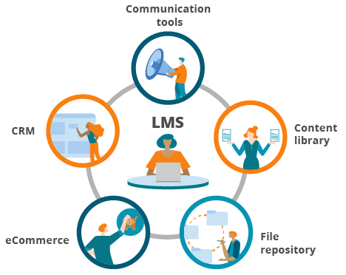

Figure 1.1 – Learning management systems

The concept of Customer Relationship Management (CRM), originally developed in the business domain, offers a useful framework for addressing this gap. CRM is focused on building long-term, value-oriented relationships with customers by integrating information about all interactions with them across channels and organisational units [1]. When adapted to education and training, learners are viewed as “customers of educational services” whose lifecycle spans initial interest, recruitment, enrolment, participation in programmes, evaluation of results and further development [5]. A number of studies have applied CRM and related concepts to higher education, demonstrating that systematic relationship management can support recruitment, retention and student satisfaction when appropriate information systems are in place [6].
At the same time, the rapid development of artificial intelligence (AI), particularly conversational AI and large language models, has opened new possibilities for supporting participants in the training process. AI-based assistants and chatbots are already being used to answer frequently asked questions, guide students through administrative procedures, provide basic academic or motivational support and enhance engagement [15]. Reviews of AI in education highlight the potential of intelligent systems to enable more personalised, data-driven and proactive support for learners, but also emphasise the importance of appropriate integration with institutional processes and data [18]. In parallel, research on AI in CRM shows that AI components can increase efficiency and personalisation in customer relationship management, while also raising questions about control, transparency and shifts in organisational power [22].
Despite the availability of LMS, CRM tools and AI technologies, there remains a noticeable gap between the needs of organisations that manage training processes and the capabilities of existing systems. LMS focus primarily on course-level content and assessment [12]; CRM implementations in education are often limited to recruitment and marketing [11]; AI assistants are typically deployed as add-ons to existing platforms rather than as integrated components of a learner-centred information architecture [17]. As a result, information about learners, programmes and interactions is fragmented across multiple systems and communication channels, making it difficult to obtain a holistic view of the learner lifecycle and to support data-driven decision making.
In this context, the subject area of the present diploma project can be defined as the management of training processes in educational and training organisations with a focus on long-term relationships with learners, supported by CRM concepts and AI-based assistance. The practical problem addressed in this work is the absence of an integrated platform that combines:
- CRM-oriented management of learners and organisations;
- training programme and course management;
- systematic recording of interactions and communication;
- analytical capabilities for monitoring outcomes;
- and an AI assistant that provides context-aware support to different user roles.
The goal of the diploma project is to design and develop a CRM platform for training with an integrated AI assistant that unifies key data and processes around the learner lifecycle and supports the work of learners, trainers, administrators and managers. Chapter 1 provides the conceptual and contextual foundation for this goal: Section 1.1 describes the technical and organisational characteristics of the subject area; Section 1.2 analyses current practice and existing tools; Section 1.3 introduces the relevant concepts of CRM, learner lifecycle and AI assistants; Section 1.4 formulates the problem statement, object, subject, aim and tasks of the research; and Section 1.5 outlines the requirements and methodological basis for the project.

1.1 Technical and organisational description of the subject area

The subject area of this diploma project is characterised by the intersection of training management, relationship management and digital technologies. Educational institutions and training organisations operate in environments where:
- learning activities are increasingly digital and hybrid;
- multiple stakeholders are involved in planning, delivering and evaluating training;
- information is distributed across heterogeneous information systems;
- and there is growing interest in using CRM concepts and AI-based tools to improve support for learners [18].
From a technical point of view, the core infrastructure for managing learning processes is typically formed by one or more LMS, combined with student or HR information systems, communication tools (e-mail, messengers, portals) and sometimes CRM or student relationship management (SRM) solutions [25]. LMS platforms support course-level operations such as publishing content, managing enrolments, collecting assignments and recording grades [13]. Student or HR systems store official records about learners, enrolments and contracts. CRM/SRM tools, where they are used, focus on tracking interactions and managing communication with prospective and current learners [9], [25]. However, these systems are rarely fully integrated, which complicates the creation of a unified view of the learner and their interactions over time.
From an organisational perspective, training processes involve a wide range of stakeholders: learners (students, employees, clients), trainers and instructors, programme and training managers, administrative and HR staff, institutional leadership and IT/support services (Fig. 1.2).

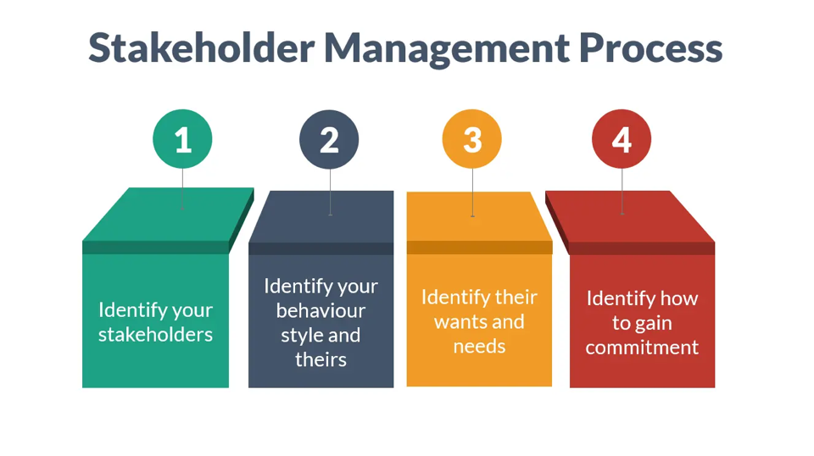
Figure 1.2 – Stakeholder management process

Each group has its own responsibilities, information needs and tools. Studies on CRM and SRM in higher education show that the quality of the student – institution relationship depends not only on the design of programmes and courses, but also on how information flows are coordinated across these stakeholders [11]. Poorly structured or fragmented processes can lead to duplicated efforts, inconsistent communication and difficulties in monitoring progress and outcomes.
The technical and organisational characteristics of the subject area can be summarised as follows:
- Multi-system environment: coexistence of LMS, student systems, communication tools and CRM/SRM components with limited integration.
- Multi-stakeholder participation: involvement of diverse roles with different perspectives on training processes and data [7].
- Lifecycle orientation: the learner’s relationship with the organisation spans multiple stages and programmes, not just isolated courses [1].
- Growing data and analytics needs: institutions seek to monitor engagement, outcomes and effectiveness, which requires coordinated data collection and analysis [19].
- Emerging role of AI and conversational agents: AI is increasingly used to support routine communication and guidance, but depends on access to reliable and structured data.
These characteristics form the context in which the proposed CRM platform with an integrated AI assistant must operate. To specify this context more precisely, the following subsections describe, respectively, modern training and educational processes and stakeholders (Section 1.1.1), the main types and formats of training (Section 1.1.2) and the information flows and key documents in training management (Section 1.1.3).

1.1.1 Modern training and educational processes and stakeholders
Modern training and educational processes are shaped by the transition from one-time, classroom-based education to continuous, digitally supported and learner-centred learning. In higher education, LMS platforms are widely used to support course management, content delivery and assessment [13]. Comparative analyses of LMS in higher education show that institutions select and configure these systems to support both traditional and blended learning, integrating them with video conferencing and other tools, especially in the post-COVID context [14]. In corporate and professional training, organisations use similar platforms to deliver onboarding, compliance and skill development programmes, often in combination with HR systems and performance management tools [26].
Across these contexts, learning processes typically follow a lifecycle that includes: identification of learning needs; planning and design of programmes; enrolment and group formation; delivery of learning activities; ongoing support and communication; assessment and feedback; and post-training follow-up. CRM and SRM frameworks emphasise that each stage generates data and interactions that should be captured as part of the relationship with the learner [8]. However, when data is spread across multiple systems and channels, it becomes difficult to reconstruct the learner’s trajectory and understand how different events and interventions influence outcomes.
A defining feature of modern training is the involvement of multiple stakeholders with different perspectives and responsibilities. On the basis of the literature on CRM and SRM in education [25], the main stakeholder groups can be summarised as follows.

Table 1.1 – Stakeholders in modern training processes and their perspectives
Stakeholder group | Main perspective on training processes
Learners (students, employees, clients) | Access to relevant programmes, clarity of requirements, timely support, recognition of results
Trainers / instructors | Design and delivery of content, group management, assessment, feedback provision
Programme and training managers | Planning and optimisation of programmes, monitoring participation and completion
Administrative and HR staff | Enrolment, records management, contracts, certification and compliance with regulations
Management (deans, heads, executives) | Alignment of training with strategic goals, resource allocation, key performance indicators
IT and support services | Stability, security and usability of platforms, support for users and integrations

As Table 1.1 shows, each group interacts with training processes from its own viewpoint:
- Learners focus on usability, flexibility, support and the perceived value of training;
- Trainers concentrate on pedagogical quality, workload and the ability to adapt content to learner needs;
- Managers and administrators emphasise operational continuity, correct and timely information, and reporting;
- Institutional leadership is concerned with strategic relevance and measurable impact.
- IT and support staff ensure that systems are available, integrated and secure.
The coexistence of these perspectives in a multi-system environment often leads to fragmentation of practices. For example, learners may receive course information via LMS, administrative notifications via e-mail and informal guidance via messengers; trainers may maintain separate spreadsheets in addition to LMS records; programme managers may rely on manually compiled reports; and management may depend on aggregated data that is not updated in real time [11]. The result is a patchwork of partial views instead of a unified, relationship-oriented picture of the learner.
In summary, modern training and educational processes are:
- Digital and hybrid, combining online, blended and face-to-face elements supported by LMS and related tools [14];
- Lifecycle-based, involving multiple stages and touchpoints across the learner’s relationship with the organisation;
- Multi-stakeholder, requiring coordination between academic, administrative, managerial and technical roles [6].
These characteristics motivate the need for a platform that can support integrated management of learners and stakeholders within a coherent CRM-oriented framework.

1.1.2 Types and formats of training (university, corporate, professional development)
The subject area of the proposed CRM platform encompasses several types and formats of training that are common in modern educational and organisational contexts. Although they differ in objectives, duration and regulatory constraints, they share similar management challenges: coordination of stakeholders, integration of information and monitoring of outcomes.
From the perspective of this project, three broad categories can be distinguished:
- University and higher education programmes
- Corporate training and internal academies
- Professional development and continuing education
Studies on LMS adoption in higher education highlight that universities use LMS to support both traditional and innovative formats, including blended, flipped and fully online courses [12]. In corporate training, similar platforms or learning experience platforms are used to deliver shorter, more practice-oriented programmes, often integrated with HR systems for tracking completion and compliance [26]. In both cases, the shift towards continuous and flexible learning has increased the volume and diversity of programmes that must be managed.
Across these contexts, training formats can also be described along several cross-cutting dimensions:
- Mode of delivery: face-to-face, online synchronous (e.g., video conferencing), online asynchronous (LMS-based), or blended combinations
- Duration: long-term programmes (months or years) vs short-term courses, workshops and microlearning units.
- Degree of formalisation: formally accredited programmes vs non-formal or informal training opportunities.
This diversity creates additional complexity for training management. For example:
- In universities, long-term degree programmes must comply with regulatory and accreditation requirements, and their management involves strict documentation and formal records [5];
- In corporate environments, training must be closely aligned with business objectives, and tracking completion and effectiveness is essential for demonstrating value;
- In professional development, flexibility and responsiveness to individual learner needs and schedules are critical.
Although existing LMS can support a wide range of formats, they often treat each course as an isolated unit and do not provide tools for managing the overall relationship with the learner across different programmes and formats [18]. CRM and SRM perspectives, by contrast, emphasise the importance of tracking learners across programmes and time, including their participation in different formats and the impact of these experiences on their development [10].
For the purposes of this project, it is therefore essential that the CRM platform:
- can represent and manage different types of training (university, corporate, professional development);
- supports multiple formats and modes of delivery (Fig. 1.3);
- and maintains a unified learner profile that aggregates participation and outcomes across programmes and formats.

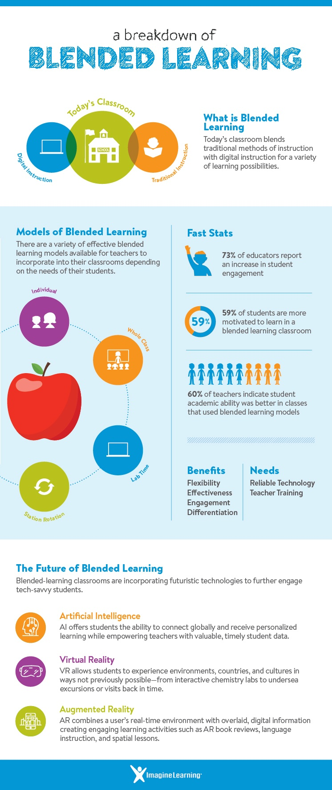

Figure 1.3 – Models of blended learning

These requirements follow directly from the typology of training described above and from the findings of LMS, CRM and SRM research in education and training [6].

1.1.3 Information flows and key documents in training management
Training management is driven by continuous information flows between stakeholders and systems and by the creation and use of a wide range of documents and records . At each stage of the training lifecycle, specific documents are generated and updated, and they serve as inputs for subsequent activities. Research on CRM and SRM in higher education stresses that the effectiveness of relationship management depends on how systematically these flows and documents are captured and integrated. From a functional standpoint, information in training management can be grouped into several categories:
- Learner and organisation data: personal information, organisational affiliation, roles, contact details.
- Programme and course data: descriptions of programmes, courses, learning outcomes, schedules.
- Participation and progress data: applications, enrolments, attendance, completions, results.
- Interaction and communication data: messages, notifications, support requests, feedback.
- Administrative and compliance data: contracts, orders, regulations, approvals, certificates.
These categories are reflected in typical key documents used in training management. Table 1.2 summarises such documents by major process stages.

Table 1.2 – Typical key documents in training management by process stage
Process stage | Examples of key documents / records
Needs analysis and planning | Training needs analysis, competency matrices, annual training plans, programme proposals
Programme and course design | Programme descriptions, course syllabi, learning outcomes, schedules, resource plans
Enrolment and group formation | Application forms, enrolment lists, group lists, consent forms, contracts (if applicable)
Delivery and ongoing support | Attendance sheets, LMS activity logs, communication logs, support tickets
Assessment and feedback | Assignment submissions, grade books, exam records, feedback forms, evaluation surveys
Post-training follow-up and reporting | Certificates, completion reports, analytics dashboards, management reports

Information flows associated with these documents connect different stakeholder groups:
- From learners to the organisation: applications, enrolment data, feedback, survey responses, support requests.
- From trainers and programme managers to learners: schedules, learning materials, instructions, announcements, assessment results.
- From administration and HR to other stakeholders: official orders, contracts, regulations, certification information.
- From systems to management: aggregated indicators, dashboards and reports used in strategic and operational decision making [5]–[7], [11], [25].
In universities, many of these documents are formalised and regulated; in corporate training and professional development they may be more flexible but serve similar purposes. Regardless of context, these documents are interconnected: training plans determine which programmes are developed; programme descriptions and schedules feed into enrolment; enrolment lists and group data underpin attendance tracking and assessment; and assessment records are summarised in completion reports and certificates, which in turn contribute to analytics and strategic reporting (Fig. 1.4).

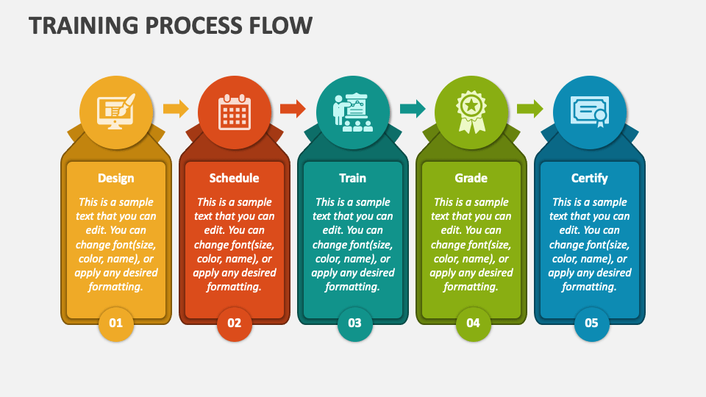

Figure 1.4 – training process flow

In many organisations, these flows are distributed across several systems: LMS for course-level data [13]; student or HR systems for official records; separate tools for surveys and feedback; document management systems for policies and certificates; and CRM/SRM tools for selected parts of the learner lifecycle. When integration is weak, several recurrent problems arise:
- Duplication and inconsistency of data between systems (e.g., different contact details in LMS and HR systems).
- Gaps in communication history, because e-mail, messaging apps and LMS messages are not consolidated.
- Manual and error-prone reporting, relying on exported spreadsheets and ad hoc data processing [11], [18], [19], [25].
A particularly dynamic subset of information flows concerns interaction and communication. Chatbots and conversational agents integrated into LMS and institutional portals generate additional logs of questions, answers and interactions [16]. If these logs are not linked to learner profiles and programme data, the organisation loses an important source of insight into learner needs and difficulties. SRM models explicitly argue that communication events should be treated as structured elements of the learner relationship history, not as untracked “background”. For the CRM platform with an integrated AI assistant proposed in this diploma project, information flows and key documents have several critical implications:
- They define which entities and relations must be represented in the data model (learners, organisations, programmes, enrolments, interactions, documents).
- They indicate which processes the system must support (from enrolment and delivery to assessment and reporting).
- They determine what context must be available to the AI assistant in order to provide meaningful, context-aware responses and recommendations [15].
Thus, understanding information flows and key documents is essential for designing a platform that can centralise and structure training-related information in a way that supports both operational needs and relationship-oriented, AI-augmented management of learners.

1.2 Current practice of training management and existing tools

Current practice of training management in universities, corporate academies and training centres is strongly conditioned by the existing digital toolset. Over the last two decades, many organisations have adopted learning management systems (LMS) as a central platform for delivering digital content, structuring courses and recording assessment results. At the same time, LMS coexist with student or HR information systems, communication tools, survey platforms, document repositories and, in some cases, CRM or student relationship management (SRM) solutions.
This has led to a situation where training processes are supported by multiple, partially overlapping systems, each focused on a particular part of the workflow: course-level teaching, enrolment, communication, marketing, analytics and so on. Research on CRM in higher education confirms that, although information systems can significantly improve the student–institution relationship, their impact depends on the degree to which data and processes are integrated across departments and platforms.
At the same time, the growing interest in CRM concepts and AI-based tools adds a new layer of complexity. CRM frameworks emphasise an integrated view of customers (in this case, learners) across their entire lifecycle [1]–[4], while SRM research calls for a similar integration of student data and interactions in educational settings. In parallel, AI and conversational agents are being introduced as add-ons to LMS and portals in order to handle routine queries and provide basic support . However, these assistants often rely on fragmented data sources and are not embedded into a coherent, CRM-oriented architecture [22].
Therefore, current practice can be described as digitally mature at the level of individual systems, but insufficiently integrated at the level of the training ecosystem. Section 1.2.1 describes this landscape and fragmentation in more detail, while Section 1.2.2 outlines the typical problems and practical needs that arise in the absence of an integrated CRM-oriented solution.

1.2.1 Typical IT landscape and fragmentation of tools and data
In most educational and training organisations, the IT landscape has evolved incrementally, resulting in a collection of specialised systems introduced at different times and for different purposes. Based on the literature on LMS, CRM and SRM in higher education and training [5]–[13], the main categories of systems can be summarised as follows:
- Learning Management Systems (LMS) – core platforms for course management, content delivery, assignments and assessment (Fig. 1.5).
- Student or HR information systems – systems of record for personal data, enrolment, contracts and formal grades.
- Communication tools – e-mail servers, messaging platforms and built-in LMS messaging modules used for announcements and support.
- Survey and feedback tools – systems used to collect course evaluations, satisfaction surveys and ad hoc feedback.
- CRM / SRM systems – tools for managing recruitment, marketing campaigns and, in some cases, current student relationship.
- Analytics and reporting tools – business intelligence (BI) tools, dashboards and data warehouses used to aggregate and analyse data from multiple sources.
- Document management systems – repositories for regulations, syllabi, certificates and other formal documents.

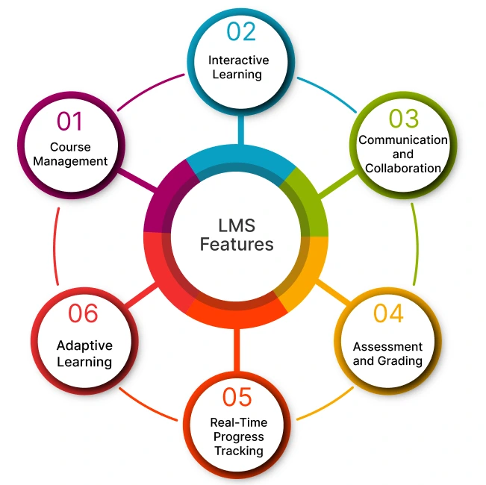

Figure 1.5 – LMS Features

Individually, each of these systems can be considered mature and effective in its domain. For example, LMS platforms provide rich functionality for course administration and are widely accepted by instructors and students. CRM implementations in higher education have demonstrated positive effects on recruitment and communication when appropriately configured [5]–[9], [11]. Analytics platforms can generate detailed dashboards for decision makers when fed with consistent data. These categories and their typical roles in training management are illustrated in Table 1.3.

Table 1.3 – Typical system categories and their roles in training management
System category | Typical role in training management
Learning Management System (LMS) | Delivery of content, course structure, assignments, quizzes, grade book
Student / HR information system | Official records of learners, enrolment, contracts, grades, employment data
Communication tools (e-mail, chat) | Announcements, individual communication, informal support
Survey / feedback platforms | Course evaluations, satisfaction surveys, targeted questionnaires
CRM / SRM systems | Recruitment campaigns, tracking interactions, retention initiatives
Analytics / reporting tools | Dashboards, KPIs, aggregated reports for management
Document management systems | Storage of policies, syllabi, certificates, official forms

However, integration between these systems is often limited or absent, leading to fragmentation of data and processes. The literature on CRM and SRM in higher education reports typical patterns such as:
- partial or one-way integrations (e.g., nightly exports from LMS to analytics tools);
- manual data transfers via spreadsheets;
- duplication of similar data in different systems (e.g., contact details in both LMS and CRM);
- inconsistent identifiers for the same learner or programme across systems.
At the same time, recent work on conversational agents and AI-driven support systems in education shows that chatbots and virtual assistants are typically bound to a single platform—most commonly an LMS, institutional portal, or standalone helpdesk module—and therefore operate with limited visibility into the broader data environment [34]. As a result, their capacity to provide context-aware guidance remains constrained. This architectural isolation further reinforces the siloed nature of institutional information flows: interactions processed by AI tools are often stored in separate logs, disconnected from other communication channels, and rarely integrated into a unified or longitudinal learner profile. Consequently, potentially valuable insights remain fragmented rather than contributing to a holistic understanding of the learner’s journey.
In summary, the typical IT landscape in training management is:
- functionally rich but structurally fragmented;
- composed of multiple specialised systems with limited interoperability;
- evolving towards increased use of AI and conversational interfaces, but without a unifying data and relationship management layer.

1.2.2 Typical problems and practical needs without an integrated CRM-oriented system
The fragmented IT landscape described in Section 1.2.1 leads to a set of recurrent problems that are well documented in the CRM and SRM literature and are directly relevant to training management [5]–[11].These problems can be grouped into several categories.
- Data fragmentation and inconsistency
- Limited visibility of the learner lifecycle
- Manual and error-prone reporting and analytics
- Uncoordinated communication and support
- Underutilisation of AI and conversational agents
These problems translate into practical needs expressed by training managers, administrators, instructors and institutional leadership. On the basis of CRM, SRM and AI-in-education research [23], [24], [25], the key needs can be summarised as follows:
- Unified learner profile. A central, CRM-like record that aggregates data about a learner’s enrolments, participation, interactions, results and support history across programmes and systems.
- Integrated communication history. A consolidated view of messages, notifications, support tickets and chatbot interactions, enabling coordinated and consistent communication.
- Lifecycle-based management and segmentation. Tools to segment learners by characteristics, behaviour and lifecycle stage, and to plan targeted interventions for recruitment, retention and development.
- Automated and reliable analytics. Built-in reporting and dashboards that draw directly from integrated data, reducing the need for manual exports and ad hoc processing.
- AI assistance grounded in institutional data. An AI assistant that can access relevant learner, programme and interaction data to provide context-aware support, while operating within clearly defined constraints and governance mechanisms.
The absence of an integrated CRM-oriented system means that many of these needs remain only partially addressed through local workarounds and manual efforts. This situation provides the problem space for the present diploma project: the development of a CRM platform for training with an integrated AI assistant that directly responds to the identified problems of fragmentation, limited visibility and underutilisation of data and AI.

1.3 Conceptual foundations: CRM, learner lifecycle and AI assistants

The development of a CRM platform for training with an integrated AI assistant is grounded in three interrelated conceptual pillars: Customer Relationship Management (CRM), the learner lifecycle as an educational analogue of the customer lifecycle, and AI assistants / conversational agents as new instruments for supporting and managing relationships.
Classical CRM literature views CRM as a strategic approach that integrates processes, people and technology to manage customer relationships and create value for both the organisation and the customer [24]. Payne and Frow, for example, describe CRM as a cross-functional process that spans strategy development, multi-channel integration, value creation and performance assessment [1]. Peppers and Rogers emphasise the importance of long-term, one-to-one relationships and the use of data to personalise interactions [4]. These ideas have been adapted to higher education, where students are viewed as customers (or partners) whose relationships with institutions extend across multiple stages, from initial contact to alumni engagement
Within this adapted perspective, the concept of a learner lifecycle mirrors the customer lifecycle in CRM. Instead of acquisition, retention and loyalty in a purely commercial sense, educational institutions manage stages such as awareness, application, enrolment, study, completion and ongoing development. Research on CRM and student relationship management in higher education shows that treating students’ interactions as part of a lifecycle supports more coherent recruitment, retention and support strategies [5].
The third pillar concerns the growing role of AI and conversational agents. Reviews of AI in education highlight the potential of AI to support adaptive learning, intelligent tutoring, feedback and decision support [20]. Systematic reviews of chatbots in education and higher education report that conversational agents are already used to answer questions, guide administrative processes, support learning and provide social or motivational support [15]. In the CRM domain, AI is increasingly used to support customer interaction, segmentation and decision making, but also raises questions about control and shifts in organisational power [23].
For this diploma project, these three strands come together in the idea of a CRM-oriented platform that organises data and processes around the learner lifecycle and leverages AI assistants to support users in a context-aware manner. Sections 1.3.1–1.3.3 elaborate these foundations in more detail.

1.3.1 CRM concepts and their adaptation to training (learner lifecycle)
Classical CRM is usually defined as a strategic approach that aims to create value by managing relationships with carefully selected customers, integrating processes across marketing, sales and service and using information to support personalised interactions [3]. Payne and Frow propose a comprehensive CRM framework that includes five core processes: strategy development, value creation, multi-channel integration, information management and performance assessment [1], [3]. Sin et al. emphasise that CRM is multi-dimensional and includes key components such as customer orientation, CRM organisation, knowledge management and technology-based CRM [2].
Adapting these concepts to the training domain implies that:
- Learners (students, employees, external clients) become the primary relationship focus instead of customers in a commercial market.
- Educational and training services (programmes, courses, workshops) replace products.
- The organisation’s goal is not only financial gain, but also educational outcomes, satisfaction, retention and long-term engagement.
A central notion in CRM is the customer lifecycle, which describes the progression of a customer’s relationship with an organisation over time (for example, awareness, acquisition, development, retention and loyalty) [24]. This concept highlights that a relationship is not a single transaction, but a sequence of stages, each of which requires specific communication, services and metrics [1]–[4]. In educational and training contexts, several authors propose analogous models of a learner lifecycle (Fig. 1.6), typically including phases such as prospect, applicant, enrolled student, active learner, graduate and alumnus, sometimes complemented by stages related to re-enrolment or continuing professional education [6], [25].

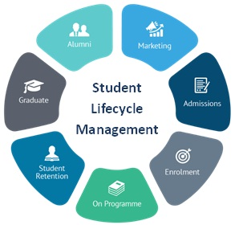

Figure 1.6 – Student Lifecycle Management

At each stage, the learner interacts with different units of the institution (admissions, programme offices, teaching staff, career services, alumni relations) and generates new data and interaction history. CRM and SRM studies in higher education emphasise that systematically managing this lifecycle – by maintaining an integrated view of the learner, coordinating communications and interventions across stages and using data to guide decisions – can improve both student satisfaction and institutional effectiveness, for example by increasing conversion and retention rates, supporting timely interventions and strengthening long-term engagement with graduates [24]–[26].
Table 1.4 illustrates a more detailed conceptual mapping between the typical stages of the CRM customer lifecycle and analogous phases within the learner lifecycle. This comparison highlights how principles of relationship management – originally developed for commercial contexts – can be systematically adapted to educational environments. By aligning each CRM stage with a corresponding learner-centric stage, institutions can better understand how engagement, communication, and support strategies evolve over time, ultimately enhancing both learner satisfaction and institutional effectiveness.

Table 1.4 – Mapping between CRM customer lifecycle and learner lifecycle
CRM lifecycle stage | Learner lifecycle analogue | Examples of activities / interactions
Awareness / acquisition | Prospect and applicant | Marketing campaigns, information requests, applications
Onboarding | Enrolment and induction | Admission decisions, enrolment, orientation sessions
Usage / relationship development | Active learning and participation in programmes | Course participation, support, mentoring, progress monitoring
Retention | Continuation of studies / repeated participation in training | Re-enrolment, additional courses, ongoing communication
Loyalty / advocacy | Graduate, alumnus, returning learner | Alumni relations, professional development, referrals

As Table 1.4 shows, many CRM concepts transfer naturally to the training domain if one focuses on long-term relationships and interactions rather than on one-time transactions [24]. In this adapted perspective:
- the unit of analysis is the learner over time, not a single course;
- each stage of the learner lifecycle generates data and interactions that can be systematically captured;
- the institution can design targeted interventions (e.g., support for at-risk learners, personalised offers for alumni) based on this lifecycle view [19].
Seeman and O’Hara argue that applying CRM principles in higher education requires appropriate information systems that can integrate data and support cross-departmental collaboration [5]. Subsequent studies on CRM and SRM extend this argument by proposing analytic frameworks for student relationship management and social student relationship management, highlighting the need to combine institutional, behavioural and social data to improve relationships in electronic learning environments [6]
For this diploma project, adapting CRM concepts to training means designing a platform that:
- maintains a comprehensive learner profile aligned with lifecycle stages;
- records interactions and events (applications, enrolments, communications, results) as part of the relationship history;
- supports segmentation and targeted actions based on lifecycle information;
- and provides analytical tools for monitoring and improving learner relationships over time [3].

1.3.2 Learner Relationship Management (LRM) vs classical LMS and CRM in education
While LMS and CRM have become common in education and training, they are often implemented as separate, specialised systems. LMS are primarily focused on course delivery and assessment, while CRM systems (when used) are oriented towards recruitment, marketing and front-office communication [18]. To describe a more integrated approach centred on the learner, researchers have introduced the notion of Learner Relationship Management (LRM) or Student Relationship Management (SRM).
LRM can be understood as the application of CRM principles and methods to the broader management of learner relationships, beyond individual courses or marketing activities. Gholami et al. propose an analytic framework for student relationship management that integrates CRM system literature and emphasises the need to support the entire student lifecycle through appropriate processes and technologies [11]. Mater et al. introduce a model of social student relationship management that integrates SRM with social and digital interaction, aiming to improve student engagement and success. Other works present architectures for SRM systems that combine institutional data with behavioural and IoT-based footprints to support decision making and interventions.
The distinction between LMS, CRM and LRM/SRM can be summarised as in Table 1.5.

Table 1.5 – Comparison of LMS, classical CRM and LRM/SRM in education
Aspect | LMS | Classical CRM in education | LRM / SRM
Primary focus | Course and content management | Recruitment, marketing, sometimes retention [5]–[9], [11] | Holistic learner relationship across lifecycle [9], [11], [25], [26]
Main entity | Course / module | Prospect, applicant, sometimes student | Learner (student/employee) over time
Key data | Enrolments, activities, assignments, grades | Contacts, campaign responses, communication logs | Integrated academic, behavioural and interaction data
Typical users | Instructors, students | Marketing, admissions, recruitment staff | Instructors, advisors, administrators, management
Time horizon | Semester or course duration | Pre-enrolment and early stages | Full learner lifecycle (pre-, during, post-programme)

As Table 1.5 indicates, LMS and CRM cover different slices of the learner experience, whereas LRM/SRM aims to provide a unifying layer that:
- connects data from LMS, student/HR systems, CRM and other sources;
- supports lifecycle-oriented processes (advising, retention strategies, early warning systems);
- and offers analytical tools to understand and improve learner relationships.
However, many institutions do not yet operate a dedicated LRM/SRM system. Instead, they combine LMS with partial CRM implementations and manual procedures. This leads to gaps such as:
- lack of a unified learner profile;
- limited visibility of interactions outside individual courses;
- difficulty linking marketing data with academic progress and outcomes.
For the purposes of this diploma project, the proposed CRM platform for training can be seen as a domain-specific LRM/SRM solution that:
- builds upon CRM concepts and technologies.
- integrates LMS-like course data and learner activity.
- and is explicitly designed to support the learner lifecycle in training contexts (university, corporate, professional development).
This perspective provides a conceptual bridge between existing tools and the envisioned integrated platform.

1.3.3 AI assistants and conversational agents in education and training CRM
The third conceptual pillar of the project is the use of AI assistants and conversational agents to support learners and staff within a CRM-oriented training platform (Fig. 1.7). Research on AI in education documents a wide range of applications, including intelligent tutoring systems, adaptive learning environments, automated feedback and decision support tools [21].

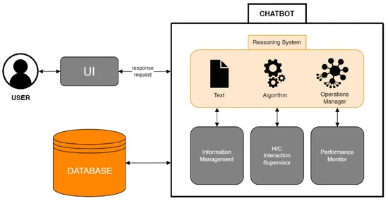

Figure 1.7 – conversational agent chatbot

Nwana’s overview of intelligent tutoring systems and later works such as Nkambou et al. show that AI has long been used to personalise learning and support individual learner needs [20]. More recent reviews emphasise the potential of AI to enhance teaching, assessment and student support, while also raising questions about ethics, transparency and the role of educators.
Within this broader AI-in-education landscape, conversational agents and chatbots have emerged as a particularly visible class of applications. Systematic reviews report that chatbots are used to:
- answer frequently asked questions about courses and institutional policies;
- guide students through administrative procedures (enrolment, deadlines, rules);
- provide reminders and motivational messages;
- offer basic academic support or direct students to relevant resources.
Examples include scoping reviews of conversational agents in higher education, systematic literature reviews on AI chatbots in education [17], and studies on specific systems such as university support agents powered by large language models, conversational “Education Buddy” interventions for international students, and AI-based academic support systems like AIMT Agent. Other works describe prototypes of virtual assistants integrated with learning and organisational systems.
These studies highlight several recurring use cases of conversational agents in educational and training contexts [28]–[34]:
- Information and navigation support – helping learners find information about programmes, courses, schedules and rules.
- Administrative guidance – supporting application, enrolment, registration and other procedural tasks.
- Learning support – providing hints, explanations or links to resources related to course content.
- Well-being and social support – offering motivational messages, check-ins and referrals to human support when needed.
- Data collection and feedback – gathering information about learner needs, satisfaction and difficulties through conversational interaction.
In the CRM domain, AI is also increasingly used to support customer segmentation, recommendation, sentiment analysis and automation of routine communication. Alnofeli et al. provide a comprehensive multidimensional exploration of AI in CRM, highlighting that AI can enhance analytical capabilities, interaction management and decision support, but must be embedded within well-defined processes and governance frameworks [35]. Monod et al. discuss how AI implementation in CRM can shift power relations and reshape responsibilities, suggesting the need for careful organisational design.
Translating these insights to the training context, an AI assistant embedded in a CRM platform can be viewed as a front-line interface that:
- interacts with learners, trainers and administrators in natural language;
- has access to structured, CRM-like data about learners, programmes and interactions;
- and logs its own interactions as part of the learner relationship history.
However, the effectiveness of such an assistant depends critically on:
- the quality and integration of underlying data;
- clear definitions of roles and responsibilities (what the AI may and may not do);
- and appropriate safeguards, logging and oversight mechanisms.
For this diploma project, AI assistants and conversational agents are therefore not just an add-on feature, but an integral component of the conceptual architecture. The CRM platform must provide the context (data, processes, user roles) and control mechanisms (policies, logging, monitoring) that enable the AI assistant to support training management in a reliable, transparent and relationship-oriented manner. These considerations will be further reflected in the architectural and design decisions described in Chapters 2 and 3.

1.4 Problem statement and objectives of the diploma project

The analysis of the subject area and current practice (Sections 1.1–1.2) has shown that training management in universities, corporate academies and training centres is usually supported by several independent systems: LMS, student or HR information systems, communication tools, analytics platforms and, in some cases, CRM/SRM components [25]. Each of these tools fulfils an important function, but taken together they do not provide an integrated, lifecycle-oriented view of the learner that is central to CRM and student relationship management.
In parallel, organisations increasingly adopt AI and conversational agents to support learners and staff. These assistants are mostly deployed as add-ons to individual systems, with limited access to the overall data landscape and without a coherent relationship management strategy [33]. As a result, AI support remains local and context-poor, and its potential for enhancing learner relationships and training management is not fully realised [18].
In this context, the core problem addressed in the diploma project can be formulated as follows. Existing digital tools for training management (LMS, CRM/SRM solutions, communication platforms and AI assistants) are not sufficiently integrated to provide a unified, CRM-oriented view of learners and their interactions across the training lifecycle. This fragmentation leads to inconsistent data, limited visibility of the learner trajectory, manual and error-prone reporting, uncoordinated communication and underutilisation of AI for relationship management.
To respond to this problem, the diploma project aims to design and develop a CRM platform for training with an integrated AI assistant. The platform should centralise key data about learners, organisations, training programmes and interactions; support lifecycle-oriented management of learner relationships in university, corporate and professional development contexts; and embed an AI assistant that can provide context-aware support to learners, trainers and administrators on the basis of integrated and reliable data. Section 1.4.1 specifies the object, subject, aim and tasks of the research. Section 1.4.2 formulates the problem in a more formal way and outlines the scope, assumptions and constraints of the project.

1.4.1 Object, subject, aim and tasks of the research
In accordance with the established structure of diploma projects, the object, subject and aim of this work are defined in Table 1.6.

Table 1.6 – Object, subject and aim of the research
Element | Description
Object | Training management processes and learner relationships in educational and training organisations
Subject | Methods, models and software solutions for a CRM platform for training with an integrated AI assistant
Aim | To develop and evaluate a CRM platform for training with an integrated AI assistant that supports lifecycle-based, data-driven management of learner relationships

The object of the study focuses on the real-world domain: how universities, corporate training departments and training centres organise, coordinate and continuously manage training activities and relationships with learners. This includes processes such as enrolment and admissions, programme and schedule management, communication workflows, progress monitoring, learner support, feedback collection and reporting mechanisms [12]. In essence, the object covers the broader ecosystem of educational service delivery and the institutional practices that shape the learner experience across its entire lifecycle.
The subject of the research narrows this broad domain to the specific methods, technologies and design approaches used to develop an integrated CRM platform for training. This involves examining conceptual modelling techniques, system architecture choices, data structure design, interoperability approaches, AI integration mechanisms and user interaction patterns that enable a unified technological solution [19]. While the object concerns the operational reality of training management, the subject focuses on how this reality can be systematically represented, instrumented and improved through software engineering.
The aim of the project reflects the need to combine CRM principles, learner lifecycle management and AI-driven support within a single cohesive platform that can be both implemented and assessed in practice. To achieve this aim, the project undertakes analytical, conceptual, design, implementation and evaluation activities. It begins by analysing the technical, organisational and communication characteristics of training management workflows, identifying recurring problems such as data fragmentation, limited visibility of the learner lifecycle, inconsistent communication channels and the restricted use of AI due to siloed systems [35]. Building on this analysis, the project adapts CRM concepts and learner lifecycle models to the training context, formulates a conceptual model and defines the high-level functional and non-functional requirements for a CRM platform equipped with an integrated AI assistant. Based on these requirements, it develops an architectural design that specifies the platform’s subsystems, modules, data model, integration points with external systems and the functional role, behaviour and technical embedding of the AI assistant.
Furthermore, the project implements a working prototype of the platform that delivers core functionality for managing learners, organisations, programmes, interactions, materials and reporting, while also integrating an AI assistant connected to an external AI/LLM provider. Finally, it establishes and applies a systematic testing and evaluation methodology to assess functional correctness, baseline performance, usability, reliability and practical applicability of the developed solution. Through this combined approach, the project aims to generate both a conceptual contribution—demonstrating how CRM principles and AI assistant capabilities can be adapted to the training domain—and a practical outcome, namely a functioning prototype of an integrated CRM platform for training enhanced with AI-driven support.

1.4.2 Formal problem statement, scope, assumptions and constraints of the project
For systematic design and implementation, the problem addressed in the diploma project can be formulated more formally. The work considers an educational or training organisation that offers several types and formats of training (university programmes, corporate training, professional development) relies on multiple information systems (LMS, student or HR systems, communication tools, analytics platforms, and sometimes CRM/SRM components) and involves several stakeholder groups (learners, trainers, programme managers, administrative and HR staff, management, IT and support units).
Such an organisation must maintain reliable and up-to-date data about learners, organisations and training programmes; manage enrolment, participation, communication and support across the learner lifecycle; perform reporting and analytics on training activities and outcomes; and provide accessible support to learners and staff, increasingly with the help of AI assistants [18]. In practice, however, the coexistence of several systems leads to inconsistent and duplicated data, limited visibility of the full learner lifecycle and communication history, high manual effort for reporting and analysis, and AI assistants that are disconnected from the broader relationship context.
Formally, the project addresses the task of designing and implementing an information system — a CRM platform for training with an integrated AI assistant — that centralises and maintains consistent data about learners, organisations, training programmes and interactions; supports lifecycle-based management of training-related processes and relationships; provides interfaces and workflows for key stakeholder roles; and exposes structured and controlled context to an integrated AI assistant, with appropriate logging and safeguards for AI behaviour.
To keep the problem tractable, the project focuses on modelling and managing a limited set of core entities (learners, organisations, training programmes or courses, enrolments, interactions and basic reports). It supports key processes such as enrolment management, high-level programme and group management, interaction tracking and simple reporting and analytics. The AI subsystem is expected to answer selected categories of questions (for example, about programmes, schedules and enrolments) using platform data and to record its own conversations as part of the learner relationship history. The solution is implemented as a web-based application for main user roles (learner, trainer or manager, administrator) with integrated access to the AI assistant.
At the same time, the project deliberately does not attempt to replace full LMS functionality (content authoring, complex assessment tools, grading workflows) [12], [13], to implement large-scale data warehousing and advanced predictive analytics (such as full early warning systems) [25], or to cover all possible types of training organisations and regulatory environments in detail.
Several assumptions are made. It is assumed that the organisation already uses, or can integrate with, an LMS and possibly student or HR systems, and that these external systems can exchange data with the CRM platform. The AI assistant is based on an external AI/LLM provider accessible via an API, so the project concentrates on integration and context management rather than on training a custom AI model [18]. It is also assumed that data volumes and performance requirements correspond to those of a typical web application with a relational database and that users are familiar with web interfaces and chat-based interaction.
The project is constrained by typical time and resource limitations of a diploma project, which restrict the breadth of implementation, testing and deployment. Technological choices must be realistic for an academic environment. Data protection and privacy requirements demand secure handling of personal data and careful control of any data exposed to the AI assistant [22]. Finally, the black-box nature of AI services means that the internal mechanisms of the AI model cannot be controlled directly; instead, safeguards must be implemented at the level of prompts, context limitation, logging and monitoring.
By defining the scope, assumptions and constraints in this way, the subsection delineates the problem space for the proposed CRM platform for training with an integrated AI assistant and prepares the ground for the requirements and methodological choices formulated in Section 1.5.

1.5 Requirements and methodological basis of the project

The development of a CRM platform for training with an integrated AI assistant is guided by a set of requirements and by a clear methodological basis. The requirements arise from the earlier analysis of the subject area, current practice and conceptual foundations of CRM, learner lifecycle and AI assistants, and reflect both the problems identified in fragmented training management and the capabilities described in CRM, SRM and AI-in-education literature [1]–[4].
In general terms, the system should provide CRM-like functionality adapted to training (management of learners, organisations, programmes and interactions), be aligned with existing LMS and training processes, incorporate an AI assistant that uses institutional data in a controlled and transparent manner, and include mechanisms for evaluating its effectiveness in supporting learner relationships and training management. Section 1.5.1 distinguishes functional and non-functional requirements. Section 1.5.2 describes user roles, key usage scenarios and evaluation criteria. Section 1.5.3 outlines the methods and approaches used in the project, including analysis, modelling, prototyping and evaluation.

1.5.1 Functional and non-functional requirements to the CRM platform with an integrated AI assistant
The requirements to the platform reflect typical problems of current practice (data fragmentation, limited lifecycle visibility, manual reporting, uncoordinated communication and underused AI) [19] and build on CRM and SRM models.
Functionally, the system must at least maintain unified profiles for learners and organisations, represent training programmes and enrolments at a level sufficient for CRM-oriented tracking, record and link interactions (messages, calls, meetings, AI conversations, system events) to specific learners, organisations and programmes, integrate an AI assistant into the platform interface and log its conversations as part of the relationship history, provide basic reporting and analytics on training activities and interactions, and implement role-based access control for different categories of users [24]–[26]. These capabilities correspond to core CRM and LRM/SRM functions such as unified profiles, interaction management, segmentation and analytical support.
Security and privacy are critical: the system must support authentication, role-based authorisation and protection of personal data and interaction logs, while limiting the data exposed to the AI assistant and ensuring appropriate logging for audit purpose. Reliability and robustness imply basic error handling and recovery in case of integration failures, especially in communication with the AI provider, and preservation of critical information. Finally, the system should be extensible and integrable, with clear separation between core CRM logic, data access, AI integration and user interface, so that additional modules (for example, connectors to specific LMS or more advanced analytics) can be added later [26]. Table 1.7 summarises the main groups of functional and non-functional requirements.

Table 1.7 – Summary of main requirement groups
Requirement type | Key groups
Functional | Learner and organisation management; programme management; interaction tracking; AI assistant integration; reporting and analytics; user and access management
Non-functional | Usability; performance and scalability; security and privacy; reliability; extensibility and integrability

Non-functional requirements define the quality attributes necessary for practical use. The platform should offer an interface that is understandable for learners, trainers and administrators, with clear navigation between profiles, programmes, interactions and the AI assistant. Its performance and scalability, at least at prototype level, should be sufficient for typical operations in a small to medium training context, and the architecture should allow future scaling and integration (for example, through layered design and API-based communication).
These requirements define the target capabilities and quality characteristics that guide the design and implementation decisions described in Chapters 2 and 3.

1.5.2 User roles, key usage scenarios and evaluation criteria
In line with CRM and SRM perspectives, the platform must take into account the needs of several stakeholder roles with different responsibilities and information needs. On the basis of the subject area analysis, four primary roles are distinguished: learner (student, employee or external client), trainer or instructor, programme or training manager, and administrator responsible for configuration, reference data and user management. IT staff and institutional leadership are important in reality, but in the prototype their needs are considered indirectly through administrative views and reports. Table 1.8 presents the main roles and their primary needs in the platform.

Table 1.8 – Main user roles and their primary needs
Role | Primary needs in the platform
Learner | View personal profile, programmes, enrolments and key interactions; obtain information and support via the AI assistant
Trainer / instructor | View groups and learner profiles; track interactions; use the AI assistant to access information and support learners
Programme manager | Monitor programmes and groups; see aggregated data; coordinate communication and interventions
Administrator | Manage users, roles and reference data; configure AI assistant integration and basic system settings

For each of these roles, the platform must support typical usage scenarios that will be further elaborated in the use case model (Section 2.1.2) and implemented in the prototype (Chapter 3). Examples include a learner logging in to view their own data and asking the AI assistant about programme requirements, a trainer inspecting the history of interactions with a particular learner, a programme manager analysing engagement at programme level and planning targeted communication, and an administrator configuring access rights and AI-related parameters.
To assess whether the platform fulfils its intended purpose, evaluation criteria are defined. They cover functional completeness (implementation of core CRM-like functions for training, such as unified learner profiles, programme management, interaction tracking, AI integration and basic reporting), usability and user acceptance (subjective ease of use and clarity of the interface), support for lifecycle visibility (ability to reconstruct key elements of the learner lifecycle from platform data), integration of AI and data (context-awareness of AI responses and correctness of logging) and basic technical quality (performance, robustness and absence of critical security issues)
These criteria will be used in Chapter 3 to structure the testing, validation and discussion of the system’s effectiveness.

1.5.3 Methods and approaches used in the project (analysis, modelling, prototyping, evaluation)
The methodological basis of the diploma project integrates a set of complementary approaches drawn from information systems design, CRM/SRM research and the development of AI-supported applications. Methodologically, the work follows an iterative and incremental trajectory that progresses from analytical exploration and conceptual modelling to system design, implementation of functional components and final evaluation. This structure ensures that theoretical insights and practical development continuously inform one another throughout the project lifecycle.
At the analytical stage, the project relies on a comprehensive literature-based investigation of CRM frameworks in the commercial sector [24], CRM and SRM applications in higher education [26], as well as research on LMS platforms and digital learning ecosystems [12]–[14]. In parallel, studies on AI, conversational agents and virtual assistants in both education and CRM domains [15] are examined to understand emerging technological capabilities and constraints. This review enables the identification of recurring concepts, architectural patterns, success factors, challenges and known limitations, all of which form the basis for the problem formulation, methodological orientation and conceptual foundations presented in Chapter 1. The analytical stage thus provides the necessary grounding for translating theoretical insights into system-level requirements.
Building on this foundation, the project proceeds to conceptual and data modelling, where CRM frameworks and SRM lifecycle models serve as methodological instruments for constructing structured representations of learner relationships, stages and interactions. These models help formalise how learners move through different phases of the lifecycle and how institutional processes interface with them. In addition, an entity–relationship (ER) or comparable logical data model is developed to capture the system’s core entities – including learners, organisations, programmes, enrolments, interactions and AI-mediated conversations – and to specify their attributes, associations and cardinalities. The modelling approach reflects the information flows and organisational processes identified earlier, ensuring that the resulting data structures directly support the requirements of the future CRM platform.
This expanded methodological perspective not only clarifies how analytical insights are transformed into design artefacts but also establishes a coherent link between theoretical foundations, architectural decisions and the subsequent implementation of the CRM platform with integrated AI support.
The next phase is architecture and system design (Fig 1.8). The project defines the architecture of the CRM platform using principles from CRM/SRM system design and AI-based support systems [19], [22]–[24]. Subsystems and modules (such as the core CRM module, AI integration module, web user interface and API layer) and their interactions are specified. Special attention is paid to security, access control, logging and AI governance mechanisms, given the sensitivity of personal data and the black-box nature of AI services [35].

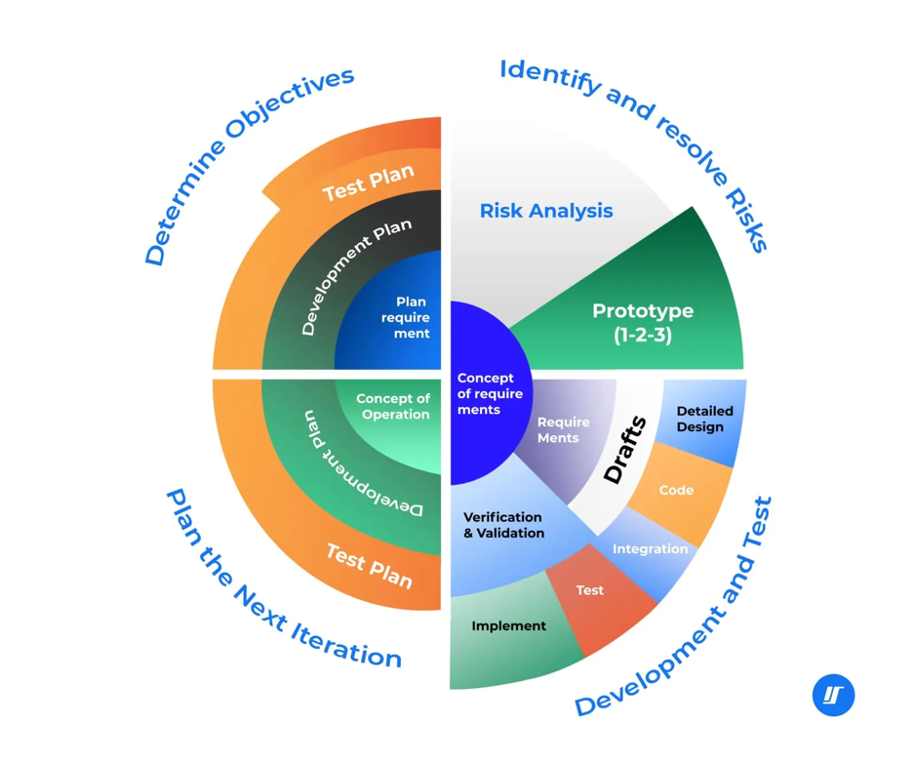

Figure 1.8 – System development life cycle

Finally, the project applies testing and evaluation methods. A testing strategy is developed to cover the functional correctness of core scenarios, basic performance characteristics and selected security-related behaviours (for example, access control and logging) [11], [18], [19], [25]. In addition to formal test cases, exploratory testing is carried out to identify edge situations that may arise in realistic usage, such as incorrect data entry, loss of connection to the AI provider or concurrent updates of learner records.
Usability and usefulness for target roles are explored qualitatively through scenario-based walkthroughs and informal feedback from potential users, focusing on clarity of navigation, transparency of AI behaviour and the effort required to complete typical tasks. The achieved capabilities are compared with the requirements and evaluation criteria defined earlier, and the results are analysed in terms of both strengths and identified limitations.
This makes it possible to draw grounded conclusions about the effectiveness and practical significance of the proposed CRM platform for training with an integrated AI assistant and to outline directions for further improvement.
Table 1.9 summarises the connection between the main project phases and the methods used.

Table 1.9 – Project phases and main methods
Project phase | Main methods and approaches
Analysis and foundations | Literature review; problem analysis; conceptualisation of CRM, SRM, AI and LMS
Modelling | Conceptual modelling of the learner lifecycle; data modelling (ER or similar)
Design | Architectural design; specification of modules and interfaces; design of security and AI governance mechanisms
Implementation | Prototyping of web application, database schema and AI integration
Testing and evaluation | Functional and non-functional testing; scenario-based evaluation; comparison with requirements

By combining these methods, the diploma project aims not only to produce a practical prototype of a CRM platform for training with an integrated AI assistant, but also to offer a structured and reproducible approach to analysing, designing and evaluating similar systems in educational and training .

