First Pre-Defense Report
Diploma Project: Design and Development of a Privacy-Aware QR/NFC-Based Emergency Medical Information System
Team: Bekbolat Yergaliuly, Olzhas Omerzak Zhunisbekuly, Shugyla Akhit Zhasulankyzy
Supervisor: Yespenbetova Dana Altynbekqyzy
Repository: https://github.com/BekbolatSE2403/Diploma_work
YouTrack: Link to YouTrack
Figma: Link to template

1. Project Proposal and Scope

1. Project Overview
The Emergency Medical Information System (EMIS) is a proposed web-based solution that enables a person to maintain essential emergency medical information and make an intentionally limited subset accessible through a QR code or NFC-enabled identification card. The concept is intended to help an emergency responder or bystander quickly locate user-provided information such as known allergies, relevant medical conditions, and emergency contacts when the card owner may be unable to communicate.
EMIS is not intended to diagnose illness, replace clinical records, verify medical facts, or substitute for professional emergency services. The initial interface is a prototype using demonstration data. QR/NFC access, backend persistence, identity verification, and production-grade access controls are planned work, not completed functionality.

2. Problem Statement
In an emergency, a person may be unable to explain important medical details. Information such as severe allergies or an emergency contact may be stored in different places, inaccessible to a nearby helper, or unavailable without unlocking the person's device. At the same time, exposing an entire medical history through a publicly scannable card would create privacy risks.
The engineering problem is to design a usable, reliable, and privacy-aware mechanism for sharing only selected emergency information through a QR/NFC entry point, while keeping sensitive profile management under the owner's control. This problem statement is an initial hypothesis; its relevance and user requirements still need validation through interviews or other documented evidence.

3. Target Users and Stakeholders
- Card owners: people who choose to store and selectively share their emergency information.
- Emergency helpers: bystanders or first responders who may scan a card to view a limited emergency profile. The design does not assume that all responders will rely on the system.
- Emergency contacts: individuals whom the card owner lists for contact in an emergency.
- Project stakeholders: the student development team, academic supervisor, and potential user representatives involved in requirements validation.

4. Aim and Objectives
Aim: Design and develop a prototype of a privacy-aware QR/NFC-based emergency medical information system that supports rapid access to a minimal emergency profile while providing a controlled process for managing the underlying information.
Objectives:
- Investigate user needs and identify the most useful and appropriate fields for an emergency profile.
- Review relevant academic work and compare existing medical ID and emergency-information solutions.
- Define functional and non-functional requirements with testable acceptance criteria.
- Compare and justify major technology choices for the frontend, backend, data storage, and component communication.
- Design system context, use case, and component diagrams, and document the data flow and trust boundaries.
- Develop accessible mobile and desktop interface prototypes for viewing an emergency profile.
- Implement, in later stages, secure profile management, a limited public emergency view, and QR/NFC-based profile access.
- Evaluate usability, correctness, access restrictions, and QR/NFC workflow behavior using defined test scenarios and metrics.

5.Project Scope

In Scope (Target Prototype)
- Responsive web interface for an emergency medical profile.
- Owner-facing profile creation and editing after authentication.
- Separation of private profile data from a minimal emergency view.
- Proposed QR-code and NFC-card linking to the emergency view.
- Storage and retrieval of selected profile fields through a backend API.
- Emergency contact display and links to general first-aid guidance, with appropriate medical disclaimers.
- Access-control, validation, logging, and security testing appropriate to a student prototype.
- Documentation, architecture diagrams, usability tests, and a demonstrable prototype.

2. Evidence of Relevance
2.1. Purpose of Stakeholder Consultation
The purpose of this illustrative stakeholder consultation is to explore the potential relevance and usability of the proposed Privacy-Aware QR/NFC-Based Emergency Medical Information System (EMIS). The consultation focuses on the challenges of accessing essential medical information during emergencies, the potential benefits of QR/NFC technologies, and concerns regarding personal data protection.
The simulation considers three stakeholder perspectives: two general potential users and one medical student.
2.2. Research Methodology
A qualitative approach using semi-structured interviews was modeled for the preliminary assessment of user needs.
The simulated participants were:
P1 — General potential user, aged 21.
P2 — General potential user, aged 35.
P3 — Medical student, aged 22.
2.3. Interview Results
Participant P1 — General Potential User
P1 expressed concern that emergency responders or bystanders may be unable to obtain important medical information when a person is unconscious or unable to communicate.
The participant considered the QR/NFC card potentially useful because it could provide emergency contacts and important medical details without requiring access to the person's smartphone.
P1 preferred a simple interface displaying allergies, chronic conditions, and emergency contacts. However, the participant was concerned about strangers accessing private medical information.
P1 suggested allowing the card owner to choose which information is publicly accessible.
Participant P2 — General Potential User
P2 considered emergency medical identification useful, particularly for older adults and individuals with chronic conditions.
The participant highlighted the importance of making the system easy to use without installing an additional application.
P2 preferred QR-code scanning because most smartphones support it through their camera applications. NFC was considered a useful alternative.
The participant also identified internet connectivity and outdated medical information as potential limitations.
P2 suggested including a visible emergency telephone number on the physical card and providing reminders to update the medical profile.
Participant P3 — Medical Student
P3 emphasized the potential importance of quickly identifying allergies, relevant medical conditions, medications, and emergency contacts.
The participant considered a concise emergency profile preferable to a complete medical history because excessive information could make important details harder to identify.
P3 also raised concerns about the accuracy of patient-entered information and the possibility that users may not update their profiles regularly.
The participant recommended using clear medical terminology, displaying the date of the last profile update, and distinguishing self-reported information from professionally verified records.
P3 noted that a digital medical profile should support emergency communication rather than replace clinical assessment or established emergency procedures.
2.4. Comparative Analysis of Simulated Findings
Participant | Main Concern | Suggested Improvement | Related EMIS Requirement
P1 — General user | Unauthorized access to medical information | User-controlled public and private fields | Privacy-aware information disclosure
P2 — General user | Internet availability and outdated information | Visible emergency contact and update reminders | Accessibility and profile maintenance
P3 — Medical student | Medical information accuracy and readability | Clear layout, update date and information-source labels | Information reliability and usability

All three participants considered rapid access to selected emergency information potentially useful. The general users emphasized accessibility and personal privacy, while the medical student placed greater importance on information accuracy and presentation.
The differences suggest that an effective emergency medical information system should balance usability, privacy, and the reliability of medical data.

3. Critical Literature Review

3.1. Literature Search and Selection
The literature review examines technologies and design concerns relevant to a privacy-aware QR/NFC emergency medical information system. The 15 supplied scientific publications were screened for relevance to contactless medical identification, emergency information access, privacy and access control, practical healthcare implementations, and supporting technology. Twelve publications were retained; three were excluded because their primary emphasis was general IoT monitoring, NFC–visible-light communication, or fog-computing architectures rather than the intended EMIS workflow. The review is a focused selection from supplied publications, not a systematic review of all available research. Exact Scopus search dates, search strings, result counts and screening records should be added if they are available from the team’s search history.

3.2. Critical Analysis of Selected Publications
Study | Contribution | Limitation | Implication for EMIS
Biju et al. (2024) [1] | NFC medical card and companion application for accessing health information. | Directly comparable system; limited evidence in the supplied paper of large-scale emergency-responder evaluation. | Benchmark card/profile functionality; clarify how EMIS differentiates public and restricted information.
Raso et al. (2022) [2] | Two privacy-aware NFC/RFID healthcare architectures, including patient-defined access policies. | Focuses on sensor data and cloud sharing, not QR-based emergency identity cards. | Inform authorization, privacy separation and secure information sharing.
Manes et al. (2026) [3] | Observed QR-code use in an emergency department: 1,895 scans across six months. | QR links provided general administrative information, not personal emergency records. | Support feasibility of low-cost QR entry points; do not infer clinical effectiveness.
Bedriova et al. (2023) [4] | Designed and tested an NFC-supported oncology workflow with 100 patients across two clinics. | Oncology treatment workflow differs from unscheduled emergency access. | Guide NFC interaction design and practical usability evaluation.
Balasubramanian et al. (2022) [5] | Contactless NFC-enabled telehealth prototype with cloud-based data structuring and visualization. | Pandemic ward monitoring and NLP are beyond EMIS scope. | Support contactless retrieval and concise presentation of medical facts.
Çobanoğlu and Akalın (n.d.) [6] | Describes NFC use in telemedicine and patient monitoring scenarios. | Publication year and formal bibliographic venue require confirmation; primarily conceptual background. | Provide historical NFC healthcare context, not primary validation evidence.
Kuo et al. (2022) [7] | RFID-based hospital/public-setting identification and monitoring solution. | Concentrates on organizational monitoring and temperature checks. | Inform identification workflow and low-cost hardware considerations.
Shojaei et al. (2024) [8] | Systematic review of health-information security, access, storage and sharing. | Broad health information systems rather than emergency-card-specific evaluation. | Support access-control, secure storage and data-sharing requirements.
Tertulino et al. (2024) [9] | Mapping study of privacy requirements and gaps in electronic health records. | Institutional EHR emphasis rather than anonymous emergency profile retrieval. | Support privacy requirements and trade-offs with interoperability.
Mwogosi et al. (2026) [10] | TCCM review of privacy practices and barriers in EHR systems in developing countries. | Evidence reflects varied national and institutional contexts. | Justify privacy-by-design and attention to practical deployment constraints.
Khan et al. (2024) [11] | Review of passive and battery-free RFID medical technologies. | Many reviewed devices are sensors rather than simple NFC medical cards. | Support assessment of passive tags and hardware limitations.
Rehman et al. (2025) [12] | Wide-ranging review of healthcare IoT, architectures and security challenges. | Broad monitoring and connected-device scope; indirect relation to EMIS. | Provide wider security context without expanding EMIS into monitoring.

3.3. Critical Synthesis
Contactless identification and emergency access. MEDxSWIFT [1] offers the closest functional precedent for an NFC medical card, while Bedriova et al. [4] and Balasubramanian et al. [5] demonstrate NFC-assisted healthcare interactions in other clinical workflows. Kuo et al. [7] and Khan et al. [11] expand the hardware perspective to RFID identification and passive devices. Together, these studies support investigating contactless access, but none alone establishes that EMIS will reduce emergency response time or improve patient outcomes.
QR accessibility and user interaction. Manes et al. [3] report sustained use of QR-linked information in an emergency department. Their study concerns non-urgent information, so its results support the practicality of QR-based entry points rather than proving the suitability of QR-linked personal medical records. For EMIS, scan success, device compatibility, information readability and task-completion time require separate prototype testing.
Privacy and access control. Raso et al. [2] explicitly compare system-managed and patient-defined access policies, while Shojaei et al. [8], Tertulino et al. [9], and Mwogosi et al. [10] identify risks associated with unauthorized access, storage, sharing, and implementation governance. These studies support separating a deliberately limited emergency-visible summary from private medical information. A QR code or NFC tag is an access mechanism, not proof of authorization: sensitive data must not be exposed merely because someone can scan a physical card.
Scope boundaries. The broader IoT and telemedicine studies [5]–[7], [11], [12] offer relevant architecture and security lessons, but EMIS does not propose continuous physiological monitoring, diagnosis, or clinical decision-making. Their findings must therefore be transferred cautiously to a static or user-maintained emergency profile.

3.4. Research Gap
The selected literature addresses NFC medical cards, QR-based information access, healthcare identification, and privacy-preserving health information systems, but typically treats these topics separately or in different clinical settings. The gap motivating EMIS is therefore an integration and evaluation problem: how to design a practical QR/NFC-linked emergency profile that provides rapid access to a carefully limited public summary while restricting sensitive records and giving owners control over their information. MEDxSWIFT [1] demonstrates that the general NFC medical-card concept already exists; EMIS should be evaluated against such precedents rather than presented as the first system of its kind.

3.5. Implications for the Proposed EMIS Design
The literature informs five planned decisions: (1) use QR and NFC as alternative entry points to the same maintained profile [1], [3], [4]; (2) avoid storing sensitive medical histories directly on a freely readable tag [2], [8]; (3) separate public emergency facts from authenticated owner-managed records [2], [9], [10]; (4) keep emergency information concise and mobile-readable [3], [5]; and (5) evaluate scan reliability, time to locate essential facts, privacy leakage and access-control behavior using test scenarios rather than asserting unmeasured benefits [3], [4], [8]. These are design implications, not claims that the planned EMIS implementation has been clinically validated.

4. Existing Systems Comparison
Project: Design and Development of a Privacy-Aware QR/NFC-Based Emergency Medical Information System

1. Purpose
This document compares existing approaches for making essential medical information available during emergencies. The objective is to identify useful design patterns, limitations, and requirements for the proposed Emergency Medical Information System (EMIS).

2. Systems Selected
- Apple Medical ID (Health app): emergency medical information stored on an iPhone, with optional visibility from the lock screen. Official information: https://support.apple.com/guide/iphone/set-up-your-medical-id-iph08022b194/ios
- Android Emergency Information: emergency details and contacts that can be configured on supported Android devices; presentation varies by manufacturer and Android version. Official Android help: https://support.google.com/android/
- MedicAlert: medical identification jewelry linked to medical information and, in some offerings, an emergency-response service. Official website: https://www.medicalert.org/
- MyID: wearable medical identification products associated with a digital medical profile. Official website: https://getmyid.com/
These four systems represent two common models: phone-based emergency information and wearable identification linked to a profile or service.

3. Comparison Criteria
The same nine criteria are used for every system:
- Emergency access mechanism: how a responder finds the information.
- Dependence on the owner's phone: whether the owner's phone is needed at the scene.
- Physical identification option: whether an external item can direct responders to information.
- QR/NFC relevance: whether QR or NFC is central to the access model.
- Medical information scope: whether the system can present key facts such as allergies, conditions, or contacts.
- Information update workflow: how an owner updates their information.
- Privacy/access approach: what is publicly accessible and what needs protection.
- Connectivity dependence: whether the information can be accessed without network service.
- Main practical limitation: a significant constraint for emergency use.

Criterion | Apple Medical ID | Android Emergency Information | MedicAlert | MyID | Proposed EMIS
Emergency access | iPhone emergency/Medical ID interface, if enabled | Device emergency information interface, if supported and configured | Medical ID item and associated service/profile | Medical ID wearable and associated profile | Scan QR or tap NFC card to open limited emergency profile
Owner's phone required | Yes, for on-device access | Yes, for on-device access | Not necessarily | Not necessarily | No, if responder has a compatible device
Physical ID item | Not inherent to Medical ID | Not inherent to emergency information | Yes | Yes | Planned QR/NFC card
QR/NFC central | No | No | Not a universal requirement | Product-dependent; verify specific product | Planned dual QR/NFC entry
Key medical facts | Yes, if entered by owner | Yes, fields vary by device | Yes, depending on enrollment/service | Yes, depending on profile/product | Planned allergies, conditions, medications, contacts
Updates | Health app on owner's device | Device settings / safety app | Account/service workflow | Account/profile workflow | Planned authenticated owner dashboard
Privacy/access | Owner controls whether lock-screen information is shown | Device-specific controls | Service- and product-specific; verify | Service- and product-specific; verify | Planned minimum public data, restricted editing
Internet required for core access | Not generally for locally stored Medical ID | Not generally for locally stored emergency info | Depends on service and interaction | Digital profile generally needs connectivity; verify | Planned online profile; offline fallback under consideration
Principal limitation | Responder must locate and access owner's iPhone | Interface and support differ by device | May depend on membership, service, and responder process | Digital access may depend on network and product | Not yet implemented; depends on responder connectivity and safe privacy design

5. Technology Comparison

1. Purpose and evaluation method
This document compares reasonable technology alternatives for four major design decisions: frontend platform, backend framework, data storage, and QR/NFC access method. Selections are proposed design decisions, not claims that the entire system has been implemented or tested. Each option is evaluated against the same decision-specific criteria. Assessments are qualitative engineering judgments to be validated during implementation.

Project constraints
- Emergency responders should be able to view a minimal emergency profile quickly, ideally without installing an app.
- Sensitive data must not be embedded directly in a publicly readable QR code or NFC tag.
- Profile owners need a controlled way to create and update their information.
- The system should support browser-based access on common phones and computers.
- The student team must be able to build, document, and test a demonstrable prototype within the diploma timeline.
- Medical information is user-provided and must not be presented as professionally verified unless independently validated.

2. Decision A — Frontend platform
Criteria: cross-device reach, installation friction, development speed, maintainability, and support for accessible responsive interfaces.
Alternative | Advantages | Limitations | Fit for EMIS
Next.js + React + TypeScript | Responsive web access without installation; component reuse; TypeScript helps manage data contracts; fits the existing prototype | Requires careful server/client boundaries, secure configuration, and accessibility testing | Selected for prototype
React single-page application with Vite | Lightweight tooling; straightforward frontend development | Routing, server-side features, and deployment conventions need separate choices | Viable alternative
Flutter mobile application | Consistent native-like mobile UI; potential access to device integrations | Requires installation for the primary experience; more platform-specific testing | Less suitable for emergency public access
Decision: Continue with Next.js, React, TypeScript, and Tailwind CSS. This matches the current frontend work and supports opening an emergency profile through an ordinary mobile browser. A responsive website is a design choice, not evidence that all devices have been tested.

3. Decision B — Backend framework
Criteria: REST API support, access-control ecosystem, team familiarity, maintainability, and integration with relational storage.
Alternative | Advantages | Limitations | Fit for EMIS
Java + Spring Boot | Mature REST API and validation ecosystem; Spring Security options; structured service architecture | More initial configuration and boilerplate; requires secure setup | Proposed selection
Node.js + NestJS | TypeScript across frontend and backend; modular architecture; strong API development workflow | Security and configuration still require careful implementation; would change assigned backend stack | Good alternative
Python + FastAPI | Concise API definitions; automatic OpenAPI documentation; rapid prototyping | Different language ecosystem; team would need to establish conventions for persistence and authorization | Good alternative
Decision: Propose Java + Spring Boot for the backend, with Maven for dependency management. No completed backend API is claimed at this pre-defense stage.

4. Decision C — Data storage
Criteria: consistency of profile and access data, query flexibility, schema clarity, backup practices, and compatibility with the proposed backend.
Alternative | Advantages | Limitations | Fit for EMIS
PostgreSQL | Relational integrity; transactions; mature tooling; clear relationships between profiles, contacts, and access policies | Schema migrations and operations require planning | Proposed selection
MySQL | Mature relational database; broad hosting and tooling support | Differences in SQL behavior and operational preferences must be considered | Suitable alternative
MongoDB | Flexible document structure; convenient nested records | Relationships and consistency rules require careful modeling; flexibility can weaken schema discipline | Possible but less preferred
Decision: Propose PostgreSQL for structured records. A preliminary schema may include users, medical_profiles, allergies, medications, emergency_contacts, public_profile_tokens, and audit_events. This is a draft, not an implemented database design. Minimize stored data and define retention/deletion behavior before production.

5. Decision D — Emergency access mechanism
Criteria: smartphone compatibility, cost, usability in emergencies, replaceability, and risk of exposing sensitive data.
Alternative | Advantages | Limitations | Fit for EMIS
QR code pointing to a controlled HTTPS profile | Widely supported by phone cameras; inexpensive to print; works without a dedicated app | Requires camera and internet access; printed codes can be copied or damaged | Primary proposed access method
NFC tag containing a controlled HTTPS profile URL | Convenient tap interaction on compatible devices; useful as a second access path | Device support and scanning behavior vary; tag can be cloned or replaced; requires compatible reader | Optional complementary method
QR/NFC storing full medical data directly | Potentially accessible without a server in some designs | Exposes information to anyone who reads the tag; updates and revocation are difficult; NFC capacity may be limited | Rejected for sensitive information

Decision: Use a QR code as the primary access method, with NFC as an optional complementary method. Both should point to a managed HTTPS URL, not store raw medical details. The public emergency view must expose only explicitly approved information. A URL token is not a substitute for authentication when accessing private data; token guessing, sharing, revocation, and rate limiting require threat-model review.
Our final decision:
Area | Proposed technology | Status
Frontend | Next.js + React + TypeScript + Tailwind CSS | Initial UI implemented
Backend | Java + Spring Boot + Maven | Planned; architecture documented
Database | PostgreSQL | Planned
API style | HTTPS REST/JSON | Planned
Emergency entry point | QR URL, optional NFC URL | Planned
Source control and tracking | GitHub and YouTrack | In use

6. Requirements Specification

1. Purpose and scope
This document defines the proposed functional and non-functional requirements for EMIS and gives measurable acceptance criteria. EMIS aims to let a profile owner maintain self-reported emergency information and share only a deliberately limited emergency view through a QR/NFC-linked identifier. It is not a medical record, diagnostic tool, identity-verification service, or substitute for emergency services.
Requirements are preliminary and must be validated with potential users and the supervisor. All tests must use fictional or explicitly authorized synthetic data.

2. Actors and assumptions
- Profile owner: manages their own data and controls public visibility (planned authenticated workflow).
- Emergency viewer: accesses the intentionally public emergency view through a QR code, NFC link, or direct URL; does not log in.
- System administrator/developer: maintains the prototype but should not have unrestricted access to sensitive data by default.
Assumptions: a viewer has a compatible phone and internet access; the information is self-reported and may be inaccurate; a printed QR code or NFC link may be copied or shared. Emergency use must not depend on EMIS availability.

3. Prioritization
Must: essential for the target prototype and its safety/privacy model.
Should: important for quality, but may follow the first integrated release.
Could: optional enhancement.
Functional requirements:
ID | Priority | Requirement | Acceptance criteria / verification
FR-01 | Must | Display a readable, mobile-friendly emergency profile. | Given a valid demo emergency URL, the page displays the configured public fields at 375 px and desktop widths without horizontal scrolling; manually inspect and test.
FR-02 | Must | Show essential self-reported emergency details (e.g., allergies, conditions, relevant medications, emergency contact), where provided. | For synthetic profiles with populated and missing optional fields, the page displays only populated permitted values and clear empty-state text where appropriate.
FR-03 | Must | Clearly distinguish user-provided information from verified medical advice. | The emergency view visibly states that information is self-reported/unverified and must not replace professional assessment.
FR-04 | Must | Allow an owner to create and edit a profile through an authenticated workflow. | A signed-in test owner can save and retrieve changes; a signed-out user cannot invoke owner edit operations. Planned.
FR-05 | Must | Let an owner select which fields are visible in the public emergency view. | Change a synthetic field from public to private; confirm it is absent from the public API response and rendered view, but remains visible to the authorized owner. Planned.
FR-06 | Must | Provide a QR code that opens the intended limited emergency view. | Scan a generated test QR code on two compatible devices and confirm the expected profile route opens. Planned.
FR-07 | Should | Support NFC tags that open the same limited emergency view. | Read a programmed test NFC tag with a compatible device and confirm it resolves to the same authorized public route. Planned.
FR-08 | Must | Display a configured emergency contact action. | With a valid synthetic contact number, activating the contact control invokes the device's telephone handler; no automatic call is initiated.
FR-09 | Must | Support a revoked or unavailable emergency link without exposing private data. | After revoking a synthetic link, an unauthenticated request returns a neutral unavailable response and no profile fields. Planned.
FR-10 | Should | Allow an owner to update or remove their profile. | An authenticated test owner can modify or request deletion of their synthetic record; subsequent reads reflect the change according to documented retention rules. Planned.
FR-11 | Should | Validate submitted profile data. | Invalid or excessively long input is rejected with helpful errors; valid input is stored without executable markup being rendered. Planned.
FR-12 | Could | Provide general first-aid information from reviewed sources. | Guidance is clearly labeled as general information, references its source, and directs users to emergency services; no personalized diagnosis is generated. Planned.

Key use cases
— View emergency profile: viewer scans QR/NFC or opens URL → system resolves public identifier → system returns only allowed fields → viewer sees information and an unverified-data notice. Alternate flow: invalid/revoked identifier → neutral unavailable page.
— Manage profile (planned): owner signs in → edits information and visibility preferences → validates and saves → reviews public preview. Alternate flow: unauthenticated request → access denied.
— Revoke a link (planned): owner revokes a shared emergency link → future requests to that identifier return no medical data → owner may generate a replacement link.

Privacy and safety rules
- Do not place full medical records, passwords, or secret keys directly on a QR code or NFC tag.
- Treat a public emergency link as potentially copyable; a hard-to-guess identifier is not equivalent to owner authentication.
- Apply field-level filtering on the backend, not only by hiding elements in the frontend.
- Avoid collecting or exposing more data than the emergency use case requires.
- Use fictional sample profiles in screenshots and tests. Real medical information requires additional consent, legal, ethics, and security review.
- Do not imply that scanning a card verifies identity or that user-provided data is clinically verified.

Traceability and current status
Area | Related YouTrack work | Current reported status
Frontend setup | EMIS-1 | Done
Figma emergency profile | EMIS-2 | Done
Frontend emergency profile UI | EMIS-5 | Done
UI/UX design documentation | EMIS-6 | Done
Backend architecture plan | EMIS-8 | Done (documentation only)
Spring Boot backend setup | EMIS-3 | Backlog / not completed
Emergency profile API | EMIS-7 | Backlog / not completed

7. Architecture and Diagrams

1. Purpose and scope
EMIS is a proposed system for giving emergency responders rapid access to a limited, owner-approved medical summary through a QR code or NFC-enabled card. The owner is expected to manage the underlying information through authenticated access. Medical data is self-reported and must not be represented as clinically verified unless a future verification process is implemented.
Current state: A Next.js frontend prototype and UI/UX design materials exist. Spring Boot API, persistent storage, authentication/authorization, and working QR/NFC workflows remain planned or in progress; their operation is not claimed here.

2. System Context Diagram
The system boundary separates EMIS from the people and external services interacting with it. A scanner uses a phone's native QR/NFC capability to open a URL; the browser then accesses the proposed EMIS web application. Emergency calls are initiated through the phone's dialer, not handled by an EMIS emergency-dispatch integration.
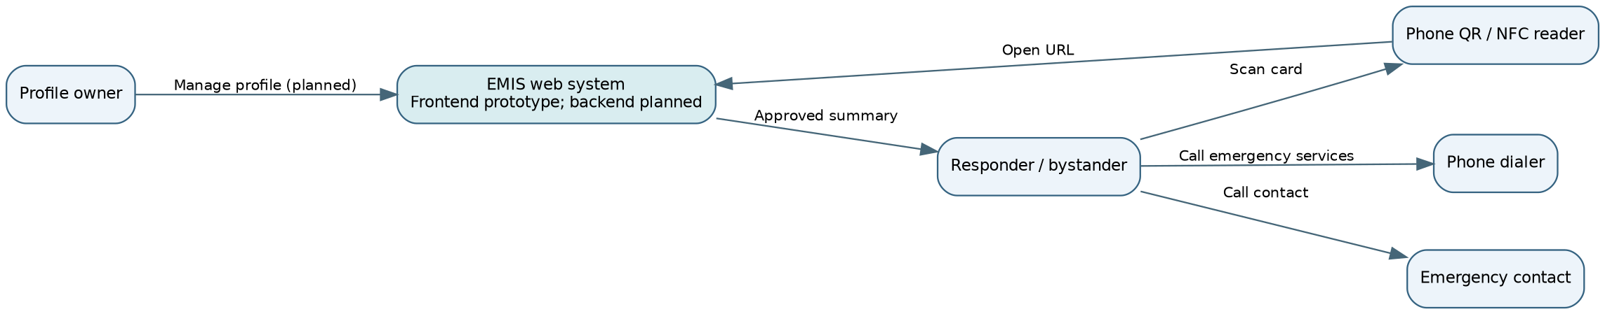

Context assumptions
The QR code and NFC tag are intended to reference a profile URL rather than store detailed medical records directly.
A public emergency view should reveal only an explicitly defined minimum dataset.
Access to editing and private fields should require owner authentication once implemented.
Internet access may be necessary for a hosted profile; offline availability is not assumed.

3. Use Case Diagram
The diagram below expresses planned interactions and is not evidence that each use case is implemented. Mermaid flowchart notation is used to show actors and use cases in an editable GitHub-compatible format.
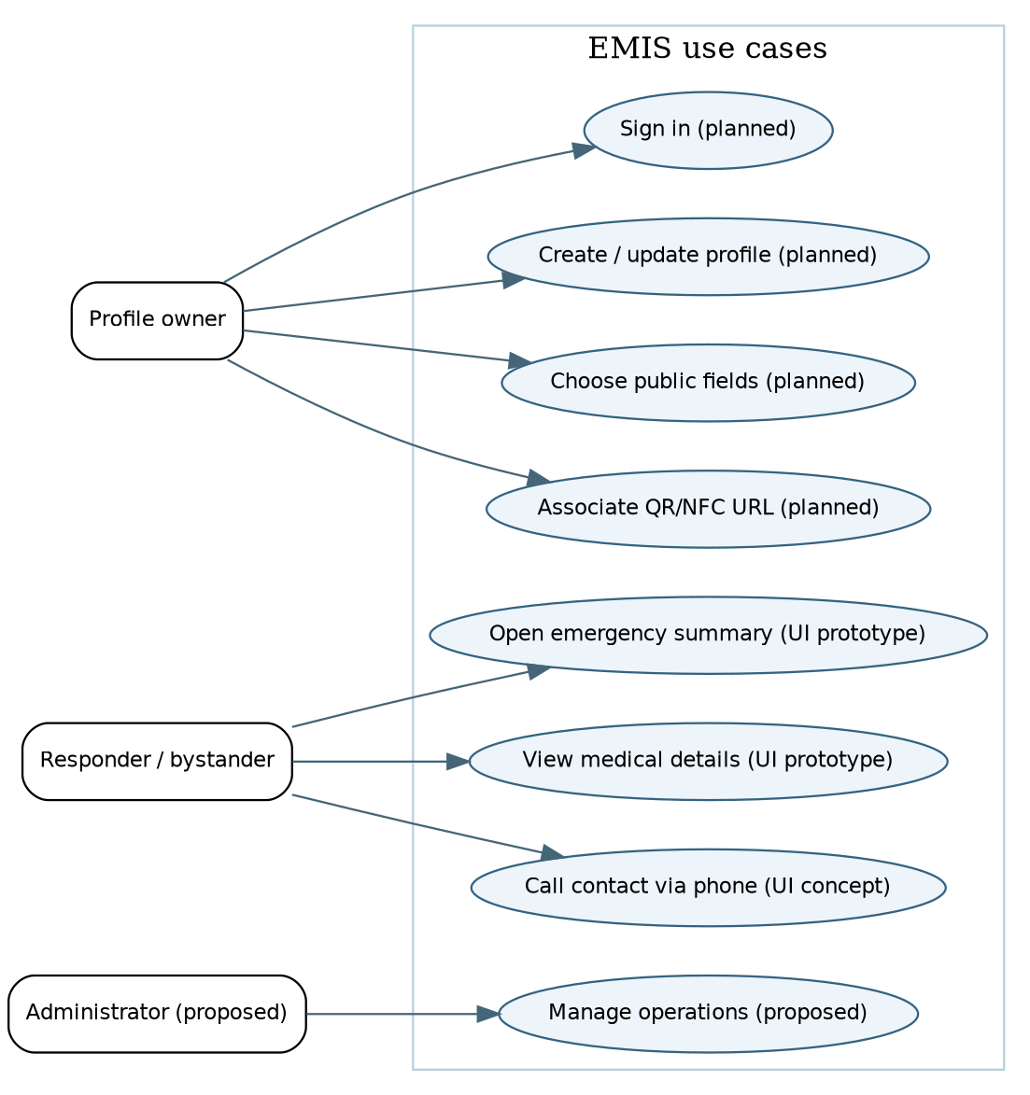

Core use case: Open emergency summary
A responder finds the physical medical ID card.
The responder scans the QR code or taps the NFC tag (future workflow).
The device opens the associated profile URL.
EMIS presents the approved emergency summary, such as allergies and emergency contacts.
The responder may use the device to call emergency services or the listed contact.
Exceptions to design and test: invalid or revoked URL; unavailable network; missing data; incorrect/self-reported information; unauthorized request for private data.

4. Component Diagram (draft)
Solid arrows describe the intended interactions. Components labeled planned have not been confirmed as operational in the current repository.
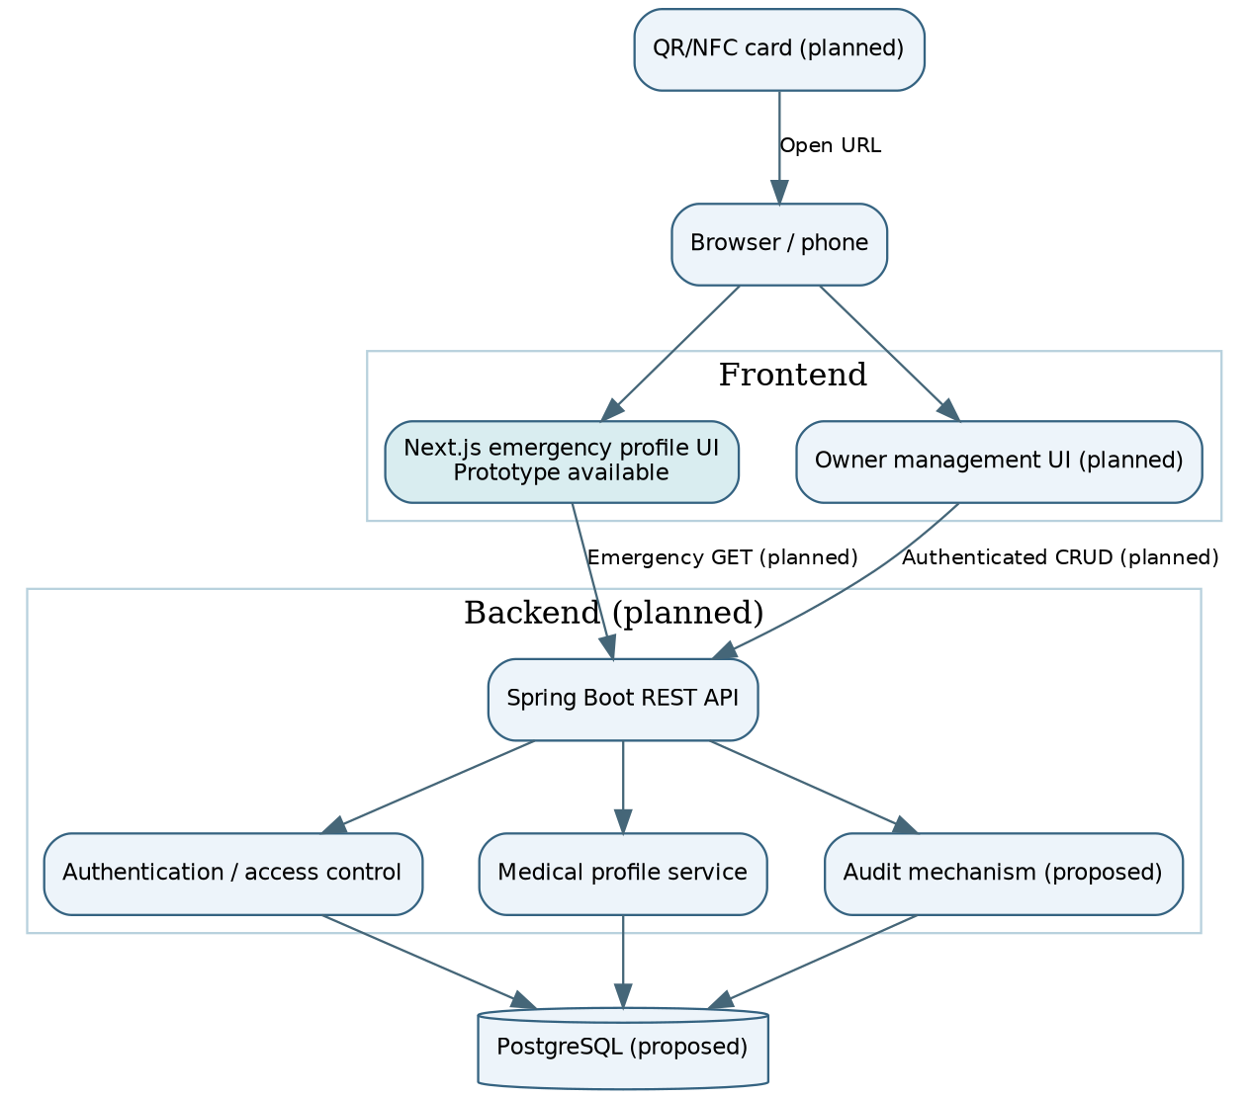

Proposed component responsibilities
Component | Responsibility | Status
Next.js emergency profile UI | Display sample emergency information and user interface | Prototype exists
QR/NFC card and link | Open the associated emergency profile URL | Planned
Spring Boot REST API | Handle profile requests and updates | Planned / development not verified
Authentication / authorization | Protect private data and profile editing | Planned
Medical profile service | Validate, retrieve, and update medical information | Planned
PostgreSQL | Persist profiles and access-related records | Proposed
Audit mechanism | Record appropriate access/change events without exposing unnecessary sensitive data | Proposed

5. Data flow and privacy boundaries
Emergency access (proposed): QR/NFC URL → browser → public emergency view → API → approved subset of profile data. No login is expected for the emergency subset, so its contents must be carefully minimized.
Owner update (proposed): owner authentication → owner management interface → API authorization → validated changes → database. The owner must not be able to edit another person's record.
Important design constraints:
Do not place complete medical histories, passwords, or access tokens on a physical card.
Use HTTPS for hosted pages and APIs.
Limit public fields and avoid indexing or inadvertent exposure of sensitive profiles.
Define revocation and lost-card replacement procedures before deployment.
Provide clear warnings that medical data may be incomplete or self-reported.
Evaluate applicable privacy and data-protection requirements before real patient deployment.

6. Requirements traceability (initial mapping)
Architecture element | Intended requirement area | Evidence / future verification
Public emergency view | Fast emergency access and limited disclosure | UI review; later API access tests
Owner management UI | Profile creation and updates | Future authenticated workflow tests
Access control | Confidentiality and authorization | Future negative authorization tests
QR/NFC URL | Emergency card navigation | Future device and invalid-link tests
Database | Persistence and data integrity | Future integration tests
Audit mechanism | Accountability | Future event and privacy tests
The exact requirement IDs should be aligned with the team's latest docs/requirements.md after review.

7. Key architecture decisions requiring validation
Confirm whether the public emergency URL should use a revocable random identifier rather than an easily guessed sequential ID.
Confirm the minimum public medical dataset with representative users and the supervisor.
Decide the owner authentication mechanism and account recovery procedure.
Select the final persistence schema and retention/deletion rules.
Test usability, mobile compatibility, accessibility, and failure behavior under poor connectivity.
Decide how NFC and QR links are provisioned and replaced if a card is lost.

8. UX and Prototype
Figma project: Link to Figma template is at the top

1. Project Overview
EMIS is a university diploma prototype designed to provide quick access to selected emergency medical information through a QR code or NFC medical ID card. The interface prioritizes clarity, accessibility, and limited disclosure of personal information.

2. Prepared Design Materials
Four Figma concepts have been prepared: a mobile emergency profile, a desktop emergency profile, a QR/NFC scanning journey, and a medical ID card concept. The designs demonstrate the proposed interface and navigation flow; they do not establish that QR/NFC functionality is operational.

3. Interface Structure
The emergency profile presents the patient’s name, critical allergies, reported blood type, medical conditions, emergency contact, and a Call 112 action for Kazakhstan. Allergy warnings are highlighted to support rapid identification. Both mobile and desktop layouts distinguish public emergency information from private records.

4. Visual Design and Usability
The visual concept uses navy typography, teal interface accents, light backgrounds, and red warning elements. Rounded cards and clear headings support quick scanning. The mobile layout uses a compact reading order, while the desktop layout separates medical information from emergency actions.

5. Privacy and Safety
The prototype uses fictional, self-reported information and includes notices that the details are not clinically verified. The proposed public profile contains only emergency-relevant information. Actual consent controls, data protection mechanisms, and backend integration remain outside the demonstrated design.

6. Review Findings and Next Steps
Before final approval, align the demo blood type across mobile and desktop screens (currently B+ and O+) and use the same fictional emergency contact (currently Batman and Sarah Johnson). Export all four frames, verify design specifications in Figma, add the project link, and review the documentation with the design contributor. The medical ID card currently contains a QR placeholder and conceptual NFC indication.

7. Visual references

Mobile emergency profile
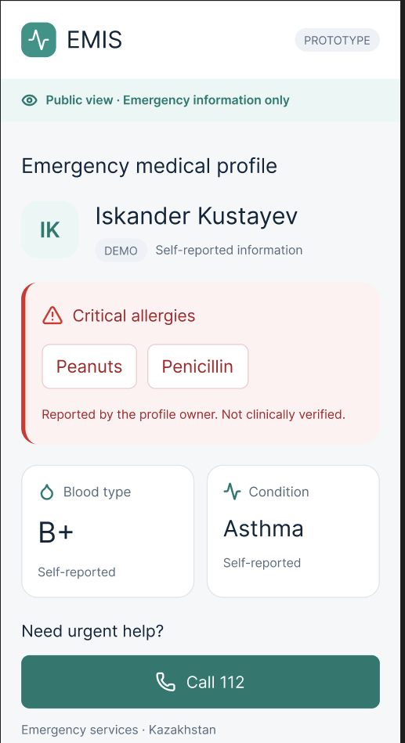

Desktop emergency profile and QR/NFC scanning journey

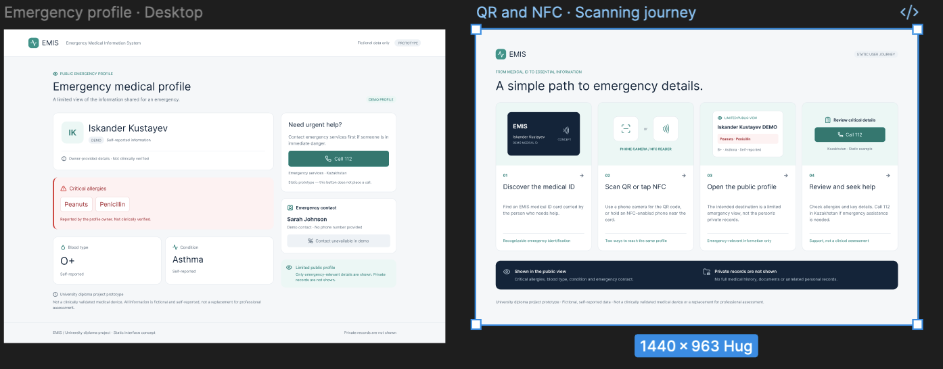

NFC medical ID card concept
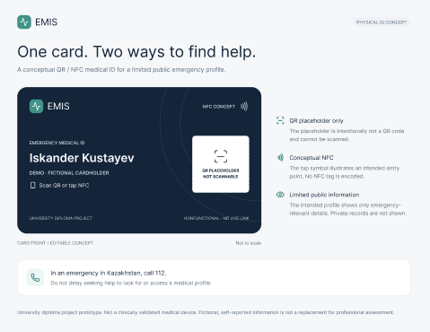

9. Verification and Evaluation Plan

1. Purpose and evaluation questions
This plan defines how the EMIS prototype and future integrated system will be verified against functional, privacy, accessibility, reliability and usability requirements. The primary evaluation question is whether an emergency responder can quickly access an intentionally limited medical summary without exposing private account-management information.
Secondary questions: Can an owner manage information securely? Does a QR/NFC link behave reliably? Can incorrect, missing or outdated information be identified? Are the access-control rules consistently enforced?

2. Current implementation baseline
As of the first pre-defense, the Next.js emergency profile UI and Figma mockups are available. The Spring Boot API, database integration, production authentication, physical QR/NFC operation, and end-to-end emergency workflow are planned and must not be represented as tested implementations.

3. Verification matrix
ID / area | Proposed verification | Acceptance criterion (target) | Stage
V-01 Public profile | Open sample profile in mobile and desktop browsers | Essential fields readable; no account editing controls exposed | Prototype
V-02 QR access | Scan printed QR from supported phones | Valid scan opens correct public profile; invalid token fails safely | Future integration
V-03 NFC access | Tap NFC card on supported devices | Tap resolves to same limited profile as QR | Future integration
V-04 Authentication | Attempt owner edit without login | Unauthenticated modification rejected (401/403) | Future backend
V-05 Data minimization | Inspect public API response and UI | Private fields absent from public response | Future backend
V-06 Update/revocation | Change or disable profile access | New values shown after update; revoked links unavailable | Future backend
V-07 Input validation | Submit invalid medical profile values | Clear validation errors; invalid data not stored | Future backend
V-08 Availability | Repeat access under network failure | Clear error state; no false claim of current information | Future integration
V-09 Accessibility | Keyboard navigation and contrast review | No critical navigation blockers; review WCAG 2.2 AA targets | Prototype + future
V-10 Safety notices | Inspect profile and first-aid content | Self-reported status, update date, and emergency disclaimer visible | Prototype + future

4. Outcome metrics and measurement conditions

Task completion rate
Percentage of participants who locate allergy, medication and emergency-contact fields without assistance.

Time to essential information
Seconds from scanning a QR code (or opening a prototype link) until a participant identifies a specified allergy; report median and range.

Error rate
Number of incorrect selections or missed critical fields per task.

Usability feedback
Post-task ease-of-use rating on a 1–5 scale and qualitative comments.

Access-control test pass rate
Passed privacy/security test cases divided by executed cases; report separately from usability.

Cross-device consistency
Pass/fail results on selected Android/iOS devices and desktop browsers, with versions recorded.
Measurement conditions: use fictional medical profiles only; record device model, OS/browser, network type, participant role, task wording, start/stop definition, and whether a task used a static prototype or a working system. Do not recruit emergency patients or use real medical records for this evaluation.

5. Baseline and comparison design
Baseline A (prototype): participants receive the same fictional emergency details in a conventional static text/PDF card view. EMIS prototype: participants locate the information through the emergency profile interface. Compare completion rate, time, and errors using identical scenarios. This is a proposed study design, not an observed result.
When QR/NFC becomes functional, add Baseline B: manually entering a profile URL versus scanning the printed QR/NFC card. Ensure the compared workflows present equivalent information.

6. Suggested test scenarios
S1: Locate a peanut allergy and identify the displayed emergency contact.
S2: Determine whether medication information is available or missing.
S3: Attempt to edit a profile while unauthenticated (expected denial after backend implementation).
S4: Open a revoked or malformed public link (expected safe error after backend implementation).
S5: View the profile with a narrow screen, keyboard navigation, and poor network connectivity.

7. Risks, limitations and ethics
A QR/NFC card may be lost, copied or scanned by anyone; public data must therefore be limited to owner-approved emergency fields. Medical information can be inaccurate or outdated; display a last-updated indicator and make no claim of clinical verification. QR/NFC access depends on device compatibility and connectivity. First-aid guidance is informational and should be reviewed against authoritative guidance before release. User studies require informed consent and non-sensitive fictional data.

8. Evidence to collect and reporting format
Screenshots or recordings of each test, with date, device and build/tag.
Test case log: ID, requirement, steps, expected outcome, actual outcome, pass/fail, defect link.
Usability summary: participant count, scenarios, median time, completion rates and observed issues.
Issue tracking: link defects and improvements to YouTrack IDs and reviewed GitHub PRs.
Supervisor review: document feedback, date and resulting changes.
Milestone | Deliverable | Status
First pre-defense | Documented plan, UI screenshots, Figma prototype, draft test cases | Planned evidence collection
Backend integration | API unit/integration tests, access-control tests | Not implemented
QR/NFC integration | Device compatibility and link lifecycle tests | Not implemented
Final evaluation | Usability study and baseline comparison with measured results | Not conducted

10. Project Management and Risks
Purpose: Document team responsibilities, milestone planning, task traceability, dependencies and risks. This document records reported progress; it is not evidence that planned backend or QR/NFC features are implemented.

1. Team and Responsibilities
Contributor | Primary responsibility | Evidence / expected outputs
Bekbolat Yergaliuly | Frontend and coordination | Next.js frontend setup, emergency profile interface, repository coordination
Shugyla Akhit Zhasulankyzy | UI/UX and design documentation | Mobile/desktop Figma mockups, card concept, scanning journey, design report
Olzhas Omerzak Zhunisbekuly | Backend architecture and planned implementation | Backend README / architecture plan; future Spring Boot API and persistence
Supervisor: Dana Yespenbetova | Academic review | Feedback on scope, architecture, research and milestones (to be collected)

2. Scope and Delivery Strategy
Current pre-defense emphasis: problem definition, prototype, architecture, technology rationale, requirements, planning and traceable contributions. A complete working application is not required at this stage.
In scope (planned system): public emergency summary accessed by QR/NFC; owner-managed private medical data; emergency contact; authentication and access controls; auditability and privacy safeguards.
Out of scope for the first pre-defense: operational Spring Boot API, production database, deployed QR/NFC cards, clinical validation, and real-patient medical data. All examples should use fictional data.

3. Current YouTrack Progress (reported 23 October 2026)
Issue | Work item | Status
EMIS-1 | Initialize Next.js frontend | Done
EMIS-2 | Design emergency profile in Figma | Done
EMIS-3 | Initialize Spring Boot backend | In development / not complete
EMIS-5 | Develop emergency medical profile UI | Done
EMIS-6 | Create UI/UX design documentation | Done
EMIS-7 | Develop emergency medical profile API | Backlog / not complete
EMIS-8 | Prepare backend architecture documentation | Done (per team report)

4. Milestones and Dependencies
Milestone | Target / stage | Dependencies
First pre-defense package | 24 October 2026 | Reviewed docs, GitHub PR evidence, YouTrack board, prototype, supervisor review
Backend foundation | After first pre-defense | Architecture confirmation, environment setup, collaborator access
Profile API and database | Next implementation stage | Backend foundation, approved data model, privacy rules
QR/NFC end-to-end integration | After API readiness | Stable URL resolution, public profile endpoint, frontend integration
Security, usability and evaluation | Before second defense | Integrated system, test data, defined baseline and metrics

5. Risk Register
Risk | Likelihood / impact | Mitigation and owner
Sensitive medical information exposed | Medium / High | Public/private field separation; access tests; no real patient data. Backend + frontend
Backend delayed | High / Medium | Submit architecture plan now; sequence API work after setup. Olzhas
QR/NFC card fails or becomes inaccessible | Medium / Medium | QR fallback, short stable URL, test multiple devices. Team
Inconsistent mockup data or terminology | Medium / Medium | Unify example patient, blood group and contacts. Shugyla + Bekbolat
Unverified clinical content | Medium / High | Avoid diagnosis/treatment claims; review emergency text with qualified sources. Team
Incomplete research or supervisor evidence | High / High | Track missing deliverables explicitly; request real feedback; no fabricated interviews. Team
Untraceable GitHub contributions | Medium / High | Individual accounts, task IDs, reviewed PRs and links to YouTrack. Team

11. Supervisor Feedback
11.1. Initial Evaluation
The supervisor positively evaluated the relevance and potential of the project, Design and Development of a Privacy-Aware QR/NFC-Based Emergency Medical Information System. The proposed solution addresses a real-world problem by providing access to essential medical information during emergencies. The supervisor also acknowledged the team's initial planning, distribution of responsibilities, and selection of an appropriate technology stack.

11.2. Areas for Improvement
The supervisor identified several aspects requiring further development:
- Requirements: Clearly define target users, stakeholders, and emergency-use scenarios.
- Privacy and Access Control: Specify public and restricted medical information, consent mechanisms, authorization, and access revocation.
- QR/NFC Mechanism: Explain how identification cards connect to medical profiles and how lost or copied cards are handled.
- Security: Implement appropriate authentication, encryption, secure sessions, and audit logging to prevent unauthorized access.
- Usability and Reliability: Ensure fast information retrieval, a clear mobile interface, and consideration of connectivity or scanning failures.
- First-Aid Resources: Use reliable medical guidelines and distinguish educational information from personalized medical advice.
- Testing: Establish measurable acceptance criteria for functionality, security, usability, scanning, and performance.

11.3. Recommendations and Next Steps
For the next checkpoint, the supervisor recommended preparing a formal requirements specification, system architecture and database design, use-case and user-flow diagrams, a threat model, an updated Figma prototype, a QR/NFC technical proof of concept, and a verification plan.
The team will prioritize defining the privacy model, emergency-access workflow, and security requirements before finalizing the system architecture. These recommendations will guide further frontend, backend, and UI/UX development.

11.4. Overall Assessment
The supervisor concluded that the project has a promising scope and practical relevance. However, its main challenge is balancing rapid emergency access with the protection of sensitive medical information. The supervisor recommended proceeding with requirements analysis and prototyping while integrating privacy, security, and usability throughout the development process.
Privacy and Access Control: Specify public and restricted medical information, consent mechanisms, authorization, and access revocation.
QR/NFC Mechanism: Explain how identification cards connect to medical profiles and how lost or copied cards are handled.
Security: Implement appropriate authentication, encryption, secure sessions, and audit logging to prevent unauthorized access.
Usability and Reliability: Ensure fast information retrieval, a clear mobile interface, and consideration of connectivity or scanning failures.
First-Aid Resources: Use reliable medical guidelines and distinguish educational information from personalized medical advice.
Testing: Establish measurable acceptance criteria for functionality, security, usability, scanning, and performance.
11.3. Recommendations and Next Steps
For the next checkpoint, the supervisor recommended preparing a formal requirements specification, system architecture and database design, use-case and user-flow diagrams, a threat model, an updated Figma prototype, a QR/NFC technical proof of concept, and a verification plan
The team will prioritize defining the privacy model, emergency-access workflow, and security requirements before finalizing the system architecture. These recommendations will guide further frontend, backend, and UI/UX development.
11.4. Overall Assessment
The supervisor concluded that the project has a promising scope and practical relevance. However, its main challenge is balancing rapid emergency access with the protection of sensitive medical information. The supervisor recommended proceeding with requirements analysis and prototyping while integrating privacy, security, and usability throughout the development process.

References:
[1] A. T. Biju, A. Joy, M. Babu, M. Shaju, and H. John, “MEDxSWIFT: NFC Based Medical Card and Application,” Journal of Network and Information Security, vol. 12, no. 1, pp. 33–38, 2024.
[2] E. Raso et al., “Privacy-Aware Architectures for NFC and RFID Sensors in Healthcare Applications,” Sensors, vol. 22, art. 9692, 2022. doi: 10.3390/s22249692.
[3] A. Manes, I. Samra, E. Fedosova, J. Sran, and A. Behboudi, “Patient engagement and feasibility of a QR code–based digital information tool in the emergency department,” International Journal for Quality in Health Care, vol. 38, no. 3, art. mzag100, 2026. doi: 10.1093/intqhc/mzag100.
[4] N. Bedriova, M. Smetana, and D. Gombarska, “Design and Development of Technical Solution for NFC-Based Self-Management Therapy in Actual Oncology Treatment,” Applied Sciences, vol. 13, art. 2397, 2023. doi: 10.3390/app13042397.
[5] V. Balasubramanian, S. Vivekanandhan, and V. Mahadevan, “Pandemic tele-smart: a contactless tele-health system for efficient monitoring of remotely located COVID-19 quarantine wards in India using near-field communication and natural language processing system,” Medical & Biological Engineering & Computing, vol. 60, pp. 61–79, 2022. doi: 10.1007/s11517-021-02456-1.
[6] B. Çobanoğlu and N. Akalın, “Near Field Communication Usage in Telemedicine Systems,” publication details and year to be verified from original venue.
[7] Y.-W. Kuo et al., “Smart Health Monitoring and Management System for Organizations Using Radio-Frequency Identification (RFID) Technology in Hospitals or Emergency Applications,” Emergency Medicine International, art. 2177548, 2022. doi: 10.1155/2022/2177548.
[8] P. Shojaei, E. Vlahu-Gjorgievska, and Y.-W. Chow, “Security and Privacy of Technologies in Health Information Systems: A Systematic Literature Review,” Computers, vol. 13, art. 41, 2024. doi: 10.3390/computers13020041.
[9] R. Tertulino, N. Antunes, and H. Morais, “Privacy in electronic health records: a systematic mapping study,” Journal of Public Health, vol. 32, pp. 435–454, 2024. doi: 10.1007/s10389-022-01795-z.
[10] A. Mwogosi et al., “Data privacy in EHR systems: A TCCM systematic literature review of practices in developing countries,” Informatics and Health, vol. 3, pp. 133–141, 2026.
[11] S. R. Khan, A. L. Bernassau, and M. P. Y. Desmulliez, “Passive and Battery-Free RFID-Based Wireless Healthcare and Medical Devices: A Review,” IEEE Journal of Radio Frequency Identification, vol. 8, pp. 724–742, 2024. doi: 10.1109/JRFID.2024.3451230.
[12] A. U. Rehman et al., “Internet of Things in Healthcare Research: Trends, Innovations, Security Considerations, Challenges and Future Strategy,” International Journal of Intelligent Systems, art. 8546245, 2025. doi: 10.1155/int/8546245.

